Supplementary materials
Figure S1. Correlation of RNA viruses expression between vmNGS and metaRNA-Seq. Each colour represents a viral family. All hits are expressed in additive log-ratio (ALR) with MS2 as reference. The blue line corresponds to the regression curve.
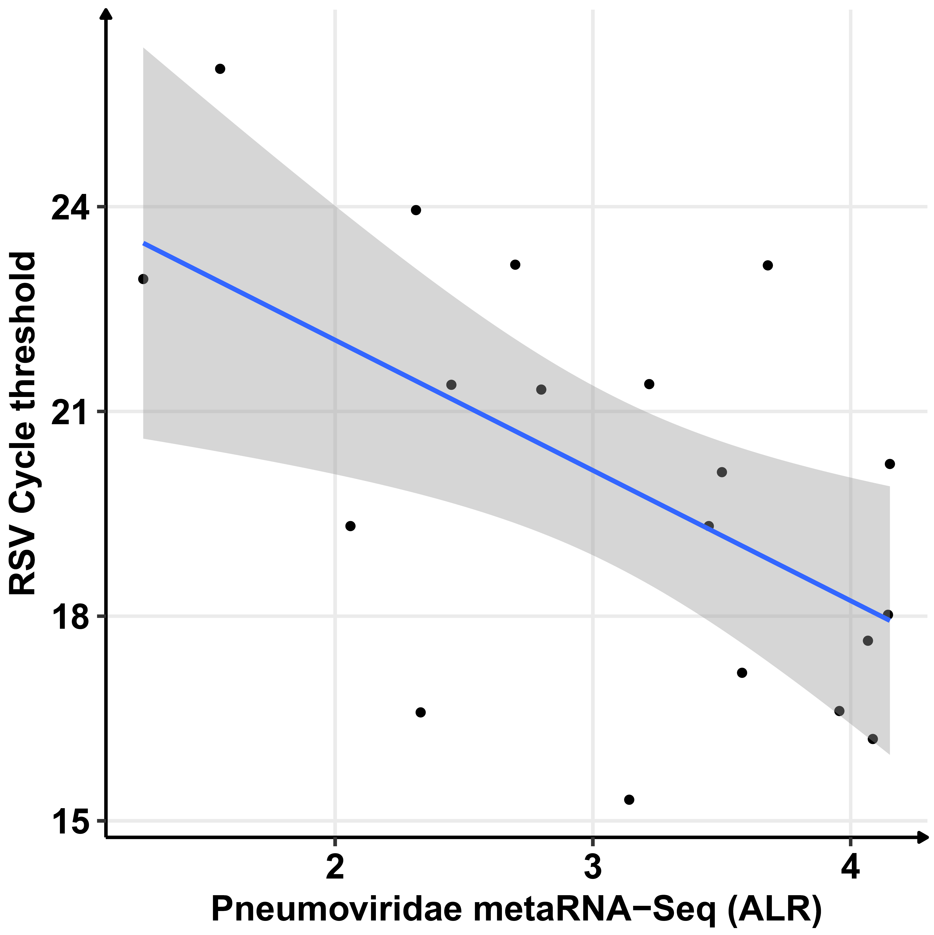
Figure S2. Correlation of RSV Cycle thresholds obtained by RT-PCR and Pneumoviridae ALR for metaRNA-Seq. The blue line represents the correlation curve.
Figure S3. Comparison of bacterial genera detected only by metaRNA-Seq. The lower panel corresponds to the number of positive samples and the distribution of relative abundances noted for the different bacterial genera.

Figure S4. Comparison of bacterial genera detected only by 16S-rRNA. The lower panel corresponds to the number of positive samples and the distribution of relative abundances noted for the different bacterial genera.
Figure S5. Non-supervised hierarchical clustering in mRNA-Seq. The 2650 genes tested in mRNA-Seq were selected as they were expressed in all patients in mRNA-Seq and metaRNA-Seq. Heatmap colors are representative of log2RPM values.

Table S1. Demographics and clinical features of the 20 selected nasopharyngeal samples
SampleID | Sex | Age (days) | Hospitalization (days) | Viral RT-PCR (Influenza Ct) | Viral RT-PCR (RSV Ct) | Viral RT-PCR (Picornavirus Ct)
59 | M | 101 | 1 | NEG | 17.64 | -
65 | M | 32 | 5 | NEG | 15.31 | -
85 | F | 115 | 1 | NEG | 26.02 | -
89 | F | 71 | 11 | NEG | 18.02 | -
91 | M | 185 | 2 | NEG | 23.14 | -
95 | F | 14 | 4 | NEG | 16.61 | -
101 | F | 30 | 4 | NEG | 20.23 | -
105 | M | 39 | 2 | NEG | 21.39 | -
108 | F | 22 | 6 | NEG | 16.2 | NEG
119 | F | 95 | 1 | NEG | 19.32 | -
121 | F | 31 | 2 | NEG | 23.95 | -
126 | F | 35 | 1 | 23.29 | NEG | NEG
20 | M | 100 | 3 | NEG | 23.15 | -
21 | M | 183 | 1 | NEG | 17.17 | -
24 | F | 86 | 5 | NEG | 20.11 | -
29 | F | 27 | 5 | NEG | 21.32 | -
32 | M | 19 | 2 | NEG | 16.59 | -
44 | M | 162 | 1 | NEG | 21.4 | NEG
47 | F | 45 | 1 | NEG | 19.32 | NEG
22 | F | 45 | 2 | NEG | 22.94 | NEG
Ct=Cycle threshold; NEG=negative
Table S2. List of bioinformatics tools used

 |  | Version | Reference
Bioinformatic pipelines | RASFLOW | v2.0 | 1
Bioinformatic pipelines | SEQMET | v0.1.0 | 2
Bioinformatic tools | BBMAP | v39.00 | 3
Bioinformatic tools | BRACKEN | v2.9 | 4
Bioinformatic tools | BWA-MEM | v0.7.17 | 5
Bioinformatic tools | CUTADAPT | v4.6 | 6
Bioinformatic tools | KRAKEN2 | v2.1.2 | 7
Bioinformatic tools | Samtools | v1.16.1 | 8
Bioinformatic tools | Srahumanscrubber | v2.2.1 | 9
R packages | Rstudio | v4.1.6 | 10
R packages | Biomart | v3.18 | 11
R packages | DADA2 | v3.2 | 12
R packages | Decontam | v1.20.0 | 13
R packages | ggplot2 | v3.4.2 | 14
R packages | vegan | v2.6.4 | 15

- Zhang, X., Jonassen, I. RASflow: an RNA-Seq analysis workflow with Snakemake. BMC Bioinformatics 21, 110 (2020). https://doi.org/10.1186/s12859-020-3433-x
- medRxiv 2022.03.24.22272871 doi: 10.1101/2022.03.24.22272871.
- https://github.com/BioInfoTools/BBMap
- Bracken's peer-reviewed paper (published Jan 2, 2017): "Bracken: estimating species abundance in metagenomics data" https://peerj.com/articles/cs-104/
- Li H. (2013) Aligning sequence reads, clone sequences and assembly contigs with BWA-MEM. arXiv:1303.3997v2 [q-bio.GN].
- DOI:10.14806/ej.17.1.200
- Wood, Derrick E et al. “Improved metagenomic analysis with Kraken 2.” Genome biology vol. 20,1 257. 28 Nov. 2019, doi:10.1186/s13059-019-1891-0
- Petr Danecek, James K Bonfield, Jennifer Liddle, John Marshall, Valeriu Ohan, Martin O Pollard, Andrew Whitwham, Thomas Keane, Shane A McCarthy, Robert M Davies, Heng Li,GigaScience, Volume 10, Issue 2, February 2021, giab008, https://doi.org/10.1093/gigascience/giab008
- https://github.com/ncbi/sra-human-scrubber
- https://posit.co/products/open-source/rstudio/
- Durinck S, Spellman P, Birney E, Huber W (2009). “Mapping identifiers for the integration of genomic datasets with the R/Bioconductor package biomaRt.” Nature Protocols, 4, 1184–1191
- Callahan, Benjamin J et al. “DADA2: High-resolution sample inference from Illumina amplicon data.” Nature methods vol. 13,7 (2016): 581-3. doi:10.1038/nmeth.3869
- Davis NM, Proctor D, Holmes SP, Relman DA, Callahan BJ (2017). “Simple statistical identification and removal of contaminant sequences in marker-gene and metagenomics data.” bioRxiv, 221499. doi:10.1101/221499
- https://cran.r-project.org/web/packages/ggplot2/index.html
- https://cran.r-project.org/web/packages/vegan/index.html

Table S3 List of contaminants identified by decontam for the four techniques
Table S4. Sequencing characteristics

