Likir Ney

Basgo

Nimmo Umla

- Ladakh
Taroo

Chilling
Sumda
Phyang

Leh
Spituk
Phey
Rumbak

Chuchhot Yokma

Saboo

Choglamsar
Shey Matho

Thiksey
Nang

Stok Shku Markh
Chuchhot
Shama
Rambir por Stakna

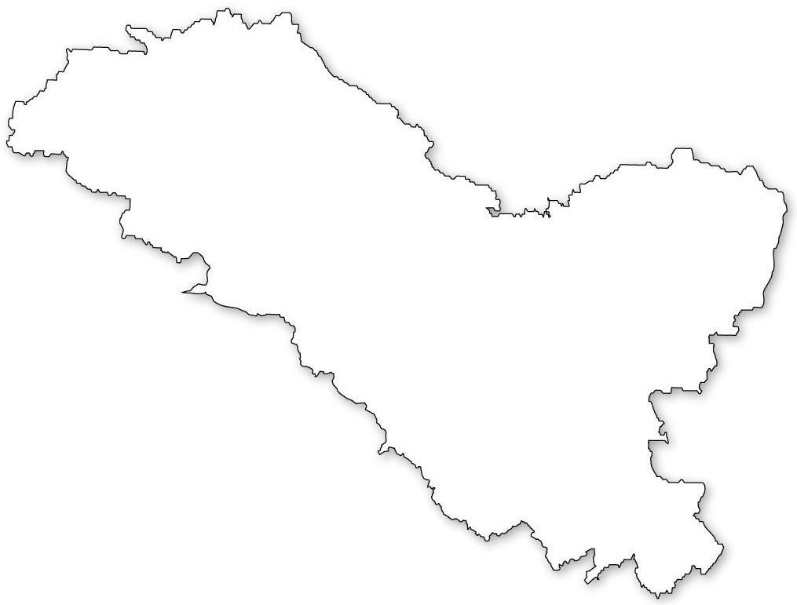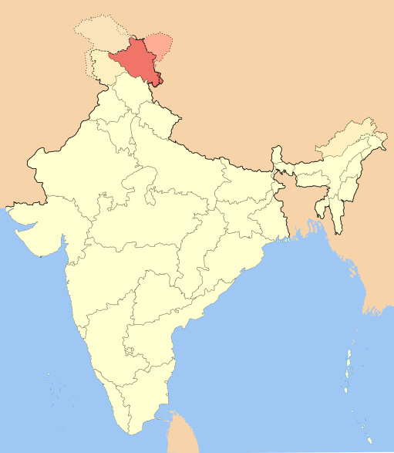Chuchhot Gongma

Ladakh, Bharat

