Figure S1
Figure S1. Frequencies of major cell populations are not different between vaccine low and high responders.
Boxplot of frequencies of major cell subsets in circulation in (A) pre-vaccination and (B) post-vaccination samples.
Figure S2
Figure S2. Visualization of cell clusters by UMAP.
Annotated major cell populations (centre plot) were further reclustered and visualized by UMAP (plots on the periphery). For the sake of consistency of visualization, all the subsequent plots display 20 meta-clusters.

Figure S3
Figure S3. CD4⁺ T cell annotation and comparison of cluster frequencies in pre-vaccination samples.
- Heatmap of median phenotypic marker and cytokine expression of annotated clusters within the CD4⁺ T cell compartment, across all stimulation condition.
- Boxplot of frequencies of CD4⁺ T cell subsets in vaccine low (LR, yellow) and high responders (HR, purple) in pre-vaccination samples for unstimulated, spike-stimulated and cytostim-treated PBMCs.

Figure S4
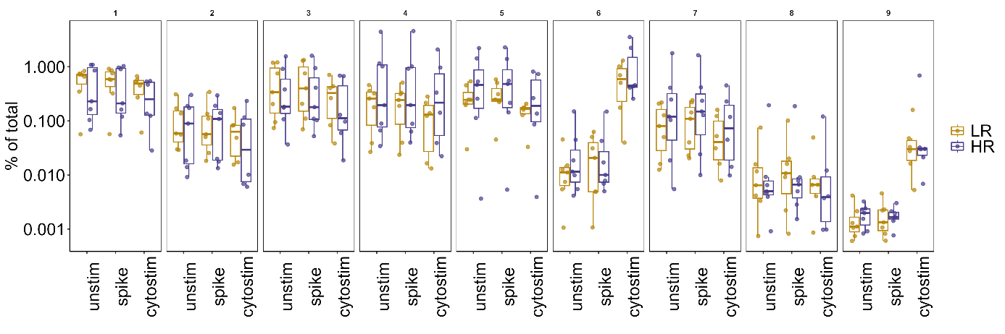
Figure S4. Frequencies of the γδ T cell subsets in pre-vaccination samples.
Boxplot of frequencies of the nine γδ T cell subsets in vaccine low (LR, yellow) and high responders (HR, purple) in pre-vaccination samples for unstimulated, spike-stimulated and cytostim-treated PBMCs.

Supplementary table 2. Naming convention of cell types
Cell type | Marker profile
B cells | CD45+ CD3- CD19⁺
Class-switched memory (SwM) | CD27⁺IgD⁻
Non-class-switched memory (NSwM) | CD27⁺IgD⁺
Transitional (Trans B) | CD27⁻CD24⁺CD38⁺
Mature | CD27⁻CD24⁻CD38^{+/-}
Naïve mature | CD27⁻CD24⁻CD38^{+/-} IgD⁺
Double negative (DN) | CD27⁻CD24⁻CD38^{+/-} IgD⁻
Resting naïve (resN) | CD27⁻CD24⁻CD38^{+/-} IgD⁺CD11c⁻
Activated naïve | CD27⁻CD24⁻CD38^{+/-} IgD⁺CD11c⁺
T cells | CD45+ CD19- CD3⁺
T_{H}1 | CD4⁺Tbet⁺
T_{H}17 | CD4⁺CCR6⁺
Treg | CD4⁺CD25⁺Foxp3⁺IL7Rα⁻
NK cells | CD45+ CD3- CD19- CD56⁺
NKT cells | CD45+ CD3- CD19- CD56⁺CD3⁺
Myeloid cells | CD3⁻CD19⁻CD56⁻CD11b⁺

