Supplemental Figures

Supplemental figure 1

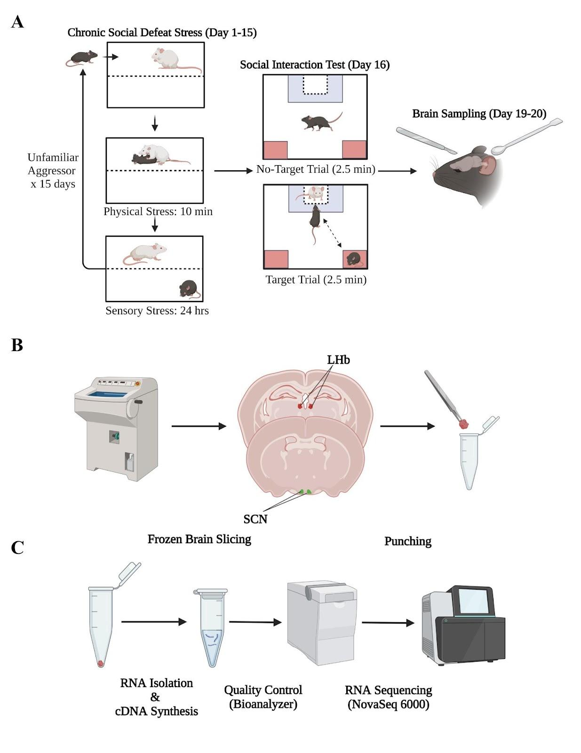

Supplemental figure 1. Graphical summary of the methodology. (A) Behavioural experimental methods and timeline. (B) Experimental methods for slicing and tissue punching. (C) Experimental methods for RNA isolation, quality control and sequencing.

Supplemental figure 2

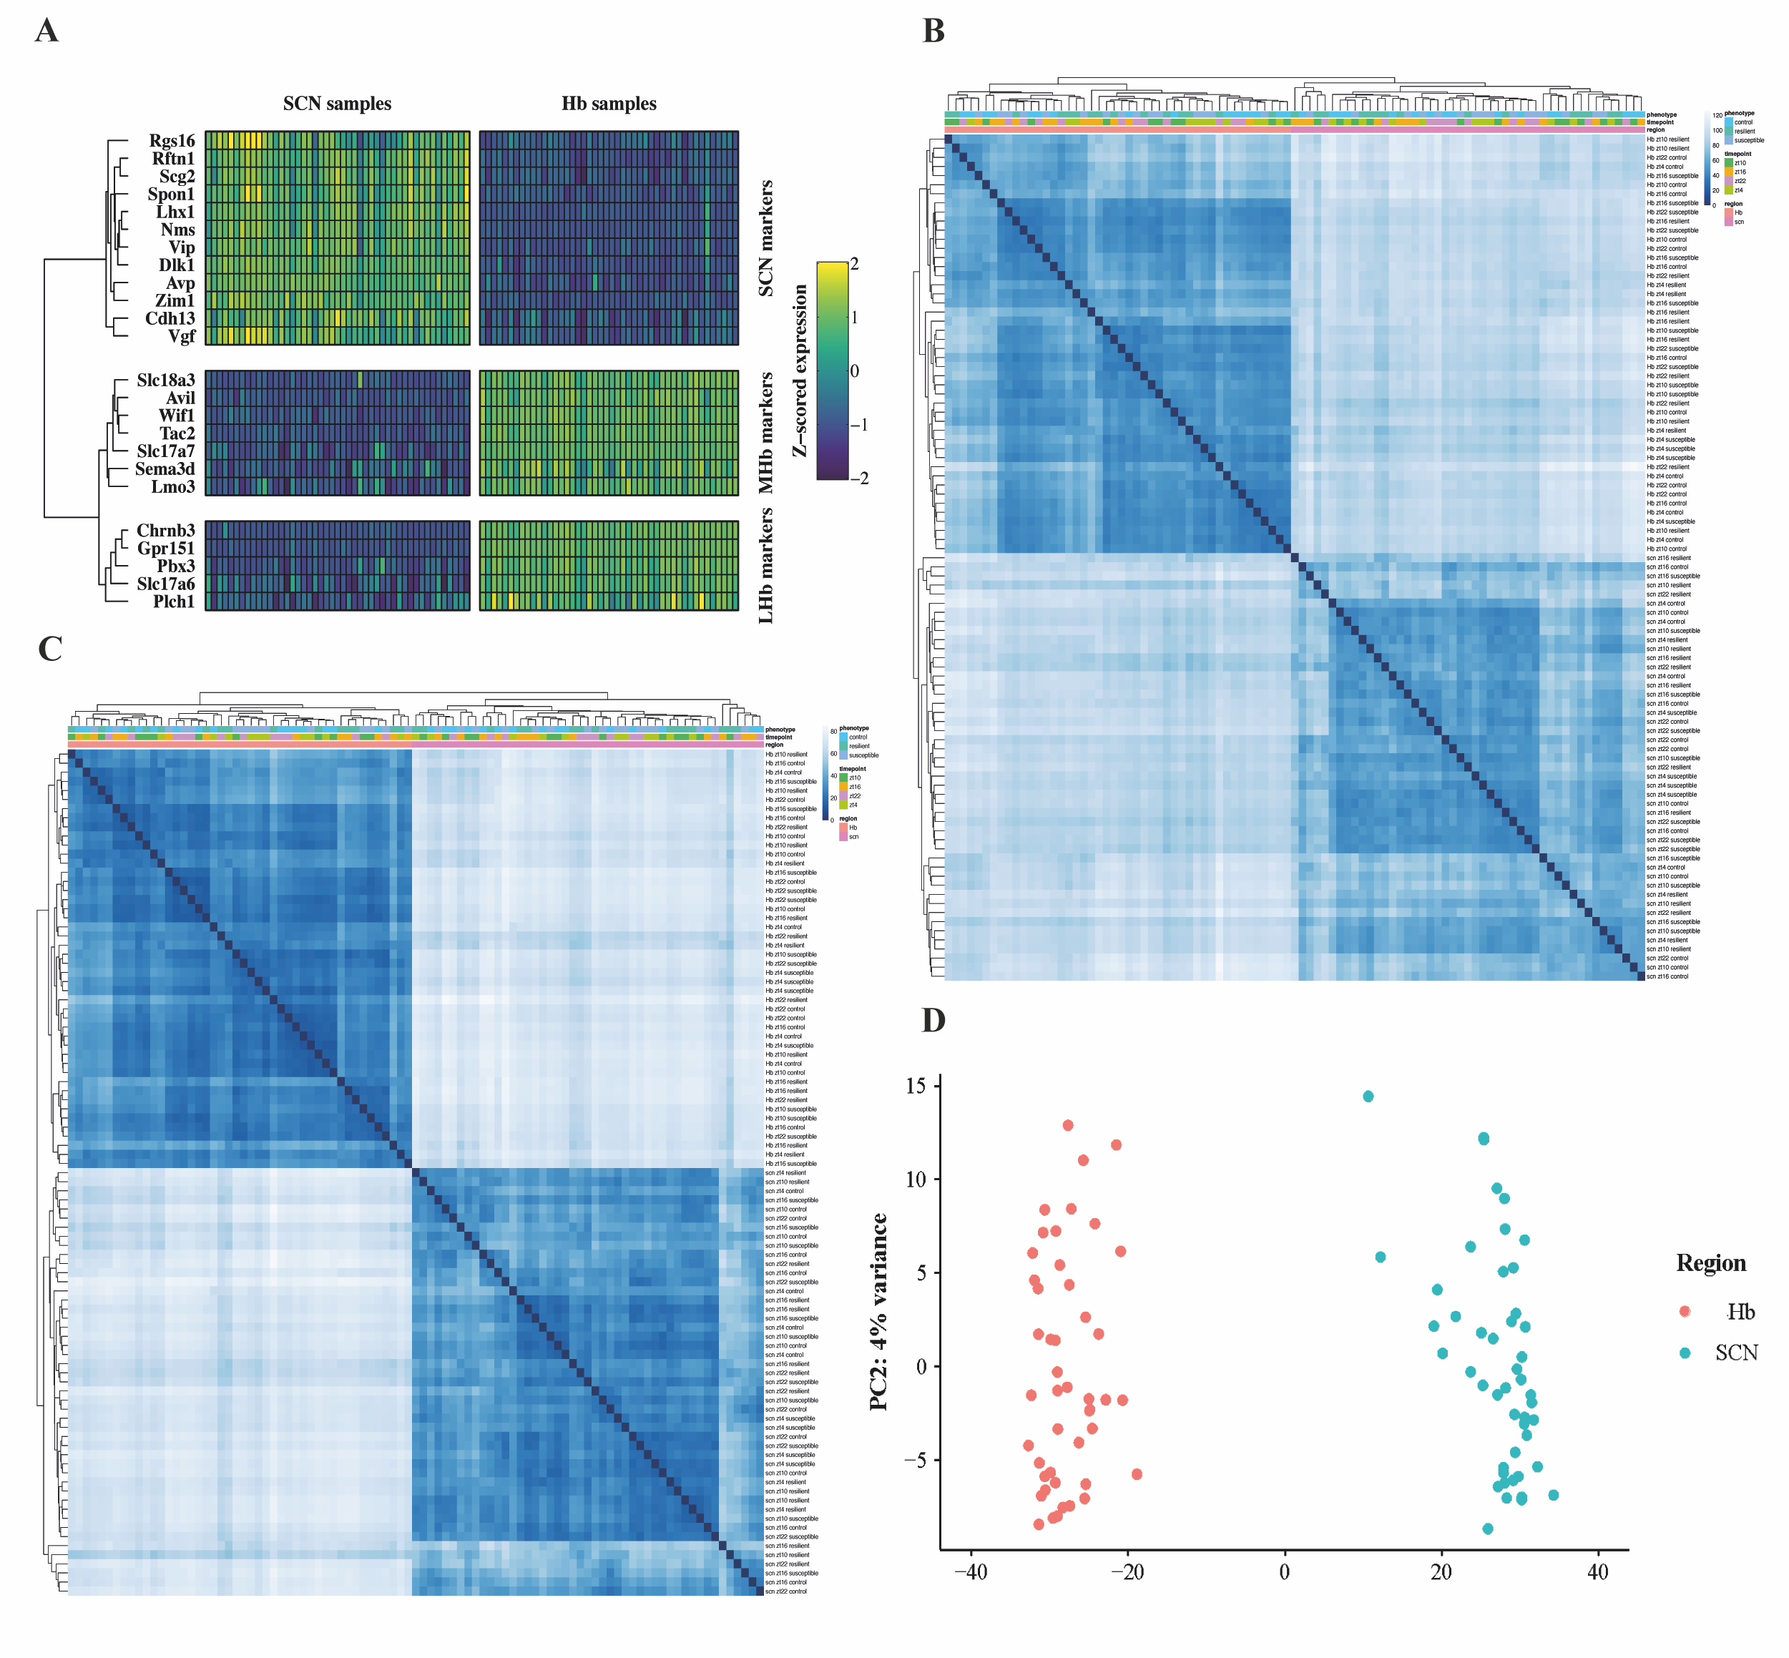
Supplemental Figure 2. Quality control and clustering. (A) Heatmap of canonical marker genes in the SCN and Hb. Normalized gene expression (variance stabilizing log2-transformed counts) across samples for reported marker genes specific to SCN, LHb and MHb ^{49,50} . (B) Sample clustering based on overall gene-expression and similarity-derived Euclidean distance. (C) Sample clustering based on 2000 most variable genes and similarity-derived Euclidean distance. (D) PCA plots showing clear separation between SCN and Hb samples. First principal component represents the regional identity of the samples and explains 82% of data variability.

Supplemental figure 3

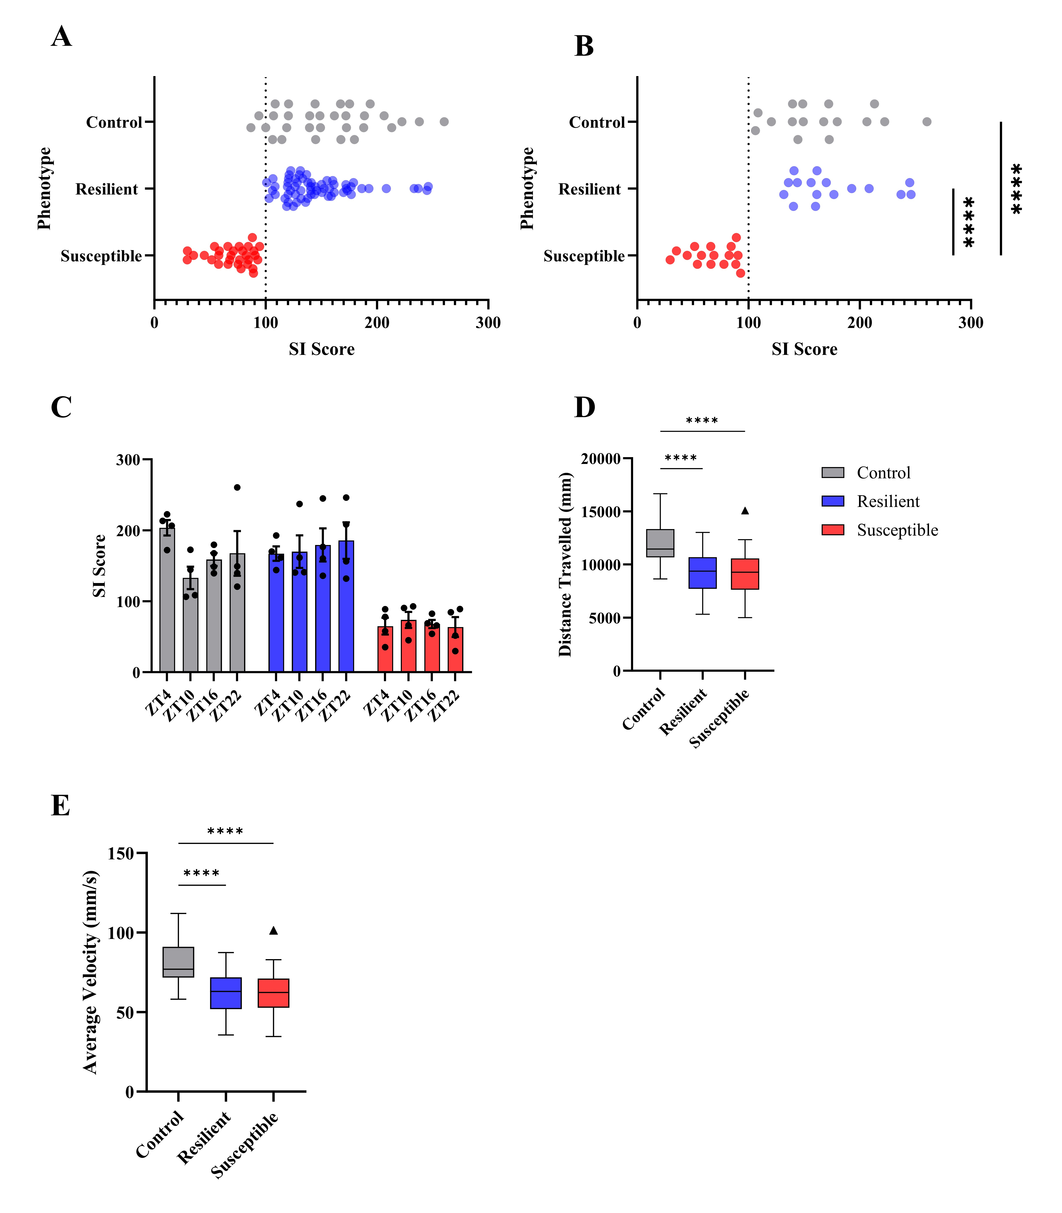
Supplemental Figure 3. Behavioural measures. (A) One-way ANOVA revealed significant variation in SI scores (F(2,120) = 63.3, p < .001). Tukey’s post hoc comparison revealed significant differences between controls and susceptible mice (p < .001, 95% C.I. = [65.4, 106.8]), and resilient and susceptible mice (p < .001, 95% C.I. = [58.9, 94.9]). Stress-naïve and resilient mice did not differ in SI scores (p = .44, 95% C.I. = [-8.6, 26.9]). (B) One-way ANOVA revealed significant variation in SI scores of sequenced mice (F(2,45) = 45.3, p < .001). Tukey’s post hoc comparison revealed significant differences between sequenced control and susceptible mice (p < .001, 95% C.I. = [67.8, 128.6]), and resilient and susceptible mice (p < .001, 95% C.I. = [77.9, 138.4]). Stress-naïve and resilient mice did not differ in SI scores (p = .72, 95% C.I. = [-40.2, 20.6]). (C) Same-phenotype mice (within-phenotype) sacrificed at the four time points (between-time point) did not significantly differ in their SI scores. (D) One-way ANOVA for total distance travelled for all mice used in the experiments was significant (F(2,120) = 23.3, p < .001). The observed differences were significant between control and susceptible mice (p < .001, 95% C.I. = [1624, 4059]), and control and resilient mice (p < .001, 95% C.I. = [1796, 3889]) (Fig.1C). (E) One-way ANOVA for average velocity travelled in all mice used in the experiments was significant (F(2,120) = 24.2, p < .001). There were significant differences in average velocity between control and susceptible mice (p < .001, 95% C.I. = [10.8, 27]), and control and resilient mice (p < .001, 95% C.I. = [12.5, 26.4]). All values and bar plots are reported as mean±SEM. The box plots were generated using Tukey method. Significance levels: ** p < .01, *** p < .001, **** p < .0001.

Supplemental figure 4
B
A

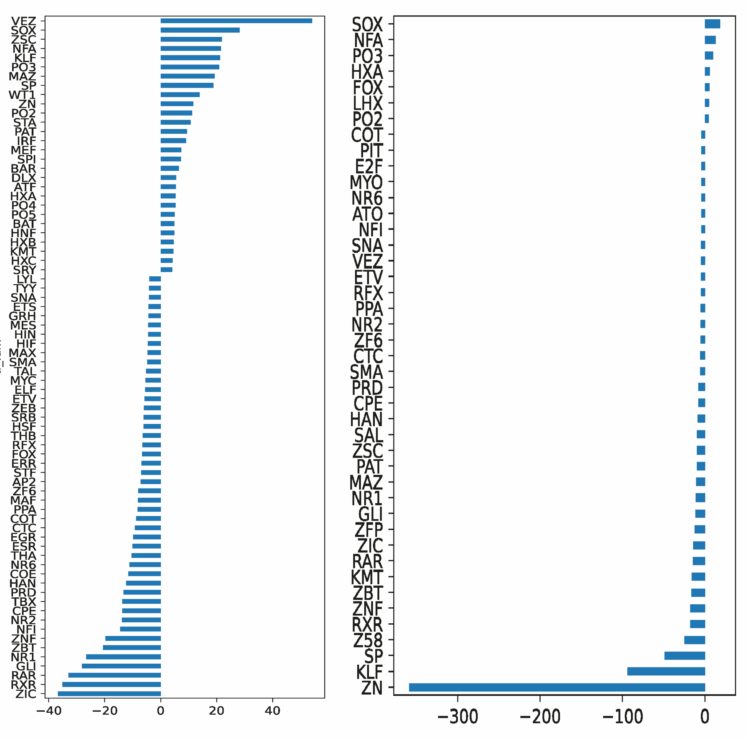

Supplemental Figure 4. Transcription family enrichment estimation at ZT16 between resilient and stress-naïve mice. (A) TF family binding patterns in the SCN. Estimated number of enriched TF families was 43 (7 TFs associated with upregulated, 36 with downregulated DEGs). (B) TF family binding patterns in the Hb. Estimated number of enriched TF families was 74 (28 TFs associated with upregulated, 46 with downregulated DEGs). (A-B) Overall, there were 8 TF families unique to the SCN and 39 TF families unique to Hb. The two regions showed enrichment of 35 common TF families.

