Appendix A

Figure 1. Alzheimer’s Disease Evoked Potential Test (ADEPT). Associatively related stimulus pairs consisting of a synchronously presented picture and a spoken word presented on a computer screen. The ADEPT elicits hippocampal function two ways: episodic memory and early integration of cross-modal sensory input.

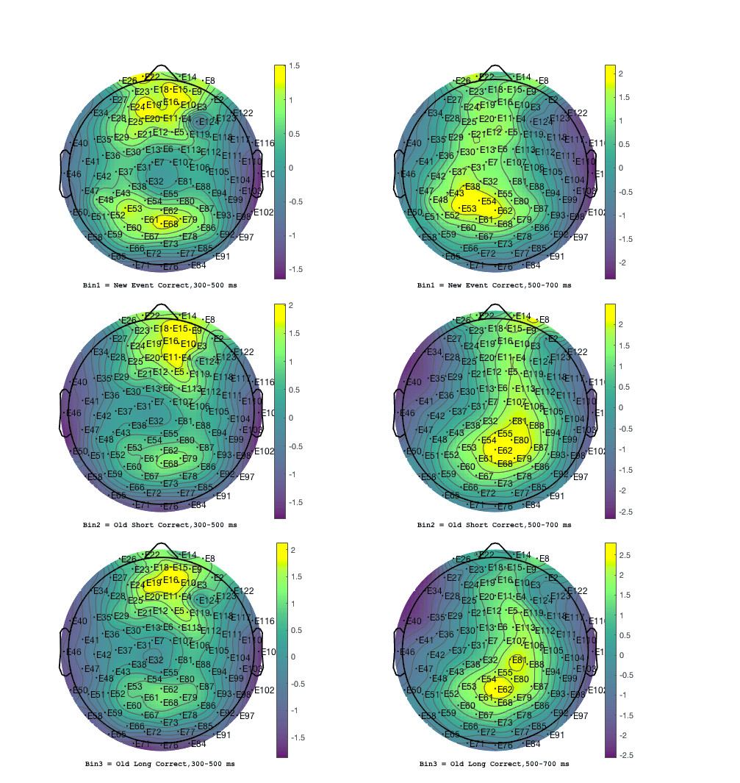 | 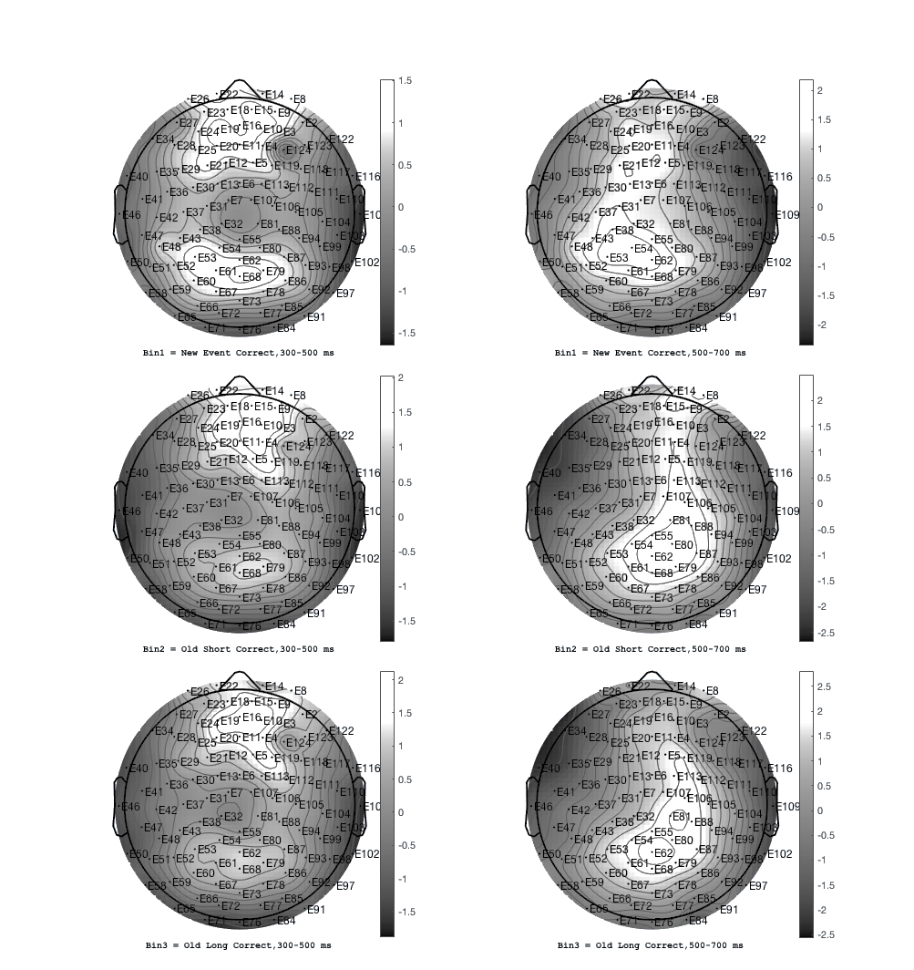

Figure 2. Grand average ERP scalp plots for (N=73) healthy controls, correct answers, average across 300-500 ms and 500-700 ms latency windows represented in lower contrast viridis and gray colormaps in EEGLab v2020.0. An example of color schemes argued by researchers to be more perceptually uniform.

Appendix B


Geodesic Sensor Net 200
128-Channel Map

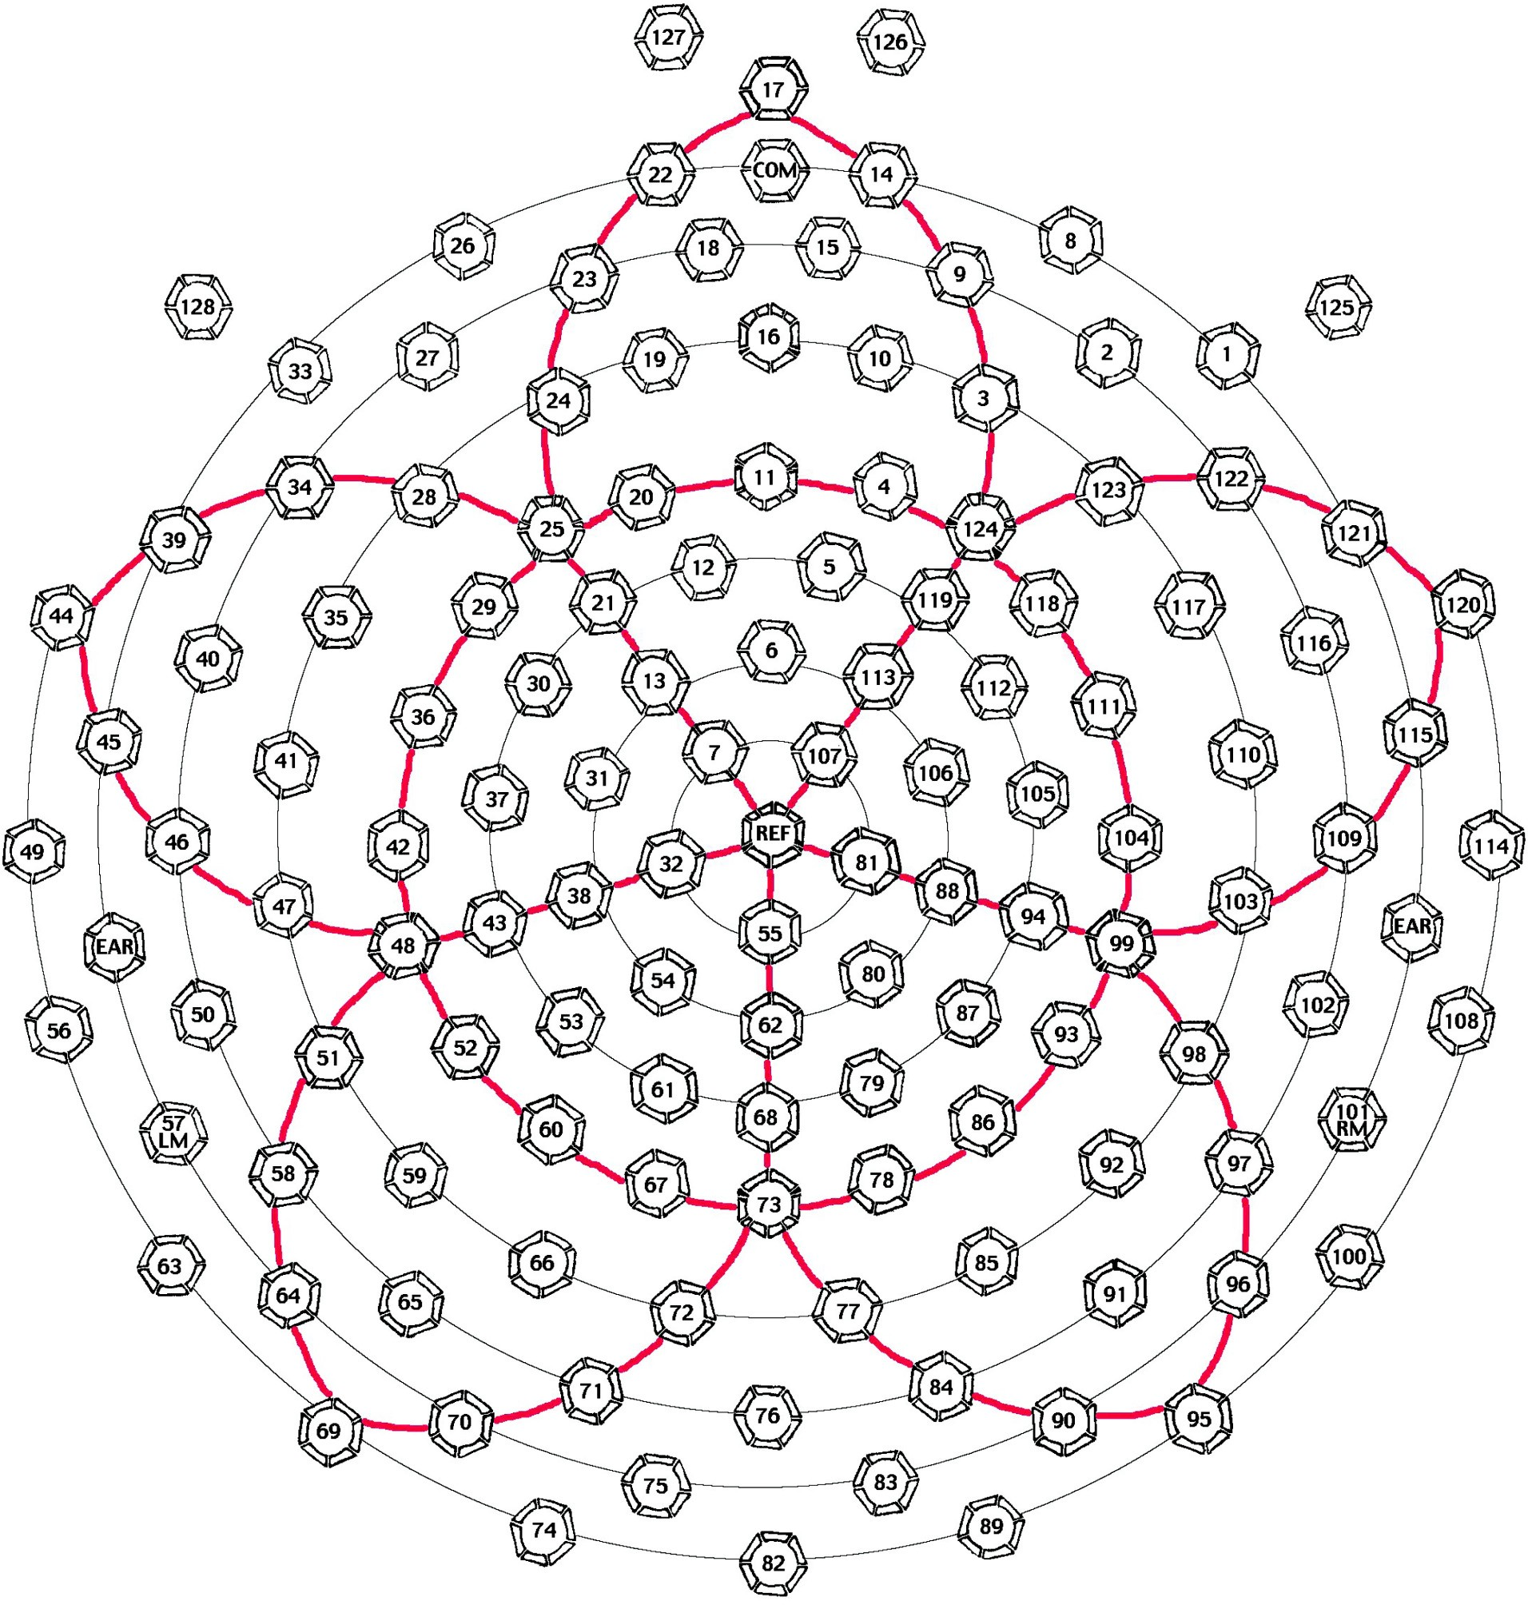

For questions or additional assistance, please refer to the Geodesic Sensor Net Technical Manual or contact us at:

Electrical Geodesics, Inc.
1600 Millrace Drive, Suite 307
Eugene, OR 97403, USA
Phone: +1-541-687-7962; Fax: +1-541-687-7963
Email: support@egi.com or info@egi.com Part number: 8402005-50

