Electronic Supplementary Information for:
X-ray Chemical Imaging of Mn-doped Co/TiO₂ Pellets reveals the significance of Cobalt Carbide Formation and Distribution on CO conversion and Alcohol Selectivity during Fischer Tropsch Synthesis
Danial Farooq^{1,2}, Matthew Potter^{1,2}, Sebastian Stockenhuber^{1,2}, Jay Pritchard^{1,2}, Antonios Vamvakeros³, Stephen W. T. Price³, Jakub Drnec⁴, Ben Ruchte⁵, James Paterson⁶, Mark Peacock⁶, Andrew M. Beale^{1,2}
¹Department of Chemistry, University College London, 20 Gordon Street, WC1H 0AJ, UK
²Research Complex at Harwell, Rutherford Appleton Laboratories, Harwell Science and Innovation Campus, Harwell, Didcot, OX11 0FA, UK
³Finden, Building R71, Harwell Campus, Oxfordshire, OX11 0QX, United Kingdom
⁴European Synchrotron Radiation Facility, ID 31 Beamline, BP 220, F-38043 Grenoble Cedex, France
⁵IXRF Systems, 10421 Old Manchaca Road, Suite 620, Austin, TX 78748, USA
⁶BP, Applied Sciences, Innovation & Engineering, Saltend, Hull, UK
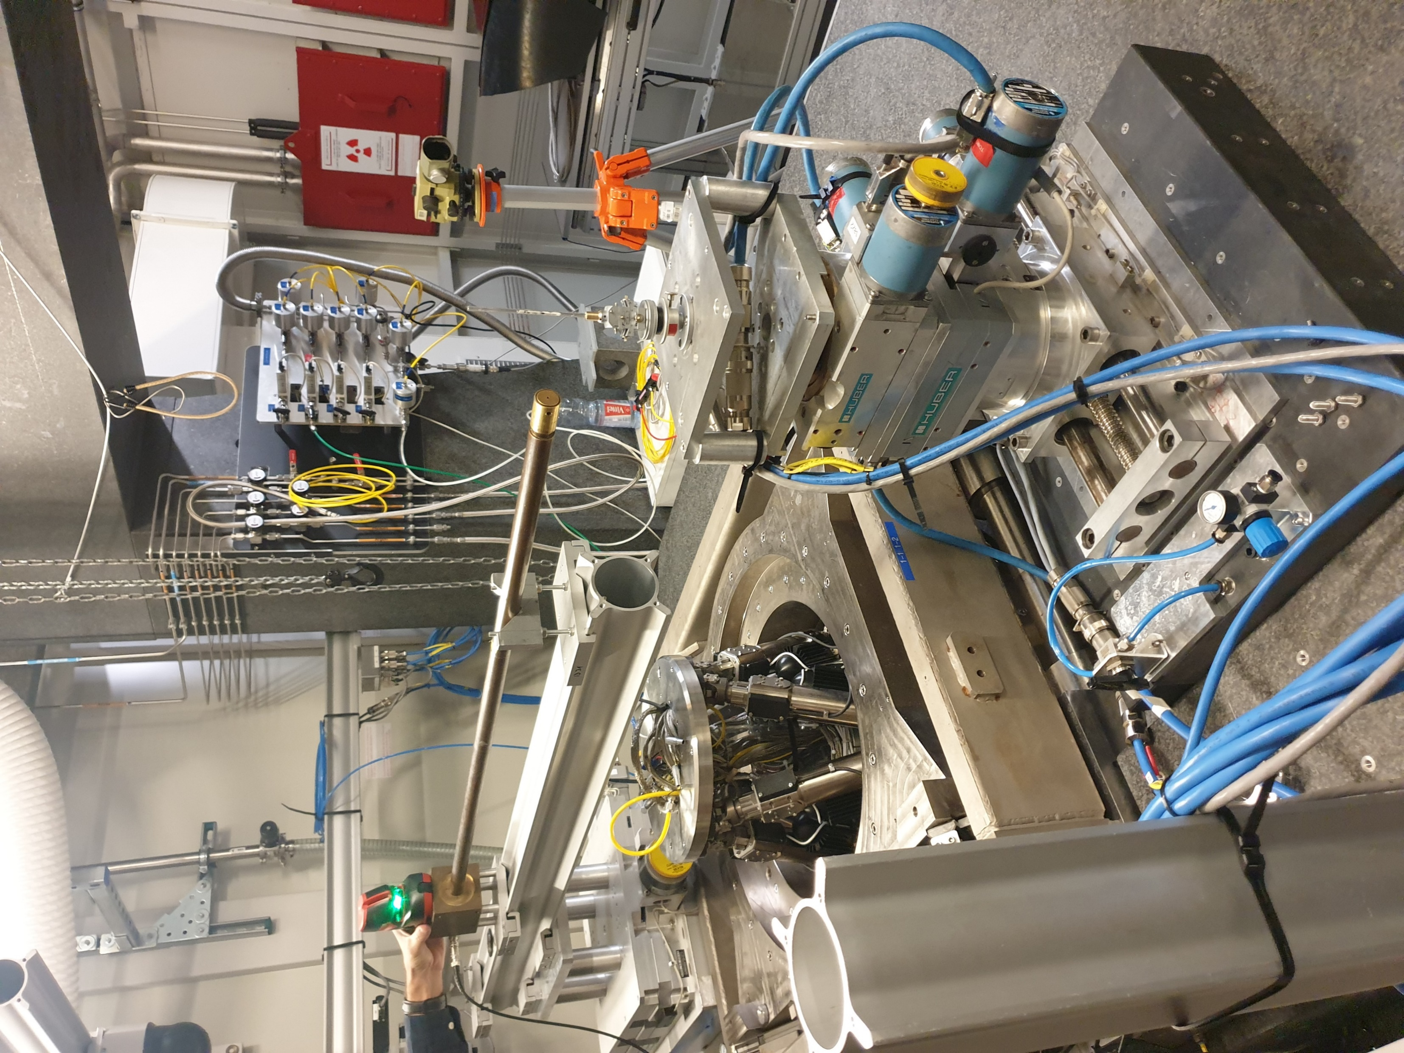
Sample in Capillary
Goniometer
Alignment camera
Stage
Figure S1 - Experimental set-up at ID31, ESRF, for the XRD-CT and PDF-CT experiments

Table S1 – Crystallographic information of identified phases.
Phase | Space Group | ICSD Code
Co₂C | P m n n (58) | 16895
FCC, Co | F m -3 m (225) | 41093
HCP, Co | P 63/m m c (194) | 44990
CoO | F m -3 m (225) | 9865
Rutile, TiO₂ | P 42/m n m (136) | 9161
Anatase, TiO₂ | I 41/ a m d S (141) | 9852
MnTiO₃ | R -3 H (148) | 60006

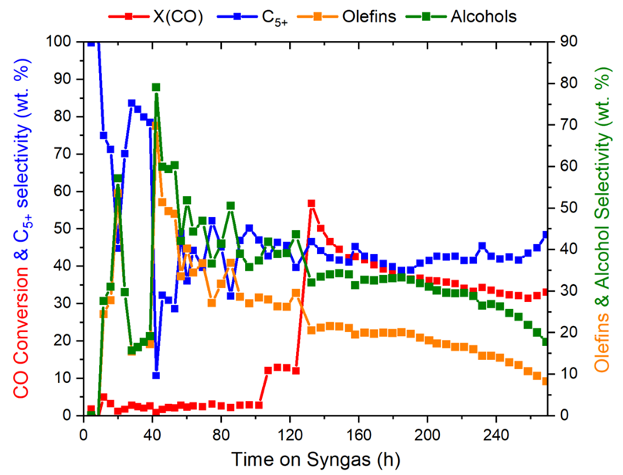
Figure S2 – CO conversion and selectivity to C5+, alcohols and olefins for the 2 % Mn sample for the reaction time from 0 to 270 h at 30 barg and 210-240 °C. The selectivity and conversion are stable with time on stream after 125 h.
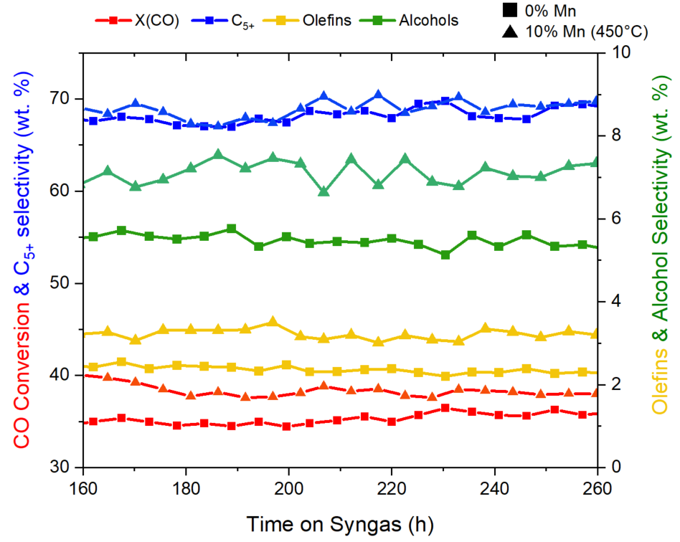
Figure S3 - CO conversion and selectivity to C5+, alcohols and olefins for the 0 % and 10 % Mn (450 °C) sample for the reaction time from 160 to 300 h at 30 barg and 210-240 °C.
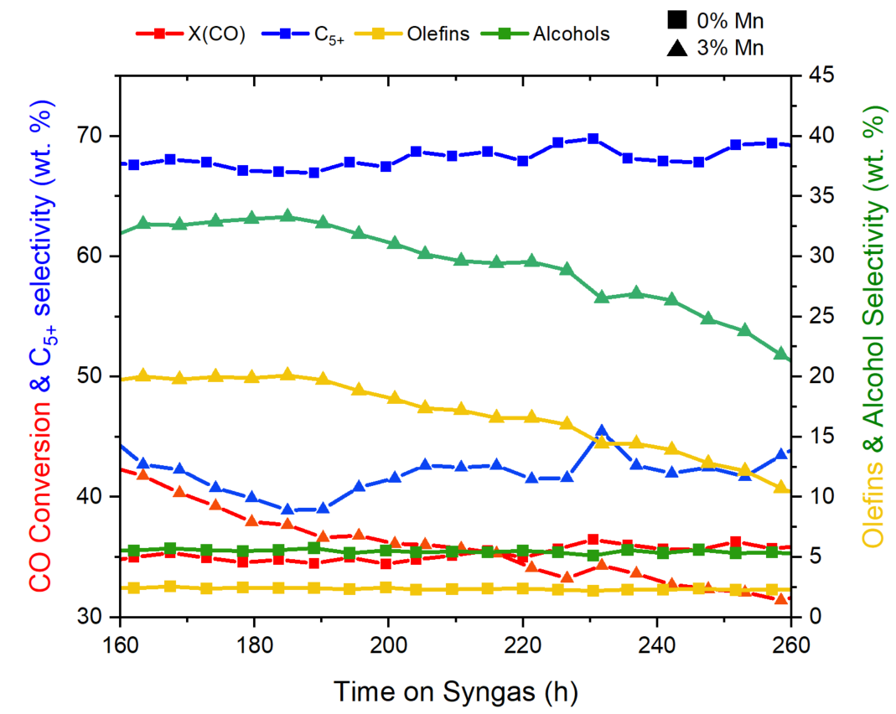
Figure S4 - CO conversion and selectivity to C5+, alcohols and olefins for the 0% and 3% Mn (450 °C) sample for the reaction time from 160 to 300 h at 30 barg and 210-240 °C.
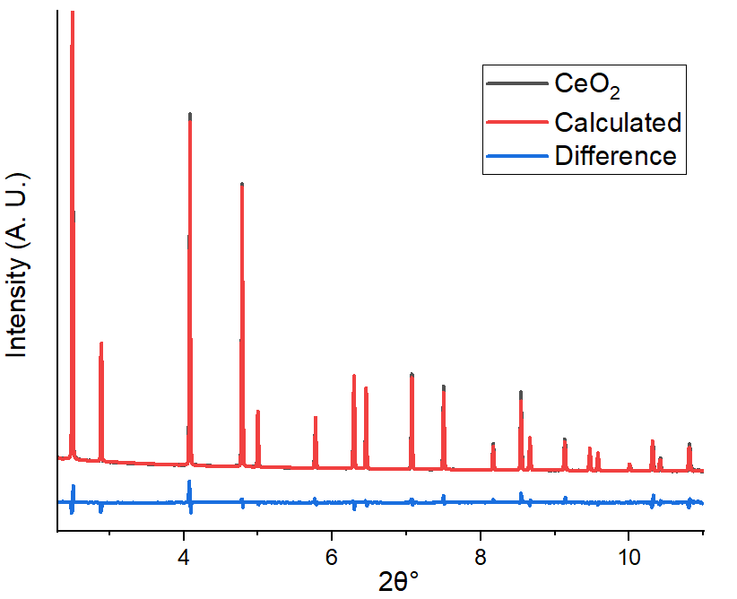
Figure S5 – XRD pattern of the CeO₂ calibrant, the calculated refined pattern and the difference pattern.

Table S2 - Rietveld Refinement results of the XRD-CT mean patterns illustrating the phase wt. %, CS (crystallite size in nm) and LP (lattice parameters) of the samples extracted after 150 h and 300 h. The Co₂C wt. % increases with Mn loading whilst the Co⁰ metal phases (FCC and HCP) decrease with increasing Mn wt. % beyond 5 %. The 10 % samples reduced at 450 °C resulted in the production of Mn titanates (MnTiO₃).
ª Reduction at 450 °C
Phase |  | Mn wt. %
Time (h) |  | 150 | 300
 |  | 5 % | 0 % | 1 % | 2 % | 3 % | 5 % | 10 % | 10 %ª
R_{wp} (%) |  | 6.4 | 6.9 | 6.2 | 6.2 | 6.2 | 6.7 | 7.9 | 7.9
Co₂C | Wt. % | 7.5 | - | 0.6 | 0.9 | 3.6 | 8.9 | 7.1 | -
Co₂C | CS | 7.5 | - | - | 6.5 | 10.6 | 9.3 | 11.7 | -
Co₂C | LP (Å) | 2.89 | - | 2.99 | 2.99 | 2.89 | 2.89 | 2.89 | -
Co₂C | LP (Å) | 4.45 | - | 4.61 | 4.65 | 4.45 | 4.45 | 4.45 | -
Co₂C | LP (Å) | 4.37 | - | 4.28 | 4.26 | 4.37 | 4.37 | 4.37 | -
FCC | Wt. % | 0.4 | 3.5 | 3.3 | 3.6 | 1.6 | 0.1 | 0.0 | 2.9
FCC | CS | 3.54 | 10.5 | 8.1 | 7.7 | 5.2 | - | - | 11.2
FCC | LP (Å) | 3.54 | 3.54 | 3.54 | 3.54 | 3.54 | - | - | 3.54
HCP | Wt. % | 0.2 | 4.9 | 4.8 | 3.8 | 3.1 | 0.2 | 0.7 | 5.3
HCP | CS | - | 2.6 | 2.2 | 2.2 | 7.1 | - | 9.9 | 2.9
HCP | LP (Å) | 2.51 | 2.51 | 2.51 | 2.52 | 2.51 | 2.51 | 2.50 | 2.51
 |  | 4.10 | 4.10 | 4.10 | 4.06 | 4.08 | 4.01 | 4.21 | 4.08
CoO | Wt. % | 0.9 | 0.3 | 0.1 | 0.2 | 0.5 | 1.2 | 3.1 | 0.4
CoO | CS | 4.0 | 7.1 | 3.0 | 3.7 | 3.1 | 3.3 | 2.6 | 5.7
CoO | LP (Å) | 4.22 | 4.28 | 4.26 | 4.27 | 4.24 | 4.24 | 4.29 | 4.28
Rutile | Wt% | 10.8 | 13.5 | 12.8 | 11.4 | 11.4 | 10.8 | 8.8 | 2.6
Rutile | CS | 25.8 | 42.6 | 40.8 | 39.6 | 38.2 | 37.4 | 28.6 | 29.1
Rutile | LP (Å) | 4.60 | 4.59 | 4.59 | 4.59 | 4.59 | 4.59 | 4.60 | 4.60
Rutile | LP (Å) | 2.96 | 2.95 | 2.96 | 2.96 | 2.96 | 2.96 | 2.96 | 2.96
Anatase | Wt. % | 80.2 | 77.8 | 78.4 | 80.1 | 79.7 | 78.9 | 80.3 | 65.1
Anatase | CS | 16.9 | 21.4 | 20.7 | 19.8 | 19.5 | 18.9 | 13.7 | 15.1
Anatase | LP (Å) | 3.79 | 3.79 | 3.79 | 3.79 | 3.79 | 3.79 | 3.79 | 3.79
Anatase | LP (Å) | 9.51 | 9.50 | 9.51 | 9.50 | 9.50 | 9.50 | 9.50 | 9.50
MnTiO₃ | Wt. % |  |  |  |  |  |  |  | 23.7
 | CS |  |  |  |  |  |  |  | 20.8
 | LP (Å) |  |  |  |  |  |  |  | 5.14
 | LP (Å) |  |  |  |  |  |  |  | 14.26

Table S3 – Errors from the Rietveld Refinement results of the XRD-CT mean patterns for the refined phase wt. %, CS (crystallite size in nm) and LP (lattice parameters) of the samples extracted after 150 h and 300 h.
ª Reduction at 450 °C
Phase |  | Mn wt. %
Time (h) |  | 150 | 300
 |  | 5 % | 0 % | 1 % | 2 % | 3 % | 5 % | 10 % | 10 %ª
R_{wp} (%) |  | 6.4 | 6.9 | 6.2 | 6.2 | 6.2 | 6.7 | 7.9 | 7.9
Co₂C | Wt. % | 0.696 | - | 0.078 | 0.108 | 0.097 | 0.139 | 0.161 | -
Co₂C | CS | 0.603 | - | - | 3.59 | 2.84 | 1.16 | 1.26 | -
Co₂C | LP (Å) | 0.001 | - | 0.007 | 0.011 | 0.001 | 0.001 | 0.001 | -
Co₂C | LP (Å) | 0.045 | - | 0.014 | 0.022 | 0.002 | 0.001 | 0.002 | -
Co₂C | LP (Å) | 0.002 | - | 0.013 | 0.019 | 0.003 | 0.002 | 0.002 | -
FCC | Wt. % | 0.035 | 0.080 | 0.074 | 0.079 | 0.087 | 0.047 | 0.083 | 0.087
FCC | CS | 1.11 | 1.26 | 1.35 | 1.27 | 1.21 | - | - | 3.40
FCC | LP (Å) | 0.006 | 0.001 | 0.001 | 0.001 | 0.003 | - | - | 0.001
HCP | Wt. % | 0.036 | 0.138 | 0.128 | 0.114 | 0.097 | 0.052 | 0.089 | 0.177
HCP | CS | 2.57 | 1.00 | 1.22 | 0.152 | 1.08 | - | 3.18 | 0.459
HCP | LP (Å) | 0.008 | 0.003 | 0.003 | 0.004 | 0.001 | 0.003 | 0.007 | 0.003
 |  | 0.024 | 0.003 | 0.010 | 0.016 | 0.004 | 0.008 | 0.027 | 0.010
CoO | Wt. % | 0.177 | 0.201 | 0.126 | 0.109 | 0.140 | 0.200 | 0.267 | 0.098
CoO | CS | 1.38 | 4.47 | 1.95 | 2.76 | 3.34 | 1.86 | 1.32 | 2.90
CoO | LP (Å) | 0.023 | 0.009 | 0.018 | 0.047 | 0.030 | 0.014 | 0.007 | 0.043
Rutile | Wt% | 0.775 | 0.150 | 0.132 | 0.133 | 0.137 | 0.157 | 0.221 | 0.120
Rutile | CS | 5.02 | 5.6 | 5.05 | 5.29 | 5.23 | 6.34 | 7.60 | 20.5
Rutile | LP (Å) | 4e-4 | 3e-4 | 2e-4 | 3e-4 | 3e-4 | 4e-4 | 8e-4 | 0.001
Rutile | LP (Å) | 5e-4 | 3e-4 | 3e-4 | 3e-4 | 3e-4 | 4e-4 | 9e-4 | 0.002
Anatase | Wt. % | 0.179 | 0.248 | 0.210 | 0.212 | 0.218 | 0.254 | 0.347 | 0.268
Anatase | CS | 0.563 | 1.78 | 1.41 | 1.37 | 1.21 | 1.05 | 0.53 | 0.860
Anatase | LP (Å) | 9e-5 | 1e-4 | 1e-4 | 1e-4 | 1e-4 | 1e-4 | 8e-4 | 2e-4
Anatase | LP (Å) | 4e-4 | 4e-4 | 4e-4 | 4e-4 | 4e-4 | 5e-4 | 9e-4 | 8e-4
MnTiO₃ | Wt. % |  |  |  |  |  |  |  | 0.219
 | CS |  |  |  |  |  |  |  | 0.815
 | LP (Å) |  |  |  |  |  |  |  | 3e-4
 | LP (Å) |  |  |  |  |  |  |  | 0.002

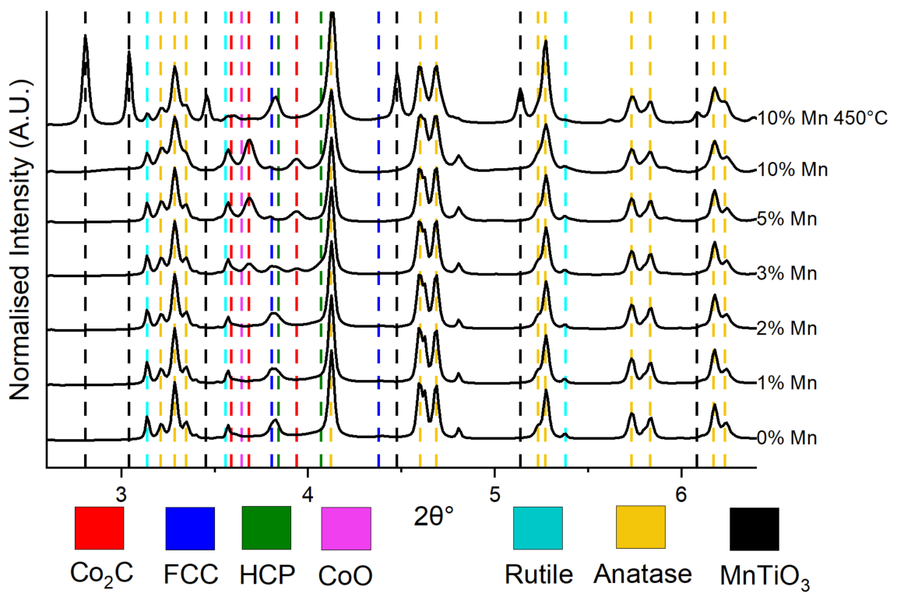
Figure S6 – Full mean XRD pattern of the samples with different Mn loading with indexing lines of all the phases present. FCC and HCP Co phases were present at low Mn loading (0-2 % Mn) and Co₂C was present at higher Mn loading (3-10 % Mn). A low percentage of Co_{x} Mn_{1-x} O was present at higher Mn loadings (5-10 %) but its peaks were underneath the Co₂C peaks. Support phases, anatase and rutile, were present in all samples and MnTiO₃ was present in the sample reduced at 450 °C.

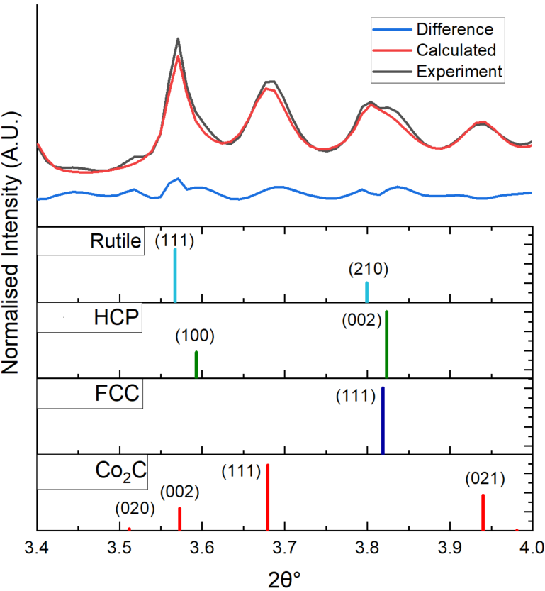
Figure S7 - Mean pattern refinement of the 3 % Mn reacted sample highlighting the 2θ ° region with reflections from the different Co containing phases (Co₂C, FCC and HCP cobalt metal phases respectively). The experimental, refined and difference XRD patterns are displayed as well as the indexing lines for the reference patterns below. The peak shapes are not fitted exactly due to the presence of stacking faults in the FCC/HCP phase, but the R_{wp} is still low at 6.2 %.
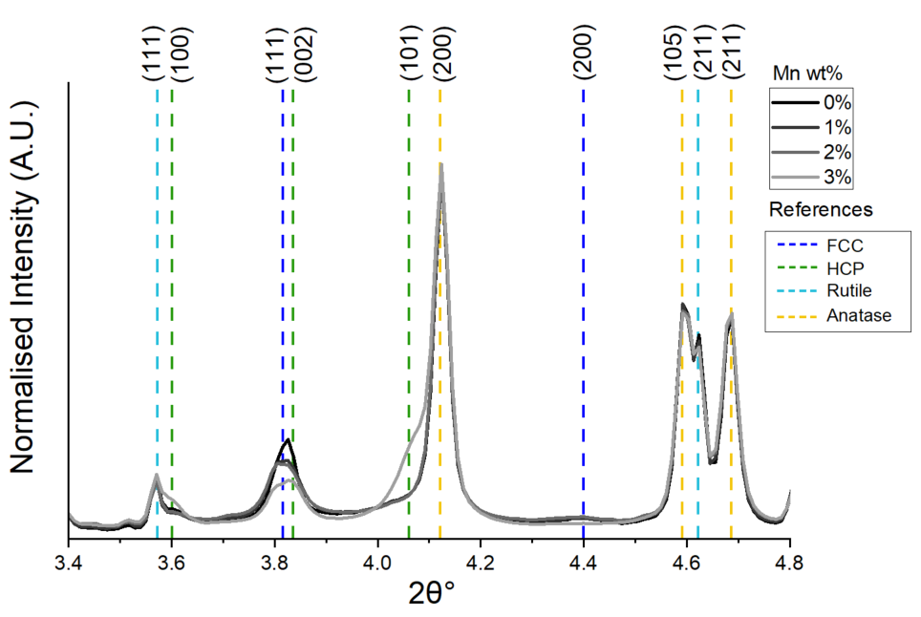
Figure S8 – XRD patterns of the 0-3 % Mn samples from the centre of the extrudates after 300 h of reaction. The 3 % Mn sample has more prominent HCP peaks at 3.60° and 4.07°.

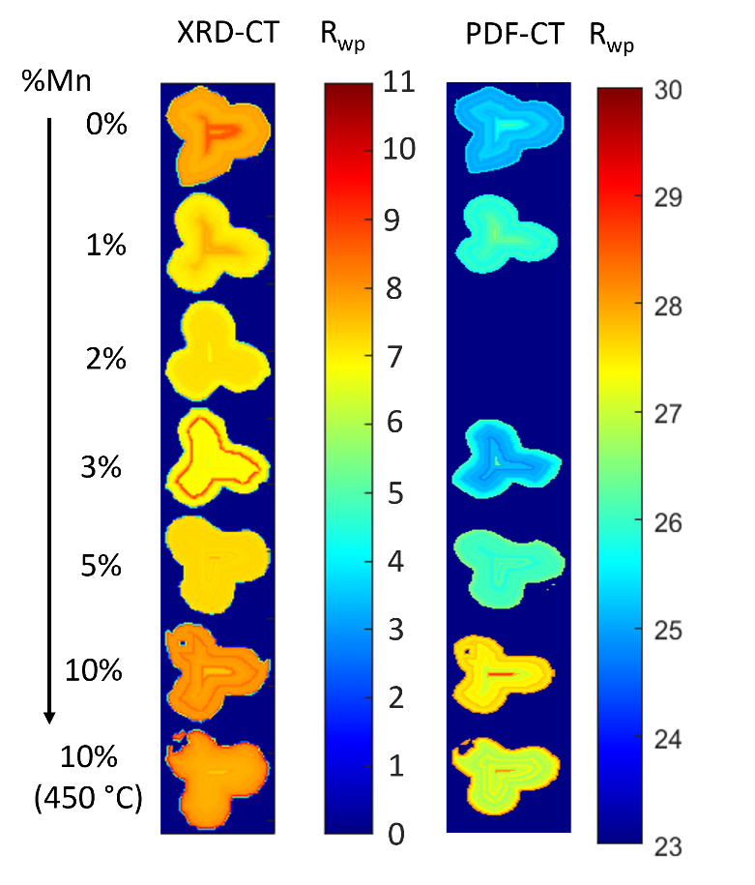
Figure S9 – R_{wp} maps for the XRD-CT and PDF-CT refinements where the XRD-CT R_{wp} was between 8 - 10 % indicating a good fit for all the samples. Increasing Mn loading resulted in a larger R_{wp} indicating increased disorder. The PDF-CT R_{wp} was between 23 - 28 % which indicates a tolerable fit for PDF data.

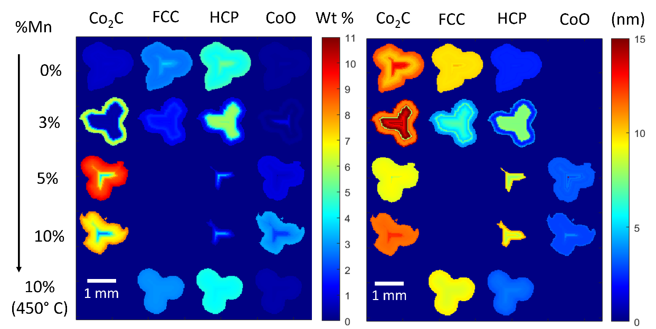
Figure S10 – Reconstructed XRD-CT 2D images of the catalytic pellets (extracted after 300 h) at alternative heights illustrating the refined wt. % percentage (left) and crystallite size (right) of the different phases present. The results at different heights show the same increase in Co₂C with Mn loading and egg-shell distribution with FCC/HCP in the centre and carbide on the periphery of the pellets.

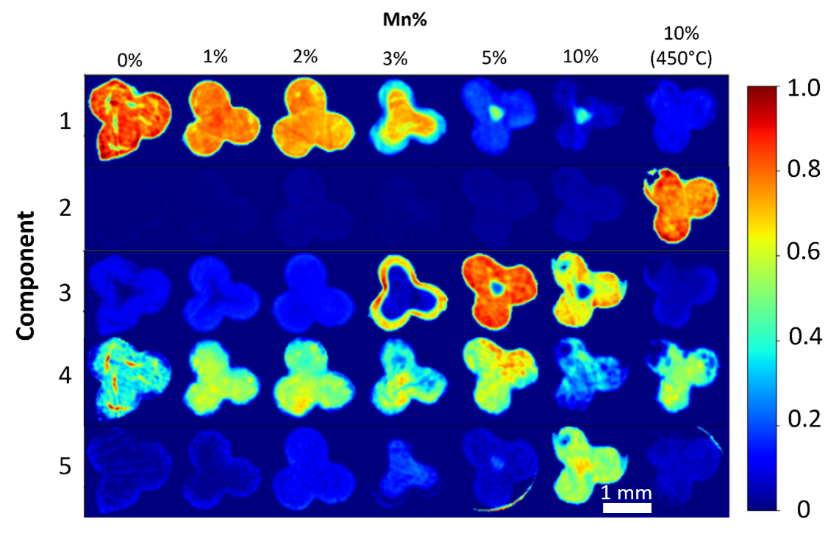
Figure S11 – XRD NMF-generated masks highlighting the spatial intensity variations of the 5 components within the catalytic samples. Component 1 exhibited similarities to the FCC/HCP phases, which tended to concentrate in the core of the catalyst at higher Mn loadings, while Component 3 contained the Co₂C phase which was found on the catalyst periphery.

Table S4 – XRD Rietveld refinement results from refining the NMF-generated components. Component 1 was found to contain FCC/HCP phases whilst component 2 contained the MnTiO_{3.} Component 3 contained the Co₂C phase whilst components 4 and 5 had a mixture of different phases. % int. refers to the percentage intensity of each component.
 | % int. | Parameter | Co₂C | FCC | HCP | CoO | Rutile | Anatase | MnTiO₃ | Wax (CH₂)
1 | 59 | wt. % | - | 4.1 | 3.1 | - | 10.1 | 64.9 | - | 14.7
1 | 59 | CS (nm) | - | 5.5 | 4.9 | - | 43.4 | 20.6 | - | 36.7
1 | 59 | LP (Å) | - | 3.54 | 2.51 | - | 4.59 | 3.79 | - | 2.55
1 | 59 | LP (Å) | - | - | 4.07 | - | 2.96 | 9.50 | - | 4.96
1 | 59 | LP (Å) | - | - | - | - | - | - | - | 7.45
2 | 16 | wt. % | - | 3.0 | 3.8 | - | 2.1 | 51.6 | 21.6 | 17.4
2 | 16 | CS (nm) | - | 7.9 | 3.8 | - | - | 15.3 | 20.5 | 41.4
2 | 16 | LP (Å) | - | 3.54 | 2.5 | - | 4.59 | 3.79 | 5.1 | 2.55
2 | 16 | LP (Å) | - | - | 4.1 | - | 2.96 | 9.50 | 14.3 | 4.96
2 | 16 | LP (Å) | - | - | - | - | - | - | - | 7.46
3 | 22 | wt. % | 7.2 | - | - | - | 8.6 | 65.4 | - | 18.3
3 | 22 | CS (nm) | 9.6 | - | - | - | 37.1 | 8.6 | - | 40.6
3 | 22 | LP (Å) | 2.89 | - | - | - | 4.59 | 3.8 | - | 2.55
3 | 22 | LP (Å) | 4.45 | - | - | - | 2.96 | 9.5 | - | 4.96
3 | 22 | LP (Å) | 4.37 | - | - | - | - | - | - | 7.44
4 | 2 | wt. % | 4.59 | 1.3 | 1.0 | - | 8.8 | 61.2 | - | 23.1
4 | 2 | CS (nm) | 9.7 | 6.0 | 5.7 | - | 41.2 | 19.8 | - | 45.9
4 | 2 | LP (Å) | 2.9 | 3.54 | 2.50 | - | 4.59 | 3.79 | - | 2.55
4 | 2 | LP (Å) | 4.4 | - | 4.08 | - | 2.96 | 9.50 | - | 4.96
4 | 2 | LP (Å) | 4.4 | - |  | - | - | - | - | 7.44
5 | 0.3 | wt. % | 1.4 | - | 4.75 | 2.75 | 5.67 | 60.6 | - | 24.8
5 | 0.3 | CS (nm) | 13.0 | - | 5.7 | 2.3 | - | 14.5 | - | 34.9
5 | 0.3 | LP (Å) | 2.91 | - | 2.50 | 4.28 | 4.59 | 3.79 | - | 2.55
5 | 0.3 | LP (Å) | 4.44 | - | 4.09 | 4.28 | 2.96 | 9.49 | - | 4.96
5 | 0.3 | LP (Å) | 4.36 | - | 4.75 | - | - | - | - | 7.44

Table S5 – Errors from the XRD Rietveld refinement of the NMF-generated components.
 | % int. | Parameter | Co₂C | FCC | HCP | CoO | Rutile | Anatase | MnTiO₃ | Wax (CH₂)
1 | 59 | wt. % | - | 0.12 | 0.14 | - | 0.18 | 0.40 | - | 0.30
1 | 59 | CS (nm) | - | 0.70 | 1.43 | - | 8.90 | 1.45 | - | 3.20
1 | 59 | LP (Å) | - | 1e-3 | 2e-3 | - | 5e-4 | 2e-4 | - | 1e-3
1 | 59 | LP (Å) | - | - | 7e-3 | - | 5e-4 | 7e-4 | - | 1e-3
1 | 59 | LP (Å) | - | - | - | - | - | - | - | 2e-3
2 | 16 | wt. % | - | 0.10 | 0.16 | - | 0.11 | 0.31 | 0.23 | 0.31
2 | 16 | CS (nm) | - | 1.33 | 0.85 | - | - | 0.96 | 3.1 | 19.7
2 | 16 | LP (Å) | - | 3e-3 | 3e-3 | - | 2e-3 | 3e-4 | 6e-4 | 2e-3
2 | 16 | LP (Å) | - | - | 0.01 | - | 3e-3 | 1e-3 | 3e-3 | 2e-3
2 | 16 | LP (Å) | - | - | - | - | - | - | - | 3e-3
3 | 22 | wt. % | 0.15 | - | - | - | 0.19 | 0.35 | - | 0.34
3 | 22 | CS (nm) | 1.98 | - | - | - | 9.16 | 1.23 | - | 5.61
3 | 22 | LP (Å) | 1e-3 | - | - | - | 6e-4 | 2e-4 | - | 1e-3
3 | 22 | LP (Å) | 2e-3 | - | - | - | 6e-4 | 6e-4 | - | 1e-3
3 | 22 | LP (Å) | 2e-3 | - | - | - | - | - | - | 2e-3
4 | 2 | wt. % | 0.13 | 0.10 | 0.13 | - | 0.19 | 0.36 | - | 0.36
4 | 2 | CS (nm) | 2.10 | 2.09 | 3.06 | - | 10.4 | 1.51 | - | 9.7
4 | 2 | LP (Å) | 2e-3 | 4e-3 | 7e-3 | - | 5e-4 | 2e-4 | - | 8e-4
4 | 2 | LP (Å) | 3e-3 | - | 0.02 | - | 6e-4 | 6e-4 | - | 1e-3
4 | 2 | LP (Å) | 3e-3 | - | - | - | - | - | - | 1e-3
5 | 0.3 | wt. % | 0.19 | - | 0.25 | 0.48 | 0.29 | 0.66 | - | 0.64
5 | 0.3 | CS (nm) | 9.02 | - | 1.36 | 5.32 | - | 0.68 | - | 23.8
5 | 0.3 | LP (Å) | 0.01 | - | 4e-3 | 0.12 | 2e-3 | 3e-4 | - | 3e-3
5 | 0.3 | LP (Å) | 0.02 | - | 0.014 | 0.12 | 2e-3 | 1e-3 | - | 2e-3
5 | 0.3 | LP (Å) | 0.03 | - | - | - | - | - | - | 4e-3

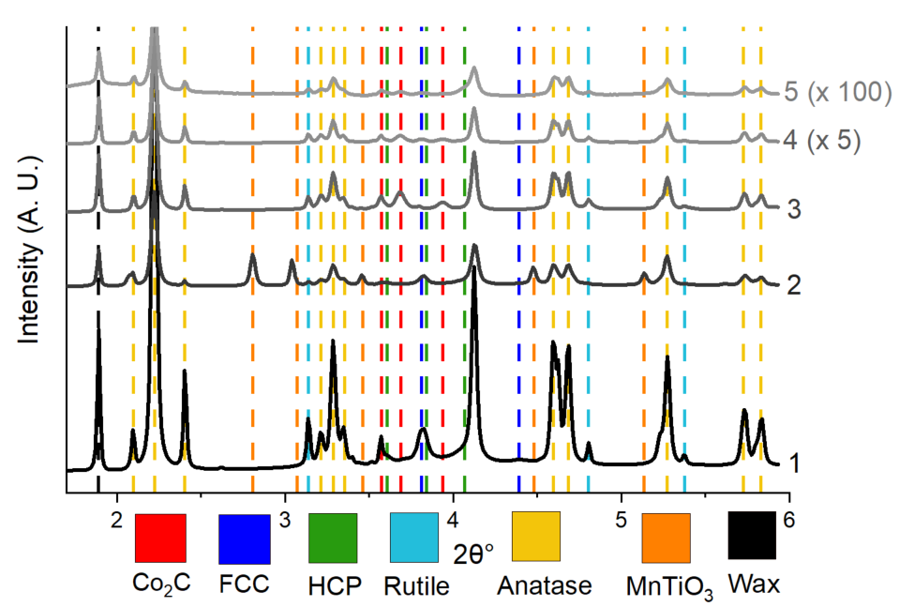
Figure S12 – XRD patterns of the NMF-generated components. All components contained the support phases as the support was homogeneous. Component 1 contained predominantly FCC/HCP Co, component 3 contained Co₂C and component 2 contained MnTiO₃. Components 4 and 5 were multiplied by 5 and 100, respectively, for visibility.

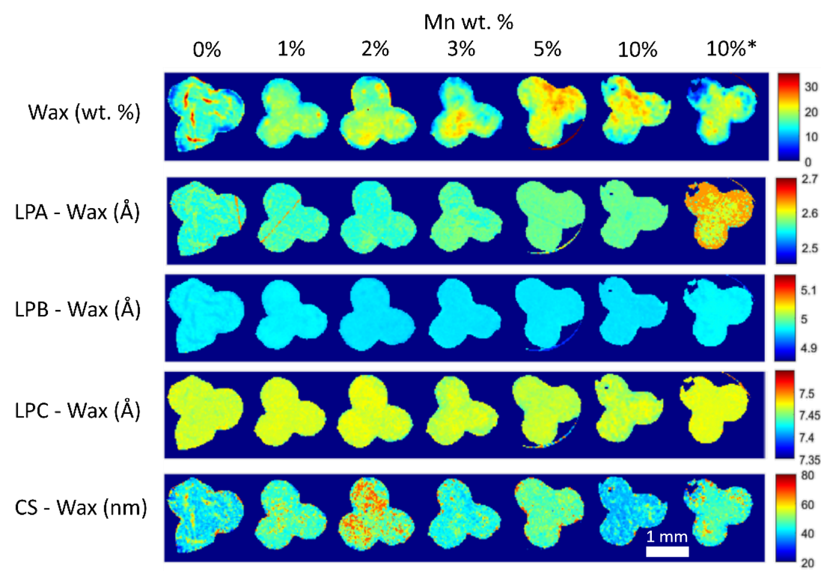
Figure S13 - XRD-CT maps of the refined parameters of the wax content (wt. %), lattice parameters (LPA, LPB and LPC), and crystallite size (CS). *Reduced at 450 °C during preparation.

Table S6 – Real-space Refinement results of the PDF-CT mean patterns illustrating the phase wt. %, CS (crystallite size) and LP (lattice parameters). The results correlate well with the XRD refinement. Co₂C wt. % increases with Mn loading whilst the Co⁰ metal phases (FCC and HCP) decrease with increasing Mn wt. % beyond 5 %.
ª Reduction at 450° C
Phase | Parameter | Mn wt. %
 |  | 0 % | 1 % | 3 % | 5 % | 10 % | 10 %ª
 | R_{wp}(%) | 21.6 | 21.5 | 21.1 | 22.1 | 23.5 | 25.8
Co₂C | Wt. % | 1.1 | 1.1 | 3.7 | 9.1 | 9.5 | 1.3
Co₂C | CS (nm) | - | - | - | 15.6 | 12.0 | -
Co₂C | LP (Å) | 2.87 | 2.87 | 2.88 | 2.88 | 2.88 | 2.87
Co₂C | LP (Å) | 4.41 | 4.42 | 4.43 | 4.43 | 4.43 | 4.42
Co₂C | LP (Å) | 4.39 | 4.39 | 4.37 | 4.37 | 4.37 | 4.39
FCC | Wt. % | 5.7 | 5.4 | 1.7 | - | 0.0 | 5.0
 | CS (nm) | 4.0 | 3.7 | 4.1 | - | - | 8.5
 | LP (Å) | 3.53 | 3.54 | 3.54 | - | - | 3.53
HCP | Wt. % | 5.0 | 4.8 | 5.4 | 0.3 | 0.2 | 2.2
HCP | CS (nm) | 3.9 | 3.6 | 4.2 | - | - | 5.6
HCP | LP (Å) | 2.49 | 2.50 | 2.50 | 2.58 | 2.60 | 2.73
HCP | LP (Å) | 4.09 | 4.09 | 4.07 | 4.04 | 4.05 | 3.96
CoO | Wt. % | 1.1 | 1.1 | 1.0 | 1.1 | 5.2 | 1.7
CoO | CS (nm) | 2.1 | 1.9 | 1.6 | 1.1 | 1.0 | 2.6
CoO | LP (Å) | 4.25 | 4.26 | 4.26 | 4.26 | 4.34 | 4.29
Rutile | Wt. % | 15.8 | 15.2 | 13.9 | 12.8 | 11.6 | 5.2
 | CS (nm) | 4.3 | 4.4 | 4.4 | 4.6 | 4.2 | 4.6
 | LP (Å) | 4.59 | 4.59 | 4.59 | 4.59 | 4.60 | 4.62
 |  | 2.95 | 2.95 | 2.95 | 2.95 | 2.94 | 2.91
Anatase | Wt. % | 71.1 | 72.1 | 74.0 | 76.2 | 73.2 | 59.3
Anatase | CS (nm) | 5.1 | 5.1 | 5.0 | 5.0 | 4.5 | 4.6
Anatase | LP (Å) | 3.78 | 3.78 | 3.78 | 3.78 | 3.78 | 3.78
Anatase | LP (Å) | 9.47 | 9.47 | 9.47 | 9.47 | 9.47 | 9.47
MnTiO₃ | Wt. % |  |  |  |  |  | 25.8
MnTiO₃ | CS (nm) |  |  |  |  |  | 9.30
MnTiO₃ | LP (Å) |  |  |  |  |  | 5.12
MnTiO₃ | LP (Å) |  |  |  |  |  | 14.23

Table S7 – Errors from the Real-space Refinement results of the PDF-CT mean patterns for the phase wt. %, CS (crystallite size) and LP (lattice parameters).
ª Reduction at 450° C
Phase | Parameter | Mn wt. %
 |  | 0 % | 1 % | 3 % | 5 % | 10 % | 10 %ª
 | R_{wp}(%) | 21.6 | 21.5 | 21.1 | 22.1 | 23.5 | 25.8
Co₂C | Wt. % | 0.204 | 0.205 | 0.214 | 0.281 | 0.252 | 0.103
Co₂C | CS (nm) | - | - | - | 3.96 | 0.46 | -
Co₂C | LP (Å) | 0.006 | 0.006 | 0.002 | 0.001 | 0.001 | 0.005
Co₂C | LP (Å) | 0.009 | 0.010 | 0.003 | 0.002 | 0.001 | 0.008
Co₂C | LP (Å) | 0.010 | 0.011 | 0.003 | 0.002 | 0.001 | 0.009
FCC | Wt. % | 0.157 | 0.166 | 0.160 | 0.17 | 0.16 | 0.19
 | CS (nm) | 0.15 | 0.14 | 0.51 | 0.01 | - | 0.42
 | LP (Å) | 6e-4 | 7e-4 | 0.003 | - | 0.74 | 7e-4
HCP | Wt. % | 0.338 | 0.343 | 0.314 | 0.192 | 0.178 | 0.239
HCP | CS (nm) | 0.30 | 0.33 | 0.41 | - | - | 0.084
HCP | LP (Å) | 0.002 | 0.003 | 0.002 | 0.004 | 0.006 | 0.001
HCP | LP (Å) | 0.007 | 0.008 | 0.006 | 0.014 | 0.020 | 0.004
CoO | Wt. % | 0.221 | 0.012 | 0.200 | 0.185 | 0.515 | 0.316
CoO | CS (nm) | 0.32 | 0.42 | 0.47 | 0.69 | 0.21 | 0.23
CoO | LP (Å) | 0.009 | 0.005 | 0.005 | 0.004 | 0.005 | 0.005
Rutile | Wt. % | 0.317 | 0.313 | 0.160 | 0.306 | 0.321 | 0.28
 | CS (nm) | 0.13 | 0.15 | 0.16 | 0.20 | 0.19 | 0.19
 | LP (Å) | 9e-4 | 9e-4 | 9e-4 | 0.001 | 0.001 | 0.002
 |  | 0.001 | 0.001 | 0.001 | 0.001 | 8e-4 | 0.003
Anatase | Wt. % | 0.434 | 0.418 | 0.441 | 0.423 | 0.518 | 0.369
Anatase | CS (nm) | 0.043 | 0.042 | 0.039 | 0.039 | 0.035 | 0.401
Anatase | LP (Å) | 2e-4 | 2e-4 | 2e-4 | 2e-4 | 2e-4 | 2e-4
Anatase | LP (Å) | 7e-4 | 7e-4 | 7e-4 | 7e-4 | 8e-4 | 8e-4
MnTiO₃ | Wt. % |  |  |  |  |  | 0.307
MnTiO₃ | CS (nm) |  |  |  |  |  | 0.50
MnTiO₃ | LP (Å) |  |  |  |  |  | 6e-4
MnTiO₃ | LP (Å) |  |  |  |  |  | 0.002

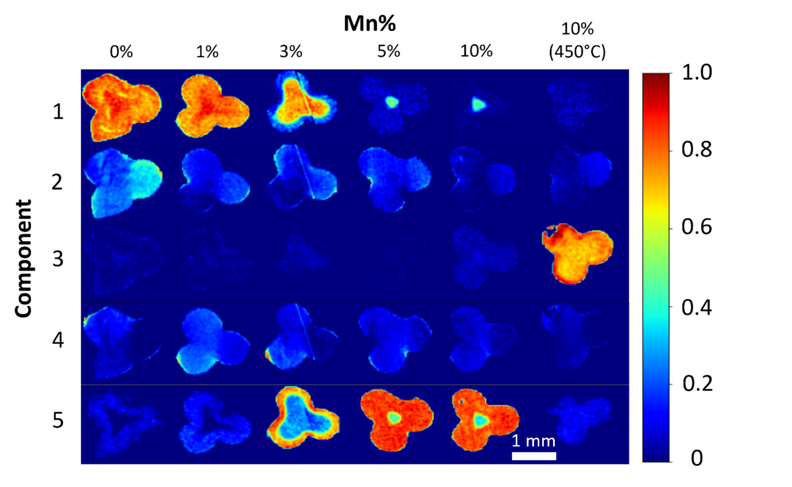
Figure S14 – PDF-CT NMF-generated masks highlighting the spatial intensity variations of the 5 components within the catalytic samples. Component 1 exhibited similarities to the FCC/HCP phases, which tended to concentrate in the core of the catalyst at higher Mn loadings, while Component 5 contained the Co₂C phase which was found on the catalyst periphery.

Table S8 – PDF Real-space refinement results from refining the NMF-generated components. Component 1 was found to contain FCC/HCP phases whilst component 3 contained the MnTiO_{3.} Component 5 contained the Co₂C phase whilst components 2 and 4 had a mixture of different phases but had low intensity. % int. refers to the percentage intensity of each component.
 | %. int | Parameter | Co₂C | FCC | HCP | CoO | Rutile | Anatase | MnTiO₃
1 | 43 | wt. % | - | 5.4 | 5.7 | 4.7 | 14.5 | 69.7 | -
1 | 43 | CS (nm) | - | 3.4 | 4.1 | 0.8 | 4.5 | 5.0 | -
1 | 43 | LP (Å) | - | 3.53 | 2.49 | 4.44 | 4.59 | 3.78 | -
1 | 43 | LP (Å) | - | - | 4.10 | - | 2.95 | 9.47 | -
1 | 43 | LP (Å) | - | - | - | - | - | - | -
2 | 0.1 | wt. % | - | 5.0 | 4.1 | 4.4 | 13.1 | 67.4 | -
2 | 0.1 | CS (nm) | - | 5.3 | 3.8 | 0.7 | 4.9 | 5.7 | -
2 | 0.1 | LP (Å) | - | 3.53 | 2.48 | 4.42 | 4.57 | 3.77 | -
2 | 0.1 | LP (Å) | - | - | 4.10 | - | 2.4 | 9.44 | -
2 | 0.1 | LP (Å) | - | - | - | - | - | - | -
3 | 15 | wt. % | - | 6.0 | 6.6 | 3.0 | 5.0 | 52.1 | 27.3
3 | 15 | CS (nm) | - | 3.5 | 3.7 | 0.9 | 4.5 | 4.8 | 6.8
3 | 15 | LP (Å) | - | 3.53 | 2.50 | 4.41 | 4.60 | 3.78 | 5.1
3 | 15 | LP (Å) | - | - | 4.10 | - | 2.93 | 9.47 | 14.2
3 | 15 | LP (Å) | - | - | - | - | - | - | -
4 | 0.2 | wt. % | 5.5 | 1.6 | 3.4 | 7.7 | 11.0 | 70.8 | -
4 | 0.2 | CS (nm) | 12.5 | 8.8 | 5.8 | 0.7 | 3.7 | 6.2 | -
4 | 0.2 | LP (Å) | 2.90 | 3.55 | 2.58 | 4.5 | 4.6 | 3.79 | -
4 | 0.2 | LP (Å) | 4.42 | - | 4.09 | - | 2.96 | 9.50 | -
4 | 0.2 | LP (Å) | 4.40 | - | - | - | - | - | -
5 | 42 | wt. % | 10.6 | - | - | 5.1 | 12.1 | 72.1 | -
5 | 42 | CS (nm) | 7.8 | - | - | 0.8 | 4.5 | 4.8 | -
5 | 42 | LP (Å) | 2.88 | - | - | 4.41 | 4.59 | 3.78 | -
5 | 42 | LP (Å) | 4.42 | - | - | - | 2.94 | 9.47 | -
5 | 42 | LP (Å) | 4.37 | - | - | - | - | - | -

Table S9 – Errors from the PDF Real-space refinement results of the NMF-generated components.
 | %. int | Parameter | Co₂C | FCC | HCP | CoO | Rutile | Anatase | MnTiO₃
1 | 43 | wt. % | - | 0.12 | 0.24 | 0.37 | 0.22 | 0.42 | -
1 | 43 | CS (nm) | - | 0.09 | 0.28 | 0.68 | 0.12 | 0.03 | -
1 | 43 | LP (Å) | - | 5e-4 | 2e-3 | 7e-3 | 6e-4 | 1e-4 | -
1 | 43 | LP (Å) | - | - | 5e-3 | - | 8e-4 | 5e-4 | -
1 | 43 | LP (Å) | - | - | - | - | - | - | -
2 | 0.1 | wt. % | - | 0.14 | 0.34 | 0.60 | 0.30 | 0.61 | -
2 | 0.1 | CS (nm) | - | 0.23 | 0.50 | 0.12 | 0.20 | 0.05 | -
2 | 0.1 | LP (Å) | - | 7e-4 | 3e-3 | 0.01 | 1e-3 | 2e-4 | -
2 | 0.1 | LP (Å) | - | - | 0.01 | - | 1e-3 | 7e-4 | -
2 | 0.1 | LP (Å) | - | - | - | - | - | - | -
3 | 15 | wt. % | - | 0.08 | 0.18 | 0.23 | 0.15 | 0.26 | 0.31
3 | 15 | CS (nm) | - | 0.73 | 0.20 | 0.09 | 0.27 | 0.03 | 0.16
3 | 15 | LP (Å) | - | 4e-4 | 1e-3 | 9e-3 | 2e-3 | 2e-4 | 5e-4
3 | 15 | LP (Å) | - | - | 4e-3 | - | 2e-3 | 6e-4 | 2e-3
3 | 15 | LP (Å) | - | - | - | - | - | - | -
4 | 0.2 | wt. % | 0.50 | 0.12 | 0.31 | 0.67 | 0.39 | 0.71 | -
4 | 0.2 | CS (nm) | 3.0 | 2.0 | 1.25 | 0.08 | 0.22 | 0.66 | -
4 | 0.2 | LP (Å) | 2e-3 | 3e-3 | 5e-3 | 0.01 | 2e-3 | 2e-3 | -
4 | 0.2 | LP (Å) | 3e-3 | - | 0.01 | - | 2e-3 | 8e-3 | -
4 | 0.2 | LP (Å) | 4e-3 | - | - | - | - | - | -
5 | 42 | wt. % | 0.31 | - | - | 0.33 | 0.21 | 0.37 | -
5 | 42 | CS (nm) | 0.45 | - | - | 0.06 | 0.14 | 0.03 | -
5 | 42 | LP (Å) | 7e-3 | - | - | 7e-3 | 8e-3 | 1e-4 | -
5 | 42 | LP (Å) | 1e-3 | - | - | - | 1e-3 | 5e-4 | -
5 | 42 | LP (Å) | 1e-3 | - | - | - | - | - | -
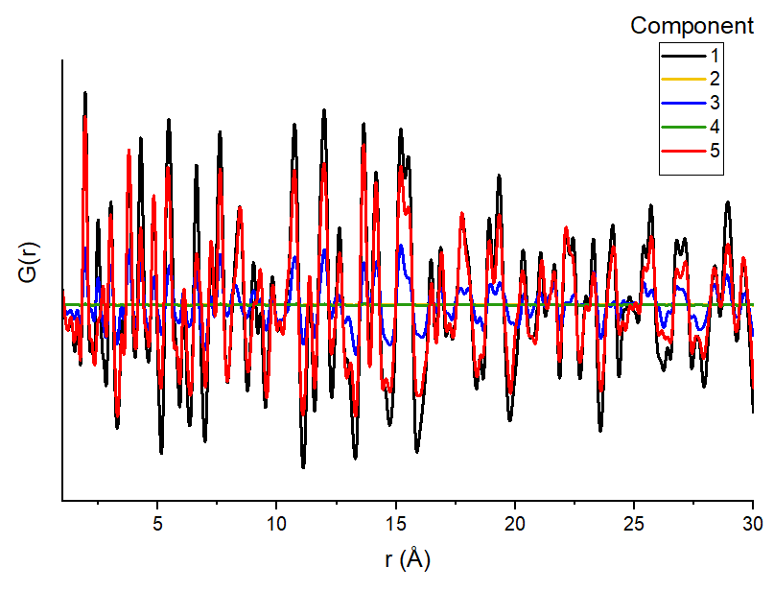

Figure S15 – PDF of the NMF-generated components. All components contained the support phases as the support was homogeneous. Component 1 contained predominantly FCC/HCP Co, component 5 contained Co₂C and component 3 contained MnTiO₃.

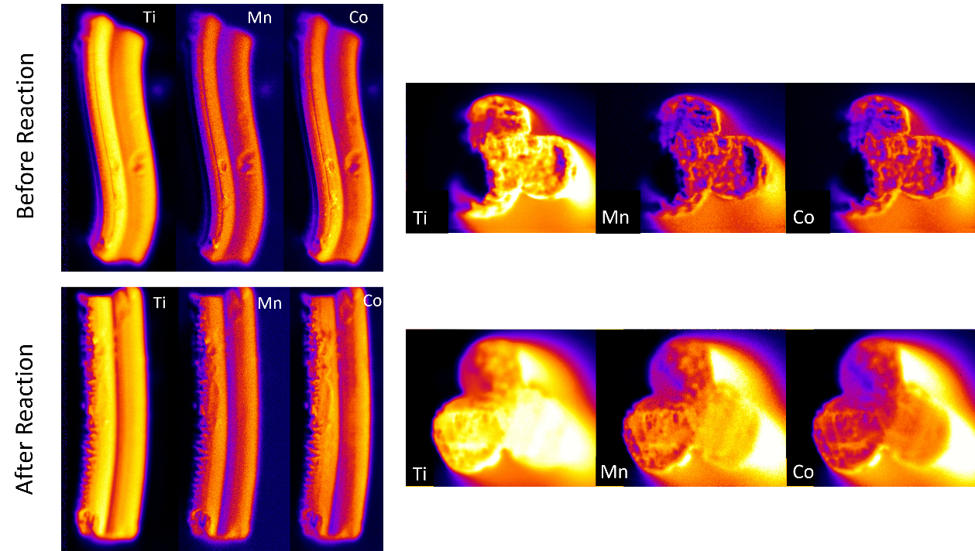
Figure S16 – µ-XRF images of the lateral faces (left) and cross-sections (right) of the 3 wt. % Mn samples extracted before and after reaction for 300 h. The Mn and Co are found to be co-located and no significant changes are found before and after reaction.

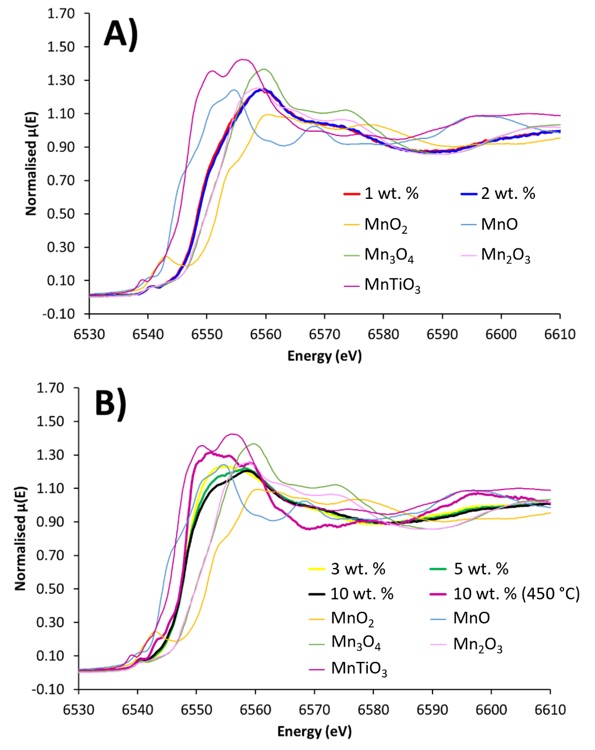
Figure S17 - Comparing Mn K-edge spectra of A) 1 and 2 wt. % CoMn/TiO₂ species and B) 3, 5, 10 and 10 wt. % Used CoMn/TiO₂ samples with a range of oxidic standards.

