Spatio-temporal response and projection of CO₂ capture rates by different rock weathering to climate change in subtropics in China
Wenpu Liu^{1#}, Yinxian Song¹∗, Xianqiang Men², Zhong Chen¹, He Chang¹, Shitao Zhang¹, Chunjun Tao³∗, Junfeng Ji⁴, Shilei Li⁴, Quan Chen⁵, Godwin A. Ayoko⁶, Ray L. Frost⁶

- Department of Geosciences, Faculty of Land Resource Engineering, Kunming University of Science and Technology, Kunming 650093, Yunnan Province, China.
- State Key Laboratory of Lake Science and Environment, Nanjing Institute of Geography and Limnology, Chinese Academy of Sciences, Nanjing, China
- Geological Survey Institute of Anhui Province, Hefei 230001, Anhui Province, China
- Key Laboratory of Surficial Geochemistry, Ministry of Education, School of Earth Sciences and Engineering, Nanjing University, Nanjing 210093, China.
- Yunnan Provincial Key Lab of Soil Carbon Sequestration and Pollution Control, Faculty of Environmental Science & Engineering, Kunming University of Science & Technology, Kunming 650500, Yunnan, China
- School of Chemistry and Physics and Centre for The Environment, Queensland University of Technology, 2 George Street, GPO Box 2324, Brisbane, QLD 4001, Australia.

1. Chemical Index of Alteration (CIA) and Plagioclase Index of Alteration (PIA)
CIA measures the degree of chemical weathering by examining the molar ratio of oxides (appendix equation 1). The degree of chemical weathering in various rock types is simultaneously determined by detecting the weathering degree of plagioclase feldspar, thereby providing evidence of silicate weathering. The Plagioclase Index of Alteration (PIA) has been introduced to quantify the degree of weathering specifically in plagioclase feldspar (appendix equation 2).
$CIA=({Al}_{2}O_{3})/({Al}_{2}O_{3}+CaO^{*}+Na_{2}O+K_{2}O)×100$ (1)
$PIA=(Al_{2}O_{3}-K_{2}O)/(Al_{2}O_{3}+CaO^{*}+Na_{2}O-K_{2}O)×100$ (2)
The equation includes CaO*, which indicates the amount of CaO in the silicate component of the rock.

2.GEM-CO₂ model
The model is based on a linear equation which computes the carbon capture rate for various rock types (Amiotte Suchet and Probst, 1993) (appendix equation 3):
$f_{CO_{2}}=a∙Q$ (3)
where $f_{CO_{2}}$is CO₂ consumption(mmol·km⁻²·s⁻¹); Q is the water flow rate on the rock surface(L·km⁻²·s⁻¹) (appendix equation 4), which is determined by the difference between precipitation and evaporation, and a represents an empirical coefficient.
$Q=N-V$ (4)
$V=\frac{1.05N}{\sqrt{1+(\frac{1.05N}{L})^{2}}}$ (5)
$L=300+25t+0.05t^{3}$ (6)
In this equation, V represents the annual average evaporation (mm) calculated using the Turc formula (appendix equation 5), N stands for the annual average precipitation (mm), L indicates the maximum annual evaporation (mm) (appendix equation 6), and t represents the temperature (℃).

Table S1. The GEM-CO₂ model index(Amiotte Suchet and Probst, 1993)
Lithology | Index a
Metamorphic rocks and plutonic rocks | 0.095
Acidic volcanic rock | 0.222
Basalt | 0.479
Sand and sandstone | 0.152
Shale class | 0.627
Acidic carbonate rocks | 1.586
Evaporative rock salt | 0.293

3. Water chemistry model：
The source of the dissolved component X in river water can be formulated(Li et al., 2014; Noh et al., 2009) (appendix equation 7) ：
$[X]_{riv}=[X]_{atm}+[X]_{hum}+[X]_{sil}+[X]_{car}+[X]_{eva}$ (7)
where [X] is the concentration of each component; riv stands for river; atm stands for atmospheric input; hum stands for human input; sil stands for silicate; car stands for carbonate; eva stands for evaporated salt;
Using the forward model for calculation(Noh et al., 2009) in combination with the distribution of watershed and human activities, several assumptions will be made. First, carbonate mineral weathering significantly contributes to the concentrations of Ca²⁺, Mg²⁺, and HCO- 3 in river water, but has negligible contribution to K⁺ and Na⁺. Second, silicate mineral weathering contributes to the concentrations of Ca²⁺, Mg²⁺, K⁺, and Na⁺ in river water. Third, the dissolution of evaporite minerals produces SO₄²⁻ that balances with Ca²⁺ and Mg²⁺, with the contribution of K⁺ being negligible. Fourth, human inputs significantly contribute to the concentrations of Cl⁻ and Na⁺ in river water, but have negligible contribution to SO₄²⁻, Ca²⁺, Mg²⁺, K⁺, and Na⁺. Based on these assumptions, appendix equation 7 can be simplified:
$$[{Cl}^{-}]_{riv}=[{Cl}^{-}]_{atm}+[{Cl}^{-}]_{hum}$$
$$[K^{+}]_{riv}=[K^{+}]_{atm}+[K^{+}]_{sil}$$
$$[{Na}^{+}]_{riv}=[{Na}^{+}]_{atm}+[{Na}^{+}]_{hum}+[{Na}^{+}]_{sil}+[{Na}^{+}]_{eva}$$
$$[{Ca}^{2+}]_{riv}=[{Ca}^{2+}]_{atm}+[{Ca}^{2+}]_{sil}+[{Ca}^{2+}]_{car}+[{Ca}^{2+}]_{eva}$$
$$[{Mg}^{2+}]_{riv}=[{Mg}^{2+}]_{atm}+[{Mg}^{2+}]_{sil}+[{Mg}^{2+}]_{car}+[{Mg}^{2+}]_{eva}$$
$$[{HCO}_{3}^{-}]_{riv}=[{HCO}_{3}^{-}]_{sil}+[{HCO}_{3}^{-}]_{car}$$
$$[{SO}_{4}^{2-}]_{riv}=[{SO}_{4}^{2-}]_{atm}+[{SO}_{4}^{2-}]_{eva}$$
Calculation of rock weathering rate (appendix equations 8~9):
$Q_{CWR}=([{Ca}^{2+}]_{car}+[{Mg}^{2+}]_{car}+0.5\left[{HCO}_{3}^{-}]_{car}\right)∙Q/A$ (8)
$Q_{SWR}=([{Ca}^{2+}]_{sil}+[{Mg}^{2+}]_{sil}+[{Na}^{+}]_{sil}+[K^{+}]_{sil})∙Q/A$ (9)
$Q_{CWR}$ represents the rate of carbonate weathering; $Q_{SWR}$ represents the rate of silicate weathering; Q is the average annual runoff; A is the watershed area.
Calculation of CO₂ consumption flux of rock weathering in watersheds (appendix equations 10~11):
$φ_{car}=([{Ca}^{2+}]_{car}+[{Mg}^{2+}]_{car})∙Q/A$ (10)
$φ_{sil}=([{Na}^{+}]_{sil}+[K^{+}]_{sil}+2[{Ca}^{2+}]_{sil}+2[{Mg}^{2+}]_{sil})∙Q/A$ (11)
$φ_{car}$ represents the rate of carbonate consumption of CO₂; $φ_{sil}$ represents the rate of silicate consumption of CO₂.

4. Gibbs free energy and equilibrium constant (logK)：
The Gibbs free energy increment can be used to determine the direction of chemical reactions under specific conditions and to assess whether a chemical reaction is reversible. Obtaining the Gibbs free energy increment of the reaction equation under standard conditions involves subtracting the Gibbs free energy of the reactants from the Gibbs free energy of the products (Harold et al., 1981) (appendix equation 12):
$∆G_{(reaction)}^{0}=\sum{∆G_{f(products)}^{0}}-\sum{∆G_{f(reactants)}^{0}}$ (12)
Under constant conditions, if ∆G⁰>0, the reaction cannot proceed spontaneously. When ∆G⁰=0, the reaction is in equilibrium and exhibits reversible behavior. If ∆G⁰<0, the reaction can proceed spontaneously and becomes irreversible. Based on the relationship between Gibbs free energy and the chemical potential energy of substances during equilibrium reactions under standard conditions, we can establish a connection between the equilibrium constant (logK) and the change in Gibbs free energy (Drever, 1997) (appendix equation 13):
$logK=\frac{-∆G_{ }^{0}}{RT}$ (13)
where R represents the gas constant (8.314 × 10⁻³ KJ·K⁻¹·mol⁻¹), while T signifies the temperature in Kelvin. The equilibrium constant is primarily determined by the temperature during the reaction process. It serves as a crucial thermodynamic parameter for predicting the direction of chemical reactions and quantifying the extent of reaction. A higher value of logK indicates a more complete reaction, while a lower value suggests a less complete reaction. When the value of logK falls between -3 and 3, the reactants undergo partial conversion into products.

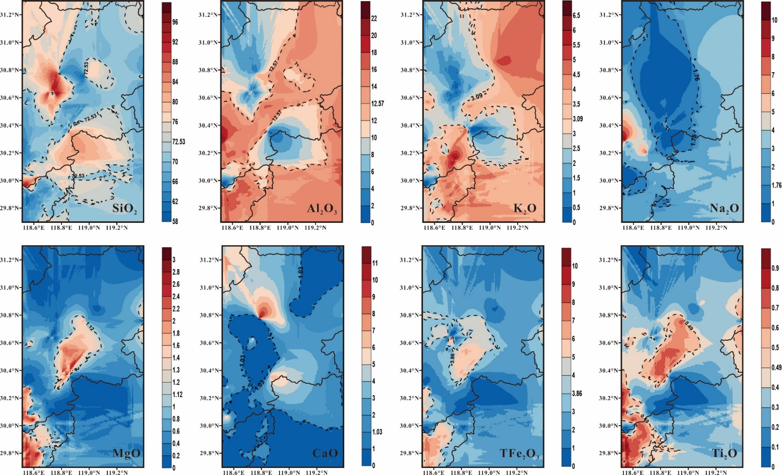
Figure S1. The spatial distribution of major elements of various rock in study area. The colors in the figure represent the variations in the content of major elemental components (wt%)
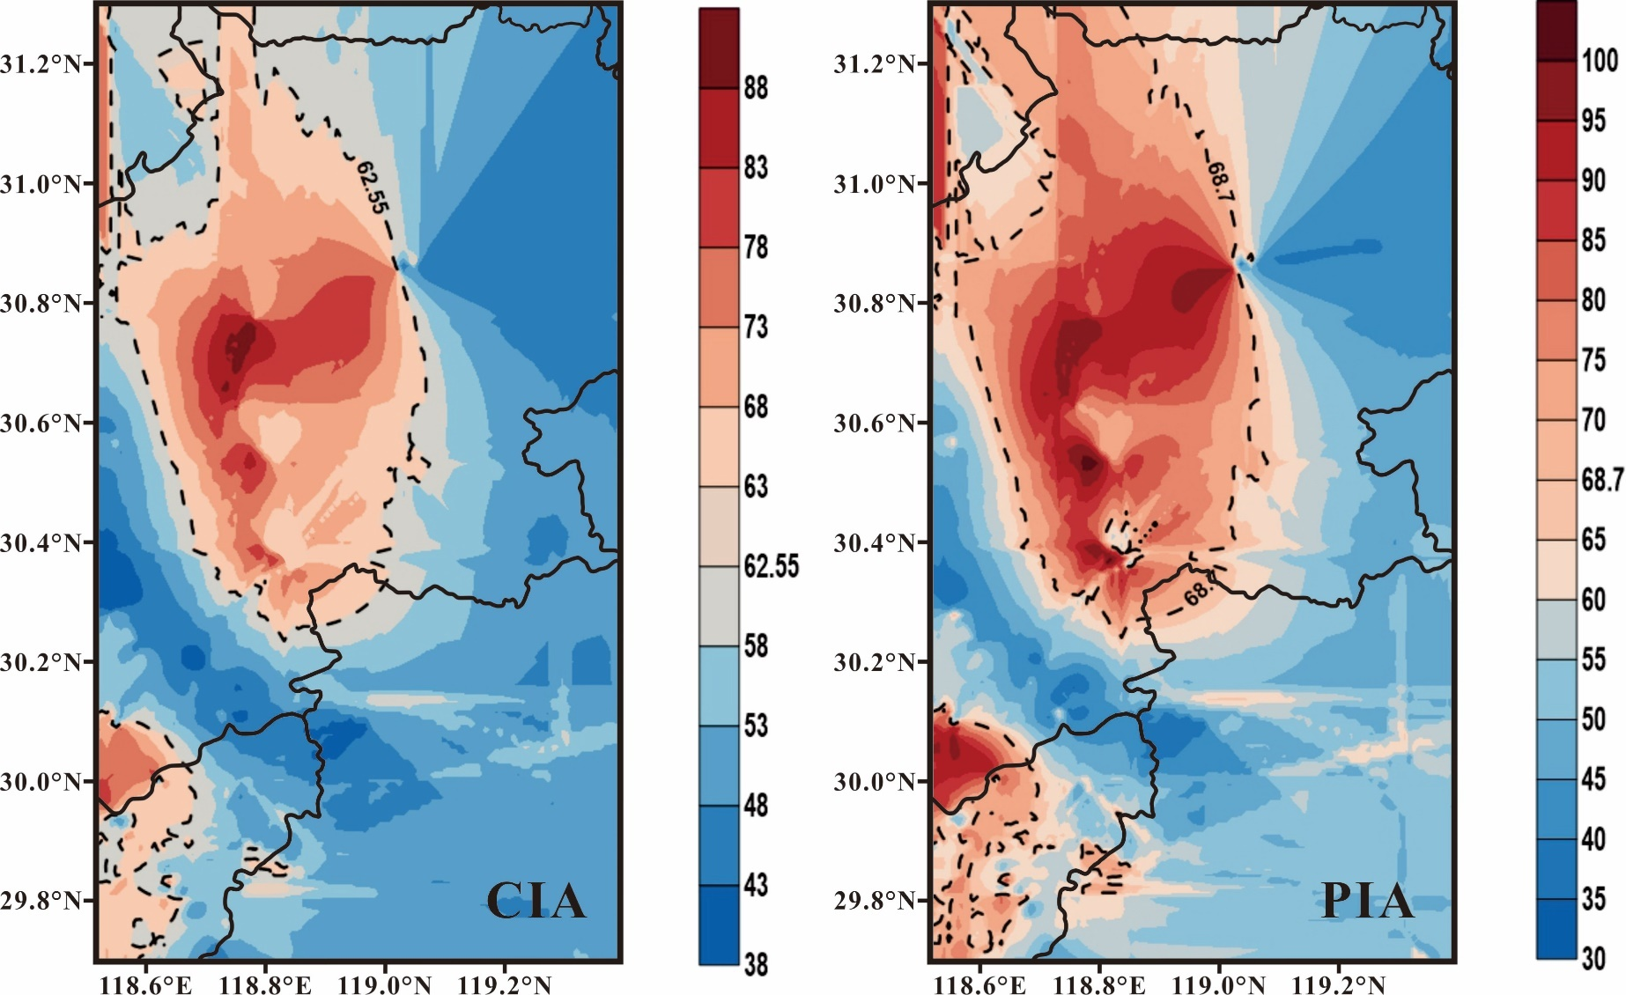
Figure S2. Spatial distribution of chemical weathering alteration index (CIA) and plagioclase alteration index (PIA).
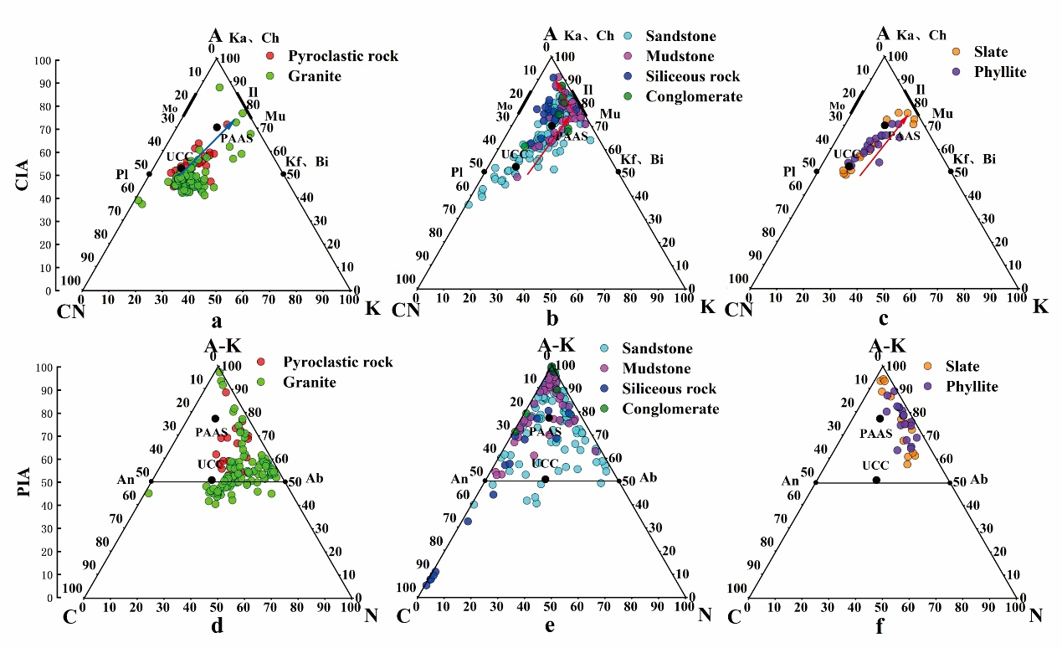
Figure S3. A-CN-K and (A-K)-C-N diagrams of various weathered rocks in southern Anhui. The diagram also represents the fields of idealized minerals: Pl=plagioclase; Kf =K-feldspars; Bi=biotite; Mu=Muscovite; Il=illite; Ka=kaolinite; Ch=chlorite; An=anorthite; Al=albite.

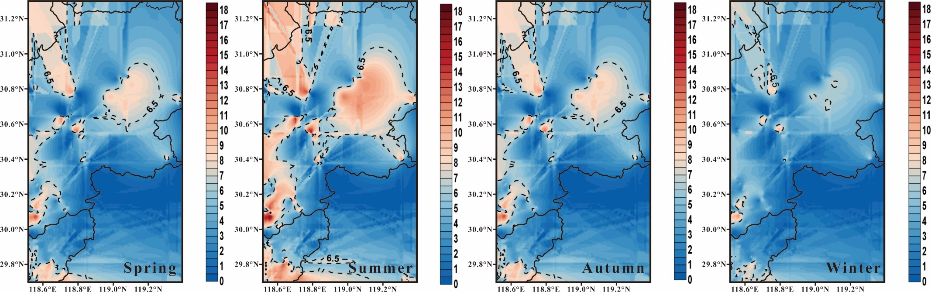
Figure S4. Spatial Distribution of Average Weathering Rates (Rw) in Different Seasons in study area. From left to right, the spatial distribution of chemical weathering rate (Rw) in spring, summer, autumn and winter is shown in the color of the legend, and the unit is (mmol·m⁻²·day⁻¹).

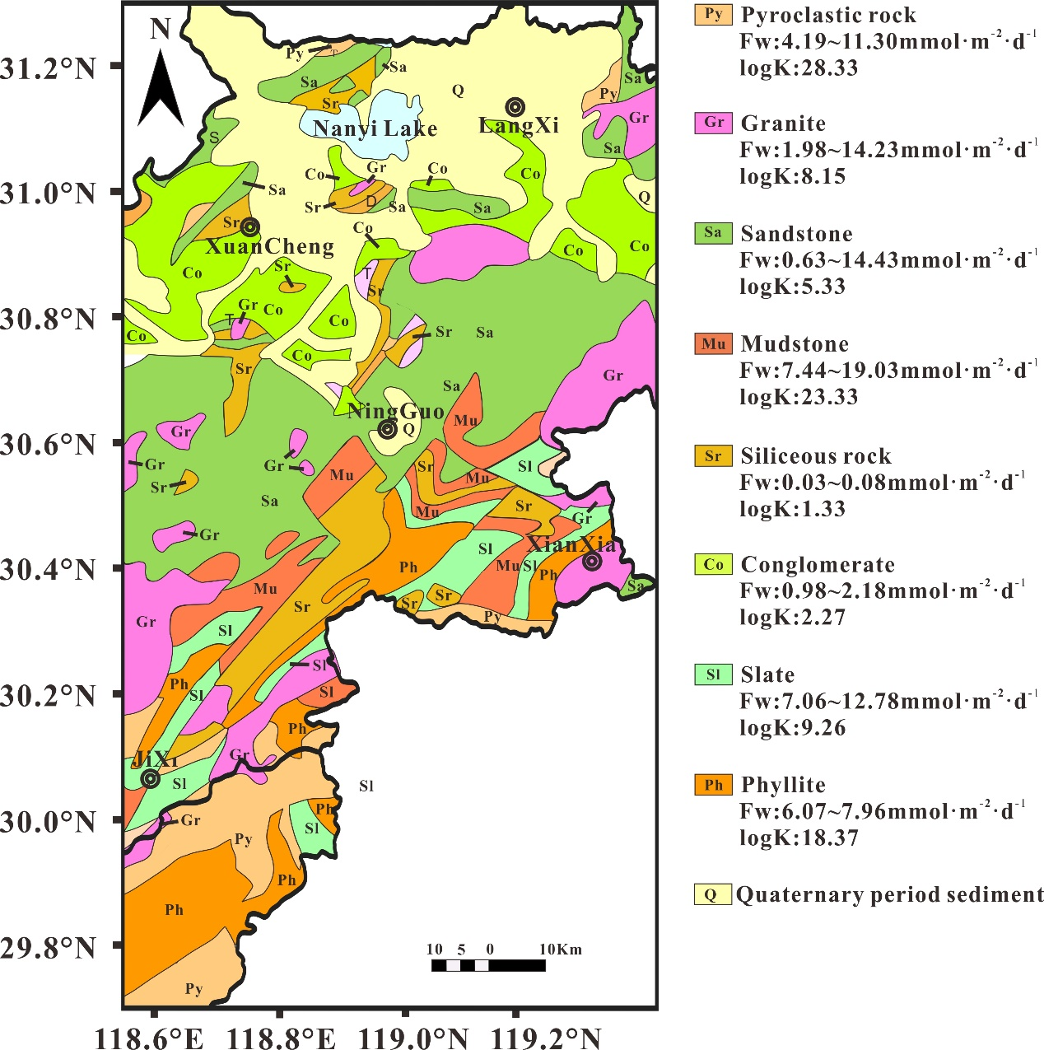
Figure S5. The distribution of various rock types in southern Anhui Province and their corresponding relationships with carbon capture rates and equilibrium constants (logK)

Table S2 Profile model parameters
Parameter | Unit | Min | Max | Mean
Al^{+a} | cmol·kg⁻¹ | 8.50 | 9.00 | 8.67
BCª | cmol·kg⁻¹ | 1.23 | 14.38 | 5.59
DOC | g·kg⁻¹ | 17.14 | 25.17 | 20.62
pHª |  | 5.00 | 7.00 | 5.66
Ɵ | % | 0.21 | 0.41 | 0.30
Xa Clay | % | 8.20 | 31.57 | 19.77
Xa Silt | % | 14.75 | 38.97 | 28.56
Xa Sand | % | 33.79 | 77.06 | 51.69
Aw (10⁶) | m2·m⁻³ | 1.55 | 5.31 | 3.37
ρ _{(soil bulk density)}ª | g·cm⁻³ | 1.28 | 1.57 | 1.41
Φ | m³·m⁻³ | 0.12 | 0.20 | 0.13
z | m |  |  | 0.20
Temperature 1970~2020^{b} | ℃ | -7.22 | 35.56 | 17.06
Temperature 2020~2100 of RCP2.6^{c} | ℃ | -3.33 | 32.74 | 18.12
Temperature 2020~2100 of RCP4.5^{c} | ℃ | -3.34 | 33.78 | 18.57
Temperature 2020~2100 of RCP6.0^{c} | ℃ | -3.51 | 34.39 | 18.63
Temperature 2020~2100 of RCP8.5^{c} | ℃ | -3.36 | 36.70 | 19.49
Precipitation in 1970~2020^{b} | mm·d⁻¹ | 0.00 | 300.23 | 4.14
Precipitation in 2020~2100 of RCP2.6^{c} | mm·d⁻¹ | 0.00 | 155.41 | 6.00
Precipitation in 2020~2100 of RCP2.6^{c} | mm·d⁻¹ | 0.00 | 155.86 | 5.94
Precipitation in 2020~2100 of RCP2.6^{c} | mm·d⁻¹ | 0.00 | 155.82 | 6.00
Precipitation in 2020~2100 of RCP2.6^{c} | mm·d⁻¹ | 0.00 | 155.57 | 6.14
P_{CO2} in 1970~2020^{d} | atm | 0.033 | 0.042 | 0.037
P_{CO2} in 2020~2100^{d} | atm | 0.042 | 0.072 | 0.055
a. Data from Soil Science Database (http://vdb3.soil.csdb.cn/);
b. Data from National Oceanic and Atmospheric Administration (NOAA) (https://ncei.noaa.gov/maps/daily/);
c. Data from World Meteorological Organization (WMO) (https://climexp.knmi.nl/start.cgi);
d. Data from Intergovernmental Panel on Climate Change (IPCC) (https://ipcc-data.org/observ/ddc_co₂.html).
Table S3. Mineral composition of different rock samples in study area (%)
Lithology |  | Quartz | Feldspar | Mica | Illite | Chlorite | Kaolinite | Calcite | Dolomite
 | wt(%)
 | d(Å) | 4.24 | 3.21 | 9.90 | 9.93 | 4.76 | 7.14 | 3.02 | 2.88
 | Factor | 2.92 | 2.80 | 6.00 | 3.00 | 4.95 | 2.25 | 1.65 | 1.53
Pyroclastic rock | PR-1 | 24.61 | 18.62 | 0.00 | 40.30 |  | 3.73 | 1.28
Pyroclastic rock | PR-2 | 30.51 | 36.74 | 0.00 | 24.52 |  | 1.19 | 7.03
Pyroclastic rock | PR-3 | 32.16 | 24.33 | 0.00 | 30.70 |  | 5.14 | 7.67
Pyroclastic rock | PR-4 | 39.47 | 14.79 | 0.00 | 29.44 | 1.90 | 5.53 | 8.87
Pyroclastic rock | PR-5 | 35.10 | 14.77 | 0.00 | 41.47 |  | 5.03 | 3.62
Granite | GR-1 | 3.33 | 74.97 | 3.35 |  | 8.21 | 3.89 |  | 0.37
Granite | GR-2 | 8.23 | 81.10 | 3.14 |  | 1.67 | 0.53 | 0.47 | 1.13
Granite | GR-3 | 5.51 | 60.62 | 12.60 |  | 2.87 | 4.39 | 1.31 | 2.95
Sandstone | SA-1 | 43.25 | 20.73 | 5.34 |  |  |  | 30.67
Sandstone | SA-2 | 39.16 | 29.15 | 4.22 |  |  |  | 25.40
Sandstone | SA-3 | 27.86 | 4.83 | 31.89 |  | 7.68 | 14.85 | 0.97
Sandstone | SA-4 | 24.57 | 14.60 | 33.62 |  | 6.21 | 15.24 | 3.18 | 2.58
Sandstone | SA-5 | 28.57 | 15.23 | 35.41 |  | 6.05 | 11.27 | 3.46
Mudstone | MU-1 | 28.83 | 27.65 |  | 35.95 |  |  |  | 7.57
Mudstone | MU-2 | 24.65 | 17.96 |  | 15.03 | 14.02 | 21.36 | 4.12 | 2.87
Mudstone | MU-3 | 24.42 | 19.98 |  | 16.17 | 13.76 | 22.85 |  | 2.82
Siliceous rock | SR-1 | 97.65 |  | 1.71
Siliceous rock | SR-2 | 73.23 | 23.68 |  |  | 2.06 | 1.03
Siliceous rock | SR-3 | 96.47 |  | 1.81 |  | 1.72
Conglomerate | CO-1 | 60.89 | 33.50 |  |  |  | 1.88 |  | 0.62
Conglomerate | CO-2 | 74.41 | 12.11 |  |  | 5.55 | 7.17 |  | 0.76
Conglomerate | CO-3 | 63.90 | 12.81 | 5.53 |  |  | 16.81 |  | 0.96
Slate | SL-1 | 30.93 | 19.16 | 29.70 |  | 6.67 | 11.50
Slate | SL-2 | 23.12 | 18.65 | 32.15 |  | 15.40 | 7.00 |  | 3.68
Phyllite | PH-1 | 28.73 | 17.20 | 19.66 |  | 12.50 | 18.94 |  | 2.98
Phyllite | PH-2 | 22.02 | 19.41 | 29.69 |  | 10.20 | 14.90 |  | 3.78
Phyllite | PH-3 | 20.39 | 30.79 | 22.42 |  | 9.80 | 13.21 |  | 3.39
When determining the mineral proportions in rocks, we apply strength factors from reference minerals to estimate the content of major minerals by measuring the quantities of the identified major minerals (Cook et al., 1975). The strength factors for various minerals are as follows: for quartz, the peak intensity at 4.24Å is multiplied by 2.92; for feldspar, the peak intensities at 3.21Å and 3.18Å are multiplied by 2.80; for mica, the peak intensity at 9.90Å is multiplied by 6.00; for illite, the characteristic peak intensity at 9.93Å is multiplied by 3.00; for chlorite, the characteristic peak intensity at 4.76Å is multiplied by 4.95; for kaolinite, the peak height at 7.14Å is multiplied by 2.25; for calcite, the characteristic peak intensity at 3.02Å is multiplied by 1.65; and for dolomite, the characteristic peak intensity at 2.88Å is multiplied by 1.53 (Cook et al., 1975; Kihara, 1990) .
Table S4 Weathering of various lithological parent layers in different seasons in the southern Anhui region in 2020
Soil parent rock | area(km²) |  | spring |  |  |  | summer |  |  |  | autumn |  |  |  | winter
 | area(km²) | n=27 | Rw | Fw | R_{BC} | F | Rw | Fw | R_{BC} | F | Rw | Fw | R_{BC} | F | Rw | Fw | R_{BC} | F
Pyroclastic rock | 218.65 | PR-1 | 2.87 | 4.04 | 2.86 | 38.83 | 3.95 | 5.77 | 3.95 | 55.54 | 2.90 | 4.08 | 2.89 | 39.23 | 2.11 | 2.84 | 2.10 | 27.33
Pyroclastic rock | 218.65 | PR-2 | 9.23 | 9.64 | 9.22 | 92.77 | 11.67 | 12.31 | 11.66 | 118.43 | 9.31 | 9.72 | 9.30 | 93.56 | 7.49 | 7.74 | 7.48 | 74.45
Pyroclastic rock | 218.65 | PR-3 | 9.60 | 9.57 | 9.59 | 92.04 | 11.99 | 11.95 | 11.98 | 114.97 | 9.67 | 9.64 | 9.66 | 92.78 | 7.87 | 7.84 | 7.86 | 75.47
Pyroclastic rock | 218.65 | PR-4 | 11.07 | 11.08 | 11.07 | 106.57 | 13.84 | 13.84 | 13.84 | 133.20 | 11.16 | 11.17 | 11.16 | 107.43 | 9.08 | 9.08 | 9.07 | 87.33
Pyroclastic rock | 218.65 | PR-5 | 4.56 | 4.52 | 4.55 | 43.51 | 5.70 | 5.65 | 5.69 | 54.37 | 4.60 | 4.56 | 4.59 | 43.87 | 3.74 | 3.71 | 3.72 | 35.68
Granite | 1182.05 | GR-1 | 0.97 | 1.93 | 1.78 | 100.58 | 1.30 | 2.62 | 2.40 | 136.23 | 0.98 | 1.95 | 1.80 | 101.58 | 0.72 | 1.42 | 1.32 | 73.79
Granite | 1182.05 | GR-2 | 3.17 | 5.35 | 5.32 | 278.20 | 4.13 | 7.02 | 6.98 | 365.34 | 3.20 | 5.40 | 5.37 | 280.79 | 2.46 | 4.09 | 4.07 | 212.55
Granite | 1182.05 | GR-3 | 8.19 | 13.91 | 13.86 | 723.71 | 10.66 | 18.28 | 18.20 | 950.58 | 8.27 | 14.04 | 13.99 | 730.44 | 6.35 | 10.63 | 10.60 | 552.86
Sandstone | 2229.94 | SA-1 | 11.72 | 11.71 | 11.71 | 1149.34 | 14.64 | 14.64 | 14.64 | 1436.41 | 11.81 | 11.81 | 11.81 | 1158.67 | 9.62 | 9.62 | 9.62 | 943.40
Sandstone | 2229.94 | SA-2 | 14.14 | 14.14 | 14.14 | 1387.02 | 17.67 | 17.67 | 17.67 | 1733.39 | 14.26 | 14.25 | 14.25 | 1398.27 | 11.61 | 11.60 | 11.60 | 1138.54
Sandstone | 2229.94 | SA-3 | 0.52 | 0.61 | 0.55 | 60.15 | 0.66 | 0.80 | 0.70 | 78.42 | 0.52 | 0.62 | 0.55 | 60.70 | 0.42 | 0.48 | 0.43 | 46.94
Sandstone | 2229.94 | SA-4 | 2.57 | 3.67 | 3.64 | 359.95 | 3.29 | 4.76 | 4.72 | 466.90 | 2.59 | 3.70 | 3.67 | 363.20 | 2.03 | 2.86 | 2.84 | 280.65
Sandstone | 2229.94 | SA-5 | 2.69 | 3.79 | 3.77 | 372.27 | 3.45 | 4.92 | 4.88 | 482.25 | 2.72 | 3.83 | 3.80 | 375.62 | 2.14 | 2.96 | 2.95 | 290.79
Mudstone | 56.90 | MU-1 | 9.36 | 18.59 | 18.61 | 46.54 | 12.40 | 24.62 | 24.65 | 61.63 | 9.45 | 18.77 | 18.79 | 46.99 | 7.07 | 14.04 | 14.05 | 35.15
Mudstone | 56.90 | MU-2 | 8.64 | 12.38 | 12.22 | 30.98 | 11.08 | 16.07 | 15.84 | 40.23 | 8.72 | 12.49 | 12.33 | 31.26 | 6.84 | 9.64 | 9.54 | 24.13
Mudstone | 56.90 | MU-3 | 3.60 | 7.27 | 7.12 | 18.20 | 4.78 | 9.68 | 9.45 | 24.23 | 3.63 | 7.34 | 7.19 | 18.38 | 2.71 | 5.46 | 5.36 | 13.66
Siliceous rock | 29.86 | SR-1 | 0.03 | 0.02 | 0.02 | 0.03 | 0.04 | 0.04 | 0.04 | 0.05 | 0.03 | 0.02 | 0.02 | 0.03 | 0.03 | 0.02 | 0.02 | 0.02
Siliceous rock | 29.86 | SR-2 | 0.06 | 0.08 | 0.05 | 0.10 | 0.08 | 0.11 | 0.07 | 0.14 | 0.06 | 0.08 | 0.05 | 0.10 | 0.05 | 0.05 | 0.04 | 0.07
Siliceous rock | 29.86 | SR-3 | 0.04 | 0.07 | 0.05 | 0.09 | 0.05 | 0.10 | 0.07 | 0.13 | 0.04 | 0.07 | 0.05 | 0.09 | 0.04 | 0.04 | 0.03 | 0.06
Conglomerate | 193.65 | CO-1 | 0.51 | 0.95 | 0.95 | 8.13 | 0.68 | 1.26 | 1.26 | 10.77 | 0.52 | 0.96 | 0.96 | 8.21 | 0.39 | 0.72 | 0.72 | 6.14
Conglomerate | 193.65 | CO-2 | 0.60 | 1.20 | 1.16 | 10.26 | 0.80 | 1.61 | 1.55 | 13.69 | 0.61 | 1.22 | 1.17 | 10.36 | 0.46 | 0.90 | 0.87 | 7.67
Conglomerate | 193.65 | CO-3 | 1.08 | 2.11 | 1.76 | 18.00 | 1.51 | 2.98 | 2.42 | 25.38 | 1.09 | 2.13 | 1.78 | 18.19 | 0.76 | 1.49 | 1.28 | 12.72
Slate | 366.81 | SL-1 | 3.46 | 6.90 | 6.80 | 111.36 | 4.58 | 9.16 | 9.01 | 147.83 | 3.49 | 6.97 | 6.87 | 112.43 | 2.60 | 5.19 | 5.12 | 83.75
Slate | 366.81 | SL-2 | 6.18 | 12.48 | 12.25 | 201.47 | 8.19 | 16.58 | 16.24 | 267.63 | 6.24 | 12.60 | 12.37 | 203.40 | 4.65 | 9.38 | 9.23 | 151.38
Phyllite | 70.32 | PH-1 | 2.87 | 5.92 | 5.81 | 18.33 | 3.81 | 7.91 | 7.74 | 24.47 | 2.89 | 5.98 | 5.87 | 18.51 | 2.16 | 4.42 | 4.35 | 13.68
Phyllite | 70.32 | PH-2 | 3.76 | 7.77 | 7.52 | 24.03 | 5.03 | 10.43 | 10.05 | 32.28 | 3.80 | 7.84 | 7.59 | 24.26 | 2.81 | 5.76 | 5.60 | 17.83
Phyllite | 70.32 | PH-3 | 3.42 | 7.01 | 6.75 | 21.69 | 4.58 | 9.42 | 9.03 | 29.15 | 3.45 | 7.08 | 6.82 | 21.90 | 2.55 | 5.20 | 5.04 | 16.09
The above data are the average weathering rate, carbon capture rate, alkaline cation leaching rate and carbon sink range of various soil parent layers，where Rw, Fw and R_{BC} are units in mmol·m⁻²·d⁻¹,the F is unit in t·d⁻¹

Table S5 Changes in Gibbs free energy during carbon capture in various types of soil parent layer at 298.15°K (25.0°C)and one atmosphere (1.013 bars) pressure
 | ∆rG(KJ/mol) |  |  | logK
Soil parent rock | max | min | mean | max | min | mean
Pyroclastic rock | -205.73 | -126.88 | -161.73 | 36.04 | 22.23 | 28.33
Granite | -61.35 | -27.96 | -46.54 | 10.75 | 4.90 | 8.15
Sandstone | -42.18 | -13.69 | -30.45 | 7.39 | 2.40 | 5.33
Mudstone | -175.35 | -109.57 | -133.18 | 30.71 | 19.19 | 23.33
Siliceous rock | -9.15 | -4.83 | -7.62 | 1.60 | 0.85 | 1.33
Conglomerate | -17.03 | -6.01 | -12.93 | 2.98 | 1.05 | 2.27
Slate | -63.77 | -41.93 | -52.85 | 11.17 | 7.34 | 9.26
Phyllite | -118.73 | -93.32 | -104.88 | 20.80 | 16.35 | 18.37

Reference
Amiotte Suchet, P., Probst, J.L., 1993. Flux de CO₂ consommé par altération chimique continentale : influences du drainage et de la lithologie = CO₂ flux consumed by chemical weathering of continents : influences of drainage and lithology. Comptes Rendus De Lacadémie Des Sciences De Paris Série II Mécanique Physique Chimie Astronomie.
Cook, H.E., Johnson, P.D., Matti, J.C., Zemmels, I., 1975. Methods of Sample Preparation and X-Ray Diffraction Data Analysis, X-Ray Mineralogy Laboratory, Deep Sea Drilling Project, University of California, Riverside.
Drever, J.I., 1997. The Geochemistry of Natural Waters: Surface and Groundwater Environments.
Harold, C.H., David, H.K., George, C.F., 1981. Theoretical prediction of the thermodynamic behavior of aqueous electrolytes by high pressures and temperatures; IV, Calculation of activity coefficients, osmotic coefficients, and apparent molal and standard and relative partial molal properties to 600 degrees C and 5kb. American Journal of Science, 281(10): 1249.
Kihara, K., 1990. An X-ray study of the temperature dependence of the quartz structure. European Journal of Mineralogy, 2(1): 63-77.
Li, S.-L., Chetelat, B., Yue, F., Zhao, Z., Liu, C.-Q., 2014. Chemical weathering processes in the Yalong River draining the eastern Tibetan Plateau, China. Journal of Asian Earth Sciences, 88: 74-84.
Noh, H., Huh, Y., Qin, J., Ellis, A., 2009. Chemical weathering in the Three Rivers region of Eastern Tibet. Geochimica et Cosmochimica Acta, 73(7): 1857-1877.

*∗Correspondence authors: Yinxian Song (songyinxian@gmail.com); Chunjun Tao (tcj9903@sina.com)

