Vacant niches in a species-poor system: resource partitioning based on diet quality for a Mexican clam in the Baltic Sea
Agnes ML Karlson^{1,2}, Nils Kautsky¹, Matilda Granberg¹, Andrius Garbaras³, Hwanmi Lim⁴, Camilla Liénart*^{1,5}
¹ Department of Ecology, Environment and Plant sciences, Stockholm University, Stockholm, Sweden
² Stockholm University Baltic Sea Centre, Stockholm, Sweden
³ Center for Physical Sciences and Technology, Vilnius, Lithuania
⁴ Lipidor AB, Svärdvägen 13, SE-182 33 Danderyd, Sweden
⁵ Université de Bordeaux, CNRS, Bordeaux INP, EPOC, UMR 5805, 33120 Arcachon, France
Corresponding author*: camilla.lienart@su.se

Supplemental figures
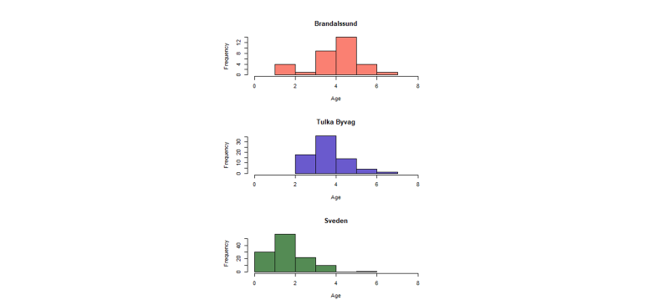
Fig. S1: Histogram of the age distribution of R. Cuneata (counts) in late summer in the three studied locations.
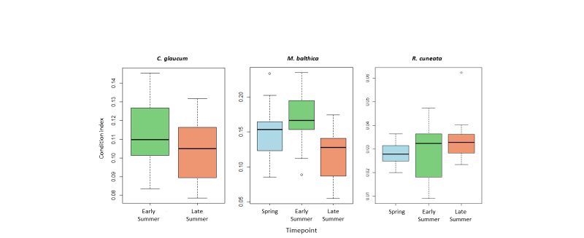
Fig. S2: Boxplot of condition index (soft tissue:shell, dry weight) of native and non-native clams collected at Brandalssund: C. glaucum for two timepoints, M. balthica and R. cuneata for three timepoints.
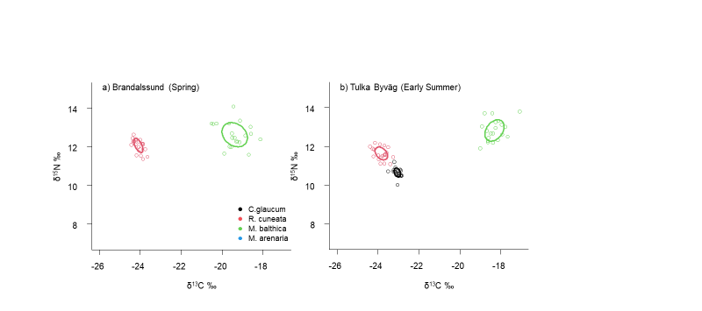
Fig. S3: Isotope niches represented by SIBER Standard Ellipses (set to 40% of the data) for the native (C. glaucum, M. balthica) and non-native (R. cuneata) clams sampled at Brandalssund in a) spring and b) Tulka Byväg early summer. Bayesian estimates are presented in Fig. S4.
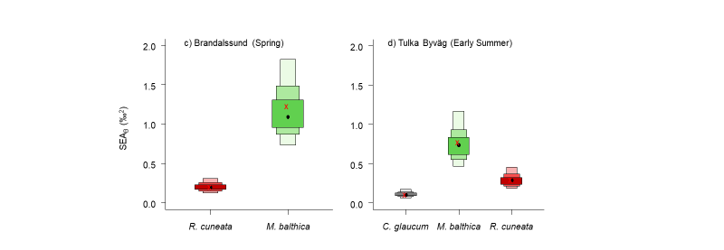
Fig. S4: Bayesian estimates for the Standard Ellipse Area (SEA_{B}) presented in Fig. S3 for the native (C. glaucum, M. balthica) and non-native (R. cuneata) clams sampled at Brandalssund in a) spring and b) Tulka Byväg early summer. The boxes represent the credible intervals of 50%, 90% and 95%. Black dot represents the mean, red crosses the mode.

