Extended Data

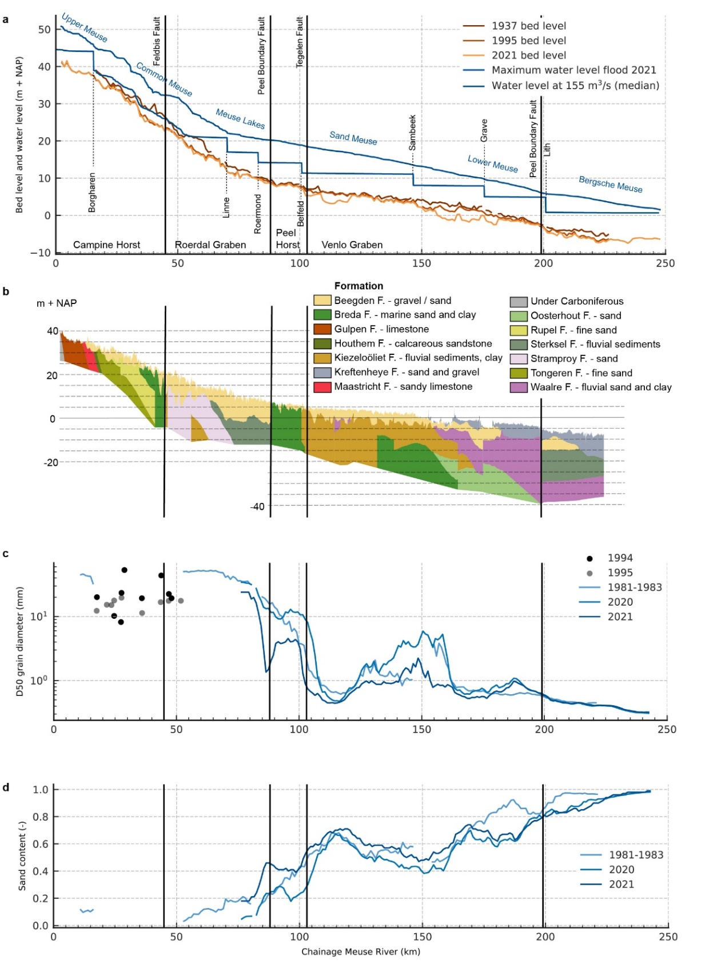
Extended Data Figure 1 | Geology, bed profile development and riverbed composition of the Meuse River. a, Longitudinal bed level profiles in 1937, 1995 and 2021 averaged over 1 km (yearly survey Rijkswaterstaat), peak water level in July 2021 (Rijkswaterstaat) and locations of faults (vertical green lines), graben and blocks⁶⁶. The riverbed incises in time due to barrages, resulting in sediment supply limited conditions, narrowing, bank protection, bend cut-offs and sediment extraction. b, Geological profile indicating gravel in yellow⁶⁷. Relatively to the adjacent Roer Valley Graben, the Campine Horst rises approximately 6 mm/100 yr²⁴, explaining that over millions of years the gravel layer thickness is much smaller than in adjacent, slowly subsiding, block regions generating accommodation space for gravel deposition. The three green colours underneath the gravel layer in the reach km 20-40 indicate fine marine sands from the Miocene (23 to 5 million B.P.), Rupelian (34 to 28 million years B.P.) or Late Eocene/Early Oligocene (37 to 30 million years B.P.). c, Characteristic grain size diameter D50 from top layer (10 cm) of the riverbed and development in time (data Rijkswaterstaat). Data from 1981-1983, 2020 and 2021 (after the flood) are based on samples every 500 m; lines show a moving average over 10 km. d, Sand content of the top layer and development in time (data Rijkswaterstaat), as a moving average over 10 km. The composition of the riverbed and location of the gravel-sand transition in the reach km 90-105 remained stable over the past 50 years. In parts of the Meuse River with a gravel bed, an armour layer on the riverbed is formed outside periods of high flows. Prior to breaking up of this armour during high flows, the armoured riverbed remained stable.
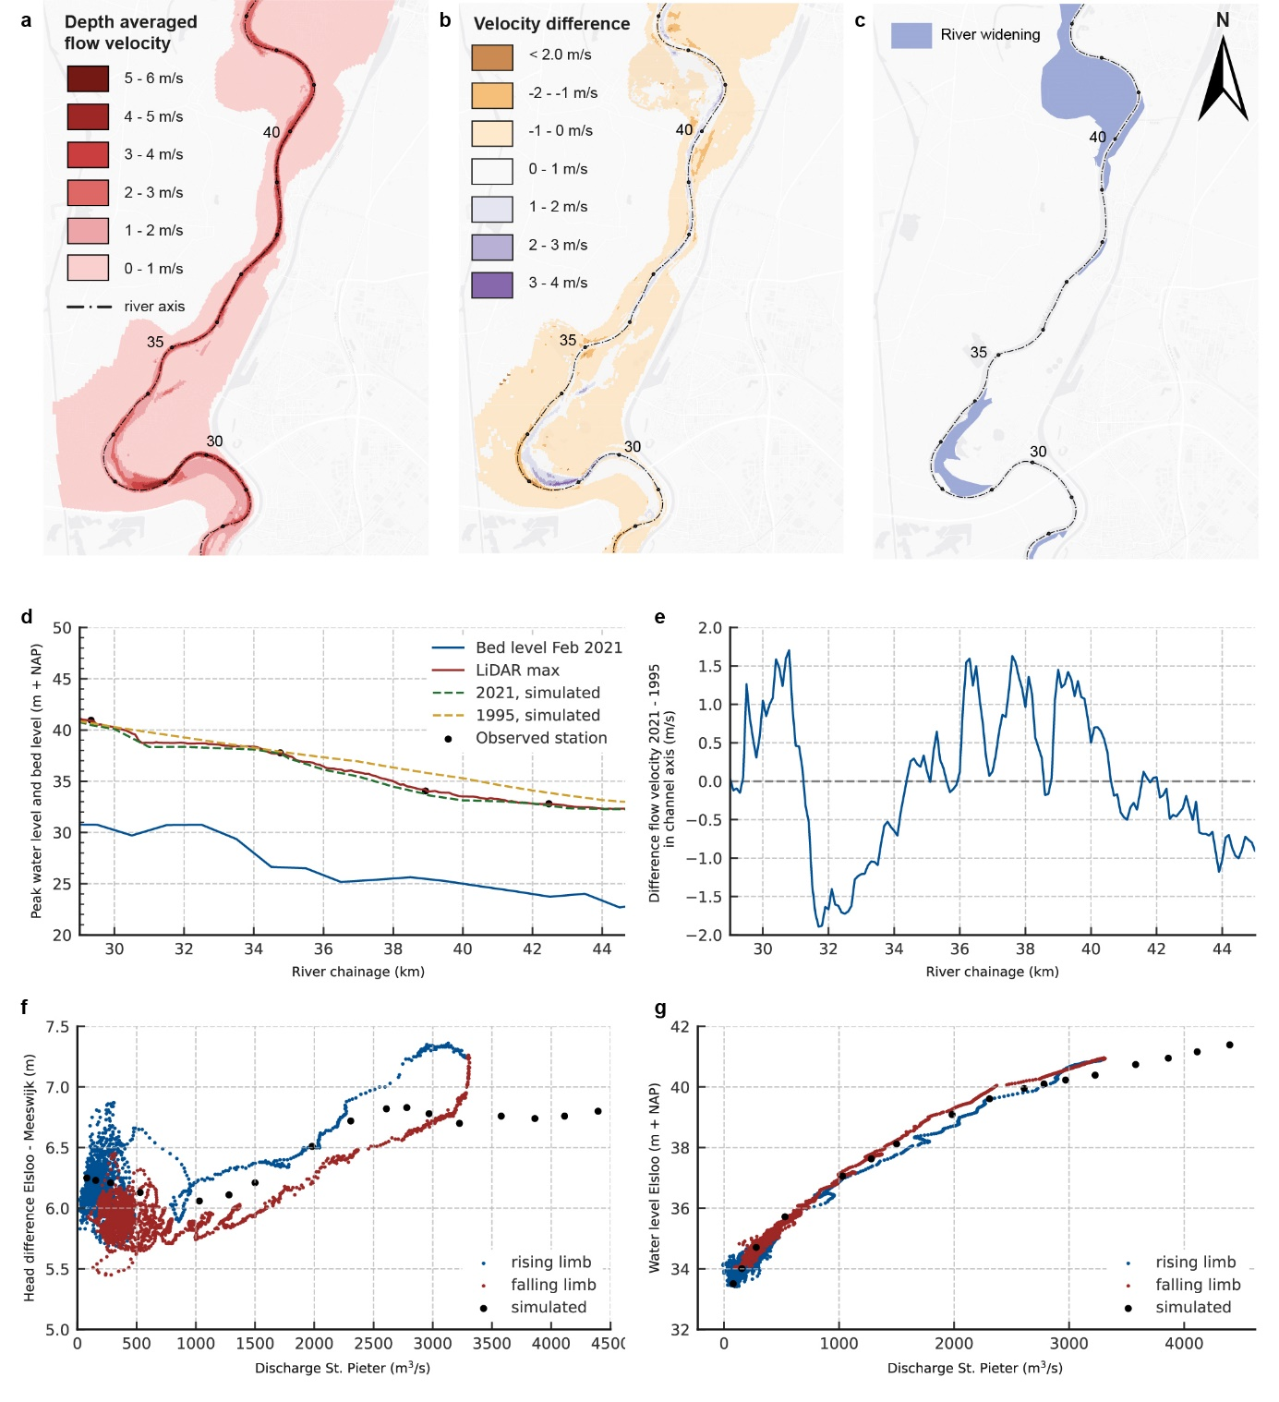 Extended Data Figure 2 | Hydrodynamic simulations and observations of peak event. a, Depth-averaged flow velocities with the Meuse Program implemented, simulated with the 2-dimensional WAQUA-model (schematization code beno17_5-v1) and average-shaped flood wave with 3,224 m³/s peak (slightly below the 2021 peak) ⁶⁸. b, Flow velocity change due to the Meuse Program²⁶, compared to 1993-reference (code j93_5-v1 ⁶⁸), showing the acceleration in the main channel of reach km34-39. c, Meuse Program measures implemented up to 2021. Planned widening within the reach km34-36 was part of the simulations, so flow velocities in this section were even higher than computed. d, Simulated and observed peak water levels at gauging stations and from LiDAR (source Rijkswaterstaat). The Meuse Program draws down water levels in the narrow reach km34-40, increasing flow velocities (Panel b and e). e, Changes in peak flow velocities at the river axis due to the Meuse Works, explaining changes in sediment transports and gradients. f, Simulated (WAQUA, steady simulation) and observed instantaneous head difference between gauging stations Elsloo (km 29.33) and Meeswijk (km 38.93) as a function of discharge. Based on gauging data, we adopted a 5-h travel time from St. Pieter station (km 10.8). The sharp increase of head difference in the rising limb between 2,000 and 2,500 m³/s and drop just after the peak indicates a system change during the passage of the peak. g, Simulated and observed relation between water level at Elsloo and discharge at St. Pieter, adopting a 3-h travel time. Deviation between simulations and measurements increases between 2,500 and 3,000 m³/s, which is not found at station of Meeswijk (near most downstream scour hole). The step at Elsloo may be explained by the morphological changes in the reach Elsloo-Meeswijk, including dunes (increase friction) and scours (local energy losses).

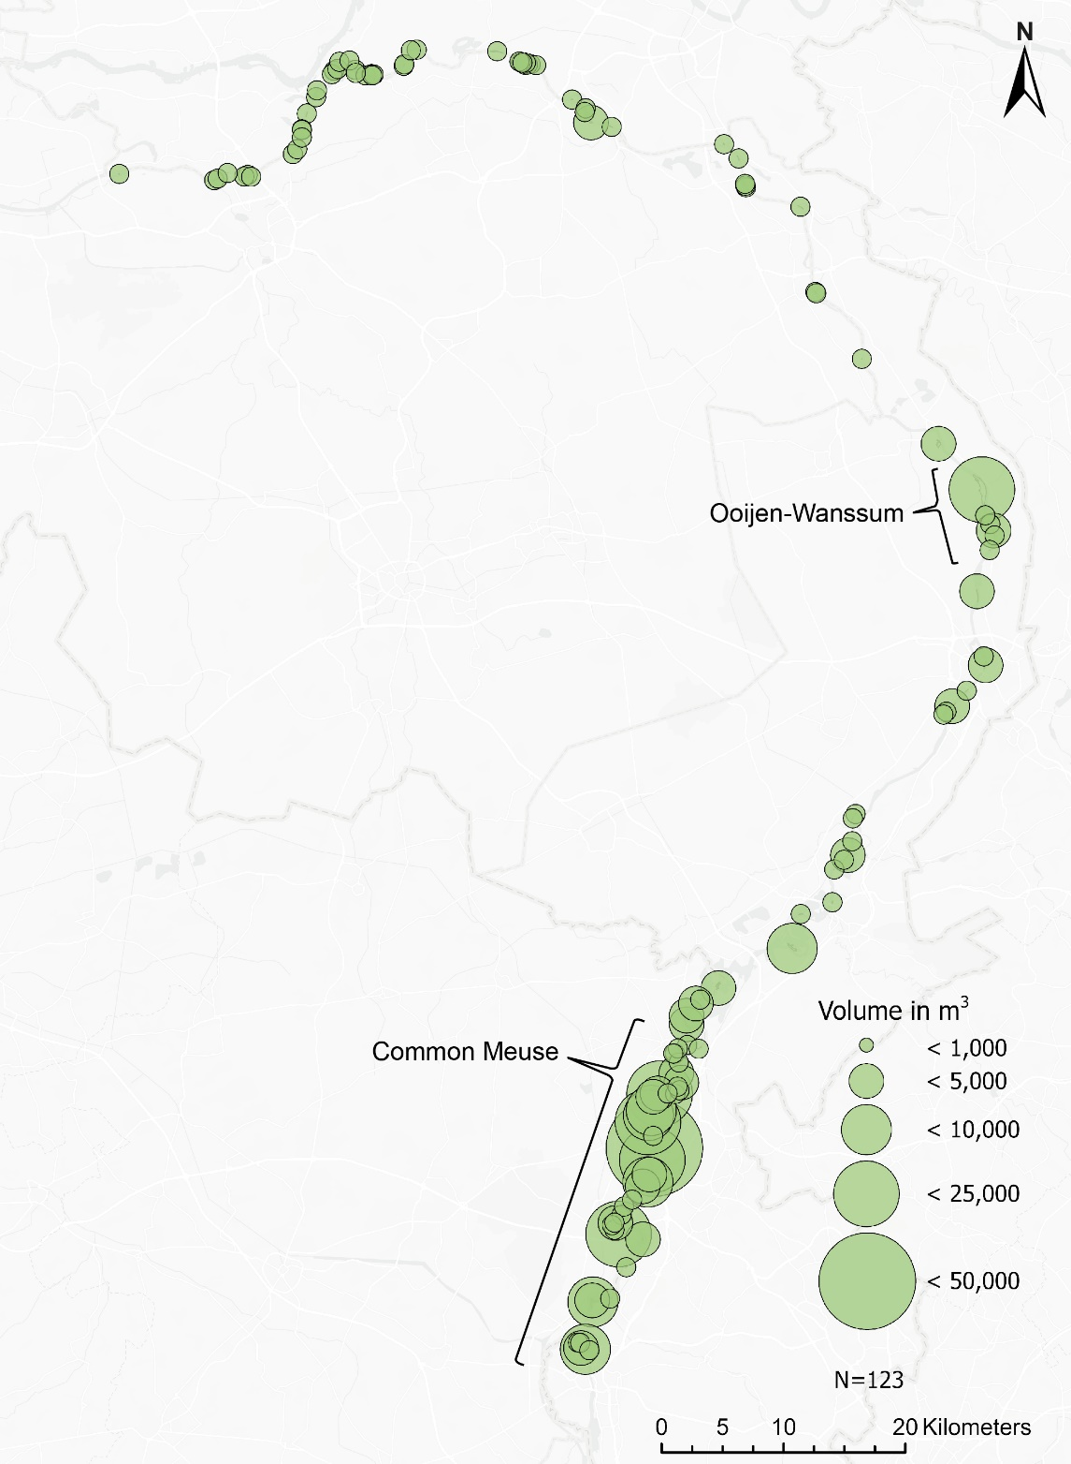
Extended Data Figure 3 | Sand volumes of deposits during the July 2021 flood based on field measurements and LiDAR data. The 89 fieldwork floodplains contained 123 deposition areas. The largest deposits occurred in the Common Meuse and in the Ooijen-Wanssum trajectory, where a large river widening project was completed in 2020.

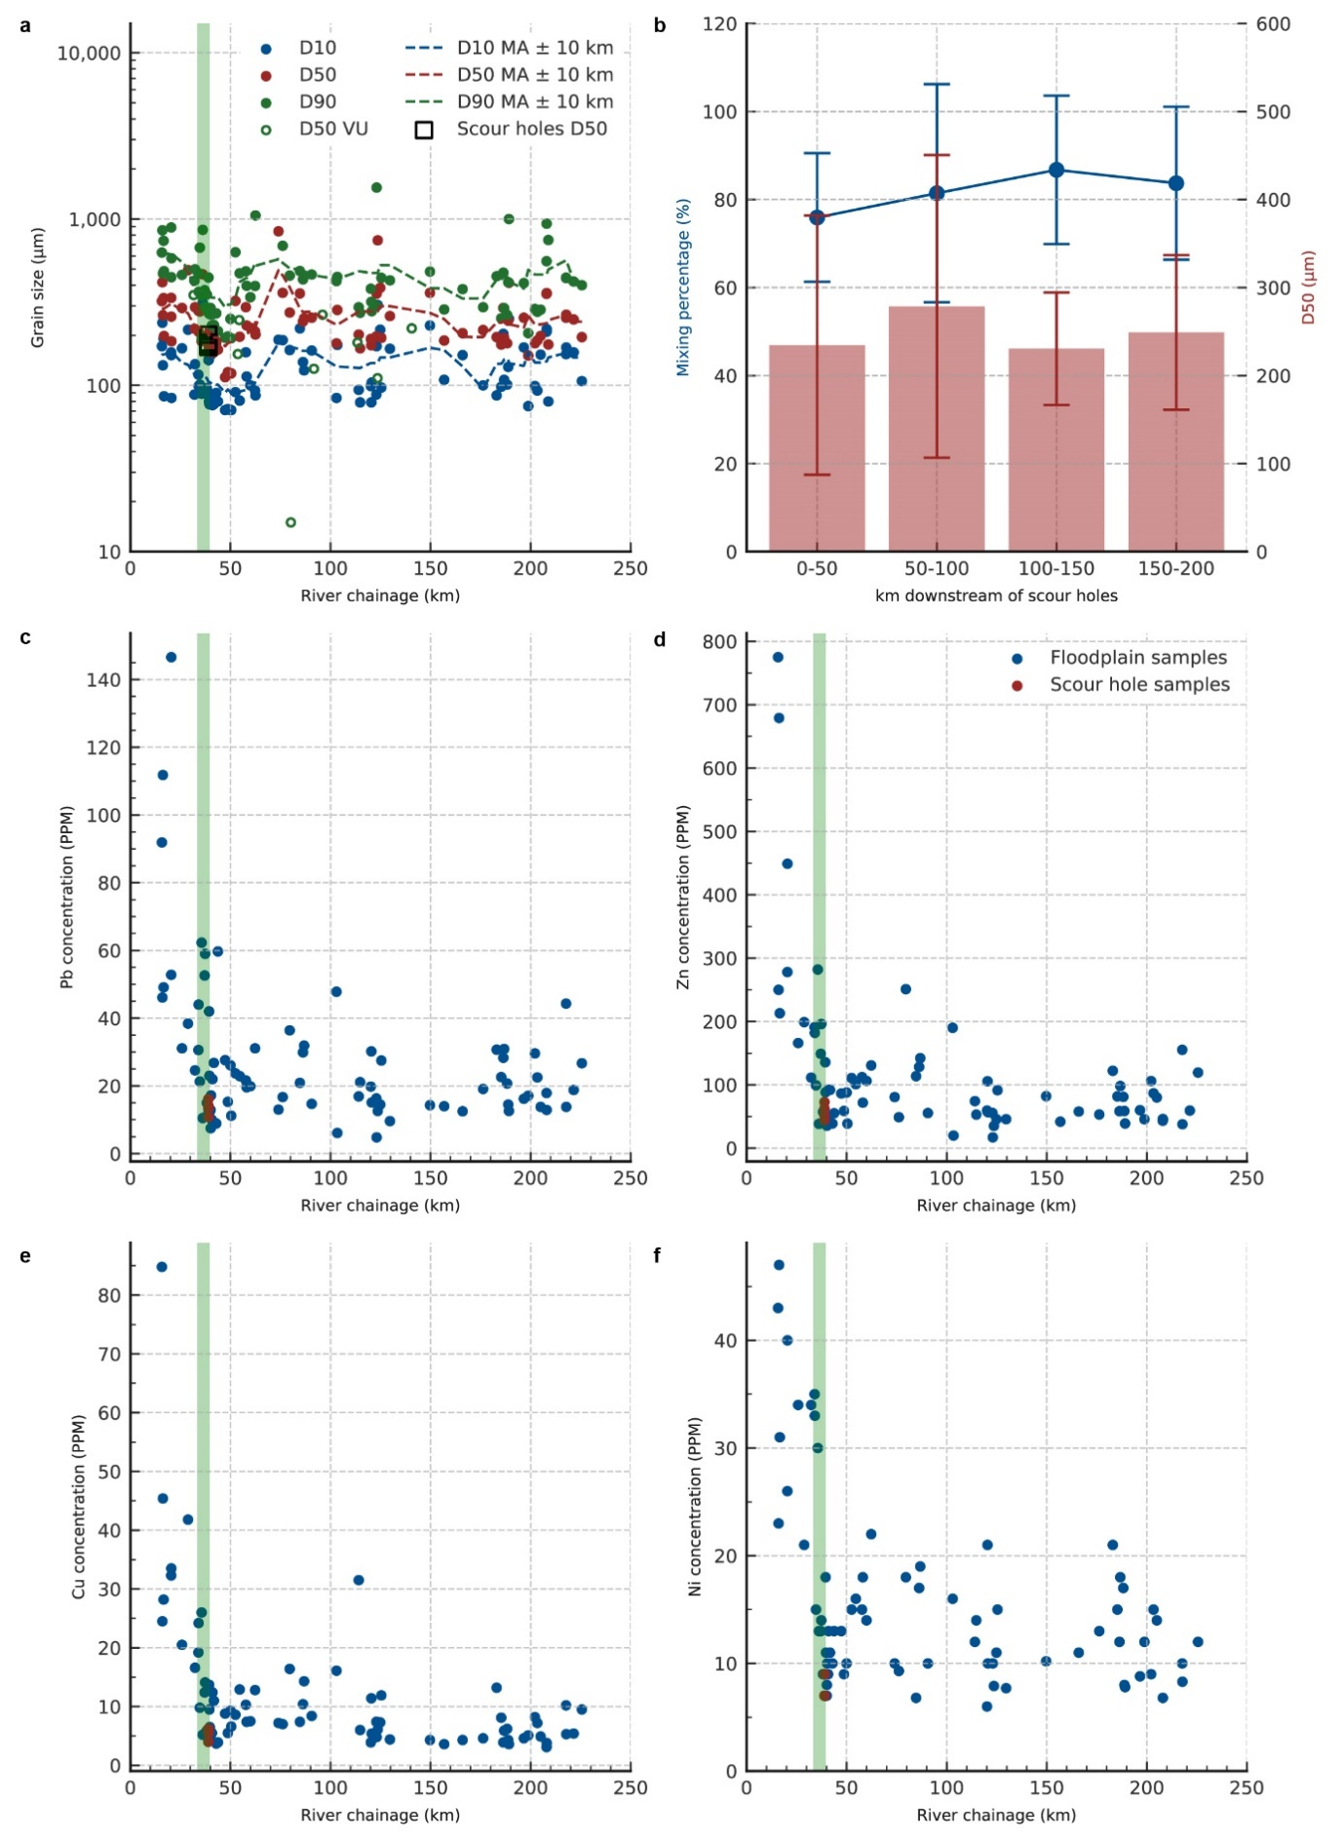
Extended Data Figure 4 | Sand deposit characteristics. a, Grain size distribution metrics for proximal zone floodplain deposits (mixed samples, see Methods) with moving average values. D50 values for samples from one scour hole (□) and near-river samples (o, “D50 VU” from Extended Data Fig. 9) are added for comparison. In a 20 km section downstream of the scour holes, deposits contain fine sediment. b, Average mixing percentages and average D50 grainsize of floodplain samples, including the standard deviations, for sections of 50 km downstream of the scour holes, showing no significant trend in composition for downstream reaches. c-f, Concentrations of Pb, Zn, Cu and Ni in sediment samples from XRF analyses. Green bars indicate the scour hole section in the river; riverbed samples were taken at km 39, in the most downstream scour hole. Low concentrations in the scour holes show eroded Tertiary sediments (23-5 million B.P.) to be uncontaminated, upstream deposits to be of more recent origin and the Tertiary sediments to be deposited on downstream floodplains. Panels b-f are based on van der Niet ⁶⁹.
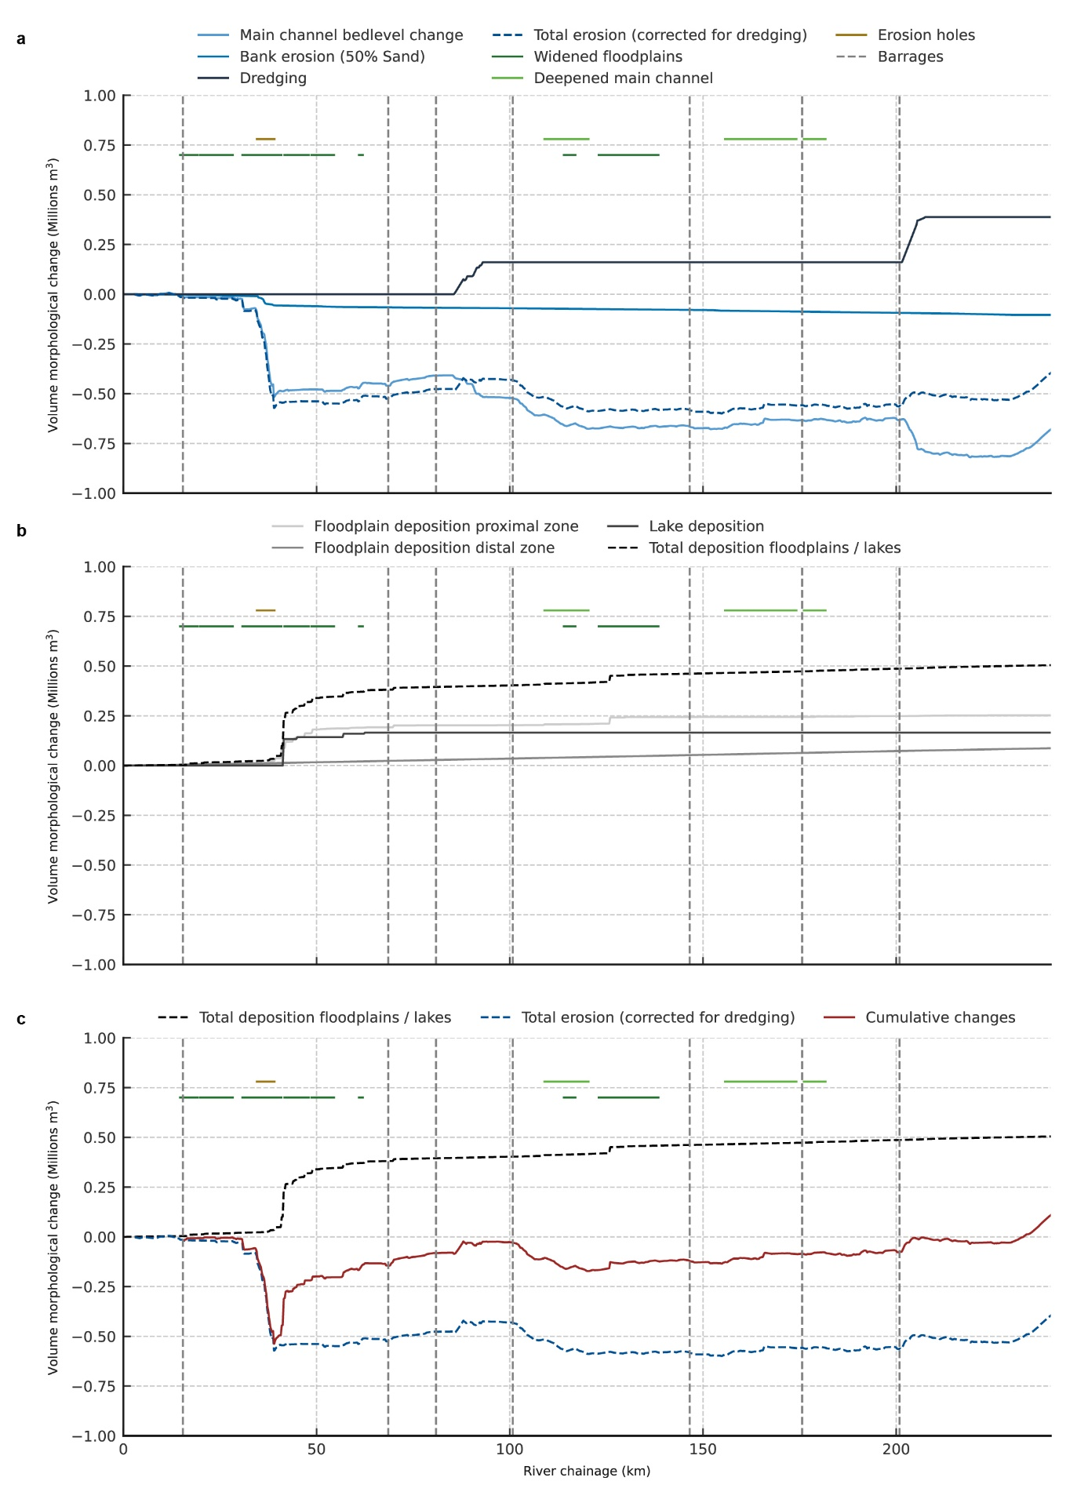
Extended Data Figure 5 | Cumulative Erosion and Deposition Volumes along the Meuse River. a, Erosion based on riverbed level information from February and July 2021, LiDAR data from April and August 2021 (for bank erosion), and dredged volumes between February and July 2021 (data Rijkswaterstaat). b, Deposition of sand on floodplains (field work and LiDAR) and in some main lakes (multi beam measurements). c, Cumulative changes based on information in panels a and b, showing that 80% of the sand eroded from the scour holes was deposited within 30 km downstream of the last scour hole.
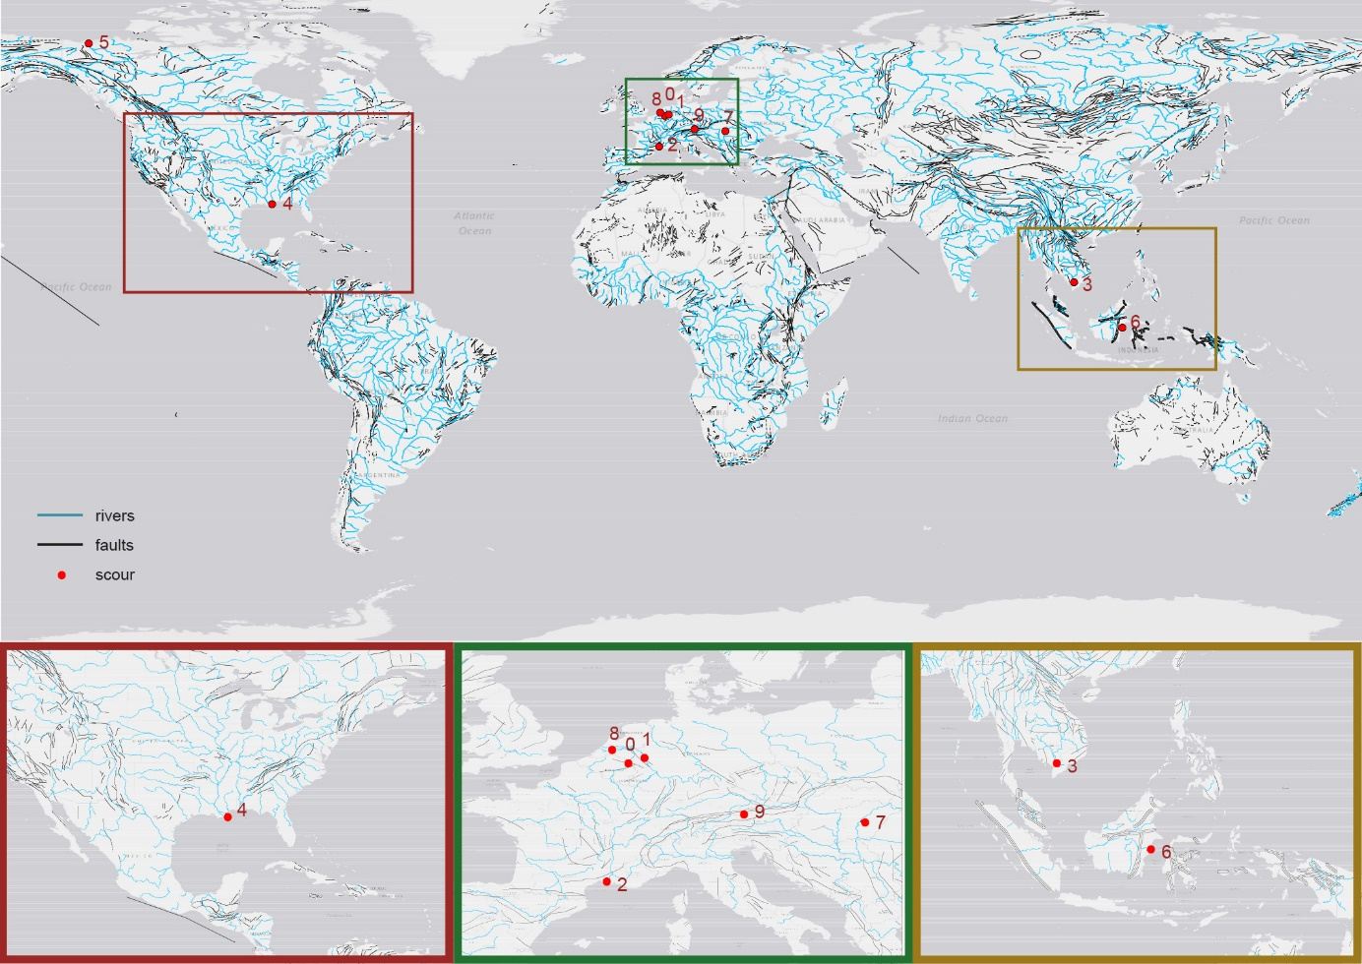
Extended Data Figure 6 | Riverbed scour and tectonic faults. World map with faults ⁷⁰ and the 10 cases of riverbed scour referred to in this manuscript (details in bottom panels): 0 – Meuse River, the Netherlands; 1 – Rhine River, Germany; 2 – Petit Rhone, France; 3 – Mekong River, Vietnam; 4 – Lower Mississippi, United States; 5 – Mackenzie Delta, United States; 6 – Mahakam River, Indonesia; 7 – Middle Tisza, Hungary; 8 – Rhine Meuse Delta – The Netherlands; 9 – Salzach River, Austria. Many rivers are located in regions with tectonic faults, where irregular sedimentary composition of the subsoil can be expected. The scour cases 0, 1, 6 and 9 can be connected to the existence of faults.

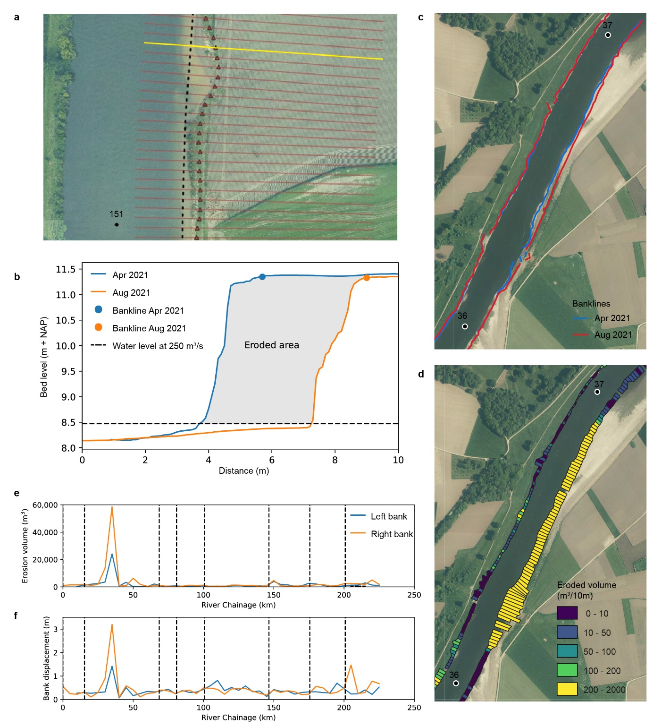
Extended Data Figure 7 | Bank erosion assessment. a, Example cross-sections on the right bank near km 151 with estimated erosion line (red triangles). b, Cross-section at km 151.14 (yellow line in panel a) and eroded area based on cross-sectional profiles and impoundment level. c, Example erosion lines before (blue) and after (red) the flood. d, Matching erosion volumes per section of 10 m long (distance in flow direction). e, Erosion volume per 5 km river length at the left and right banks. Dotted black lines show the locations of 7 barrages in the river. f, Average bank displacement per 5 km river length at the left and right banks.
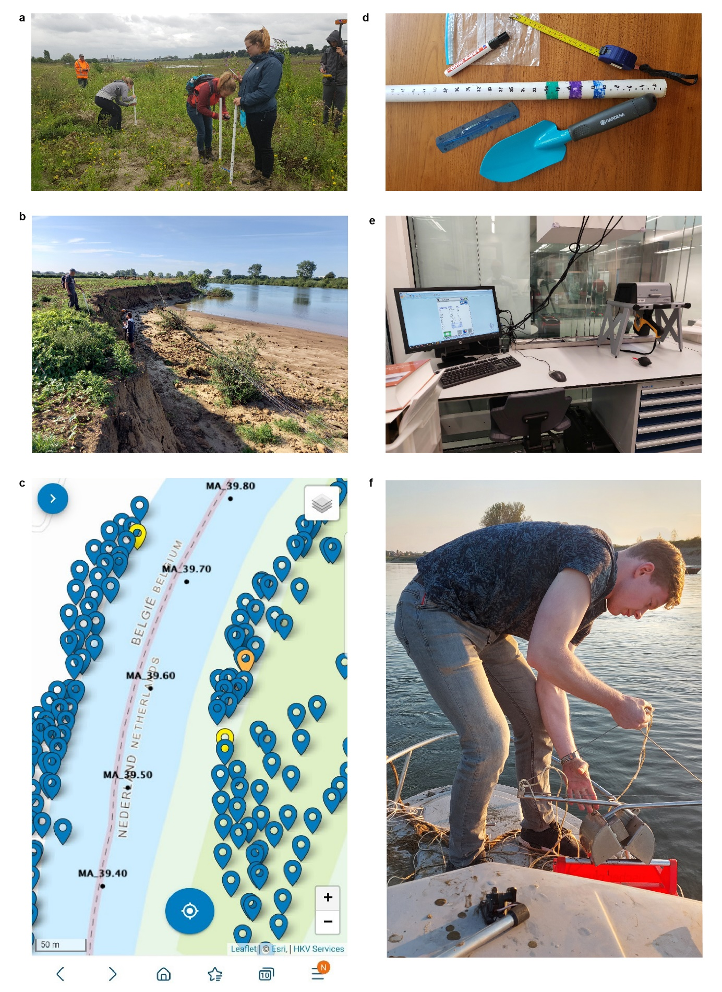
Extended Data Figure 8 | Floodplain deposit sampling and analysis. a, Measuring the thickness of deposits with a plastic tube. b, Use of a high-resolution GPS positioning system (Altus APS3G) for mapping bank erosion and recording boundaries of deposits (photo Steven van Ree). c, Screen of the MapSediment App used for storing depth measurements, photographs, sample numbers and field work comments. d, Equipment campaign with (top to bottom) plastic bags for samples, tape measure, marker, 1 m by 2 cm diameter hollow plastic tube with cm scale, ruler, scoop. e, XRF (X-Ray fluorescence spectroscopy) measurements to assess the concentration of chemical elements in the samples. f, Collecting sediment samples from the riverbed in scour holes with a Van Veen Grab.

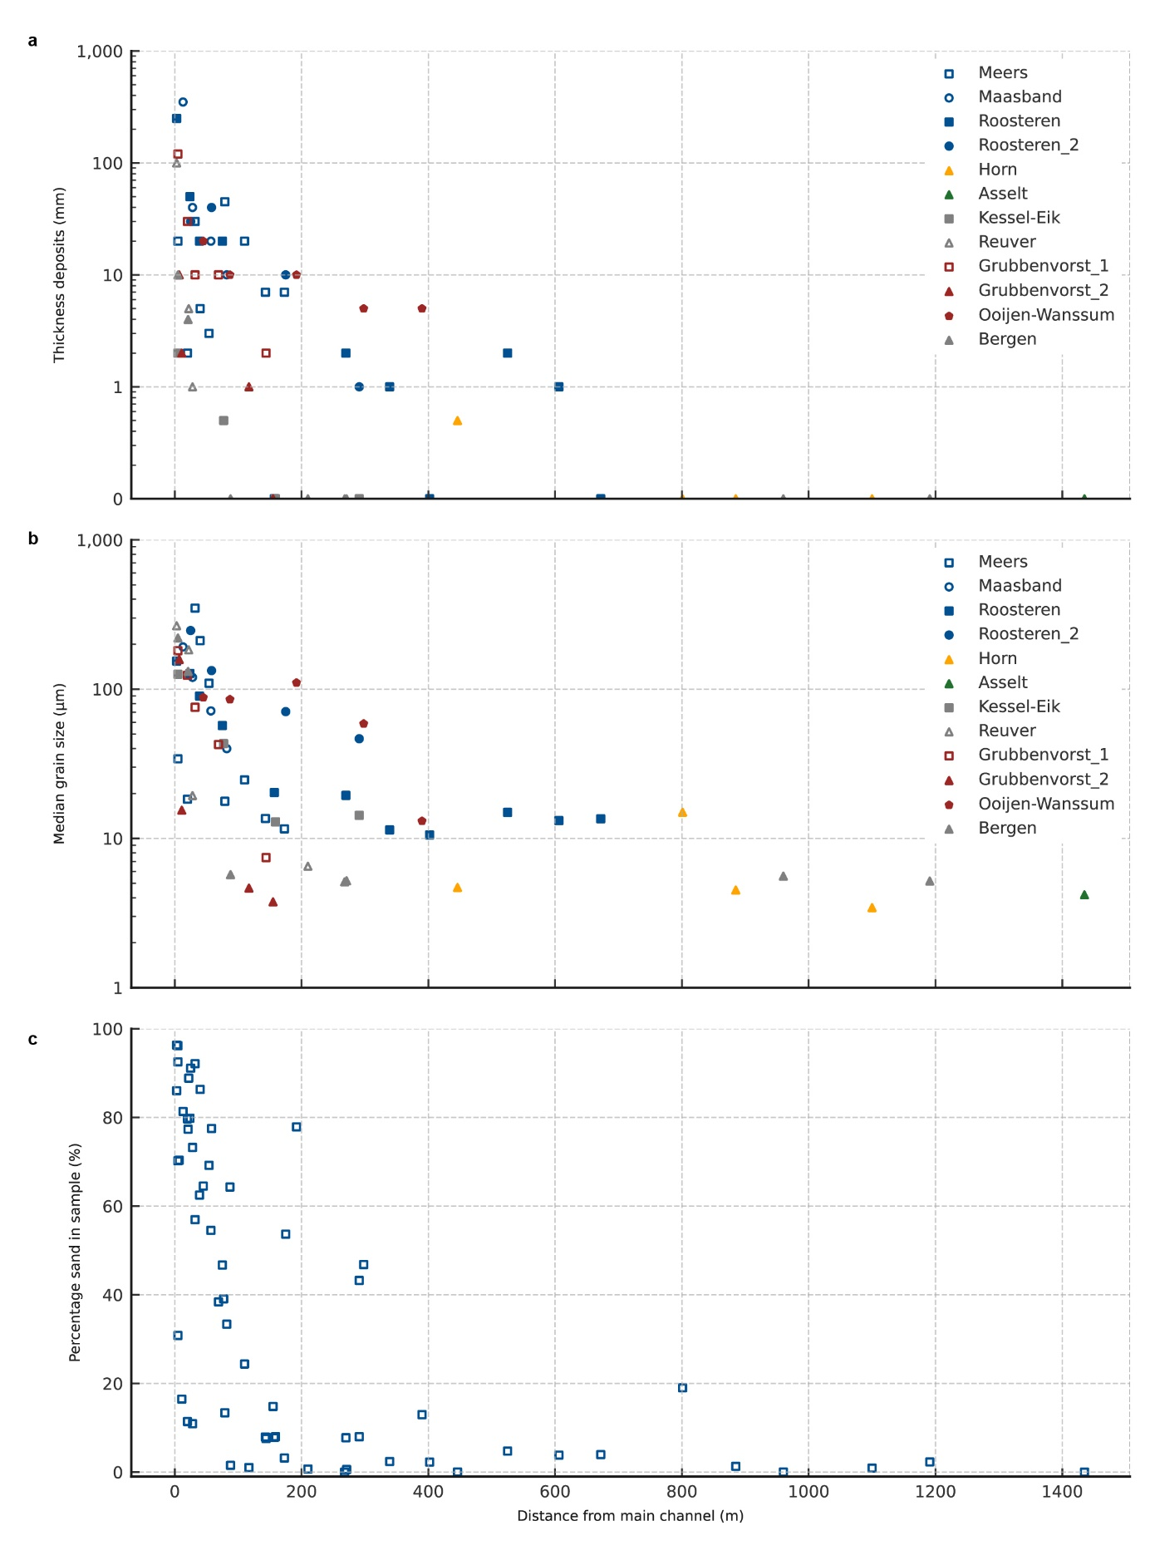
Extended Data Figure 9 | Composition of samples in transverse direction from the main channel at 10 locations. a, Thickness of deposits. b, Median grain diameter of sample. In panel a and b, locations in the legend are sorted from upstream to downstream. Square, circled and triangle markers indicate respectively inner bends, outer bends, and straight sections. c, Sand content in samples.

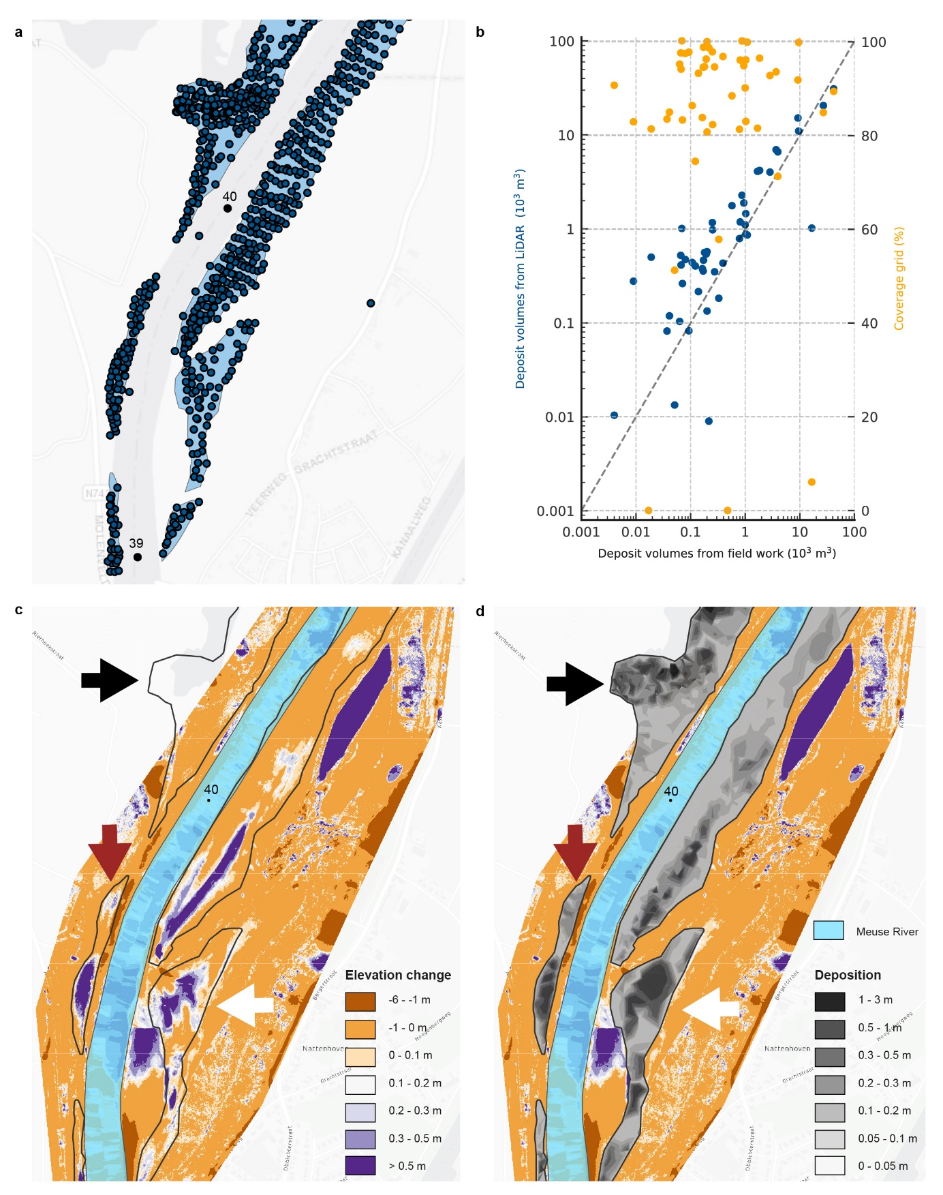
Extended Data Figure 10 | Deposit volumes from field sampling and laser altimetry (LiDAR). a, Locations of fieldwork thickness measurements and deposition areas (blue). b, Deposit volumes from field measurements (x-axis) and from LiDAR (primary y-axis) for all Meuse floodplains within the same areas, and relation to coverage of the LiDAR data per area (secondary y-axis). LiDAR-based overestimation can be explained by vegetation or gravel aggradation during the flood prior to sand deposition in the July flood. LiDAR-based underestimation can be explained by a reduced coverage of LiDAR, i.e. in the large deposition areas of Ooijen-Wanssum and Negenoord (2 largest volumes). Analyses show that the field data are a solid base for the deposition volumes during the flood on the often-vegetated floodplains of the Meuse River where excavation works took place in 2021. LiDAR data supplement the field work in areas with thick deposits (>1 m) and outside survey areas. c, Floodplain level changes based on LiDAR data from April 2021 and August 2021. Brown (-1 – 0 m) generally represent small bed level lowering. The dark brown areas at the Eastern edge show overestimation of LiDAR where trees are (incorrectly) classified as ground in April. d. Floodplain level changes based on the field surveys, plotted over the LiDAR differences in Panel b. Deposition patterns from LiDAR and fieldwork are identical, despite local differences in deposition depths and volumes. At red arrows LiDAR volumes exceed the fieldwork by 25%, probably due to detection of vegetation as ground in August 2021. White arrows point to the area where LiDAR volumes are 33% lower than estimations from the field surveys, which can be explained by excavation works in the period April-July 2021, being part of the LiDAR-difference. Black arrows show an example of underestimation of LiDAR volumes, because LiDAR measurements were missing in April 2021 for this area.

______________________
*Corresponding author: Hermjan Barneveld, (hermjan.barneveld@wur.nl and barneveld@hkv.nl)

Rijkswaterstaat is the executive organization of the Ministry of Infrastructure and Water Management, which manages, maintains and develops the three major infrastructure networks of the Netherlands: the main road network, the main waterway network and the main water system.

