Supplementary information
for
Proteomic analysis reveals dynamic changes in cloacal fluid composition during the reproductive season in a sexually promiscuous passerine

Kristýna Míčková, Václav Jelínek, Oldřich Tomášek, Romana Stopková, Pavel Stopka & Tomáš Albrecht

Supplementary Table 1. Summary of Comp1, Comp2 and Comp3 loadings extracted from a Sparse Partial Least Squares Discriminant Analysis (sPLS-DA) of four phases (prereceptive – PRE, receptive before (REC-BL) and during (REC-L) egg laying, postreceptive – POST) in reproductive season.
 | AUC | p value
Comp1:
PRE vs. others | 0.5644 | 0.540
REC-BL vs. others | 0.6414 | 0.319
REC-L vs. others | 0.8512 | 0.008
POST vs. others | 0.7470 | 0.021
Comp2:
PRE vs. others | 0.6515 | 0.149
REC-BL vs. others | 0.6966 | 0.166
REC-L vs. others | 1.0000 | <0.001
POST vs. others | 0.8577 | <0.001
Comp3:
PRE vs. others | 0.6136 | 0.280
REC-BL vs. others | 1.0000 | <0.001
REC-L vs. others | 1.0000 | <0.001
POST vs. others | 0.8933 | <0.001
Supplementary Table 2. Summary of COMP1 and COMP2 loadings extracted from a Sparse Partial Least Squares Discriminant Analysis (sPLS-DA) of three phases (receptive before (REC-BL) and during (REC-L) egg laying, nonreceptive – NON) in reproductive season.
 | AUC | p value
Comp1:
NON vs. others | 0.8379 | 0.002
REC-BL vs. others | 0.6897 | 0.181
REC-L vs. others | 0.845 | 0.009
Comp2:
NON vs. others | 1.000 | <0.001
REC-BL vs. others | 0.7931 | 0.039
REC-L vs. others | 0.9940 | <0.001

Supplementary Figure 1. Protein loadings from Sparse Partial Least Squares Discriminant Analysis (sPLS-DA) of four phases – prereceptive (PRE), receptive before (REC-BL) and during egg laying (REC-L) and postreceptive (POST). The proteins responsible for differences in protein composition of cloacal fluids among reproductive season are displayed using loadings from the sPLS-DA analysis. The proteins are ranked from bottom (highest importance) to top and the same colour code as in Fig. 1A was used.
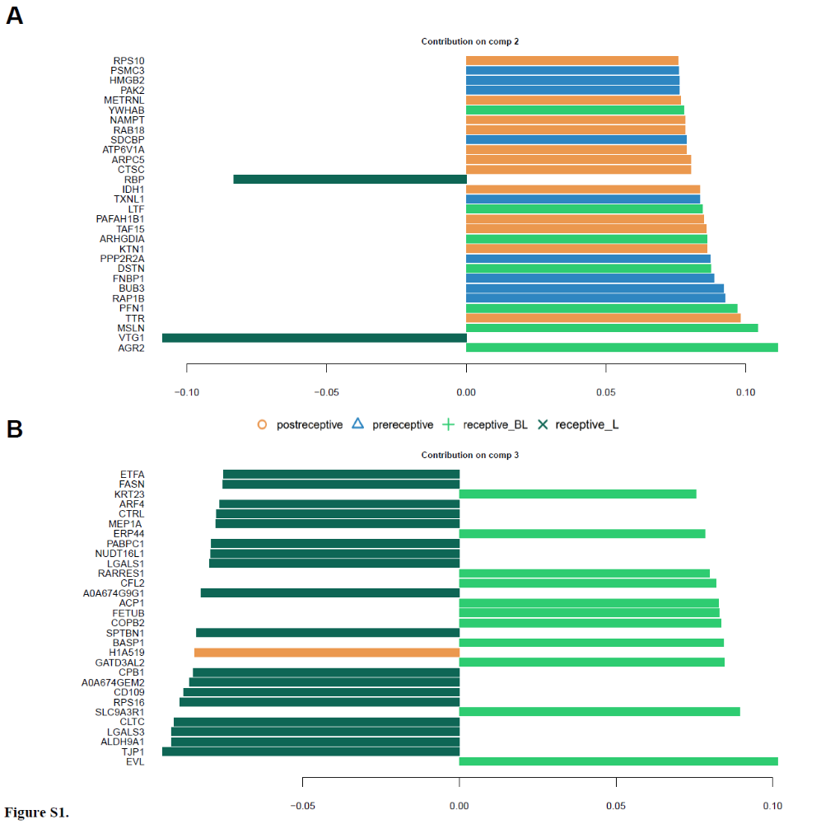

Supplementary Figure 2. Protein loadings from Sparse Partial Least Squares Discriminant Analysis (sPLS-DA) of three phases – nonreceptive (after merging PRE and POST in NON), receptive before (REC-BL) and during egg laying (REC-L). The proteins responsible for differences in protein composition of cloacal fluids among reproductive season are displayed using loadings from the sPLS-DA analysis. The proteins are ranked from bottom (highest importance) to top and the same colour code as in Fig. 1B was used.
