Supplementary Information
A rapid LAMP assay for the diagnosis of oak wilt with the naked eye.
Vinni Thekkudan Novi¹, Hamada A. Aboubakr¹, Melanie J. Moore², Jennifer Juzwik² and Abdennour Abbas¹*
Primer type | Primer name | Primer sequence
Forward outer | P42L28-F3 | GAGAATTATTCATTGCTGAGTTG
Forward outer | P55L1-F3 | TGAAGAACGCAGCGAAAT
Forward outer | P87L1-F3 | GCAGTATTCTGCTAGGCAT
Backward outer | P42L28-B3 | CAAGCAAGGCTTGAGTGG
Backward outer | P55L1-B3 | AGTTTTACTACGCAGGGAAG
Backward outer | P87L1-B3 | ACTTTTGTGTTACGCTTCGAAACTC
Forward inner | P42L28-FIP | CGCATTTCGCTGCGTTCTTCAGTTAAAACTTTCAACAACGGAT
Forward inner | P55L1-FIP | AGCAGAATACTGCTAGGCGCGTAATGTGAATTGCAGAATTCAGT
Forward inner | P87L1-FIP | ATTTGCAGCTTCCCTGCGTA-GGTTTGTTTTACGGCAATGTC
Backward inner | P42L28-BIP | CAGTGAATCATCGAATCTTTGAACGGAAATGACGCTCGGACAG
Backward inner | P55L1-BIP | CCACTCAAGCCTTGCTTGGTGCAAATACTACAGCCGATG
Backward inner | P87L1-BIP | TACAGCCGATGCATTTCGGTG-CGTCATTTCACCACTCAAG
Forward loop | P42L28-LF | TCGATGCTAGAGCCAAGAG
Forward loop | P55L1-LF | GTGCGTTCAAAGATTCGATGATTC
Forward loop | P87L1-FIP | CCTCCAACACCAAGCAAGG
Backward loop | P42L28-LB | CCTAGCAGTATTCTGCTAGGCA
Backward loop | P55L1-LB | TTGGAGGACCCCGCTTGT
Backward loop | P87L1-LB | CCTAGCAGTATTCTGCTAGGCA
¹Department of Bioproducts and Biosystems Engineering, University of Minnesota, St. Paul, MN 55108, U.S.A.
²USDA Forest Service, Northern Research Station, St. Paul, MN 55108, U.S.A.
*Corresponding author: aabbas@umn.edu

Table S1 Nucleic acid sequences of LAMP primers sets used for specificity tests including the chosen set

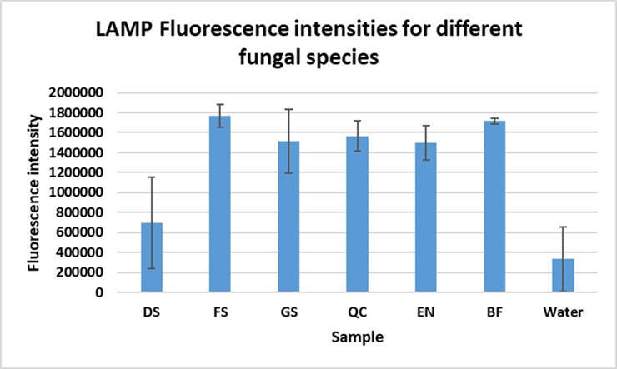
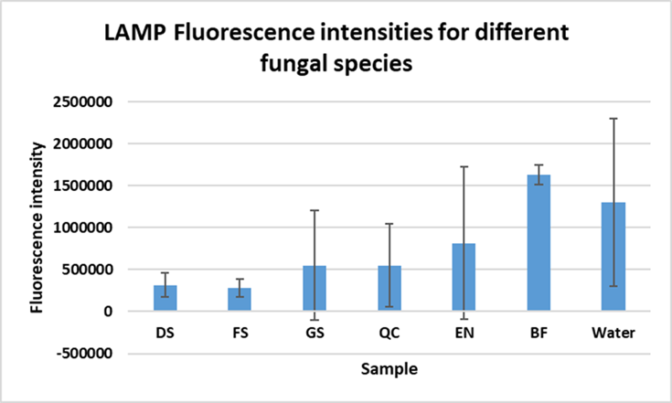

Fig. S1 Primer specificity tests using different fungal species: Dicarpella sp. (DS), Fusarium sporotrichoides (FS), Graphostroma sp. (GS), Querciphoma carteri (QC), Epicoccum nigrum (EN), Bretziella fagacearum (BF). a) LAMP reaction results for tests with primer set 42, b) LAMP reaction results for tests with primer set 55

