Supplementary information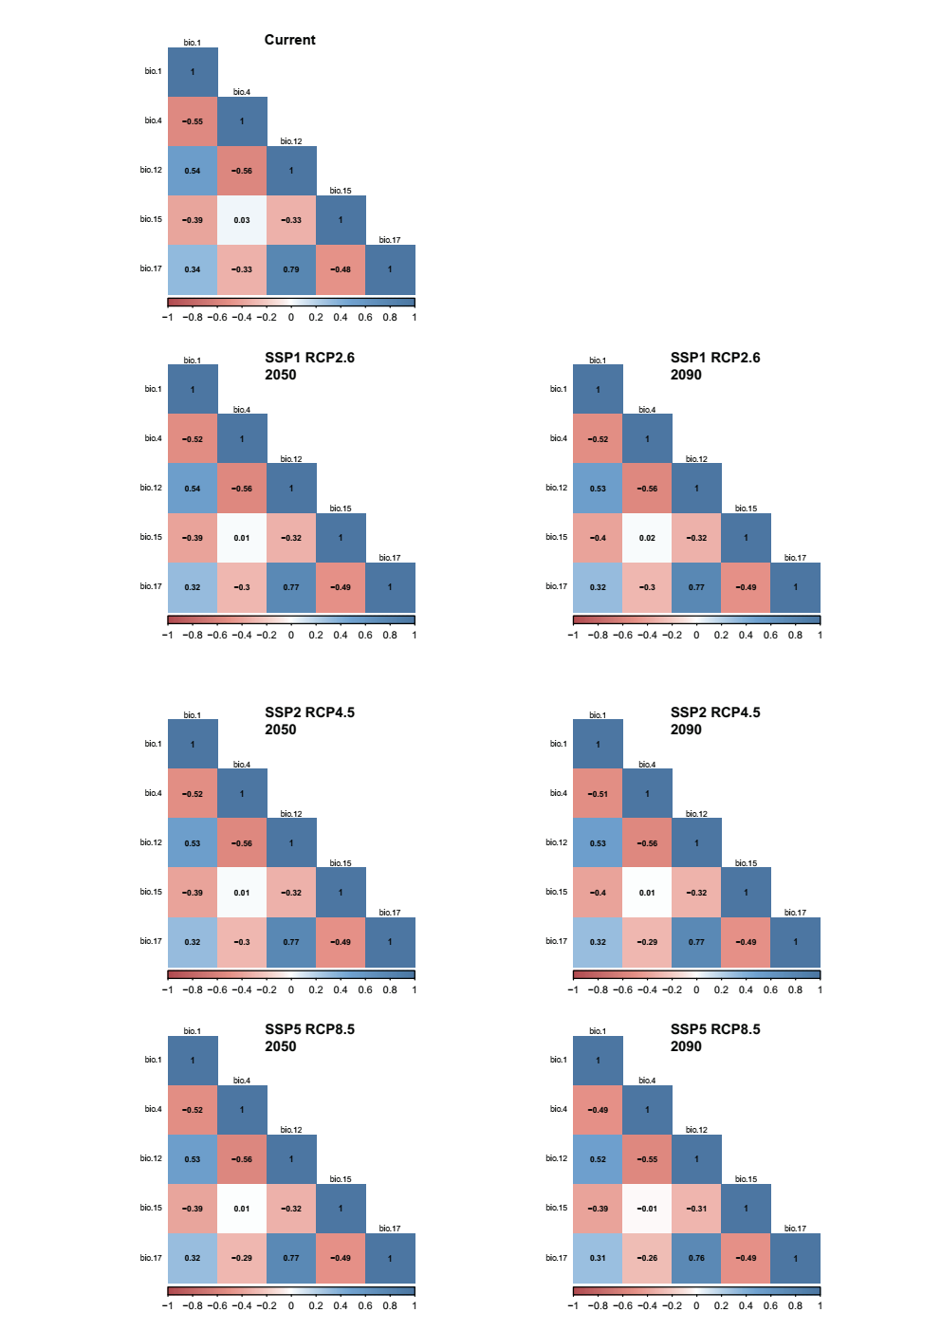
Figure S1 Pearson correlation coefficient between selected bioclimate variables in different climate scenarios and time periods.
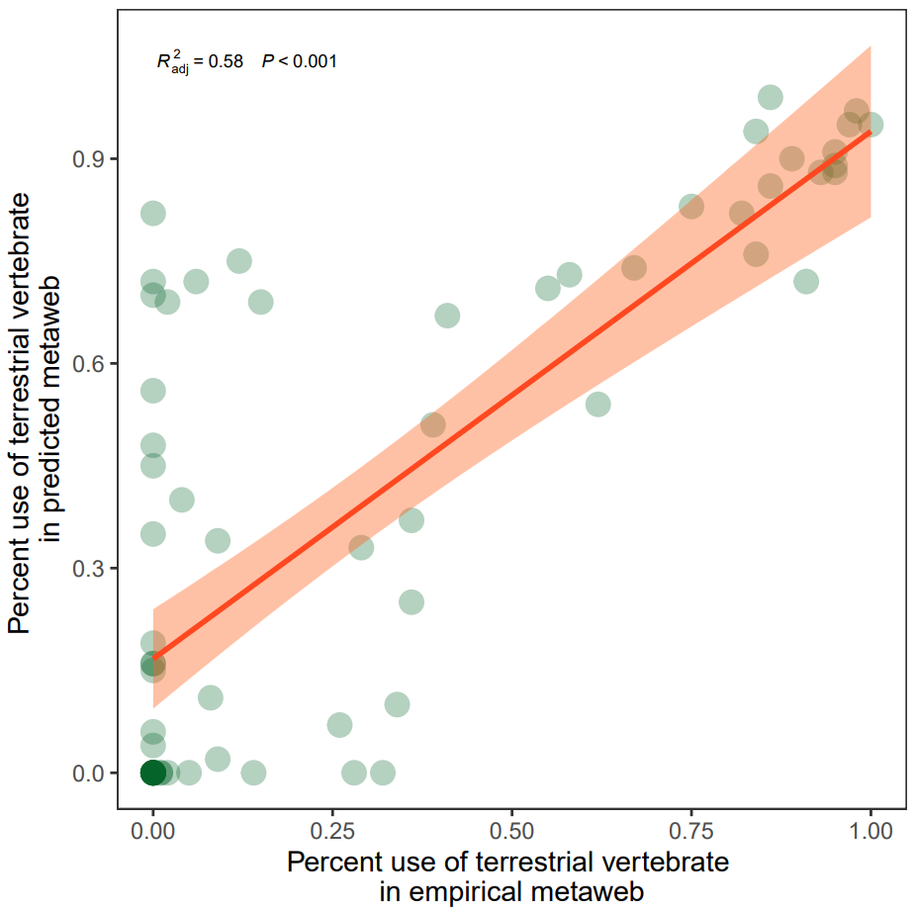
Figure S2. The relationship of percentage of terrestrial vertebrate diet in the empirical metaweb vs. percentage of terrestrial vertebrate diet in the predicted metaweb.

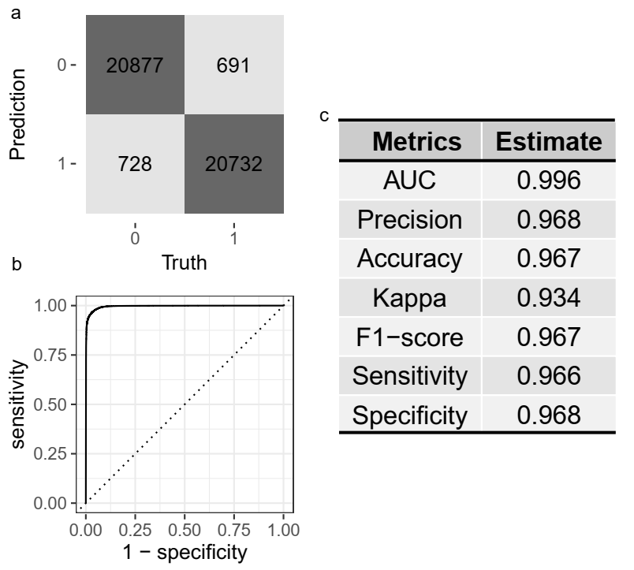
Figure S3. The evaluation for the deep-learning model based on the confusion matrix (a) ROC (Receiver Operating Characteristic) curve plot (b) and several common evaluation metrics (c).

Figure S4. Geographic distributions of basic food web descriptors in the contemporary era. The maps display linkage density (a), vulnerability (b), generality (c) proportion of omnivorous species (d), number of basal species (e), number of top species (f) number of intermediate species (g) and characteristic path length (h) for global terrestrial vertebrate food webs. The charts right represent the network descriptors’ distributions averaged across latitude and smoothed by a generalized addition model (dark line) within the 95% confidence limits (grey shadow).

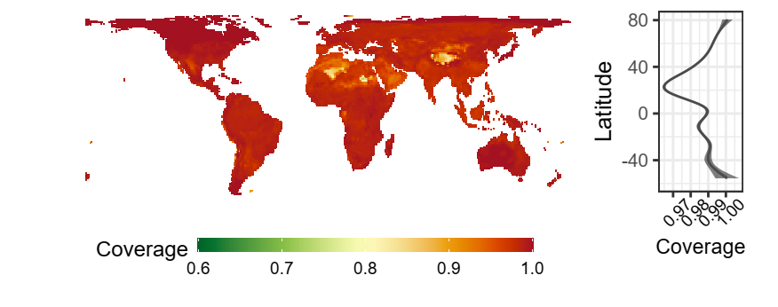
Figure S5. Geographic distribution of species coverage and its patterns of variation across latitudes. The charts right represent the distribution averaged across latitude and smoothed by a generalized addition model (dark line) within the 95% confidence limits (grey shadow).

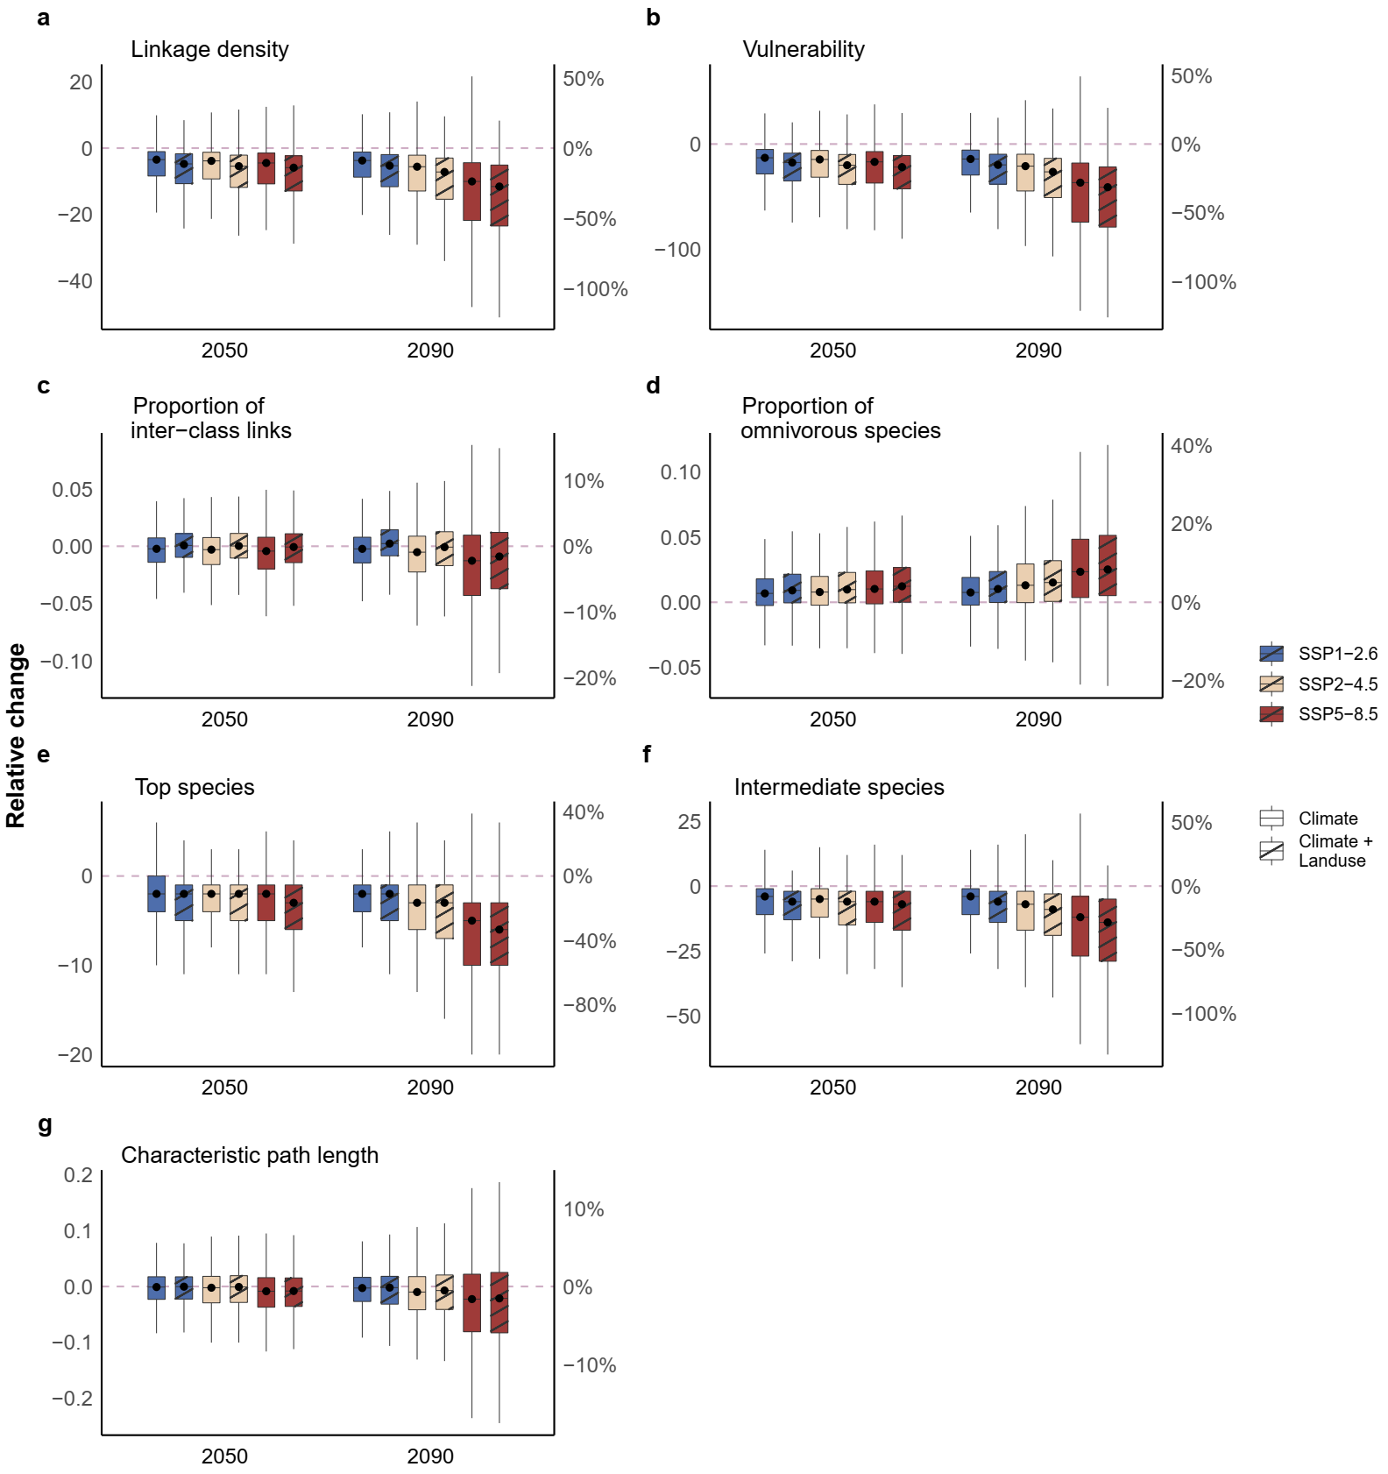Figure S6. The changes of food web descriptors in three future climate scenarios (SSP1-2.6, SSP2-4.5 and SSP5-8.5) and two time periods (2050 and 2090) with a no-dispersal scenario with or without land use. The descriptors are linkage density (a), vulnerability (b), proportion of interclass links (c), proportion of omnivorous species (d), number of top species (e), number of intermediate species (f) and characteristic path length (g). The box ranges from the first (Q1) to the third quartile (Q3), representing the interquartile range (IQR). The whiskers are lines extending from Q1 and Q3 to end points defined as data points within Q1 − 1.5 × IQR and Q3 + 1.5 × IQR.

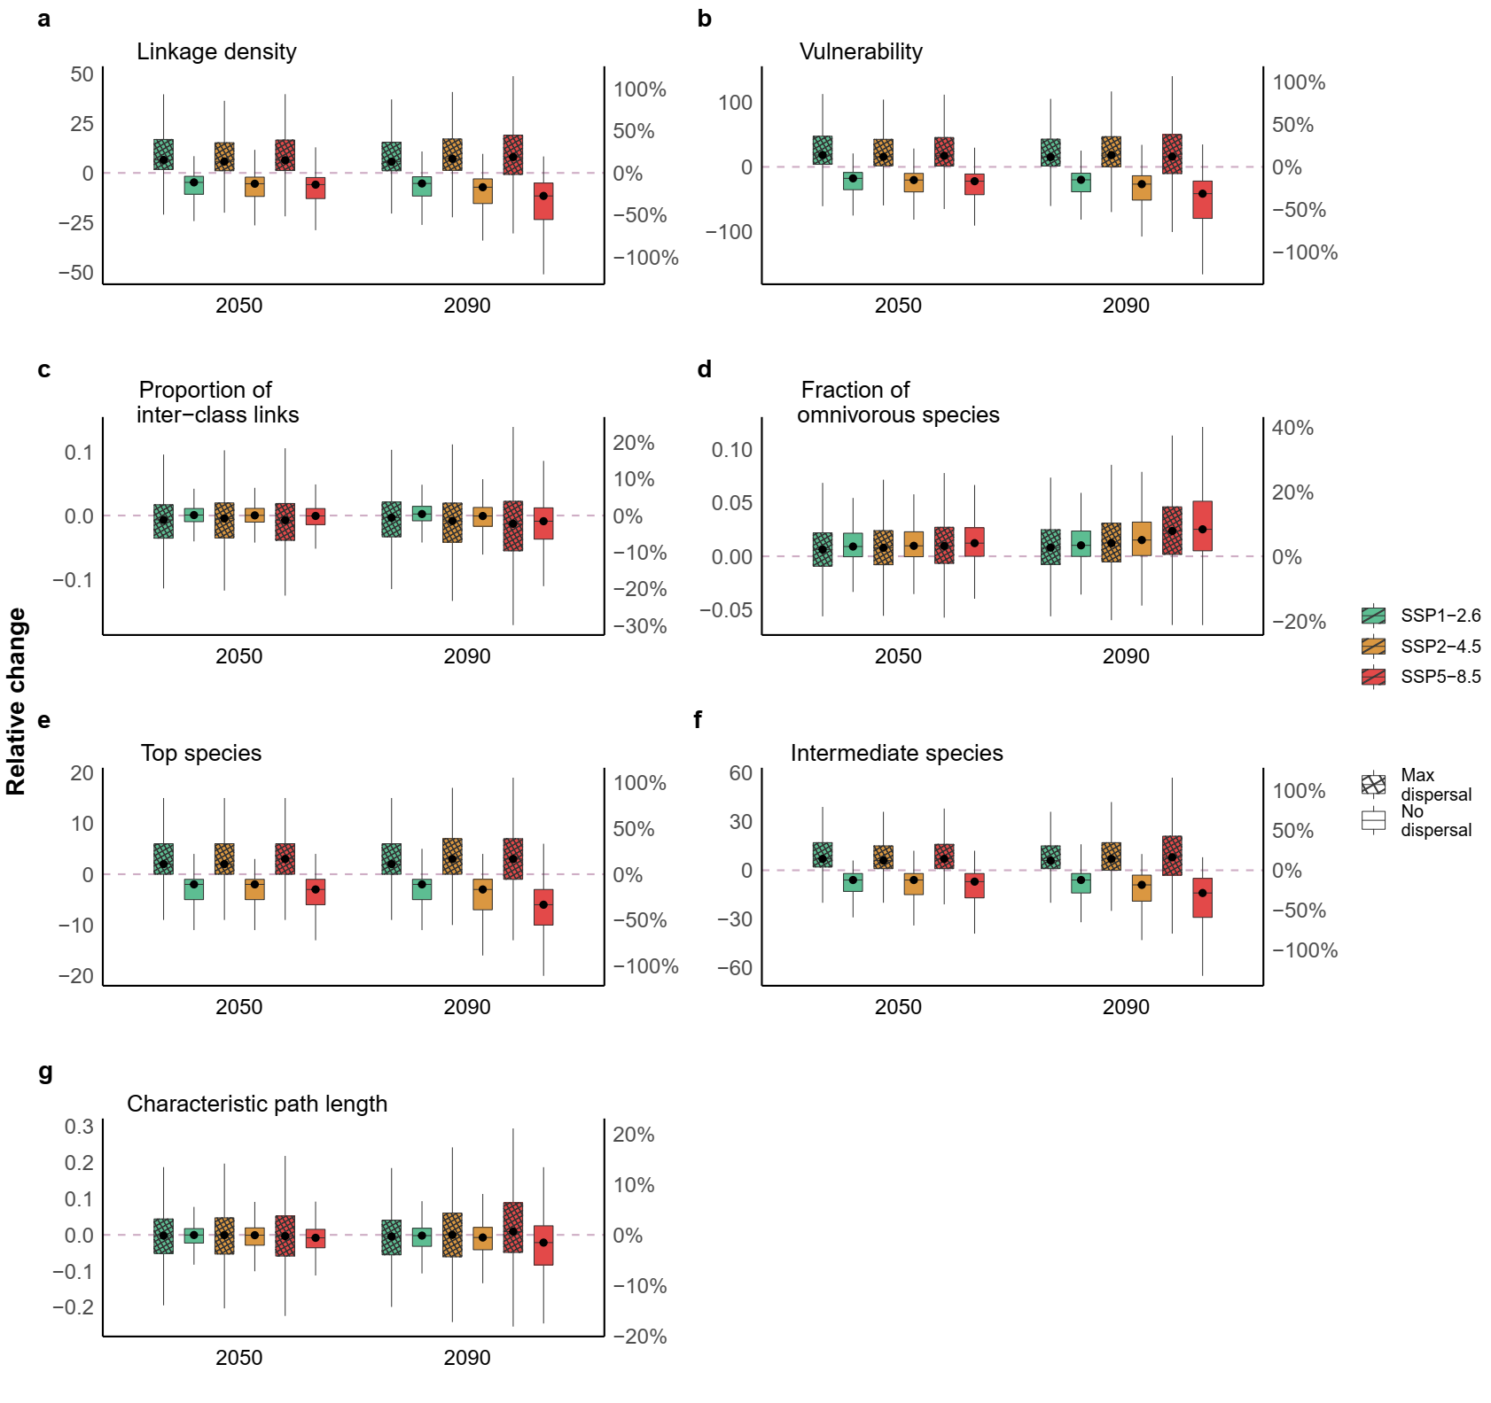
Figure S7. Changes of food web descriptors in three future climate scenarios (SSP1-2.6, SSP2-4.5 and SSP5-8.5) and two time periods (2050 and 2090) with two different dispersal scenarios (no-dispersal and max-dispersal). “Climate + Landuse” were considered for each network metric. The descriptors are linkage density (a), vulnerability (b), proportion of interclass links (c), proportion of omnivorous species (d), number of top species (e), number of intermediate species (f) and characteristic path length (g). The box ranges from the first (Q1) to the third quartile (Q3), representing the interquartile range (IQR). The whiskers are lines extending from Q1 and Q3 to end points defined as data points within Q1 − 1.5 × IQR and Q3 + 1.5 × IQR.

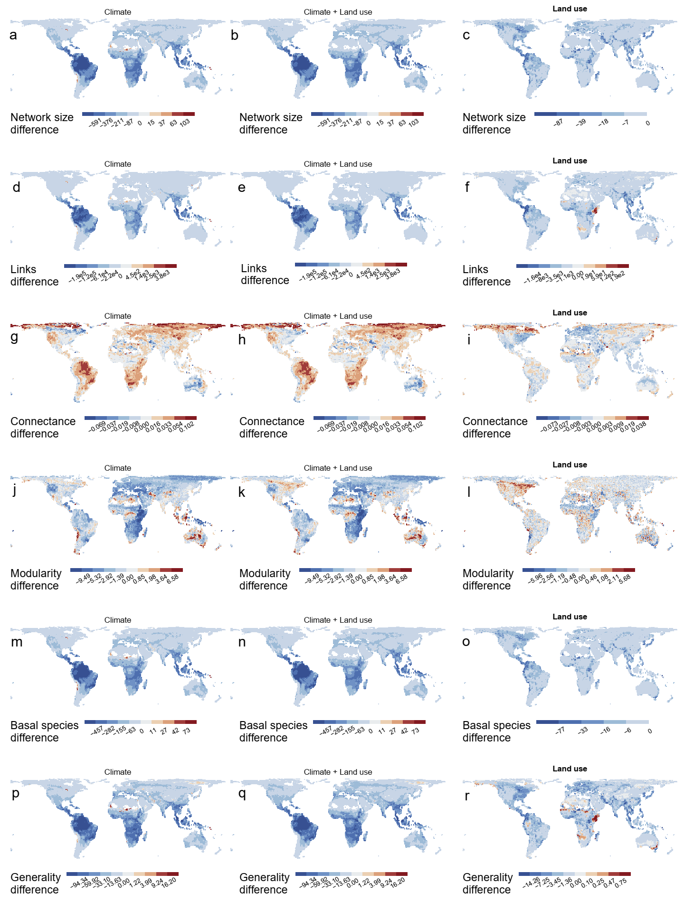 Figure S8. Changes of food-web descriptors due to climate change and land-use change under the most severe climate scenario (SSP5-8.5) and no-dispersal by the end of the century (2090). Colour scale displays relative changes of network size (a, b), number of links (d, e), connectance (g, h), modularity (j, k), number of basal species (m, n) and generality (p, q) in the “Climate” and “Climate + Land use” change scenarios. The maps right show the net effect of land use on changing food web descriptors (c, f, i, l, o, r) under the SSP5-8.5 scenario by the end of the century (2090).
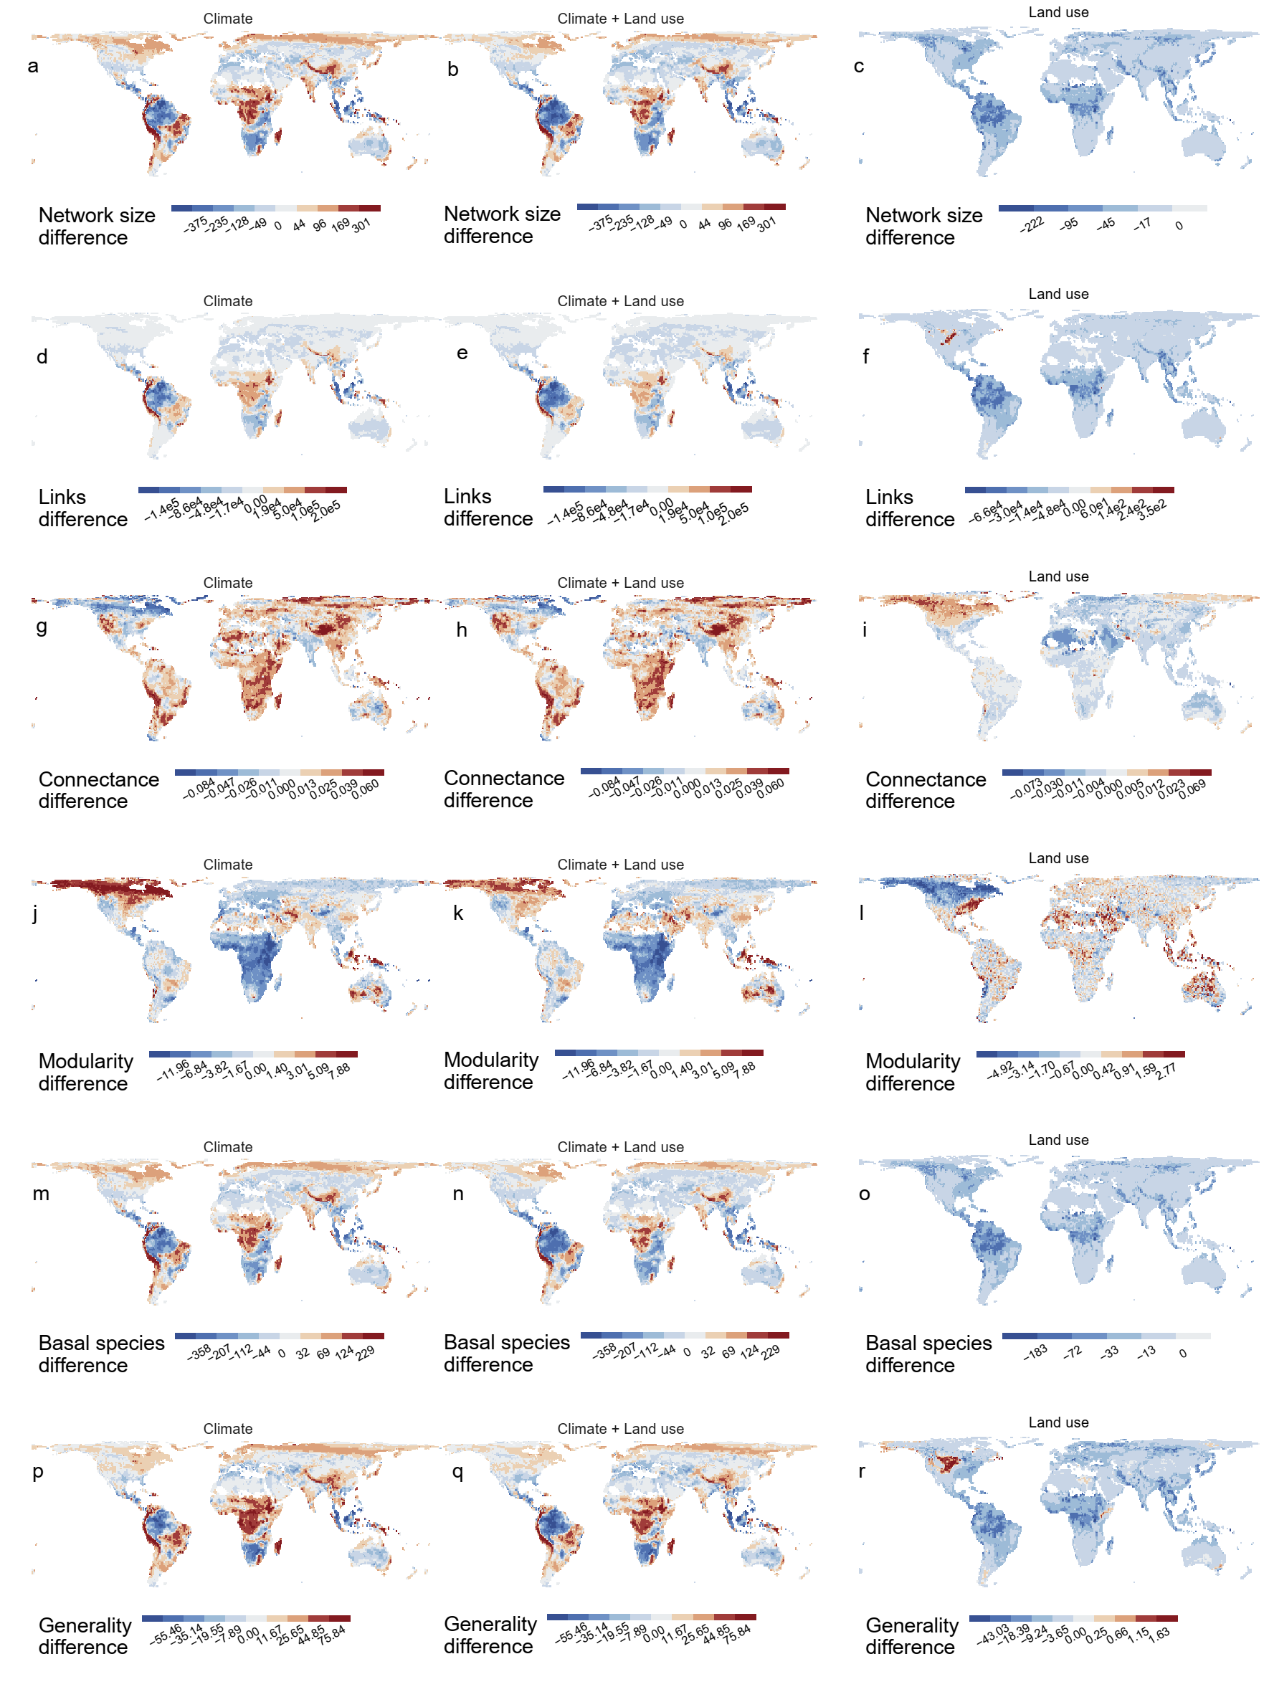Figure S9. Changes of food-web descriptors due to climate change and land use under the most severe climate scenario (SSP5-8.5) and max-dispersal by the end of the century (2090). Colour scale displays relative changes of network size (a, b), links (d, e), connectance (g, h), modularity (j, k), number of basal species (m, n) and generality (p, q) in the scenarios “Climate” and “Climate + Land use”. The maps right show the net effect of land use on changing food-web descriptors (c, f, i, l, o, r) under the SSP5-8.5 scenario by the end of the century (2090).
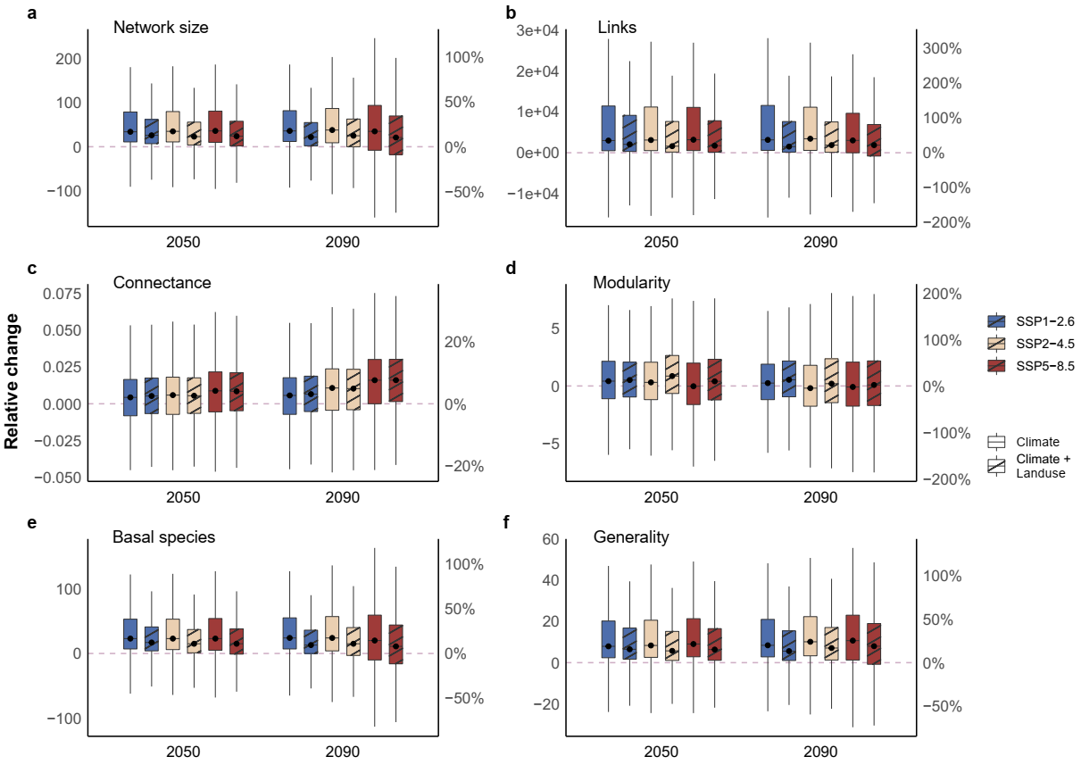 Figure S10. The changes of food web descriptors in three future climate scenarios (SSP1-2.6, SSP2-4.5 and SSP5-8.5) and two time periods (2050 and 2090) with max-dispersal with land use considered or not. Network metrics are network size (a), link (b), connectance (c), modularity (d), number of basal species (e) and generality (f). The box ranges from the first (Q1) to the third quartile (Q3), representing the interquartile range (IQR). The whiskers are lines extending from Q1 and Q3 to end points defined as data points within Q1 − 1.5 × IQR and Q3 + 1.5 × IQR.
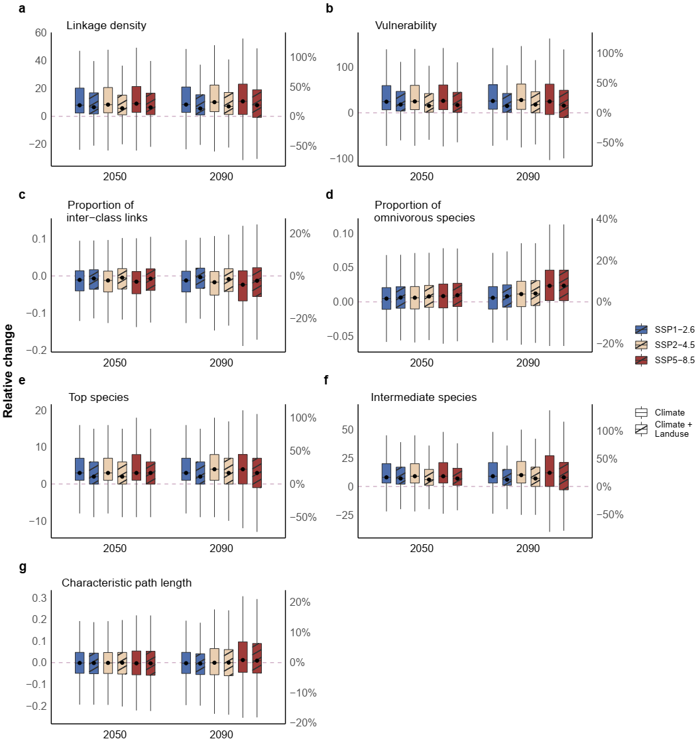
Figure. S11 The changes of food-web descriptors in three future climate scenarios (SSP1-2.6, SSP2-4.5 and SSP5-8.5) and two time periods (2050 and 2090) with max-dispersal and with or without land use change. The descriptors are linkage density (a), vulnerability (b), proportion of interclass links (c), proportion of omnivorous species (d), number of top species (e), number of intermediate species (f) and characteristic path length (g). The box ranges from the first (Q1) to the third quartile (Q3), representing the interquartile range (IQR). The whiskers are lines extending from Q1 and Q3 to end points defined as data points within Q1 − 1.5 × IQR and Q3 + 1.5 × IQR.
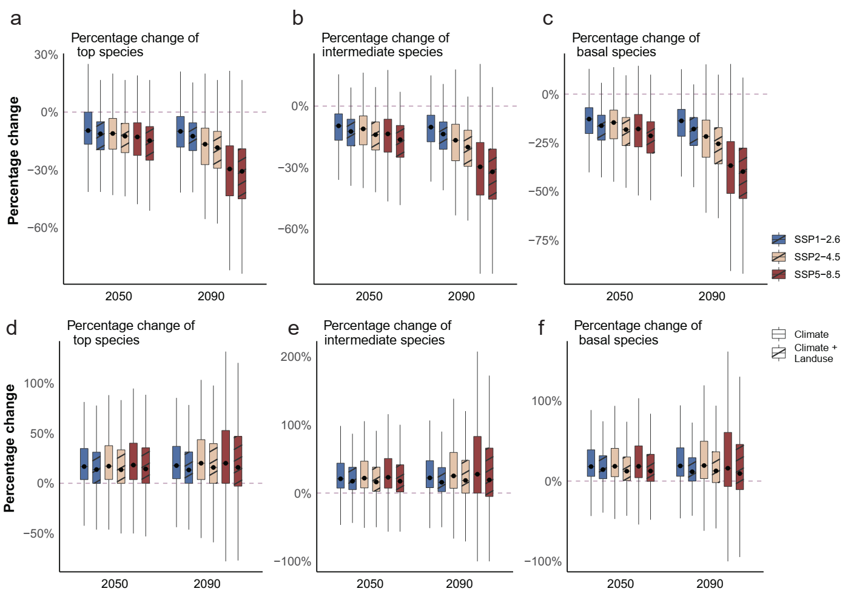
Figure S12. Percentage change in the number of top, intermediate, and basal species in three future climate scenarios (SSP1-2.6, SSP2-4.5 and SSP5-8.5), two time periods (2050 and 2090) and two species dispersal scenarios (no-dispersal, a-c; max-dispersal, d-f) with corresponding land use considered or not. The box ranges from the first (Q1) to the third quartile (Q3), representing the interquartile range (IQR). The whiskers are lines extending from Q1 and Q3 to end points defined as data points within Q1 − 1.5 × IQR and Q3 + 1.5 × IQR.
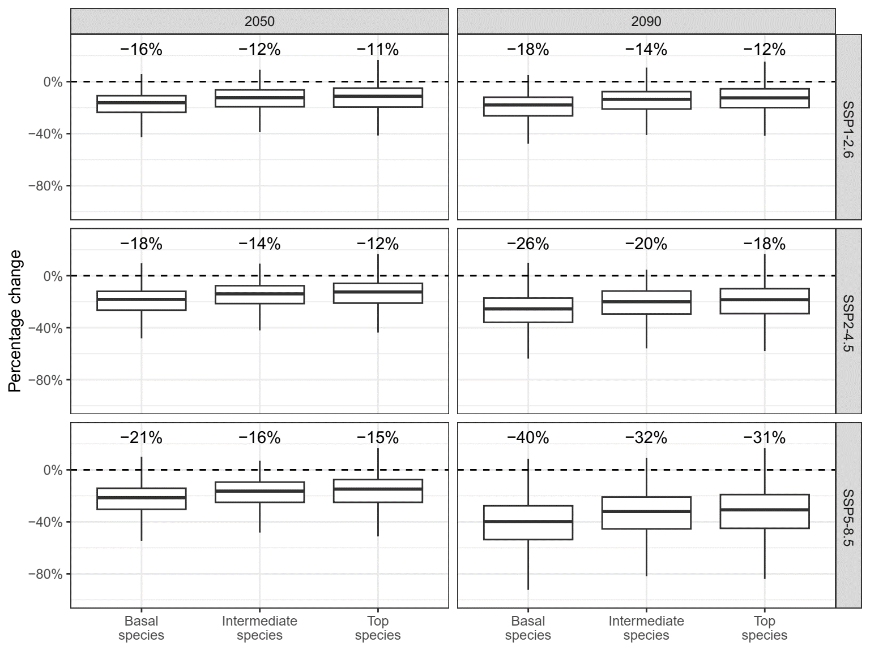
Figure S13. Comparison of the percentage changes in the number of top, intermediate, and basal species in three future climate scenarios (SSP1-2.6, SSP2-4.5 and SSP5-8.5) and two time periods (2050 and 2090) with no-dispersal and land-use change considered. In all climate scenarios and time periods, percentage changes in the number of top, intermediate, and basal species are significantly different from each other in pairwise comparisons (Wilcoxon pairwise tests with Bonferroni-corrected P values, P < 0.05), with small effect size values (E² < 0.06, from 0.044 to 0.055) in Kruskal-Wallis tests. Median values are shown on each box plot. The box ranges from the first (Q1) to the third quartile (Q3), representing the interquartile range (IQR). The whiskers are lines extending from Q1 and Q3 to end points defined as data points within Q1 − 1.5 × IQR and Q3 + 1.5 × IQR.
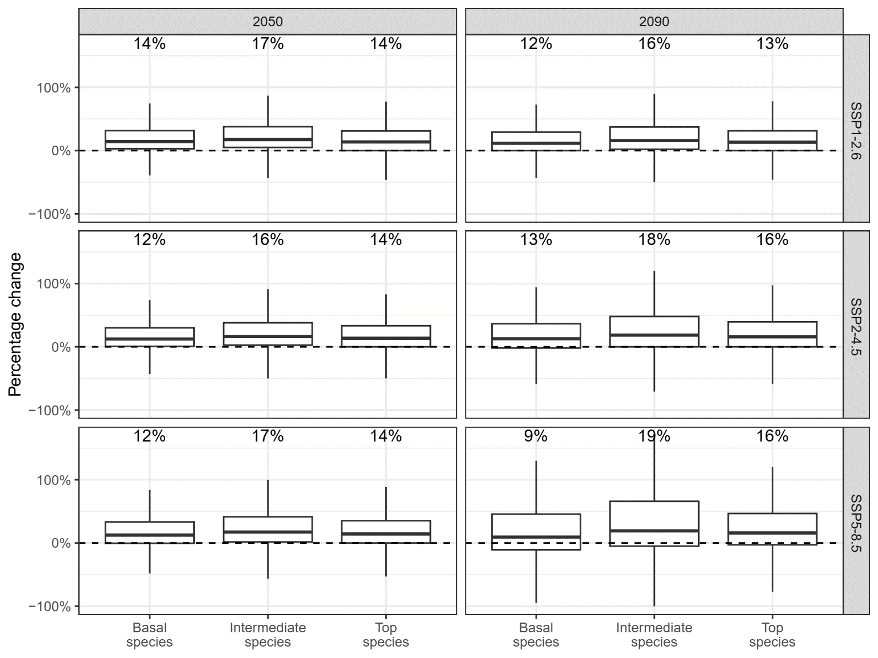
Figure S14. Comparison of the percentage changes in the number of top, intermediate, and basal species in three future climate scenarios (SSP1-2.6, SSP2-4.5 and SSP5-8.5) and two time periods (2050 and 2090) with max-dispersal and land-use change considered. In all climate scenarios and time periods, percentage changes in the number of top, intermediate, and basal species are significantly different from each other in pairwise comparisons (Wilcoxon pairwise tests with Bonferroni-corrected P values, P < 0.05), with a small effect size (E² < 0.06, from 0.005 to 0.010) in Kruskal-Wallis tests. Median values are shown on each box plot. The box ranges from the first (Q1) to the third quartile (Q3), representing the interquartile range (IQR). The whiskers are lines extending from Q1 and Q3 to end points defined as data points within Q1 − 1.5 × IQR and Q3 + 1.5 × IQR.
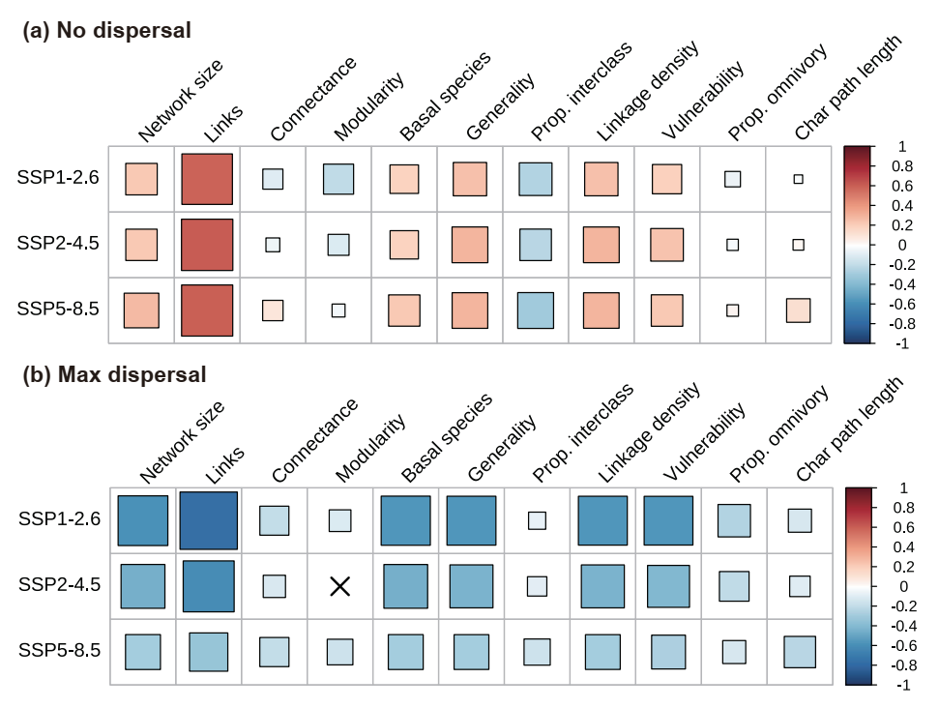
Figure S15. The correlation between the changes of the food web descriptors under climate change and under land use in 2090 in three climate scenarios (SSP1-2.6, SSP2-4.5 and SSP5-8.5) and two dispersal scenarios (a, no-dispersal; b, max-dispersal). The correlations were calculated using Spearman methods. The size of the squares indicates the magnitude of the correlation, and non-significant correlations (P > 0.05) are indicated using ×. "Prop. omnivory" indicates the proportion of species that were omnivorous, and "Char path length" indicates characteristic path length.

Table S1. List of Chinese literature searched.
Number | Chinese literature searched
1 | Xiongwei, Y. A preliminary study on feeding habits and intestinal microbial diversity of Sus scrofa chirodontus in Guizhou province, China, Guizhou University.
2 | Qunxiu, L. Activity Rhythm, Home Range and Habitat Selection of the Tibetan Fox, East China Normal University, (2009).
3 | Tiying, L. & Fang, L. Analysis of feeding habits of main birds in Huimin. Journal of Shandong Forestry Science and Technology, 41-47 (1987).
4 | Xinkang, B. Analysis of Seasonal Diet Composition of Sable (Martes zibellina) in Daxinganling Mountains,Northeastern China. Acta Theriologica Sinica, 203-207 (2003).
5 | Yinghong, H. & Lei, Q. Breeding Ecological Characteristics of Three Kinds of Owls in Pangquangou National Reserves. Journal of Shanxi Agricultural University(Natural Science Edition) 33, 536-541 (2013).
6 | Chengqian, S., Ning, F. & Zhelin, Z. Breeding,Diet and cannibalism of Relic Gull (Larus relictus) in Breeding Season in Hongjiannao Lake. Chinese Journal of Wildlife, 27-29, doi:10.19711/j.cnki.issn2310-1490.2007.05.009 (2007).
7 | Weidong, B., Xiaojing, L. & Yang, S. Comparative Analysis of Food Habits in Carnivores from Three Areas of Beijing. Zoological Research, 118-122 (2005).
8 | Xiaojing, Z. Diet and Prey Consumption of Common Kestrels (Falco tinnunculus) During Breeding Period, Northeast Normal University, (2008).
9 | Yusufu, A. Diet And Trophic Niche of Four Sympatric Raptors, Xinjiang Agricultural University, (2016).
10 | Xinping, L., Honghai, Z., Huashan, D., Songtao, L. & Guohai, L. Diet Composition of Nyctereutes procyonoides by Dung Analysis. Chinese Journal of Zoology 44, 3 (2009).
11 | Xuanlong, L. Diet Habitat and Interspecific Relationship of Three Carnivorous Species in the Southern Junggar Basin, Xinjiang Agricultural University, (2010).
12 | Shengwu, Z. Diet on the food of Tibetan sand fox. Acta Theriologica Sinica, 222-222 (1985).
13 | Qunxiu, L., Minghai, Z., Bailian, Z. & Zhongxin, G. Diets of Corsac Fox on Eastern Prairie of Inner Mongolia in Spring and Summer. Journal of Northeast Forestry University, 62-64 (2008).
14 | Zhaohui, S. Dispersal mechanism on of Ziziphus acidojujuba by Vulpes vulpes in the Helan Mountains, Northeast Forestry University, (2014).
15 | Wei, Z., Wei, L. I., Qing, Z., Shu-Guang, P. & Ming-Hui, L. I. Effects of Food Resource in Aquatic Environment on Food Habits of Rana chaochiaoensis Tadpoles. Journal of Yunnan Agricultural University, 96-102 (2007).
16 | Xinning, S., Dazhao, S., Qiaowen, H., Sheng, L. & Meng, Y. Fast surveys and molecular diet analysis of carnivores based on fecal DNA and metabarcoding. Biodiversity Science 27, 543-556 (2019).
17 | Qishan, W. Feeding data of Milvus korschunlineatus(Gray). Chinese Journal of Zoology, 45 (1975).
18 | Yi-Qun, W. U., Ming, M. A., Feng, X. U., Dixon, A. & Ragyov, D. Feeding Habits Analysis of Saker Falcon and the Effect of Raptor on Prevention Mouse Population. Journal of Xinjiang Agricultural University, 13-16 (2006).
19 | Mingtao, S. FOOD HABIT OF GREAT SALAMANDER OF CHINA. CHINESE JOURNAL OF ZOOLOGY, 38-42 (1994).
20 | Wen, W. Food Habit、Home Range and Habitat of Asiatic Black Bear (Ursus Thibetanus) in the Lesser Khingan Mountains, Northeast Forestry University, (2007).
21 | Xuanlong, L., Kefan, W. & Lei, S. Food habitats of the red fox (Vulpes vulpes) in the Junggar Basin Desert. Acta Theriologica Sinica, 5 (2010).
22 | Aichun, X., Zhigang, J., Chunwang, L. & Ping, C. Food habits and hunting patterns of Tibetan brown bear during warm seasons in Kekexili region on Qinghai-Tibetan Plateau. Zoological Research 31, 5 (2010).
23 | Yang, Z. Food Habits and Habitat Selection of Five Carnivores in Saihanwula Nature Reverse, Beijing Forestry University, (2008).
24 | Wen, W., Jianzhang, M. A., Huiliang, Y. U. & Liqing, H. U. Food habits of Asiatic black bears in the Xiao Xing'anling Mountains. Acta Theriologica Sinica, 7-13 (2008).
25 | Yi, R. Food habits of badger (Meles leucurus) in the Helan Mountain, Ningxia, Northeast Forestry University, (2019).
26 | Geng, C. Food habits of badger (Meles leucurus) in the ZhangGuangcai Mountain, Heilongjiang Province., Northeast Forestry University, (2015).
27 | Wen, W. & Gaomin, C. Food Habits of Siberian Ferrets in Badaerhu Region of Inner Mongolia. Journal of Northeast Forestry University, 33-35 (2006).
28 | Mahmood-Ul-Hassan, M., Beg, M. A. & Mushtaq-Ul-Hassan, M. Food habits of the spotted owlet Athene brama in central Punjab,Pakistan. Acta Zoologica Sinica 53, 64-68 (2007).
29 | Honghai, Z., Zhenlong, W., Wenxiang, M. & Yuying, S. FOOD HABITS OF WOLF (Canis lupus) IN XING’ANLING MOUNTAINS. Journal of Qufu Normal University 26, 80-82, doi:10.3969/j.issn.1001-5337.2000.01.026 (2000).
30 | Tancheng, D. et al. Food Habits of Wolves (Canis lupus) during Summer and Autumn in the Mt. Kalamaili Ungulate Nature Reserve,Xinjiang. Arid Zone Research 32, 512-517, doi:10.13866/j.azr.2015.03.15 (2015).
31 | Jialiang, H. Food Selective tests of S.murinus and Observation of bait effects. Chinese Journal of Vector Biology and Control, 305-307 (1992).
32 | Yang, H. Habitat Selection and Diet Analysis of Snow Leopard (Panthera Unica) in Wolong Nature Reserve, China West Normal University, (2021).
33 | Qi, L. et al. Metabarcoding diet analysis of snow leopards (Panthera uncia) in Wolong National Nature Reserve, Sichuan Province. Biodiversity Science 27, 960-969 (2019).
34 | Peichao, W., Guozhen, Q., Helin, S. & Houji, L. Winter feeding habits of raccoon dogs and ocelots. Chinese Journal of Zoology, 43-35, doi:10.13859/j.cjz.1977.02.023 (1977).
35 | Renguang, H., Bohong, P. & Zhaofeng, C. A preliminary investigation of the ecology of the red-cheeked mongoose. Chinese Journal of Zoology, 14-15 (1985).
36 | Guozhen, Q., Helin, S. & Peichao, W. Study on the winter feeding habits of ferret badger. Chinese Journal of Zoology, 39 (1976).
37 | Jiayan, W. A preliminary observation of feeding habits of black bears in Qinling Mountains. Chinese Journal of Zoology, 48-51, doi:10.13859/j.cjz.1983.04.023 (1983).
38 | Song, J., Wei, L., Haijun, Z. & Yingli, J. Observation and feeding behavior analysis of wild boar in the area of Baishi Gongzi. LiaoNing Forestry Science and Technology, 25-26 (2005).
39 | Jingxi, L. & Cunyao, H. Observation on feeding habits of Nycticebus coucang and Nycticebus pygmaeus in captivity. Chinese Journal of Wildlife, 28-29+25, doi:10.19711/j.cnki.issn2310-1490.1994.06.011 (1994).
40 | Yuping, C. & Jianxu, Z. Overwintering population of Asio otus in Baoding, Hebei Province and its rat-catching effect. Sichuan Journal of Zoology, 134-135 (1995).
41 | Jiuyi, C., Yanjia, Z., Anmeng, W., Li, Y. & Weidong, B. Population, distribution and food composition of wolves (Canis lupus) at Saihanwula Nature Reserve, Inner Mongolia. Zoological Research 32, 4 (2011).
42 | Yusup, A., Ye, L. I., Xiang, Z. & Lei, S. Preliminary Analysis on Feeding Habits of Buteo hemilasius in Altun Mountain National Nature Reserve in Summer. Journal of Xinjiang Agricultural University, 452-455 (2015).
43 | Lijia, Z. et al. Preliminary comparison of diet composition of four small sized carnivores at Saihanwula Nature Reserve,Inner Mongolia. Acta Theriologica Sinica 31, 55-61 (2011).
44 | Huanjin, L., Jianqiang, R. & Yu'e, H. Preliminary observation on feeding habits of larger-billed crows. Chinese Journal of Zoology, 9-12 (1986).
45 | Zhongxin, G., Jianzhang, M., Honghai, Z., Yinsheng, G. & Guian, Z. Preliminary studies on the food habits of the wolves in eastern Mongolia. ACTA THERIOLOGICA SINICA 16, 95-99 (1996).
46 | Huanjin, L. & Hualong, S. Preliminary study on feeding habits of black Stork. Chinese Journal of Zoology 25, 3 (1990).
47 | Jie, W. & Jinchu, H. PRIMARY STUDY ON BLACK BEAR BIOLOGY IN WEST SICHUAN PLATEAU. Journal of Henan Normal University(Natural Science), 124-130 (1990).
48 | Juntian, W. & Jin, L. Primary Study on Ecological Habits of Four Species of Owls in Shanxi Province. Chinese Agricultural Science Bulletin 33, 139-146 (2017).
49 | Gangyun, J. Qualitative analysis of the diet of Lanius schach. Journal of Huaihua University, 97-102 (1992).
50 | Chu-Guang, L., Sheng-Wu, Z. & Jun-Rang, R. Research foods and foods source about snow Leopard (Panthera uncia). Journal of Shaanxi Normal University(Natural Science Edition), 154-159 (2003).
51 | Lan, Y. Research on food selection and nutrition niche of Amur tiger and leopard, Northeast Forestry University, (2017).
52 | Yusufu, A., Ye, L., Xiang, Z. & Lei, S. Seasonal Variation of the Diet of Athene noctua in Altun Mountain National Nature Reserve. Sichuan Journal of Zoology 35, 351-355 (2016).
53 | Yanfa, L. SOME BIOLOGICAL INFORMATIONS OF DESERT CAT IN QINGHAI. Acta Theriologica Sinica, 128-131 (1988).
54 | Yuping, C. Studics on the Overwintering Behavior and Feeding Habits of the Long-Eared Owl in City. Journal of Hebei University(Natural Science Edition), 40-45 (1989).
55 | Yuping, C. Studies on Feeding Habits of Long-Eared Owls Surviving Winter in Baoding. Journal of Hebei University(Natural Science Edition), 60-65 (1990).
56 | Fang, Z., Jiang, Y. L., Qiang, A. S., Yuan, Y. C. & Iang, L. Studies on the feeding preference of white-eared night heron Gorsachius magnificus in captivity. Journal of Guangxi Agricultural and Biological Science, 69-72 (2005).
57 | Fei, K. Study on the Ecology of Chinese Softshelled Turtle (Pelodiscus Sinensis) in the Yellow River Beach,Shaanxi Province,China, Hainan Normal University, (2020).
58 | Mingtao, S. THE ANALYSIS OF FOOD OF GIANT SALAMANDER (Andrias davidianus). Zoological Research, 192 (1990).
59 | Jinchu, H. THE DIET HABITS OF THE ASIATIC LEOPARD (Panthera pardus fusea) IN WOLONG NATURAL RESERVE,SICHUAN PROVINCE, CHINA. JOURNAL OF SICHUAN TEACHERS COLLEGE(NATURAL SCIENCE), 320-324 (1994).
60 | Jiakun, L. & Tingzheng, W. The food and food consumption of greater long—tailed hamster (Cricetulus triton). Journal of Shaanxi Normal University(Natural Science Edition), 54-57 (1993).
61 | Yingyong, W. The Food Habit and Poisoning-killed Effect of Musk Shrew. Ecologic Science, 141-147 (1990).
62 | Zuojian, F., Guiquan, C. & Changlin, Z. THE MAMMALS OF XIZANG. (Science Press, 1986).
63 | Senlong, J. et al. The species diversity and diet of some carnivores in Wolong National National Nature reserve, Sichuan Province. Chinese Journal of Wildlife 42, 958-964, doi:10.19711/j.cnki.issn2310-1490.20210901.001 (2021).
64 | Jiayin, G. The Status of Current Population and Distribution,Winter Prey Selection and Movement Characteristics of Amur Tigers (Panthera Tigris Altaica) in China, Northeast Forestry University, (2017).
65 | Baorong, G., Fujian, K. & Huoxue, L. The Study of Feeding Habits and Behaviour of Hoplobatrachus rugulosa. Journal of Fujian Normal University(Natural Science Edition), 73-76 (2002).
66 | Yingying, G. Winter Diet Analysis for the Wolverine (Gulo Gulo) in the Great Khingan Mountains Area, Northeast Forestry University, (2016).
67 | Yang, W., Yaqi, Z., Yifeng, G., Wang, Z. & Lei, S. Winter Diet Analysis of Long-eared Owl (Asio otus) in Urumqi City. Chinese Journal of Zoology 47, 36-40, doi:10.13859/j.cjz.2012.04.014 (2012).
68 | Li, X. U. & Wbuskirk, S. Winter food habits of sable (Martes zibellina) in Daxinganling Mountains, China. Acta Theriologica Sinica 16, 272-277 (1997).
69 | Xiaojuan, L., Caiquan, Z., Jinchu, H., Bo, W. & Wuyang, H. Winter Habits and Food Habits of Short-eared Owls at Gaoping Airport of Nanchong. Chinese Journal of Zoology, 120-124, doi:10.13859/j.cjz.2007.06.013 (2007).
70 | Shibing, Z. Wolverine (Gulo Gulo) Winter Habitat Use And Evaluation Based on The Analysis of The Movement Behavior And Diet, Northeast Forestry University, (2015).

Table S2 Description of the trait indicators used in the deep learning model. The first seven trait indicators were integrated from the databases. The last seven traits were the representations of each species’ physiological characteristics (flying ability and ectothermy) and taxonomy (class).

Trait indicators | Description | Type | Ecological  Category | Variable codes | Completeness
Adult mass | Body mass of adults | Floating Point | Morphology | NA | 78.1%
Adult body length | Body length of adults | Floating Point | Morphology | NA | 68.9%
Max longevity | Max longevity | Floating Point | Life History | NA | 29.9%
Female maturity | Female sexual maturity time | Floating Point | Life History | NA | 25.4%
Litter size | The number of offspring produced at one birth | Floating Point | Life History | NA | 62.2%
Diet vertebrate | Whether to feed on vertebrates | Binary | Ecology | 0: no;  1: yes | 61.4%
Activity cycle | Circadian rhythm | Binary | Ecology | 0: Diurnal or All day;  1: nocturnal | 70.6%
Volant | Whether can fly | Binary | Physiology | 0: no;  1: yes | 99.1%
Is.poikilotherm | Whether poikilotherm | Binary | Physiology | 0: no;  1: yes | 100%
Is.aves | Belong to Aves | Binary | Taxonomy | 0: no;  1: yes | 100%
Is.mamm | Belong to Mammalia | Binary | Taxonomy | 0: no;  1: yes | 100%
Is.rept | Belong to Reptilia | Binary | Taxonomy | 0: no;  1: yes | 100%
Is.amph | Belong to Amphibia | Binary | Taxonomy | 0: no;  1: yes | 100%
Is.amniote | Belong to amniote | Binary | Taxonomy | 0: no;  1: yes | 100%

Table S3. The phylogenetic signals estimated with Abouheif’s C_{mean} statistic for the seven traits. Flying ability (Volant) was not estimated for amphibians and reptiles because of the lack of volant species for these two groups (in the databases). The data Diet vertebrate for amphibians was too sparse to estimate and we assigned 0 to the groups which have missing values considering that most of the amphibians do not feed on other vertebrates.
Taxa | Trait | Statistic | P.value
Amphibia | Body mass | 0.152 | 0.001
 | Body length | 0.743 | 0.001
 | Litter size | 0.354 | 0.001
 | Female maturity | 0.363 | 0.001
 | Longevity | 0.198 | 0.001
 | Diet vertebrate | NA | NA
 | Activity | 0.426 | 0.001
 | Volant | NA | NA
Aves | Body mass | 0.494 | 0.001
 | Body length | 0.817 | 0.001
 | Litter size | 0.672 | 0.001
 | Female maturity | 0.817 | 0.001
 | Longevity | 0.583 | 0.001
 | Diet vertebrate | 0.549 | 0.001
 | Activity | 0.981 | 0.001
 | Volant | 0.970 | 0.001
Crocodilian and Testudines | Body mass | 0.530 | 0.001
 | Body length | 0.755 | 0.001
 | Litter size | 0.700 | 0.001
 | Female maturity | 0.187 | 0.007
 | Longevity | 0.584 | 0.001
 | Diet vertebrate | 0.358 | 0.001
 | Activity | 0.293 | 0.001
 | Volant | NA | NA
Mammalia | Body mass | 0.328 | 0.001
 | Body length | 0.813 | 0.001
 | Litter size | 0.835 | 0.001
 | Female maturity | 0.880 | 0.001
 | Longevity | 0.807 | 0.001
 | Diet vertebrate | 0.777 | 0.001
 | Activity | 0.830 | 0.001
 | Volant | 0.999 | 0.001
Reptilia | Body mass | 0.256 | 0.001
 | Body length | 0.797 | 0.001
 | Litter size | 0.611 | 0.001
 | Female maturity | 0.463 | 0.001
 | Longevity | 0.645 | 0.001
 | Diet vertebrate | 0.725 | 0.001
 | Activity | 0.781 | 0.001
 | Volant | NA | NA

Table S4. Transformation table for PFT classification and corresponding IGBP land-cover classes.
PFT Classification | Chen et al. 2022 (Chen et al. 2022) | IGBP Class | IGBP-Custom
Water | Water | Class 0 | 1
Needleleaf evergreen tree: temperate | Forest | Class 1-5 | 2
Needleleaf evergreen tree: boreal | Forest | Class 1-5 | 2
Needleleaf deciduous tree: boreal | Forest | Class 1-5 | 2
Broadleaf evergreen tree: tropical | Forest | Class 1-5 | 2
Broadleaf evergreen tree: temperate | Forest | Class 1-5 | 2
Broadleaf deciduous tree: tropical | Forest | Class 1-5 | 2
Broadleaf deciduous tree: temperate | Forest | Class 1-5 | 2
Broadleaf deciduous tree: boreal | Forest | Class 1-5 | 2
Broadleaf evergreen shrub: temperate | Forest | Class 1-5 | 2
Broadleaf deciduous shrub: temperate | Forest | Class 1-5 | 2
Broadleaf deciduous shrub: boreal | Forest | Class 1-5 | 2
C3 Arctic | Grass | Class 0, 6-11, 15-16 | 1
C3 Grass | Grass | Class 0, 6-11, 15-16 | 1
C4 Grass | Grass | Class 0, 6-11, 15-16 | 1
Corn: rainfed | Cropland | Class 14 | 3
Corn: irrigated | Cropland | Class 14 | 3
Wheat: rainfed | Cropland | Class 14 | 3
Wheat: irrigated | Cropland | Class 14 | 3
Soybean: rainfed | Cropland | Class 14 | 3
Soybean: irrigated | Cropland | Class 14 | 3
Cotton: rainfed | Cropland | Class 14 | 3
Cotton: irrigated | Cropland | Class 14 | 3
Rice: rainfed | Cropland | Class 14 | 3
Rice: irrigated | Cropland | Class 14 | 3
Sugar crop: rainfed | Cropland | Class 14 | 3
Sugar crop: irrigated | Cropland | Class 14 | 3
Other crop: rainfed | Cropland | Class 14 | 3
Other crop: irrigated | Cropland | Class 14 | 3
Bioenergy crop: rainfed | Cropland | Class 14 | 3
Bioenergy crop: irrigated | Cropland | Class 14 | 3
Urban | Urban | Class 13 | 4
Barren | Barren | Class 12 | 5

Table S5. Transformation table for IUCN classification and corresponding IGBP land-cover classes
IUCN  Level 1 | Level 1  Code | IUCN  Level 2 | Level 2  Code | IGBP Class | IGBP-Custom
1. Forest | 1 | 1.1. Boreal Forest | 1.1 | 1. Evergreen Needleleaf forest | 2
 | 1 | 1.2. Subarctic Forest | 1.2 | 2. Evergreen Broadleaf forest | 2
 | 1 | 1.3. Subantarctic Forest | 1.3 | 3. Deciduous Needleleaf forest | 2
 | 1 | 1.4. Temperate Forest | 1.4 | 4. Deciduous Broadleaf forest | 2
 | 1 | 1.5. Subtropical/Tropical Dry Forest | 1.5 | 5. Mixed forest | 2
 | 1 | 1.6. Subtropical/Tropical Moist Lowland Forest | 1.6 |  | 2
 | 1 | 1.7. Subtropical/Tropical Mangrove Forest Vegetation Above High Tide Level | 1.7 |  | 2
 | 1 | 1.8. Subtropical/Tropical Swamp Forest | 1.8 |  | 2
 | 1 | 1.9. Subtropical/Tropical Moist Montane Forest | 1.9 |  | 2
2. Savanna | 2 | 2.1. Dry Savanna | 2.1 | 8. Woody savannas | 1
 | 2 | 2.2. Moist Savanna | 2.2 | 9. Savannas | 1
3. Shrubland | 3 | 3.1. Subarctic Shrubland | 3.1 | 6. Closed shrublands | 1
 | 3 | 3.2. Subantarctic Shrubland | 3.2 | 7. Open shrublands | 1
 | 3 | 3.3. Boreal Shrubland | 3.3 |  | 1
 | 3 | 3.4. Temperate Shrubland | 3.4 |  | 1
 | 3 | 3.5. Subtropical/Tropical Dry Shrubland | 3.5 |  | 1
 | 3 | 3.6. Subtropical/Tropical Moist Shrubland | 3.6 |  | 1
 | 3 | 3.7. Subtropical/Tropical High Altitude Shrubland | 3.7 |  | 1
 | 3 | 3.8. Mediterranean-type Shrubby Vegetation | 3.8 |  | 1
4. Grassland | 4 | 4.1. Tundra | 4.1 | 10. Grasslands | 1
 | 4 | 4.2. Subarctic Grassland | 4.2 |  | 1
 | 4 | 4.3. Subantarctic Grassland | 4.3 |  | 1
 | 4 | 4.4. Temperate Grassland | 4.4 |  | 1
 | 4 | 4.5. Subtropical/Tropical Dry Lowland Grassland | 4.5 |  | 1
 | 4 | 4.6. Subtropical/Tropical Seasonally Wet/Flooded Lowland Grassland | 4.6 |  | 1
 | 4 | 4.7. Subtropical/Tropical High Altitude Grassland | 4.7 |  | 1
5. Wetlands(inland) | 5 | 5.1. Permanent Rivers, Streams, Creeks[includes waterfalls] | 5.1 | 0. Water | 1
 | 5 | 5.2. Seasonal/Intermittent/Irregular Rivers, Streams, Creeks | 5.2 | 11. Permanent wetlands | 1
 | 5 | 5.3. Shrub Dominated Wetlands | 5.3 |  | 1
 | 5 | 5.4. Bogs, Marshes, Swamps, Fens,Peatlands [generally over 8 ha] | 5.4 |  | 1
 | 5 | 5.5. Permanent Freshwater Lakes [over 8 ha] | 5.5 |  | 1
 | 5 | 5.6. Seasonal/Intermittent Freshwater Lakes [over 8 ha] | 5.6 |  | 1
 | 5 | 5.7. Permanent Freshwater Marshes/Pools [under 8 ha] | 5.7 |  | 1
 | 5 | 5.8. Seasonal/Intermittent Freshwater Marshes/Pools [under 8 ha] | 5.8 |  | 1
 | 5 | 5.9. Freshwater Springs and Oases | 5.9 |  | 1
 | 5 | 5.10. Tundra Wetlands [includes pools and temporary waters from snowmelt] | 5.10 |  | 1
 | 5 | 5.11. Alpine Wetlands [includes temporary waters from snowmelt] | 5.11 |  | 1
 | 5 | 5.12. Geothermal Wetlands | 5.12 |  | 1
 | 5 | 5.13. Permanent Inland Deltas | 5.13 |  | 1
 | 5 | 5.14. Permanent Saline, Brackish or Alkaline Lakes | 5.14 |  | 1
 | 5 | 5.15. Seasonal/Intermittent Saline, Brackish or Alkaline Lakes and Flats | 5.15 |  | 1
 | 5 | 5.16. Permanent Saline, Brackish or Alkaline Marshes/Pools | 5.16 |  | 1
 | 5 | 5.17. Seasonal/Intermittent Saline, Brackish or Alkaline Marshes/Pools | 5.17 |  | 1
 | 5 | 5.18. Karst and Other Subterranean Inland Aquatic Systems | 5.18 |  | 1
6. Rocky Areas | 6 |  | 6 | 15. Snow and ice | 1
 | 6 |  | 6 | 16. Barren or sparsely vegetated | 1
7. Caves and Subterranean Habitats (nonaquatic) | 7 | 7.1. Caves | 7.1 | N/A | N/A
 | 7 | 7.2. Other Subterranean Habitats | 7.2 |  | N/A
8. Desert | 8 | 8.1. Hot | 8.1 | 15. Snow and ice | 1
 | 8 | 8.2. Temperate | 8.2 | 16. Barren or sparsely vegetated | 1
 | 8 | 8.3. Cold | 8.3 |  | 1
9. Marine –Neritic | 9 | 9.1. Pelagic | 9.1 | 0. Water | 1
 | 9 | 9.2. Subtidal Rock and Rocky Reefs | 9.2 |  | 1
 | 9 | 9.3. Subtidal Loose Rock/Pebble/Gravel | 9.3 |  | 1
 | 9 | 9.4. Subtidal Sandy | 9.4 |  | 1
 | 9 | 9.5. Subtidal Sandy-Mud | 9.5 |  | 1
 | 9 | 9.6. Subtidal Muddy | 9.6 |  | 1
 | 9 | 9.7. Macroalgal/Kelp | 9.7 |  | 1
 | 9 | 9.8. Coral Reef | 9.8 |  | 1
 | 9 | 9.8.1 Coral Reef | 9.8.1 |  | 1
 | 9 | 9.8.2 Coral Reef | 9.8.2 |  | 1
 | 9 | 9.8.3 Coral Reef | 9.8.3 |  | 1
 | 9 | 9.8.4 Coral Reef | 9.8.4 |  | 1
 | 9 | 9.8.5 Coral Reef | 9.8.5 |  | 1
 | 9 | 9.8.6 Coral Reef | 9.8.6 |  | 1
 | 9 | 9.9. Seagrass (submerged) | 9.9 |  | 1
 | 9 | 9.10. Estuaries | 9.10 |  | 1
 | 9 |  | 9 |  | 1
 | 9 |  | 9 |  | 1
10. Marine – Oceanic | 10 | 10.1. Epipelagic (0–200 m) | 10.1 | 0. Water | 1
 | 10 | 10.2. Mesopelagic (200–1,000 m) | 10.2 |  | 1
 | 10 | 10.3. Bathypelagic (1,000–4,000 m) | 10.3 |  | 1
 | 10 | 10.4. Abyssopelagic (4,000–6,000 m) | 10.4 |  | 1
 | 10 |  | 10 |  | 1
11. Marine - Deep Ocean Floor (Benthic and Demersal) | 11 | 11.1. Continental Slope/Bathyl zone (200–4,000 m) | 11.1 | 0. Water | 1
 | 11 | 11.2. Abyssal Plain (4,000–6,000 m) | 11.2 |  | 1
 | 11 | 11.3. Abyssal Mountain/Hills (4,000–6,000m) | 11.3 |  | 1
 | 11 | 11.4. Hadal/Deep Sea Trench (>6000 m) | 11.4 |  | 1
 | 11 | 11.5. Seamount | 11.5 |  | 1
 | 11 | 11.6. Deep Sea Vents (Rifts/Seeps) | 11.6 |  | 1
12. Marine -Intertidal | 12 | 12.1. Rocky Shoreline | 12.1 | 0. Water | 1
 | 12 | 12.2. Sandy Shorelines and/or Beaches, Sand Bars, Spits, etc. | 12.2 |  | 1
 | 12 | 12.3. Shingle and/or Pebble Shoreline and/or Beaches | 12.3 |  | 1
 | 12 | 12.4. Mud Shoreline and Intertidal Mud Flats | 12.4 |  | 1
 | 12 | 12.5. Salt Marshes (Emergent Grasses) | 12.5 |  | 1
 | 12 | 12.6. Tidepools | 12.6 |  | 1
 | 12 | 12.7. Mangrove Submerged Roots | 12.7 |  | 1
13. Marine - Coastal/Supratidal | 13 | 13.1. Sea Cliffs and Rocky Offshore Islands | 13.1 | 0. Water | 1
 | 13 | 13.2. Coastal Caves/Karst | 13.2 |  | 1
 | 13 | 13.3. Coastal Sand Dunes | 13.3 |  | 1
 | 13 | 13.4. Coastal Brackish/Saline Lagoons/Marine Lakes | 13.4 |  | 1
 | 13 | 13.5. Coastal Freshwater Lakes | 13.5 |  | 1
14. Artificial –Terrestrial | 14 | 14.1. Arable Land | 14.1 | 12. Croplands | 3
 | 14 | 14.2. Pastureland | 14.2 | 13. Urban and built-up | 3
 | 14 | 14.3. Plantations | 14.3 | 14. Cropland/Natural vegetation mosaic | 3
 | 14 | 14.4. Rural Gardens | 14.4 |  | 4
 | 14 | 14.5. Urban Areas | 14.5 |  | 4
 | 14 | 14.6. Subtropical/Tropical Heavily Degraded Former Forest | 14.6 |  | 3
15. Artificial –Aquatic | 15 | 15.1. Water Storage Areas | 15.1 | 0. Water | 1
 | 15 | 15.2. Ponds | 15.2 | 12. Croplands | 1
 | 15 | 15.3. Aquaculture Ponds | 15.3 | 13. Urban and built-up | 1
 | 15 | 15.4. Salt Exploitation Sites | 15.4 | 14. Cropland/Natural vegetation mosaic | 1
 | 15 | 15.5. Excavations (open) | 15.5 |  | 1
 | 15 | 15.6. Wastewater Treatment Areas | 15.6 |  | 1
 | 15 | 15.7. Irrigated Land | 15.7 |  | 1
 | 15 | 15.8. Seasonally Flooded Agricultural Land | 15.8 |  | 1
 | 15 | 15.9. Canals and Drainage Channels,Ditches | 15.9 |  | 1
 | 15 | 15.10. Karst and Other Subterrranean Hydrological Systems | 15.10 |  | 1
 | 15 | 15.11. Marine Anthropogenic Structures | 15.11 |  | 1
 | 15 | 15.12. Mariculture Cages | 15.12 |  | 1
 | 15 | 15.13. Mari/Brackish-culture Ponds | 15.13 |  | 1
16. Introduced Vegetation | 16 |  | 16 | N/A | N/A
17. Other | 17 |  | 17 | N/A | N/A
18. Unknown | 18 |  | 18 | N/A | N/A

Box S1. The ODMAP protocol for conducting species distribution modelling. ODMAP: Overview, Data, Model, Assessment and Prediction (Zurell et al. 2020). This protocol was created through ODMAP v.1.0 (https://odmap.wsl.ch/).
Authorship
Contact: haoxy21@lzu.edu.cn, yanchuan@lzu.edu.cn
Model objective
Model objective: Forecast and transfer
Target output: suitable vs. unsuitable habitat
Focal Taxon
Focal Taxon: terrestrial vertebrates (birds, mammals, reptiles and amphibians)
Location
Location: worldwide
Scale of Analysis
Spatial extent: -180, 180, -90, 90 (xmin, xmax, ymin, ymax)
Spatial resolution: 0.5 degree
Temporal extent: we forecast the potential suitable areas in near current (1980 - 2000), the middle of this century (2041-2060) and the end of this century (2081-2100).
Boundary: natural
Biodiversity data
Observation type: range map
Response data type: presence/absence
Predictors
Predictor types: Bioclimatic variables
Hypotheses
Hypotheses: Species will be driven by climate pressures and their ranges will change.
Assumptions
Model assumptions: Species will be driven by climate pressures and their ranges will change.
Algorithms
Modelling techniques: ensemble forecasting framework based on four algorithms [one regression methods (GAM) and three machine learning methods (RF, XGboost and Maxent)].
Model complexity: For each species, we generated presence points based on species’ habitat-suitable maps and generated absence points based on systematic sampling outside the presence points based on 0.5°. We performed this process three times to eliminate the bias and reduce uncertainty caused by single simulation as much as possible.
Model averaging: For each species, all acceptable models were merged to generate ensemble model which is the consensus for high-performance models only.
Workflow
Model workflow: For each species, three replicates were fitted using random sampled points within the current range. In each repeat, we chose 75% of observations to calibrate the model and the remaining 25% were saved for validation. Thus, we obtained 12 models in total for each species, based on the combination of four statistical models and three input data resamples. The maximized the True Skill Statistic (MTSS) were used to convert the probabilistic outputs to binary outputs. All models with a TSS value larger than 0.7 and a ROC value larger than 0.8 were considered as well performed models and acceptable.
Software
Software: R version 4.2.1, biomod2 4.2.4, foreach, doSNOW, terra, raster, dismo, etc.
Platform: x86_64-w64-mingw32/x64 (64-bit) Running under: Windows 10 sever with 128 cores and 256 GB memory
Data
Biodiversity data
Taxon names: all extant tetrapods species with distribution range maps
Taxonomic reference system: we use GBIF BCAKBONE taxonomic reference system as our species taxonomy. All species names from non-GBIF sources were corrected using GBIF's classification system.
Ecological level: species
Data sources: The species distribution data and their corresponding names were downloaded from IUCN REDLIST online database in 2021.12.
<Sampling design>
<Sample size>
<Absence data>
<Background data>
Data partitioning
Training data: 75% of observations to calibrate the model and the remaining 25% were saved for validation.
Validation data: 75% of observations to calibrate the model and the remaining 25% were saved for validation.
Predictor variables
Predictor variables: mean annual temperature (BIO1), temperature seasonality (BIO4), annual precipitation (BIO12), precipitation seasonality (coefficient of variation; BIO15) and precipitation of the driest quarter (BIO17)
Data sources: worldclim2 near currrent and future bioclimate data (https://worldclim.org/).
Spatial extent: -180, 180, -90, 90 (xmin, xmax, ymin, ymax)
Spatial resolution: 10 arc-minutes
Coordinate reference system: EPSG:4326 (WGS84)
Temporal extent: near current: 1980-2000; future: 2021-2040, 2041-2060, and 2081-2100
Transfer data
<Data sources>
<Spatial extent>
<Spatial resolution>
<Temporal extent>
<Models and scenarios>
<Quantification of Novelty>
Model
Multicollinearity
Multicollinearity: The pairwise Pearson correlation coefficients of 19 bioclimatic factors were calculated for each climate scenario and time period, Pairs of variables with correlation coefficients greater than 0.8 are removed until eventually the Pearson correlation coefficient for climate variables under all climate scenarios and time periods is less than 0.8 to reduce the impact of collinearity.
Model settings
Model settings (extrapolation): we set k =3 for GAM models and set default parameters for RF, XGboost and Maxent.
Model estimates
<Coefficients>
Analysis and Correction of non-independence
<Spatial autocorrelation>
Threshold selection
Threshold selection: maximized True Skill Statistic was adopted to reclassify the outputs to generate the binary map.
Assessment
Performance statistics
Performance on training data: AUC, TSS
<Performance on validation data>
Performance on test data: AUC, TSS
Plausibility check
<Response shapes>
<Expert judgement>
Prediction
Prediction output
Prediction unit: After generating the best model, we fit current bioclimatic variables and projected these models to future scenarios and time periods.
Uncertainty quantification
<Scenario uncertainty>
Novel environments: In our model post-processing, we made a restriction buffer based on the species dispersal distance for each species. We considered two scenarios which are “no-dispersal” and “max-dispersal”.

References:
1.
Chen, G., Li, X. & Liu, X. (2022). Global land projection based on plant functional types with a 1-km resolution under socio-climatic scenarios. Scientific Data, 9, 125.
2.
Zurell, D., Franklin, J., König, C., Bouchet, P.J., Dormann, C.F., Elith, J. et al. (2020). A standard protocol for reporting species distribution models. Ecography, 43, 1261-1277.

