Supplementary materials:

Atmospheric CO₂ inversion models overestimate northern extratropical land and ocean carbon uptake as assessed at background in-situ sites

Suman Maity^{1,*}, Prabir K. Patra^{1,2,*}, Naveen Chandra¹, Britton B. Stephens³, Frederic Chevallier⁴, Scot M. Miller⁵, Benjamin Gaubert³, Sudhanshu Pandey⁶, Shamil Maksyutov⁷, Matthew S. Johnson⁸, David Baker⁹, Junjie Liu⁶, Zhiqiang Liu¹⁰, Andrew Schuh¹¹, Sean Crowell¹², Sourish Basu^{13,14}, Masayuki Takigawa¹

1. Research Institute for Global Change, JAMSTEC, Yokohama, Japan
2. Research Institute for Humanity and Nature, Kyoto, Japan
3. NSF National Center for Atmospheric Research, Boulder, CO, USA
4. Laboratoire des Sciences du Climat et de L’Environnement, LSCE/IPSL, CEA-CNRS-UVSQ, Université Paris-Saclay, 91191 Gif-sur-Yvette, France
5. Department of Environmental Health and Engineering, Johns Hopkins University, Baltimore, MD 21218, USA
6. Jet Propulsion Laboratory, California Institute of Technology, Pasadena, CA, USA
7. Earth System Division, National Institute for Environmental Studies, Tsukuba, Japan
8. Earth Science Division, NASA Ames Research Center, Moffett Field, CA, USA
9. Cooperative Institute for Research in the Atmosphere, Colorado State University, Fort Collins, CO, USA
10. CMA Key Open Laboratory of Transforming Climate Resources to Economy, Chongqing Institute of Meteorological Sciences, Chongqing 401147, China
11. Colorado State University, Fort Collins, CO, USA
12. University of Oklahoma, Norman, OK, USA
13. NASA Goddard Space Flight Center, Global Modeling and Assimilation Office, Greenbelt, MD, USA
14. Earth System Science Interdisciplinary Center, University of Maryland, College Park, MD, USA

*Corresponding authors’ e-mail: suman.buie@gmail.com; prabir@jamstec.go.jp

Basic characteristics of global land and ocean fluxes
Figure S1 shows the annual variation in global total land and ocean fluxes estimated by OCO-2 v10 MIP (3 inversion types; IS (a), LNLG (b), LNLGIS (c) in addition to three types of MIROC4-ACTM inversions. The OCO-2 v10 MIP inversions using ocean glint (OG) data are not used in the analysis due to the issues in OCO-2 OG measurement biases (BB22). The global ocean fluxes are complementary to the global land fluxes, leading to the fairly consistent global total CO₂ fluxes. The mean global ocean CO₂ uptake (ensemble mean ± IAV: -2.28±0.10 PgC yr⁻¹) is slightly greater than the land uptake (-2.15±0.62 PgC yr⁻¹) by the OCO2_MIP IS inversions, which compare well with MIROC4-ACTM results of -1.56±0.09 (mean ± IAV) and -2.62±0.63 PgC yr⁻¹, respectively (see Table S3, S4). The implied ocean storage change is larger, considering the riverine export correction, in the range of 0.4 to 0.7 PgC yr⁻¹, and the implied land storage smaller by equal amount¹. The oceanic sink is strengthened when the OCO-2 XCO₂ data are used in the inversions, producing -2.51±0.11 PgC yr⁻¹ and a land sink of -1.90±0.61 PgC yr⁻¹ (middle column, Table S4 and S5). It is desired to reduce the range of global total land and ocean uptake estimation for better accounting of carbon sources and sinks.
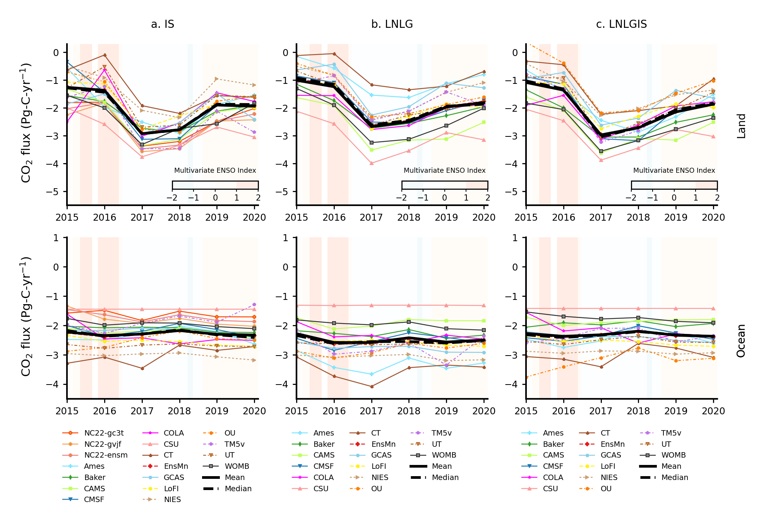

Figure S1: Land-ocean partitioning of annual CO₂ flux estimated by the inversions using in-situ and OCO2 XCO₂ data. Upper (lower) row shows land (ocean) flux. Columns represent (a) IS, (b) LNLG and (c) LNLGIS inversions. All OCO-2 v10 MIP models are shown here for reference. The mean and median do not include NC22.
Rationale for selecting IS and LNLG inversions (two extremes)
Figure S2 and S3 are showing the regional sources and sinks of CO₂ over 15 land divisions and 11 ocean divisions, respectively, as estimated by OCO-2 v10 MIP inversions and prior fluxes in comparison with those from MIROC4-ACTM inversions. All the inversion fluxes for each of the land regions and global totals show much smaller 1-σ standard deviations compared to the prior flux differences. The inversions using surface measurements (IS case) show weaker sink/source with greater uncertainty over Brazil and Northern Africa compared to the inversions including OCO-2 data (LNLG, LNLGIS). The latter two inversions using OCO-2 data suggest a stronger source and with much smaller uncertainty over the tropical land regions, which are lacking IS observations.
NC22 fluxes show good agreement with BB22 results, except for Tropical America, Europe, Russia, Southeast Asia.

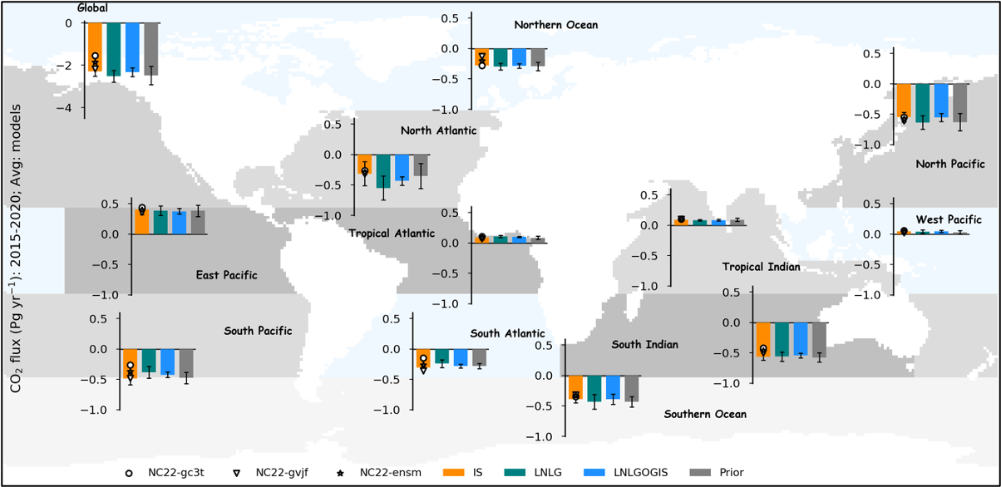
Figure S2: Comparison of CO₂ ocean fluxes estimated by OCO2 v10 -MIP inversions, i.e., BB22 [multi-model mean (bar chart) and 1-σ standard deviation (error bar) in comparison with MIROC4-ACTM inversions, i.e., NC22 (symbols for 2 representative cases)] over 11 TransCom regions and global totals that are identified by the colour shading on the map.
When the fluxes are averaged over different inversion types for a given model (not shown), CAMS and TM5 show the weakest land sink, and OU and UT show the strongest sink. Only for Russia, all models under different inversion types result in a net CO₂ sink, and most regions in the northern temperate and high latitudes are most likely to be net CO₂ sink. Brazil and most of Africa are resulting in CO₂ sources to the atmosphere, whilst Tropical America, South Asia, Southeast Asia and Australia-NZ are appearing as neutral to a weak sink.
By averaging all the models for a specific inversion type (Fig. S2), we find the inversion using all the OCO-2 data (case LNLGOG; not shown) produces a net source and some models using OG data also suggest global land as a source. Sinks over Temperate and Boreal North America are reduced and sources over Brazil and Northern Africa are increased when glint data OG data are used, with an exception to a large sink appearing in Central Africa. It is likely that the sun-glint OCO-2 data are biased low over both the in-land waters and ocean, as discussed already in BB22.
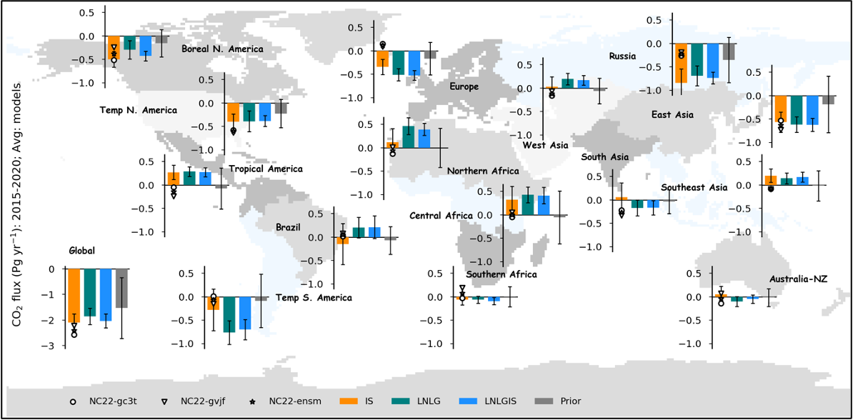
Figure S3: Comparison of CO₂ land fluxes estimated by OCO2 v10 MIP inversions, i.e., BB22 [multi-model mean (bar chart) and 1-σ standard deviation (error bar) in comparison with MIROC4-ACTM inversions, i.e., NC22 (symbols for 2 representative cases)] over 15 land regions that are identified by the colour shading on the map.
Among all the regions, only the Northern Ocean, North Pacific, South Indian and Southern Oceans show net sinks in all inversions (Fig. S3). The North and South Atlantic are also estimated to be sinks of CO₂ by most of the models. We find very large variabilities in the fluxes estimated by different inversion types by each of the models.
Cleaner results are obtained for the different inversion types when averaged over all models (bottom figure), for the all regions in the cases of IS, LG, LN and LNLG inversions, i.e., without using the OG data. The North Atlantic sink is increased by the use of OCO-2, which is apparently a result of compensating the large source increase over the Northern Africa region. Three cases of MIROC4-ACTM inversions using in situ CO₂ data are shown in Fig. S2 and Fig. S3 as symbols, for comparison with the OCO-2 v10 MIP IS inversion results.
We consider the IS and LNLG inversion fluxes as two extreme cases of among the 3 OCO-2 v10 MIP inversions considered in this study, and will sufficiently cover the full range of flux diversity for our analysis.

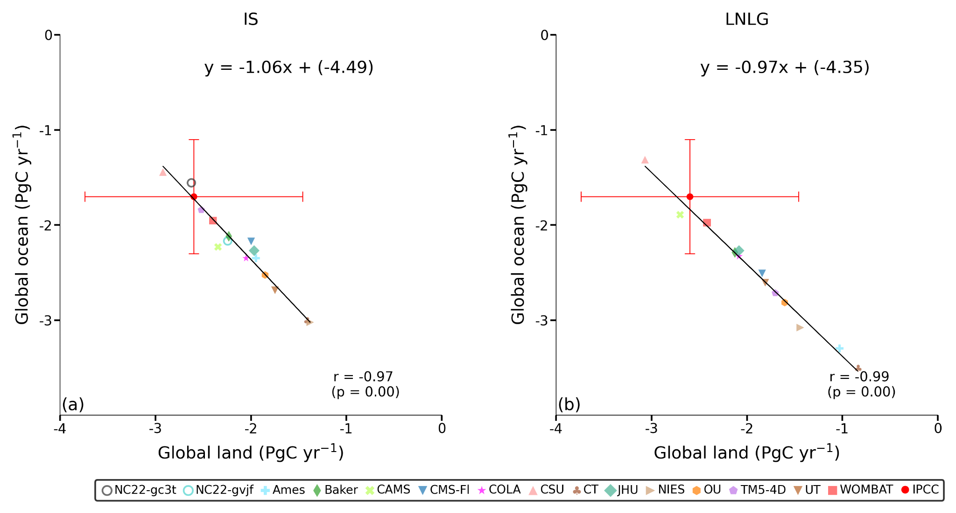
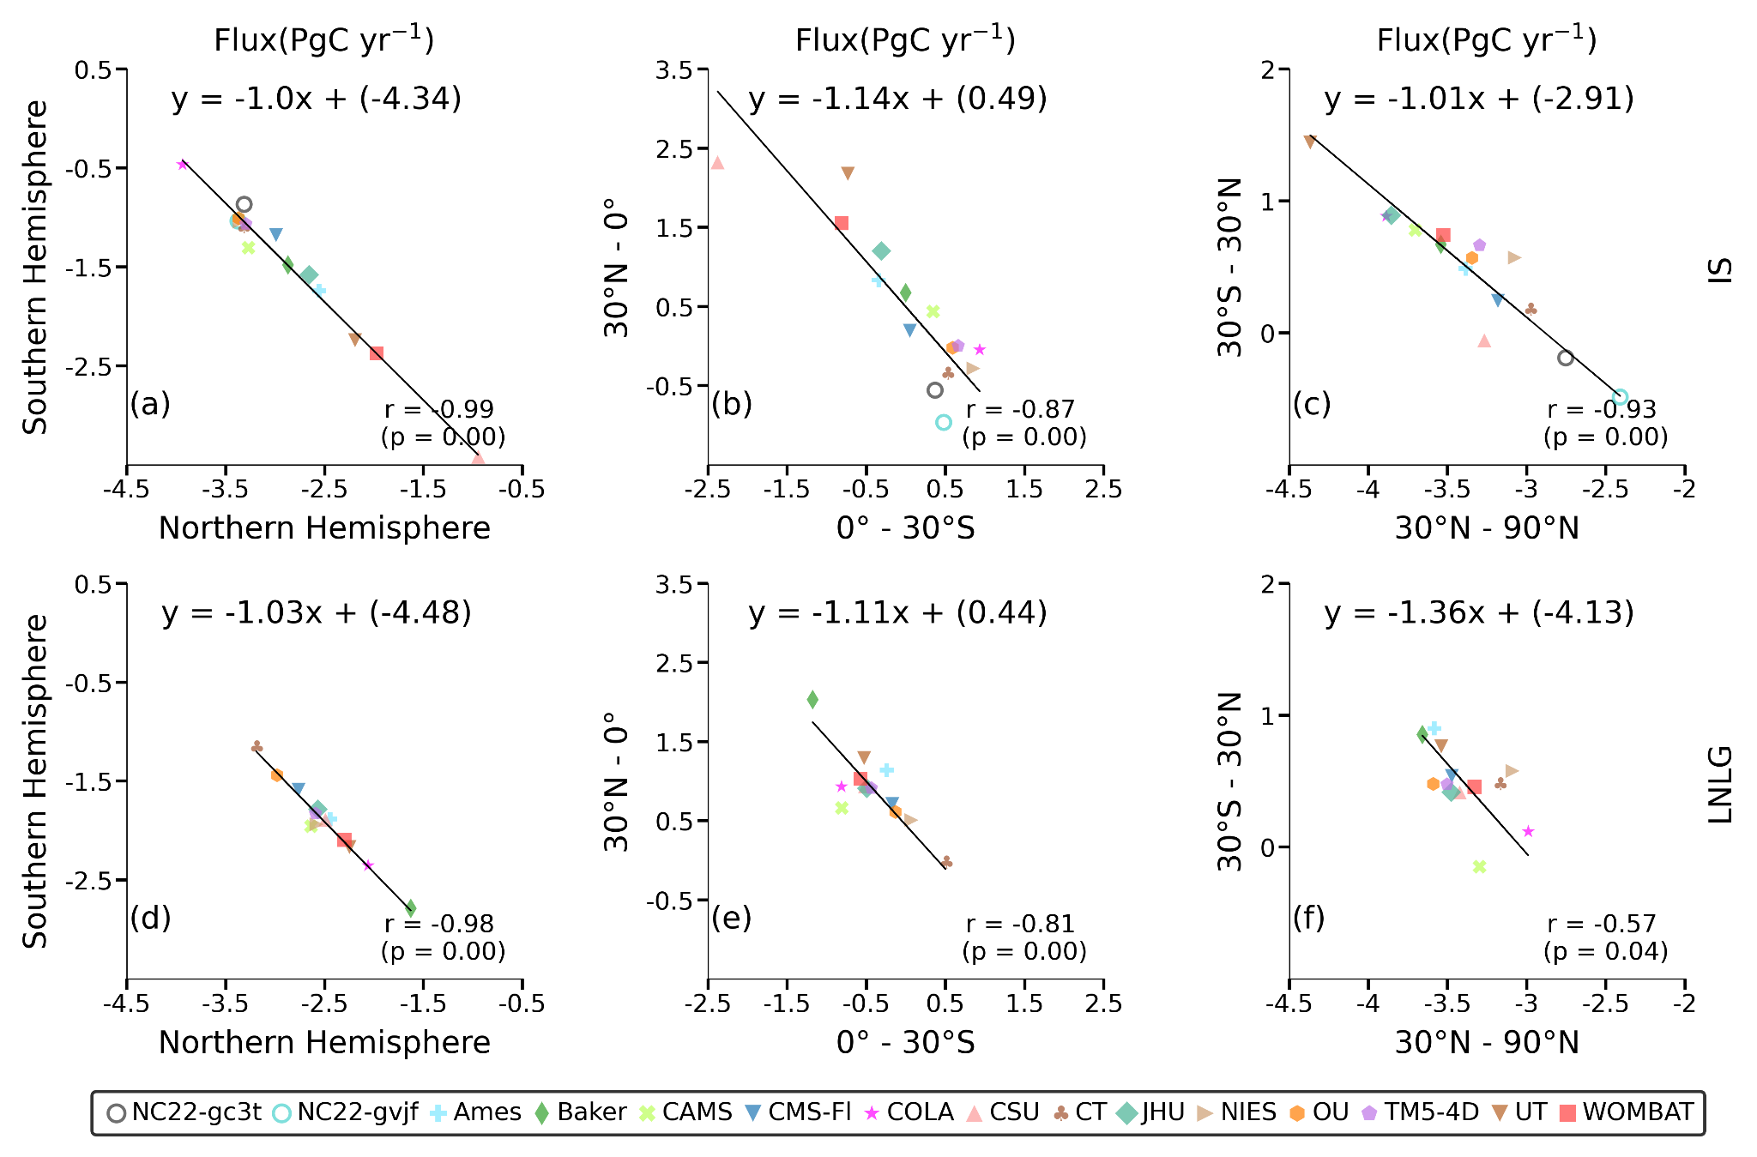
Figure S4: Global land-ocean CO₂ flux partitioning is shown for IS and LNLG inversions (top row; in the left and right column, respectively), which depicts a strong dipole with compact land-ocean flux anti-correlation. IPCC reference values and their STDEV are plotted as red circle with error bars, while BB22 and NC22 inversions are also depicted (legend at the bottom).
The middle (IS) and bottom (LNLG) rows show (land+ocean) flux dipoles for the northern vs southern hemisphere (left column), southern vs northern tropics (middle column), and northern extratropics vs tropics, for IS (top row) and LNLG (bottom row). The correlation between fluxes for other regional combinations are also checked, and found to have weaker correlations, as given below:
30ºS -90ºS (x) vs. 30ºS-30ºN (y): y = -2.21 x (r=-0.31) (for IS); y = -1.28 x (r=-0.56) (for LNLG)
30ºN-90ºN (x) vs. 0º - 30ºN (y): y = -2.03 x (r=-0.67) (for IS); y = -2.29 x (r=-0.56) (for LNLG)
30ºS -90ºS (x) vs. 0º - 30ºS (y): y = -3.38 x (r=-0.61) (for IS); y = -1.96 x (r=-0.35) (for LNLG)
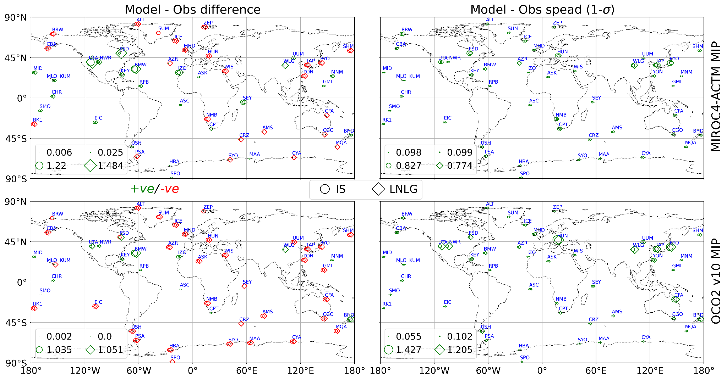
Figure S5: Maps of multi-model means (left columns) and 1-sigma STDEVs (right column) of bias (model-observation) at fifty background sites. NOAA GML site code name of those sites are mentioned in blue color). The figure shows large bias and variability at the sites within the 30-60ºN latitude bands, both over the land and ocean. Marker symbols indicate the inversion while the colour represents +ve/-ve bias/spread. Marker size shows magnitude of the positive bias/spread (marker size is constant for negative biases). Maximum and minimum positive values are given in the legend of each subplot.
Basic checks of MIROC4-ACTM simulations: Comparisons of growth rates
Growth rate (GR) is an important sanity check and therefore it is calculated and evaluated separately from four different datasets viz., In-situ, TCCON, GOSAT and OCO-2 during 2015-2020 in this section (Fig. S6 and S7).
- TCCON data: XCO₂ measurements from upward looking Total Carbon Column Observing Network (TCCON: http://www.tccon.caltech.edu/). Because these XCO₂ retrievals are made from the measurements of direct sunlight, the accuracy is considered to be better than satellite measurements, which are based on reflected light from the Earth surface. TCCON measurements are used for calibration of satellite measurements.
- GOSAT data: XCO₂ measurement from Greenhouse gases Observing Satellite (GOSAT: https://www.gosat.nies.go.jp/en/). GOSAT is the first dedicated satellite for CO₂ and CH4 measurements, but the data coverage and instrumental precision is slightly poorer when compared with the OCO-2 retrievals.
- OCO2 data: XCO₂ measurements from Orbiting Carbon Observatory-2 (OCO-2: https://ocov2.jpl.nasa.gov/), which has been providing high density and high-quality retrievals of XCO₂ since 2014.
In contrast to BB22, here GR is calculated considering interannual variability which is noticed as large STDEVs in each panel especially in-situ data (Fig. S6). It is noted that 2015 is a clear outlier, as an effect of the strong El Niño of 2014-2016, which leads to higher STDEV in the calculation of both observed and model GRs. Observed GR varies as 2.64±0.39 ppm year⁻¹, 2.56±0.49 ppm year⁻¹, 2.64±0.41 ppm year⁻¹, 2.57±0.37 ppm year⁻¹ for in-situ, TCCON, GOSAT and OCO-2 respectively. Model GRs are generally in agreement with the observed GR.

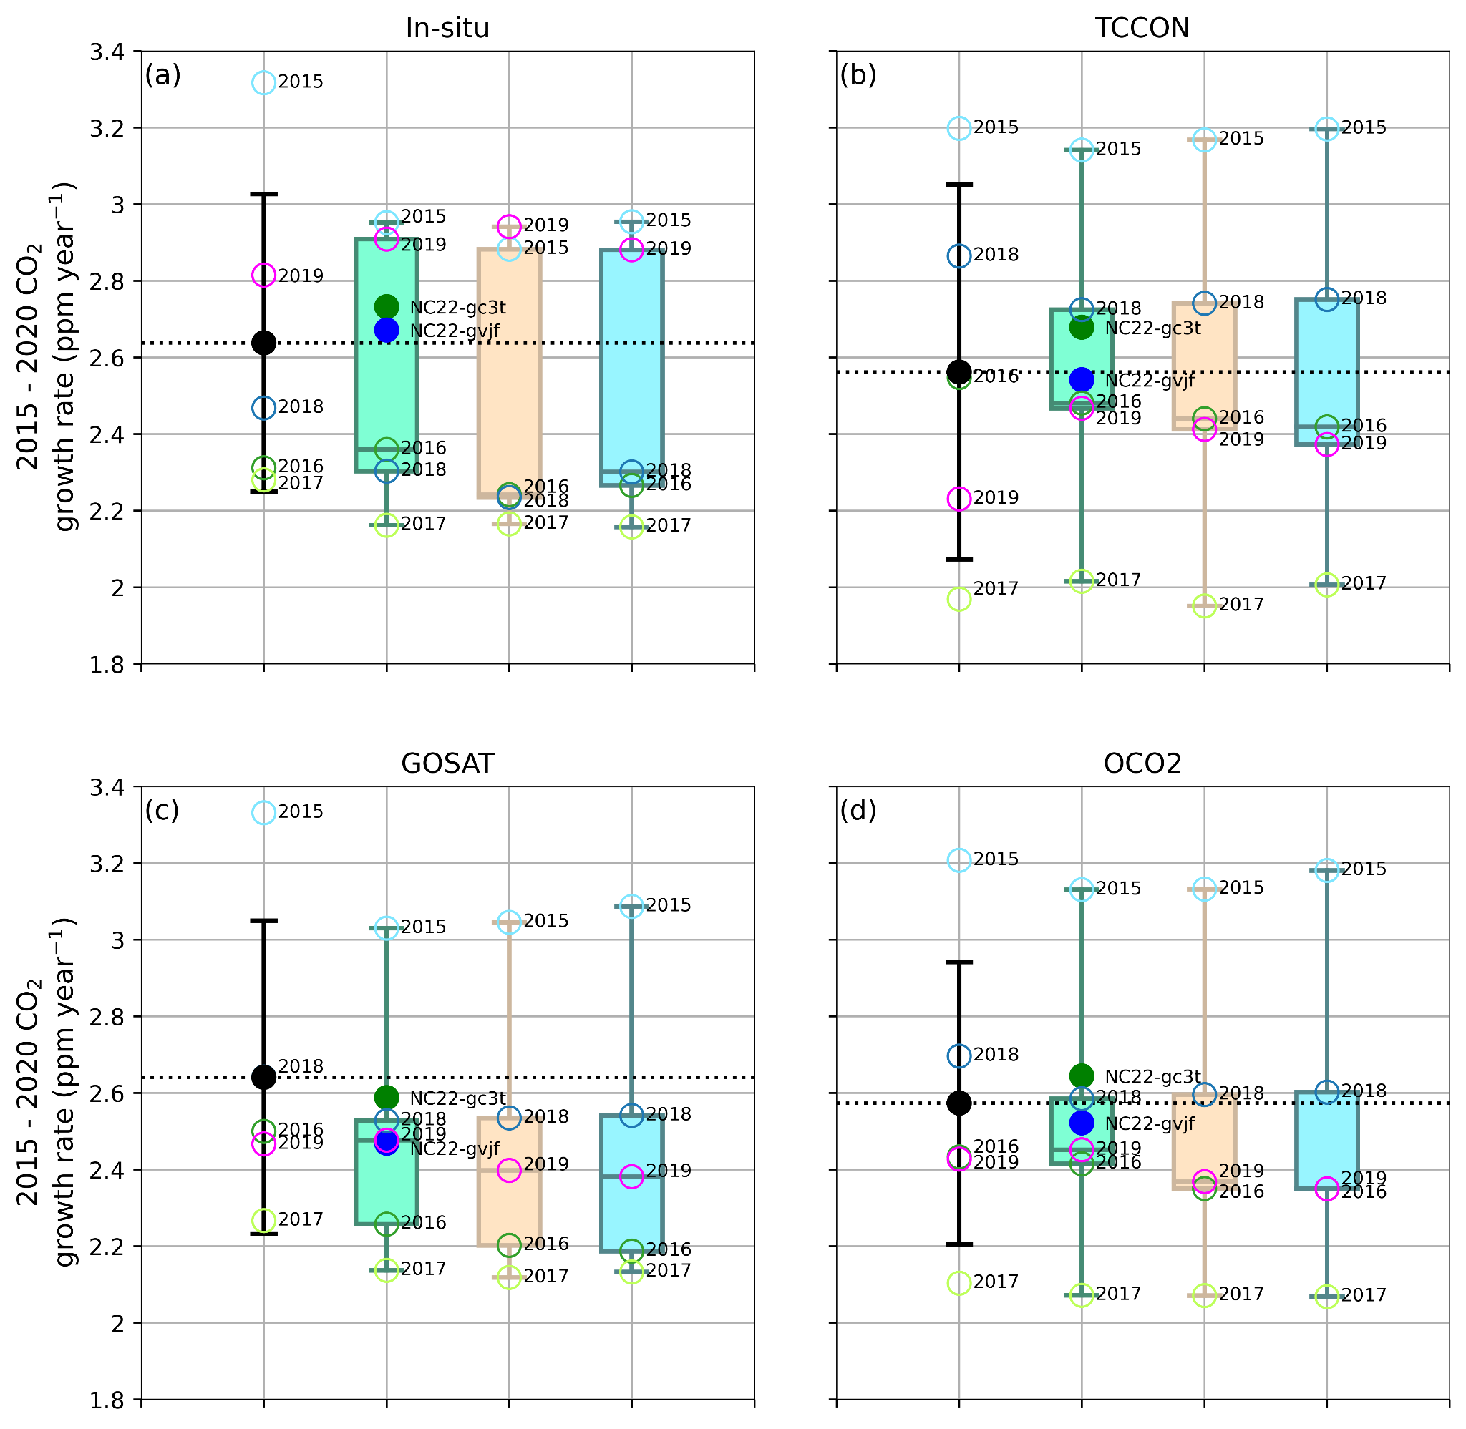
Figure S6: Comparisons of observed (black circle) and simulated multi-model mean growth rates (GRs) for in-situ CO₂ (a), TCCON XCO₂ (b), GOSAT XCO₂ (c) and OCO-2 XCO₂ (d). Simulated growth rates are shown for IS (green bar), LNLG (brown bar) and LNLGIS (cyan bar). The error bars depict GR interannual variability, where the values for each year are marked as the open symbols (e.g., 2015 GR = 2016 - 2015 annual means). All models are sampled at the time and locations of surface, TCCON, GOSAT and OCO-2 observations separately and annual means are calculated. 13 OCO2-MIP models are averaged for annual mean growth rates (open symbols) while the box-whiskers plots are representing model ensemble results. Two independent MIROC4-ACTM inversion cases are shown individually (gc3t and gvjf).
In addition, we also calculated GR considering inter-model variation (Fig. S7). In comparison to the earlier GR figure (Fig. S6), this figure closely matches with that of BB23 with much smaller standard deviations. Irrespective of the inversions, model GRs usually vary in the range of 2.45-2.65 ppm year⁻¹.
The lower mean growth rate for GOSAT sampling of the models compared to the observed (Fig. S6c, Fig. S7c) partly arise from the greater tropical source sensitivity of GOSAT at the beginning of the analysis time period (note the high measured growth rate for 2015 by >0.2 ppm/yr, compared to the models). This indicates that partial sampling of all emissions and removals is still present, but it is not not clear why the other 3 data streams are in very good agreement. It is possible that the small network size of in situ and TCCON observations failed to capture the tropical emission signals due to the El Niño, and OCO-2 has greater high latitude coverage than GOSAT for moderating tropical emission signals in the annual means of 2016.

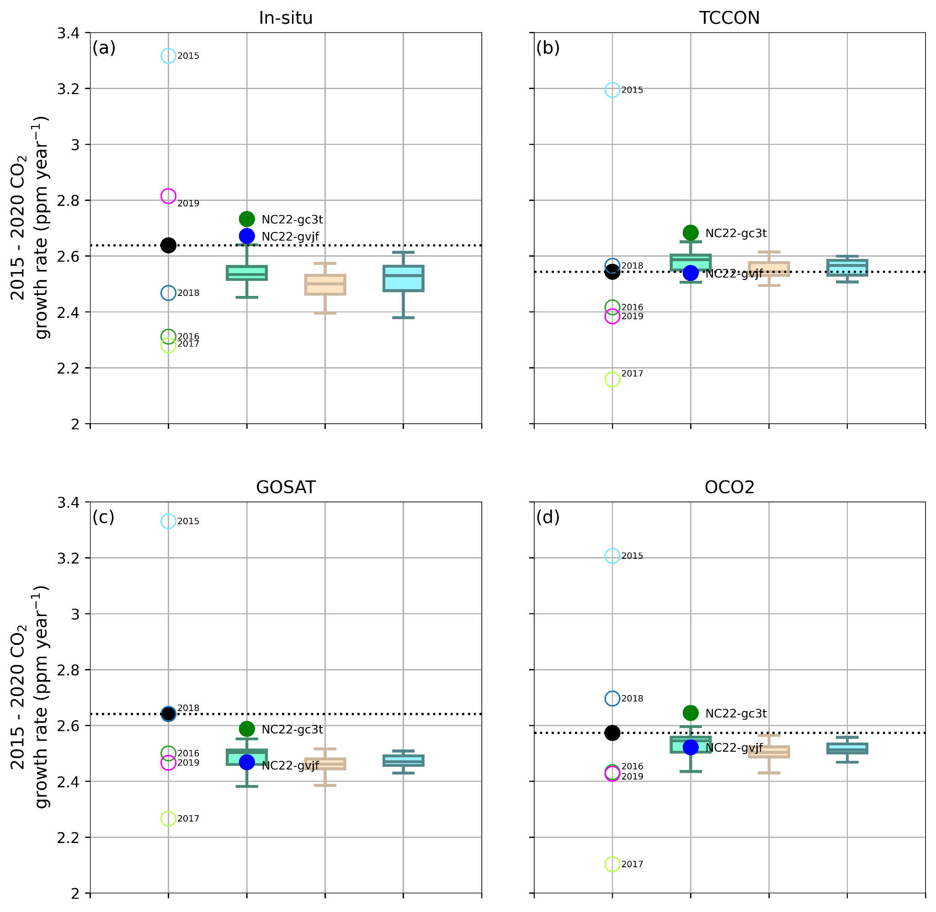
Figure S7: Multi-model mean of 2015-2020 average GRs for observed and simulated CO₂ concentrations; In-situ (a), TCCON (b), GOSAT (c), and OCO-2 (d). Each box-whisker is calculated considering GR from 13 OCO-2 v10 MIP models. MIROC4-ACTM is separately plotted (filled colour circle). In each panel, observed GR in each year is drawn with colored open circle and that for 2015-2020 average GR with a black filled circle.

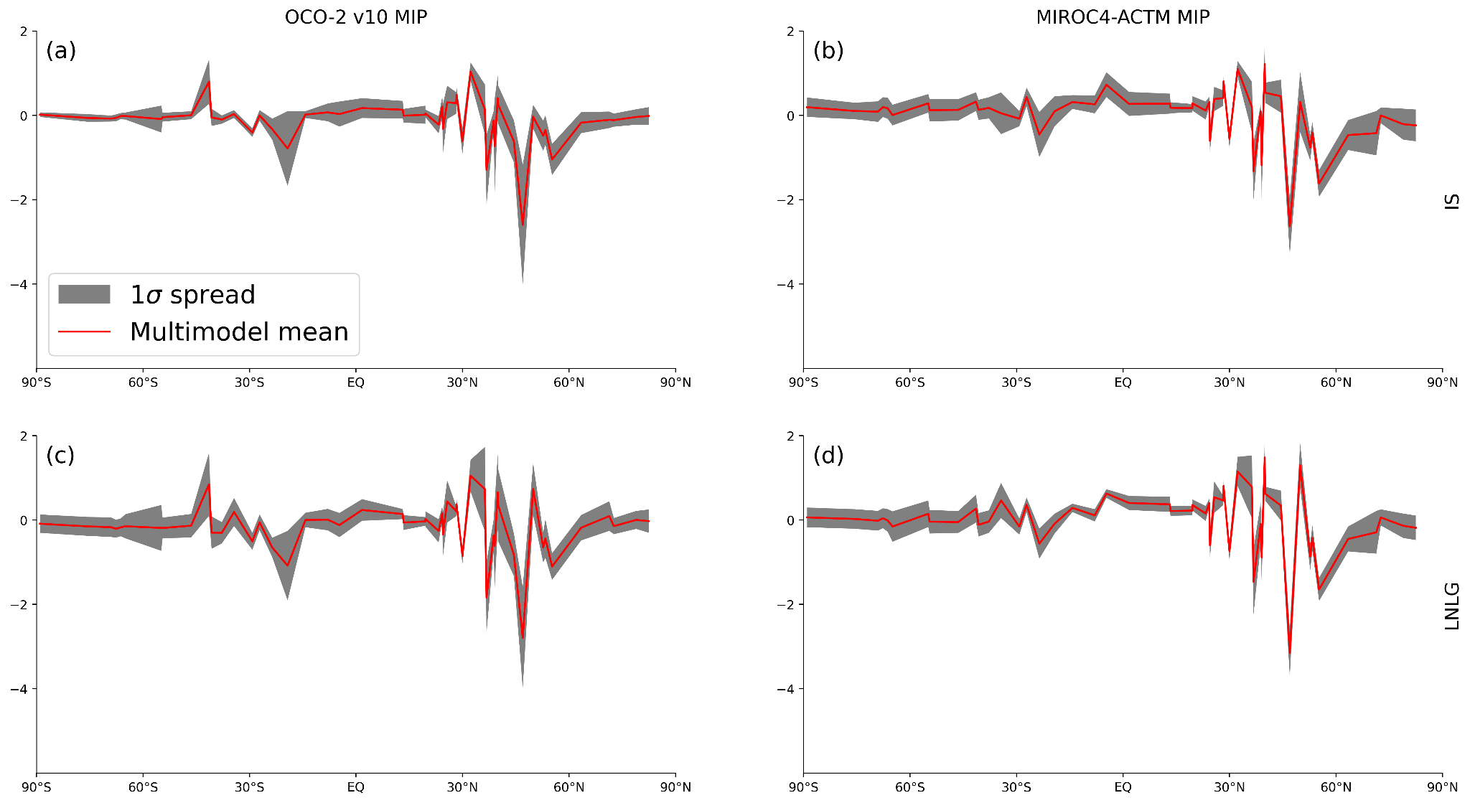
Fig. S8: Multi-model mean and 1-σ spread of the bias (model - observation) for each of the 50 background sites. This information is embedded in Figure 3, but is difficult to read. Uncertainty input for different latitude bands, needed in the emergent constraint calculation (Figure 4 in the main text), are computed based on these spreads. Calculation procedure is detailed in the methodology section (2nd paragraph of the “Emergent constraint formulation” subsection).

Table S1. Inverse model fluxes used in this analysis are from 15 inverse modelling systems, and 3 sets of fluxes for each model are considered. Model details are in Table 1 of BB22 and at www.esrl.noaa.gov/gmd/ccgg/OCO2_v9mip/index.php.
Model code name | Transport model& | Meteorology | Forward model,  Lat⋅Lon⋅Lev | Prior fluxes
 |  |  |  | Land | Ocean | Fire
1. Ames | GEOS-Chem | MERRA-2 | 4º ⋅ 5º ⋅ 47_{Lev} | CASA-GFED4.1s | CT-2009OI | GFEDv4.1s
2. Baker | PCTM | MERRA-2 | 1º ⋅ 1.25º ⋅ 40_{Lev} | CASA-GFED3 | PL-2020 | GFEDv4
3. CAMS$ | LMDz | ERA5-nudged | 1.9º ⋅ 3.75º ⋅ 39_{Lev} | ORCHIDEE (climatology) | CMEMS | GFEDv4.1s
4. CMS-Flux | GEOS-Chem | MERRA-2 | 4º ⋅ 5º ⋅ 47_{Lev} | CARDAMOM | MOM-6 | CARDAMOM
5. COLA | GEOS-Chem | MERRA-2 | 4º ⋅ 5º ⋅ 47_{Lev} | VEGAS | CR-2021 | VEGAS
6. CSU | GEOS-Chem | MERRA-2 | 4º ⋅ 5º ⋅ 47_{Lev} | SiB-4 w/ MERRA-2 | PL-2018 | GFEDv4.1s
7. CT | TM5 | ERA5 | 2º ⋅ 3º ⋅ 25_{Lev} (N.Am:1º ⋅ 1º) | CT-CASA-GFED4.1s | CT-2009OI | GFEDv4.1s
8. JHU | GEOS-Chem | MERRA-2 | 4º ⋅ 5º ⋅ 47_{Lev} | CASA-GFED4.1s | TT-2009 | GFEDv4.1s
9. LoFI* | GEOS GCM | GEOS GCM | 0.5º ⋅ 0.625º ⋅ 72_{Lev} | CASA-GFED3 | TT-2009 | QFED
10. NIES | NIES-TM/ FLEXPART | ERA5/ JRA55 | 3.75º ⋅ 3.75º ⋅ 42_{Lev}/0.1º ⋅ 0.1º | Zeng-2020 | PL-2020 | GFAS
11. OU | TM5 | ERA-interim | 4º ⋅ 6º ⋅ 25_{Lev} | CASA-GFED3 | TT-2009 | GFEDv3
12. TM5-4DVAR | TM5 | ERA-interim | 2º ⋅ 3º ⋅ 25_{Lev} | SiB-CASA | CT-2019 | GFEDv4
13. UT | GEOS-Chem | GEOS-FP | 4º ⋅ 5º ⋅ 47_{Lev} | BEPS | TT-2009 | GFEDv4
14. WOMBAT | GEOS-Chem | MERRA-2 | 2º ⋅ 2.5º ⋅ 47_{Lev} | SiB-4 w/ MERRA-2 | PL-2020 | GFEDv4.1s
15. ACTM**,$  (NC22) | MIROC4-ACTM | JRA55-nudged | 2.8º⋅2.8º ⋅ 67_{Lev} | CASA-3hr | TT-2009 | GFEDv4.1s
*not a traditional inversion, **IS only inversions - not a part of OCO2-MIP (thus, 13 of the 15 models, and IS & LNLG results are used in the main analysis); $nudged GCM meteorology.
&Transport model details: 1. Ames²; 2. Baker³; 3. CAMS⁴; 4. CMS-Flux⁵; 5. COLA⁶; 6. CSU⁷; 7. CT⁸; 8. JHU⁹; 9. LoFI¹⁰; 10. NIES¹¹; 11. OU¹²; 12.TM5-4DVAR¹³; 13. UT¹⁴; 14.WOMBAT¹⁵; MIROC4-ACTM (NC22). Further information on individual modelling systems are in Peiro et al.¹⁶ & BB22.
Table S2: List of sites used in this study 50 background sites (in situ; 44 surface-flask and 6 continuous sites; NC22)
Sl.  No | ObsPack dataset name (3 alphabets after “co2_” indicate site code name of WMO) | Latitude | Longitude | Altitude | Operating Institute
1 | co2_alt_surface-flask_1_representative | 82.5 | -62.5 | 190 | GML/NOAA
2 | co2_asc_surface-flask_1_representative | -8 | -14.4 | 85 | GML/NOAA
3 | co2_ask_surface-flask_1_representative | 23.3 | 5.6 | 2710 | GML/NOAA
4 | co2_azr_surface-flask_1_representative | 38.8 | -27.4 | 19 | GML/NOAA
5 | co2_bmw_surface-flask_1_representative | 32.3 | -64.9 | 30 | GML/NOAA
6 | co2_brw_surface-flask_1_representative | 71.3 | -156.6 | 11 | GML/NOAA
7 | co2_cba_surface-flask_1_representative | 55.2 | -162.7 | 21 | GML/NOAA
8 | co2_cgo_surface-flask_1_representative | -40.7 | 144.7 | 94 | GML/NOAA
9 | co2_chr_surface-flask_1_representative | 1.7 | -157.2 | 0 | GML/NOAA
10 | co2_crz_surface-flask_1_representative | -46.4 | 51.8 | 197 | GML/NOAA
11 | co2_eic_surface-flask_1_representative | -27.2 | -109.4 | 47 | GML/NOAA
12 | co2_gmi_surface-flask_1_representative | 13.4 | 144.7 | 0 | GML/NOAA
13 | co2_hba_surface-flask_1_representative | -75.6 | -26.2 | 30 | GML/NOAA
14 | co2_hun_surface-flask_1_representative | 47 | 16.7 | 248 | GML/NOAA
15 | co2_ice_surface-flask_1_representative | 63.4 | -20.3 | 118 | GML/NOAA
16 | co2_izo_surface-flask_1_representative | 28.3 | -16.5 | 2373 | GML/NOAA
17 | co2_key_surface-flask_1_representative | 25.7 | -80.2 | 1 | GML/NOAA
18 | co2_kum_surface-flask_1_representative | 19.5 | -154.8 | 3 | GML/NOAA
19 | co2_mhd_surface-flask_1_representative | 53.3 | -9.9 | 5 | GML/NOAA
20 | co2_mid_surface-flask_1_representative | 28.2 | -177.4 | 11 | GML/NOAA
21 | co2_mlo_surface-flask_1_representative | 19.5 | -155.6 | 3397 | GML/NOAA
22 | co2_nmb_surface-flask_1_representative | -23.6 | 15 | 456 | GML/NOAA
23 | co2_nwr_surface-flask_1_representative | 40.1 | -105.6 | 3523 | GML/NOAA
24 | co2_psa_surface-flask_1_representative | -64.9 | -64 | 10 | GML/NOAA
25 | co2_rpb_surface-flask_1_representative | 13.2 | -59.4 | 15 | GML/NOAA
26 | co2_sey_surface-flask_1_representative | -4.7 | 55.5 | 2 | GML/NOAA
27 | co2_shm_surface-flask_1_representative | 52.7 | 174.1 | 23 | GML/NOAA
28 | co2_smo_surface-flask_1_representative | -14.2 | -170.6 | 42 | GML/NOAA
29 | co2_spo_surface-flask_1_representative | -89 | -24.8 | 2810 | GML/NOAA
30 | co2_sum_surface-flask_1_representative | 72.6 | -38.4 | 3209 | GML/NOAA
31 | co2_syo_surface-flask_1_representative | -69 | 39.6 | 14 | GML/NOAA
32 | co2_tap_surface-flask_1_representative | 36.7 | 126.1 | 16 | GML/NOAA
33 | co2_ush_surface-flask_1_representative | -54.8 | -68.3 | 12 | GML/NOAA
34 | co2_uta_surface-flask_1_representative | 39.9 | -113.7 | 1327 | GML/NOAA
35 | co2_uum_surface-flask_1_representative | 44.5 | 111.1 | 1007 | GML/NOAA
36 | co2_wis_surface-flask_1_representative | 30 | 35.1 | 151 | GML/NOAA
37 | co2_wlg_surface-flask_1_representative | 36.3 | 100.9 | 3810 | GML/NOAA
38 | co2_zep_surface-flask_1_representative | 78.9 | 11.9 | 474 | GML/NOAA
39 | co2_cfa_surface-flask_2_representative | -19.3 | 147.1 | 2 | CSIRO
40 | co2_mqa_surface-flask_2_representative | -54.5 | 159 | 6 | CSIRO
41 | co2_cya_surface-flask_2_representative | -66.3 | 110.5 | 47 | CSIRO
42 | co2_maa_surface-flask_2_representative | -67.6 | 62.9 | 32 | CSIRO
43 | co2_ams_surface-insitu_11_representative | -37.8 | 77.5 | 55 | LSCE/IPSL
44 | co2_bhd_surface-flask_426_representative | -41.4 | 174.9 | 85 | SIO-CO2
45 | co2_rk1_surface-flask_426_representative | -29.2 | -177.9 | 2 | SIO-CO2
46 | co2_cpt_surface-insitu_36_marine | -34.4 | 18.5 | 230 | SAW
47 | co2_fsd_surface-insitu_6_allvalid | 49.9 | -81.6 | 210 | ECCC
48 | co2_mnm_surface-insitu_19_representative | 24.3 | 154 | 8 | JMA
49 | co2_ryo_surface-insitu_19_representative | 39 | 141.8 | 260 | JMA
50 | co2_yon_surface-insitu_19_representative | 24.5 | 123 | 30 | JMA

Table S3: Global total flux (land+ocean) distribution (Unit: PgC yr⁻¹) over different meridional belts in IS inversions. Calculation is performed by taking 2015-2020 mean first. MIROC4-ACTM is calculated separately and excluded from multi-model statistics. Northern extratropics (NHE; 90ºN-30ºN); tropics (TRP; 30ºN-30ºS) and southern extratropics (SHE; 30ºS-90ºS). Values in the brackets for individual model rows indicate interannual variability but in the multi-model mean row, it shows multi-model spread (1-σ).
Model | SHE | TRP | NHE | Global mean
NC22-gc3t | -1.24 (0.16) | -0.19 (0.53) | -2.75 (0.23) | -4.18 (0.69)
NC22-gvjf | -1.51 (0.18) | -0.49 (0.66) | -2.41 (0.23) | -4.41 (0.72)
Ames | -1.40 (0.16) | 0.49 (0.74) | -3.38 (0.45) | -4.30 (0.64)
Baker | -1.48 (0.11) | 0.67 (0.65) | -3.54 (0.29) | -4.35 (0.5)
CAMS | -1.65 (0.12) | 0.78 (0.80) | -3.70 (0.25) | -4.58 (0.72)
CMS-Fl | -1.23 (0.14) | 0.24 (0.9) | -3.18 (0.33) | -4.17 (0.97)
COLA | -1.40 (0.18) | 0.89 (0.54) | -3.89 (0.29) | -4.40 (0.79)
CSU | -1.04 (0.10) | -0.06 (0.60) | -3.27 (0.14) | -4.37 (0.56)
CT | -1.62 (0.19) | 0.18 (0.64) | -2.98 (0.23) | -4.42 (0.71)
JHU | -1.27 (0.17) | 0.89 (0.99) | -3.86 (0.37) | 4.24 (0.72)
NIES | -1.90 (0.15) | 0.57 (0.83) | -3.07 (0.34) | -4.40 (0.65)
OU | -1.60 (0.3) | 0.57 (0.69) | -3.35 (0.31) | -4.38 (0.60)
TM5-4D | -1.73 (0.22) | 0.66 (0.86) | -3.30 (0.23) | -4.36 (0.73)
UT | -1.51 (0.11) | 1.44 (0.63) | -4.37 (0.27) | -4.43 (0.74)
WOMBAT | -1.57 (0.16) | 0.74 (0.89) | -3.53 (0.34) | -4.35 (0.64)
Multi-model Mean | -1.49 (0.22) | 0.62 (0.36) | -3.49 (0.37) | -4.37 (0.09)

Table S4: Same as Table S3 but for LNLG inversions.
Model | SHE | TRP | NHE | Global mean
Ames | -1.64 (0.23) | 0.90 (0.57) | -3.58 (0.34) | -4.32
Baker | -1.61 (0.17) | 0.85 (72) | -3.66 (0.43) | -4.41
CAMS | -1.15 (0.19) | -0.15 (0.71) | -3.30 (0.34) | -4.59
CMS-Fl | -1.42 (0.21) | 0.54 (0.70) | -3.47 (0.36) | -4.35
COLA | -1.54 (0.24) | 0.12 (0.58) | -2.99 (0.22) | -4.41
CSU | -1.38 (0.12) | 0.41 (0.66) | -3.42 (0.11) | -4.38
CT | -1.66 (0.24) | 0.48 (0.47) | -3.17 (0.40) | -4.35
JHU | -1.29 (0.12) | 0.42 (0.84) | -3.48 (0.24) | 4.35
NIES | -2.01 (0.10) | 0.58 (0.68) | -3.09 (0.23) | -4.52
OU | -1.31 (0.21) | 0.48 (0.67) | -3.59 (0.27) | -4.42
TM5-4D | -1.39 (0.26) | 0.48 (0.68) | -3.51 (0.32) | -4.42
UT | -1.64 (0.09) | 0.76 (0.60) | -3.54 (0.24) | -4.42
WOMBAT | -1.52 (0.11) | 0.46 (0.75) | -3.33 (0.26) | -4.40
Multi-model Mean | -1.50 (0.21) | 0.49 (0.27) | -3.39 (0.20) | -4.41 (0.07)

Table S5: Global ocean flux (Unit: PgC yr⁻¹) during 2015 - 2016. MIROC4-ACTM is calculated separately and excluded from multi-model statistics. Blue cells are the temporal mean and standard deviation of those individual year’s values while the light brown cells correspond to multi-model statistics.
Model | 2015 |  | 2016 |  | 2017 |  | 2018 |  | 2019 |  | 2020 |  | Multi - model mean (spread) (IS) | IAV spread 2015 - 2020 (IS) | Multi - model mean (spread) (LNLG) | IAV spread 2015 - 2020 (LNLG)
Model | IS | LNLG | IS | LNLG | IS | LNLG | IS | LNLG | IS | LNLG | IS | LNLG
NC22-gc3t | -1.52 |  | -1.41 |  | -1.72 |  | -1.52 |  | -1.58 |  | -1.59 |  | -1.56 | 0.09
NC22-gvjf | -1.86 |  | -2.22 |  | -2.23 |  | -2.12 |  | -2.28 |  | -2.30 |  | -2.17 | 0.15
Ames | -2.46 | -2.84 | -2.49 | -3.43 | -2.28 | -3.66 | -2.01 | -3.11 | -2.21 | -3.46 | -2.63 | -3.28 | -2.35 |  | -3.30
Baker | -2.03 | -2.18 | -2.08 | -2.27 | -2.06 | -2.37 | -2.08 | -2.14 | -2.23 | -2.44 | -2.24 | -2.33 | -2.12 |  | -2.29
CAMS | -2.10 | -1.74 | -2.25 | -2.12 | -2.20 | -2.01 | -2.11 | -1.80 | -2.32 | -1.83 | -2.40 | -1.84 | -2.23 |  | -1.89
CMS-Fl | -2.00 | -2.43 | -2.37 | -2.84 | -2.20 | -2.54 | -1.92 | -2.24 | -2.13 | -2.41 | -2.41 | -2.59 | -2.17 |  | -2.51
COLA | -1.61 | -1.87 | -2.46 | -2.39 | -2.41 | -2.34 | -2.63 | -2.58 | -2.48 | -2.32 | -2.50 | -2.47 | -2.35 |  | -2.33
CSU | -1.44 | -1.31 | -1.44 | -1.32 | -1.44 | -1.31 | -1.44 | -1.31 | -1.44 | -1.31 | -1.44 | -1.32 | -1.44 |  | -1.31
CT | -3.28 | -3.07 | -3.08 | -3.72 | -3.46 | -4.05 | -2.68 | -3.43 | -2.84 | -3.34 | -2.71 | -3.41 | -3.01 |  | -3.50
JHU | -2.27 | -2.27 | -2.28 | -2.28 | -2.29 | -2.29 | -2.31 | -2.31 | -2.31 | -2.31 | -2.15 | -2.15 | -2.27 |  | -2.27
NIES | -2.96 | -3.01 | -3.03 | -3.09 | -2.97 | -3.02 | -2.94 | -2.98 | -3.07 | -3.20 | -3.18 | -3.17 | -3.03 |  | -3.08
OU | -2.87 | -2.88 | -2.74 | -3.10 | -2.41 | -2.93 | -2.18 | -2.61 | -2.45 | -2.77 | -2.50 | -2.61 | -2.52 |  | -2.82
TM5-4D | -1.98 | -2.14 | -2.27 | -2.97 | -1.93 | -2.87 | -1.68 | -2.60 | -1.89 | -3.34 | -1.29 | -2.36 | -1.84 |  | -2.71
UT | -2.64 | -2.60 | -2.77 | -2.61 | -2.67 | -2.65 | -2.62 | -2.62 | -2.69 | -2.59 | -2.72 | -2.56 | -2.68 |  | -2.60
WOMBAT | -1.75 | -1.81 | -1.99 | -1.91 | -1.91 | -1.98 | -1.91 | -1.88 | -2.04 | -2.10 | -2.11 | -2.16 | -1.95 |  | -1.97
Mul_mod_mn | -2.26 | -2.32 | -2.40 | -2.62 | -2.33 | -2.62 | -2.19 | -2.43 | -2.32 | -2.57 | -2.33 | -2.48 | -2.30 (0.43) | -2.31 (0.07) | -2.51 (0.58) | -2.51 (0.11)

Table S6: Same as Table S5 but for land flux.
Model | 2015 |  | 2016 |  | 2017 |  | 2018 |  | 2019 |  | 2020 |  | Multi - model mean (spread) (IS) | IAV spread 2015 - 2020 (IS) | Multi - model mean (spread) (LNLG) | IAV spread 2015 - 2020 (LNLG)
Model | IS | LNLG | IS | LNLG | IS | LNLG | IS | LNLG | IS | LNLG | IS | LNLG
NC22-gc3t | -1.94 |  | -1.98 |  | -3.55 |  | -3.31 |  | -2.73 |  | -2.23 |  | -2.62 | 0.63
NC22-gvjf | -1.61 |  | -1.40 |  | -3.19 |  | -3.04 |  | -2.08 |  | -2.14 |  | -2.24 | 0.67
Ames | -0.59 | -0.21 | -2.01 | -0.60 | -2.58 | -1.58 | -3.00 | -1.72 | -1.94 | -1.21 | -1.58 | -0.85 | -1.95 |  | -1.03
Baker | -1.62 | -1.20 | -1.81 | -1.77 | -2.83 | -2.78 | -2.96 | -2.65 | -2.21 | -2.34 | -1.95 | -2.02 | -2.23 |  | -2.13
CAMS | -1.37 | -1.69 | -1.84 | -1.94 | -3.42 | -3.58 | -3.21 | -3.24 | -2.21 | -3.18 | -2.01 | -2.56 | -2.34 |  | -2.70
CMS-Fl | -0.38 | -0.90 | -1.44 | -1.10 | -3.16 | -2.53 | -3.16 | -2.59 | -1.95 | -2.15 | -1.90 | -1.77 | -2.00 |  | -1.84
COLA | -2.58 | -1.56 | -0.68 | -1.57 | -3.08 | -2.79 | -2.63 | -2.67 | -1.53 | -2.02 | -1.81 | -1.89 | -2.05 |  | -2.08
CSU | -2.02 | -2.15 | -2.60 | -2.59 | -3.78 | -4.02 | -3.35 | -3.55 | -2.72 | -2.93 | -3.07 | -3.17 | -2.92 |  | -3.07
CT | -0.72 | -0.19 | -0.14 | -0.09 | -2.00 | -1.26 | -2.30 | -1.44 | -1.65 | -1.30 | -1.66 | -0.76 | -1.41 |  | -0.84
JHU | -0.92 | -0.73 | -1.48 | -1.43 | -3.13 | -3.07 | -2.49 | 3.09 | -1.91 | -1.96 | -1.88 | -2.23 | -1.97 |  | -2.09
NIES | -0.54 | -0.54 | -0.95 | -0.86 | -2.15 | -2.44 | -2.41 | -2.18 | -1.03 | -1.50 | -1.20 | -1.13 | -1.38 |  | -1.44
OU | -0.78 | -0.47 | -1.10 | -0.87 | -2.84 | -2.39 | -2.93 | -2.29 | -1.83 | -1.95 | -1.63 | -1.65 | -1.85 |  | -1.60
TM5-4D | -1.68 | -1.17 | -1.27 | -0.89 | -3.52 | -2.52 | -3.55 | -2.19 | -2.20 | -1.50 | -2.91 | -1.95 | -2.52 |  | -1.70
UT | -1.29 | -0.72 | -0.55 | -1.19 | -2.75 | -2.65 | -2.68 | -2.33 | -1.57 | -2.12 | -1.63 | -1.85 | -1.74 |  | -1.81
WOMBAT | -1.58 | -1.34 | -2.05 | -1.94 | -3.38 | -3.30 | -2.87 | -3.20 | -2.63 | -2.68 | -1.87 | -2.04 | -2.40 |  | -2.42
Mul_mod_mn | -1.24 | -0.99 | -1.38 | -1.30 | -2.97 | -2.69 | -2.89 | -2.55 | -1.95 | -2.06 | -1.9s | -1.84 | -2.06 (0.41) | -2.06 (0.67) | -1.90 (0.60) | -1.90 (0.61)
References
1. Canadell, J. G. et al. Global Carbon and other Biogeochemical Cycles and Feedbacks. in IPCC AR6 WGI, Final Government Distribution chapter 5 (2021).
2. Philip, S. et al. OCO-2 Satellite-Imposed Constraints on Terrestrial Biospheric CO2 Fluxes Over South Asia. Journal of Geophysical Research: Atmospheres 127, e2021JD035035 (2022).
3. Baker, D. F., Doney, S. C. & Schimel, D. S. Variational data assimilation for atmospheric CO2. Tellus B: Chemical and Physical Meteorology 58, 359–365 (2006).
4. Chevallier, F. et al. Inferring CO2 sources and sinks from satellite observations: Method and application to TOVS data. Journal of Geophysical Research: Atmospheres 110, (2005).
5. Liu, J. et al. Carbon Monitoring System Flux Net Biosphere Exchange 2020 (CMS-Flux NBE 2020). Earth System Science Data 13, 299–330 (2021).
6. Liu, Z. et al. Improving the joint estimation of CO₂ and surface carbon fluxes using a constrained ensemble Kalman filter in COLA (v1.0). Geoscientific Model Development 15, 5511–5528 (2022).
7. Schuh, A. E. et al. Quantifying the Impact of Atmospheric Transport Uncertainty on CO2 Surface Flux Estimates. Global Biogeochemical Cycles 33, 484–500 (2019).
8. Jacobson et al., N. Global Monitoring Laboratory - Carbon Cycle Greenhouse Gases. https://gml.noaa.gov/ccgg/carbontracker/CT2019B/CT2019B_doc.php.
9. Miller, S. M., Saibaba, A. K., Trudeau, M. E., Mountain, M. E. & Andrews, A. E. Geostatistical inverse modeling with very large datasets: an example from the Orbiting Carbon Observatory 2 (OCO-2) satellite. Geoscientific Model Development 13, 1771–1785 (2020).
10. Weir, B. et al. Regional impacts of COVID-19 on carbon dioxide detected worldwide from space. Science Advances 7, eabf9415 (2021).
11. Maksyutov, S. et al. Technical note: A high-resolution inverse modelling technique for estimating surface CO₂ fluxes based on the NIES-TM–FLEXPART coupled transport model and its adjoint. Atmospheric Chemistry and Physics 21, 1245–1266 (2021).
12. Crowell, S. et al. The 2015–2016 carbon cycle as seen from OCO-2 and the global in situ network. Atmospheric Chemistry and Physics 19, 9797–9831 (2019).
13. Basu, S. et al. Global CO₂ fluxes estimated from GOSAT retrievals of total column CO₂. Atmospheric Chemistry and Physics 13, 8695–8717 (2013).
14. Deng, F., Jones, D. B. A., O’Dell, C. W., Nassar, R. & Parazoo, N. C. Combining GOSAT XCO2 observations over land and ocean to improve regional CO2 flux estimates. Journal of Geophysical Research: Atmospheres 121, 1896–1913 (2016).
15. Zammit-Mangion, A. et al. WOMBAT v1.0: a fully Bayesian global flux-inversion framework. Geoscientific Model Development 15, 45–73 (2022).
16. Peiro, H. et al. Four years of global carbon cycle observed from the Orbiting Carbon Observatory 2 (OCO-2) version 9 and in situ data and comparison to OCO-2 version 7. Atmospheric Chemistry and Physics 22, 1097–1130 (2022).

