Combinatorial chemotherapy via poloxamer 188 surface-modified PLGA nanoparticles that traverse the blood-brain-barrier in a glioblastoma model

Fatemeh Madani¹, Hassan Morovvati², Thomas J. Webster^{3,4} , Sareh Najaf Asaadi², Seyed Mahdi Rezayat^{1,5}, Mahmoudreza Hadjighassem⁶, Masood Khosravani^{1*}, and Mahdi Adabi^{1*}
¹Department of Medical Nanotechnology, School of Advanced Technologies in Medicine, Tehran University of Medical Sciences, Tehran, Iran
²Department of Basic Science, Faculty of Veterinary Medicine, University of Tehran, Tehran, Iran
³School of Health Sciences and Biomedical Engineering, Hebei University of Technology, Tianjin, China
⁴Program in Materials Science, UFPI, Teresina, Brazil
⁵Department of Pharmacology, School of Medicine, Tehran University of Medical Sciences, Tehran, Iran
⁶Brain and Spinal Cord Injury Research Center, Tehran University of Medical Sciences, Tehran, Iran

*Corresponding author.
Tel.: +98 (21) 43052132
E-mail: drkhosravani@tums.ac.ir (M. Khosravani), madabi@tums.ac.ir (M. Adabi)

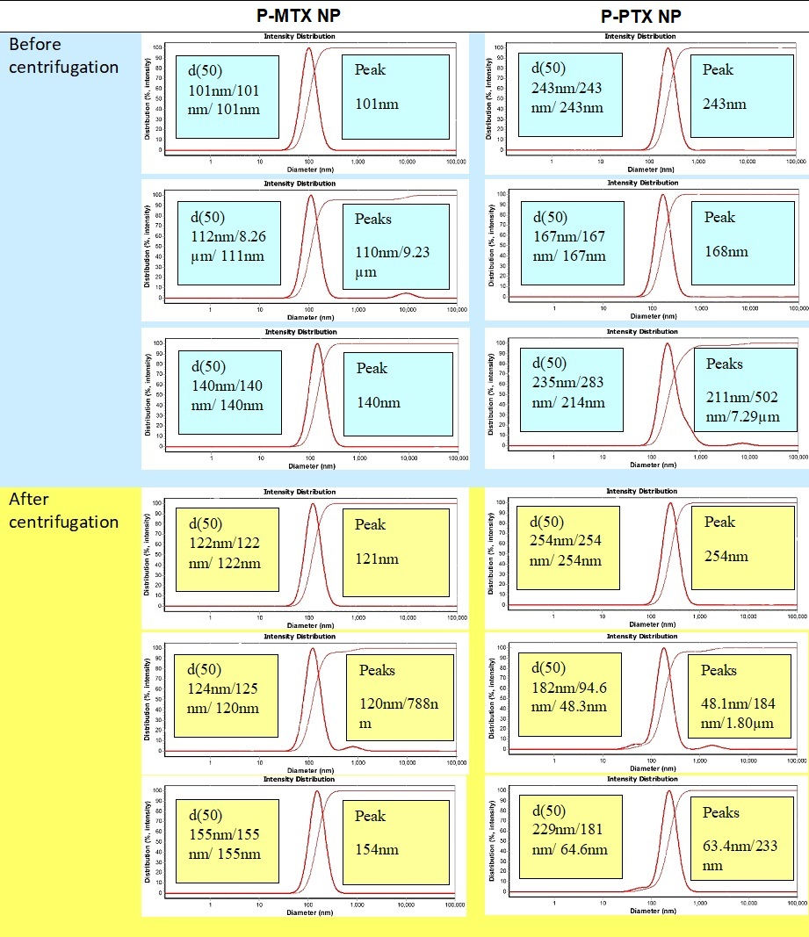
Fig. S1. DLS diagram of P-MTX NPs and P-PTX NPs before and after centrifugation, one month, two months and three months after preparation.

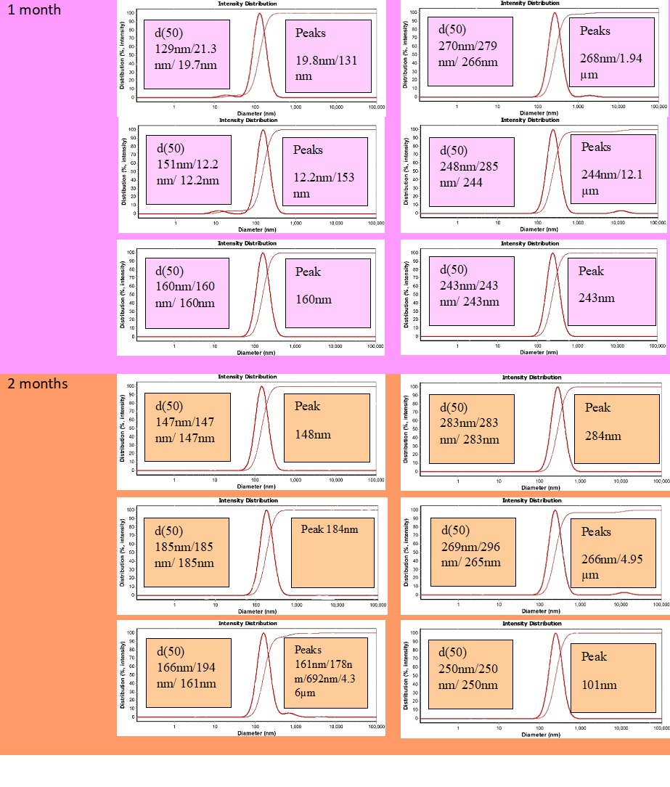
Fig. S1. Continued.
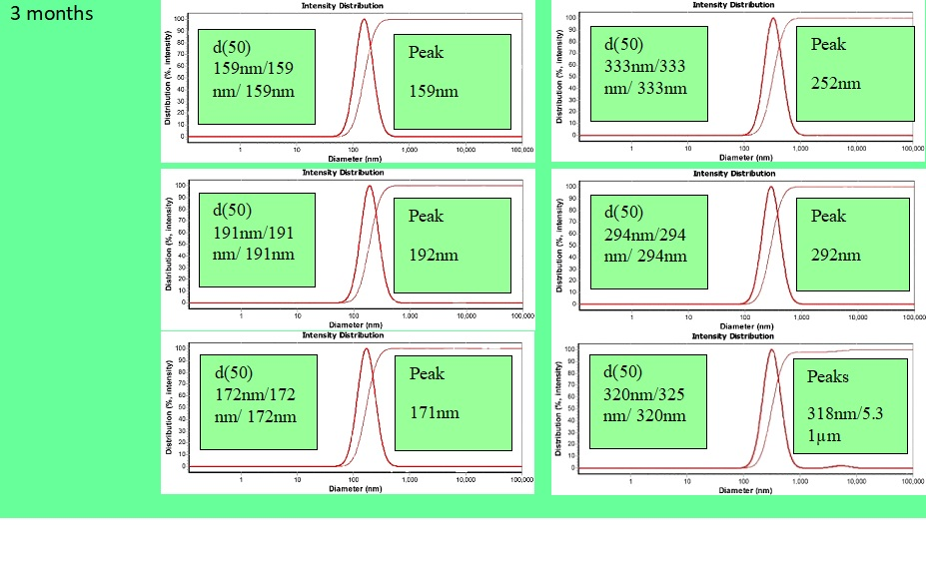
Fig. S1. Continued.

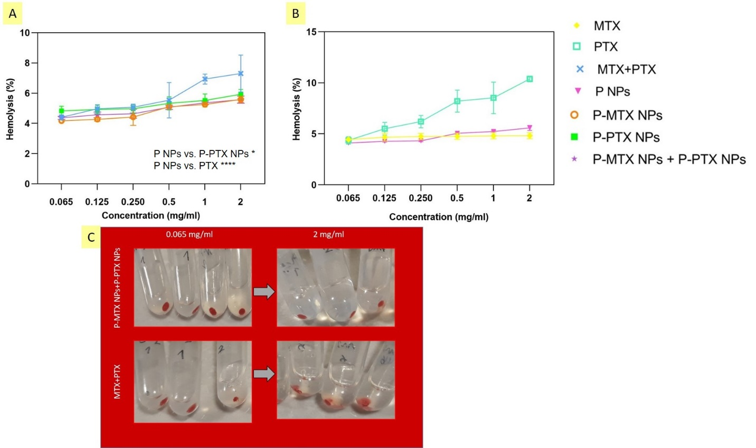

Fig. S2 (A, B) Hemolysis results of P NPs, MTX, PTX, MTX+PTX, P-MTX NPs, P-PTX NPs, and P-MTX NPs+P-PTX NPs. Data= mean±SD, n=3 (significant p values are: P value of P NPs vs. P-PTX NPs=0.0427, P value of P NPs vs. PTX=<0.0001). (C) Hemolysis assay on P-MTX NPs+P-PTX NPs and MTX+PTX samples at the lowest (0.065 mg/ml) and highest (2 mg/ml) concentrations.
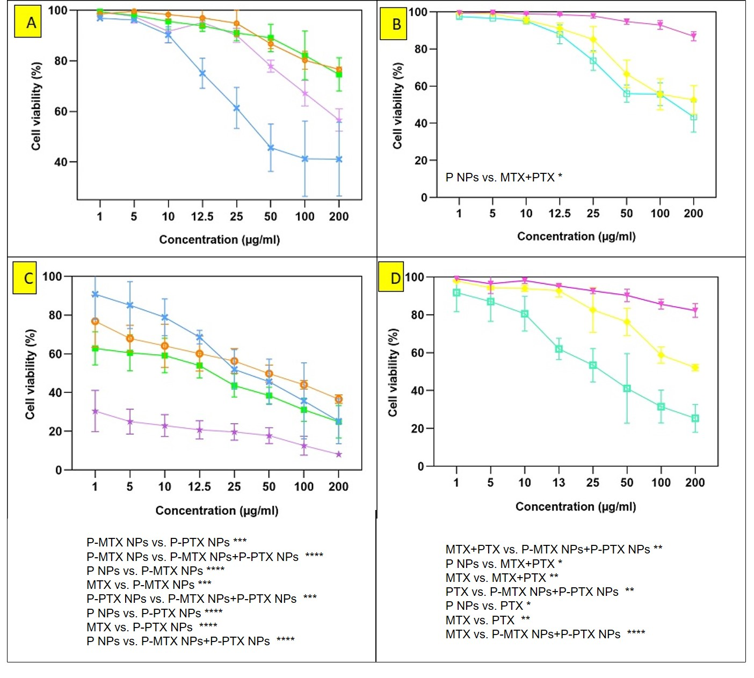
Fig. S3.The survival results of C6 cells treated with P NPs, MTX, PTX, MTX+PTX, P-MTX NPs, P-PTX NPs, and P-MTX NPs+P-PTX NPs after (A,B) 24 hours (Data = mean +/- SD; N = 3; significant p value is P NPs vs. MTX+PTX 0.0343) and (C,D) 72 hours (Data = mean +/- SD; N = 3; significant p values are MTX+PTX vs. P-MTX NPs+P-PTX NPs 0.0034, P NPs vs. MTX+PTX 0.0165, MTX vs. MTX+PTX 0.0041, P-MTX NPs vs. P-PTX NPs 0.0007, P-MTX NPs vs. P-MTX NPs+P-PTX NPs <0.0001, P NPs vs. P-MTX NPs <0.0001, MTX vs. P-MTX NPs 0.0002, P-PTX NPs vs. P-MTX NPs+P-PTX NPs 0.0003, P NPs vs. P-PTX NPs <0.0001, MTX vs. P-PTX NPs <0.0001, P NPs vs. P-MTX NPs+P-PTX NPs <0.0001, MTX vs. P-MTX NPs+P-PTX NPs <0.0001, PTX vs. P-MTX NPs+P-PTX NPs 0.0064, P NPs vs. PTX 0.0207, MTX vs. PTX 0.0092).

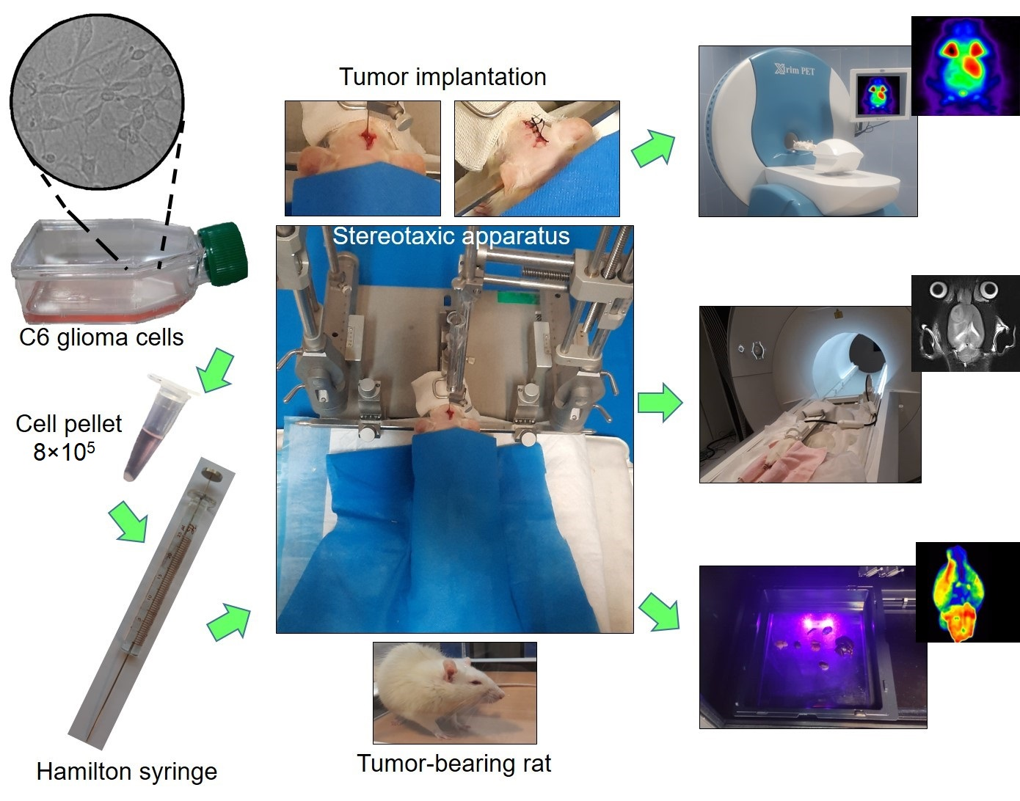
Fig. S4. Schematic view of the tumor implantation procedure and imaging processes.

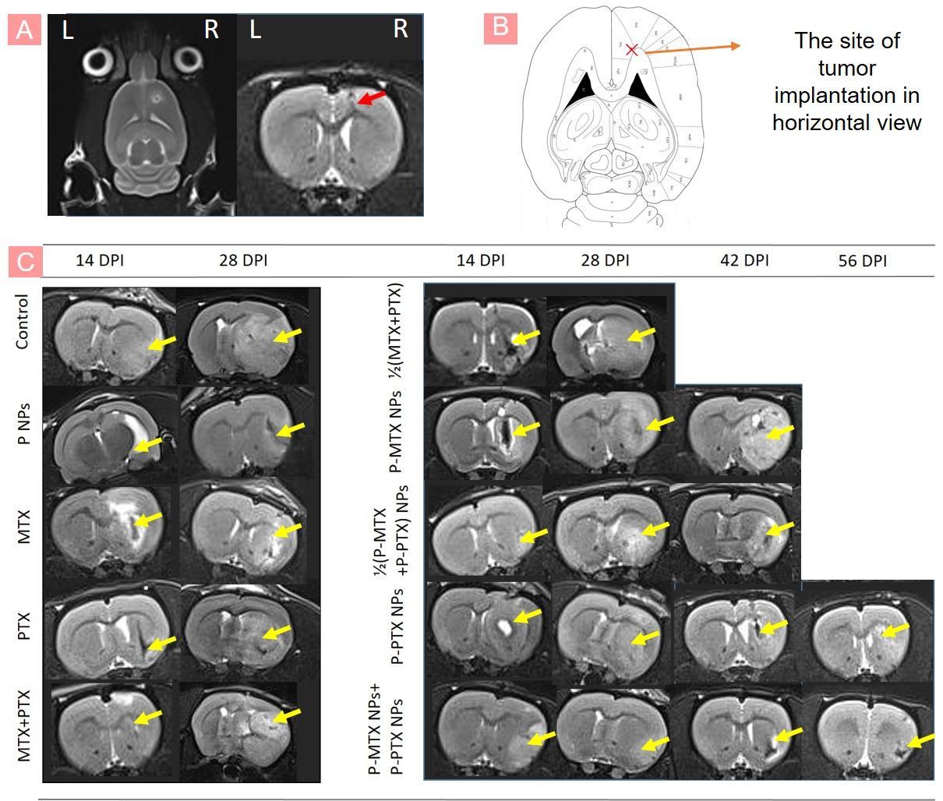
Fig. S5. (A) MRI pictures of the sham group, (B) The site of tumor implantation in the horizontal view
(captured from http://labs.gaidi.ca), and (C) Coronal section of the control, P NPs, MTX, PTX, MTX+PTX, 1/2(MTX+PTX), P-MTX NPs, 1/2(P-MTX + P-PTX) NPs, P-PTX NPs, and P-MTX NPs+P-PTX NPs groups.

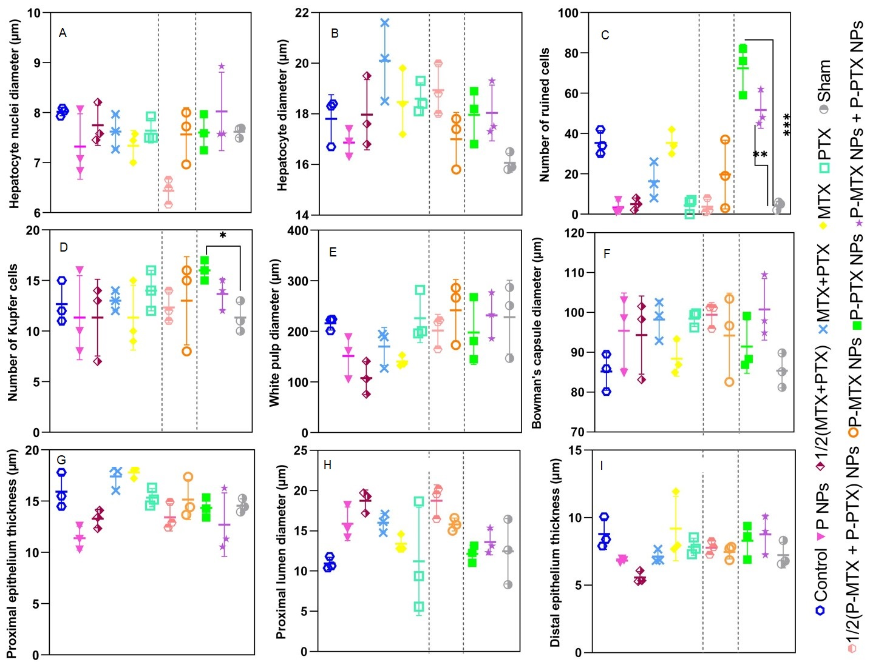
Fig. S6. Quantitative analysis of H&E results from the liver, spleen, kidney and testis tissues (Data = mean +/- SD;, statistical analysis was done only among sham, P-PTX NPs and P-MTX NPs+P-PTX NPs): (A) hepatocyte nuclei diameter, (B) hepatocyte diameter, (C) number of ruined cells in the liver (significant p values are sham vs. P-PTX NPs 0.0002, sham vs. P-MTX NPs+P-PTX NPs 0.0014), (D) number of Kupfer cells (significant p value is sham vs. P-PTX NPs 0.0141), (E) white pulp diameter, (F) Bowman’s capsule diameter, (G) proximal epithelium thickness in the kidney, (H) proximal lumen diameter in the kidney, (I) distal epithelium thickness in the kidney, (J) distal lumen diameter in the kidney, (K) number of leyding cells, (L) number of Sertoli cells, (M) number of spermatid cells, (N) number of spermatocyte cells, (O) number of spermatogonium cells, (P) number of spermatozoid cells, (Q) epithelium thickness of testis (significant p values are P-PTX NPs vs. P-MTX NPs+P-PTX NPs 0.0112, sham vs. P-MTX NPs+P-PTX NPs 0.0038), and (R) seminiferous tube diameter significant p value is P-PTX NPs vs. P-MTX NPs+P-PTX NPs 0.0372.

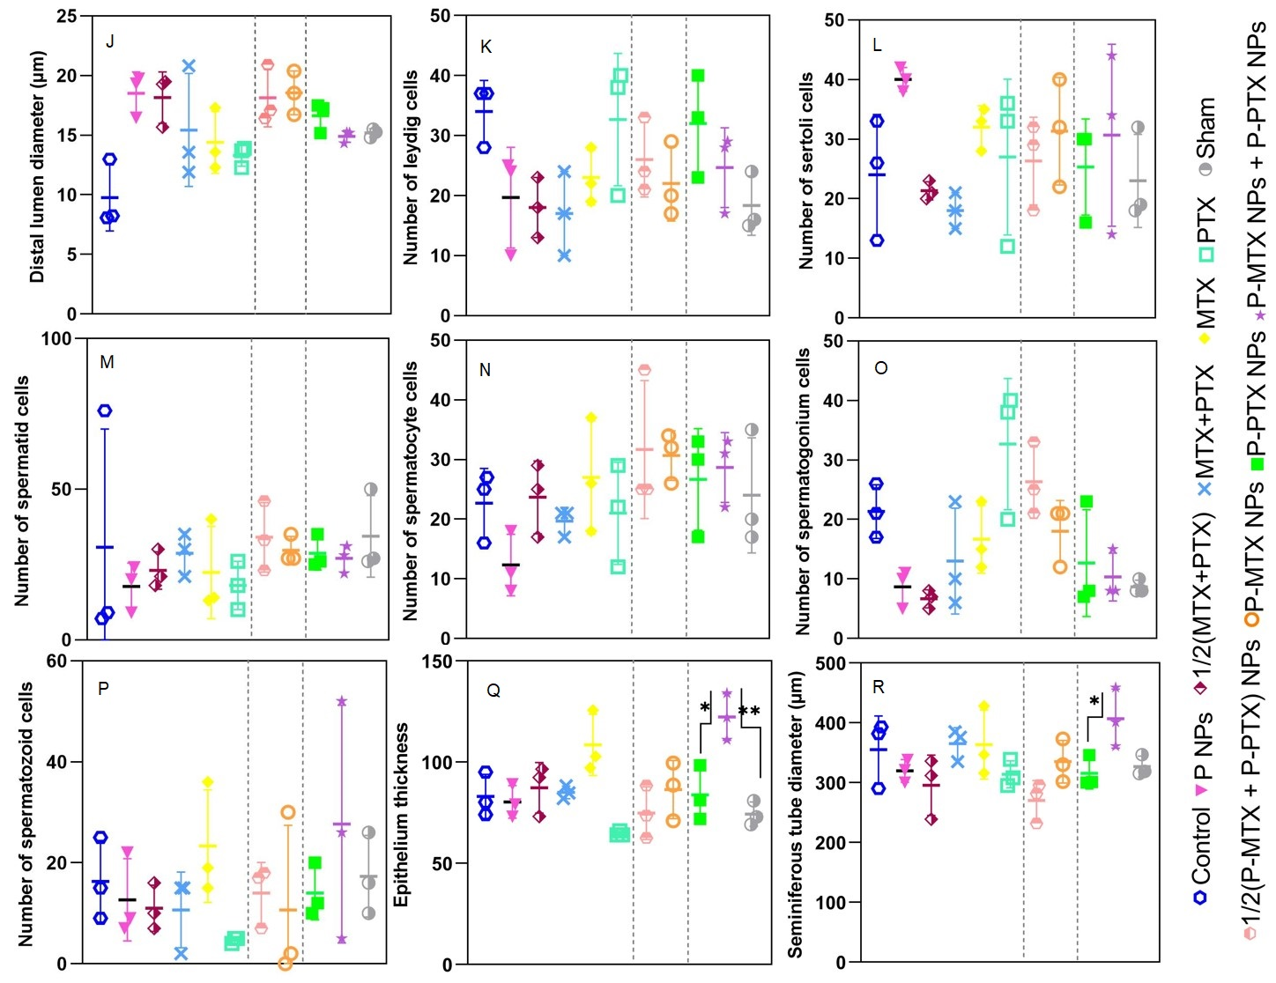

Fig. S6. Continued

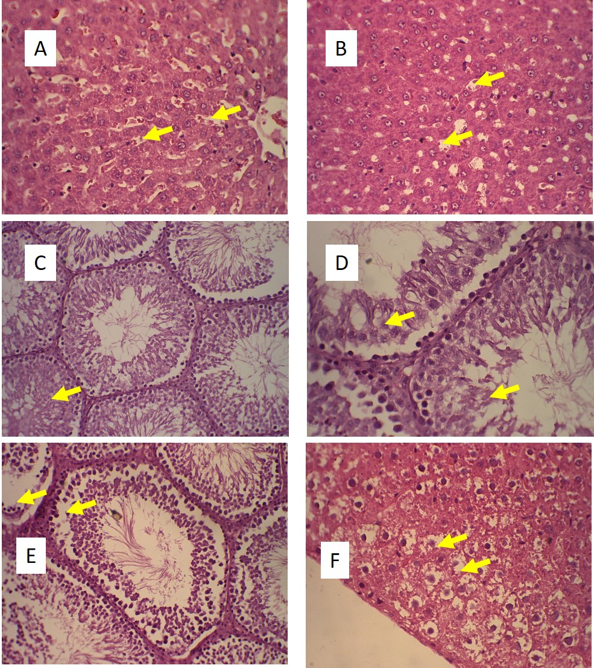
Fig. S7. H&E images of (A,B) focal bleeding in liver sections of a PTX treated rat (X400 magnification), (C,D) morphological change of testis tissue in PTX treated rat (X200 and X400 magnifications, respectively), (E) morphological changes of testis tissue in P-PTX NPs treated rat (X200 magnification), and (F) vacuolization of hepatocytes in P-PTX NPs treated rats (X400 magnification).
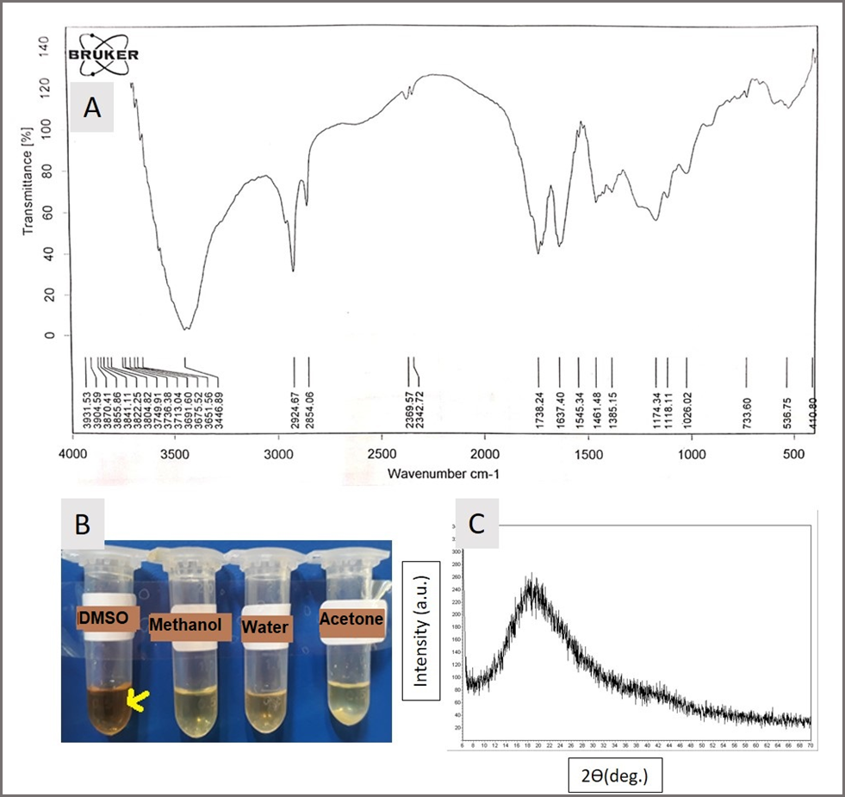
Fig. S8. (A) FTIR diagram of CQD, (B) solubilization of CQD in DMSO, methanol, water and acetone to identify a better solvent, and (C) XRD graph of CQD.

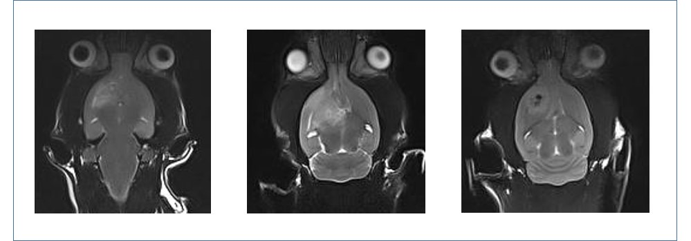
Fig. S9. MRI graph of three tumor-bearing rats which were used for the biodistribution assay.

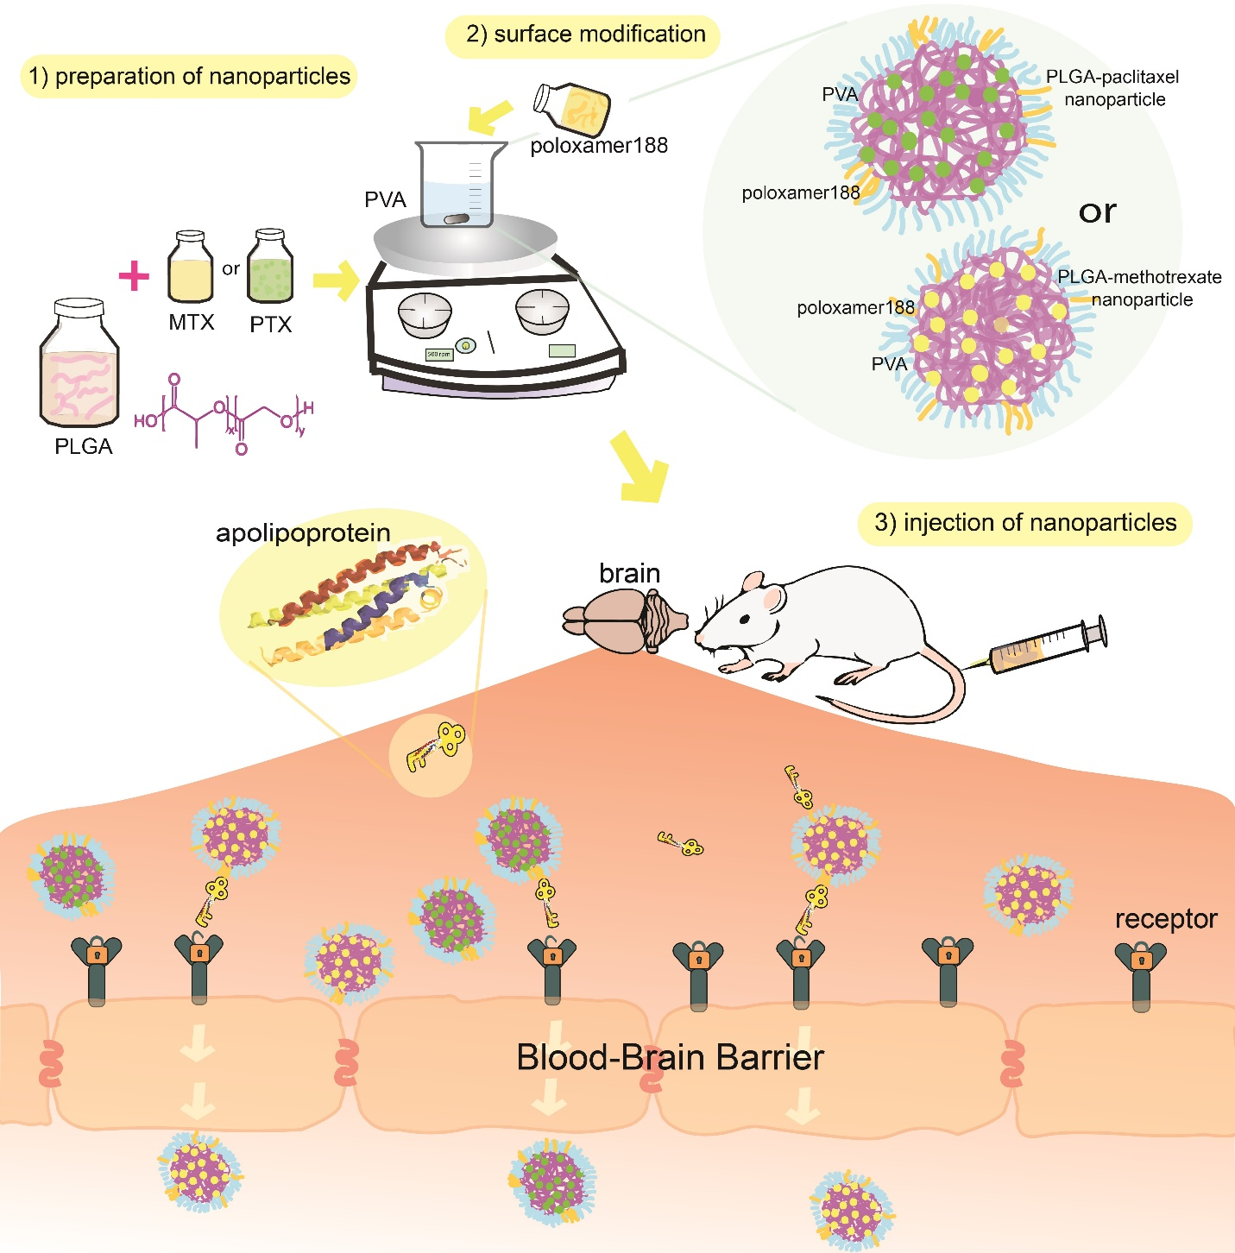
Fig. S10. A schematic process of nanoparticle preparation and entrance into the brain.

