Supplementary materials

Contents

Supplementary 1: outline of recent green infrastructure metrics 2
Supplementary 2: mapping a graded 3-30-300 metric 2
Supplementary 3: Exploring impacts of parametric changes 6
Supplementary 4: Discussion of Methodological Frontiers 11
Supplementary 5: data sources 13
Supplementary 6: FME workflows and intermediate result example 14
Supplementary 7: detailed outline of limitations 16
Processing limitations 17
Data limitations 17
References (supplementary) 19

Supplementary 1: outline of recent green infrastructure metrics

Barron et al. (2016) propose a ranked set of 9 broad indicators of urban forest structure and function, based on expert elicitation, for use in scenario analysis. GreenR is a package for the R programming language which relies on OpenStreetMap data to generate a relative measure of greenness for street segments, promising a very scalable metric where open data quality is high, though it does not set thresholds of adequacy (Majahan, 2023). The Tree Equity Score (produced so far for the US and UK) is a canopy-based metric which borrows elements of the 3-30-300 rule, but focuses strongly on equity, factoring in metrics of risk exposure such as age, employment and income. Interestingly this metric includes a step which reduces canopy requirements in higher-density neighbourhoods, targeting as little as 20% canopy in denser neighbourhoods due to perceived limits to plantable area (American Forests, 2023). MIT’s ‘Treepedia’ processes Streetview data to simply derive a percentage of visible greenery from each photographed location in Streetview for a number of cities globally; while the use green view indices is now more common (e.g. Abril & Sánchez, 2023; Labib et al., 2021), the release of the metric drew strong media attention, partly due to its intuitive presentation and easy comparison between world cities (Balch, 2019). The index does not consider park access, only visible canopy (Li et al., 2015). Finally, the Singapore Index on Cities’ Biodiversity is a set of 28 diverse metrics ranging from canopy cover to invasive species to institutional capacity, budgets and public education (Secretariat of the Convention on Biological Diversity, 2021).

Supplementary 2: mapping a graded 3-30-300 metric

Methods

Simply assessing whether buildings meet each of the 3-30-300 tests yields a simple ‘yes/no’ binary of achievement for each answer – effectively a score out of three points. This can be mapped to give a basic view of which locations fail to meet the standard. However, it offers little insight into how close each non-achieving building might be to meeting each of the three benchmarks. Accordingly, partial achievement in each of the three tests was graded to derive a score out of ten, as follows:
- For the ‘3’ test, buildings scored 1 point for having one tree visible, 2 points for two trees visible, and 3 points for having three or more trees visible.
- For the ‘30’ test, buildings scored 1 point for having canopy over 10%, 2 points for canopy over 20%, 3 points for canopy over 25% and 4 points for canopy over 30%.
- For the ‘300’ test, buildings scored 1 point for being within 500m walk of a park, 2 points for being within 400m, and 3 points for being within 300m.
This difference was visualised for Denver and compared to a simple scoring out of three to demonstrate the finer insights that a graded scoring can offer.

Results

Mapping overall achievement rates in a city paints a clear picture of the spatial heterogeneity of green infrastructure provision in urban areas. Figure 1a examines downtown Denver, and has been colourised to highlight total failures to meet the rule. The central city is strikingly bright (indicating low achievement of the 3-30-300 rule) compared to its adjacent suburbs. However, the histogram shows such a predominance of buildings scoring ‘0’ or ‘1’ that a user of this map may struggle to decide where action should be prioritised.
Figure 1a – Denver – simple scorings indicating achievement of each 3-30-300 standard.
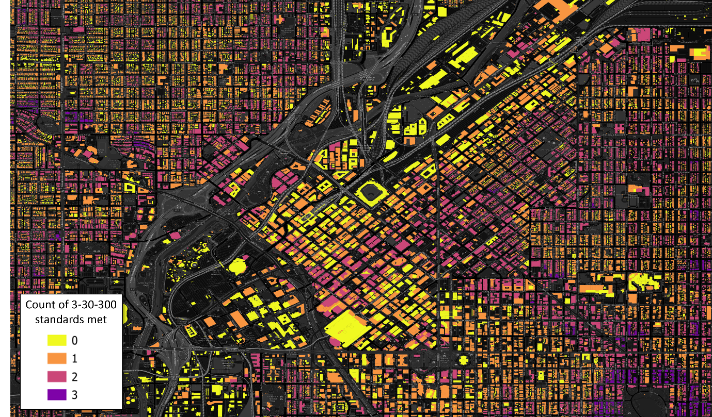

As one aim of this study was to understand not only the ‘pass/fail’ result for each building but also how far buildings have fallen short, we modified our scorings to make partial achievement visible in spatial visualisations. Figure 4b is the result; it seeks to offer a better degree of differentiation between near-success, mediocrity and abject failure. By assigning each building a score out of ten, where 10/10 represents full achievement of the 3-30-300 rule, we see that the downtown area of Denver still is severely lacking green infrastructure, but also that there is some variability in access. Truly low scores stand out more clearly, and much more of the difference between the suburbs in the east and the west is apparent. The histogram of scores in figure 4b also offers a much clearer sense that halfway achievements of the standard (scores between 4-6) are common, and outright failures are rarer. This contrasts with the picture painted in figure 4a of a city with buildings mainly scoring 0 and 1.
Figure 1b - graded
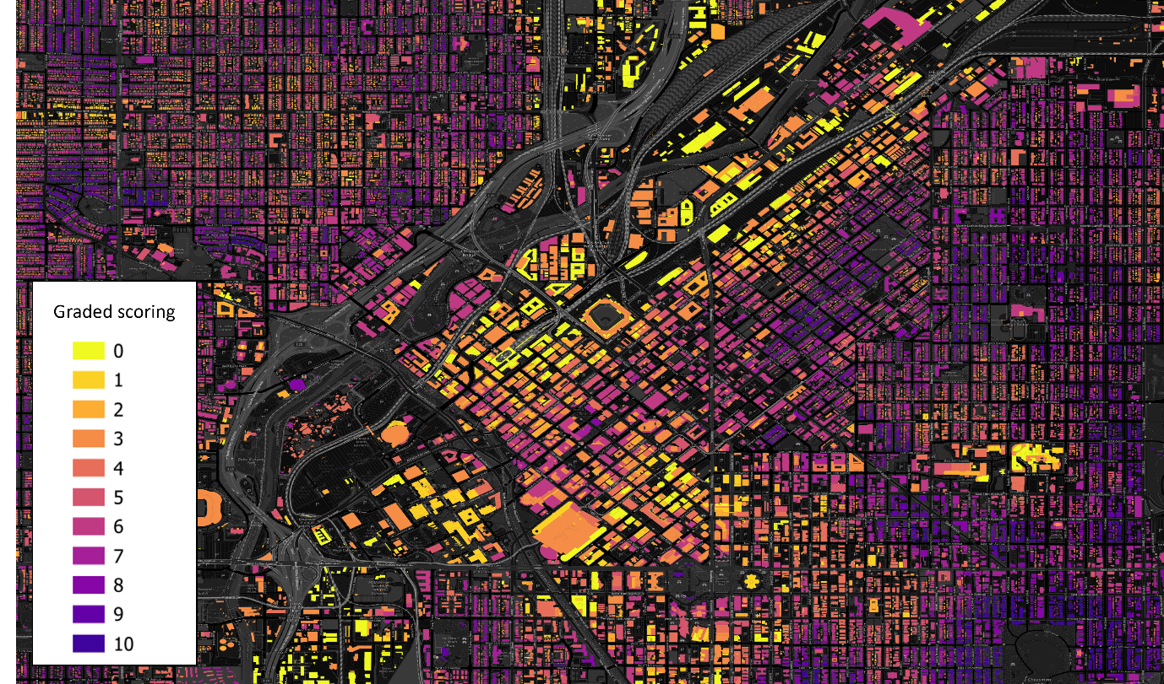

Exploring a map using the graded scoring demonstrated in Figure 4b allows a better understanding of what these mid-range results look like. Figure 3 offers examples of streetscapes in Denver, contrasting a street scoring mostly a 5 with streets scoring 0 and 10. While the 0 result is predictably stark, it is striking that the 5 result – which represents multiple failures to meet a minimum standard – is not as clearly inadequate, with numerous smaller trees visible, and a park four blocks (~500m) north.
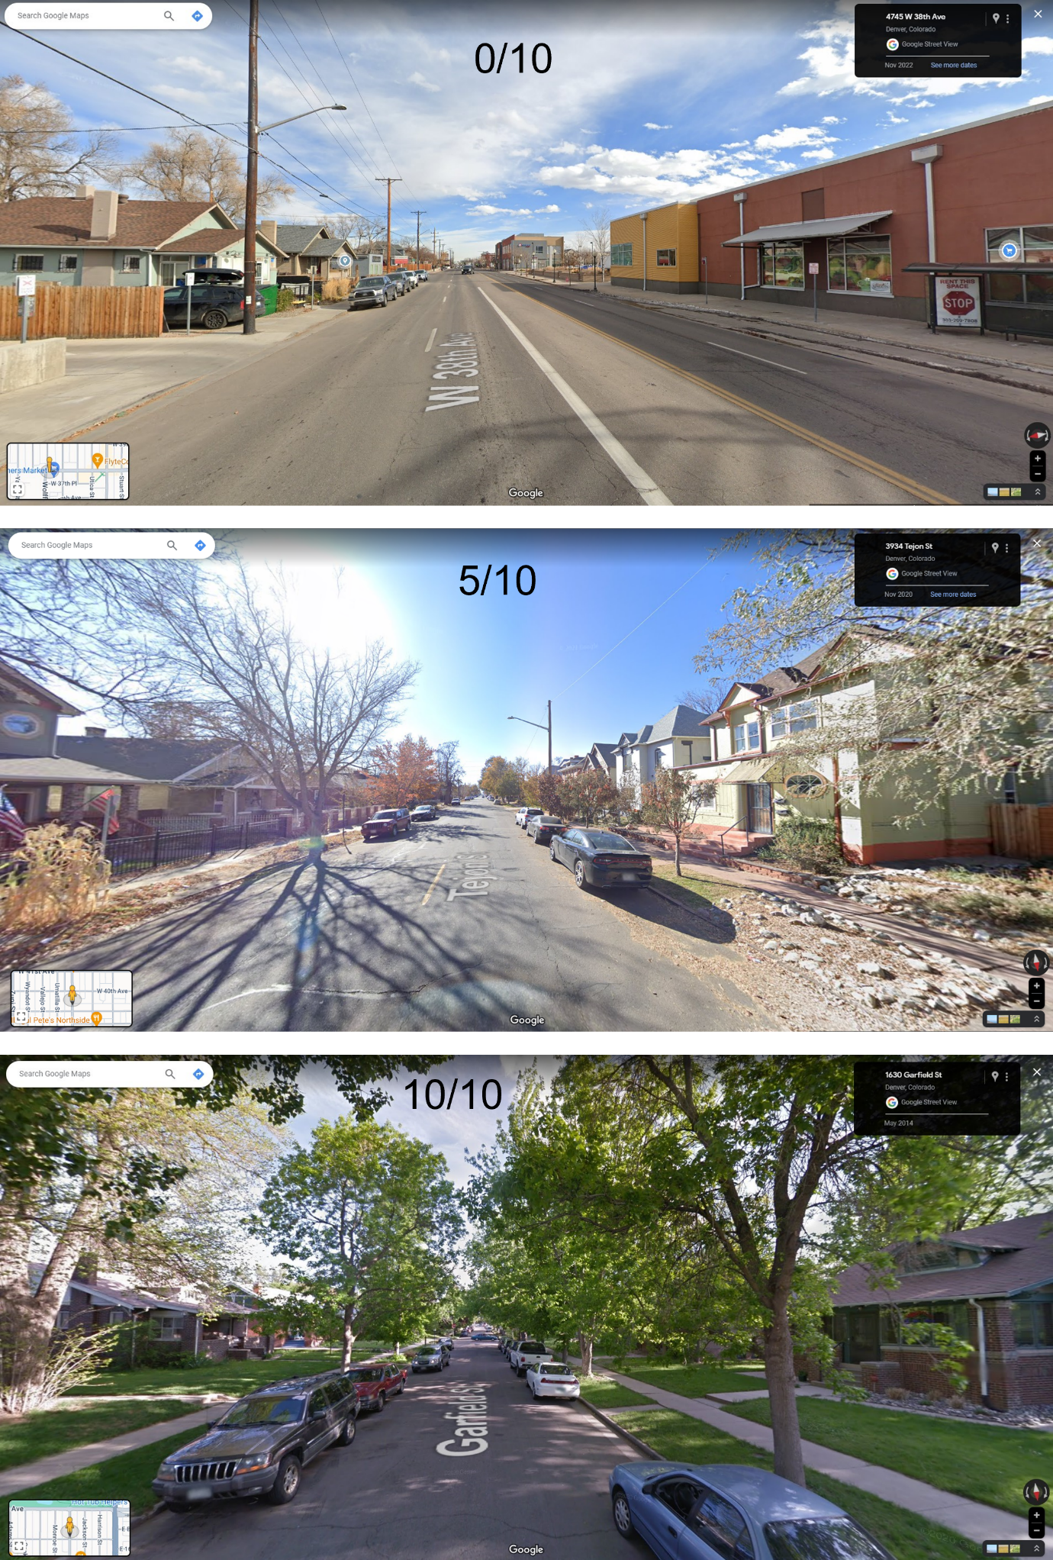
Figure 3 – Streetview images of scored streets in Denver.

Supplementary 3: Exploring impacts of parametric changes

In this analysis, we prepared and re-ran a number of variants to the analysis in New York, examining how results changed when the parameters of the analysis changed (for example in relation to how distances were calculated, or which trees were deemed eligible parts of the analysis).

Methods employed in testing

The 3-30-300 rule specifies that visible trees meeting the ‘3’ must be ‘established’. This is a difficult trait to capture with a single metric, but Konijnendijk (2022) suggests a canopy of at least 24sqm as a possible test for established trees. Without actively interrogating the suitability of this threshold, we tested it’s application in New York, which had sufficiently detailed data within its tree inventory (point) layer. Most cities in this study do not have canopy data for individual trees. By filtering the trees dataset by attributes, trees above 24sqm could be isolated, and then run through the generic ‘3’ test described above. Joining this dataset to the original tree dataset allowed this study to establish which buildings had views of 3 or more established trees, which buildings only meet the 3 rule if views of small trees are counted, and which locations failed both tests.
The ’30’ rule requires 30% neighbourhood canopy, but the best available proxy for ‘neighbourhood’ varied in definition from city to city, and in many cases we used census-based spatial units. This does change the level of spatial aggregation applied in the canopy test. In New York we were able to identify and test three different options to use as ‘neighbourhoods’ for this test: a set of census tracts, a set of administrative districts used by the municipality, and a set of boundaries that attempt to identify neighbourhoods as social units. Each of these was visualised and compared to identify the effects of spatial aggregation.
Browning et al. (2024) note that there is also some ambiguity in the calculation of the ‘300’ test. While network analysis is recommended, they do countenance the use of simple buffers, which effectively calculate a direct linear distance (i.e. ‘as the crow flies’). This is not a precise measure, especially where road networks are disconnected and/or circuitous (e.g. in cul-de-sac neighbourhood designs), but could give a broad estimate and avoid the processing demands and (occasionally substantial) routing failures associated with network analysis. Accordingly, New York was analysed using a simple buffer-based analysis, where buffers of 100,200, 300, 400 and 500m were generated around parks, and the number of properties within each buffer set was counted. This was compared to the network-based result to understand both how similar the results might be, and also how different the demands of calculation were.
Finally, this study’s generic process for calculating ‘300’ involved all parks from each city, but a strict reading of the 3-30-300 rule would exclude all parks under 0.5ha (5000sqm). In a dense city like New York, where numerous ‘pocket parks’ offer high-quality locations for passive recreation (e.g. Greenacre Park, Manhattan), this rule would exclude a significant number of the city’s green spaces. To determine how results change when a strict 0.5ha limit is applied to parks, we re-ran the generic ‘300’ test but added an attribute filter to exclude all parks under this size. This enables an understanding of how many buildings rely on smaller parks in New York.

Results of parametric testing

Our experiments with changes to our method in New York highlighted the scope for variances in results depending on the quality of analysis and data that is possible within a given city. Figure 1 shows that three different approaches to the definition of ‘neighbourhood’ yield three quite different spatial distributions of achievement of the rule, with the use of census tracts (which was our approach in the main study for all US cities) proving the most generous and fine-grained. It is clear that the way ‘neighbourhood’ is defined has potential to sway results considerably. Our finding also indicates that pockets of high canopy are more likely to achieve the ‘30’ rule in smaller neighbourhood units, suggesting that what canopy does exist is very patchy and easily diluted by surrounding low-canopy areas. While the results in Figure 1 do show spatial variance, all three represent an achievement rate of under 2% of the total building stock.
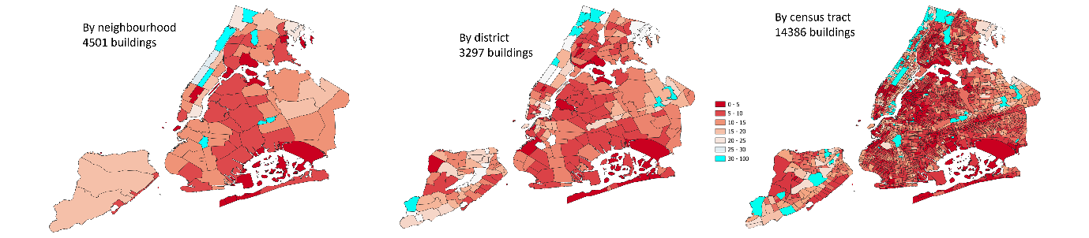
Figure 1 – Count of buildings meeting 30% standard under different ‘neighbourhood’ boundaries. Census tracts are the default unit used in this study. Districts are an administrative unit defined by the municipal government, whereas the neighbourhood dataset sought to capture socially-defined neighbourhood boundaries.
Other experiments with methodological changes in New York focused on how rates of achievement of specific standards changed; these are visualised in Figure 2.
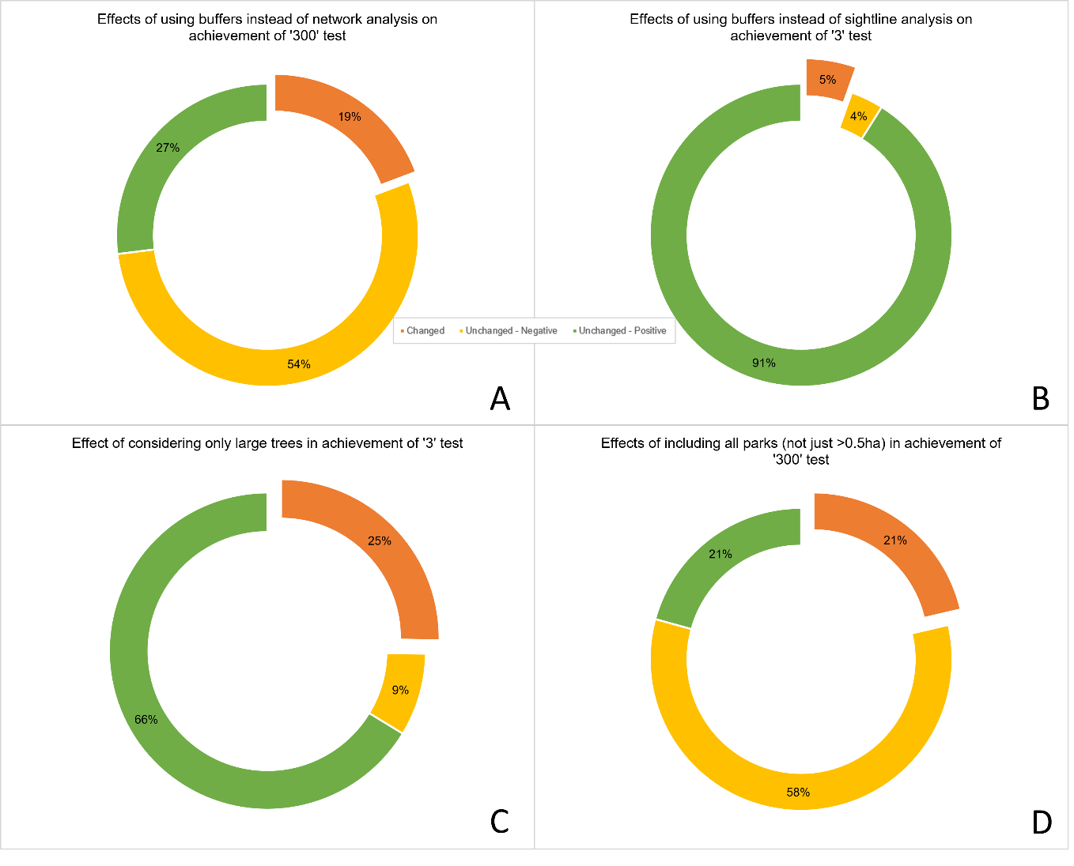Figure 2 – Changes in results observed in New York when methods or definitions were modified.

The use of 300m buffers instead of walking distances led to a 19% rise in achievement of the standard (Panel A). New York’s very high achievement of the standard ‘3’ test meant that the use of a 30m buffer instead of testing sightlines showed only a modest difference in achievement of the standard (5%, Panel B).The exclusion of small trees (<24m², as per Konijnendijk (2023)) from the ‘3’ test reduced achievement of the standard from over 90% to 66%, suggesting that where this exclusion is possible (i.e., where canopy data is available for each tree) it offers valuable distinction between locations (Panel C). Inclusion of parks under 0.5ha in park walking distance analyses adds a large number of small parks to the analysis, resulting in an additional 21% of buildings meeting the standard (Panel D). Histograms for each of these analyses are included below in Figure 3.

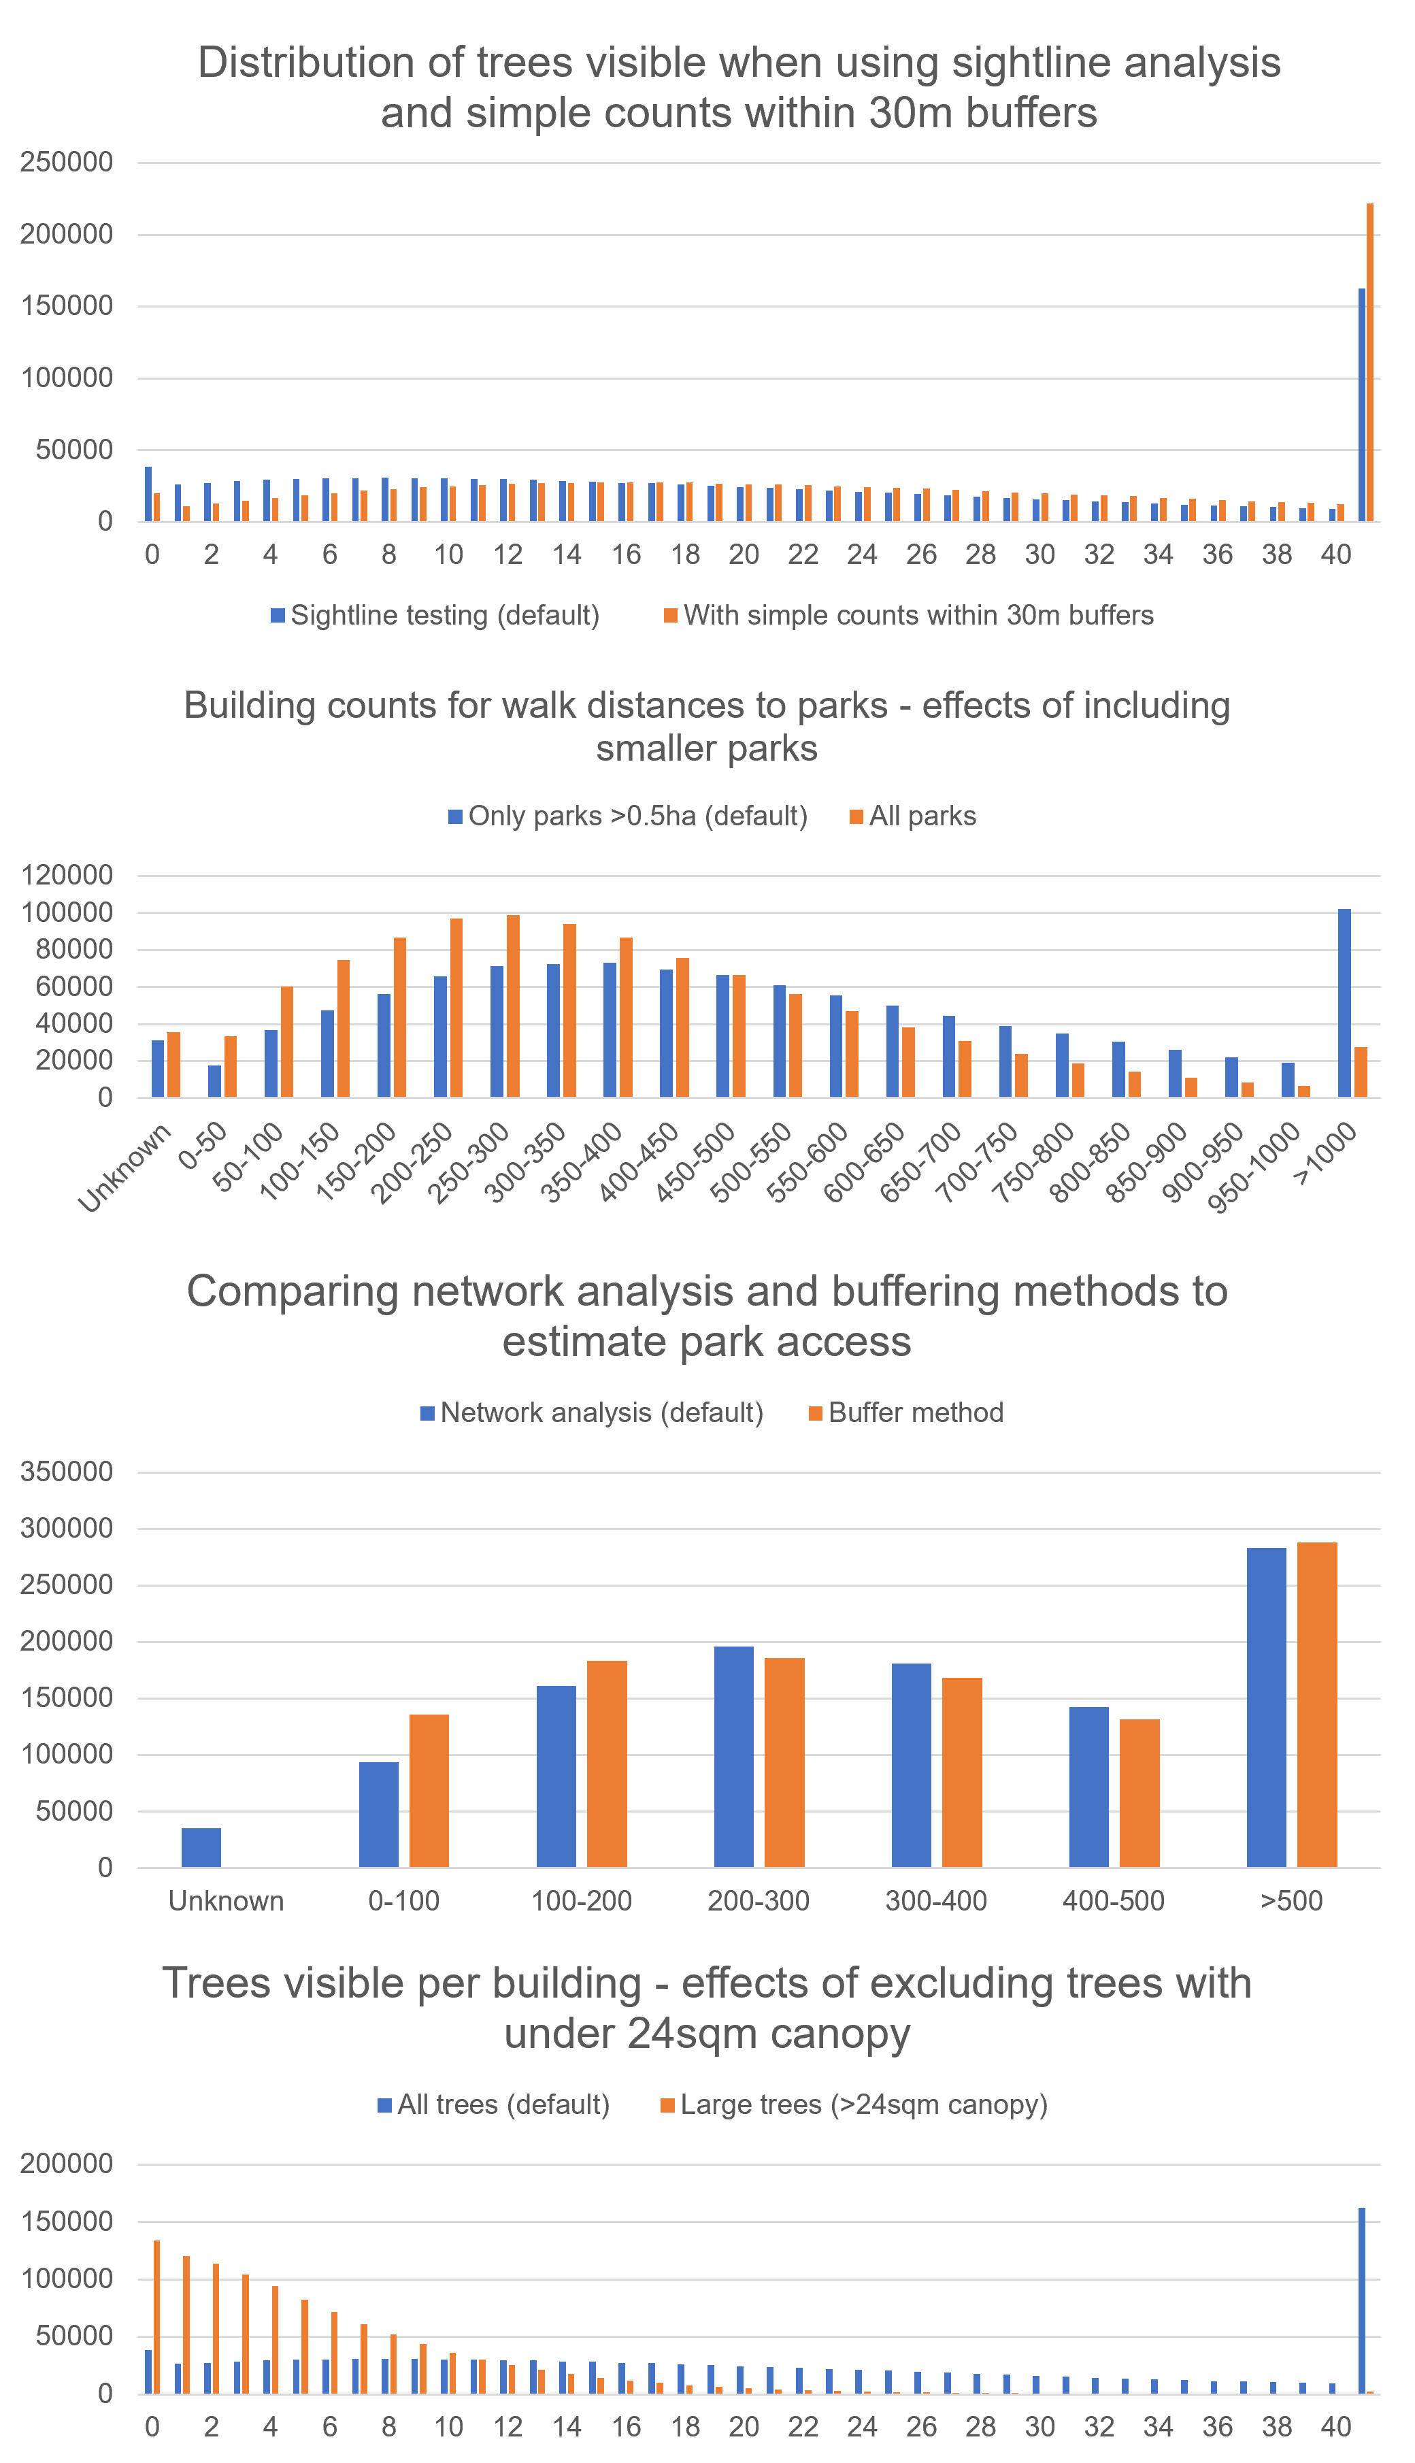
Figure 3 – Changes in distribution of results.

Supplementary 4: Discussion of Methodological Frontiers

As may be expected in a new indicator designed primarily to work as a heuristic, many details of the method for calculating 3-30-300 are yet to be clarified and standardised. These are well-documented by Browning et al. (2023), and our experiences in calculating the metric in different ways and with different input data have highlighted how thresholds and definitions can produce somewhat different results. Konijnendijk is transparent that his proposed ‘rule’ is a heuristic metric that cannot possibly accommodate the diversity of benefits associated with trees and parks documented in the literature, nor the diversity of cities in which the benchmark might be applied; it simply aims to balance these findings to set a ‘rule of thumb’ benchmark. Nevertheless, this study has highlighted a few promising areas for development of the method.
The ‘300’ test is evidence-based, reflecting WHO guidelines for Europe (Annerstedt Van Den Bosch et al., 2016; Battisti et al., 2024), and it fits well in terms of heuristic ‘rhyme’ with the other tests. However, many other organisations plan to thresholds of 400m (Victorian Planning Authority, 2021) or 500m (City of Darebin, 2019), and it may be argued that a network of larger parks with 400-500m walking distances may not meet the ‘300’ rule but could provide better overall amenity. However, even if this benchmark was eased to 500m, our results show that all cities except Singapore would still have at least one-third of buildings that fail the test. Similarly, the minimum size of parks adopted in this study (0.5ha) could be contested, either for being too small (e.g. Konijnendijk (2022) notes that the WHO proposes 1ha) or for excluding very small parks that can still support some important recreational needs in dense areas (Balai Kerishnan & Maruthaveeran, 2021); as noted in our tests in New York, inclusion of all the city’s parks (regardless of size) meant that 21% more of the city’s buildings passed the ‘300’ test.
The ‘3’ test also has a few important uncertainties which highlight both the data requirements of large-scale operation of this test, and a need for some development of the test itself. It is not firmly established that exactly three trees is essential; the importance of views to nature is scientifically established, but the specific test of 3 trees was chosen to ‘rhyme’ with the more evidence-based ‘30’ and ‘300’ tests (Konijnendijk, 2022). It is also clear when a tree is too small or too distant to be counted. Konijnendijk (2022) does refer to a study by a Dutch consulting firm which defined the threshold for ‘established’ trees as an individual canopy of 25m². Similarly, the distance at which a view to a tree counts or does not count is not set, but the same study proposed 30m, which is what our study used. While very useful as initial ballpark figures, these thresholds may be a suitable focus for further evidence-based refinement.
The data limitations we encountered that prevented a minimum tree size in the ’3’ test highlights the need for high-quality data if the test is to be strictly applied. As we observed in New York, which did have suitable data, the application of a 25m² minimum canopy changed ‘3’ test results for the city significantly (an additional quarter of all buildings failed the test). Individual tree point data with canopy dimensions for each tree may become more accessible in coming years, as this is an area of ongoing methodological refinement (Zhao et al., 2023).
The GIS-based assessment method we developed to enable the ‘3’ test at a metropolitan scale offers significant efficiency advantages over the practical challenges of surveying individual residents about their views, which was advocated by Browning et al (2024). Battisti et al. (2024) called for a more detailed GIS method to calculate this test at fine scales, and our study demonstrates a way to do this, albeit while introducing a margin of error, as discussed in the limitations outlined in Supplementary 7. Working to reduce these limitations – for example using a finer analysis based on individual dwellings or windows instead of buildings – would enhance the precision of the ‘3’ test.
Sensitivity testing of the ‘30’ test to neighbourhood definition in New York did reveal significant variances in the units used. It may be best to ensure consistency by simply counting canopy within a set euclidean distance of each property, rather than in an unrelated spatial unit which varies strongly between definitions.
Given the computational demands of calculating this rule at the city scale, and its required data inputs, a rigorous calculation of the 3-30-300 rule may require cities to invest in high-quality tree inventories, and then seek the support of GIS specialists with access to powerful computers. Where this is not feasible, simplifying the calculation of 3-30-300 may be necessary. Our tests revealed that the use of buffers for the ‘3’ and ‘300’ tests can produce results much more quickly than using more rigorous techniques, and for users seeking a ‘ballpark’ estimate of green infrastructure adequacy the margins of overestimation associated with buffer techniques may be acceptable. We do caution that in highly circuitous street layouts with few intersections (e.g. cul-de-sac suburbia) the divergence between results from buffer analysis and network analysis may be quite severe as these street designs can significantly increase access distances. Labib et al. (2020) demonstrates how buffering and network analysis can produce quite different extents of cover.
With these methodological frontiers noted, we also see the potential for diminishing returns in endless technical refinement, particularly of a heuristic measure like 3-30-300. Metrics do not need to be perfect to be influential; for example Santamour’s 10-20-30 rule for tree diversity is noted as being based on ‘relatively little empirical evidence’ (Galle et al., 2021, p.2). Metrics of liveability succeed in generating headlines annually by ranking cities globally, despite being widely criticised for being opaque in their methods and sources as well as potentially harmful in the issues they conceal. This highlights how important it is that the discursive power of an engagingly-framed measurement is matched by appropriately selected and calculated component measures, to ensure it promotes genuinely useful policy action and avoids perverse outcomes (McArthur & Robin, 2019). While 3-30-300 certainly could be calculated with greater precision, and this is a valid endeavour, these refinements should focus on ensuring enough precision for policy impact rather than perfection.

Supplementary 5: data sources

City | Data type | Source | Link
New York | Tree inventory | Publication | link
New York | Canopy | Publication | link
New York | Parks | Local dataset | link
New York | Roads | Local dataset | link
New York | Buildings | Local dataset | link
New York | Census Tracts | Local dataset | link
New York | Neighbourhoods | Third-party dataset | link
New York | Admin districts | Local dataset | link
Melbourne | Tree inventory | Local dataset | link
Melbourne | Canopy | Local dataset | link
Melbourne | Parks | State dataset | link
Melbourne | Roads | State dataset | link
Melbourne | Buildings | Local dataset | link
Melbourne | Census tracts | National dataset | link
Sydney | Tree inventory | Local dataset | link
Sydney | Canopy | State dataset | link
Sydney | Parks | State dataset | link
Sydney | Roads | State dataset | link
Sydney | Buildings | Corporate dataset (Microsoft) | link
Sydney | Census tracts | National dataset | link
Denver | Tree inventory | State dataset | link
Denver | Canopy | Local dataset | link
Denver | Parks | Local dataset | link
Denver | Roads | Local dataset | link
Denver | Buildings | Local dataset | link
Denver | Census tracts | Local dataset | link
Seattle | Tree inventory | Local dataset | link
Seattle | Canopy | Local dataset | link
Seattle | Parks | Local dataset | link
Seattle | Roads | Local dataset | link
Seattle | Buildings | Local dataset | link
Seattle | Census tracts | Local dataset | link
Buenos Aires | Tree inventory | Local dataset | link
Buenos Aires | Canopy | Treepedia | link
Buenos Aires | Parks | Local dataset | link
Buenos Aires | Roads | Local dataset | link
Buenos Aires | Buildings | Corporate dataset (Google) | link
Buenos Aires | Neighbourhoods | Municipal dataset | link
Amsterdam | Tree inventory | Local dataset | link
Amsterdam | Canopy | National dataset | link
Amsterdam | Parks | Local dataset | link
Amsterdam | Roads | Open Street Map | link
Amsterdam | Buildings | EU dataset | link
Amsterdam | Neighbourhoods | Local dataset | link
Singapore | Tree inventory | National (trees.sg), hosted informally | link
Singapore | Canopy | Treepedia | link
Singapore | Parks | National | link
Singapore | Roads | OSM | link
Singapore | Buildings | Google Open Buildings | link
Singapore | Neighbourhoods | National | link

Supplementary 6: FME workflows and intermediate result example

Figures in this supplement show the FME processing steps involved in calculating the ‘3’ and ‘300’ tests. The relatively simple ’30’ test is omitted.
The ‘3’ test: examining tree visibility from properties.
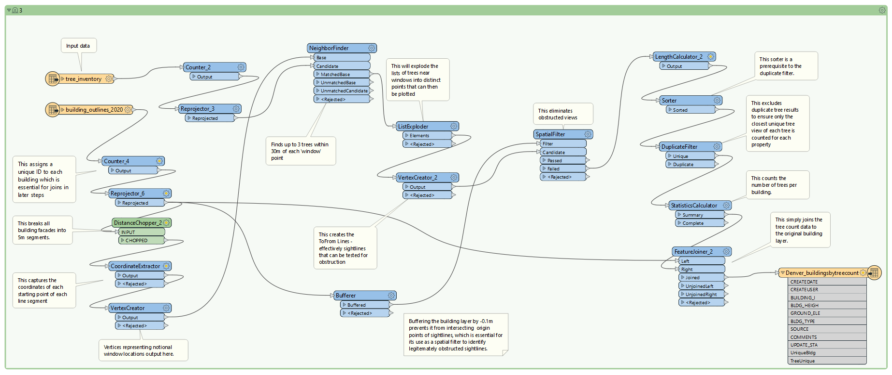

The ‘300’ test: examining open space accessibility to properties.
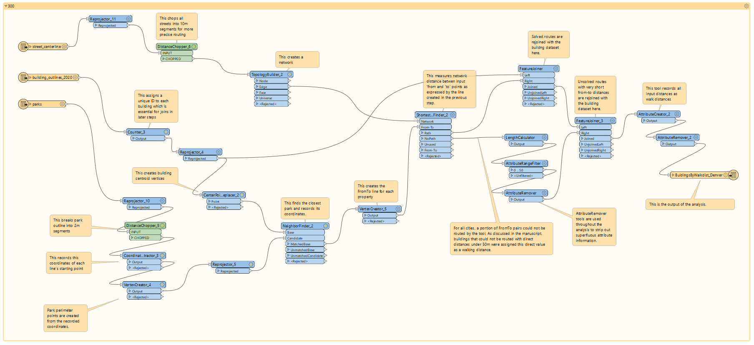
Example of sightline analysis showing views from buildings to trees (blue dots). Counts are posted on each building.
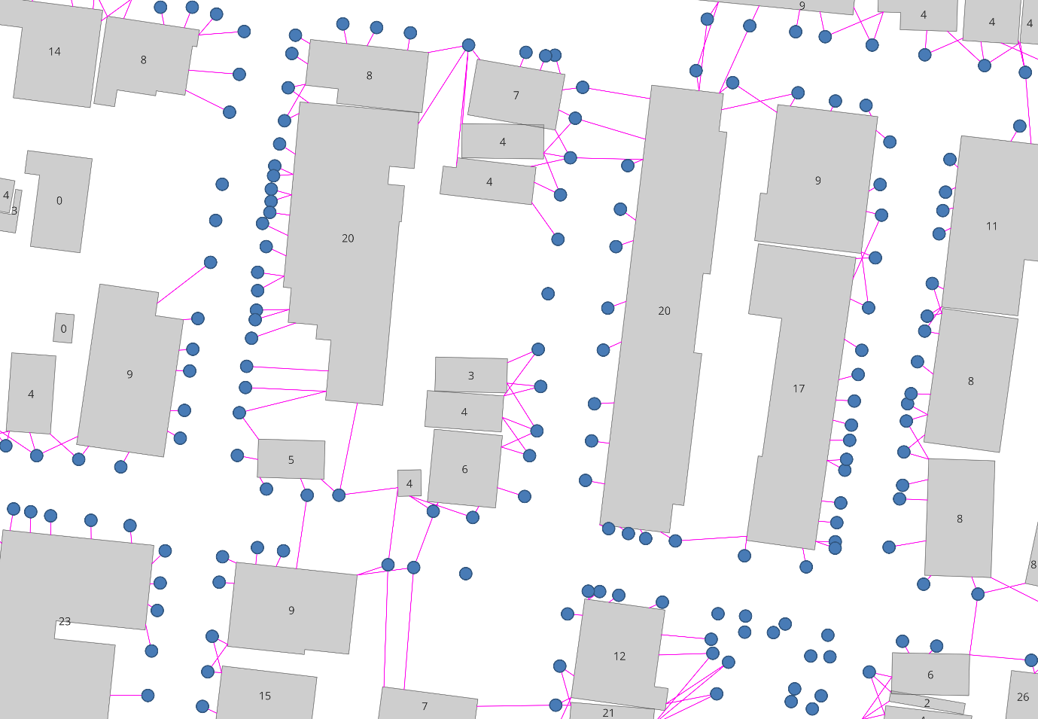
Example of routing problem identified in early iterations of the analysis. This is a site in New York, where origin-destination pairs (represented by red lines) were not routable because of large interceding pedestrian areas.
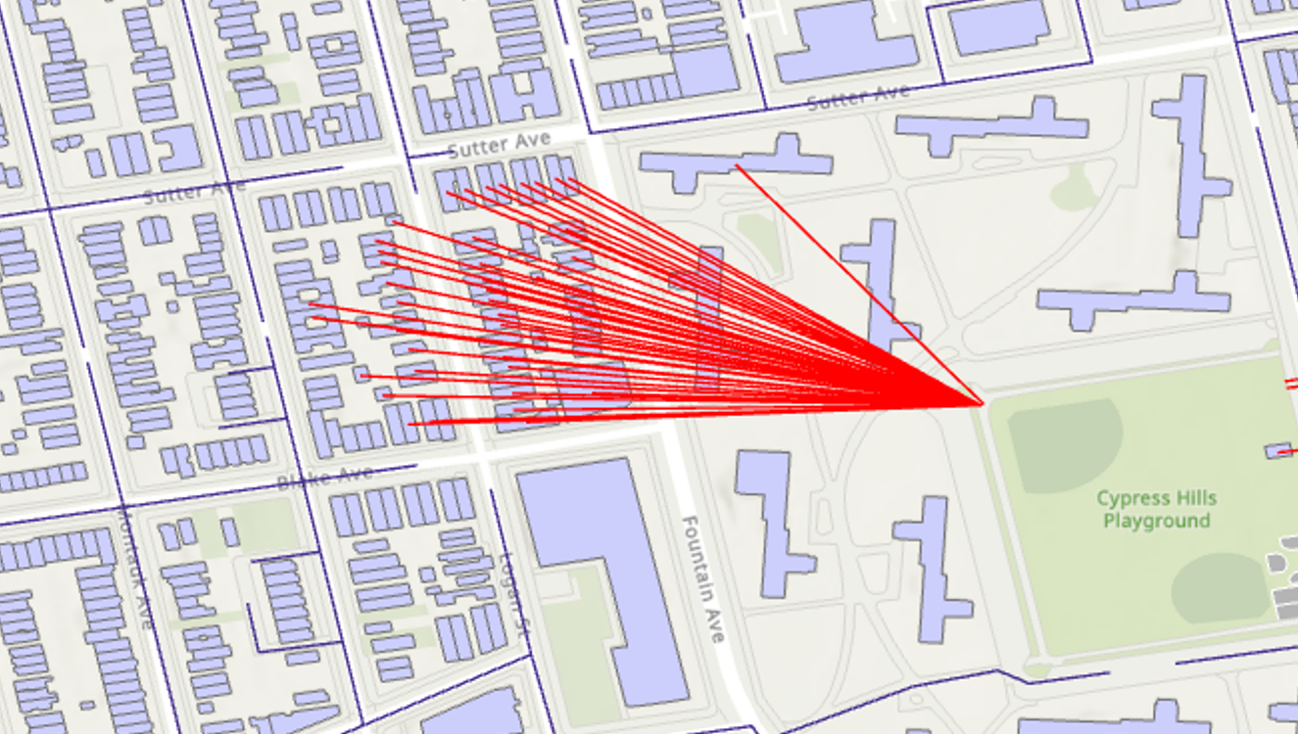

Supplementary 7: detailed outline of limitations

City | Quality concerns | Processing concerns | Relative precision
NY | Tree data was quite old (2010-2014) and resolution was somewhat coarse (1m). | Network analysis failed to find a small fraction of paths | Highest – minimal approximations and shortcuts required
Melbourne | Public trees only  Building dataset included some unusual structures e.g. bridges, stadiums | Network analysis failed to find a small fraction of paths | High
Sydney | Public trees only | Network analysis failed to find a small fraction of paths | High
Denver | Parks layer included golf courses | Network analysis failed to find a small fraction of paths | High
Seattle | Machine-learned canopy and tree location data – includes a margin of error. |  | Highest
Buenos Aires | Building layer was approximate (machine learned)  Tree inventory was from 2017-18  Greenview instead of canopy |  | Lower – significant approximations and workarounds required
Amsterdam | Public trees only | Road network had severe routing issues – proximity analysis was used instead | Lower – significant approximations and workarounds required
Singapore | Parks layer derived from OSM  Somewhat informal tree data source  Greenview | Road network had severe routing issues – proximity analysis was used instead | Lower – significant approximations and workarounds required

Processing limitations

The method employed by this study to calculate views of three or more trees was the largest deviation from Browning et al. (2024), who contend that views from windows are best determined by either the use of questionnaires or advanced analyses based on the precise location of windows (including window height, location and landscape elevation). While more precise, these analyses are not practical for city-scale estimates; for example, our analysis of New York involved over one million buildings. Analyses based on individual windows also would require sophisticated input data that is not currently available at the city scale; while assuming a window every 5m is fairly coarse, it does give a sense of which buildings have an unobstructed line of sight to trees, which is the only aspect of the urban forester’s job that is within their control (urban foresters can offer the opportunity to view three trees, but the visibility of those trees for residents ultimately depends on whether the building’s design includes windows).
Spatial software offers a range of ways of calculating a ‘viewshed’ from a digital elevation model. In lay terms, this is essentially the use of an algorithm to show which areas on a map are visible from a given point. While this is more conventionally used in landscape-scale analyses (e.g. to determine which houses in a valley will be able to see a new wind farm), it could also be used to create viewsheds for single properties in urban settings. Intersecting a viewshed for each property with a tree inventory layer would offer a more precise estimate of tree visibility. However, carrying out this relatively ‘heavy’ calculation at city scale quickly proved to be computationally unfeasible with generic desktop computers, and the simpler ‘line of sight’ method was developed as a substitute.
Routing along these road networks proved complex and error-prone, but was eventually achieved by increasing snapping distances or substituting buffer methods. We note that computer scientists have recently published specifically on the nuances of this task (Jafari et al., 2022).
Network analysis for this study quickly revealed the need to use ‘snapping’ distances of up to 100m to ensure building and park centroids link to a road network (thereby avoiding a high proportion of ‘no path’ errors), which does mean that measures of travel distance are also not completely precise.
Finally, the construction of a scoring out of ten was an experiment in adding nuance to the ‘rule’, but it was quite coarse. Use of a stepped scoring which offered up to 4 points for canopy cover to produce a score out of ten does bias the index toward one of the three tests; the metric also does not reward over-achievement of the tests (e.g. a 40% canopy result, or a park within 100m, is not treated differently to 30% canopy or 299m park distance). The test also assumes linear decrease in benefit with decreasing green infrastructure. A more precise partial scoring might weight the three tests equally, and apportion scores based on evidence of how beneficial a partial achievement of the result really is. Parametrising such a test was beyond the scope of our study.

Data limitations

Most of the urban forest datasets in this study are generated and maintained by municipality staff, and accordingly are limited to public trees. This does lead to some underestimates of green space access; for example the University of Sydney has many privately-owned trees on its large campus, but the use of public urban forest datasets for the ‘3’ test meant that its buildings performed poorly on this test.
Conversely, some areas received scores were either false positives – such as buildings that got positive scores for open space access because they were near grassy areas associated with airport runways – or negative scores that may not be problematic, e.g. in port areas. In both cases this is because data was not meticulously cleaned for tailored use; this step may be necessary for some municipalities.
Data limitations also prevented the exclusion of small trees from the analysis, as data that links individual trees to their canopy cover is still a relative novelty. It also limited the precision of the analysis to the building scale; multi-unit dwellings were treated as single structures, which may limit accuracy in large structures where individual apartments have substantially different views or locations.

References (supplementary)
Abril, I., & Sánchez, V. (2023). Accessing Eye-level Greenness Visibility from Open- Source Street View Images : A methodological development and implementation in multi-city and multi-country contexts. 1–34.
American Forests. (2023). Tree Equity Score UK. https://uk.treeequityscore.org/
Annerstedt Van Den Bosch, M., Egorov, A. I., Mudu, P., Uscila, V., Barrdahl, M., Kruize, H., Kulinkina, A., Staatsen, B., Swart, W., & Zurlyte, I. (2016). Development of an urban green space indicator and the public health rationale. Scandinavian Journal of Public Health, 44(2), 159–167. https://doi.org/10.1177/1403494815615444
Balai Kerishnan, P., & Maruthaveeran, S. (2021). Factors contributing to the usage of pocket parks―A review of the evidence. Urban Forestry and Urban Greening, 58(April 2020), 126985. https://doi.org/10.1016/j.ufug.2021.126985
Balch, O. (2019). Green streets: which city has the most trees? The Guardian. https://www.theguardian.com/cities/2019/nov/05/green-streets-which-city-has-the-most-trees
Barron, S., Sheppard, S. R. J., & Condon, P. M. (2016). Urban forest indicators for planning and designing future forests. Forests, 7(9), 1–17. https://doi.org/10.3390/f7090208
Battisti, L., Giacco, G., Moraca, M., Pettenati, G., Dansero, E., Larcher, F., & Forest, U. (2024). Spatializing Urban Forests as Nature-based Solutions : a methodological proposal. Cities, 144(June 2023), 104629. https://doi.org/10.1016/j.cities.2023.104629
City of Darebin. (2019). Breathing Space: City of Darebin Open Space Strategy. https://www.darebin.vic.gov.au/About-Council/Policies-and-transparency/Council-policies-and-strategies
Galle, N. J., Halpern, D., Nitoslawski, S., Duarte, F., Ratti, C., & Pilla, F. (2021). Mapping the diversity of street tree inventories across eight cities internationally using open data. Urban Forestry and Urban Greening, 61. https://doi.org/10.1016/j.ufug.2021.127099
Jafari, A., Both, A., Singh, D., Gunn, L., & Giles-Corti, B. (2022). Building the road network for city-scale active transport simulation models. Simulation Modelling Practice and Theory, 114(August 2021), 102398. https://doi.org/10.1016/j.simpat.2021.102398
Konijnendijk, C. C. (2022). Evidence-based guidelines for greener, healthier, more resilient neighbourhoods: Introducing the 3–30–300 rule. Journal of Forestry Research. https://doi.org/10.1007/s11676-022-01523-z
Labib, S. M., Huck, J. J., & Lindley, S. (2021). Modelling and mapping eye-level greenness visibility exposure using multi-source data at high spatial resolutions. Science of the Total Environment, 755, 143050. https://doi.org/10.1016/j.scitotenv.2020.143050
Labib, S. M., Lindley, S., & Huck, J. J. (2020). Spatial dimensions of the influence of urban green-blue spaces on human health: A systematic review. Environmental Research, 180(May 2019), 108869. https://doi.org/10.1016/j.envres.2019.108869
Li, X., Zhang, C., Li, W., Ricard, R., Meng, Q., & Zhang, W. (2015). Assessing street-level urban greenery using Google Street View and a modified green view index. Urban Forestry and Urban Greening, 14(3), 675–685. https://doi.org/10.1016/j.ufug.2015.06.006
Majahan, S. (2023). greenR: An Open-Source Framework for Quantifying Urban Greenness. GitHub. https://github.com/sachit27/greenR
McArthur, J., & Robin, E. (2019). Victims of their own (definition of) success: Urban discourse and expert knowledge production in the Liveable City. Urban Studies, 56(9), 1711–1728. https://doi.org/10.1177/0042098018804759
Secretariat of the Convention on Biological Diversity. (2021). Handbook on the Singapore Index of Cites’ Biodiversity. https://www.cbd.int/doc/publications/cbd-ts-98-en.pdf
Victorian Planning Authority. (2021). Precinct Structure Planning Guidelines. https://vpa.vic.gov.au/project/psp-guidelines/
Zhao, H., Morgenroth, J., Pearse, G., & Schindler, J. (2023). A Systematic Review of Individual Tree Crown Detection and Delineation with Convolutional Neural Networks (CNN). Current Forestry Reports, 9(3), 149–170. https://doi.org/10.1007/s40725-023-00184-3

