Outcomes of a parallel randomised trial testing community fibrosis assessment for patients with suspected non-alcoholic fatty liver disease (LOCATE-NAFLD) - Supplementary Materials 2

Recruitment
The target sample size was 156 participants, the final recruitment was 98 participants, hence we were 37% short of our target.
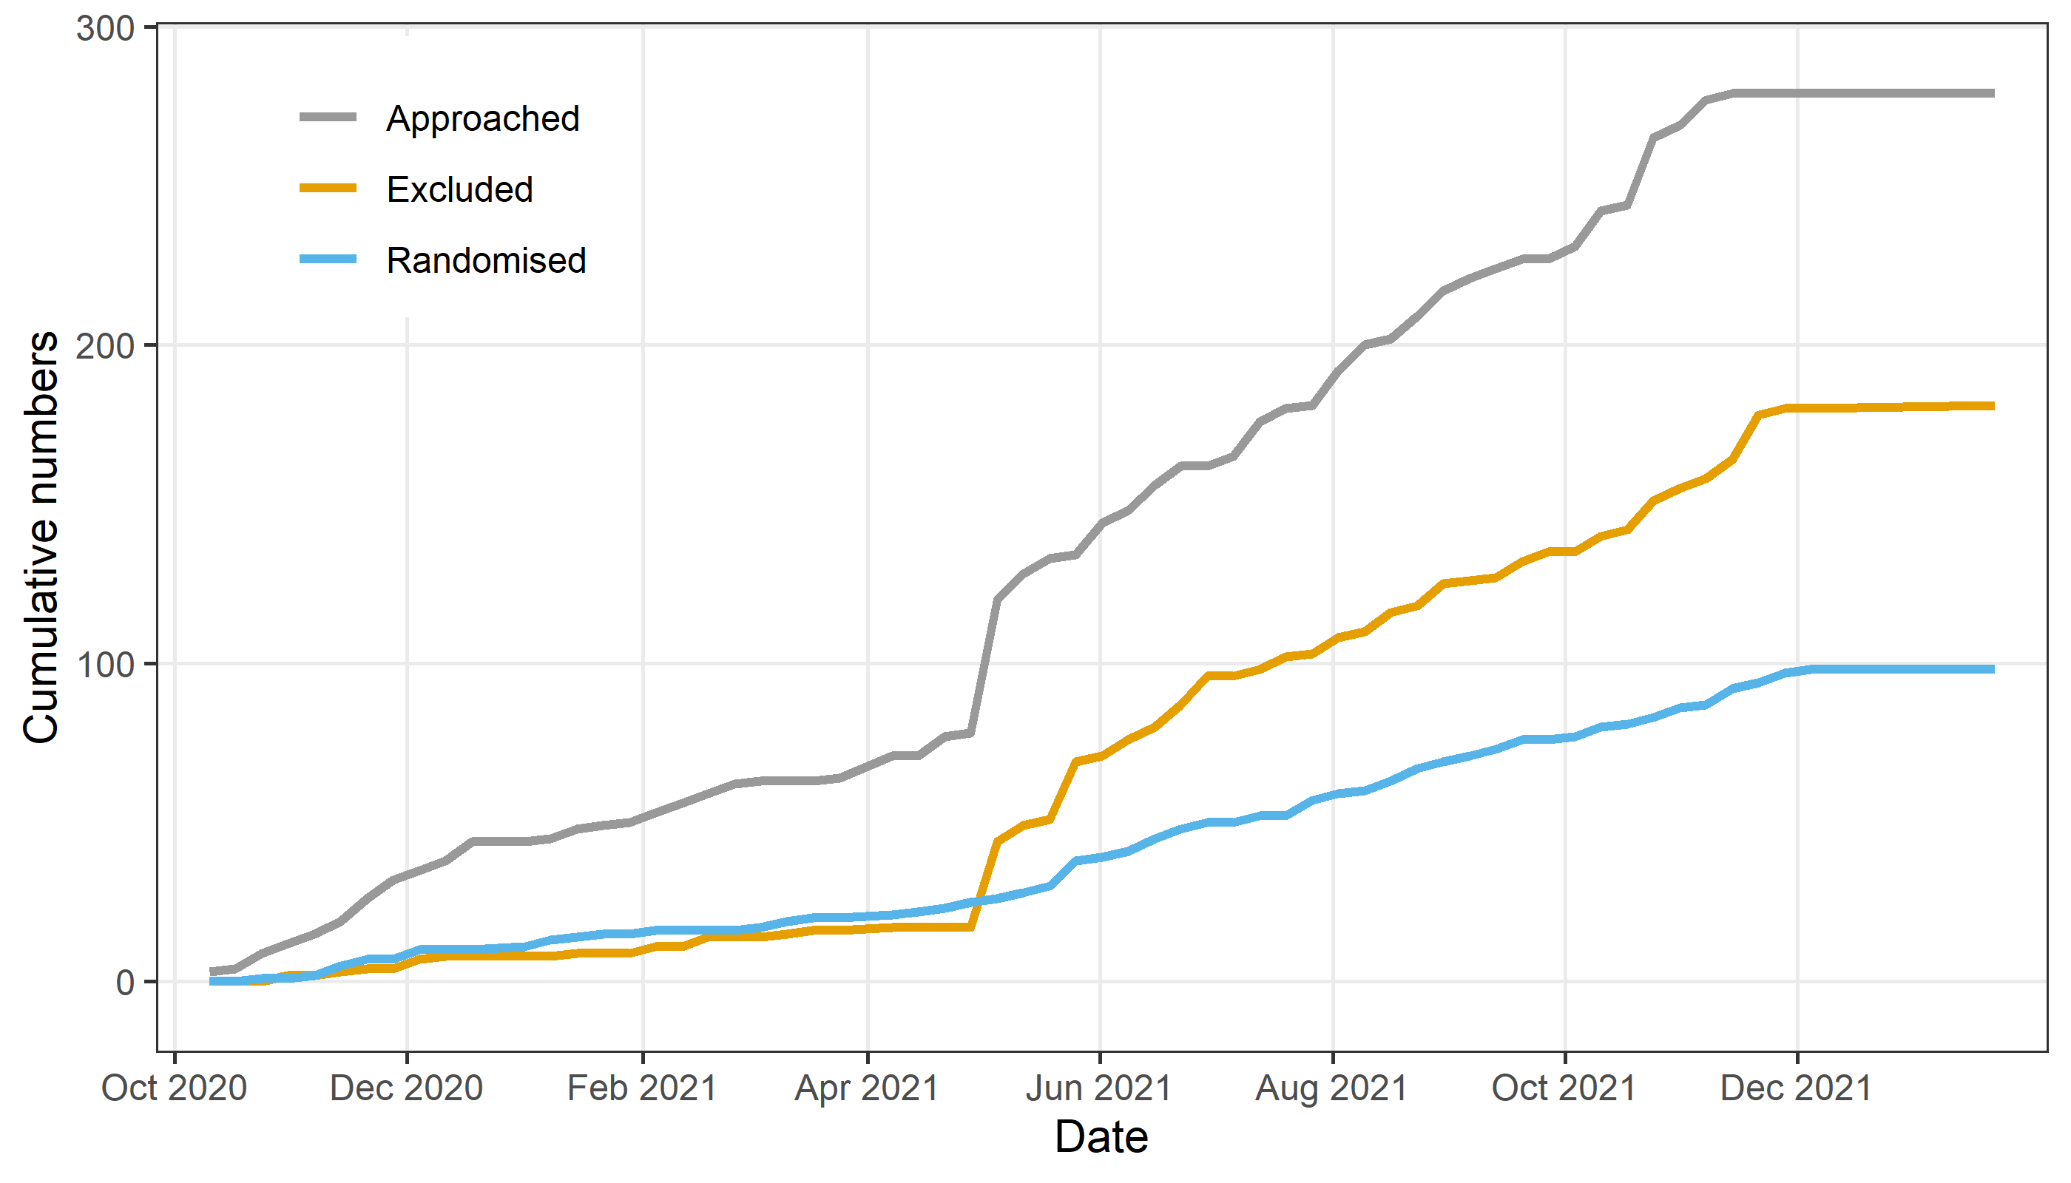
Fig 1: Cumulative participant numbers over time
The final numbers are: 279 approached, 181 excluded and 98 randomised. The first patient was randomised on 27-Oct-2020 and the last on 06-Dec-2021.

Test of randomisation
The plot below is an overall test of the differences at baseline between the randomised groups (Barnett 2022). It examines the distribution of t-statistics and checks if it is over- or under-dispersed compared the expected distribution when the two groups were randomised.
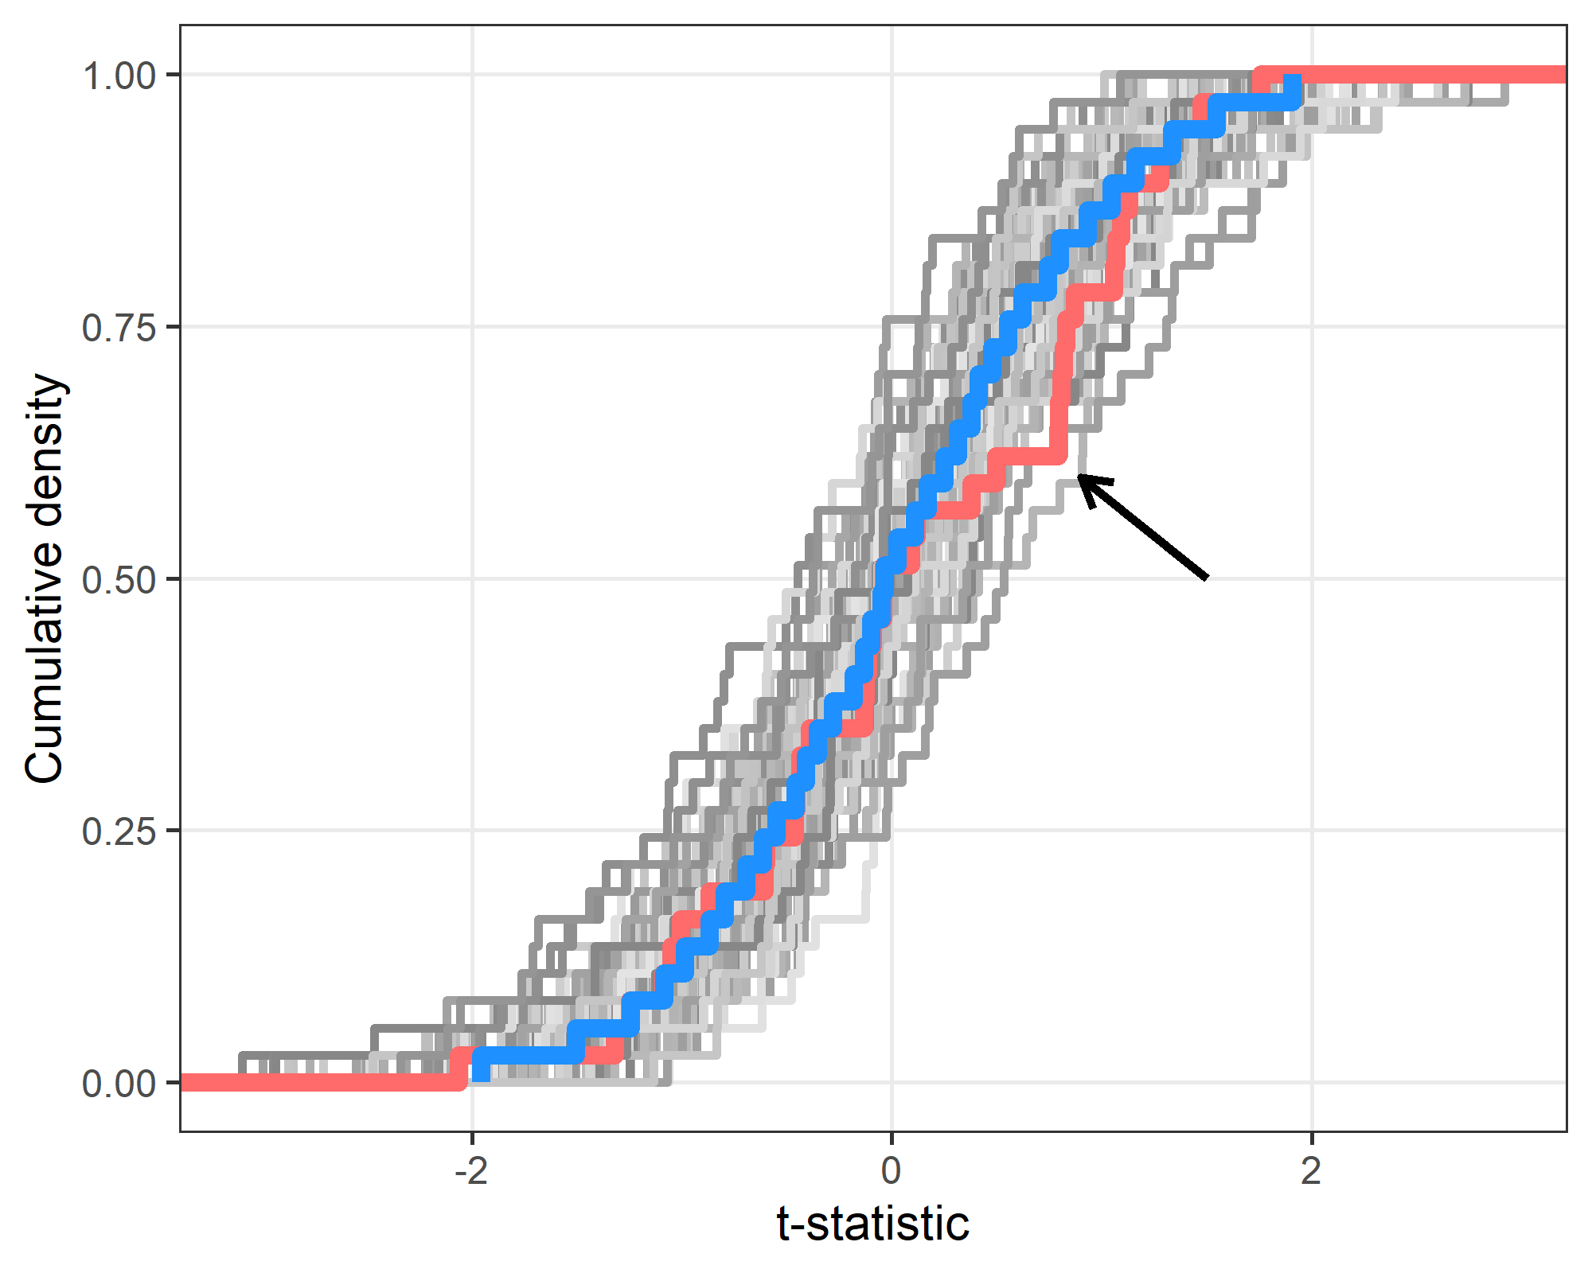
Fig 2: Test of randomisation
The plot shows the cumulative distribution function (CDF) of t-statistics. The trial CDF is in red and 100 simulated trial CDFs in grey. The simulated trials were generated following the null hypothesis of no dispersion. The median of the simulations is in blue. If the groups in the trial were correctly randomised, then the trial CDF should be similar to the CDFs from the simulated data. If the trial CDF is outside the simulated CDFs then this will indicate if the trial summary statistics are under- or over-dispersed.
The plot shows no strong concerns about the trial. There is a small shortage of observed t-statistics between around 0.3 to 0.8 (highlighted by arrow), but this is a moderate departure from the expected distribution.

Emergency department presentations
In this section we examine the time from randomisation to first emergency department presentation.
This outcome was listed in the published protocol as a secondary clinical outcome.
One participant was excluded from this analysis due to negative or missing times. The total follow-up time over all participants is 133 years and 28 participants had at least one ED presentation.
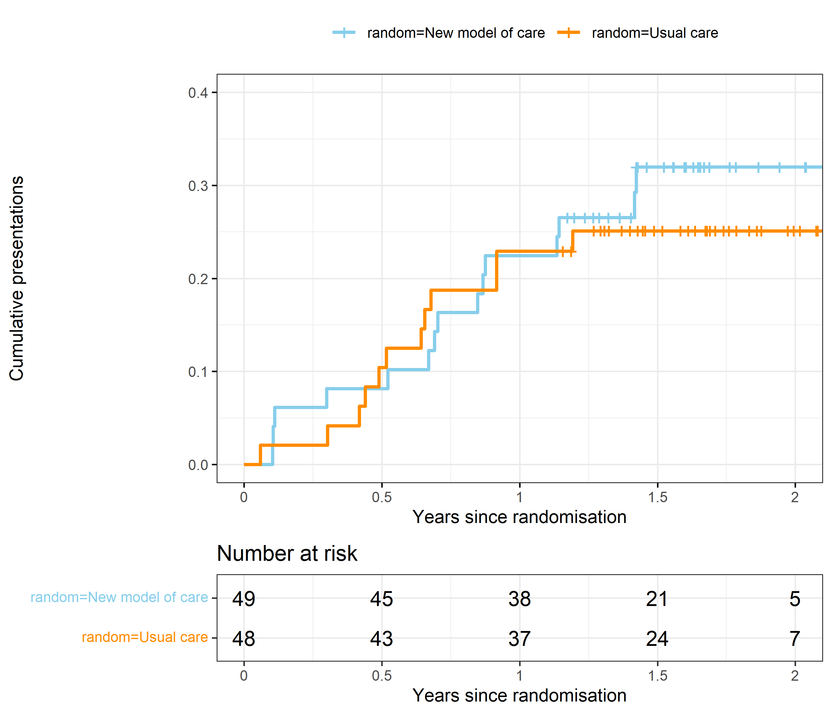
Fig 3: Kaplan–Meier plot (time to ED presentation)
The Kaplan–Meier plot shows little difference between the groups with a steady accumulation of ED presentations in both groups.

Improved health-related quality of life
This outcome was listed in the published protocol as a secondary clinical outcome.
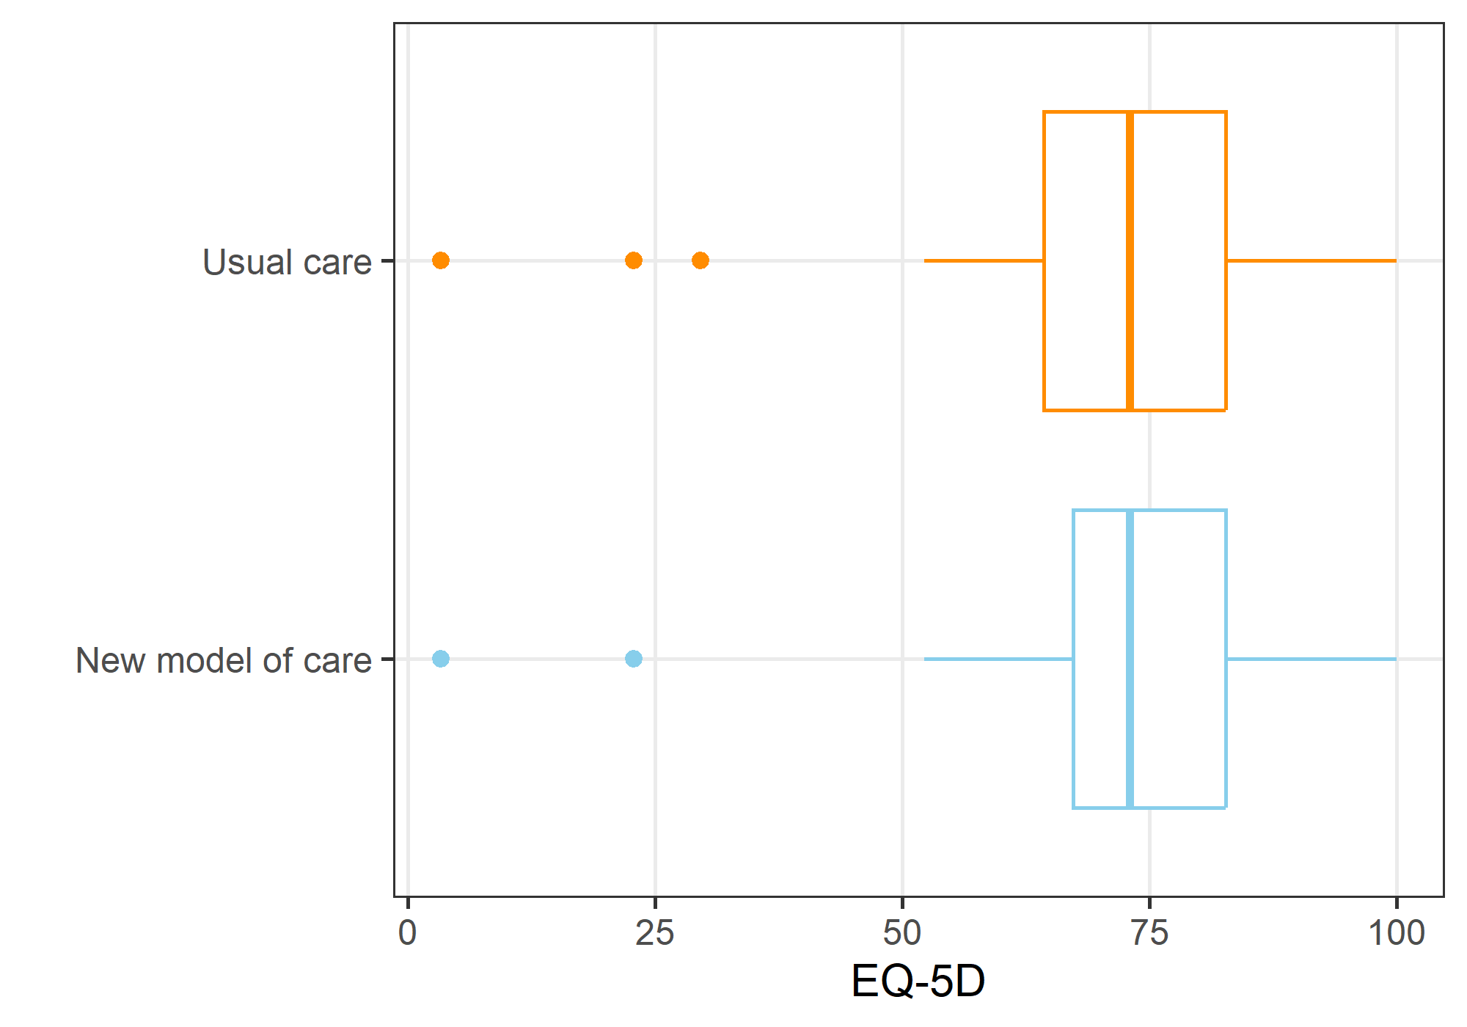
Fig 4: Quality of Life boxplot by randomised group
The higher the score, the better the quality of life. The highest possible score is 100, and the lowest 0.

Table 1: Quality of life – Statistical results from the generalised linear model. The table shows the means and 95% confidence intervals.
Variable | Mean | Lower | Upper
Intercept | 65.9 | 57.3 | 74.4
EQ-5D at baseline | 0.7 | 0.5 | 0.9
New model of care | –3.6 | –12.6 | 5.5
Age (+10 years) | 1.3 | –1.8 | 4.5
Male | 6.3 | –3.2 | 15.8
Time since randomisation (months) | 5.3 | –0.5 | 11.1
Standard deviation | 17.1 | 14.1 | 20.8
The results are on the scale of EQ-5D from 0 to 100. The model adjusted for baseline EQ-5D, age, gender, time since randomisation, and centre. Time since randomisation was added because there was some variance in when the participants were called, although most were close to the 12-month time.
Because of missing follow-up data, there were 61 participants available for this analysis. There was little difference in quality of life between the usual care and new model of care groups.
Baseline quality of life was strongly predictive of follow-up quality of life, which is as expected.
Increased statin use
Table 2: Statin use. The table shows the number of participants and percentage.
 | New model of care | Usual care
Already on cholesterol lowering drugs 12 months ago | 11 (37%) | 5 (16%)
No drugs | 15 (50%) | 23 (74%)
Yes, started cholesterol lowering drug (not a statin) | 1 (3%) | 1 (3%)
Yes, started statin | 3 (10%) | 2 (7%)
Table 3: Statistical model (statin use) from the generalised linear model. The table shows the mean odds ratio and 95% confidence interval. An odds ratio above 1 indicates an increased use of Statin.
Variable | Mean | Lower | Upper
New model of care | 4.0 | 0.40 | 56
Age (+10 years) | 0.50 | 0.19 | 1.14
Male | 0.07 | <0.01 | 0.68
Sunshine Coast | 2.8 | 0.22 | 36
The dependent variable is starting a statin. We excluded those patients who were already on a statin at baseline. The number of participants included was 45. We used a logistic regression model.
The model adjusted for age, gender, and centre. Men had a lower odds of starting a statin but the size of the reduction was uncertain with wide confidence intervals. The new model of care was associated with a much higher odds of new statin use, but the 95% credible intervals were wide and included a reduced use of new statins relative to the usual care group.

Increased referrals to a specialist, other than a hepatologist: dietician/nutritionist or psychologist
This outcome was listed in the published protocol as a secondary clinical outcome.
These results are taken from the 12-month follow-up phone call with participants. There were 37 participants who were missing this outcome and so were excluded from this analysis.
Table 4: Participants accessing additional services at 12 months. The table shows the number of participants and percent.
 | New model of care (LOCATE) (n=30) | Usual care (n=31)
Seeing a dietitian or nutritionist at 12 months (n, %)
Yes | 13 (43%) | 9 (29%)
No | 17 (57%) | 22 (71%)
Seeing a psychologist at 12 months (n, %)
Yes, psychologist | 4 (13%) | 8 (26%)
Yes, accredited counsellor | 3 (10%) | 1 (3%)
No | 23 (77%) | 22 (71%)
Increased GP use
This outcome was not listed in the published protocol or trial registration.
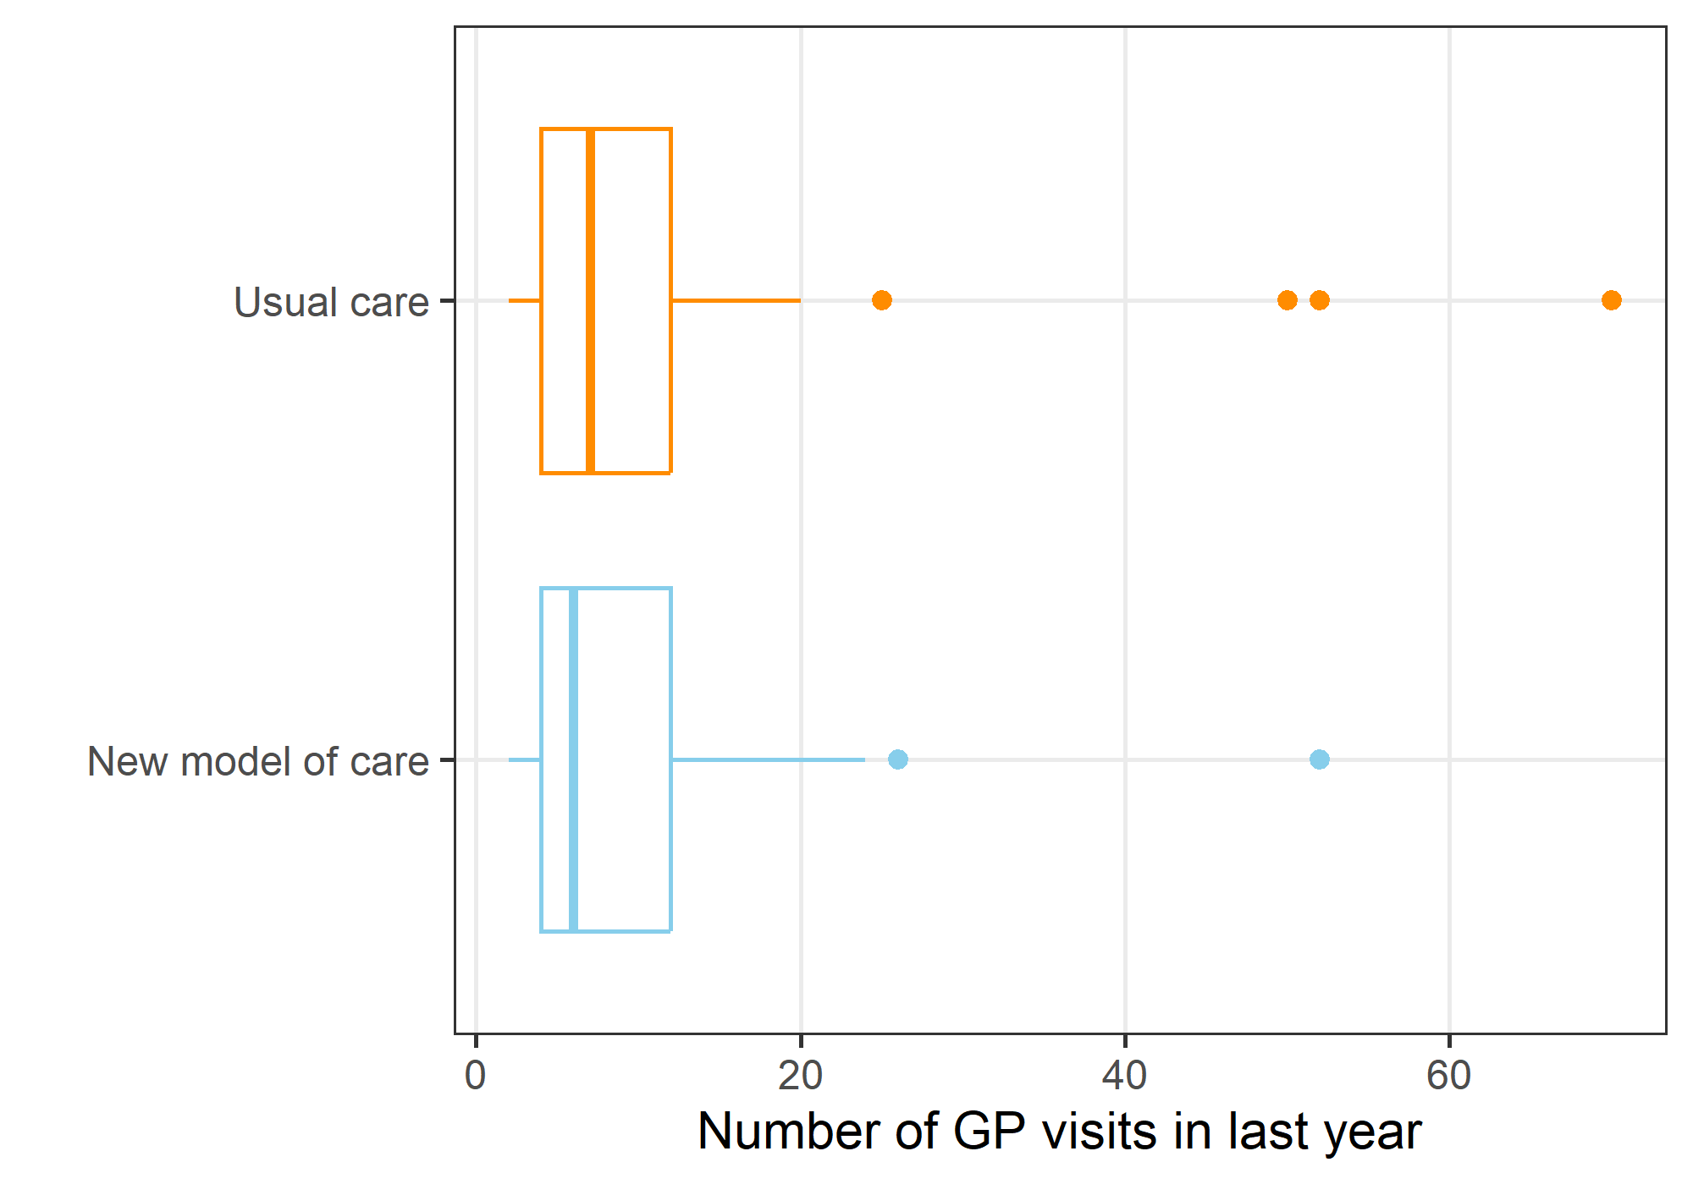
Fig 5: GP Use – Box Plot by randomised group
The number of GP visits in the last year has a strong positive skew and four outliers of over 40 visits. There were 37 participants who were missing this outcome and so were excluded from this analysis. There were 4 participants with missing data for their number of GP visits at baseline. We used multiple imputation to impute their missing values before running the model.

Table 5: GP Use – Statistical Model from the generalised linear model. The table shows the rate ratios and 95% confidence interval. A rate ratio above 1 indicates an increase in GP Use.
Variable | Mean | Lower | Upper
New model of care | 0.81 | 0.69 | 0.94
GP visits at baseline (log-transformed) | 3.58 | 2.78 | 4.60
Age (+10 years) | 1.08 | 1.01 | 1.14
Male | 1.10 | 0.75 | 1.62
We adjusted for GP use at baseline and, not surprisingly, there was a strong positive association between baseline GP usage and follow-up usage. We also adjusted for age and sex and older people were associated with an increase in GP Usage (average 8% higher per 10 year increase in age).
The new model of care was associated with a decrease in GP usage, with a mean decrease of 19%.

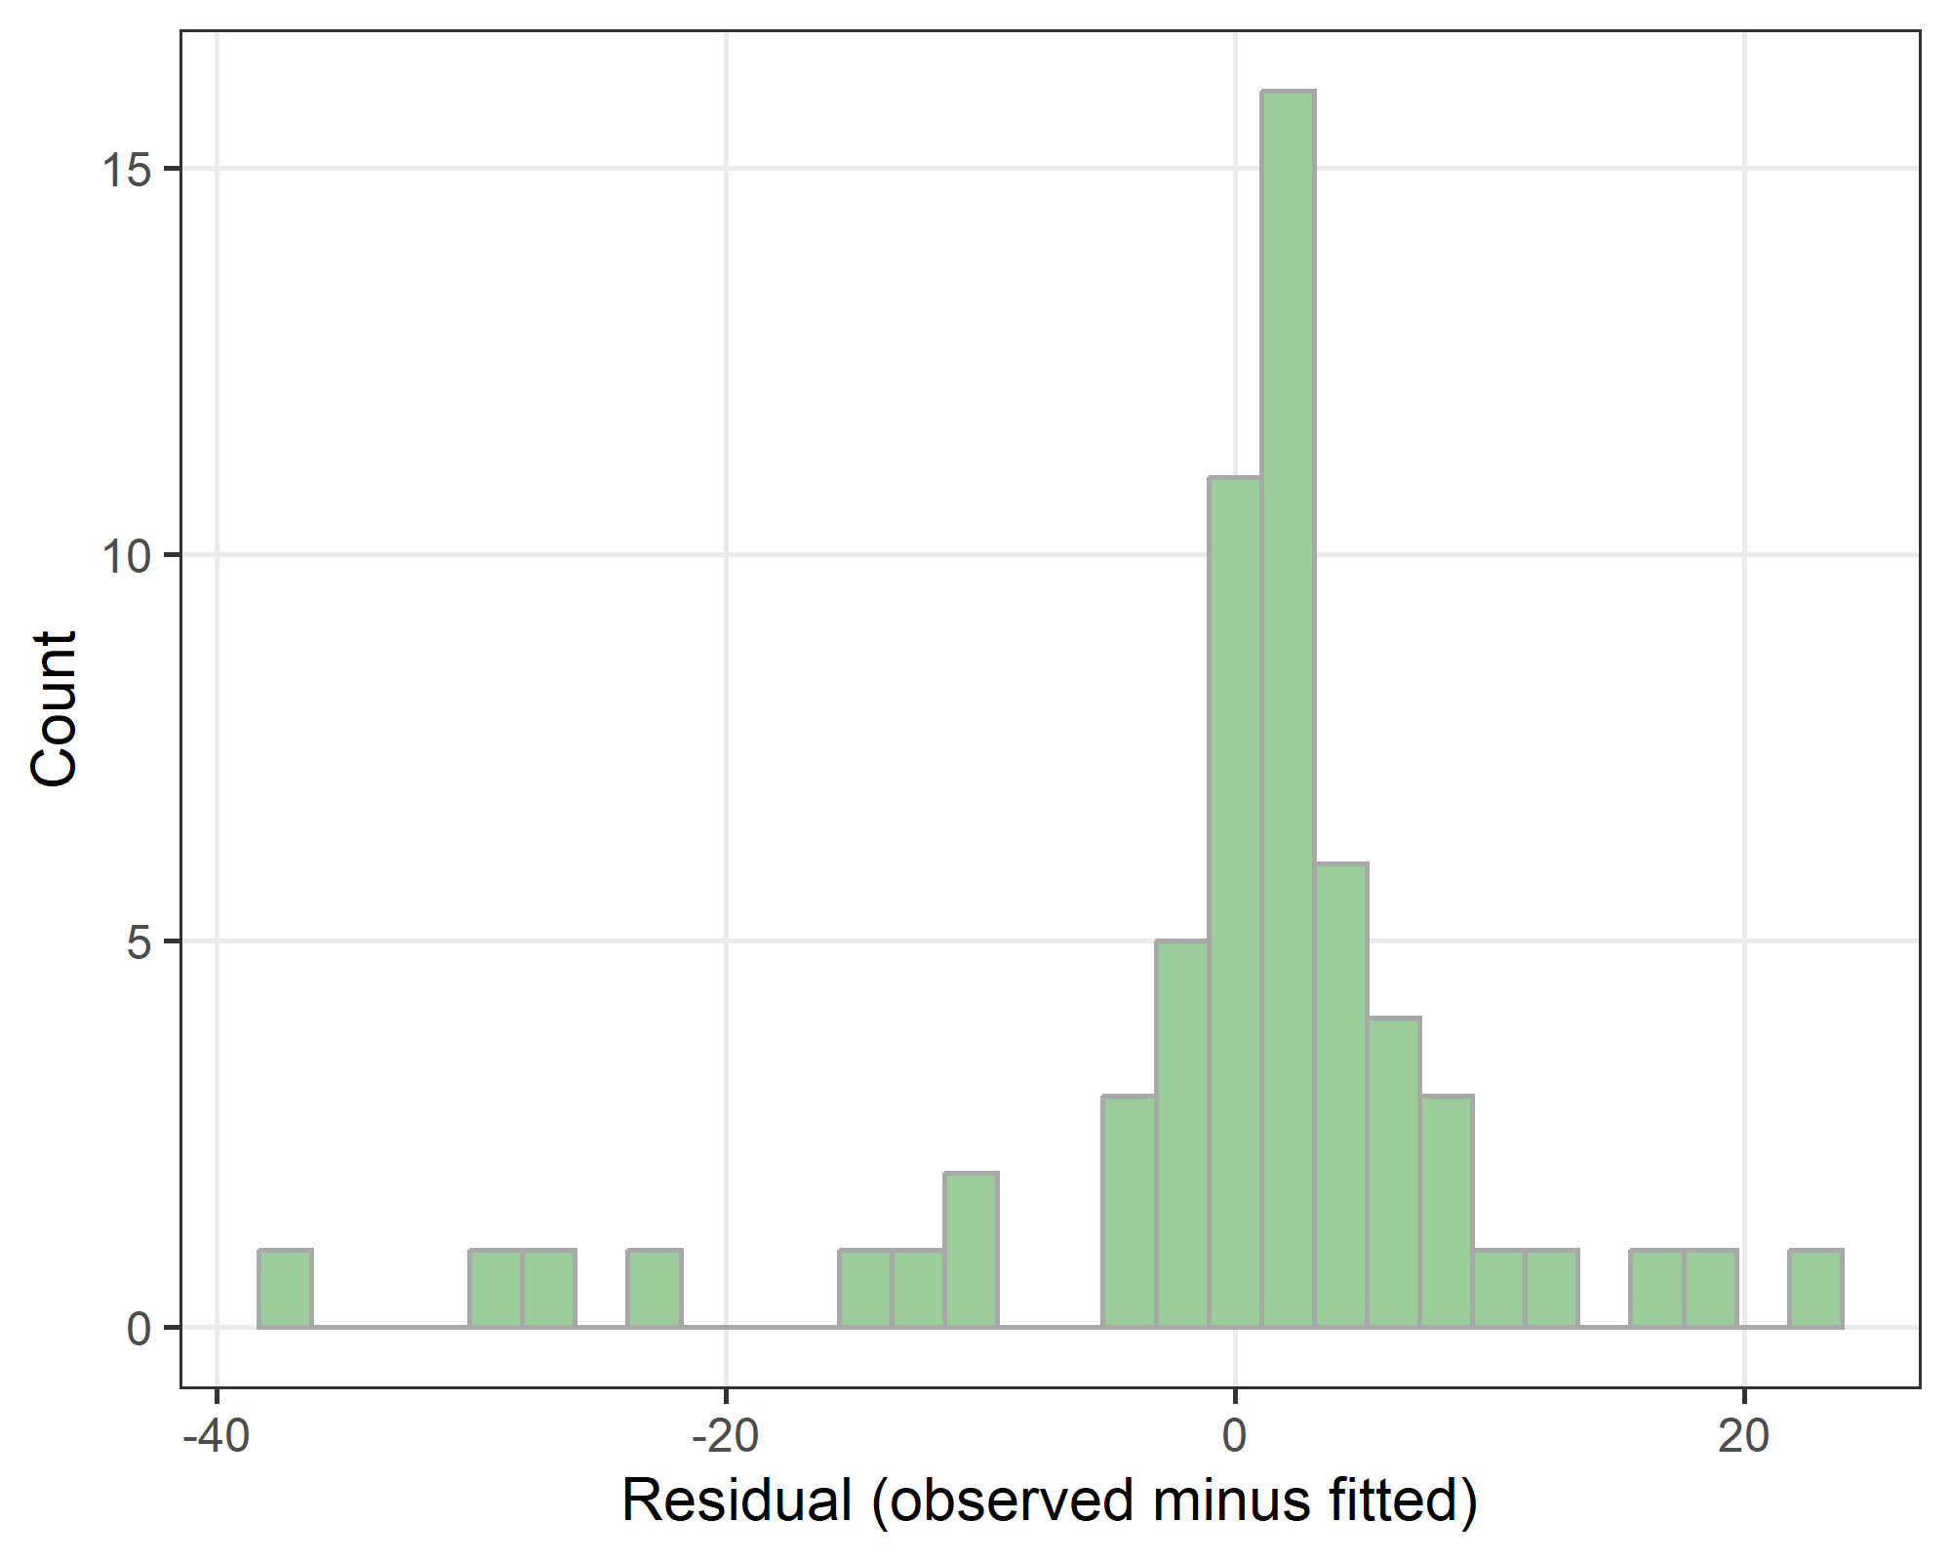
Fig 6: GP use - Residual check
There are no clear concerns in the residual plot as the residuals are unimodal and roughly symmetric.

Per protocol analysis
Per protocol | New model of care | Usual care
False | 2 | 0
True | 48 | 48
The table above shows the number of participants by randomised group that followed the per protocol definition. Only 2 patients did not follow the protocol. Given this small difference we did not run a separate per protocol analysis.

Bayesian models
The statistical models were fitted using a Bayesian paradigm, so the results are given as means and 95% credible intervals, which have a more intuitive interpretation than standard 95% confidence intervals.
We used the nimble package (version 1.0.1) to fit the Bayesian models. We used 2 chains, with a burn-in of 20,000 followed by a sample of 20,000 thinned by 10.
In this section we show the graphical estimates of model convergence.
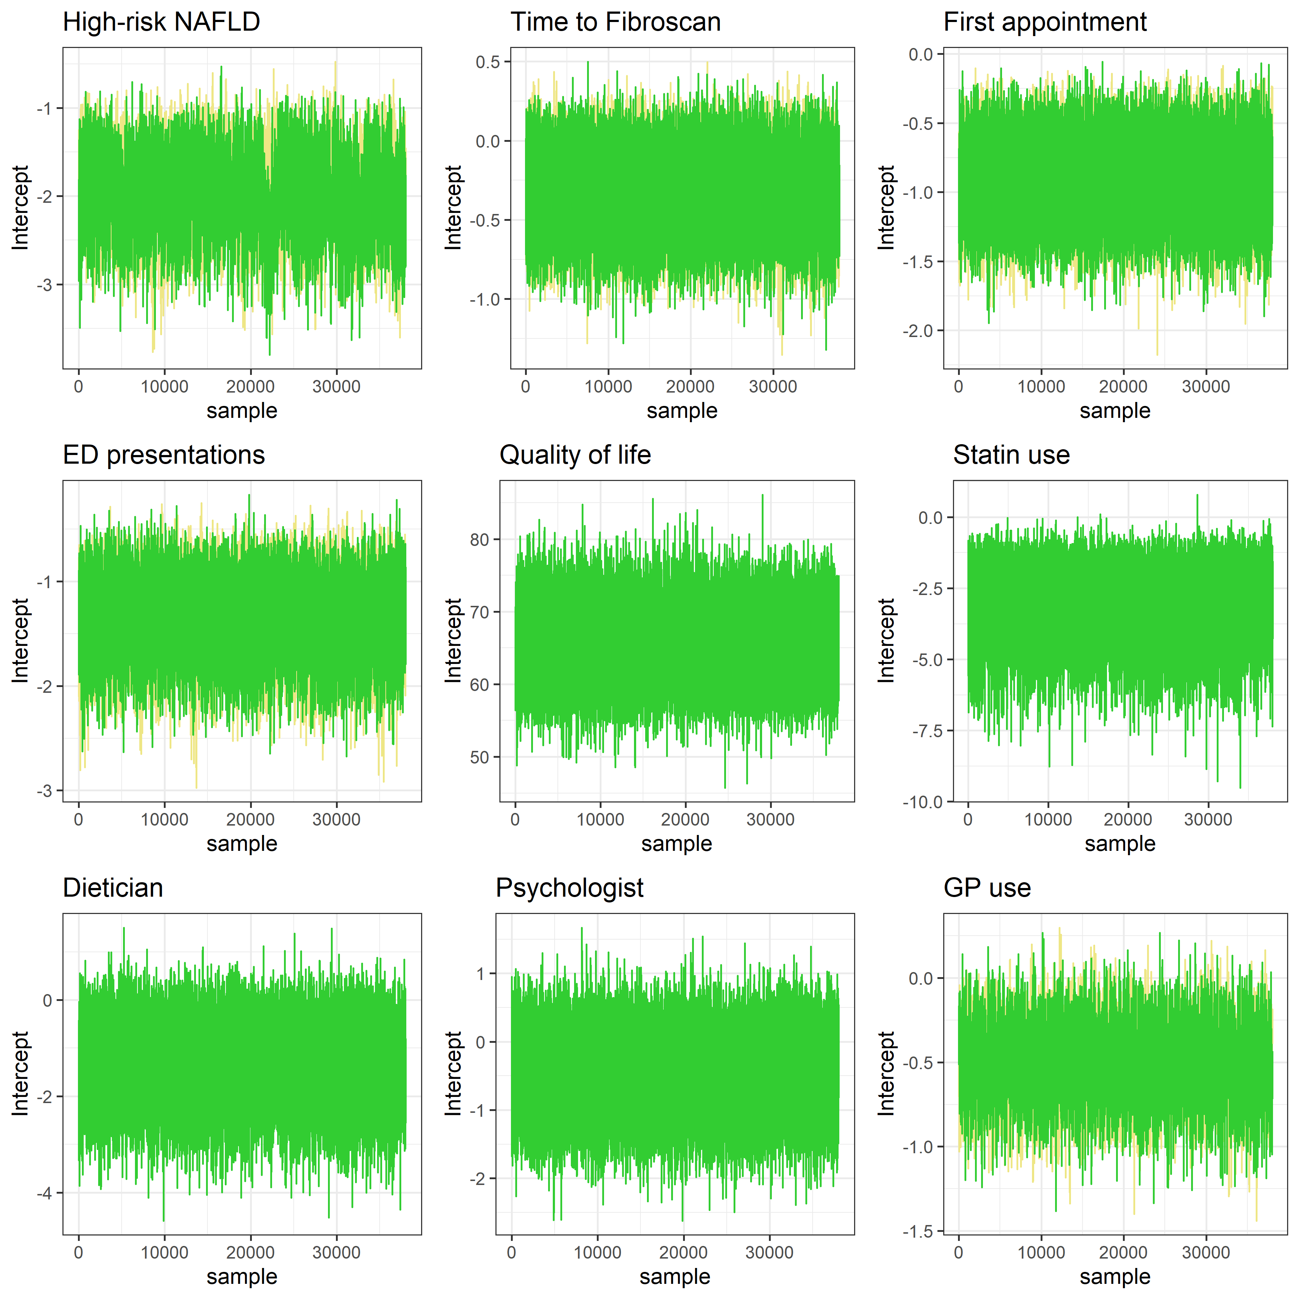
Fig 7: Bayesian model convergence
All the chains appear to show good mixing and convergence, so there are no concerns for any of the models.

