- LOCATE Questionnaire: About You
Page 1 of 5

- What year were you born? __________

- I am:

- Male
- Female
- Other
- Prefer not to say

- Please tick what best describes your current employment:

- Full-time
- Part-time
- Unemployed
- Disability pension
- Other (please describe): ______________

- Are you planning to leave the area where you live in the next 12 months, for example moving overseas or to another state?
- Yes
- No

- In the last year, how many times have you seen a GP for your own health? ____________________

- In the last year, have you seen a dietician or nutritionist for your own health?
- Yes, a dietician
- Yes, a nutritionist
- Yes, both a dietician and a nutritionist
- No

2. LOCATE Questionnaire: Quality of life
Page 2 of 5
By placing a tick in one box in each group below, please indicate which statements best describe your own health state today.

Mobility
I have no problems in walking about
I have some problems in walking about
I am confined to bed

Self-Care
I have no problems with self-care
I have some problems with washing or dressing myself
I am unable to wash or dress myself

Usual Activities (e.g. work, study, housework, family or leisure activities)
I have no problems with performing my usual activities
I have some problems with performing my usual activities
I am unable to perform my usual activities

Pain / Discomfort
I have no pain or discomfort
I have moderate pain or discomfort
I have extreme pain or discomfort

Anxiety / Depression
I am not anxious or depressed
I am moderately anxious or depressed
I am extremely anxious or depressed

Page 3 of 5

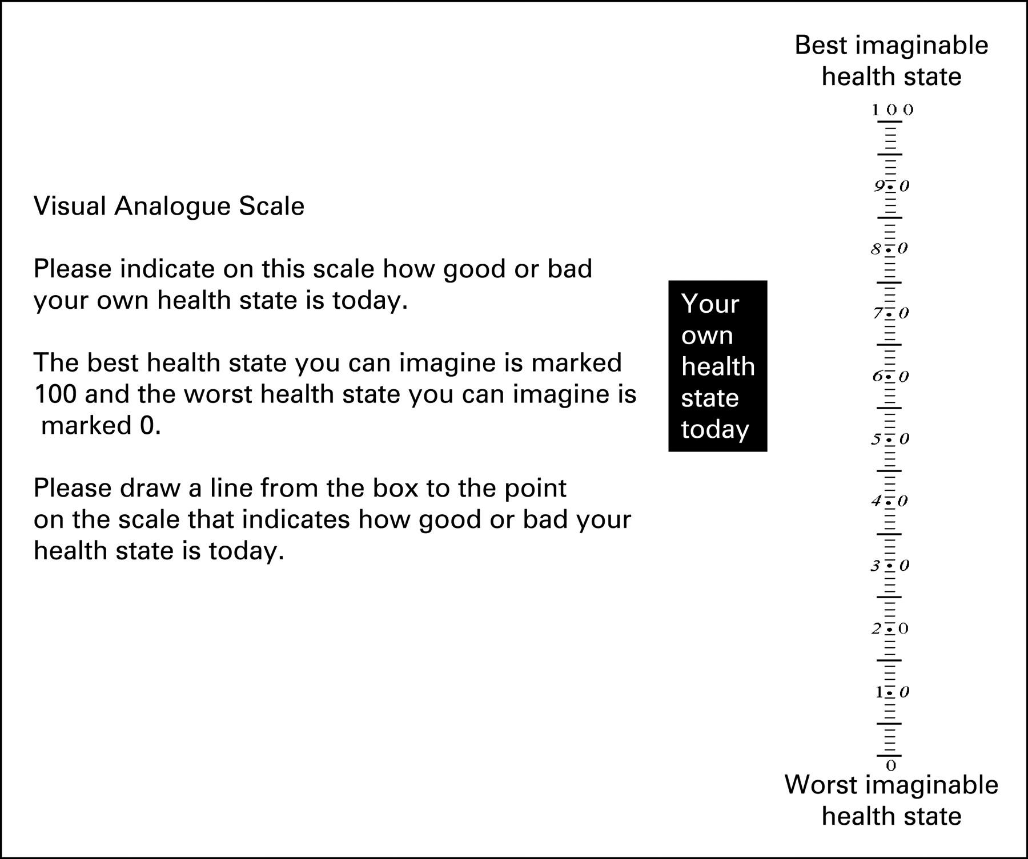

Now, please write the number you marked on the scale in the box below.

YOUR HEALTH TODAY =

3. LOCATE Questionnaire: AUDIT Tool
Page 4 of 5
Please tick the answer that is correct for you

- How often do you have a drink containing alcohol?

- Never
- Monthly or less
- 2 to 4 times a month
- 2 to 3 times a week
- 4 or more times a week

- How many standard drinks containing alcohol do you have on a typical day when drinking?

- 1 or 2
- 3 or 4
- 5 or 6
- 7 to 9
- 10 or more

- How often do you have six or more drinks on one occasion?

- Never
- Less than monthly
- Monthly
- Weekly
- Daily or almost daily

- During the past year, how often have you found that you were not able to stop drinking once you had started?

- Never
- Less than monthly
- Monthly
- Weekly
- Daily or almost daily

- During the past year, how often have you failed to do what was normally expected of you because of drinking?

- Never
- Less than monthly
- Monthly
- Weekly
- Daily or almost daily
Page 5 of 5
- During the past year, how often have you needed a drink in the morning to get yourself going after a heavy drinking session?

- Never
- Less than monthly
- Monthly
- Weekly
- Daily or almost daily

- During the past year, how often have you had a feeling of guilt or remorse after drinking?

- Never
- Less than monthly
- Monthly
- Weekly
- Daily or almost daily

- During the past year, have you been unable to remember what happened the night before because you had been drinking?

- Never
- Less than monthly
- Monthly
- Weekly
- Daily or almost daily

- Have you or someone else been injured as a result of your drinking?

- No
- Yes, but not in the past year
- Yes, during the past year

- Has a relative or friend, doctor or other health worker been concerned about your drinking or suggested you cut down?

- No
- Yes, but not in the past year
- Yes, during the past year

Have you ever been told by a doctor that you have a liver problem due to drinking alcohol?
- Yes
- No
Questionnaires are now complete – thank you.

