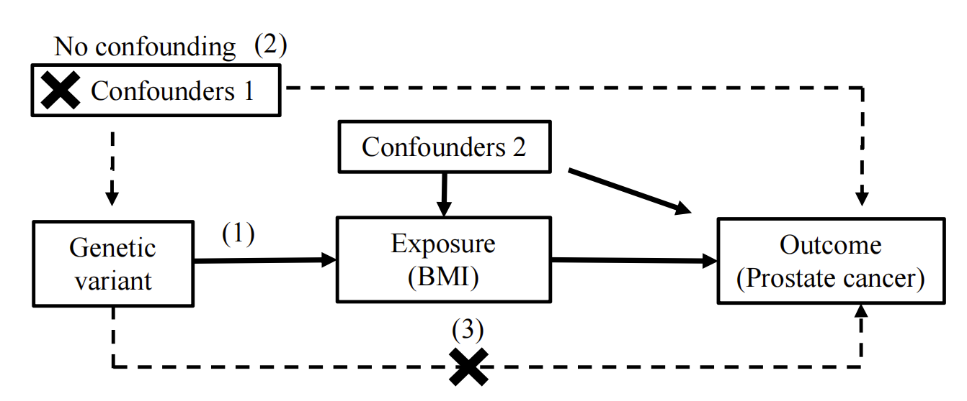
Supplement Figure 1 Diagram of the MR assumptions
The three assumptions are: (1) the genetic variant must be robustly associated with the exposure; (2) the genetic variant should not be associated with confounders of the exposure-outcome association; and (3) the genetic variant must influence the outcome through the exposure only and not through any direct or alternative pathways. The dashed lines represent pathways that violate the assumptions.
MR, Mendelian randomization

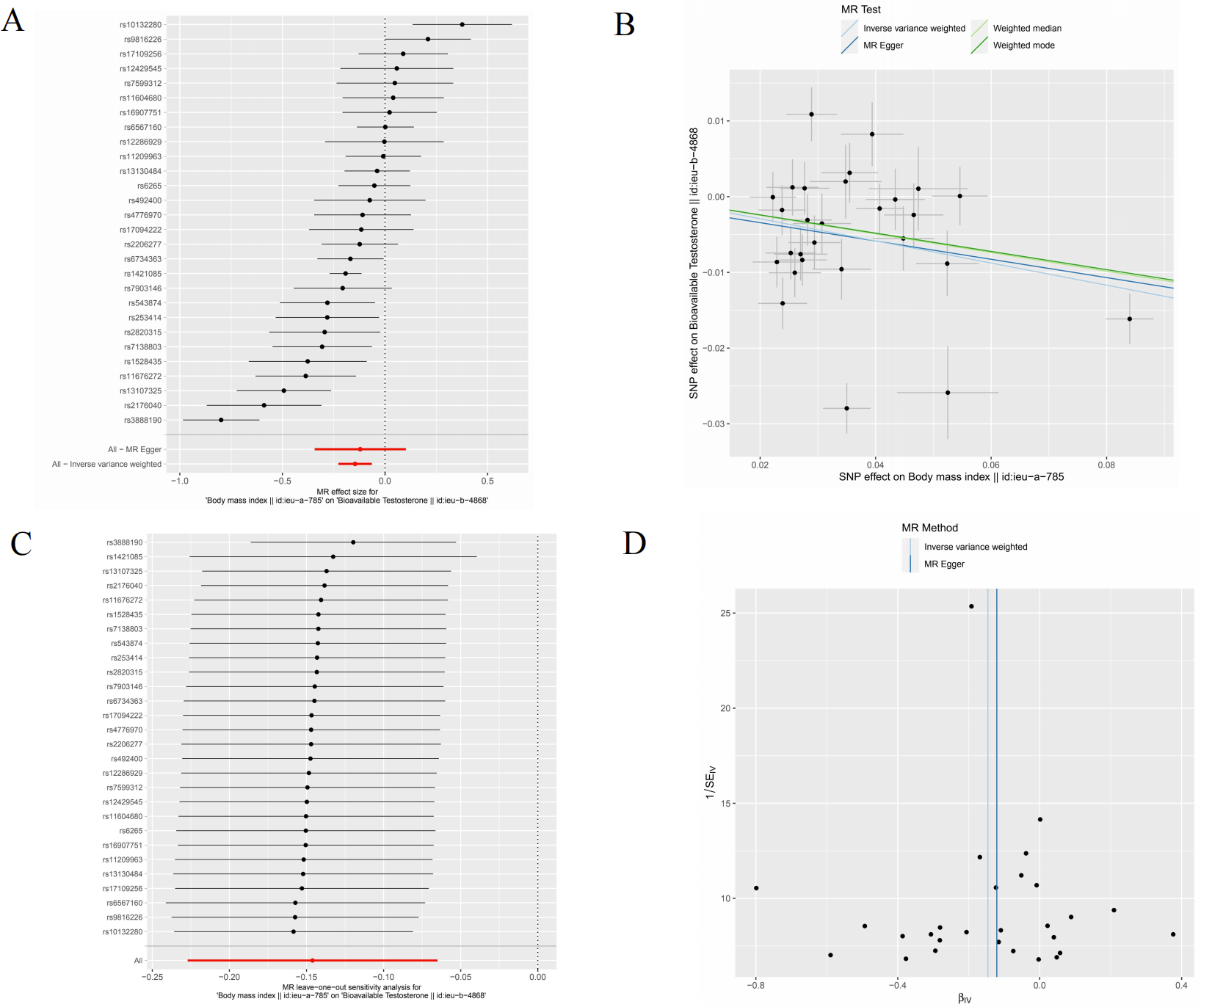
Supplement Figure 2 MR analysis from BMI to bioavailable testosterone
(A) Forest plots from BMI to bioavailable testosterone. (B) Scatter plots. (C) Leave-one-out sensitivity analysis. (D) Funnel plots.
MR, Mendelian randomization; SNP, single-nucleotide polymorphism; MR, Mendelian randomization; IVW, inverse‐variance weighted.

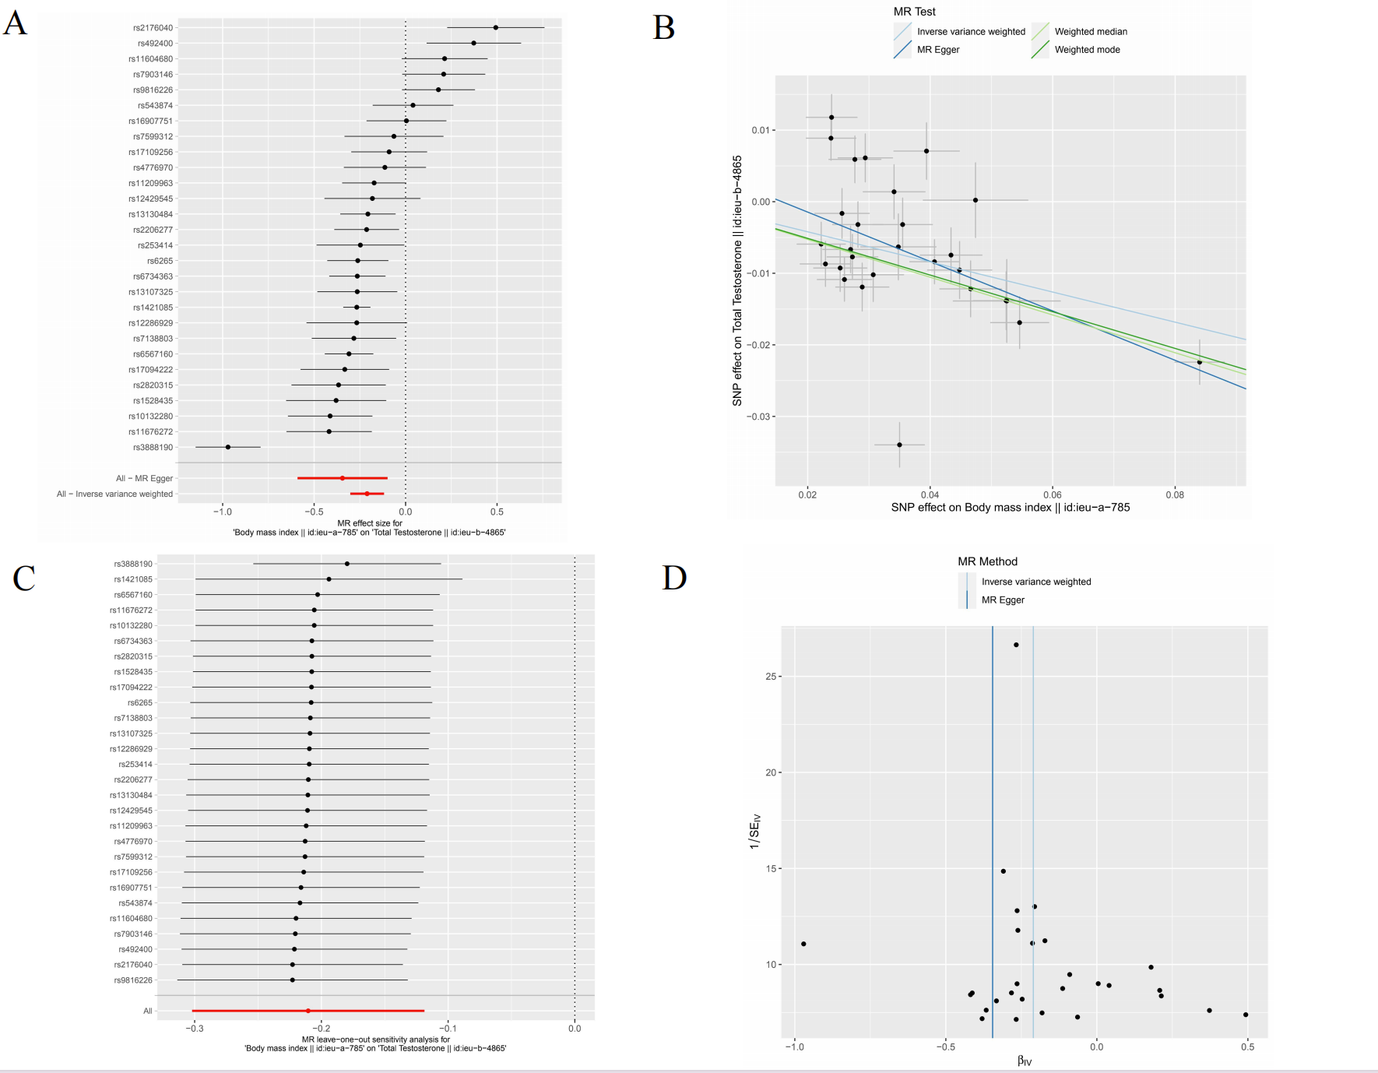
Supplement Figure 3 MR analysis from BMI to total testosterone
(A) Forest plots from BMI to total testosterone. (B) Scatter plots. (C) Leave-one-out sensitivity analysis. (D) Funnel plots.
MR, Mendelian randomization; SNP, single-nucleotide polymorphism; MR, Mendelian randomization; IVW, inverse‐variance weighted.

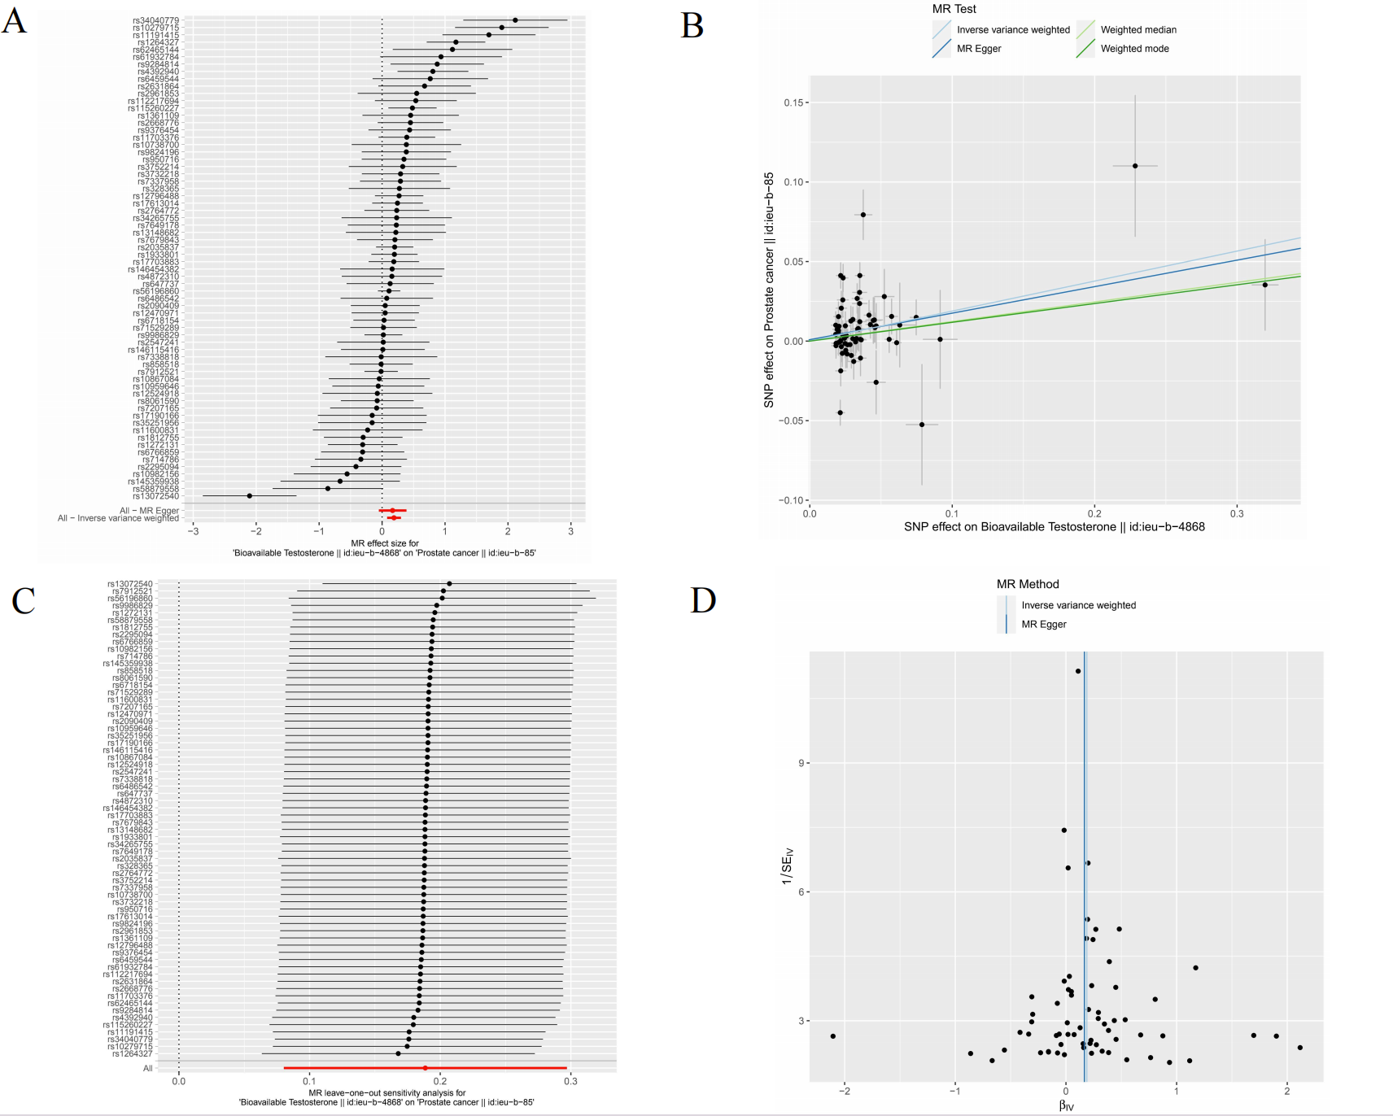
Supplement Figure 4 MR analysis from bioavailable testosterone to prostate cancer
(A) Forest plots from bioavailable testosterone to prostate cancer. (B) Scatter plots. (C) Leave-one-out sensitivity analysis. (D) Funnel plots.
MR, Mendelian randomization; SNP, single-nucleotide polymorphism; MR, Mendelian randomization; IVW, inverse‐variance weighted.

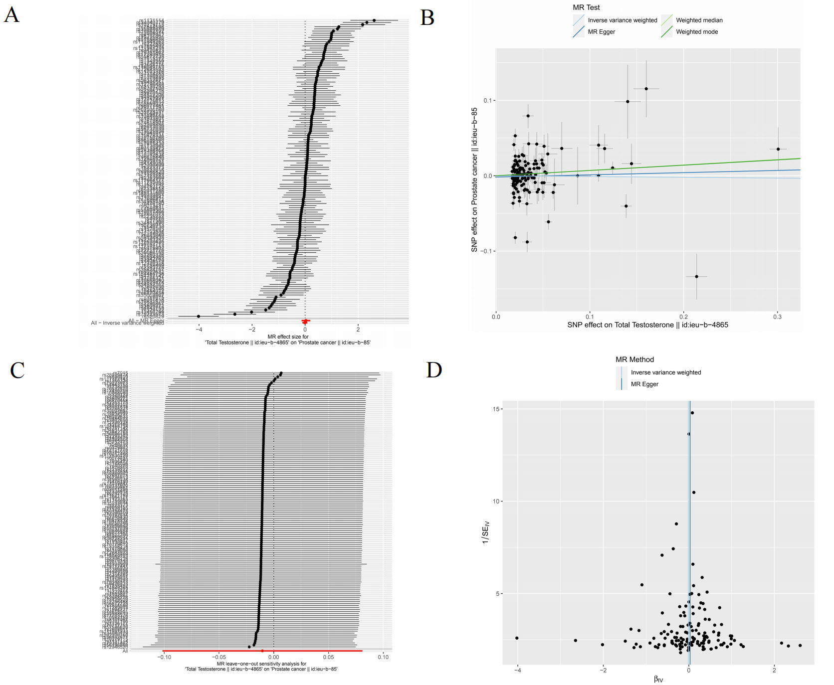
Supplement Figure 5 MR analysis from total testosterone to prostate cancer
(A) Forest plots from total testosterone to prostate cancer. (B) Scatter plots. (C) Leave-one-out sensitivity analysis. (D) Funnel plots.
MR, Mendelian randomization; SNP, single-nucleotide polymorphism; MR, Mendelian randomization; IVW, inverse‐variance weighted.

SNP | EA | Other | EAF | Associations with BMI |  |  |  | Associations with prostate cancer/bioavailable testosterone/total testosterone
SNP | EA | allele | EAF | Beta | se | P value |  | Beta | se | P value
rs10132280 | A | C | 0.333 | -0.029 | 0.004 | 0.000 |  | 0.011 | 0.009 | 0.227
rs11209963 | G | A | 0.822 | 0.043 | 0.005 | 0.000 |  | 0.002 | 0.010 | 0.868
rs11604680 | G | A | 0.383 | 0.028 | 0.004 | 0.000 |  | -0.029 | 0.009 | 0.001
rs11676272 | G | A | 0.483 | 0.026 | 0.005 | 0.000 |  | 0.007 | 0.009 | 0.394
rs12286929 | G | A | 0.433 | 0.022 | 0.004 | 0.000 |  | -0.019 | 0.008 | 0.026
rs12429545 | A | G | 0.100 | 0.035 | 0.006 | 0.000 |  | -0.015 | 0.013 | 0.246
rs13107325 | T | C | 0.117 | 0.053 | 0.009 | 0.000 |  | -0.015 | 0.016 | 0.365
rs13130484 | T | C | 0.433 | 0.041 | 0.004 | 0.000 |  | 0.001 | 0.008 | 0.911
rs1421085 | C | T | 0.450 | 0.084 | 0.004 | 0.000 |  | -0.016 | 0.008 | 0.055
rs1528435 | T | C | 0.583 | 0.023 | 0.004 | 0.000 |  | -0.009 | 0.008 | 0.258
rs16907751 | T | C | 0.042 | -0.047 | 0.009 | 0.000 |  | 0.013 | 0.013 | 0.325
rs17094222 | C | T | 0.208 | 0.031 | 0.005 | 0.000 |  | -0.013 | 0.010 | 0.189
rs17109256 | A | G | 0.275 | 0.036 | 0.005 | 0.000 |  | 0.003 | 0.010 | 0.802
rs2176040 | G | A | 0.608 | -0.024 | 0.004 | 0.000 |  | 0.010 | 0.008 | 0.235
rs2206277 | T | C | 0.092 | 0.045 | 0.005 | 0.000 |  | -0.006 | 0.010 | 0.593
rs253414 | T | C | 0.658 | 0.027 | 0.005 | 0.000 |  | -0.013 | 0.008 | 0.128
rs2820315 | T | C | 0.281 | 0.025 | 0.004 | 0.000 |  | -0.008 | 0.009 | 0.387
rs3888190 | A | C | 0.358 | 0.035 | 0.004 | 0.000 |  | 0.003 | 0.008 | 0.703
rs4776970 | T | A | 0.342 | -0.028 | 0.004 | 0.000 |  | 0.006 | 0.008 | 0.449
rs492400 | T | C | 0.675 | -0.024 | 0.004 | 0.000 |  | 0.001 | 0.008 | 0.877
rs543874 | G | A | 0.267 | 0.034 | 0.005 | 0.000 |  | 0.014 | 0.010 | 0.155
rs6265 | T | C | 0.175 | -0.047 | 0.005 | 0.000 |  | 0.001 | 0.010 | 0.964
rs6567160 | C | T | 0.283 | 0.055 | 0.005 | 0.000 |  | -0.018 | 0.010 | 0.055
rs6734363 | A | G | 0.875 | 0.052 | 0.005 | 0.000 |  | -0.030 | 0.011 | 0.004
rs7138803 | A | G | 0.442 | 0.027 | 0.004 | 0.000 |  | 0.013 | 0.008 | 0.126
rs7599312 | A | G | 0.292 | -0.026 | 0.005 | 0.000 |  | -0.005 | 0.009 | 0.550
rs7903146 | T | C | 0.250 | -0.029 | 0.005 | 0.000 |  | 0.011 | 0.009 | 0.237
rs9816226 | T | A | 0.850 | 0.039 | 0.005 | 0.000 |  | -0.018 | 0.011 | 0.097
Supplement Table 1 Characteristics of the SNPs associated with BMI and prostate cancer/bioavailable testosterone/total testosterone
BMI, Body mass index; SNP, Single-nucleotide polymorphism; EA, Effect allele; EAF, Effect allele frequency; se, Standard error.

SNP | EA | Other | EAF | Associations with bioavailable testosterone |  |  |  | Associations with prostate cancer
SNP | EA | allele | EAF | Beta | se | P value |  | Beta | se | P value
rs10279715 | G | A | 0.463 | -0.022 | 0.003 | 0.000 |  | -0.041 | 0.008 | 0.000
rs10738700 | G | A | 0.429 | -0.019 | 0.003 | 0.000 |  | -0.007 | 0.009 | 0.382
rs10867084 | C | T | 0.488 | 0.020 | 0.003 | 0.000 |  | -0.001 | 0.008 | 0.911
rs10959646 | A | G | 0.282 | -0.025 | 0.004 | 0.000 |  | 0.002 | 0.009 | 0.868
rs10982156 | A | T | 0.070 | 0.047 | 0.007 | 0.000 |  | -0.026 | 0.020 | 0.199
rs11191415 | T | G | 0.290 | -0.023 | 0.004 | 0.000 |  | -0.040 | 0.009 | 0.000
rs112217694 | C | G | 0.058 | -0.052 | 0.007 | 0.000 |  | -0.028 | 0.017 | 0.106
rs115260227 | G | A | 0.012 | -0.228 | 0.016 | 0.000 |  | -0.110 | 0.045 | 0.013
rs11600831 | T | C | 0.161 | -0.025 | 0.004 | 0.000 |  | 0.006 | 0.011 | 0.606
rs11703376 | T | C | 0.270 | 0.042 | 0.004 | 0.000 |  | 0.016 | 0.010 | 0.086
rs12470971 | A | G | 0.338 | 0.033 | 0.003 | 0.000 |  | 0.002 | 0.009 | 0.858
rs12524918 | C | T | 0.427 | 0.018 | 0.003 | 0.000 |  | -0.001 | 0.008 | 0.865
rs1264327 | A | G | 0.341 | 0.035 | 0.003 | 0.000 |  | 0.041 | 0.008 | 0.000
rs1272131 | C | T | 0.389 | 0.029 | 0.003 | 0.000 |  | -0.009 | 0.008 | 0.271
rs12796488 | A | C | 0.177 | -0.057 | 0.004 | 0.000 |  | -0.016 | 0.011 | 0.167
rs13072540 | C | A | 0.453 | -0.021 | 0.003 | 0.000 |  | 0.045 | 0.008 | 0.000
rs13148682 | G | C | 0.101 | -0.034 | 0.005 | 0.000 |  | -0.008 | 0.014 | 0.588
rs1361109 | T | C | 0.454 | 0.021 | 0.003 | 0.000 |  | 0.009 | 0.008 | 0.249
rs144956283 | T | A | 0.494 | 0.022 | 0.003 | 0.000 |  | 0.011 | 0.008 | 0.176
rs145359938 | C | G | 0.024 | -0.079 | 0.011 | 0.000 |  | 0.053 | 0.038 | 0.168
rs146115416 | T | C | 0.018 | -0.092 | 0.012 | 0.000 |  | -0.001 | 0.031 | 0.971
rs146454382 | A | G | 0.022 | 0.063 | 0.011 | 0.000 |  | 0.010 | 0.027 | 0.705
rs17190166 | A | C | 0.424 | 0.018 | 0.003 | 0.000 |  | -0.003 | 0.008 | 0.722
rs17613014 | C | T | 0.344 | 0.043 | 0.003 | 0.000 |  | 0.010 | 0.009 | 0.233
rs17703883 | C | T | 0.256 | 0.046 | 0.004 | 0.000 |  | 0.009 | 0.009 | 0.361
rs1812755 | C | T | 0.201 | -0.036 | 0.004 | 0.000 |  | 0.011 | 0.011 | 0.347
rs1933801 | T | C | 0.678 | 0.046 | 0.003 | 0.000 |  | 0.009 | 0.009 | 0.293
rs2035837 | C | T | 0.148 | -0.075 | 0.005 | 0.000 |  | -0.015 | 0.011 | 0.182
rs2090409 | A | C | 0.316 | -0.030 | 0.004 | 0.000 |  | -0.002 | 0.008 | 0.858
rs2295094 | A | G | 0.172 | -0.031 | 0.004 | 0.000 |  | 0.013 | 0.011 | 0.257
rs2547241 | G | A | 0.458 | 0.022 | 0.003 | 0.000 |  | 0.000 | 0.008 | 0.965
rs2631864 | G | A | 0.105 | 0.035 | 0.005 | 0.000 |  | 0.024 | 0.013 | 0.072
rs2668776 | T | C | 0.531 | -0.030 | 0.003 | 0.000 |  | -0.014 | 0.008 | 0.089
rs2733341 | A | T | 0.554 | 0.024 | 0.003 | 0.000 |  | 0.002 | 0.008 | 0.813
rs2764772 | A | T | 0.333 | 0.034 | 0.003 | 0.000 |  | 0.008 | 0.009 | 0.371
rs28613899 | C | G | 0.435 | -0.020 | 0.003 | 0.000 |  | -0.012 | 0.008 | 0.134
rs2961853 | C | T | 0.467 | 0.018 | 0.003 | 0.000 |  | 0.010 | 0.009 | 0.252
rs328365 | A | G | 0.422 | 0.020 | 0.003 | 0.000 |  | 0.006 | 0.008 | 0.506
rs34040779 | C | T | 0.076 | -0.038 | 0.006 | 0.000 |  | -0.079 | 0.016 | 0.000
rs34265755 | G | T | 0.542 | 0.018 | 0.003 | 0.000 |  | 0.004 | 0.008 | 0.600
rs35251956 | T | C | 0.260 | 0.022 | 0.004 | 0.000 |  | -0.004 | 0.010 | 0.719
rs3732218 | A | G | 0.082 | -0.045 | 0.006 | 0.000 |  | -0.013 | 0.014 | 0.347
rs3752214 | A | G | 0.568 | 0.020 | 0.003 | 0.000 |  | 0.007 | 0.009 | 0.451
rs4392940 | A | G | 0.757 | 0.033 | 0.004 | 0.000 |  | 0.027 | 0.010 | 0.005
rs4655598 | A | T | 0.552 | -0.026 | 0.003 | 0.000 |  | -0.004 | 0.008 | 0.665
rs4872310 | A | G | 0.247 | -0.023 | 0.004 | 0.000 |  | -0.004 | 0.009 | 0.702
rs56196860 | A | C | 0.031 | 0.320 | 0.009 | 0.000 |  | 0.035 | 0.029 | 0.220
rs58879558 | C | T | 0.230 | 0.022 | 0.004 | 0.000 |  | -0.019 | 0.010 | 0.055
rs61932784 | A | C | 0.217 | -0.022 | 0.004 | 0.000 |  | -0.021 | 0.011 | 0.057
rs62465144 | C | T | 0.197 | -0.023 | 0.004 | 0.000 |  | -0.026 | 0.011 | 0.021
rs6459544 | G | A | 0.314 | -0.020 | 0.004 | 0.000 |  | -0.015 | 0.009 | 0.100
rs647737 | T | C | 0.735 | -0.026 | 0.004 | 0.000 |  | -0.003 | 0.009 | 0.721
rs6486542 | T | C | 0.430 | -0.024 | 0.003 | 0.000 |  | -0.002 | 0.009 | 0.845
rs6718154 | T | C | 0.274 | 0.035 | 0.004 | 0.000 |  | 0.001 | 0.009 | 0.898
rs6766859 | T | C | 0.628 | 0.026 | 0.003 | 0.000 |  | -0.008 | 0.009 | 0.357
rs714786 | A | G | 0.371 | -0.023 | 0.003 | 0.000 |  | 0.008 | 0.009 | 0.363
rs71529289 | T | C | 0.253 | -0.036 | 0.004 | 0.000 |  | -0.001 | 0.010 | 0.933
rs7207165 | C | T | 0.714 | -0.027 | 0.004 | 0.000 |  | 0.002 | 0.010 | 0.819
rs7337958 | G | A | 0.095 | -0.045 | 0.006 | 0.000 |  | -0.013 | 0.015 | 0.372
rs7338818 | T | C | 0.552 | -0.021 | 0.003 | 0.000 |  | 0.000 | 0.010 | 0.972
rs7649178 | A | G | 0.130 | -0.034 | 0.005 | 0.000 |  | -0.008 | 0.013 | 0.564
rs7679843 | G | C | 0.095 | 0.047 | 0.006 | 0.000 |  | 0.010 | 0.014 | 0.505
rs7693957 | A | T | 0.457 | -0.018 | 0.003 | 0.000 |  | 0.006 | 0.008 | 0.468
rs7912521 | C | T | 0.417 | 0.061 | 0.003 | 0.000 |  | -0.001 | 0.008 | 0.900
rs8061590 | G | A | 0.400 | -0.028 | 0.003 | 0.000 |  | 0.002 | 0.008 | 0.788
rs858518 | A | G | 0.573 | -0.032 | 0.003 | 0.000 |  | 0.001 | 0.008 | 0.954
rs9284814 | A | G | 0.886 | -0.035 | 0.005 | 0.000 |  | -0.031 | 0.013 | 0.020
rs9376454 | T | C | 0.221 | -0.029 | 0.004 | 0.000 |  | -0.013 | 0.010 | 0.193
rs950716 | G | A | 0.136 | -0.035 | 0.005 | 0.000 |  | -0.012 | 0.012 | 0.313
rs9824196 | T | G | 0.721 | 0.025 | 0.004 | 0.000 |  | 0.010 | 0.009 | 0.289
rs9986829 | A | G | 0.507 | 0.056 | 0.003 | 0.000 |  | 0.001 | 0.009 | 0.895
Supplement Table 2 Characteristics of the SNPs associated with bioavailable testosterone and prostate cancer
SNP, Single-nucleotide polymorphism; EA, Effect allele; EAF, Effect allele frequency; se, Standard error.

SNP | EA | Other | EAF | Associations with total testosterone |  |  |  | Associations with prostate cancer
SNP | EA | allele | EAF | Beta | se | P value |  | Beta | se | P value
rs10017466 | T | C | 0.696 | -0.028 | 0.003 | 0.000 |  | 0.004 | 0.009 | 0.651
rs10192634 | T | C | 0.268 | 0.023 | 0.004 | 0.000 |  | 0.002 | 0.009 | 0.817
rs10279715 | G | A | 0.463 | -0.019 | 0.003 | 0.000 |  | -0.041 | 0.008 | 0.000
rs10484012 | C | T | 0.282 | -0.020 | 0.003 | 0.000 |  | 0.016 | 0.010 | 0.098
rs10750766 | A | C | 0.710 | -0.023 | 0.003 | 0.000 |  | -0.003 | 0.009 | 0.743
rs10779612 | A | G | 0.758 | -0.022 | 0.004 | 0.000 |  | -0.008 | 0.010 | 0.429
rs10832570 | G | A | 0.389 | -0.025 | 0.003 | 0.000 |  | 0.029 | 0.008 | 0.000
rs10846658 | A | C | 0.285 | -0.020 | 0.003 | 0.000 |  | -0.005 | 0.009 | 0.583
rs10868080 | A | T | 0.744 | -0.036 | 0.004 | 0.000 |  | 0.022 | 0.009 | 0.015
rs10878334 | G | C | 0.100 | -0.034 | 0.005 | 0.000 |  | -0.004 | 0.014 | 0.745
rs10892924 | T | A | 0.567 | 0.032 | 0.003 | 0.000 |  | 0.009 | 0.009 | 0.292
rs10982192 | T | C | 0.222 | 0.024 | 0.004 | 0.000 |  | 0.026 | 0.010 | 0.009
rs11039847 | C | G | 0.761 | 0.023 | 0.004 | 0.000 |  | -0.001 | 0.010 | 0.918
rs111981233 | G | T | 0.079 | 0.051 | 0.006 | 0.000 |  | 0.039 | 0.015 | 0.011
rs112530420 | C | T | 0.165 | 0.026 | 0.004 | 0.000 |  | -0.008 | 0.012 | 0.537
rs1131114 | C | T | 0.266 | -0.020 | 0.004 | 0.000 |  | -0.053 | 0.009 | 0.000
rs114949263 | C | T | 0.112 | 0.029 | 0.005 | 0.000 |  | 0.027 | 0.014 | 0.058
rs11621792 | T | C | 0.454 | -0.017 | 0.003 | 0.000 |  | 0.000 | 0.009 | 0.997
rs11703376 | T | C | 0.270 | 0.034 | 0.004 | 0.000 |  | 0.016 | 0.010 | 0.086
rs11735092 | C | T | 0.436 | -0.037 | 0.003 | 0.000 |  | 0.000 | 0.008 | 0.996
rs117372143 | A | G | 0.071 | -0.139 | 0.006 | 0.000 |  | 0.040 | 0.016 | 0.011
rs117664177 | T | C | 0.012 | -0.087 | 0.014 | 0.000 |  | 0.000 | 0.038 | 0.999
rs118049783 | G | C | 0.025 | -0.055 | 0.010 | 0.000 |  | -0.029 | 0.028 | 0.296
rs12320328 | G | A | 0.084 | -0.045 | 0.006 | 0.000 |  | 0.018 | 0.015 | 0.235
rs12429920 | A | G | 0.473 | 0.020 | 0.003 | 0.000 |  | 0.020 | 0.009 | 0.027
rs12450799 | C | T | 0.624 | 0.018 | 0.003 | 0.000 |  | -0.037 | 0.008 | 0.000
rs1260326 | C | T | 0.603 | 0.061 | 0.003 | 0.000 |  | -0.022 | 0.008 | 0.007
rs12717441 | G | C | 0.193 | 0.028 | 0.004 | 0.000 |  | 0.010 | 0.010 | 0.344
rs12796488 | A | C | 0.177 | -0.040 | 0.004 | 0.000 |  | -0.016 | 0.011 | 0.167
rs12946520 | T | G | 0.640 | 0.124 | 0.003 | 0.000 |  | 0.010 | 0.008 | 0.220
rs13029936 | T | C | 0.183 | 0.024 | 0.004 | 0.000 |  | 0.005 | 0.010 | 0.642
rs13103534 | G | A | 0.600 | -0.017 | 0.003 | 0.000 |  | 0.004 | 0.009 | 0.685
rs13108218 | G | A | 0.615 | -0.037 | 0.003 | 0.000 |  | -0.004 | 0.009 | 0.683
rs1349359 | A | G | 0.436 | 0.018 | 0.003 | 0.000 |  | 0.012 | 0.009 | 0.184
rs1408579 | T | C | 0.497 | 0.019 | 0.003 | 0.000 |  | -0.008 | 0.008 | 0.354
rs149131600 | T | C | 0.173 | 0.034 | 0.004 | 0.000 |  | -0.001 | 0.012 | 0.926
rs1513272 | T | C | 0.501 | 0.019 | 0.003 | 0.000 |  | 0.013 | 0.008 | 0.090
rs1570203 | A | G | 0.527 | -0.018 | 0.003 | 0.000 |  | 0.004 | 0.008 | 0.672
rs17289915 | G | C | 0.012 | -0.140 | 0.014 | 0.000 |  | -0.098 | 0.049 | 0.044
rs1730865 | T | G | 0.656 | -0.034 | 0.003 | 0.000 |  | -0.003 | 0.009 | 0.691
rs1736177 | T | C | 0.294 | 0.031 | 0.003 | 0.000 |  | 0.019 | 0.009 | 0.047
rs17580 | A | T | 0.048 | 0.051 | 0.007 | 0.000 |  | -0.009 | 0.020 | 0.639
rs184485758 | A | C | 0.075 | -0.033 | 0.006 | 0.000 |  | 0.019 | 0.015 | 0.203
rs1933801 | T | C | 0.679 | 0.036 | 0.003 | 0.000 |  | 0.009 | 0.009 | 0.293
rs1979835 | A | G | 0.136 | -0.032 | 0.005 | 0.000 |  | -0.014 | 0.012 | 0.262
rs1994721 | A | G | 0.149 | -0.050 | 0.004 | 0.000 |  | -0.014 | 0.011 | 0.206
rs2013030 | G | A | 0.085 | -0.046 | 0.006 | 0.000 |  | -0.010 | 0.014 | 0.472
rs202200760 | C | G | 0.039 | 0.116 | 0.009 | 0.000 |  | 0.036 | 0.020 | 0.068
rs2090409 | A | C | 0.316 | -0.027 | 0.003 | 0.000 |  | -0.002 | 0.008 | 0.858
rs2144026 | A | G | 0.275 | -0.020 | 0.003 | 0.000 |  | 0.004 | 0.009 | 0.632
rs222855 | C | A | 0.264 | -0.022 | 0.003 | 0.000 |  | -0.018 | 0.010 | 0.058
rs223373 | C | G | 0.218 | 0.022 | 0.004 | 0.000 |  | 0.001 | 0.010 | 0.900
rs2239222 | G | A | 0.350 | 0.020 | 0.003 | 0.000 |  | -0.003 | 0.009 | 0.702
rs2269856 | T | C | 0.707 | 0.030 | 0.003 | 0.000 |  | 0.007 | 0.009 | 0.432
rs2290867 | C | A | 0.627 | -0.019 | 0.003 | 0.000 |  | 0.023 | 0.008 | 0.006
rs2293252 | T | C | 0.659 | 0.025 | 0.003 | 0.000 |  | -0.007 | 0.009 | 0.429
rs2306216 | G | A | 0.831 | -0.027 | 0.004 | 0.000 |  | -0.010 | 0.011 | 0.352
rs2393775 | A | G | 0.621 | 0.027 | 0.003 | 0.000 |  | -0.013 | 0.008 | 0.114
rs2393969 | C | A | 0.471 | 0.109 | 0.003 | 0.000 |  | 0.000 | 0.008 | 0.983
rs2608911 | G | T | 0.190 | -0.028 | 0.004 | 0.000 |  | -0.028 | 0.010 | 0.007
rs2668776 | T | C | 0.531 | -0.023 | 0.003 | 0.000 |  | -0.014 | 0.008 | 0.089
rs28394864 | A | G | 0.459 | -0.052 | 0.003 | 0.000 |  | -0.005 | 0.008 | 0.532
rs28929474 | T | C | 0.020 | 0.214 | 0.011 | 0.000 |  | -0.134 | 0.030 | 0.000
rs3130293 | A | G | 0.700 | -0.025 | 0.003 | 0.000 |  | -0.009 | 0.009 | 0.286
rs329122 | A | G | 0.420 | -0.019 | 0.003 | 0.000 |  | 0.029 | 0.008 | 0.000
rs34040779 | C | T | 0.076 | -0.034 | 0.006 | 0.000 |  | -0.079 | 0.016 | 0.000
rs34532102 | T | C | 0.206 | 0.030 | 0.004 | 0.000 |  | -0.019 | 0.011 | 0.066
rs34851490 | G | A | 0.116 | 0.049 | 0.005 | 0.000 |  | -0.009 | 0.013 | 0.468
rs34955534 | A | G | 0.099 | -0.040 | 0.005 | 0.000 |  | 0.003 | 0.014 | 0.830
rs35002667 | A | T | 0.175 | 0.023 | 0.004 | 0.000 |  | -0.021 | 0.010 | 0.035
rs35233014 | A | C | 0.745 | -0.023 | 0.004 | 0.000 |  | -0.001 | 0.010 | 0.913
rs35728231 | G | A | 0.163 | 0.026 | 0.004 | 0.000 |  | 0.008 | 0.011 | 0.496
rs35824797 | T | C | 0.078 | -0.044 | 0.006 | 0.000 |  | 0.022 | 0.016 | 0.169
rs35988619 | C | T | 0.069 | 0.035 | 0.006 | 0.000 |  | 0.042 | 0.016 | 0.007
rs36086195 | T | C | 0.577 | 0.022 | 0.003 | 0.000 |  | -0.007 | 0.008 | 0.389
rs3768321 | T | G | 0.196 | -0.031 | 0.004 | 0.000 |  | 0.018 | 0.011 | 0.092
rs3802650 | G | A | 0.478 | -0.018 | 0.003 | 0.000 |  | 0.013 | 0.008 | 0.119
rs3809272 | A | G | 0.302 | -0.019 | 0.003 | 0.000 |  | 0.024 | 0.009 | 0.008
rs3842763 | T | G | 0.241 | 0.023 | 0.004 | 0.000 |  | -0.009 | 0.009 | 0.335
rs40270 | C | A | 0.771 | -0.023 | 0.004 | 0.000 |  | 0.004 | 0.010 | 0.684
rs40831 | G | A | 0.429 | -0.034 | 0.003 | 0.000 |  | 0.004 | 0.009 | 0.641
rs4149056 | C | T | 0.151 | -0.054 | 0.004 | 0.000 |  | -0.004 | 0.011 | 0.734
rs4522206 | C | G | 0.353 | -0.019 | 0.003 | 0.000 |  | -0.007 | 0.010 | 0.474
rs4757142 | A | G | 0.608 | -0.018 | 0.003 | 0.000 |  | 0.011 | 0.008 | 0.210
rs476180 | A | G | 0.644 | -0.019 | 0.003 | 0.000 |  | 0.002 | 0.008 | 0.855
rs4782568 | G | C | 0.450 | 0.025 | 0.003 | 0.000 |  | 0.006 | 0.009 | 0.482
rs4843753 | G | A | 0.494 | -0.025 | 0.003 | 0.000 |  | 0.034 | 0.008 | 0.000
rs4925809 | T | C | 0.468 | 0.020 | 0.003 | 0.000 |  | 0.007 | 0.008 | 0.401
rs520829 | G | T | 0.476 | 0.020 | 0.003 | 0.000 |  | -0.082 | 0.008 | 0.000
rs540730 | C | T | 0.757 | -0.032 | 0.004 | 0.000 |  | 0.006 | 0.010 | 0.538
rs55707100 | T | C | 0.026 | -0.109 | 0.010 | 0.000 |  | -0.041 | 0.026 | 0.124
rs55737039 | G | A | 0.197 | 0.023 | 0.004 | 0.000 |  | 0.005 | 0.010 | 0.622
rs55869022 | G | C | 0.132 | -0.028 | 0.005 | 0.000 |  | -0.009 | 0.013 | 0.479
rs55869502 | T | C | 0.496 | -0.020 | 0.003 | 0.000 |  | 0.003 | 0.008 | 0.742
rs55872725 | T | C | 0.406 | -0.023 | 0.003 | 0.000 |  | -0.016 | 0.008 | 0.056
rs558944 | C | G | 0.562 | -0.020 | 0.003 | 0.000 |  | -0.005 | 0.008 | 0.543
rs56196860 | A | C | 0.031 | 0.301 | 0.009 | 0.000 |  | 0.035 | 0.029 | 0.220
rs56332871 | A | C | 0.274 | 0.049 | 0.003 | 0.000 |  | 0.021 | 0.010 | 0.031
rs575146 | A | G | 0.601 | -0.018 | 0.003 | 0.000 |  | 0.013 | 0.009 | 0.131
rs5752773 | C | G | 0.674 | -0.023 | 0.003 | 0.000 |  | 0.007 | 0.009 | 0.448
rs57586626 | C | T | 0.065 | -0.043 | 0.006 | 0.000 |  | -0.042 | 0.016 | 0.009
rs59194935 | A | G | 0.433 | 0.020 | 0.003 | 0.000 |  | -0.005 | 0.008 | 0.558
rs6029632 | A | G | 0.399 | 0.021 | 0.003 | 0.000 |  | -0.012 | 0.008 | 0.156
rs6073431 | T | C | 0.532 | 0.031 | 0.003 | 0.000 |  | -0.003 | 0.008 | 0.720
rs6077461 | G | A | 0.442 | -0.017 | 0.003 | 0.000 |  | -0.006 | 0.009 | 0.509
rs62011286 | A | G | 0.343 | -0.028 | 0.003 | 0.000 |  | 0.001 | 0.009 | 0.955
rs645040 | T | G | 0.772 | -0.042 | 0.004 | 0.000 |  | 0.009 | 0.010 | 0.361
rs6676846 | A | G | 0.796 | 0.029 | 0.004 | 0.000 |  | 0.003 | 0.010 | 0.796
rs6736913 | G | A | 0.979 | -0.062 | 0.011 | 0.000 |  | 0.012 | 0.035 | 0.729
rs6792725 | G | A | 0.693 | 0.020 | 0.003 | 0.000 |  | 0.000 | 0.009 | 0.990
rs6870458 | T | G | 0.548 | 0.022 | 0.003 | 0.000 |  | -0.018 | 0.008 | 0.035
rs6939861 | A | G | 0.262 | -0.024 | 0.004 | 0.000 |  | 0.001 | 0.009 | 0.929
rs6984305 | T | A | 0.886 | 0.029 | 0.005 | 0.000 |  | -0.011 | 0.013 | 0.384
rs7015 | G | A | 0.815 | 0.056 | 0.004 | 0.000 |  | -0.061 | 0.010 | 0.000
rs7123283 | T | C | 0.475 | -0.018 | 0.003 | 0.000 |  | 0.000 | 0.008 | 0.994
rs71529289 | T | C | 0.253 | -0.033 | 0.004 | 0.000 |  | -0.001 | 0.010 | 0.933
rs7166920 | G | A | 0.499 | -0.019 | 0.003 | 0.000 |  | -0.009 | 0.008 | 0.271
rs72683923 | C | T | 0.019 | 0.070 | 0.011 | 0.000 |  | 0.036 | 0.035 | 0.302
rs72721770 | C | G | 0.345 | -0.019 | 0.003 | 0.000 |  | 0.006 | 0.009 | 0.494
rs7314285 | G | T | 0.069 | 0.042 | 0.006 | 0.000 |  | 0.020 | 0.017 | 0.252
rs7338818 | T | C | 0.552 | -0.019 | 0.003 | 0.000 |  | 0.000 | 0.010 | 0.972
rs738409 | G | C | 0.217 | 0.050 | 0.004 | 0.000 |  | -0.022 | 0.010 | 0.027
rs74618501 | T | C | 0.402 | 0.044 | 0.003 | 0.000 |  | 0.010 | 0.009 | 0.248
rs7679843 | G | C | 0.095 | 0.040 | 0.005 | 0.000 |  | 0.010 | 0.014 | 0.505
rs7696472 | A | G | 0.476 | 0.038 | 0.003 | 0.000 |  | -0.003 | 0.009 | 0.761
rs7697073 | T | C | 0.336 | -0.019 | 0.003 | 0.000 |  | 0.003 | 0.009 | 0.741
rs7835492 | C | T | 0.148 | 0.025 | 0.004 | 0.000 |  | 0.020 | 0.011 | 0.082
rs7844586 | C | T | 0.752 | 0.020 | 0.004 | 0.000 |  | 0.026 | 0.010 | 0.007
rs7915430 | G | T | 0.203 | -0.025 | 0.004 | 0.000 |  | -0.003 | 0.010 | 0.791
rs79223973 | C | A | 0.102 | 0.033 | 0.005 | 0.000 |  | -0.088 | 0.014 | 0.000
rs79391862 | C | A | 0.014 | -0.160 | 0.014 | 0.000 |  | -0.115 | 0.038 | 0.002
rs7945917 | G | A | 0.585 | -0.025 | 0.003 | 0.000 |  | -0.004 | 0.008 | 0.608
rs79598313 | T | C | 0.023 | -0.144 | 0.010 | 0.000 |  | -0.016 | 0.027 | 0.548
rs79717793 | A | G | 0.154 | -0.049 | 0.004 | 0.000 |  | -0.016 | 0.011 | 0.138
rs80138475 | T | C | 0.113 | -0.030 | 0.005 | 0.000 |  | -0.003 | 0.013 | 0.811
rs8057818 | A | G | 0.074 | 0.033 | 0.006 | 0.000 |  | -0.037 | 0.016 | 0.017
rs8059151 | G | T | 0.815 | 0.025 | 0.004 | 0.000 |  | 0.002 | 0.011 | 0.873
rs8107967 | G | A | 0.566 | 0.021 | 0.003 | 0.000 |  | 0.021 | 0.008 | 0.012
rs9379802 | A | T | 0.402 | 0.020 | 0.003 | 0.000 |  | -0.006 | 0.008 | 0.475
rs9426823 | G | A | 0.698 | 0.020 | 0.003 | 0.000 |  | 0.015 | 0.009 | 0.094
rs9495551 | T | C | 0.220 | -0.026 | 0.004 | 0.000 |  | -0.011 | 0.010 | 0.275
rs9970140 | G | A | 0.075 | 0.043 | 0.006 | 0.000 |  | 0.016 | 0.017 | 0.350
rs9986829 | A | G | 0.507 | 0.042 | 0.003 | 0.000 |  | 0.001 | 0.009 | 0.895
Supplement Table 3 Characteristics of the SNPs associated with total testosterone and prostate cancer
SNP, Single-nucleotide polymorphism; EA, Effect allele; EAF, Effect allele frequency; se, Standard error.

