Supplementary information
Please report pilot data in detail here and include any other material that provides background information.

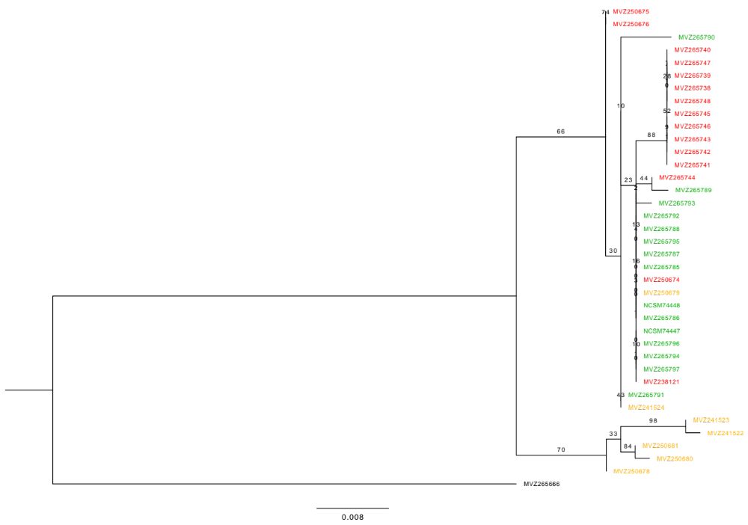

Figure S1. The ML tree inferred using RAxML v8.2.10, with haplotypes of T. s. scripta colored in yellow, T. s. elegans in red, and T. s. troostii in green. Numbers on branches are support values based on 100 bootstrapping replicates. Scale bar represents substitutions per site.

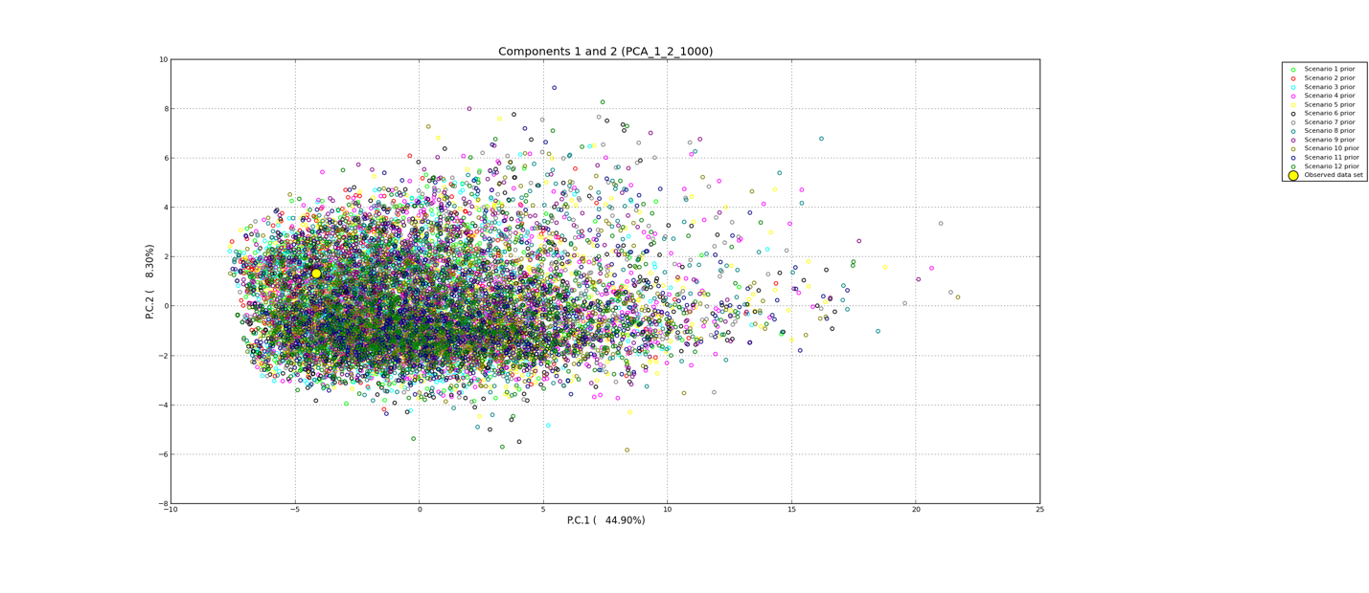
Figure S2. The prior distributions of the tweleve historical scenarios.

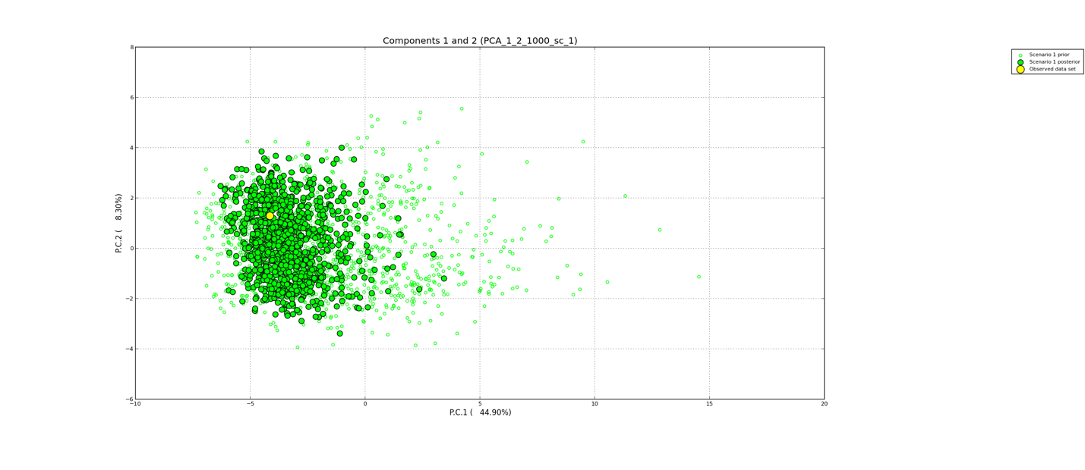
Figure S3. Scenario 1 model performance check.

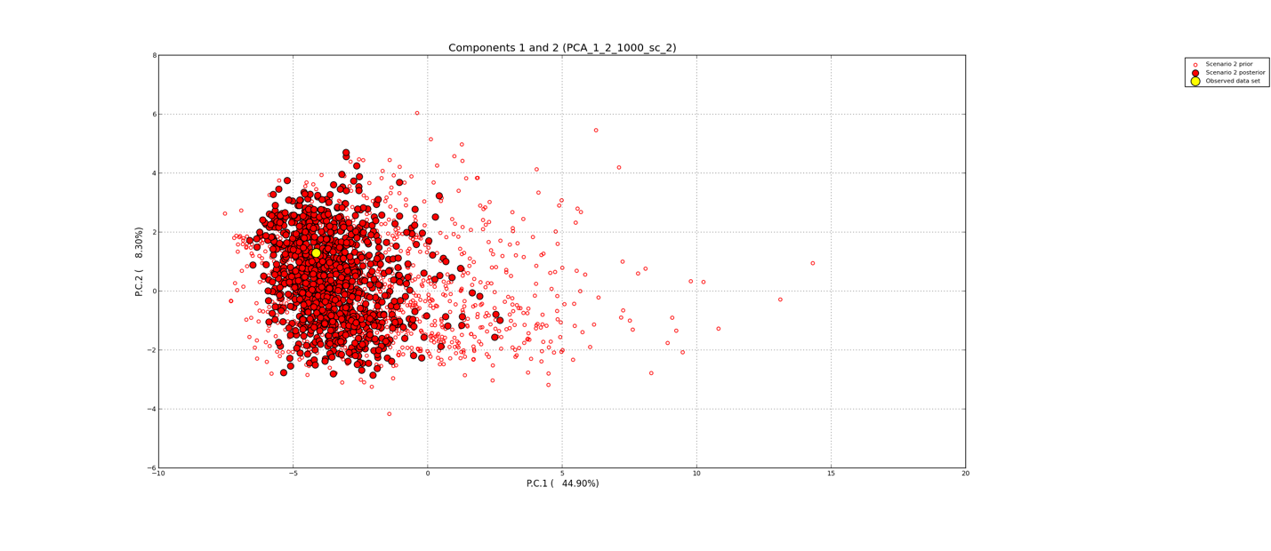
Figure S4. Scenario 2 model performance check.

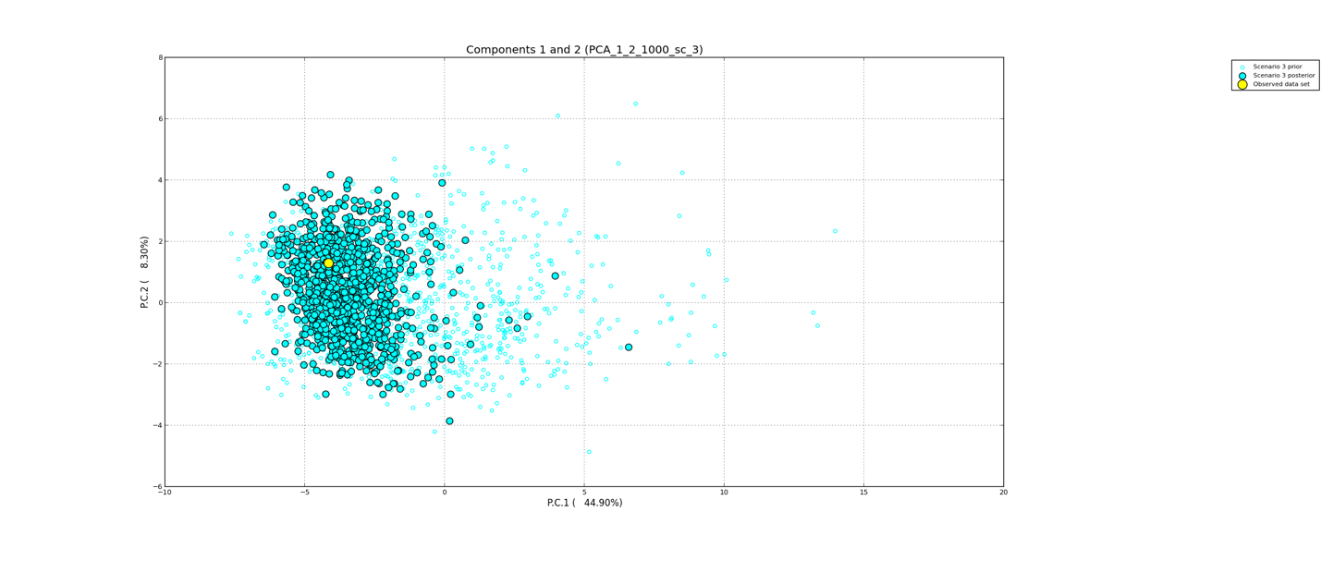
Figure S5. Scenario 3 model performance check.

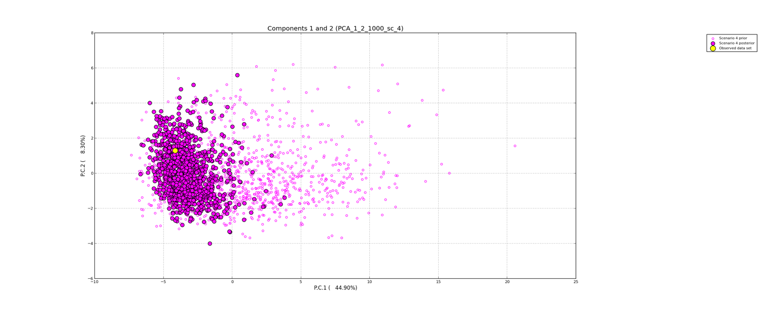
Figure S6. Scenario 4 model performance check.

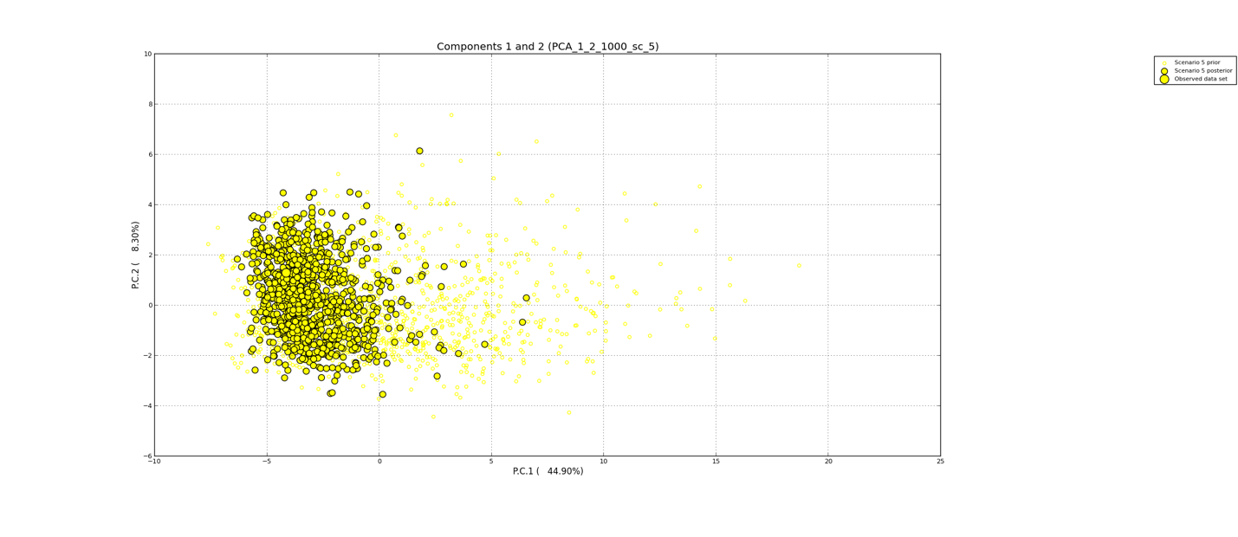
Figure S7. Scenario 5 model performance check.

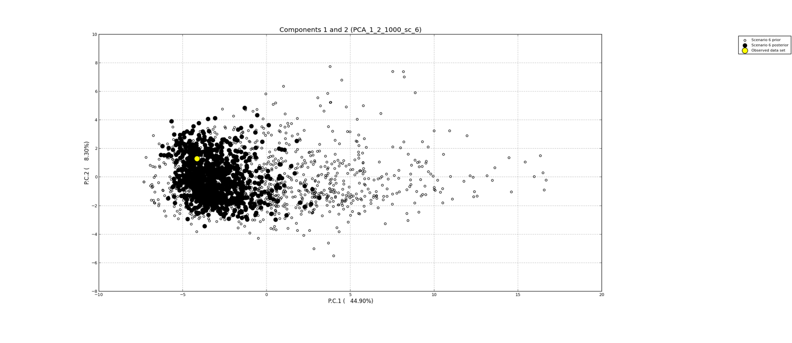
Figure S8. Scenario 6 model performance check.

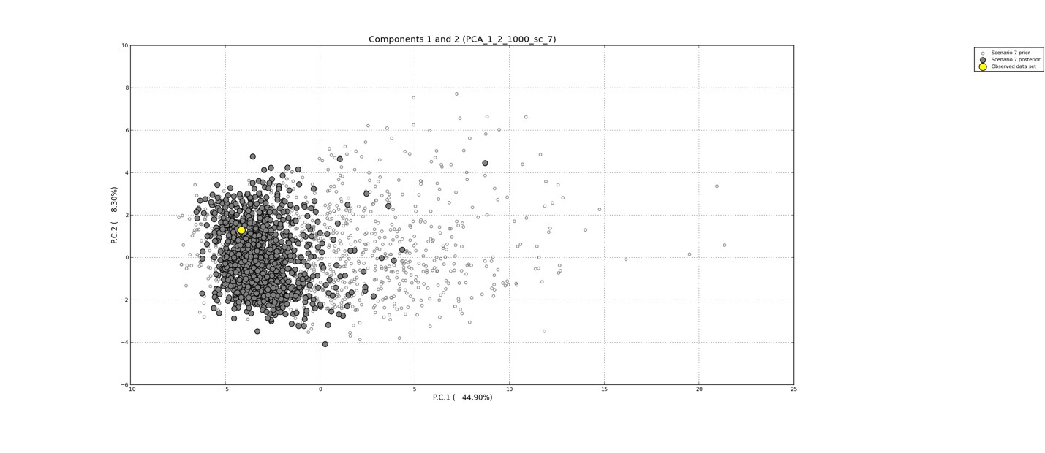
Figure S9. Scenario 7 model performance check.

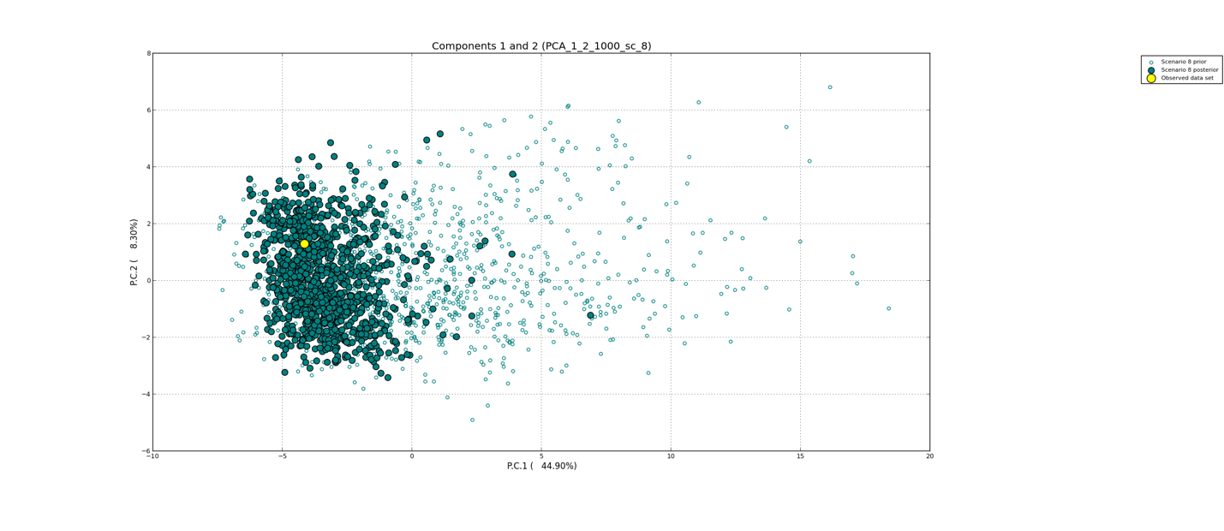
Figure S10. Scenario 8 model performance check.

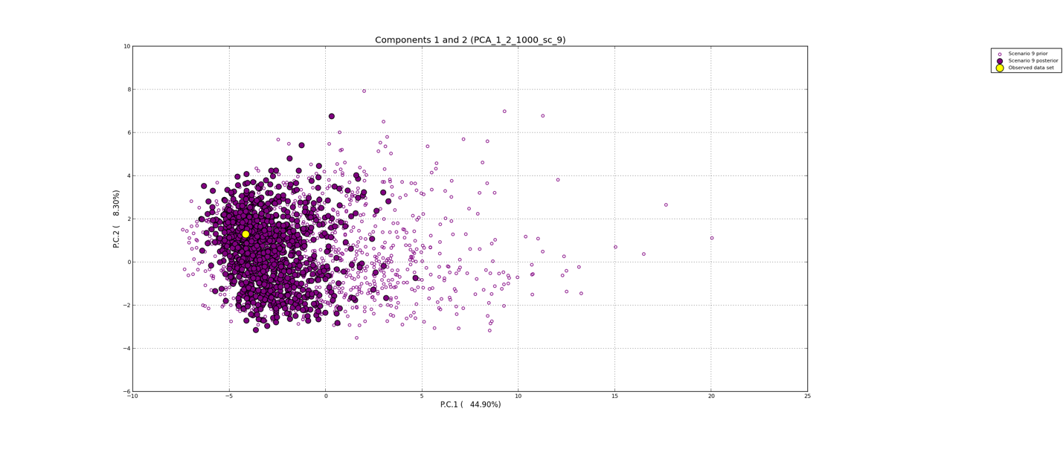
Figure S11. Scenario 9 model performance check.

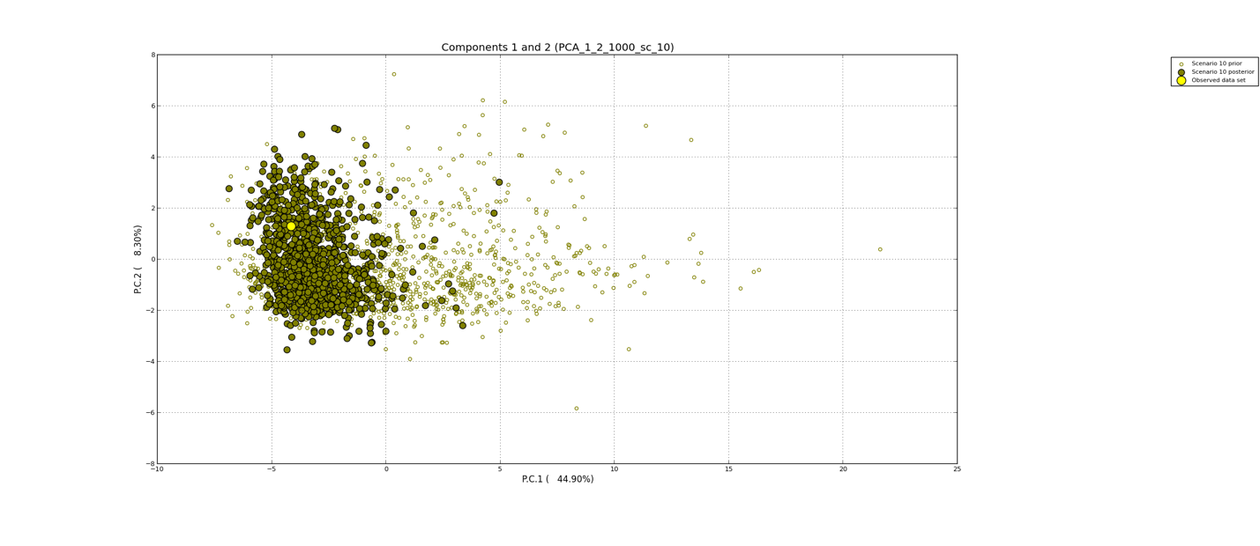
Figure S12. Scenario 10 model performance check.

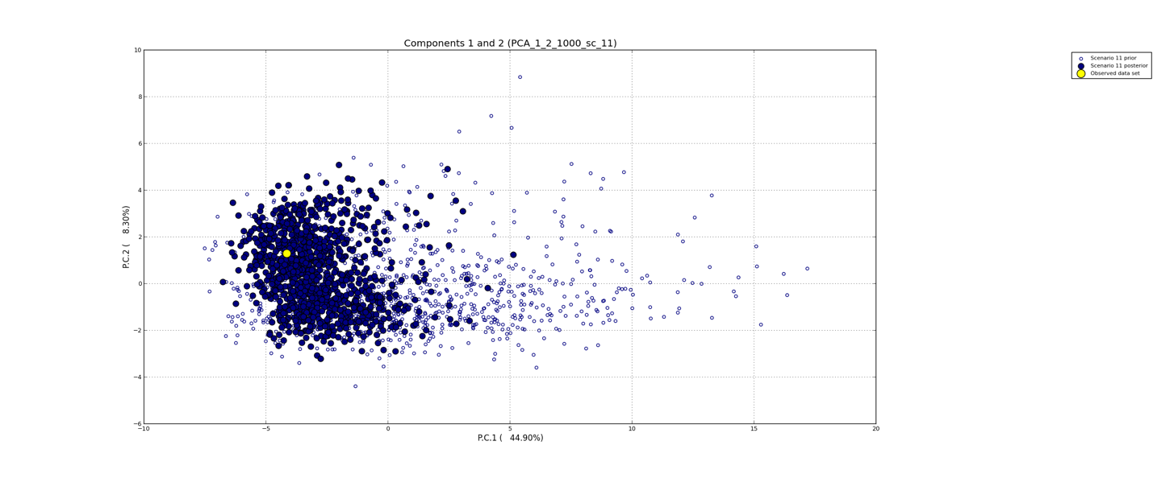
Figure S13. Scenario 11 model performance check.

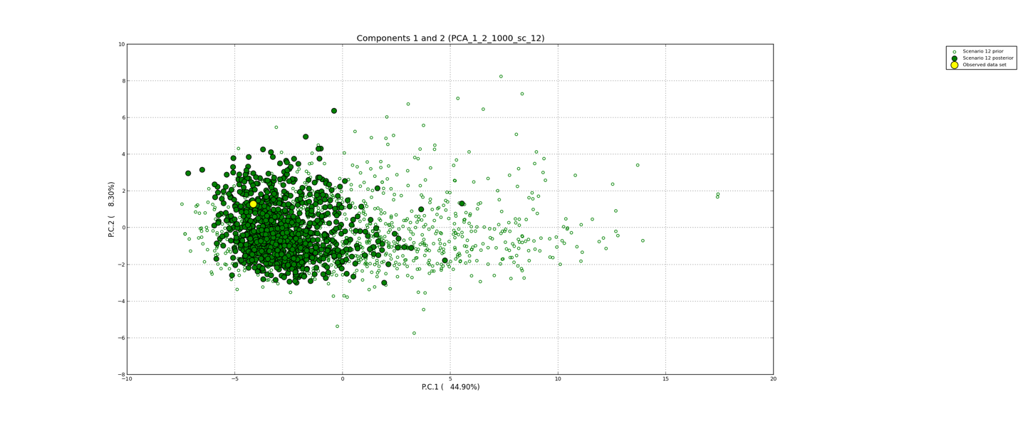
Figure S14. Scenario 12 model performance check.

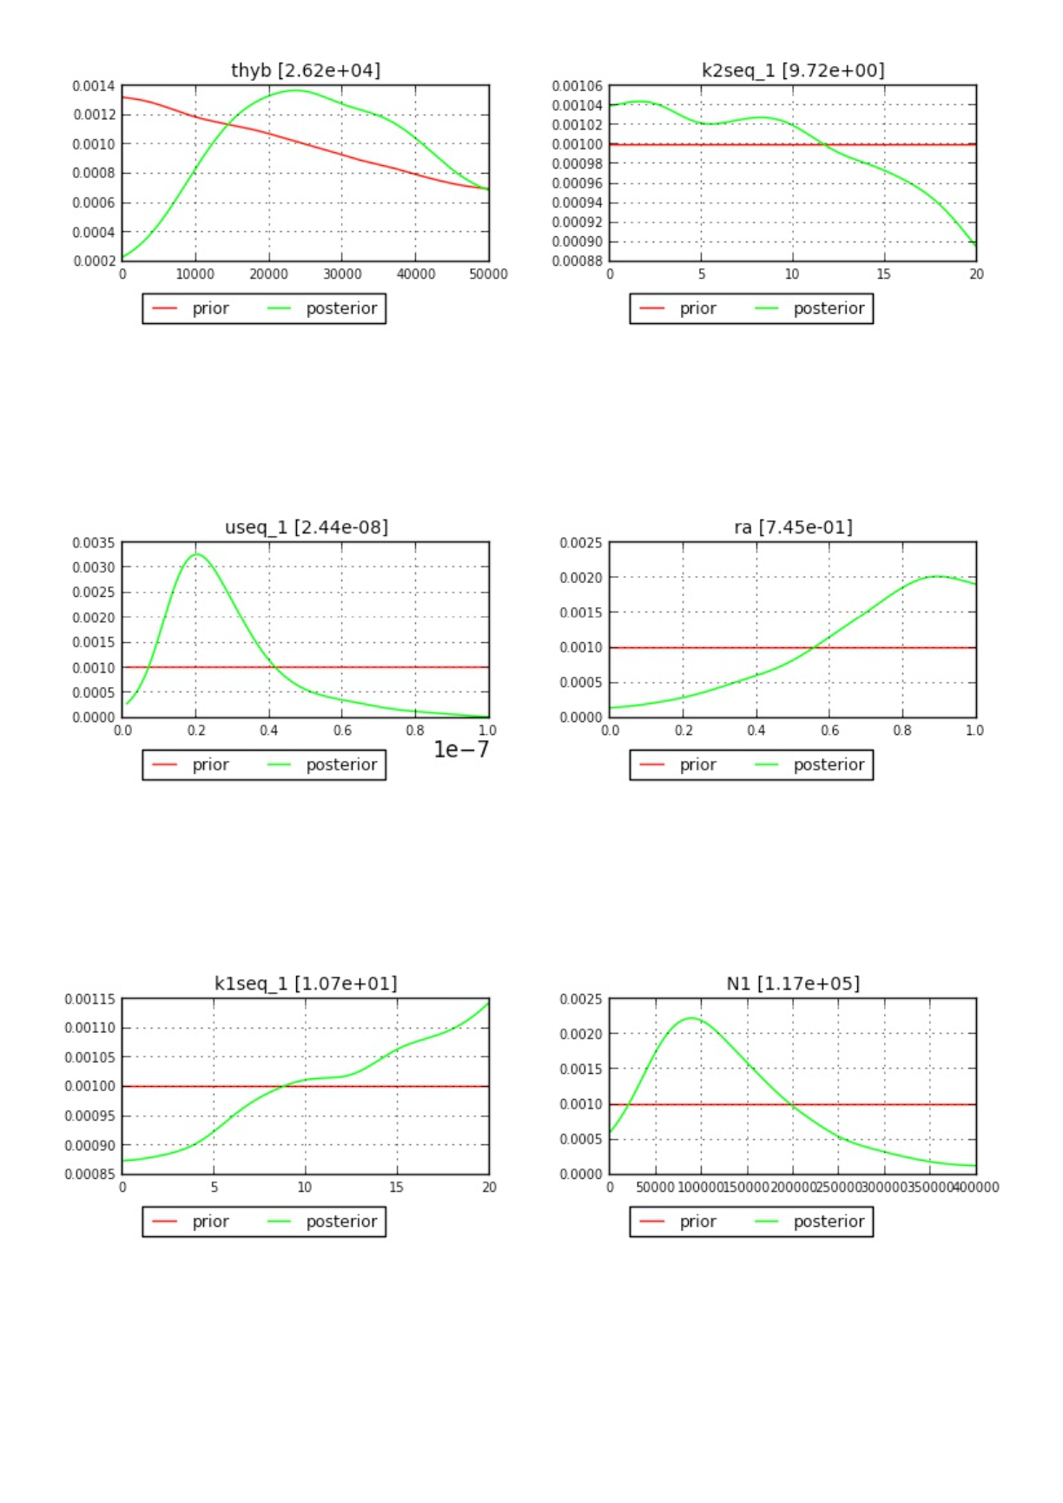
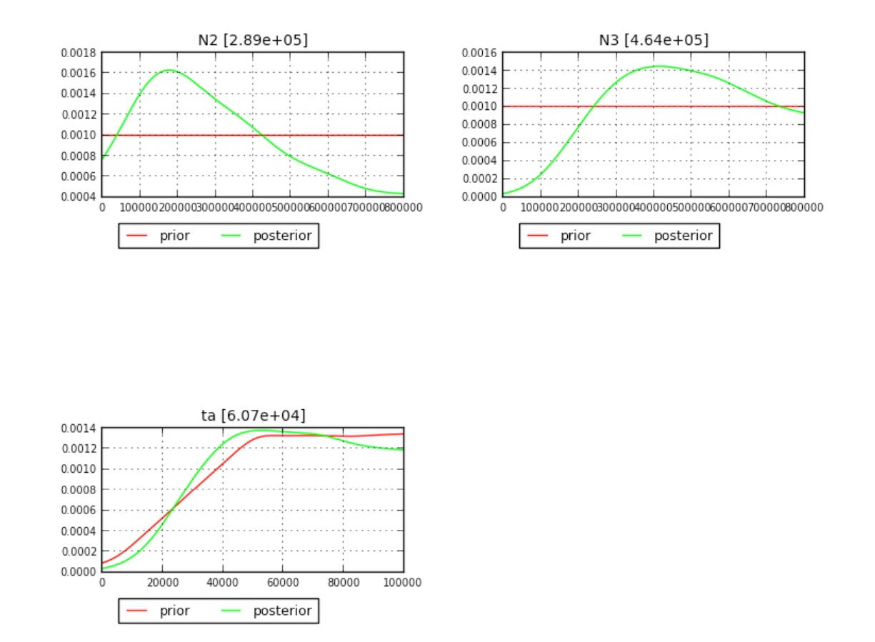

Figure S15. Parameter estimations based on scenario 1.

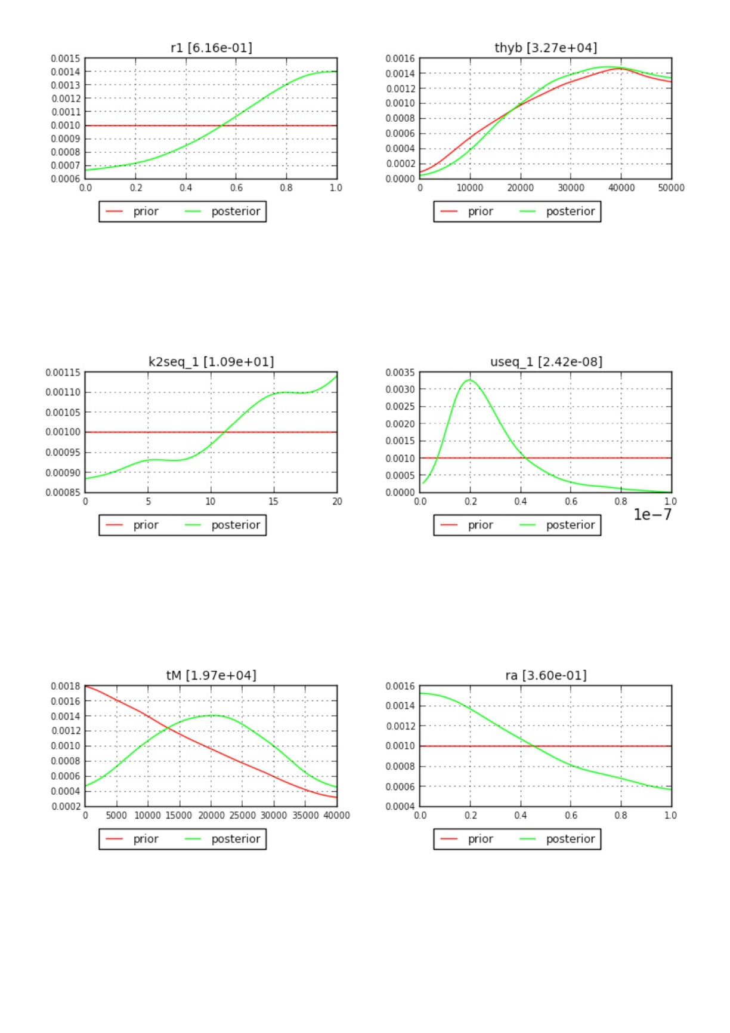
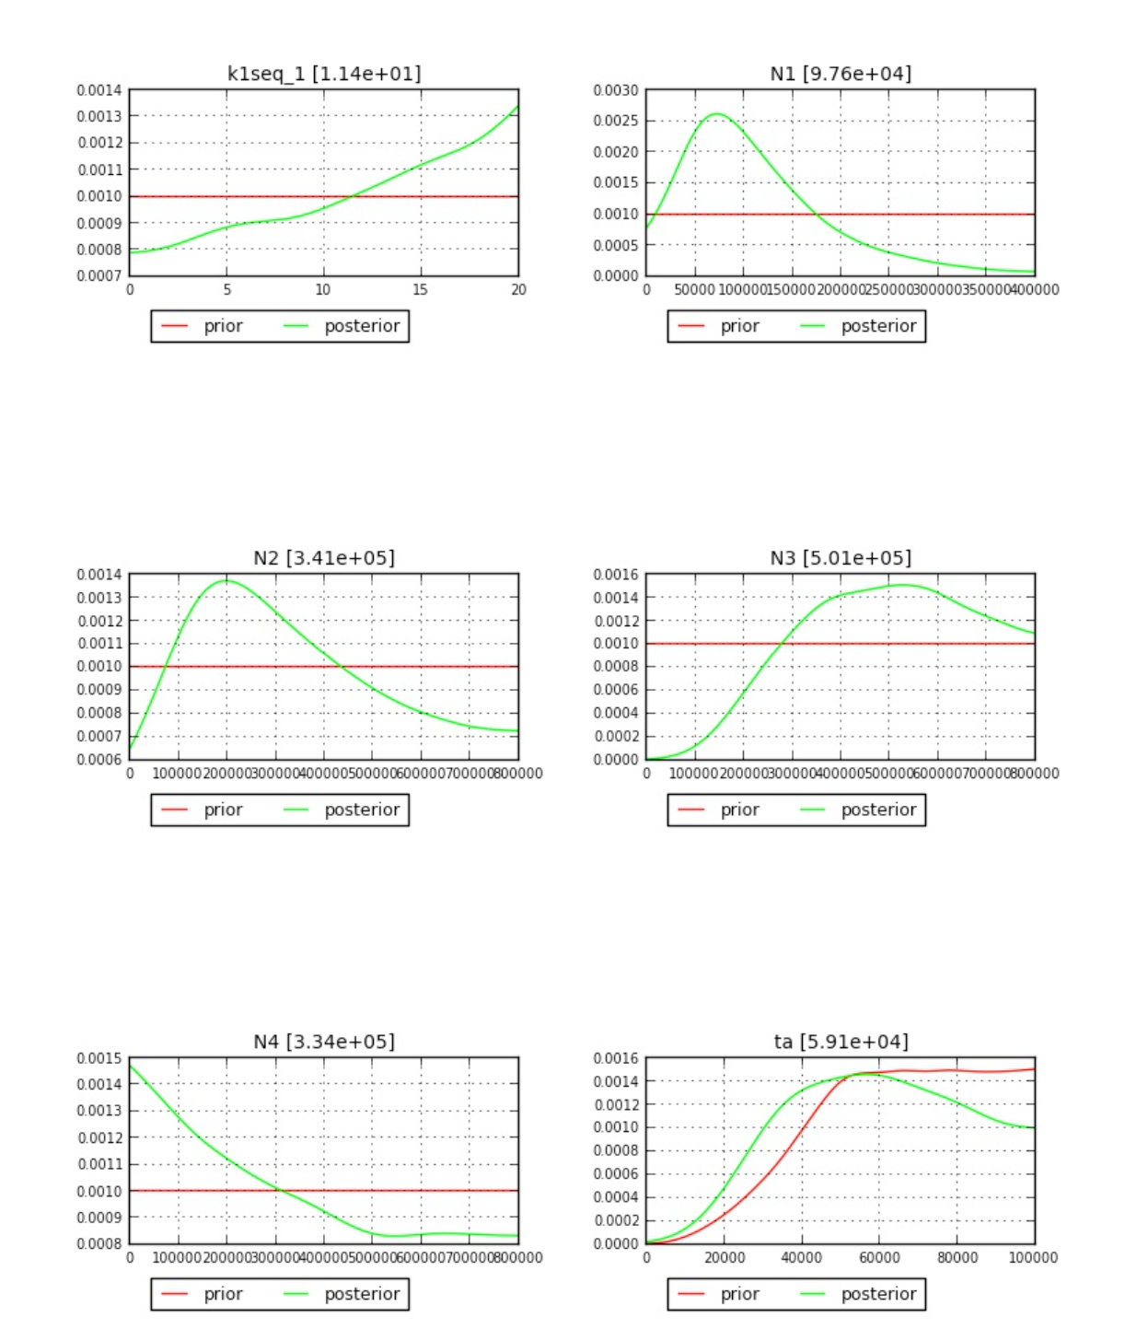
Figure S16. Parameter estimations based on scenario 2.

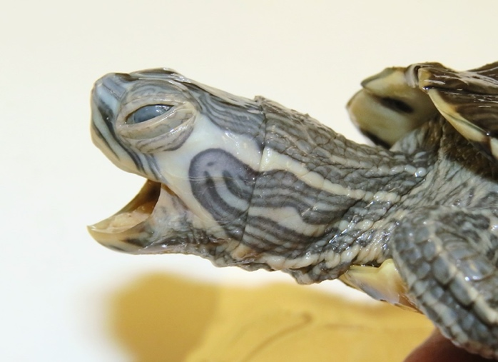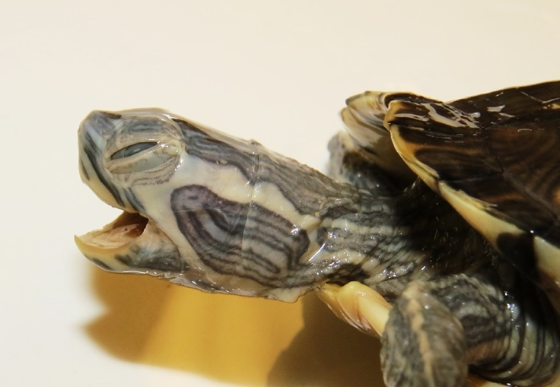

Figure S17. Photographs of (left to right) the head of NCSM74447–48.

