Supplementary material

Figure S1. Hospital mortality in patients with COVID-19 at time of surgery
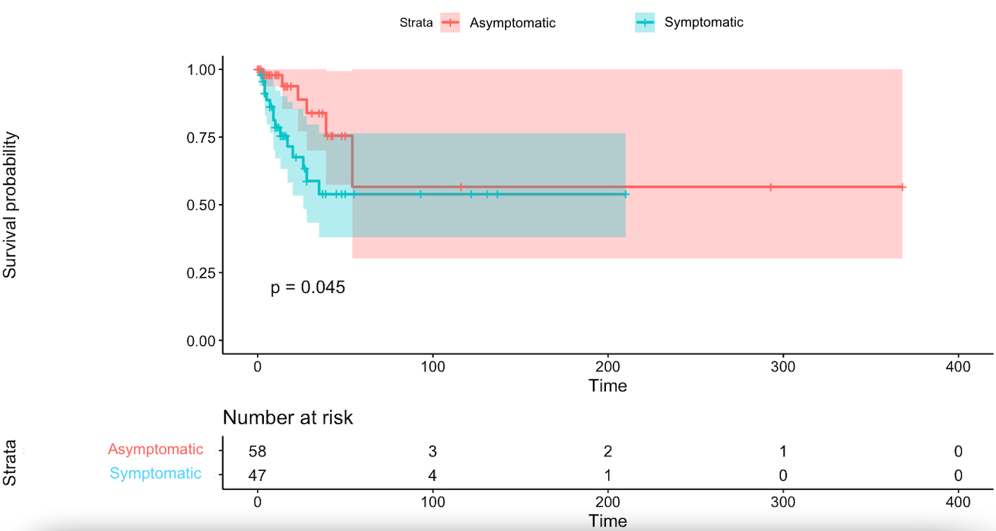
Kaplan-Meier survival curve with 95% confidence bands and a log-rank test
Table S1. Definition of a “recovered” COVID-19 status as of November 2020
Immunosuppressed patient OR  with admission to Intensive Care | Immunocompetent patient AND  no admission to Intensive Care
Absence of temperature > 48 hours (without taking an antipyretic)
Absence of acute symptoms > 24 hours (excluding cough and residual anosmia)
> 21 days from the onset of symptoms (or the date of  test if asymptomatic) IF COVID is severe with  admission to ICU  OR  ≥ 28 days from onset of symptoms (or date of  test if asymptomatic) if patient is immunosuppressed | ≥ 10 days from onset of symptoms (or the date  of the test if asymptomatic)

Table S2. Reported symptoms in symptomatic COVID-19 patients
Symptoms | N = 47
Fever | 24 (51%)
Fatigue | 4 (9%)
Cough | 26 (55%)
Myalgia | 4 (9%)
Dyspnea | 30 (64%)
Diarrhea | 7 (15%)
Vomiting | 5 (11%)
Respiratory failure | 22 (47%)
Abdominal pain | 3 (6%)
Categorical variables are presented as frequency (proportion).

Table S3. Categories of surgery for COVID-19 patients
 | Symptomatic status at time of surgery
Variable | Asymptomatic  (N = 58) | Symptomatic  (N = 47)
Type of major surgery
Abdominal | 6 (29%) | 6 (35%)
Cardiac | 1 (5%) | 3 (18%)
Neurosurgery | 11 (52%) | 4 (24%)
Thoracic | 2 (10%) | 2 (12%)
Vascular | 1 (5%) | 2 (12%)
Type of minor surgery
Breast cancer surgery | 0 (0%) | 0 (0%)
Ear, nose, throat | 3 (8%) | 11 (37%)
Obstetrics | 6 (16%) | 6 (20%)
Orthopedic | 17 (46%) | 2 (7%)
Other | 2 (5%) | 3 (10%)
Peripheral vascular | 2 (5%) | 4 (13%)
Plastic surgery | 1 (3%) | 0 (0%)
Urogenital | 6 (16%) | 4 (13%)
Categorical variables are presented as frequency (proportion).

Table S4. Association between the presence of symptoms and the incidence of postoperative pulmonary complications in patients with COVID-19 at time of surgery (excluding patients who had a tracheostomy as their index surgery)
Variable | Odds Ratio (95% CI) | P value
Presence of symptoms | 2.89 (0.94; 9.31) | 0.07
Preoperative hospitalization | 1.40 (0.33; 5.44) | 0.63
Preoperative oxygen requirement | 0.89 (0.26; 2.87) | 0.85
Urgent surgery | 0.38 (0.11; 1.17) | 0.10
Major surgery | 3.55 (1.13; 12.31) | 0.04
CI = Confidence interval
No random effect

Table S5. Association between the presence of symptoms and the incidence of postoperative pulmonary complications in patients with COVID-19 at time of surgery (excluding patients who had a tracheostomy as their index surgery and patients who had preoperative respiratory failure)
Variable | Odds Ratio (95% CI) | P value
Presence of symptoms | 2.45 (0.67; 8.89) | 0.17
Preoperative hospitalization | 1.55 (0.32; 11.32) | 0.61
Preoperative oxygen requirement | 0.58 (0.11; 2.30) | 0.47
Urgent surgery | 0.36 (0.08; 1.34) | 0.15
Major surgery | 2.92 (0.81; 11.42) | 0.11
CI = Confidence interval
No random effect

Table S6. Association between the presence of symptoms and hospital mortality in patients with COVID-19 at time of surgery (excluding patients who had a tracheostomy as their index surgery)
Variable | Hazard Ratio (95% CI) | P value
Presence of symptoms | 2.60 (0.75; 8.99) | 0.13
Preoperative hospitalization | 1.02 (0.23; 4.63) | 0.98
Preoperative oxygen requirement | 1.14 (0.36; 3.66) | 0.83
Urgent surgery | 0.69 (0.21; 2.30) | 0.55
Major surgery | 3.26 (0.86; 12.29) | 0.08
CI = Confidence interval
This model has center as frailty effect. Number of events = 15 (N=92)

Table S7. Association between the presence of symptoms and hospital mortality in patients with COVID-19 at time of surgery (excluding patients who had a tracheostomy as their index surgery and patients who had preoperative respiratory failure)
Variable | Hazard Ratio (95% CI) | P value
Presence of symptoms | 1.35 (0.32; 5.76) | 0.68
Preoperative hospitalization | 1.37 (0.21; 8.87) | 0.74
Preoperative oxygen requirement | 1.40 (0.37; 5.29) | 0.62
Urgent surgery | 0.47 (0.10; 2.17) | 0.33
Major surgery | 8.43 (1.59; 44.80) | 0.01
CI = Confidence interval
This model has center as a frailty effect. Number of events = 10 (N=80)

Table S8. Characteristics of patients who have recovered from COVID-19 at time of surgery depending on the number of weeks since first positive COVID-19 test
 | Time between first positive COVID-19 test and surgery
Variable | 0 - 4 weeks  (N = 48) | 4 - 8 weeks  (N = 49) | > 8 weeks  (N = 109)
Baseline Characteristics
Age (years) | 60.5 [46.0 - 69.5] | 64.0 [51.0 - 75.0] | 61.0 [45.0 - 72.0]
Sex (female) | 19 (40%) | 28 (57%) | 57 (52%)
Diabetes | 12 (25%) | 15 (31%) | 26 (24%)
Hypertension | 7 (15%) | 10 (20%) | 23 (21%)
COVID characteristics
Days from first positive COVID test to surgery | 22.0 [15.8 - 23.3] | 42.0 [32.0 - 47.0] | 124.0 [84.0 - 211.0]
Pulmonary infiltrates | 16 (33%) | 6 (12%) | 7 (6%)
Any steroids | 7 (15%) | 6 (12%) | 4 (3.7%)
Any antibiotics | 16 (33%) | 11 (22%) | 23 (21%)
Preoperative respiratory support
No oxygen | 37 (77%) | 44 (90%) | 102 (94%)
Oxygen | 3 (6%) | 1 (2%) | 4 (4%)
Invasive ventilation | 8 (17%) | 4 (8%) | 3 (3%)
Surgical characteristics
Preoperative location
Home | 22 (46%) | 30 (61%) | 77 (71%)
Emergency department | 5 (10%) | 3 (6.1%) | 12 (11%)
Ward | 12 (25%) | 11 (22%) | 14 (13%)
Intensive care unit | 9 (19%) | 5 (10%) | 6 (6%)
Urgent surgery | 33 (69%) | 32 (65%) | 84 (77%)
Major surgery | 17 (35%) | 12 (24%) | 23 (21%)
Duration of surgery (minutes) | 66.0 [35.5 - 141.0] | 54.0 [29.0 - 117.0] | 46.0 [30.0 - 100.0]
Intraoperative variables
Type of anesthesia¹
Local | 11 (4%) | 19 (8%) | 27 (25%)
Regional | 6 (15%) | 4 (31%) | 29 (21%)
General | 39 (81%) | 30 (61%) | 58 (53%)
Intraoperative transfusions of blood products | 8 (17%) | 6 (12%) | 9 (8%)
Categorical variables are presented as frequency (proportion).
Continuous variables are presented as mean ± standard deviation or as median [1st quartile - 3rd quartile].

Table S9. Categories of surgery for patients who had recovered from COVID-19
 | Time between first positive COVID-19 test and surgery
Variable | 0 - 4 weeks  (N = 48) | 4 - 8 weeks  (N = 49) | > 8 weeks  (N = 109)
Type of major surgery
Abdominal | 9 (53%) | 3 (25%) | 15 (65%)
Cardiac | 3 (18%) | 2 (17%) | 3 (13%)
Neurosurgery | 4 (24%) | 2 (17%) | 3 (13%)
Thoracic | 1 (6%) | 4 (33%) | 1 (4%)
Vascular | 0 (0%) | 1 (8%) | 1 (4%)
Type of minor surgery
Breast cancer surgery | 0 (0%) | 1 (3%) | 2 (2%)
Ear, nose and throat | 10 (34%) | 3 (8%) | 5 (6%)
Obstetrics | 1 (3%) | 2 (5%) | 2 (2%)
Orthopedic | 7 (24%) | 15 (41%) | 14 (16%)
Other | 1 (3%) | 2 (5%) | 27 (31%)
Peripheral vascular | 2 (7%) | 0 (0%) | 9 (10%)
Plastic surgery | 3 (10%) | 2 (5%) | 6 (7%)
Urogenital | 5 (17%) | 12 (32%) | 21 (24%)
Categorical variables are presented as frequency (proportion).

Table S10. Postoperative outcomes of patients who have recovered from COVID-19 at time of surgery depending on the number of weeks since first positive COVID-19 test
 | Time between first positive COVID-19 test and surgery
Variables | 0 - 4 weeks  (N = 48) | 4 - 8 weeks  (N = 49) | > 8 weeks  (N = 109)
Postoperative complications
Any complication | 16 (33%) | 18 (37%) | 24 (22%)
Any pulmonary complication | 6 (13%) | 11 (22%) | 8 (7%)
Atelectasis | 4 (8%) | 6 (12%) | 6 (6%)
Pneumonia | 3 (6%) | 4 (8%) | 3 (3%)
ARDS | 0 (0%) | 0 (0%) | 0 (0%)
Pneumothorax | 0 (0%) | 4 (8%) | 1 (1%)
Acute kidney injury | 1 (2%) | 3 (6%) | 6 (6%)
New postoperative renal replacement therapy | 1 (2%) | 1 (2%) | 0 (0%)
Myocardial infarction | 1 (2%) | 0 (0%) | 5 (5%)
Stroke | 1 (2%) | 0 (0%) | 0 (0%)
Non-pulmonary infection | 6 (13%) | 7 (14%) | 12 (11%)
Surgical reintervention | 3 (6%) | 1 (2%) | 10 (9%)
Resource utilization and mortality
Need for a new postoperative ICU admission | 10 (21%) | 9 (18%) | 9 (8%)
Hospital length of stay (days) | 3.5 [1.0 – 13.0] | 3.0 [0.0 – 8.0] | 0.0 [0.0 – 4.0]
One or more days on postoperative mechanically ventilated | 11 (23%) | 7 (14%) | 7 (6%)
30-day organ dysfunction free days | 26.7 ± 7.9 | 27.9 ± 6.5 | 28.1 ± 5.8
Hospital mortality | 4 (8%) | 2 (4%) | 2 (2%)
Status at hospital discharge among living patients
Discharged at home | 37 (77%) | 42 (86%) | 92 (84%)
Transferred to another acute care setting | 3 (6%) | 3 (6%) | 5 (5%)
Transferred to another long-term care setting | 4 (8%) | 2 (4%) | 10 (9%)
Categorical variables are presented as frequency (proportion).
Continuous variables are presented as mean ± standard deviation or as median [1st quartile - 3rd quartile].
ARDS = acute respiratory distress syndrome

Table S11. Association between the time elapsed from initial COVID-19 test and postoperative mortality in patients with COVID-19 at time of surgery
Variable | Hazard Ratio (95% CI) | P value
Time from first positive COVID test | 1.00 (0.99; 1.01) | 0.70
Preoperative hospitalization | 1.81 (0.15; 22.01) | 0.64
Preoperative oxygen requirement | 0.87 (0.15; 4.97) | 0.88
Urgent surgery | 0.82 (0.17; 4.00) | 0.80
Major surgery | 0.31 (0.04; 2.63) | 0.28
CI = Confidence interval
This model has center as frailty effect. Number of events = 8 (N=206)

Table S12. Association between “recovered status” and postoperative pulmonary complications compared to asymptomatic carriers
Variable | Odds Ratio (95% CI) | P value
Recovered status (versus asymptomatic carriers) | 1.60 (0.57; 4.45) | 0.37
Preoperative hospitalization | 3.83 (1.25; 11.71) | 0.02
Preoperative oxygen requirement | 1.78 (0.70; 4.56) | 0.23
Urgent surgery | 0.41 (0.16; 1.02) | 0.05
Major surgery | 2.14 (0.95; 4.83) | 0.07
C.I. = Confidence interval
This model has center as a random effect. Intracluster correlation = 0.025

Table S13. Association between “recovered status” and in-hospital mortality compared to asymptomatic carriers
Variable | Hazard Ratio (95% CI) | P value
Recovered status (versus asymptomatic carriers) | 0.74 (0.24; 2.28) | 0.60
Preoperative hospitalization | 2.15 (0.42; 11.01) | 0.36
Preoperative oxygen requirement | 1.11 (0.34; 3.67) | 0.86
Urgent surgery | 0.55 (0.17; 1.75) | 0.31
Major surgery | 1.42 (0.47; 4.27) | 0.54
CI = Confidence interval
This model has center as a frailty effect. Number of events = 14 (N=264)

List of participating centres:
- Centre Hospitalier de l’Université de Montréal
- Hôpital du Sacré-Cœur-de-Montréal, CIUSSS du Nord de l’Île de Montréal
- Hôpital Maisonneuve-Rosemont, CIUSSS de l’Est de l’île de Montréal
- McGill University Health Center
- Centre Hospitalier Universitaire de Sherbrooke
- Centre Hospitalier Universitaire de Québec – Université Laval
- Institut Universitaire de Cardiologie et de Pneumologie de Québec - Université Laval

