Supplemental Information for

Title: The effects of inducible defenses on population stability and persistence in Paramecium aurelia

Authors: Catherine M. McClure¹, Kayla Hancey¹, Edd Hammill

¹ Department of Watershed Sciences and the Ecology Center, Utah State University, Logan, Utah 84341 USA cat.mcclure@usu.edu; A00816865@aggies.usu.edu; edd.hammill@usu.edu

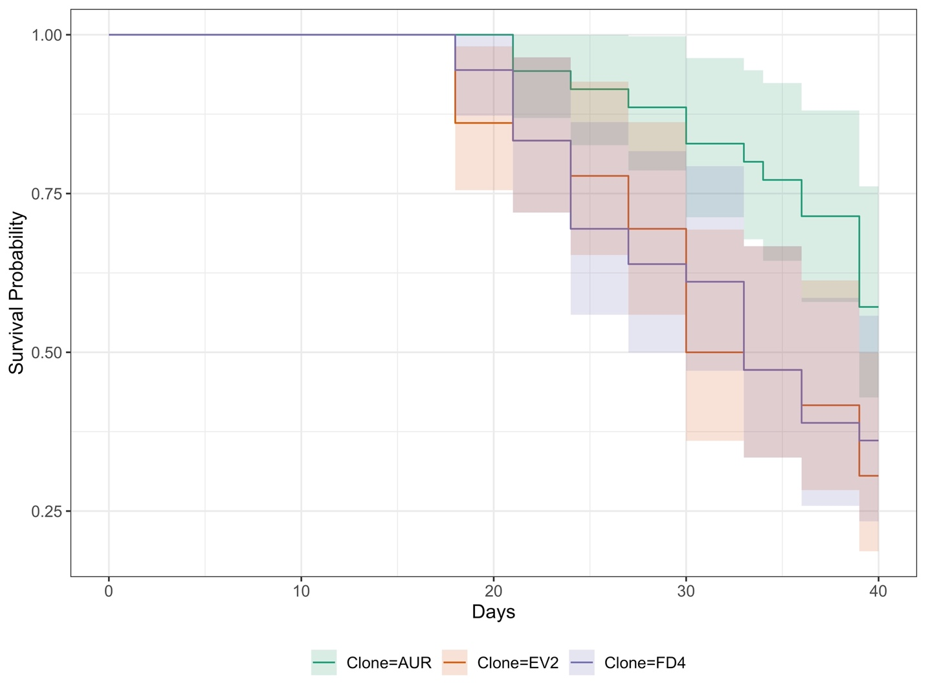
Figure S1. Survival probability curves for three genetically distinct P.aurelia populations over a 40-day experimental period. The AUR population displays an inducible defense mechanism (i.e., grows wider in response to predation threat). The EV2 population does not display an inducible defense (i.e., does not grow wider in response to predation threat). The FD4 population remains in a permanently defended state (i.e., remains in a wider state regardless of predation threat). Shaded areas represent the 95% confidence interval.

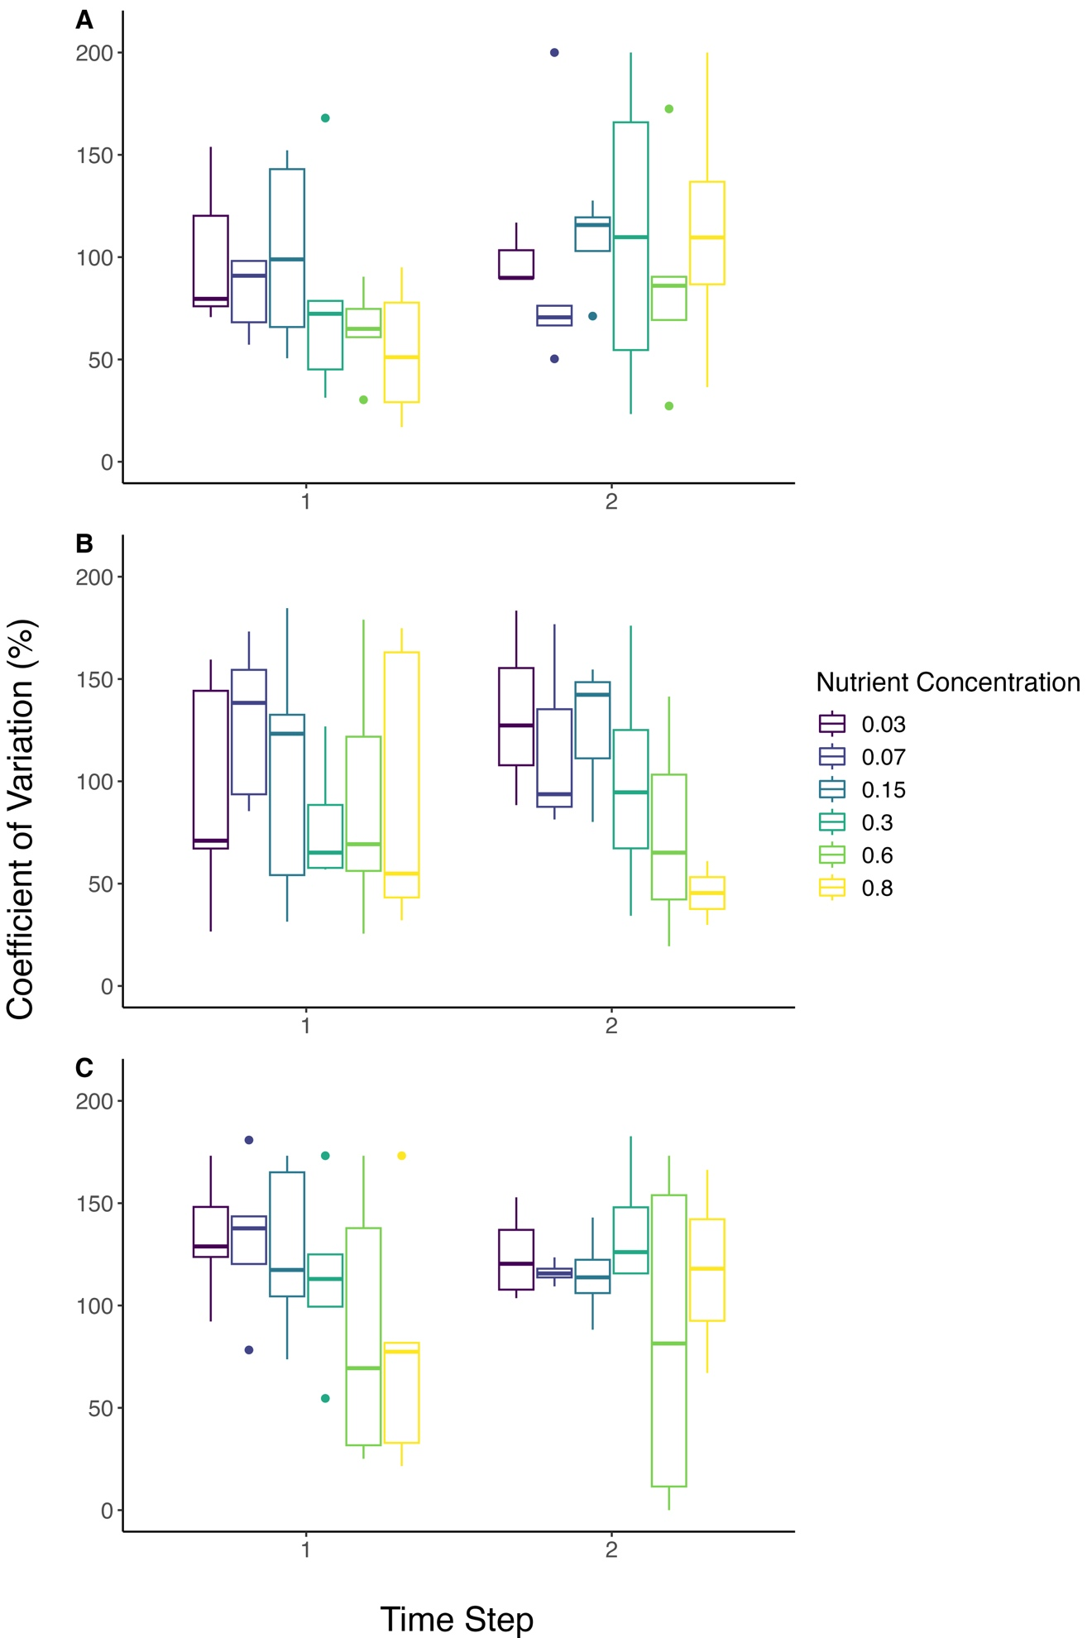
Figure S2. Changes in a measure of population stability (i.e., coefficient of variation (%); ± SE) across an increasing nutrient concentration gradient for a population of P.aurelia that utilizes an inducible defense mechanism (i.e., grows wider in response to predation threat, AUR; Panel A), remains in a permanently defended state (i.e., remains in a wider state regardless of predation threat, FD4; Panel B), and does not utilize an inducible defense (i.e., does not grow wider in response to predation threat, EV2; Panel C). Population stability was measured over two separate time windows within a 40-day experimental period. Time step one included sampling days 9-18, and time step two included sampling days 21-30. The dashed line is included for comparison between clonal population estimates.

CM and EH conceived and formulated the idea. CM, EH, and KH developed the methodology. CM and KH performed the experiment and collected the data. CM and EH analyzed the data. CM and EH wrote the original draft of the manuscript. CM, EH, and KH edited and reviewed the manuscript. EH provided the funding and resources for the project.

