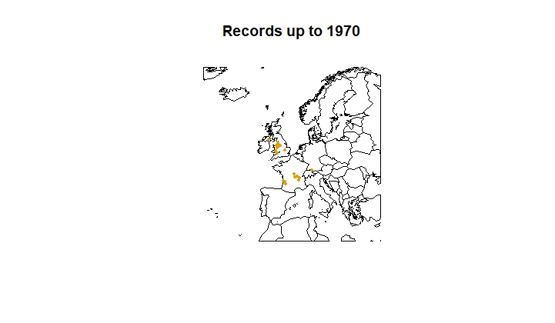
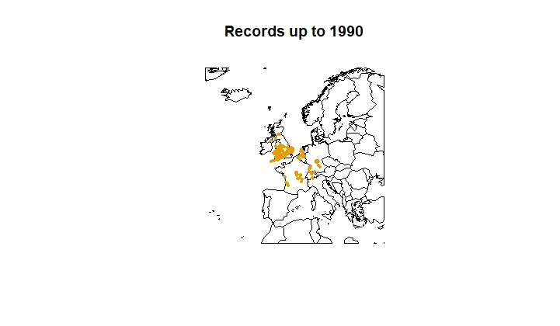
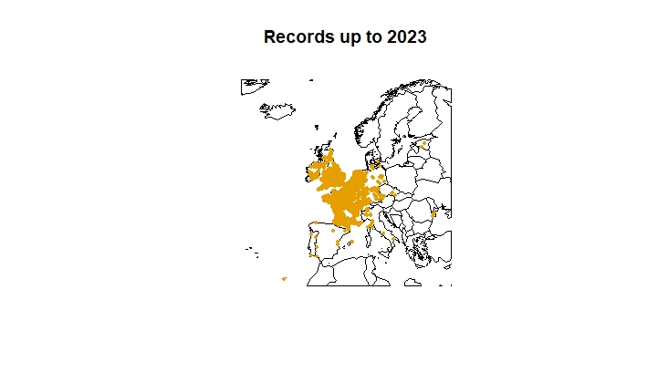
Appendix 1. Recent range expansion of least duckweed in Europe.

Occurrence maps are based on unique records retrieved from GBIF.org on 2023-10-02 (https://doi.org/10.15468/dl.g5m5h8)

Appendix 2. Thermal performance curve for a native and an invasive strain in the US.
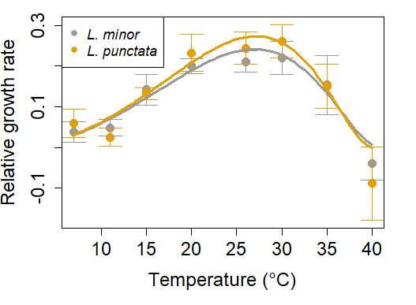
Thermal performance curve for a native strain in the US (common duckweed, L. minor) and an invasive strain (dotted duckweed, L. punctata). Relative growth rates were calculated based on individual frond counts after a 5-day experimental period. Points indicate mean performance and bars are standard errors. Curves were calculated using the Ratkowsky function (Ratkowskly, 1983). Linear mixed models, relative growth rate ~ species * mean temperature, were used to compare growth rates of each species across mean temperatures, and included experiment run ID as a random factor (model including ascending portion of curve < 31 ºC = Marginal R² / Conditional R² = 0.776 / 0.892; model including descending portion of curve > 31 ºC = Marginal R² / Conditional R² = 0.772 / 0.985). The models revealed no significant differences between the 2 species within any of the temperatures tested. The number of replicates in each temperature, for L. minor and L. punctata, respectively, are: 7 °C (5,6), 11 °C (3,3), 15 °C (4 ,4), 20 °C (4,6), 26 °C (3,5), 30 °C (5,5), 35 °C (5,7), 40 °C (3,4).

Appendix 3. Additional sources of L. punctata observation records.
Location | Lon | Lat | Coordinates provided? | Year | Reference
Amstelveen, Netherlands | 4°51"E | 52°18"N | Yes | 2007 | van Valkenburg & Pot, 2008
Vinkeveense Plassen, Netherlands | 4°95"E | 52°23"N | Yes | 2007 | van Valkenburg & Pot, 2008
Bleiswijk, Netherlands | 4°31"E | 52°00"N | Yes | 2007 | van Valkenburg & Pot, 2008
Pijnacker, Netherlands | 4°25"E | 52°00"N | Yes | 2007 | van Valkenburg & Pot, 2008
Belfeld, Netherlands | 6°12"E | 51°31"N | Yes | 2007 | van Valkenburg & Pot, 2008
North Brabant, Netherlands | 5°23"E | 51°48"N | Yes | 2007 | van Valkenburg & Pot, 2008
Unreported, Belgium | 4°47"E | 50°50"N | No (country capital location used) | 2020 | Neucker & Scheers, 2023
Unreported, England | 0°11"E | 51°50"N | No (country capital location used) | 2006 | EPPO, 2015
Unreported, Italy | 12°57"E | 41°87"N | No (country capital location used) | NA | EPPO, 2015
Unreported, Spain | 12°57"E | 41°87"N | No (country capital location used) | NA | EPPO, 2015
Unreported, Switzerland | 6°14"E | 46°20"N | No (country capital location used) | NA | EPPO, 2015
Unreported, Finland | 24°94"E | 60°19"N | No (country capital location used) | NA | EU, 2023
Tenerife, Spain | 16°15"W | 28°28"N | Yes | NA | EU, 2023
San Marino, Italy | 12°27"E | 43°56"N | Yes | NA | EU, 2023
Vatican City, Italy | 12°45"E | 41°90"N | Yes | NA | EU, 2023
Unreported, Sweden | 18°30"E | 59°20"N | No (country capital location used) | NA | CABI, 2019

Appendix 4. Candidate model selection.
4.1. Models using current lake water temperature predictors
Features | Regularization multiplier | Training AUC | Mean testing AUC | AICc | Delta AICc | Parameters
L | 0.5 | 0.74 | 0.7 | 17,271 | 1,660 | 3
LQ | 0.5 | 0.9 | 0.82 | 15,610 | 0 | 6
L | 1 | 0.74 | 0.69 | 17,262 | 1,651 | 3
LQ | 1 | 0.89 | 0.78 | 15,832 | 221 | 6
L | 1.5 | 0.74 | 0.69 | 17,254 | 1,643 | 3
LQ | 1.5 | 0.88 | 0.77 | 16,029 | 418 | 6
L | 2 | 0.74 | 0.69 | 17,246 | 1,635 | 3
LQ | 2 | 0.87 | 0.77 | 16,216 | 605 | 6
L | 2.5 | 0.74 | 0.69 | 17,237 | 1,626 | 3
LQ | 2.5 | 0.86 | 0.77 | 16,372 | 761 | 5
L | 3 | 0.74 | 0.69 | 17,229 | 1,618 | 3
LQ | 3 | 0.85 | 0.77 | 16,524 | 913 | 5
L | 3.5 | 0.74 | 0.69 | 17,222 | 1,611 | 3
LQ | 3.5 | 0.84 | 0.76 | 16,670 | 1,059 | 5
L | 4 | 0.74 | 0.69 | 17,214 | 1,603 | 3
LQ | 4 | 0.84 | 0.76 | 16,758 | 1,148 | 4

4.2. Models using current air temperature predictors
Features | Regularization multiplier | Training AUC | Mean testing AUC | AICc | Delta AICc | Parameters
L | 0.5 | 0.77 | 0.69 | 21,987 | 1,769 | 3
LQ | 0.5 | 0.87 | 0.77 | 20,218 | 0 | 5
L | 1 | 0.77 | 0.69 | 21,981 | 1,763 | 3
LQ | 1 | 0.87 | 0.76 | 20,328 | 110 | 5
L | 1.5 | 0.77 | 0.7 | 21,976 | 1,757 | 3
LQ | 1.5 | 0.87 | 0.75 | 20,440 | 222 | 5
L | 2 | 0.77 | 0.7 | 21,971 | 1,752 | 3
LQ | 2 | 0.86 | 0.75 | 20,575 | 357 | 6
L | 2.5 | 0.77 | 0.7 | 21,966 | 1,748 | 3
LQ | 2.5 | 0.85 | 0.75 | 20,709 | 491 | 6
L | 3 | 0.77 | 0.7 | 21,962 | 1,744 | 3
LQ | 3 | 0.85 | 0.75 | 20,858 | 640 | 6
L | 3.5 | 0.77 | 0.7 | 21,959 | 1,741 | 3
LQ | 3.5 | 0.84 | 0.74 | 21,012 | 793 | 6
L | 4 | 0.76 | 0.7 | 21,956 | 1,738 | 3
LQ | 4 | 0.83 | 0.74 | 21,158 | 940 | 5

4.3. Models using future air temperature predictors
Features | Regularization multiplier | Training AUC | Mean testing AUC | AICc | Delta AICc | Parameters
L | 0.5 | 0.76 | 0.7 | 22,212 | 2,122 | 3
LQ | 0.5 | 0.89 | 0.8 | 20,089 | 0 | 6
L | 1 | 0.76 | 0.7 | 22,207 | 2,117 | 3
LQ | 1 | 0.88 | 0.78 | 20,322 | 232 | 6
L | 1.5 | 0.76 | 0.7 | 22,202 | 2,112 | 3
LQ | 1.5 | 0.86 | 0.76 | 20,520 | 431 | 5
L | 2 | 0.76 | 0.7 | 22,197 | 2,108 | 3
LQ | 2 | 0.85 | 0.75 | 20,697 | 607 | 5
L | 2.5 | 0.76 | 0.7 | 22,193 | 2,103 | 3
LQ | 2.5 | 0.84 | 0.75 | 20,887 | 798 | 5
L | 3 | 0.76 | 0.69 | 22,189 | 2,099 | 3
LQ | 3 | 0.83 | 0.74 | 21,090 | 1,001 | 5
L | 3.5 | 0.75 | 0.69 | 22,185 | 2,095 | 3
LQ | 3.5 | 0.82 | 0.72 | 21,302 | 1,213 | 5
L | 4 | 0.75 | 0.69 | 22,181 | 2,092 | 3
LQ | 4 | 0.81 | 0.72 | 21,526 | 1,437 | 6

