Supporting Information
In vitro effect-based monitoring of water, sediment and soil
from a floodplain restoration site
Nina Kuschik-Maczollek¹*, Malte Glock¹, Markus Schmitz², Henner Hollert², Martin Krauss³, Aleksandra Piotrowska³, Werner Brack^{2, 3}, Jörg Oehlmann¹

¹ Goethe University Frankfurt am Main, Institute for Ecology, Evolution and Diversity,
Department Aquatic Ecotoxicology, Max-von-Laue-Str. 13, 60438 Frankfurt am Main, Germany
² Goethe University Frankfurt am Main, Institute for Ecology, Evolution and Diversity,
Department of Evolutionary Ecology and Environmental Toxicology,
Max-von-Laue-Str. 13, 60438 Frankfurt am Main, Germany
³ Helmholtz Centre for Environmental Research – UFZ, Department of Effect Directed Analysis, Permoserstraße 15, 04318 Leipzig, Germany

*Corresponding author: n.kuschik@outlook.de
Malte Glock: malte.glock@web.de
Markus Schmitz: schmitz@bio.uni-frankfurt.de
Henner Hollert: hollert@bio.uni-frankfurt.de
Martin Krauss: martin.krauss@ufz.de
Aleksandra Piotrowska: aleksandra.piotrowska@ufz.de
Werner Brack: werner.brack@ufz.de
Jörg Oehlmann: oehlmann@bio.uni-frankfurt.de

Sample collection and preparation
Water samples from the tributary, the ponds and the flood depressions were taken on April 28, 2021 and from the Main river on August 8, 2021, with air temperatures of 21°C and 25°C, respectively. There was no rainfall on either sampling day. Water samples from the Main river were taken in approximately 1 m distance from the riverbank. The 24 h composite sample was taken from August 9, 2021 (7:15 AM) to August 10, 2021 (7:15 AM).
Suspended particulate matter (SPM) from the Main river was sampled with self-made sedimentation-traps from August 10, 2021 to September 14, 2021.
Sediments from the tributary and the ponds were collected on April 28, 2021. Sediments from Main river sites M1, M2, M3 and M6 were taken on November 13, 2021 and from sites M4 and M5 on February 5, 2022 using multiple wastewater pipes (Marley Deutschland GmbH, HTEM poly-propylene pipes, DIN EN 1451-1, EAN: 4002644090856) that were plugged together to reach a water depth of up to 5 m. The samples were stored in the pipes for 48 h at 10°C before being divided into surface and core sediment based on the respective color profile, if visible. Otherwise, the top two 2 cm were defined as surface, the bottom 2 cm as core sediment.
Soil samples were taken from the upper two horizons and stored in 500 mL glass vessels on November 5, 2021. The first horizon from the riparian profile R1 reached a depth of 15 cm, the second one 42.5 cm. The profile from the area of the future tributary T4 was located at the edge of the flood channel, with the first horizon being 20 cm deep, the second one 35 cm. The soil horizons were classified by the Hessian State Office for Environment and Geology.
All glass vessles used for sampling were previously cleaned with acetone and ultrapure water and heated to 200°C in a drying oven (VWR VENTI-line 115, VWR International GmbH, Darmstadt, Germany). All materials used in the PLE were cleaned three times each with tap water, demineralized water and acetone. The glass vessels for the PLE were soaked overnight in Edinosite® and then cleaned in the same way. During the sample clean up process, all materials were rinsed with methanol, ethyl acetate, acetone and dichloromethane.

Overview of results
Table S1 In vitro effect-based methods
Results of in vitro effect-based methods of water (w), suspended particulate matter (p; SPM), surface sediment (ss), core sediment (sc), and soil (h) samples from the Main river (M) and the tributary (T), ponds (P), the flood depressions (F) and riparian area (R) of the floodplain restoration site. For SPM, sediment and soil samples, 2,3,7,8-tetrachlordibenzodioxin eqivalents (TCDD-EQs) are calculated from β-naphtoflavon (β-NF) EQs using an intern conversion factor. Significant differences in activities at the estrogen receptor (ER) and aryl hydrocarbon receptor (AhR) in Main river samples M2-M6 and the effluent sample E were compared to the reference site M1 using an unpaired t-test (α=0.05) if they exceeded the limit of quantification (LOQ). Welch’s correction was applied for datasets with significantly different variances. *p<0.05; **p<0.01; ***p<0.001; ns= not significant; n=3 for positive results, n=2 for negative results with 8 technical replicates each. MoA: Mode of action; E2: 17β-estradiol. In all Ames assays, the effluent sample was analyzed in lower concentrations (6.76 REF) than the other samples (16.8 REF) due to cytotoxicity (*).

Table S2 Chemical analysis of water samples
Results of LC-HRMS of water samples (w), from the Main river (M) and the WWTP effluent sample (E). M1 represents the reference site. The screening included 507 chemicals from 12 categories. The selection of contaminants was based on known or anticipated occurrence in the aquatic environment based on previosu studies and literature data. The method detection limit (MDL) was set acoording to US EPA (2016): Definition and Procedure for the Determination of the Method Detection Limit, Revision 2 EPA 821-R-16-006. Missing values are below MDL.

Table S3 Chemical analysis of suspended particulate matter, sediment and soil samples
Results of LC- and GC-HRMS of suspended particulate matter (p; SPM), surface sediment (ss), core sediment (sc), and soil (h) samples from the Main river (M) and the tributary (T), ponds (P), the flood depressions (F) and riparian area (R) of the floodplain restoration site. M1 represents the reference site for samples from the Main river and the new tributary (T1-T3). The screening included 556 chemicals from 14 categories. The selection of contaminants was based on known or anticipated occurrence in the aquatic environment based on previosu studies and literature data. The data is not corrected for the method detection limit. Missing values are zero values.

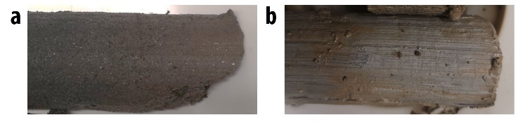
Figure legends
Figure S1 Different sediment types sampled in the Main river. (a) Typical sandy river sediment with clear separation of surface sediment and anoxic core sediment found at sampling sites M1, M4 and M6. (b) Gray and clayay sediment found at sampling sites M2, M3 and M5.
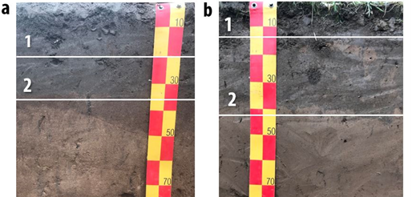

Figure S2 Soil profiles taken from the the area of the future tributary (T4) (a) and the riparian area (R1) (b). Both sites are affected by 5-year floods. Samples were taken from the first two horizons.

