Additional file 2 of the article:
Agricultural practices influence soil microbiome assembly and interactions at different depths identified by machine learning

Yujie Mo¹, Raven Bier^{2,3}, Xiaolin Li⁴, Melinda Daniels², Andrew Smith⁵, Lei Yu^{1*}, and Jinjun Kan^{2*}

¹Sino-French Engineer School, Beihang University, Beijing, 100191, China
²Stroud Water Research Center, Avondale, PA 19311, USA
³Savannah River Ecology Laboratory, University of Georgia, Aiken, SC 29802, USA
⁴Zibo Vocational Institute, Zibo, Shandong 255300, China
⁵Rodale Institute, Kutztown, PA 19530, USA

*Correspondence: yulei@buaa.edu.cn or jkan@stroudcenter.org

This file includes:
Supplementary Figures S1-S4

a  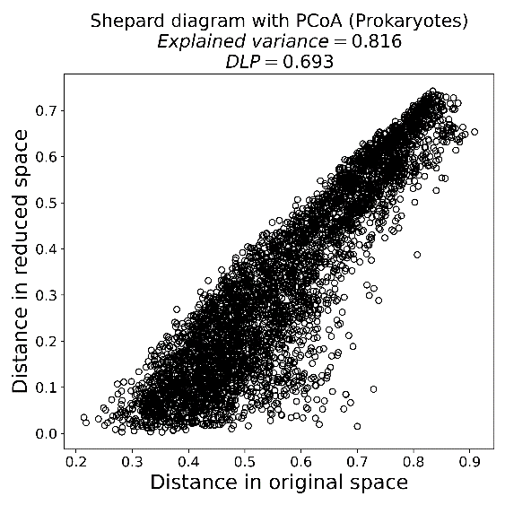 | b  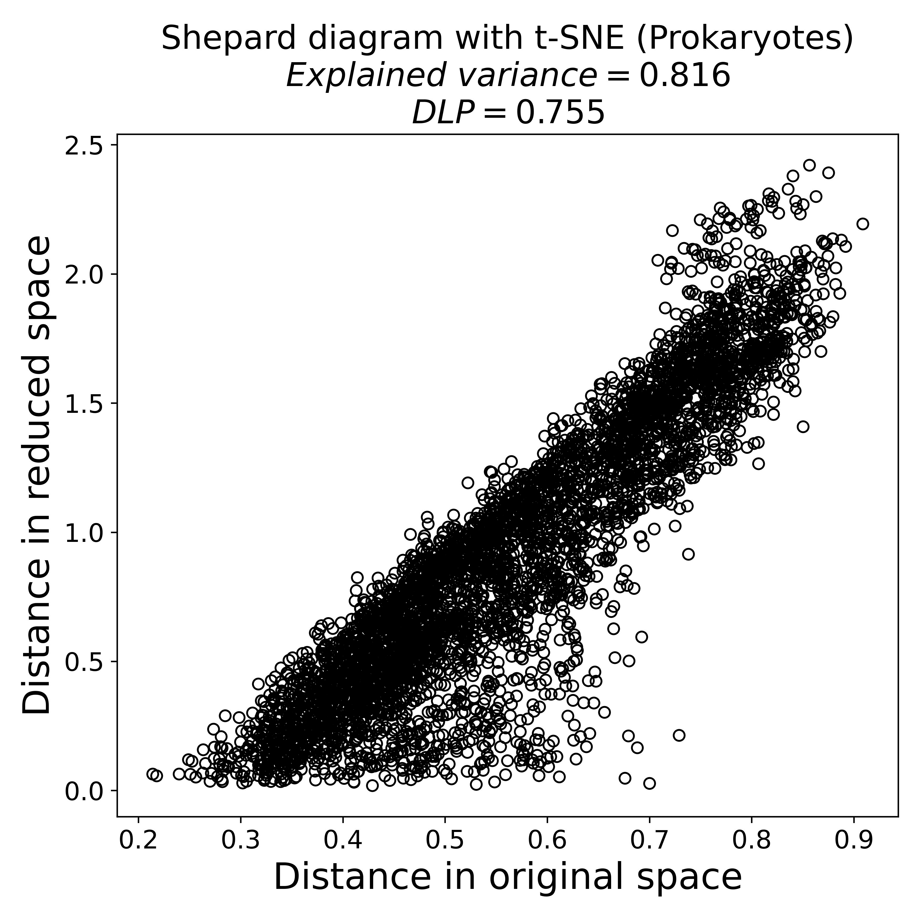
c  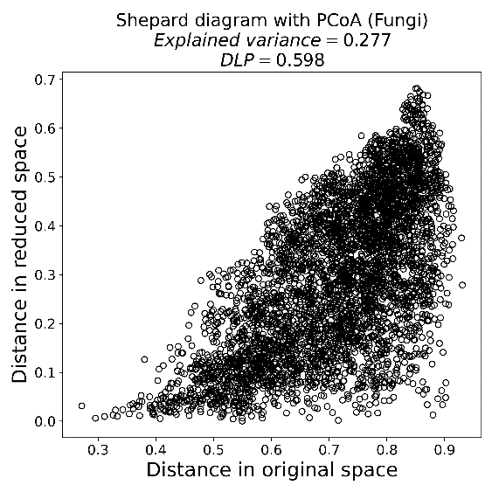 | d  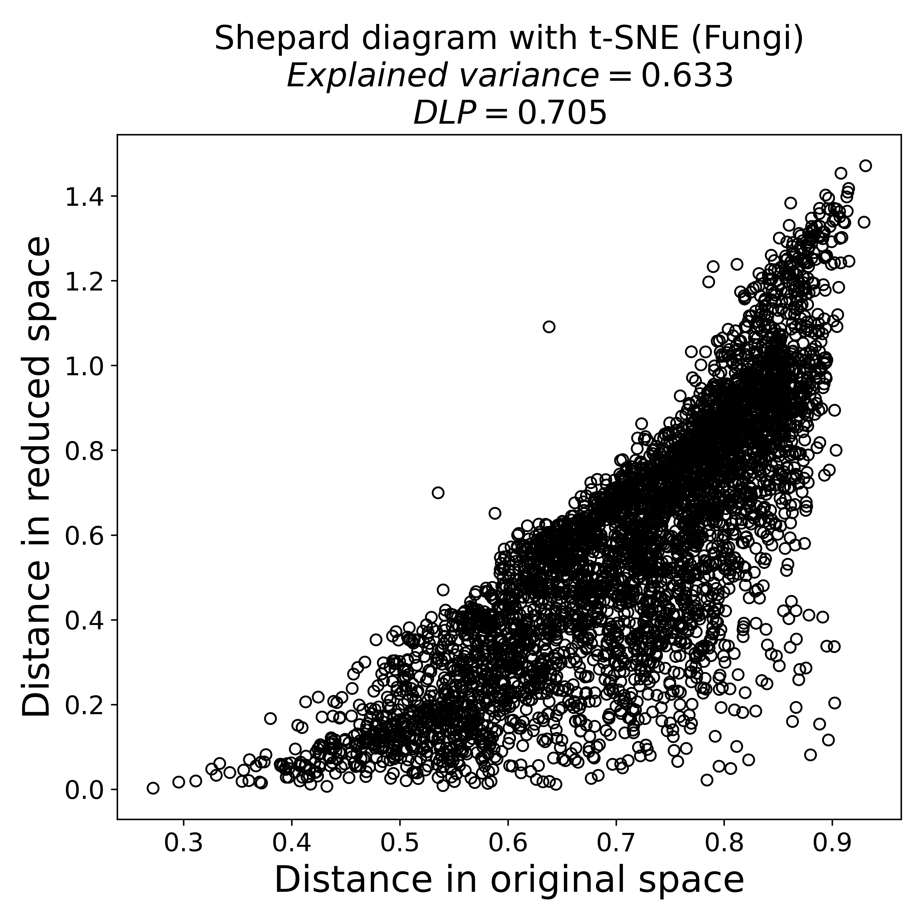

Fig. S1 Shepard diagrams with PCoA and t-SNE for prokaryotes (a and b) and fungal (c and d) soil communities. The degree of locality of preservation (DLP) is calculated to assess the preservation of structure after reduction by PCoA and t-SNE, and the explained variance scores are used to estimate the variation explained by the ordination.

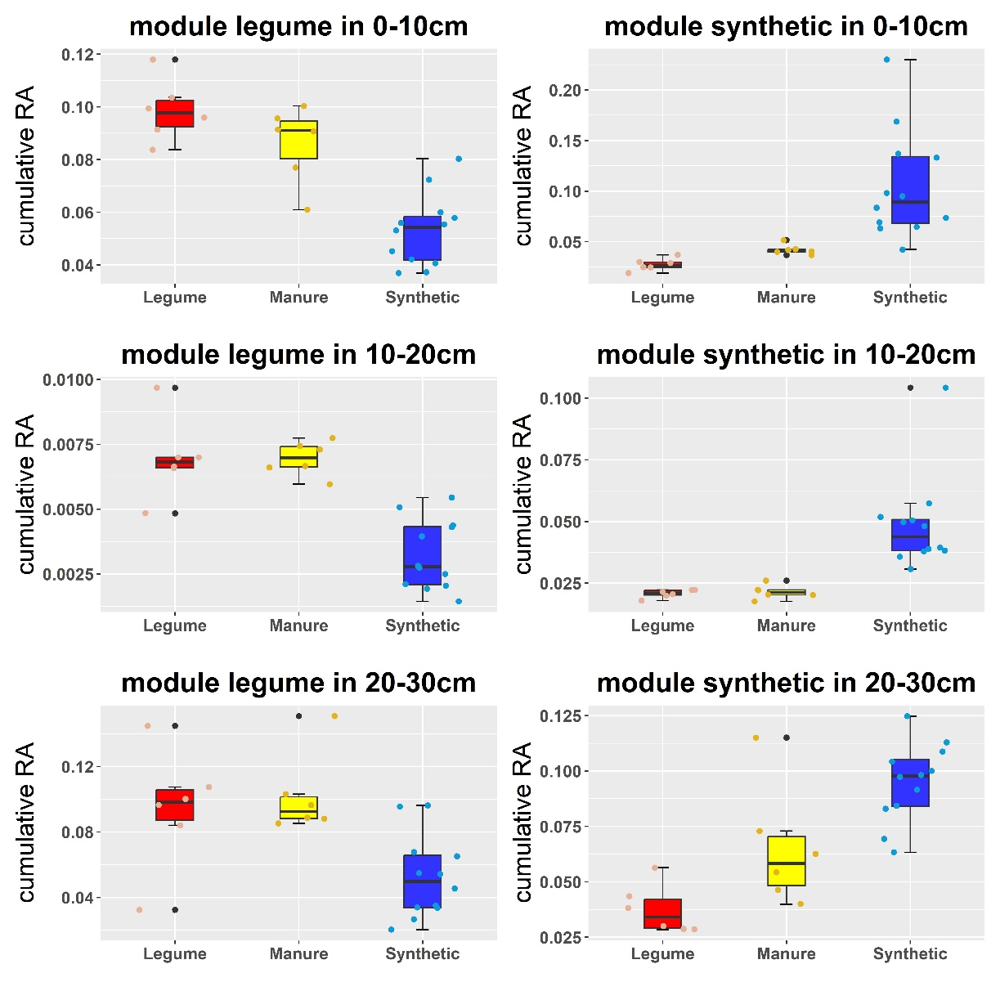
Fig. S2 Cumulative relative abundance of prokaryotic ASVs in fertility source-sensitive modules from different soil depths. Cumulative RA: cumulative relative abundance.
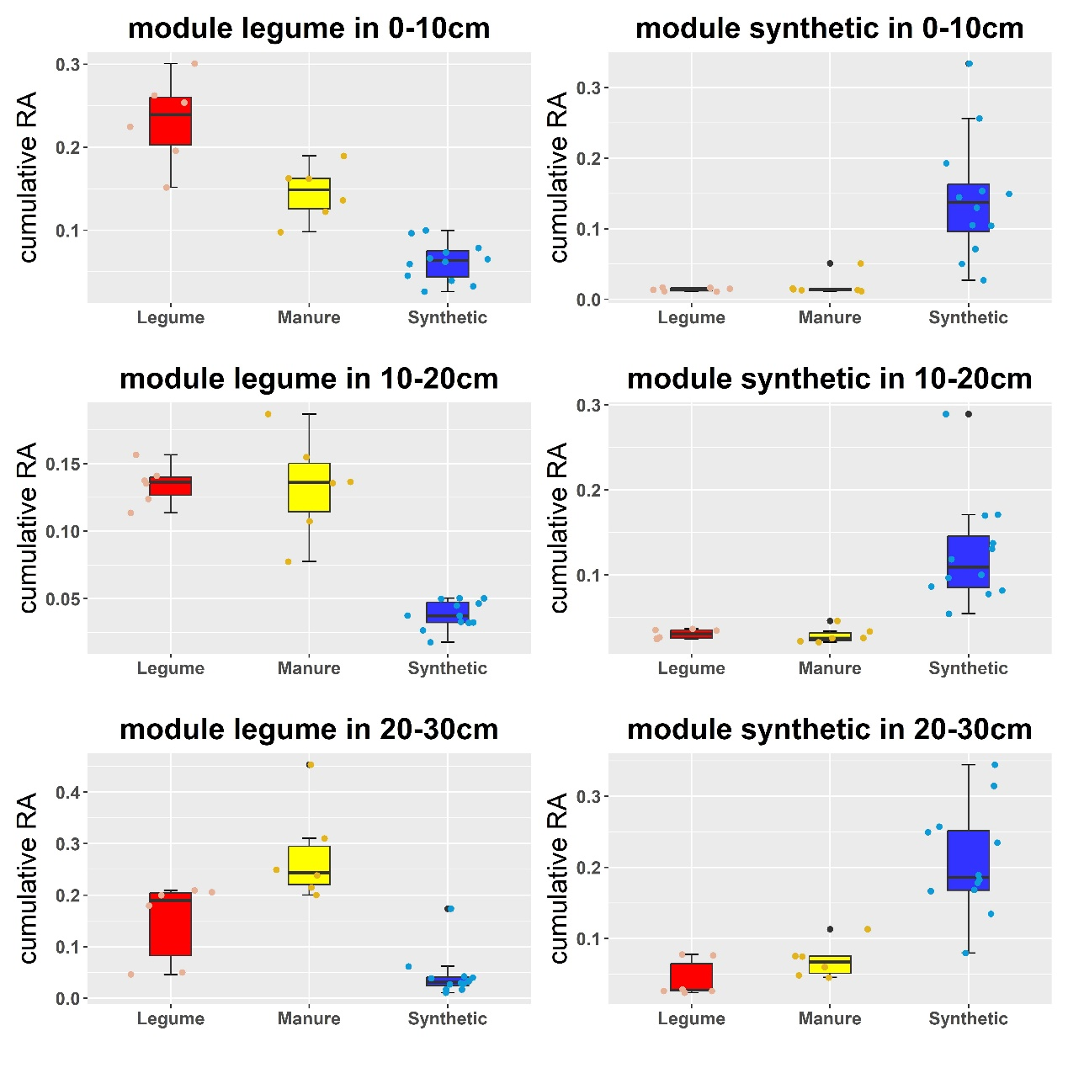
Fig. S3 Cumulative relative abundance of fungal ASVs in fertility source-sensitive modules from different soil depths. Cumulative RA: cumulative relative abundance.

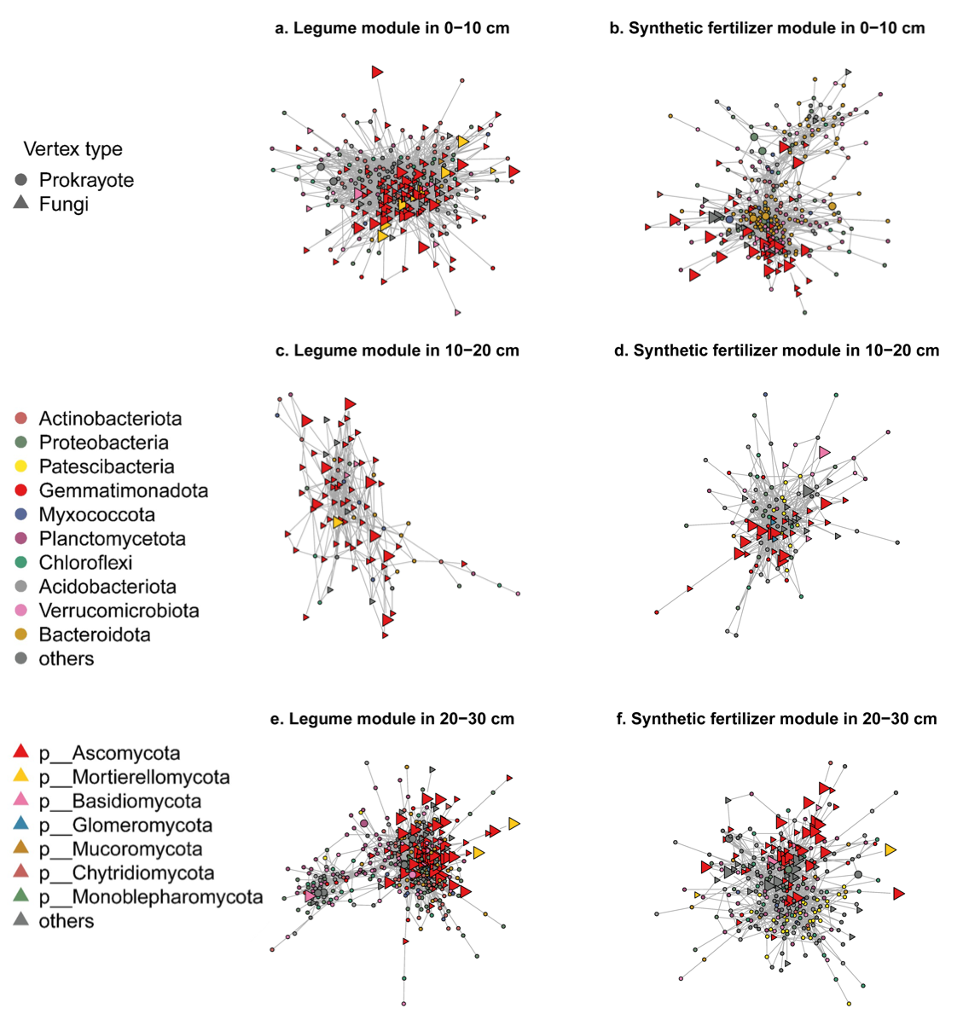
Fig. S4 Subnetworks of legume (a, c, and e) or synthetic fertilizer (b, d, and f) modules from different soil depths. Hub taxa, identified as the top 10% of ASVs with the greatest impact on the module using the SHAP-based framework, are represented with a larger size.

