Supplementary Information for

Wireless Brain Oscillation Control via Magnetoelectric Stimulation with Millisecond Precision

Chao-Chun Cheng¹, Li-Ling Chen¹, Mu-Yun Huang¹, Chih-Ning Tseng¹, Yen-Jing Ting¹, Guan-Jhong Tseng¹, Jun-Xuan Huang¹, Chih-Hsuan Wu¹, Po-Han Chiang¹*

*Corresponding author: phc@nycu.edu.tw

The PDF file includes:
Methods
Supplementary Figures. S1 to S6

Methods
Preparation of nanomaterials
We procured different particle sizes (100 nm, 300 nm, and 500 nm) of Barium Titanate (BTO) from US Research Nanomaterials. Following the protocol outlined in a previous study, we synthesized Hematite nanodiscs (HNDs) and Magnetite nanodiscs (MNDs) in two primary steps: Initially, HNDs were produced by combining 10 ml of 99.5% ethanol, 0.8 g of anhydrous sodium acetate (Sigma-Aldrich), 0.273 g of FeCl₃·6H₂O (Sigma-Aldrich), and deionized water (ddH2O) — 0.6 ml for 250 nm and 1 ml for 200 nm MNDs and HNDs. This mixture was thoroughly stirred to ensure homogenization, then sealed in a Teflon-lined steel vessel and heated at 180 °C for 18 hours in an oven. Post-heating, the HNDs were sequentially washed twice with ddH2O and twice with ethanol, followed by drying in a vacuum desiccator. These prepared HNDs were either used for further conversion into MNDs or set aside for control experiments. In the reduction step, 1 mg of HNDs was mixed with 20 ml of tri-octylamine (Acros Organics) and 1 g of oleic acid (Sigma-Aldrich). This mixture was then placed in a three-neck flask, connected to a Schlenk line, and heated to 370 °C for 25 minutes under a controlled atmosphere of H2 (5% with 95% Argon, Chiah Lung) and N2 (99.9%, Chiah Lung). During this process, a notable change was observed in the nanodiscs' color, transitioning from red to dark gray. Once cooled, the discs were washed with hexane (Alfa Aesar) and dispersed in chloroform (J.T. Baker), stored at 4 ºC in a glass vial.

Surface functionalization and water transfer
To functionalize BTO with a mPEG coating, 20 mg of mPEG-silane was dissolved in 9 ml of ethanol. Subsequently, 10 mg of BTO powder was added, and the mixture was sonicated for 2 hours. After sonication, the solution was centrifuged using a microcentrifuge at 8500 rpm for 5 minutes to pellet the particles. The supernatant was removed and replaced with deionized water (ddH2O). This process, encompassing sonication to ddH2O refill, was repeated three times. To functionalize MNDs and HNDs with PMAO coating, the nanodiscs, initially in chloroform, were dried in a vacuum desiccator. Next, 10 mg of 30,000 MW PMAO (419117, Sigma-Aldrich) was dissolved in 1 ml of chloroform. To this, 1 mg of dried MND or HND powder was added, and the mixture was sonicated for 1 hour until the nanodiscs were well suspended. The PMAO-coated nanodiscs were then dried in a vacuum desiccator overnight. The dried nanodiscs were subsequently added to a TAE buffer (Tris-acetate-EDTA, Biomate) at a concentration of 25% (w/v) and sonicated at 80 ºC for 3 hours. After sonication, the particles were pelleted using a microcentrifuge at 8500 rpm for 10 minutes. The supernatant was removed, and the pellet was refilled with ddH2O. This sonication-to-ddH2O refill process was repeated three times. For surface modification of neutravidin-BTO, 10 mg of dried mPEG-coated BTO was mixed with 1 ml of neutravidin solution for 2 hours. The mixture was centrifuged at 8500 rpm for 3 minutes, the supernatant was removed, and 3 ml of ddH2O was added. This process was repeated three times. Similarly, for surface modification of biotinylated nanodiscs, 10 mg of dried PMAO-coated nanodiscs was mixed with 200 μl of biotin buffer (30 μM, Mix-n-Stain Reaction Buffer, MXBIOS100, Sigma-Aldrich) for 2 hours. This mixture was centrifuged at 8500 rpm for 3 minutes, followed by removing supernatant and adding 3 ml of ddH₂O, repeating the process three times.

Characterization of nanomaterials
Initially, in chloroform, nanodiscs were dried in a vacuum desiccator and dissolved in deionized water (ddH2O). For morphological analysis, an aqueous suspension of BTO or nanodiscs (2 μg/ml) was placed on a copper grid (Ted Pella Inc.) and examined using transmission electron microscopy (TEM). The TEM analysis used an HT7800 (Hitachi) instrument at the Chang Gung Memorial Hospital (CGMH) microscopy core laboratory. The diameter and thickness of the nanodiscs were quantified using ImageJ software from TEM images. Three diagonals were drawn for each hexagonal nanodisc, and the longest distance was considered as the diameter measurement.
The crystalline structure of the nanodisc powders was confirmed through X-ray diffraction (XRD), performed with an XtaLAB Synergy DW (Rigaku) at the Instrumentation Center of National Tsing Hua University (NTHU). Hematite or magnetite samples were mixed with N-grease (Apiezon) and positioned on MicroMeshesTM (MiTeGen). These were then analyzed using a HyPix-Arc 150° curved Hybrid Photon Counting X-ray detector with graphite-monochromated Mo Kα radiation (λ = 0.71073 Å) at 100 K.
The nanodiscs' saturation magnetization (Ms) was studied using a vibrating sample magnetometer to obtain hysteresis curves within a range of ± 9 kOe. The magnetic moments were measured with an MPMS SQUID Vibrating Sample Magnetometer (VSM; Quantum Design) at the Core Facility Center of National Cheng Kung University (NCKU). An Agilent 725 Inductively Coupled Plasma Optical Emission Spectrometer (ICP-OES) at the NTHU Instrumentation Center quantified the iron element concentration for magnetic moment calculation.
For calculating magnetic moment, we followed the formula mentioned in previous study⁴:
$|μ| = V∙ρ∙M_{s }$ (1)
μ is the magnetic moment. V is the volume of nanodiscs, which was measured from TEM. ρ is the density of magnetite (Fe₃O₄)⁴. M_{s} is the saturation magnetization that is measured from VSM. The magnetic moment of MNDs is:

$1.09×{10}^{-21} m^{3}·5150 kg/ m^{3}·60 {Am}^{2}/ kg=3.37×{10}^{-16 }{Am}^{2}$ (2)

For potential property analysis, PMAO-coated nanodiscs dissolved in ddH2O were examined for their zeta potential using electrophoretic light scattering with a DelsaTM Nano C Particle Analyzer (Beckman Coulter). For cellular interaction studies, 3.5 μl of 20 mg/ml PMAO-coated nanodiscs were applied to hippocampal neurons at 7 days in vitro (DIV) for 15 minutes. This facilitated the attachment of nanodiscs to cell membranes. The cells were washed three times with 1× PBS (Gibco) and fixed using a buffer (3% glutaraldehyde, 2% paraformaldehyde in 0.1 M cacodylate buffer) prepared by CGMH. The fixed samples were stored at 4 ºC until analyzed with field emission scanning electron microscopy (FE-SEM) to visualize the attachment of nanodiscs on neurons. The FE-SEM, conducted with a SU8220 (Hitachi) at the CGMH microscopy core laboratory, was utilized to record nanodisc attachments at 2,000× magnification and examine the nanodiscs' surface features at 30,000× magnification.

Fluorescence resonance energy transfer
The linkage of functionalized BTOs and MNDs was analyzed by fluorescence resonance energy transfer (FRET). To visualize the nanoparticles, neutravidin-conjugated BTOs were linked to Alexa-488 by adding 5 mg neutravidin-conjugated BTOs to 200 μl of Alexa Fluor 488 dye (Thermo Scientific) for two hours. The mixture was centrifuged at 8500 rpm for 5 minutes, the supernatant was removed, and 250 μl of Tyrode’s solution was added. Biotinylated MNDs were linked to Alexa-594 by adding 5 mg biotinylated MNDs to 200 μl of Alexa Fluor 594 dye (Thermo Scientific) for two hours. The mixture was centrifuged at 8500 rpm for 5 minutes, the supernatant was removed, and 250 μl of Tyrode’s solution was added. During the FRET experiment, 3 μl of 20mg/ml Alexa-488-conjugated BTOs were applied to the primary hippocampal neurons in a 24-well cultured dish, then transferred to a fluorescence microscope (SS-1000-00, Scientifica) with W-view (A12801-01, Hamamatsu). LED light source (pE300, CoolLED), Hamamatsu C13440 camera, and filter cubes (DM3000B, Leica) with AT450/50x excitation filter and AT485DC, AT495lp emission filter were used for imaging. After capturing the BTOs alone image, 3 μl of 20mg/ml Alexa-594-conjugated MNDs were applied to the cultured neurons in the sample holder of a fluorescence microscope after 10 min. FRET images were captured by using the 470 nm blue light (pE300, CoolLED). The Hamamatsu C13440 camera and W-view (A12801-01, Hamamatsu) with AT450/50x excitation filter and AT485DC, AT495lp emission filter were used for FRET images. ImageJ calculated The FRET ratio by dividing the red fluorescence intensity by the green fluorescence intensity at the same location.

Primary hippocampal neuronal culture
The Institutional Animal Care and Use Committee (IACUC) of National Yang Ming Chiao Tung University (NYCU) approved all animal experimental procedures. Pregnant Sprague-Dawley rats acquired from LASCO were used for the study. Hippocampal cultures were prepared using pups less than three days old. The hippocampi were extracted in a cold dissection solution consisting of 160 mM NaCl, 5 mM KCl, 1 mM MgSO₄, 4 mM CaCl₂, 5 mM HEPES, and 5.5 mM glucose, with pH adjusted to 7.4 using NaOH. Post-extraction, hippocampus from 2 to 3 pups were combined and placed into a prewarmed digestion solution containing 1 mM L-Cysteine, 0.5 mM EDTA, 1 mM CaCl2, 1.5 mM NaOH, and 10 units/ml papain (76220, Sigma-Aldrich). This mixture was then incubated at 37 °C for 25 minutes.
The action of papain was halted by removing the digestion solution and incubating the tissues in an inactivation solution composed of 0.25% bovine albumin, 0.25% trypsin inhibitor, 0.4% D-glucose, and 5% fetal bovine serum (6140079, Gibco) in Minimum Essential Medium (MEM w/Earle’s salts w/o L-glutamine; 11090-081, Gibco). This step was carried out at 37 °C for 2 minutes. Subsequently, after removing the inactivation solution, the tissues were triturated in a serum medium (0.4% D-glucose and 5% fetal bovine serum in MEM w/Earle’s salts w/o L-glutamine) using a fire-polished glass pipette (111096, Kimble). The dissociated cells were filtered through a cell strainer (93070, SPL) and incubated in the serum medium at 37 °C before seeding. After cell counting, the cells were seeded onto Matrigel (354234, Corning)-)-coated 12 mm coverslips in 24-well plates at a density of approximately 110,000 cells per well. The hippocampal cells were cultured in Neurobasal medium (10888-022, Gibco) supplemented with B27 (17504-044, Gibco) and GlutaMAX (35050-061, Gibco). On the third day in vitro (DIV), 20 μl of a mitotic inhibitor (5-fluoro-2’-deoxyuridine, Sigma; 4 μM in Neurobasal medium) was added to inhibit the growth of glial cells. All imaging and stimulation procedures were performed between the DIV 5 and 14.

Ca²⁺ imaging in primary hippocampal neuronal culture
Tyrode's solution, composed of 125 mM NaCl, 2 mM KCl, 2 mM MgCl₂, 2 mM CaCl₂, 25 mM HEPES, and 51 mM D-glucose (Sigma-Aldrich), was prepared for all Ca²⁺ imaging experiments on cultured cells. The Fluo-4 Ca²⁺ Imaging Kit (Invitrogen) was utilized to measure the Ca²⁺ responses in cultured neurons, following the protocol provided by Invitrogen. Neurons were incubated in 1 mM Fluo-4 solution for 15 to 30 minutes, then transferred to Tyrode’s solution without Fluo-4 for imaging purposes. For the experiments, 3 μl of functionalized BTO at 20 mg/mL was added to each well containing 497 μL of solution in a 24-well plate. Following a 5-minute incubation, cells were washed three times with Tyrode’s solution. Next, 3 μl of functionalized MNDs or HNDs at a concentration of 20 mg/mL was added to each well, also containing 497 μL of solution, in the 24-well plate. The final concentration of the nanodiscs reached 60 μg/well. After another 5-minute incubation, cells were washed thrice with Tyrode’s solution. Subsequently, the coverslip with hippocampal neurons was transferred to a custom stage for applying a magnetic field under a fluorescence microscope (SS-1000-00, Scientifica). Imaging was performed using an LED light source (pE300, CoolLED), a Hamamatsu C13440 camera, and a GFP filter cube (39002, Chroma).
For pharmacological experiments, cultured cells were transferred from Tyrode’s solution containing Fluo-4 to antagonist-containing Tyrode’s solutions for imaging. Tetrodotoxin (TTX) (Abcam) was added to Tyrode’s solution at a concentration of 100 nM to block the voltage-gated sodium channels. For concurrent blockade of voltage-gated Na⁺ and Ca²⁺ channels, a combination of 100 nM TTX and 3 μM mibefradil (Abcam) was added into Tyrode’s solution.

Ca²⁺ Imaging Analysis
Videos capturing Ca²⁺ activity were recorded using an upright fluorescence microscope (SS-1000-00, Scientifica) and saved in the “.avi” format through HCImage software (Hamamatsu). The frame rate of these videos was set at 1 Hz. We processed the videos using a custom Python script developed on the OpenCV2 platform. Additionally, for converting fluorescence intensity into ΔF/F₀, we employed a previously described custom Python script based on NumPy, adapting the algorithm from a prior study⁴.
A cell was defined as responding if it exhibited a ΔF/F₀ greater than three standard deviations from the mean during specified periods. The cell activity rate for each culture sample was determined by calculating the ratio of the number of activated cells to the total number of cells. For detailed information on the custom scripts and methodologies, refer to the supplementary information section of previous publication⁴.

Cell viability test
The death of primary cultured neurons with multiple magnetomechanical stimulations was measured with propidium Iodide (PI; P1304MP, Invitrogen). After imaging the multiple MagTIES-induced Ca²⁺ responses of primary cultured neurons with Fluo-4, PI was added to the extracellular solution to achieve a final concentration at 120 μM. After 5 min, the fluorescence of Fluo-4 and PI were imaged by using a fluorescence microscope (SS-1000-00, Scientifica). LED light source (pE300, CoolLED), Hamamatsu C13440 camera, and filter cubes (39002 and 39010, Chroma) were used for imaging.

Magnetic apparatus for fluorescence microscope
The air-core magnetic coil with 4 cm height, 13.5 cm outer diameter, and 3.5 cm inner diameter was constructed using 2000 turns of 18 AWG self-bonding copper wire (SBWR, Chientai). This coil featured a resistance of 7 ohms and an inductance of 60 mH. For 10 Hz magnetic stimulation, a current of 3.2 A was employed to achieve a 50 mT stimulation. A custom-made H-bridge driver was utilized to generate varying magnetic fields with the coil. This H-bridge comprised two p-channel MOSFETs (IRF4905, International Rectifier) and two n-channel MOSFETs (IRF3710, International Rectifier). Additionally, two extra n-channel MOSFETs were implemented to control the p-channel MOSFETs within the H-bridge. The operational voltage range of the circuit is adjustable through two pairs of resistances and MOSFET parameters, allowing for easy modification by replacing different resistances or MOSFETs. A function generator (33210A, Keysight) produced ± 5 V square waves. These signals from the function generator were then passed through a voltage follower and an inverter (TLC2272, Texas Instrument), with gains equal to one. The voltage follower and the inverter outputs were 180° out of phase, with each signal controlling one-half of the full-bridge driver. An internal power supply (PS-3030DF model, LONGWEI) powered the op-amps on the custom-made H-bridge driver. In contrast, an external power supply (IT6721, ITECH) was employed to generate magnetic fields in the coil.
To evaluate magnetic fields generated by coils, we use Finite Element Method Magnetics software (version 4.2) to simulate the magnetic fields of the coil in 2D. In the program setting, we used magnetics problem mode and planar configuration in FEMM4.2. The parameters of copper wire (12 or 18 AWG) and air were from the materials library in FEMM4.2. A gauss meter (TM801, KANETEC) was used to measure the magnetic field in the coil. The axial probe was used to detect the magnetic field that was generated inside the coil.

Animal surgery
NYCU IACUC approved all the animal surgeries and experiments following the Guide for the Care and Use of Laboratory Animals of NYCU. All mice were purchased from LASCO. Mice were maintained under a 12 h light-dark cycle at NYCU Laboratory Animal Center before experiments. 8 to 12 weeks old C57BL/6 male and female mice were used in all in vivo experiments. Mice were anesthetized under 1.5−2.0% isoflurane in oxygen and placed on a stereotaxic frame. Ophthalmic ointment was applied to prevent eyes from drying, and body temperature was maintained using the regulated heated pad.
For the c-fos experiment, Neutravidin-conjugated BTOs, along with biotinylated MNDs and HNDs, were unilaterally injected into the lateral basolateral amygdala (AP −1.75 mm, DV −4.80, and -4.70 mm; ML -3.15 mm from bregma). Each point was injected with 1 μl of BTOs, MNDs, or HNDs in PBS at different concentrations by using a microinjection syringe (7653-01, Hamilton) with 33GA needle (7803-05, Hamilton) and a micropump (LEGATO130, Kd Scientific) with injection rates of 100 nl/min. After cranial surgery, 0.2 ml of Carprofen (PHR1452, Sigma-Aldrich) was given to mice through subcutaneous injection to release the postsurgical pain. The MagTIES stimulation was performed one day after surgery.
For photometry experiments, the virus was injected by microinjection syringe (7653-01, Hamilton) with 33GA needle (7803-05, Hamilton) and micropump (LEGATO130, Kd Scientific) at a rate of 100 nl min–1 with the following coordinates: the virus was injected unilaterally into the basolateral amygdala (AP −1.55 mm, DV −4.75 mm; ML +3.15 mm from bregma) A total viral volume of 500 nl was delivered to the site, with the needle left in the site for at least 15 min to permit diffusion. Following injection (100 nl/min), the needles were progressively removed. All coordinates were based on the mouse brain stereotaxic coordinates from Bragma. After one month of viral expression, Neutravidin-conjugated BTOs, along with biotinylated MNDs and HNDs, were unilaterally injected into the basolateral amygdala (AP −1.55 mm, DV −4.75 mm; ML +3.15 mm from bregma) The two materials were injected at rates of 80 nl/min and 60 nl/min, respectively. On the same day, the optic fibers with 400 μm diameter, 5 mm length, and 0.5 NA (Inper) were implanted into the basolateral amygdala (AP −1.55 mm, DV −4.5mm; ML +3.17 mm from bregma) and secured with dental cement (Superbond, Sun Medical). The mice were then kept warm using a heating pad, and the analgesic carprofen was administered through subcutaneous injection post-surgery. A one-week recovery period was allowed before proceeding with photometry. All photometry and MagTIES experiments were performed 1 to 3 weeks after surgery.

Fixed brain slicing and immunostaining
For c-fos staining, nanodiscs injected C57BL/6 male and female mice were placed in a custom-made coil for magnetic stimulation in vivo 1 day after nanodiscs injection. Mice were sacrificed 90 min after magnetic stimulations. All brains were collected following transcranial perfusion with 4 % PFA in PBS. Coronal brain sections were sliced into 60 μm by a vibratome (5100 MZ, Campden) with an amplitude of 0.5 and a frequency of 50 Hz. The brain slices were washed three times with PBS for 5 min; the slices were permeabilized with 2% (v/v) Triton X-100 (Sigma-Aldrich) for 20 min. The background was cleared up with 2% Triton-X-100, 30 % H₂O₂, and methanol for 10 min. After PBS washed the slices three times, the slices were blocked by 3% normal goat serum in PBS for 60 min at room temperature. Slices were washed with PBS three times. For immunostaining, slices were incubated with 1st antibody solution with 1:750 rabbit anti-c-Fos monoclonal antibody (9F6#2250, Cell signaling), 1 % normal goat serum and 2% Triton-X 100 in PBS. Slices were incubated at 4°C for 16-18 h. After three times washes of the slices with PBS, slices were incubated with matching secondary antibodies in the PBS (1:500 goats anti-rabbit Alexa Fluor 594 (ab150080, Abcam)). All slices were washed with PBS three times before mounting. Slices were mounted on glass microscope slides using a mounting medium with DAPI (GTX30920, Genetex). Upright fluorescence microscope (SS-1000-00, Scientifica), LED light source (pE300, CoolLED), Hamamatsu C13440 camera, and filter cubes (39000, 19008, 31002, Choursoma) were used for imaging.

Fiber photometry measurement of fluorescence in freely moving mice
After virus injection and fiber optic implantation, the mice recovered in their home cage for more than seven days before beginning photometry recording; a fiber photometry system (R810, RWD Life Science Co. Ltd., China) was used for recording fluorescence signal (GCaMP and isosbestic wavelengths), which was produced by an excitation laser beam from 470- and 410-nm LED lights. Calcium fluorescence signals were acquired at 300 Hz with alternating pluses of both lights. The recorded parameter settings indicate that 410 nm light is set at 38.11%, while 470 nm light is configured at 17.18%, which demonstrates the least amount of photobleaching while allowing for sufficient detection of the calcium response. A digital camera was used for behavioral recordings that were synchronized with calcium signal recordings. Experiments were conducted using the above parameters and equipment to record the fluorescence signals of neurons in the virus expression region. To minimize environmental stress, mice were allowed to acclimate to the surroundings in the behavioral laboratory for one hour upon entry. Prior to recording fiber photometry measurements, the mice were fitted with sleeves and mono-channel optical fibers and then returned to their cages for 15 minutes of free activity to adapt. Subsequently, they were placed inside the experimental cylinder within the 10cm coil for an additional 15 minutes to acclimate to the stimulation environment, thereby mitigating the impact of environmental influences. After the acclimation period, baseline fluorescence was recorded for 4 min. without applying magnetic fields. Fluorescence was then recorded with the optical fiber twice for stimulation, and the stimulation duration was adjusted according to the experimental groups.

Magnetic apparatus for in vivo experiments
To generate a uniform magnetic field for wireless neuronal stimulation in vivo. Two custom-made air-core coils were used for c-fos experiments. Four custom-made air-core coils were used for fiber photometry experiments. Each magnetic coil had a 4 cm height, 21 cm outer diameter, and 11 cm inner diameter. When the coils stack on each other, the gap between the coils is 1 cm. Each coil has 350 turns of 12 AWG copper wire. The resistance and inductance of each coil are 1.02 to 1.55 Ω and 22 to 31.6 mH, respectively. Full bridge modules (AQMH3615NS, AKELC) were used as the drivers for each coil. The drivers were controlled by the 5 V square waves generated by Arduino UNO (Arduino). A custom-made script with Arduino IDE controlled the Arduino board. The internal power supply is 5V and provided by Arduino to give working voltage for complete bridge modules. An external power supply (HJS-1000 model, HuntKey) was used to supply the coil currents. The magnetic field intensity in the coil was measured by a Gauss meter (TM801, KANETEC) before the animal experiment.

Statistics and Reproducibility
All statistics were performed in JASP (v0.15.0.0 and v0.18.0.0, JASP team). All the error bars in the dot plots indicate the standard error of the mean (s.e.m.). All the gray and light areas in the fluorescence changes and power intensity traces indicate standard error of mean (s.e.m.). The paired t-test was used for comparing paired data. The unpaired t-test was used for comparing independent data. Tukey post-hoc test and one-way ANOVA were used to compare independent data from multiple groups.

Supplementary Figures
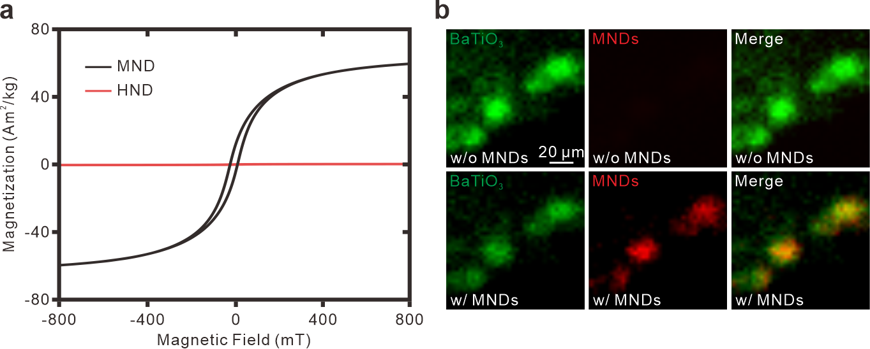
Figure S1. Characterization of nanomaterials. a, VSM results of MNDs and HNDs. b, FRET image excited by 470 nm light to analyze the 100 nm Alexa-488-conjugated BTOs with 250 nm Alexa-594-conjugated MNDs. Top, Neurons with Alexa-488-conjugated BTOs before application of Alexa-594-conjugated MNDs. Bottom, Neurons with Alexa-488-conjugated BTOs and Alexa-594-conjugated MNDs. Left, Green fluorescence excited by 470 nm blue light. Middle, Red fluorescence excited by 470 nm blue light. Right, Merged image.

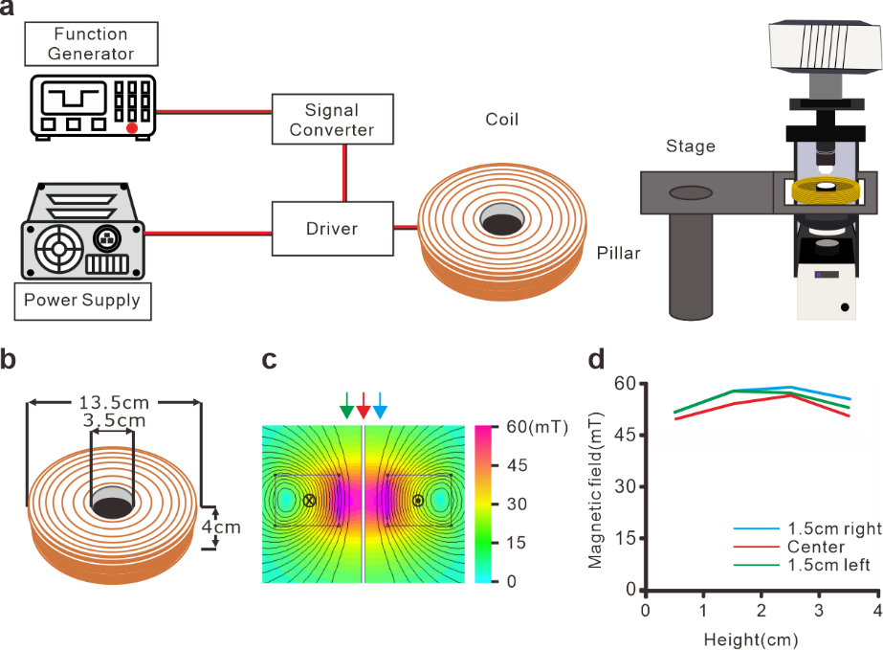
Figure S2. Magnetic apparatus for upright fluorescence microscope. a, Scheme of magnetic setup. b, Dimension of magnetic coil for fluorescence microscope. c, Heatmap of FEMM simulation for magnetic field distribution. (D) Measured magnetic intensity from the coil by Gaussmeter. The measurement was vertically along the arrow indicated location in (c).

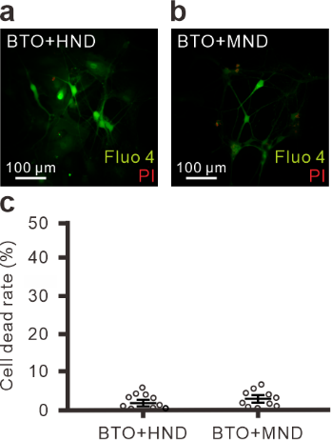
Figure S3. Cell viability test by using PI after MagTIES. a and b, Merged fluorescence image of Fluo-4 (green) and PI (red) in BTO₁₀₀/MND₂₅₀ group (a) and BTO₁₀₀/HND₂₅₀ group (b). c, Average cell death rate was measured by portions of PI-stained neurons (n = 10) from fluo-4-stained neurons (n = 10). p = 0.225.

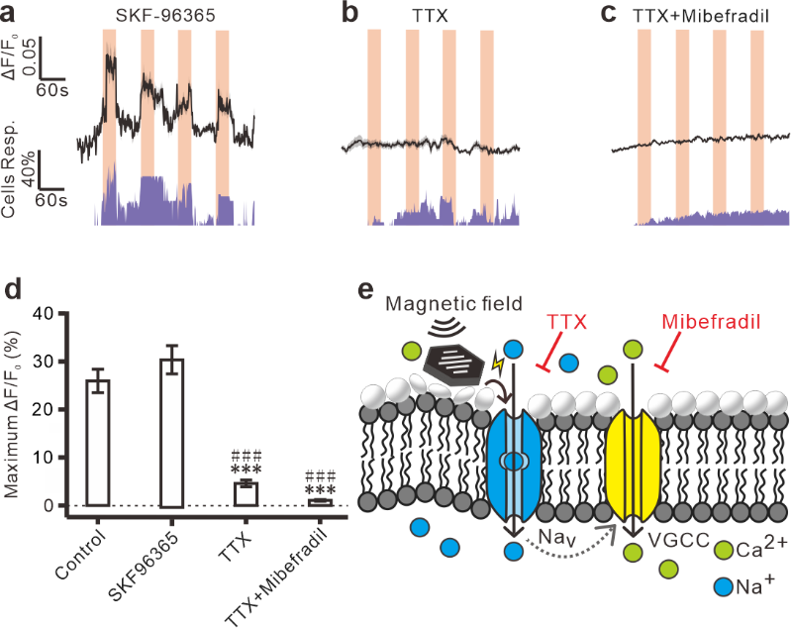
Figure S4. MagTIES responses in cultured neurons with voltage-gated channel blockers. a to c, Fluorescence change (top) and cell response rate (bottom) of MagTIES in cultured neurons with BTO₁₀₀ and MND₂₅₀ while bath application of SKF96365 (a, n = 71), TTX (b, n = 30) or TTX + Mibefradil (c, n = 38). Light orange area, periods of 50 mT AMF at 10Hz. d, Maximum fluorescence change of neurons from (a), (b), (c), and Figure 2e. ***p ≤ 0.001, compare to BTO₁₀₀/MND₂₅₀ control group (n = 139). ###p ≤ 0.001 compare to SKF96365 group. §§p = 0.007, compared to TTX group. e, Schematic of hypothesis. The MagTIES can trigger the activation of the voltage-gated Na⁺ channel or voltage-gated Ca²⁺ channel on the membrane.

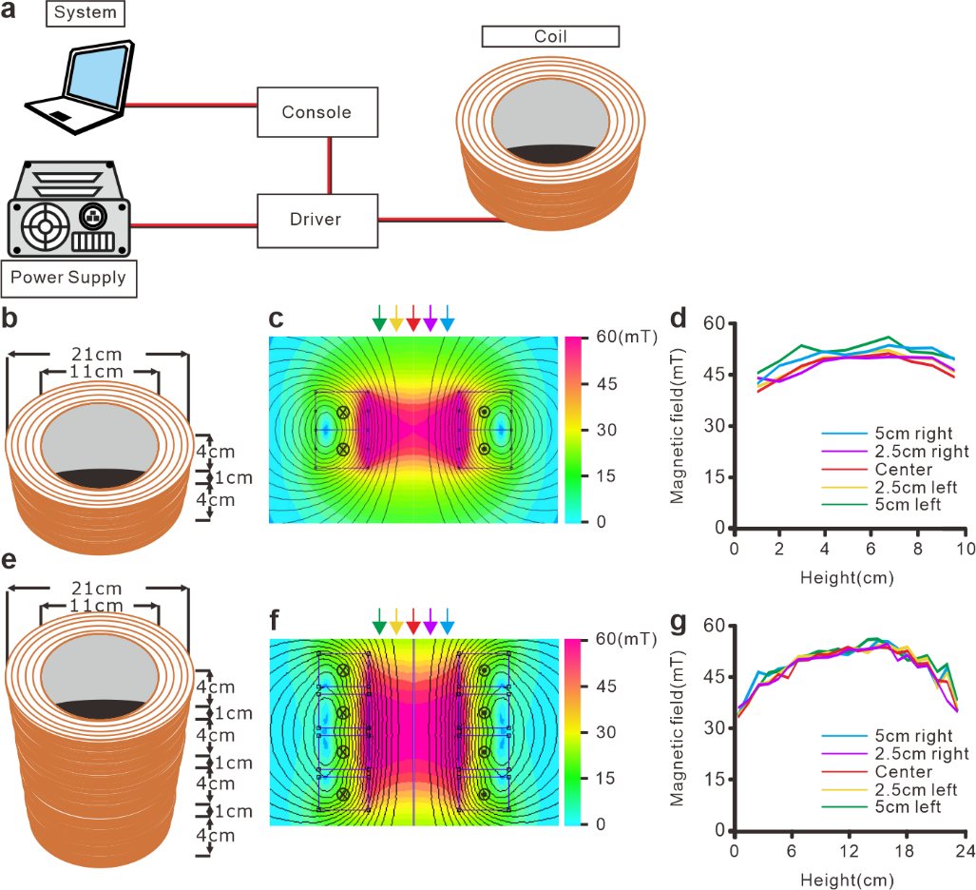
Figure S5. Magnetic apparatus for in vivo experiments. a, Scheme of magnetic setup for in vivo experiments. b, Dimension of magnetic coils for c-fos experiment. c, Heatmap of FEMM simulation for magnetic field distribution from coils designed in (b). d, Measured magnetic intensity from the coil by Gaussmeter. The measurement was vertically along the arrow indicated location in (c). e, Dimension of magnetic coils for fiber photometry experiment. f, Heatmap of FEMM simulation for magnetic field distribution from coils designed in (e). g, Measured magnetic intensity from the coil by Gaussmeter. The measurement was vertically along the arrow indicated location in (f).

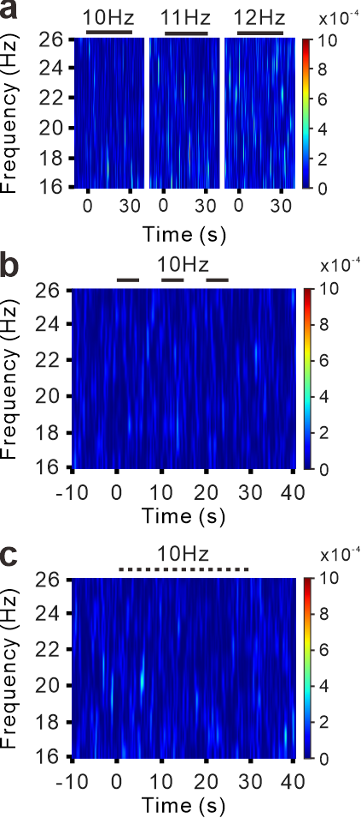
Figure S6. Power spectrum of Ca²⁺ responses by photometry in BTO/HND injected mice. a, Power spectrum of MagTIES in BTO+HND group with 50mT AMF at 10, 11, and 12 Hz for 30 s. b, Power spectrum of MagTIES in BTO+HND group with 5 s AMF at 10 Hz for 3 times with 5 s intervals. c, Power spectrum of MagTIES in BTO+HND group with 1 s AMF at 10 Hz for 15 times with 1 s intervals.

