Large disagreements in estimates of urban land across scales and their implications for science and applications

TC Chakraborty^{1,*}, Zander S. Venter², Matthias Demuzere³, Wenfeng Zhan⁴, Jing Gao⁵, Lei Zhao^{6,7,8}, Yun Qian¹
¹Atmospheric, Climate, and Earth Sciences Division, Pacific Northwest National Laboratory, Richland, WA, USA
²Norwegian Institute for Nature Research - NINA, Oslo, Norway
³B-Kode VOF, Ghent, Belgium
⁴International Institute for Earth System Science, Nanjing University, Nanjing, China
⁵Department of Geography and Spatial Sciences, University of Delaware, Newark, DE, USA
⁶Department of Civil and Environmental Engineering, University of Illinois at Urbana-Champaign, Urbana, IL, USA.
⁷Institute for Sustainability, Energy, and Environment (iSEE), University of Illinois at Urbana-Champaign, Urbana, IL, USA.
⁸National Center for Supercomputing Applications, University of Illinois at Urbana-Champaign, Urbana, IL, USA.

*Corresponding author: TC Chakraborty, Email: tc.chakraborty@pnnl.gov

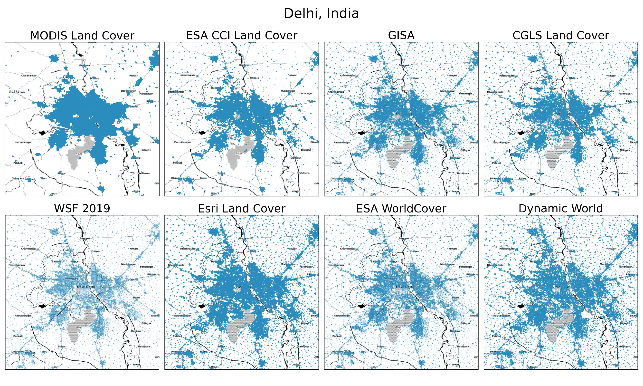

Fig. S1 | Present-day urban estimates across datasets for Delhi | Spatial extent of urban pixels for the eight datasets for Delhi, India.

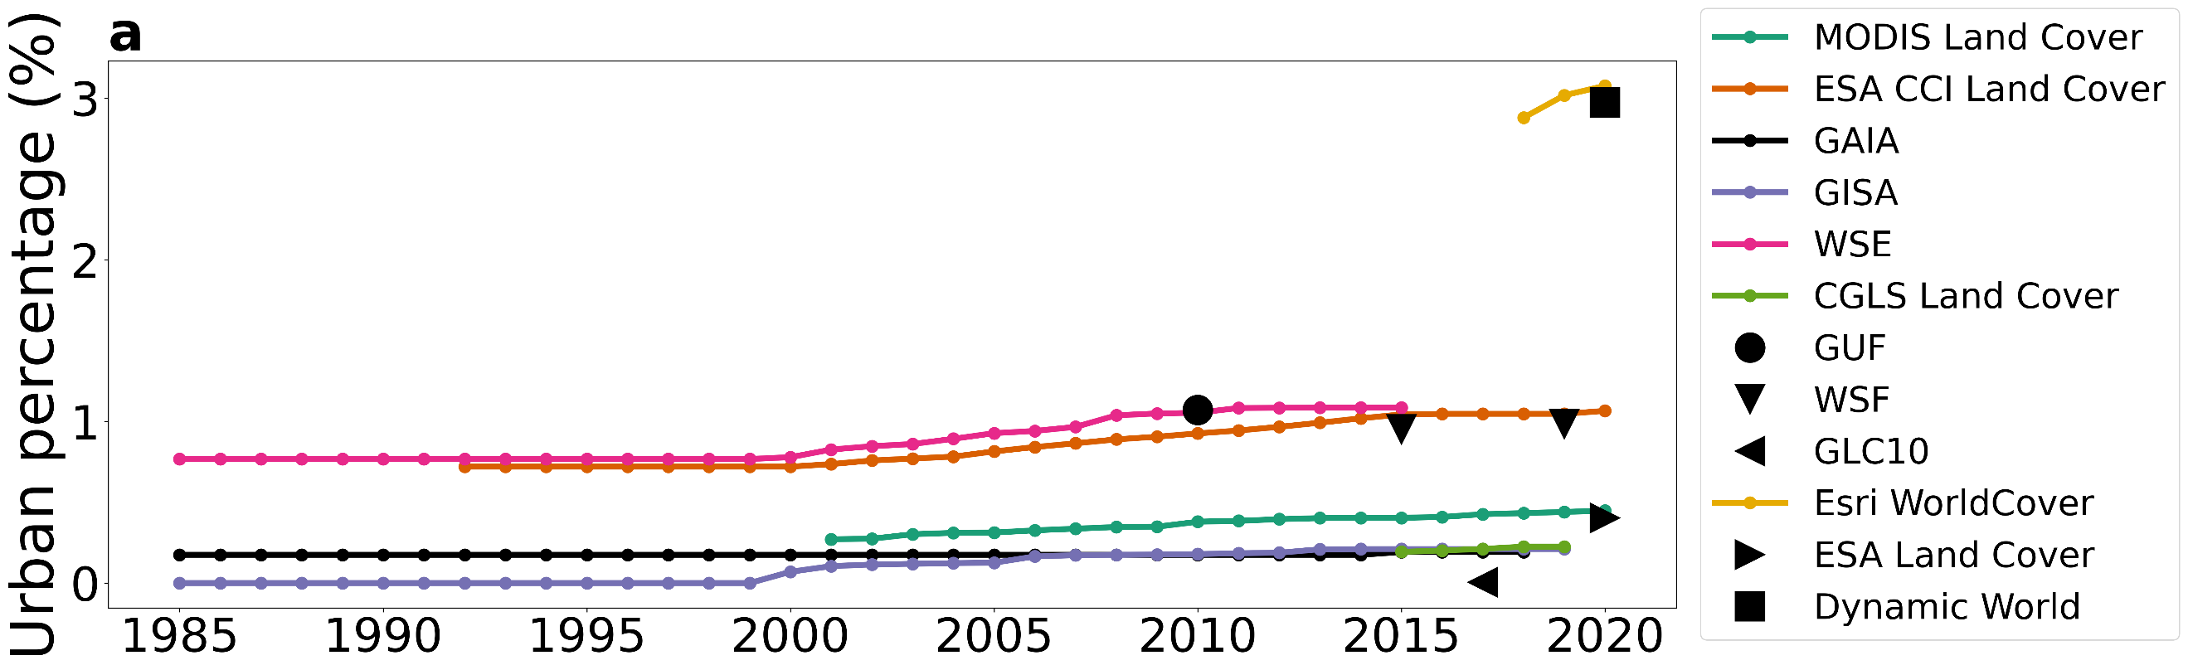
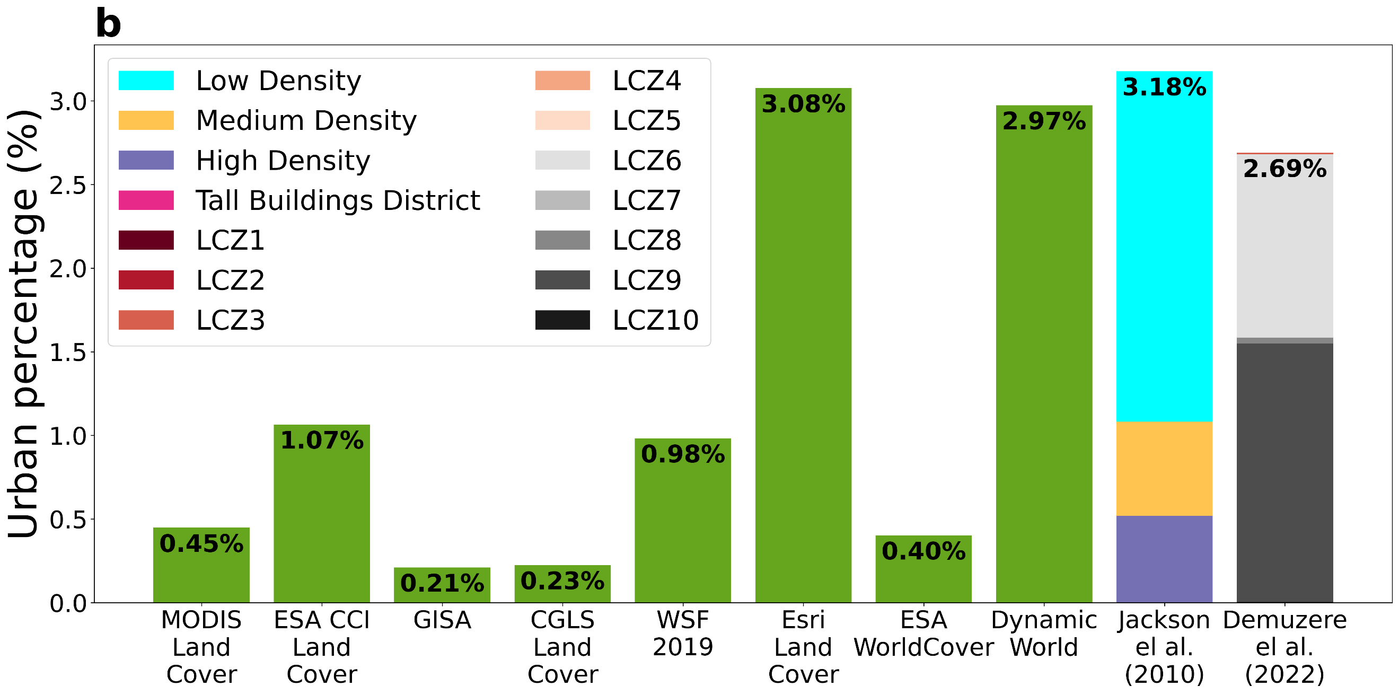
Fig. S2 | Results for island nations | Sub-figures a and b are identical to Fig. 3 and 4b of main text, respectively, but for the island nations (not officially part of any continent).
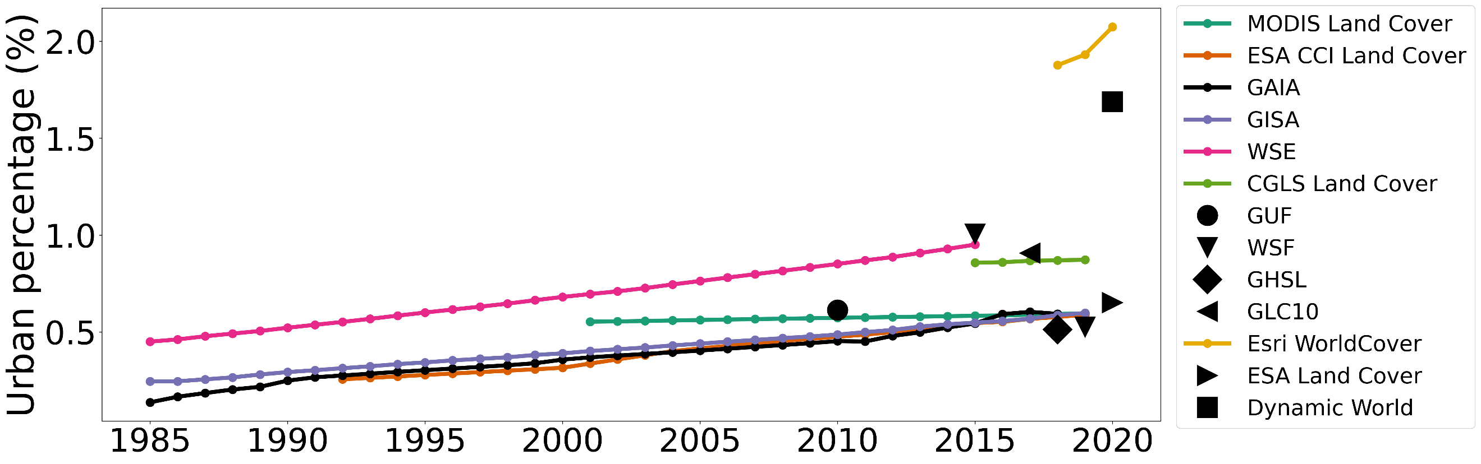
Fig. S3 | Urban percentage and its long-term changes across datasets (including GHSL) | Same as Fig. 3 of the main text, but includes the2018 estimate from the Global Human Settlement (GHSL) layer.

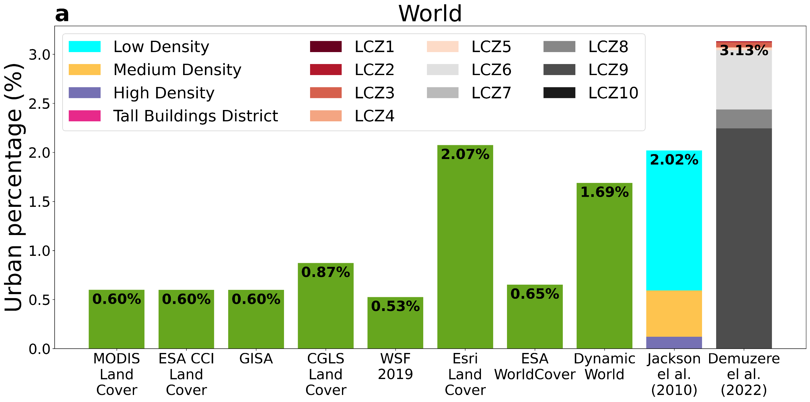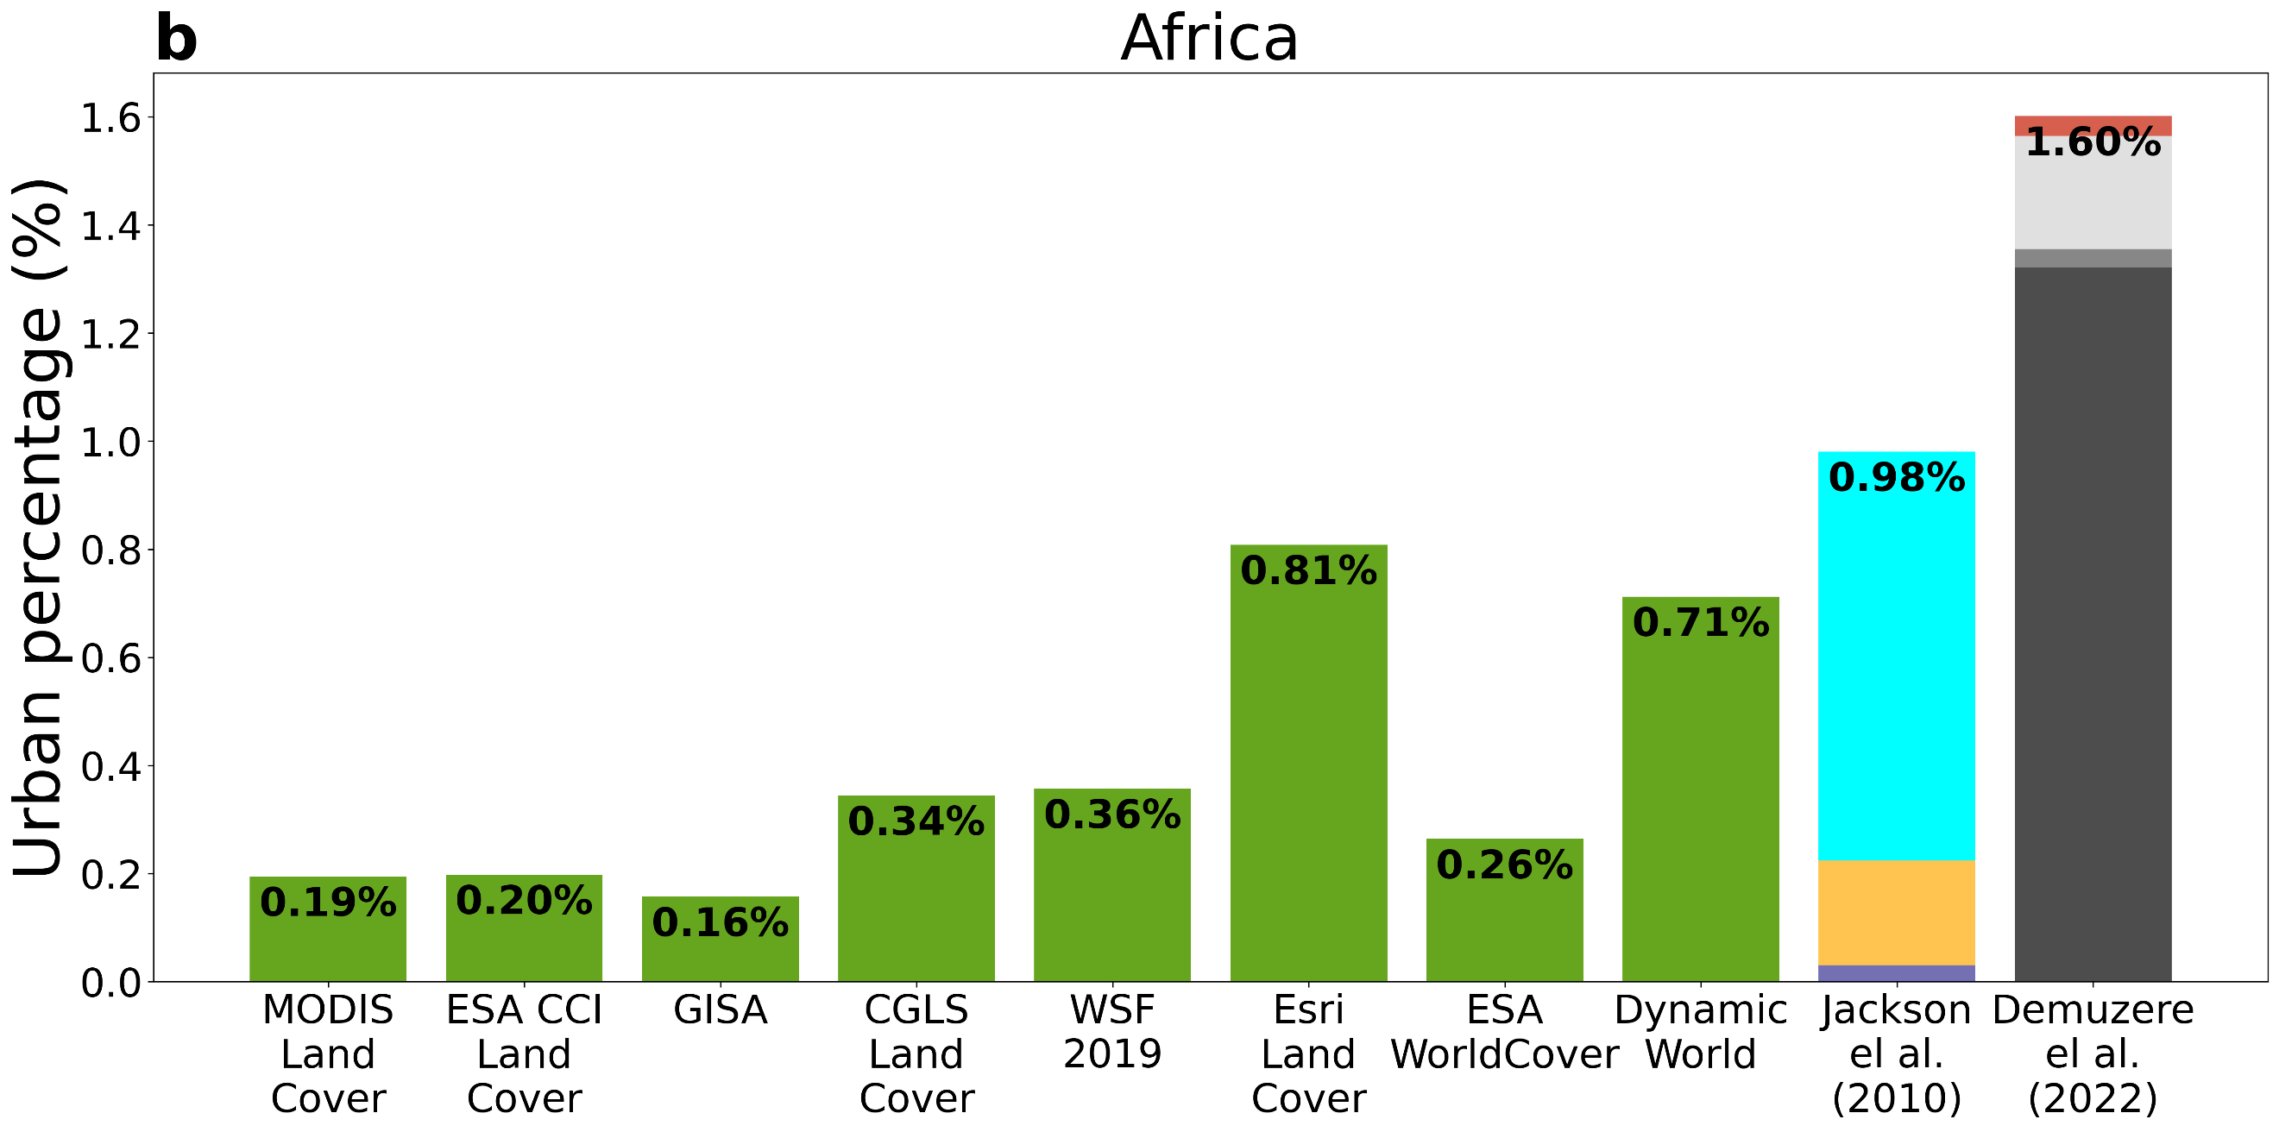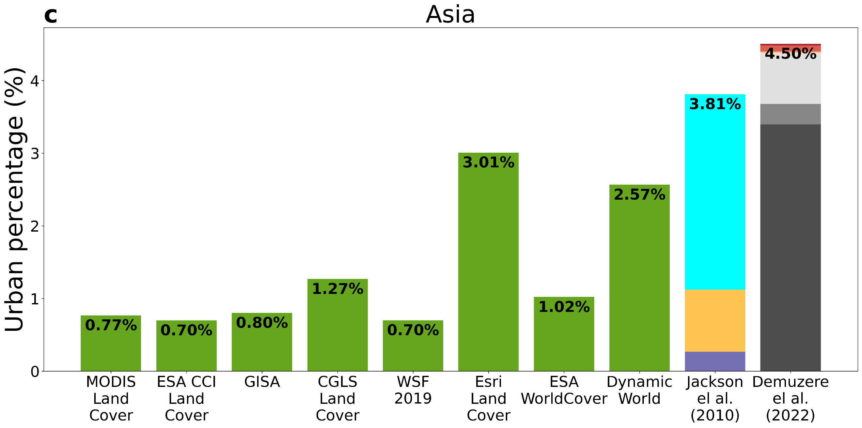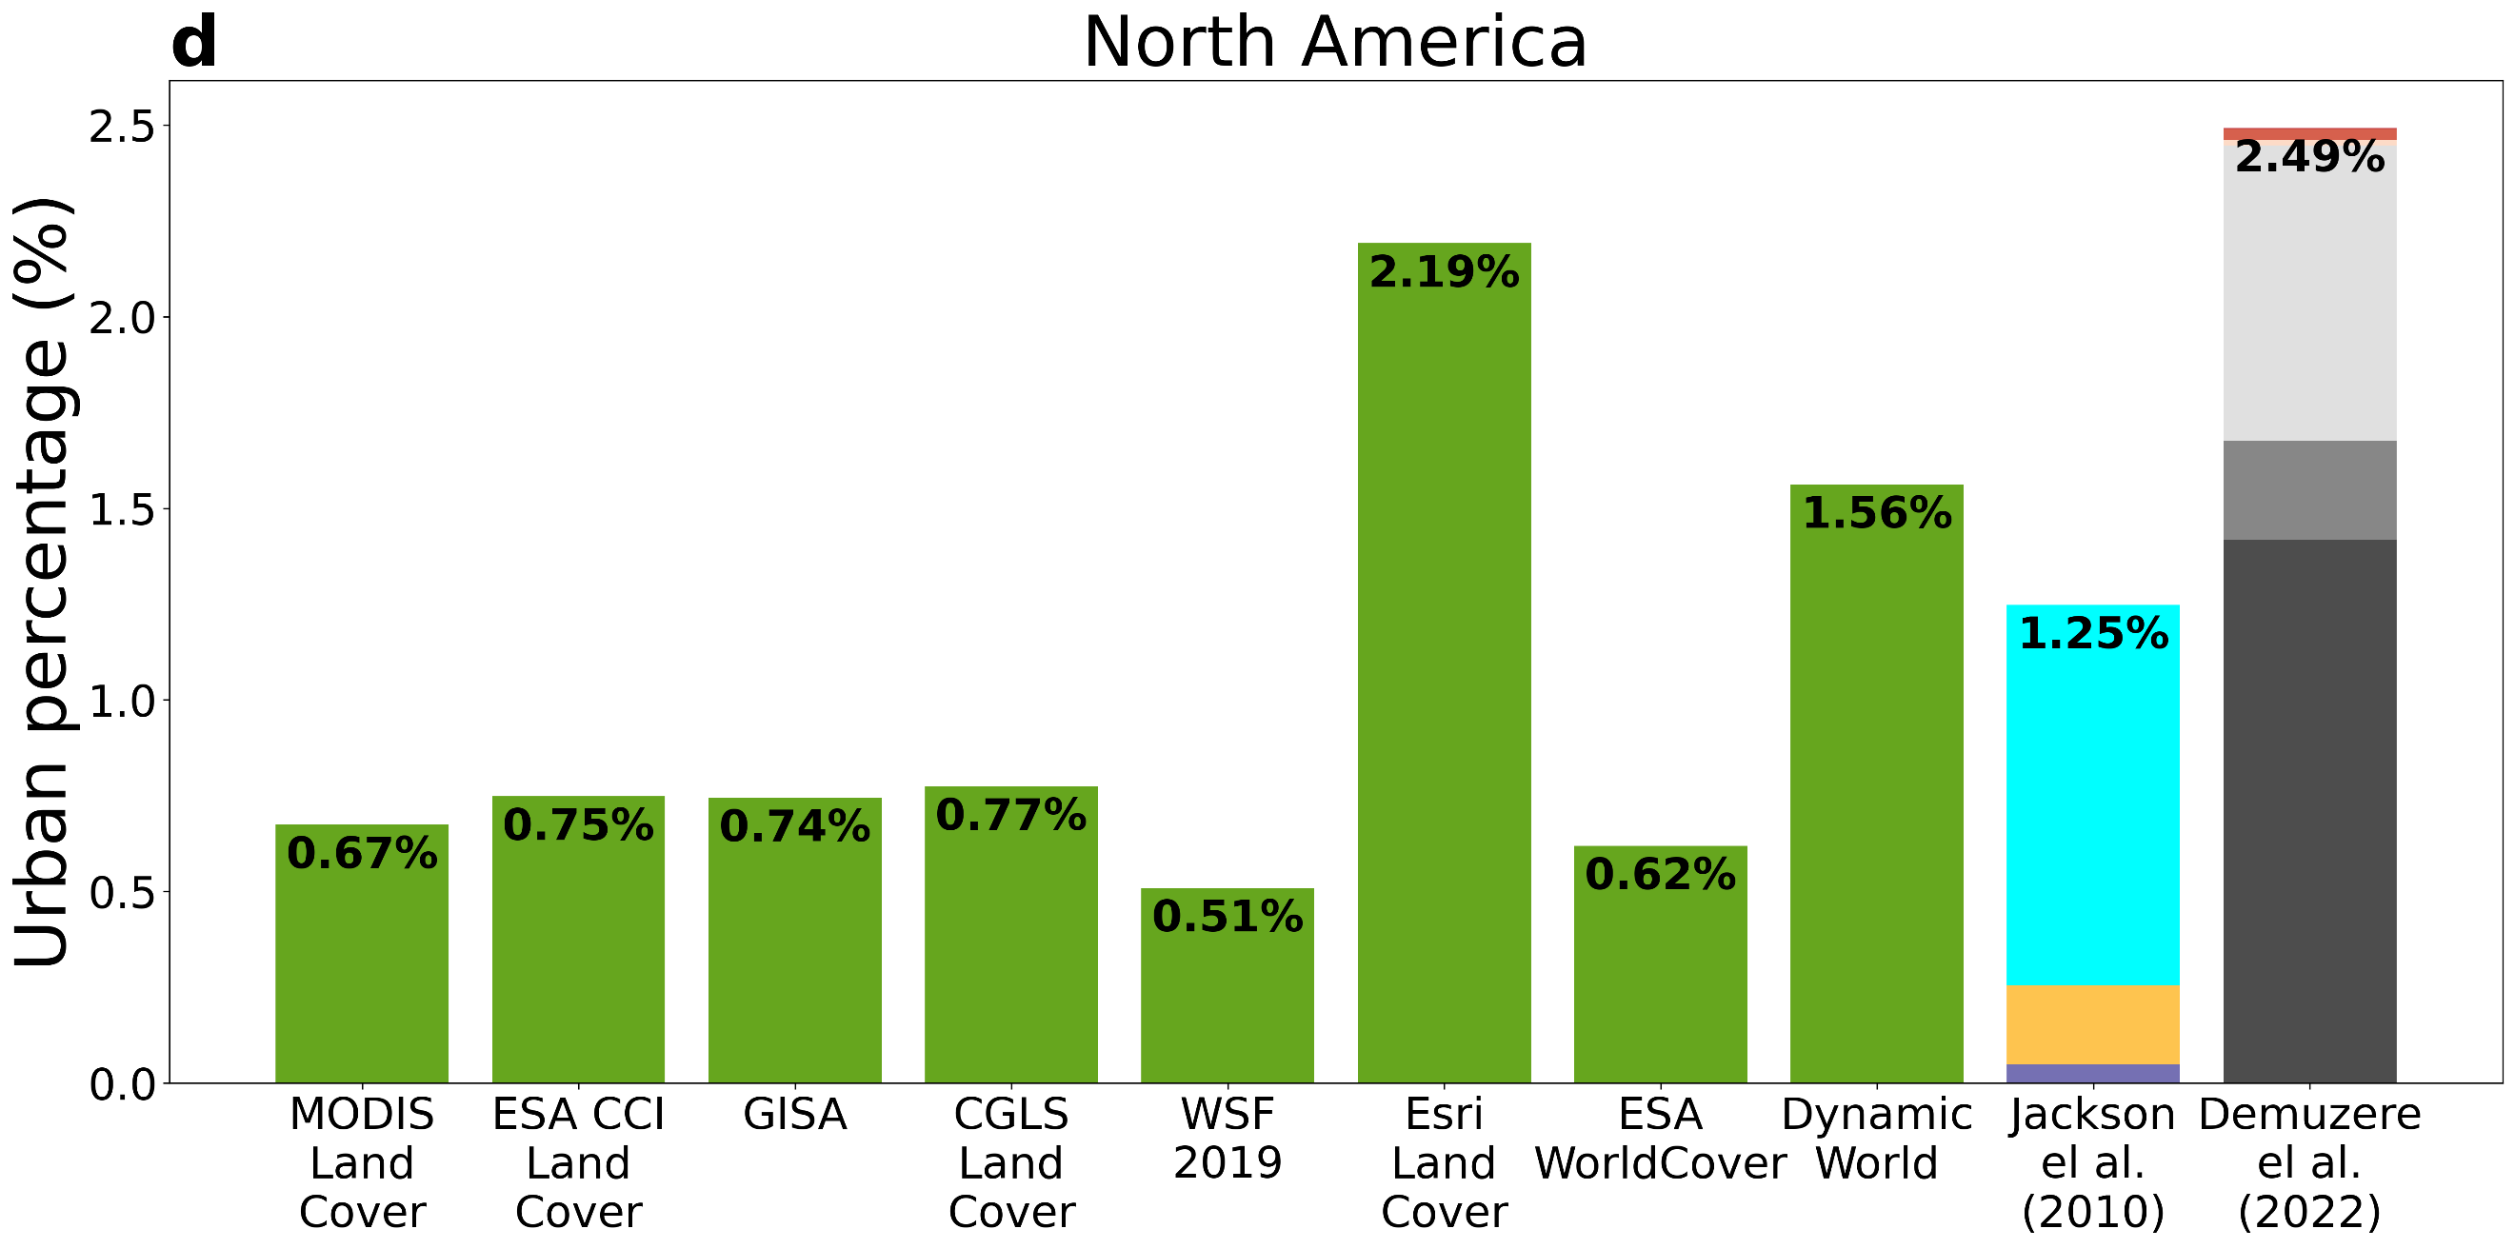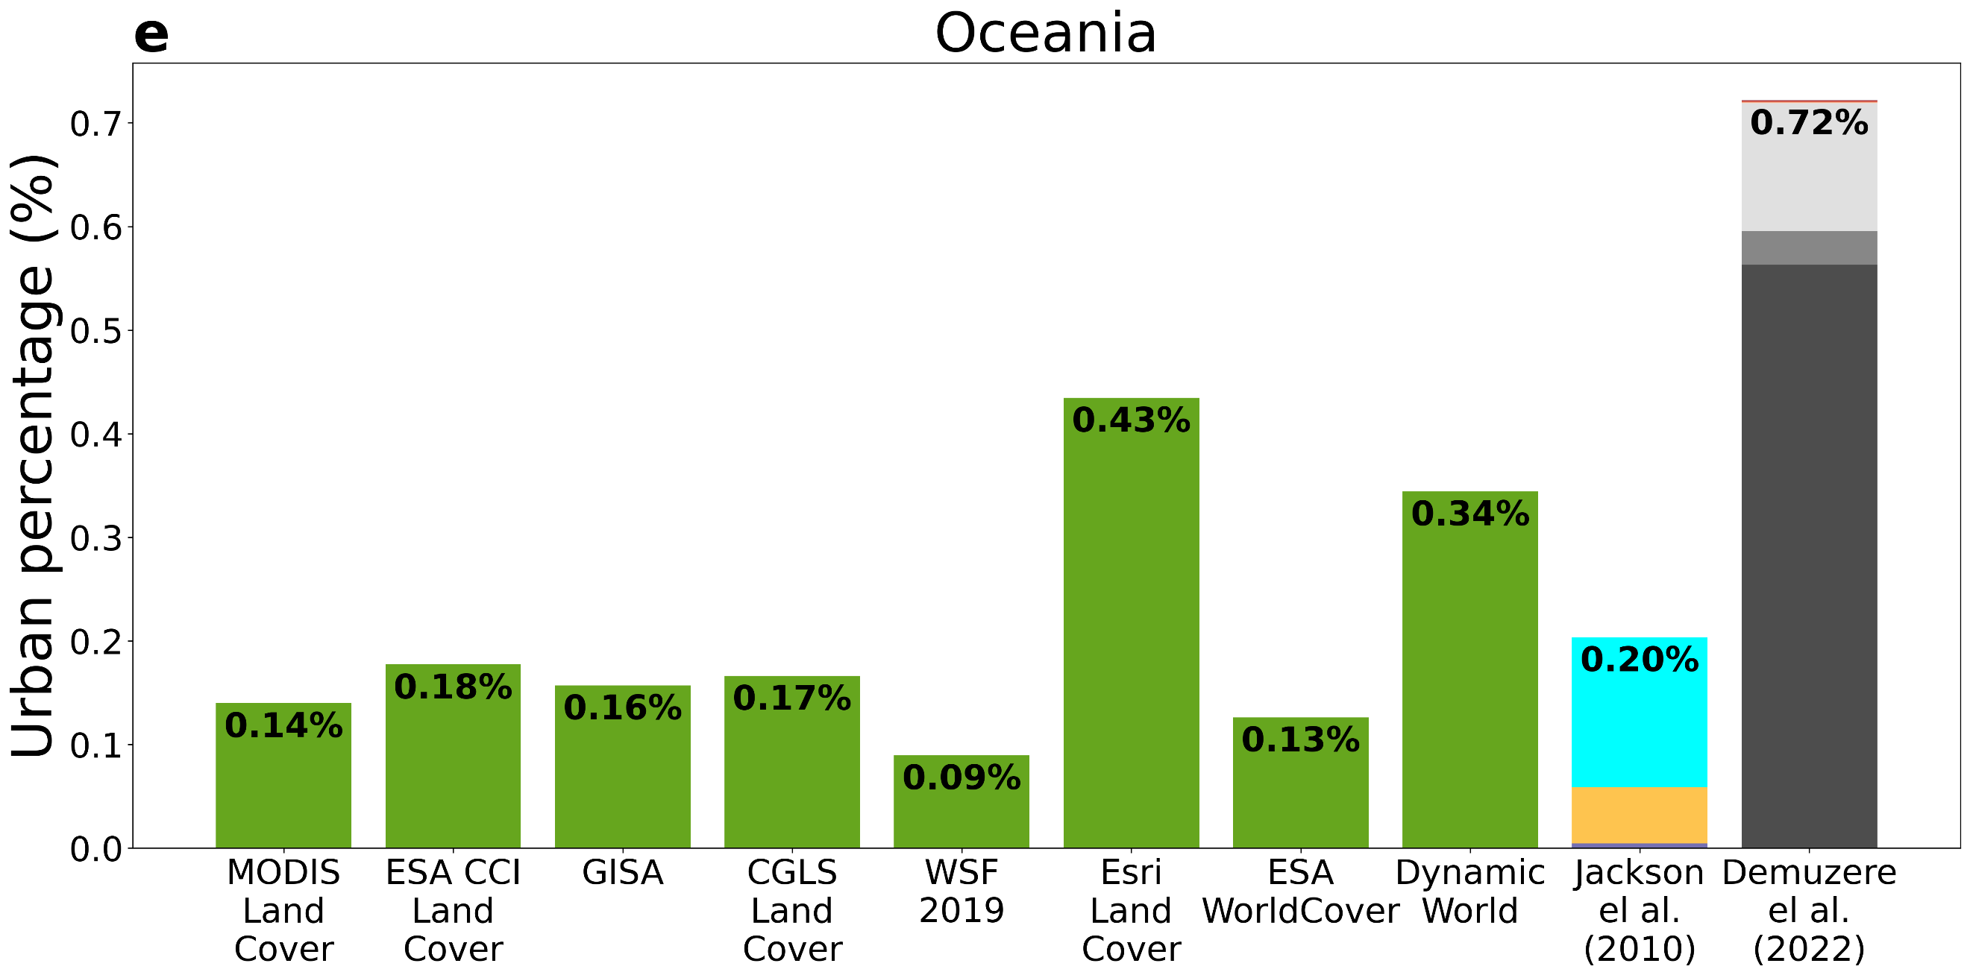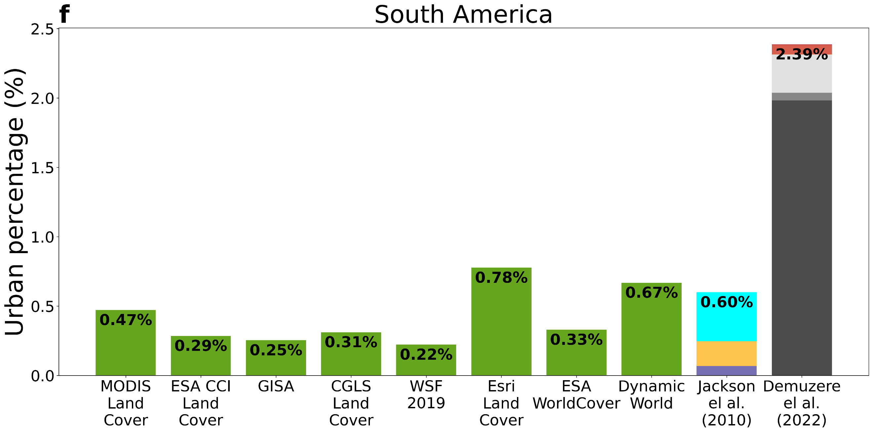
Fig. S4 | Urban percentage in observations and models | Urban percentage across eight datasets as well as two additional estimates of urban areas used in weather and climate models for a World, b Africa, c Asia, d North America, e Oceania, and f South America. LCZ stands for local climate zone.

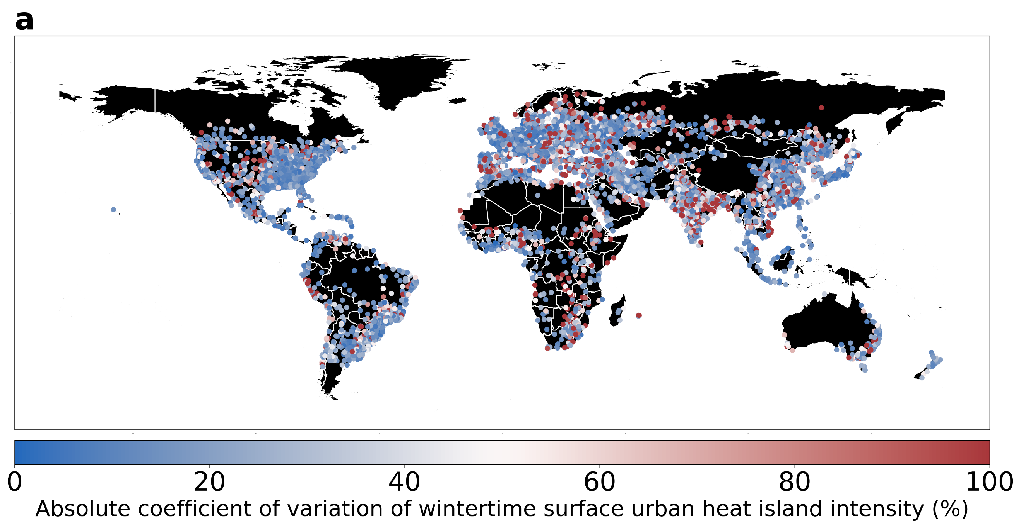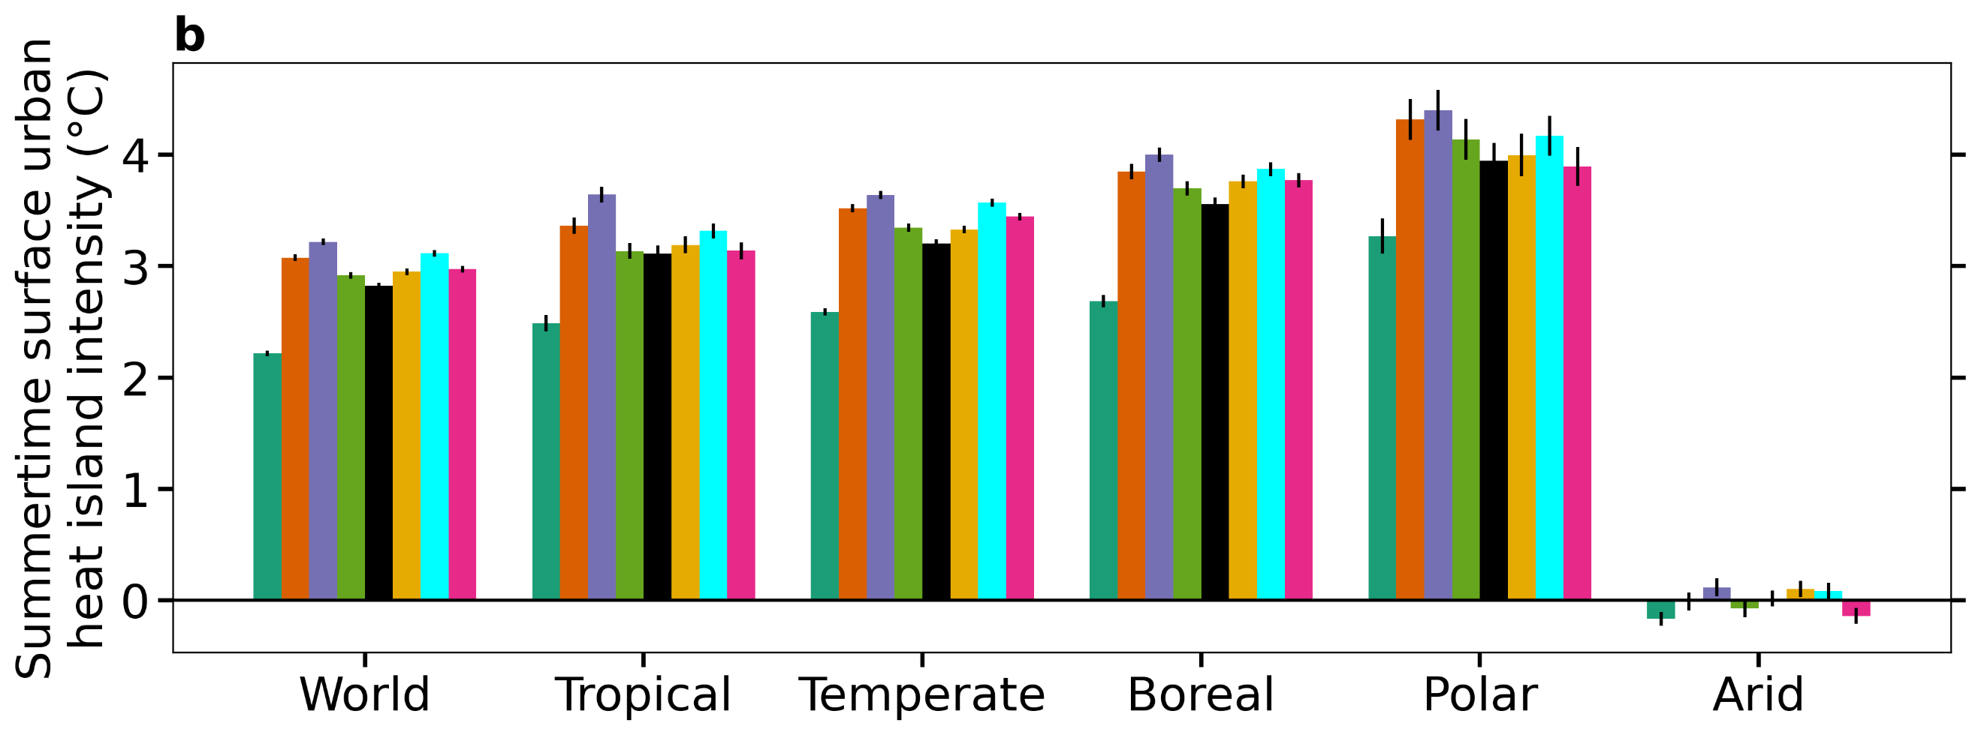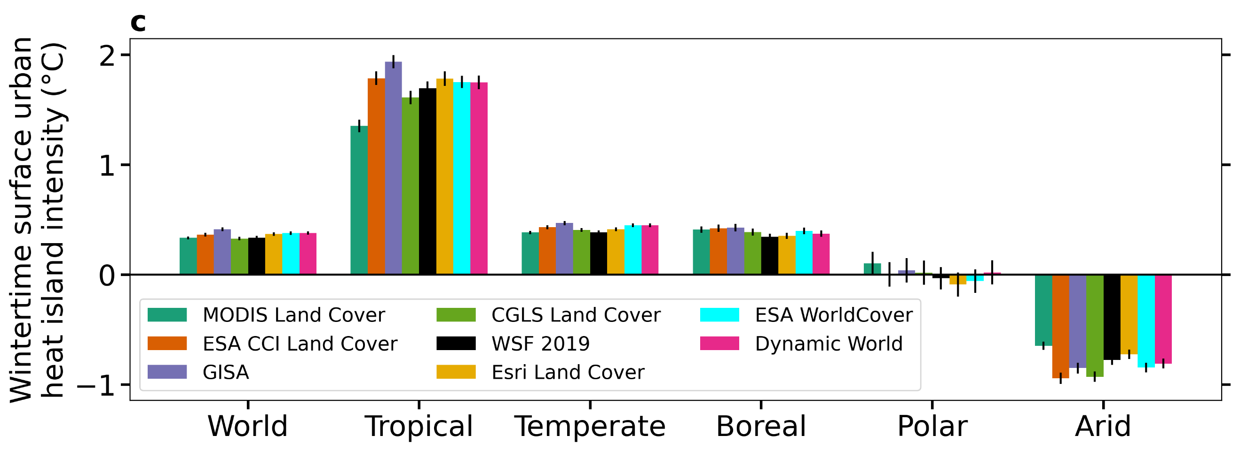
Fig. S5 | Variability in surface urban heat island intensity based on different datasets | Sub-figure a shows the absolute coefficient of variation in calculated surface urban heat island intensity during 2018-2022 winter for around 10,000 global urban clusters from eight urban land cover datasets. Sub-figures b and c show the actual magnitude of the surface urban heat island intensity based on the eight datasets for the world and different climate zones for summer and winter, respectively.

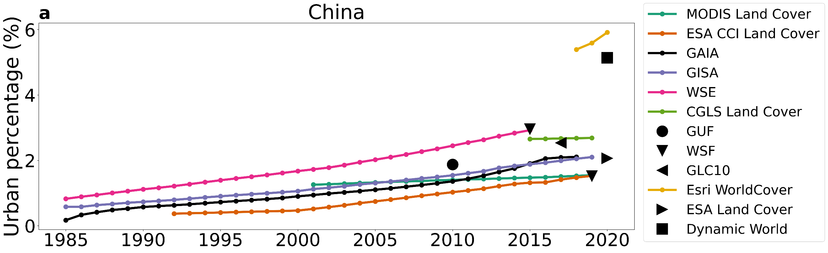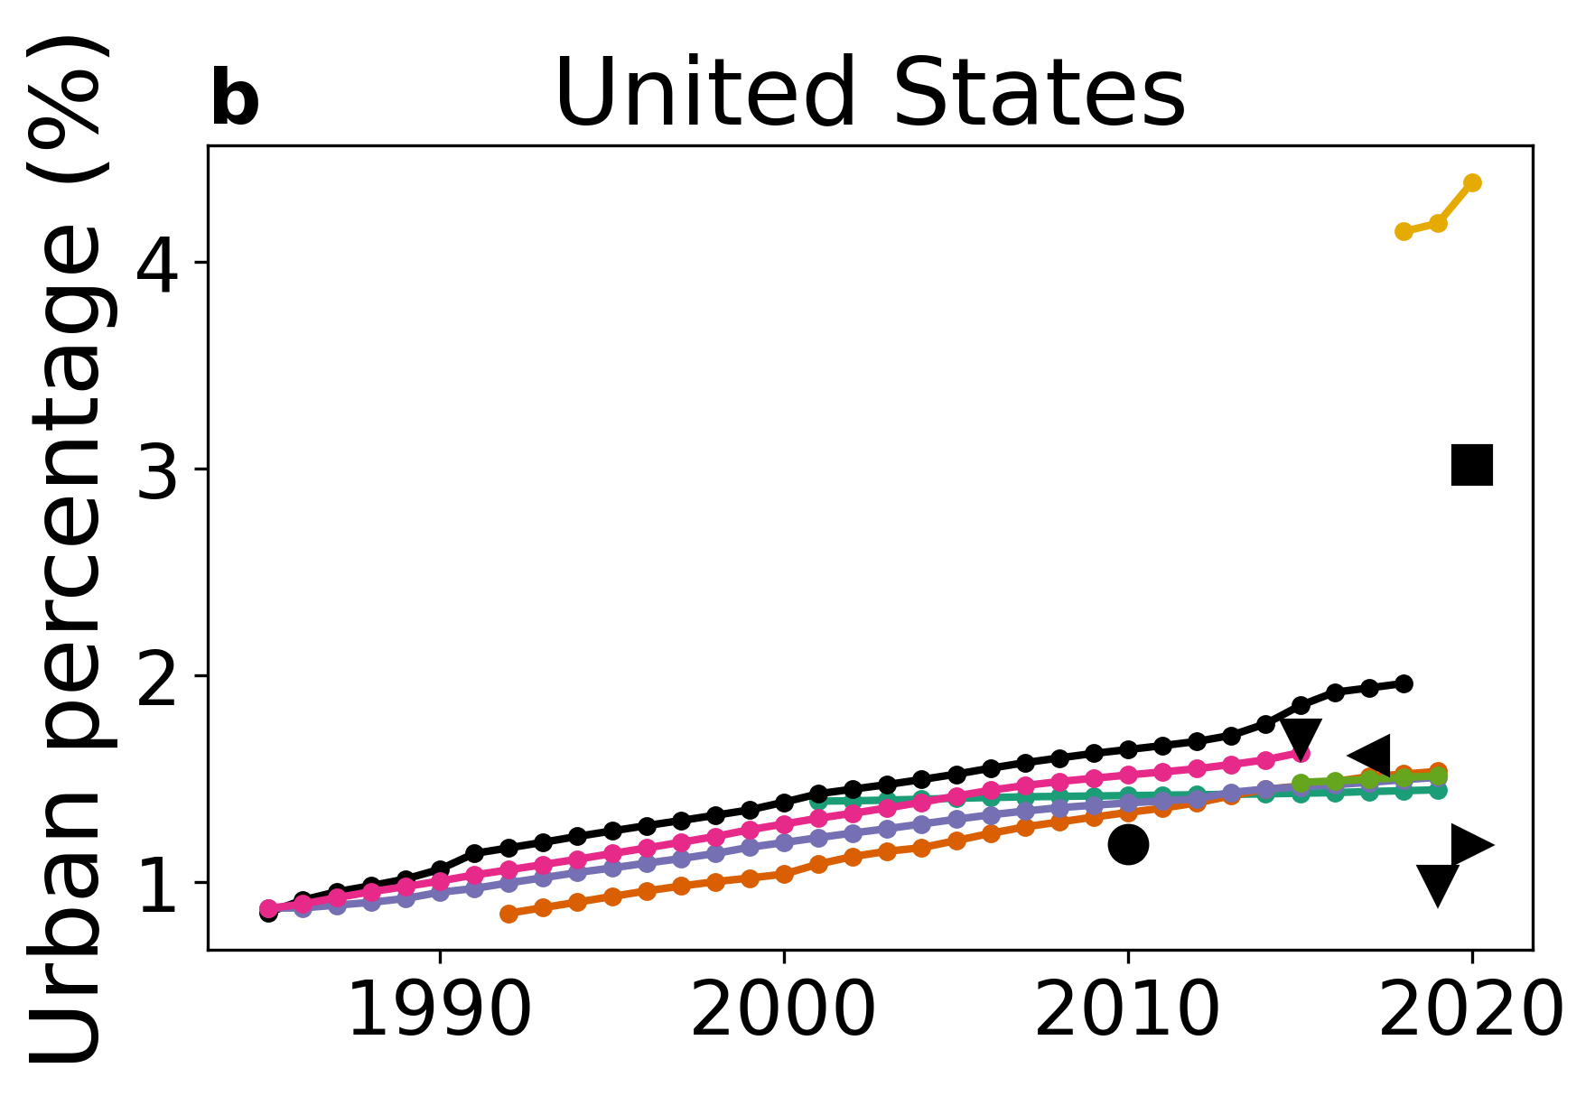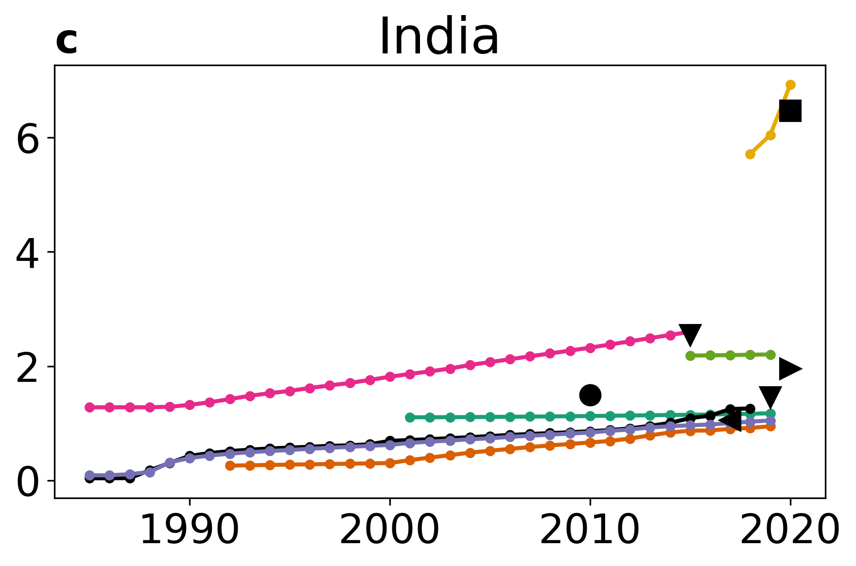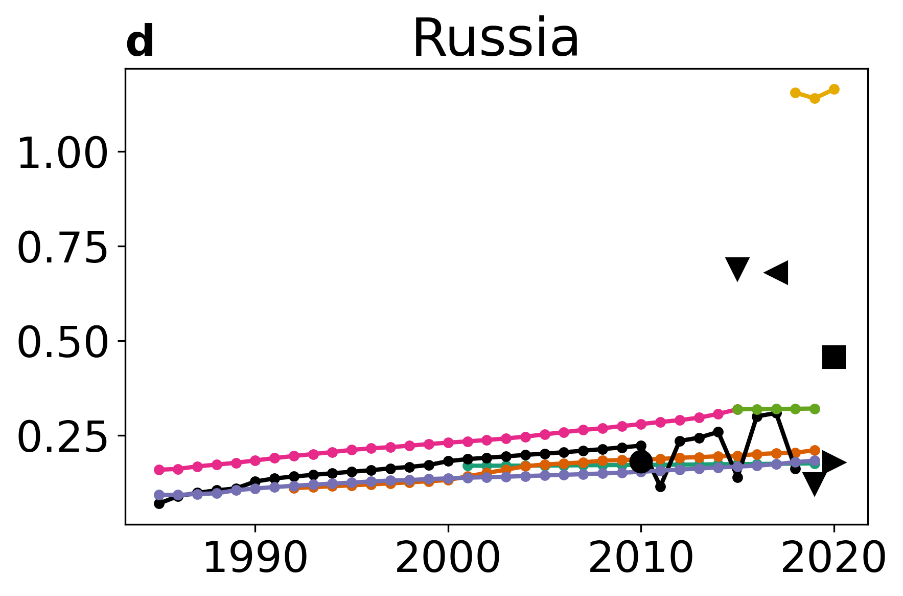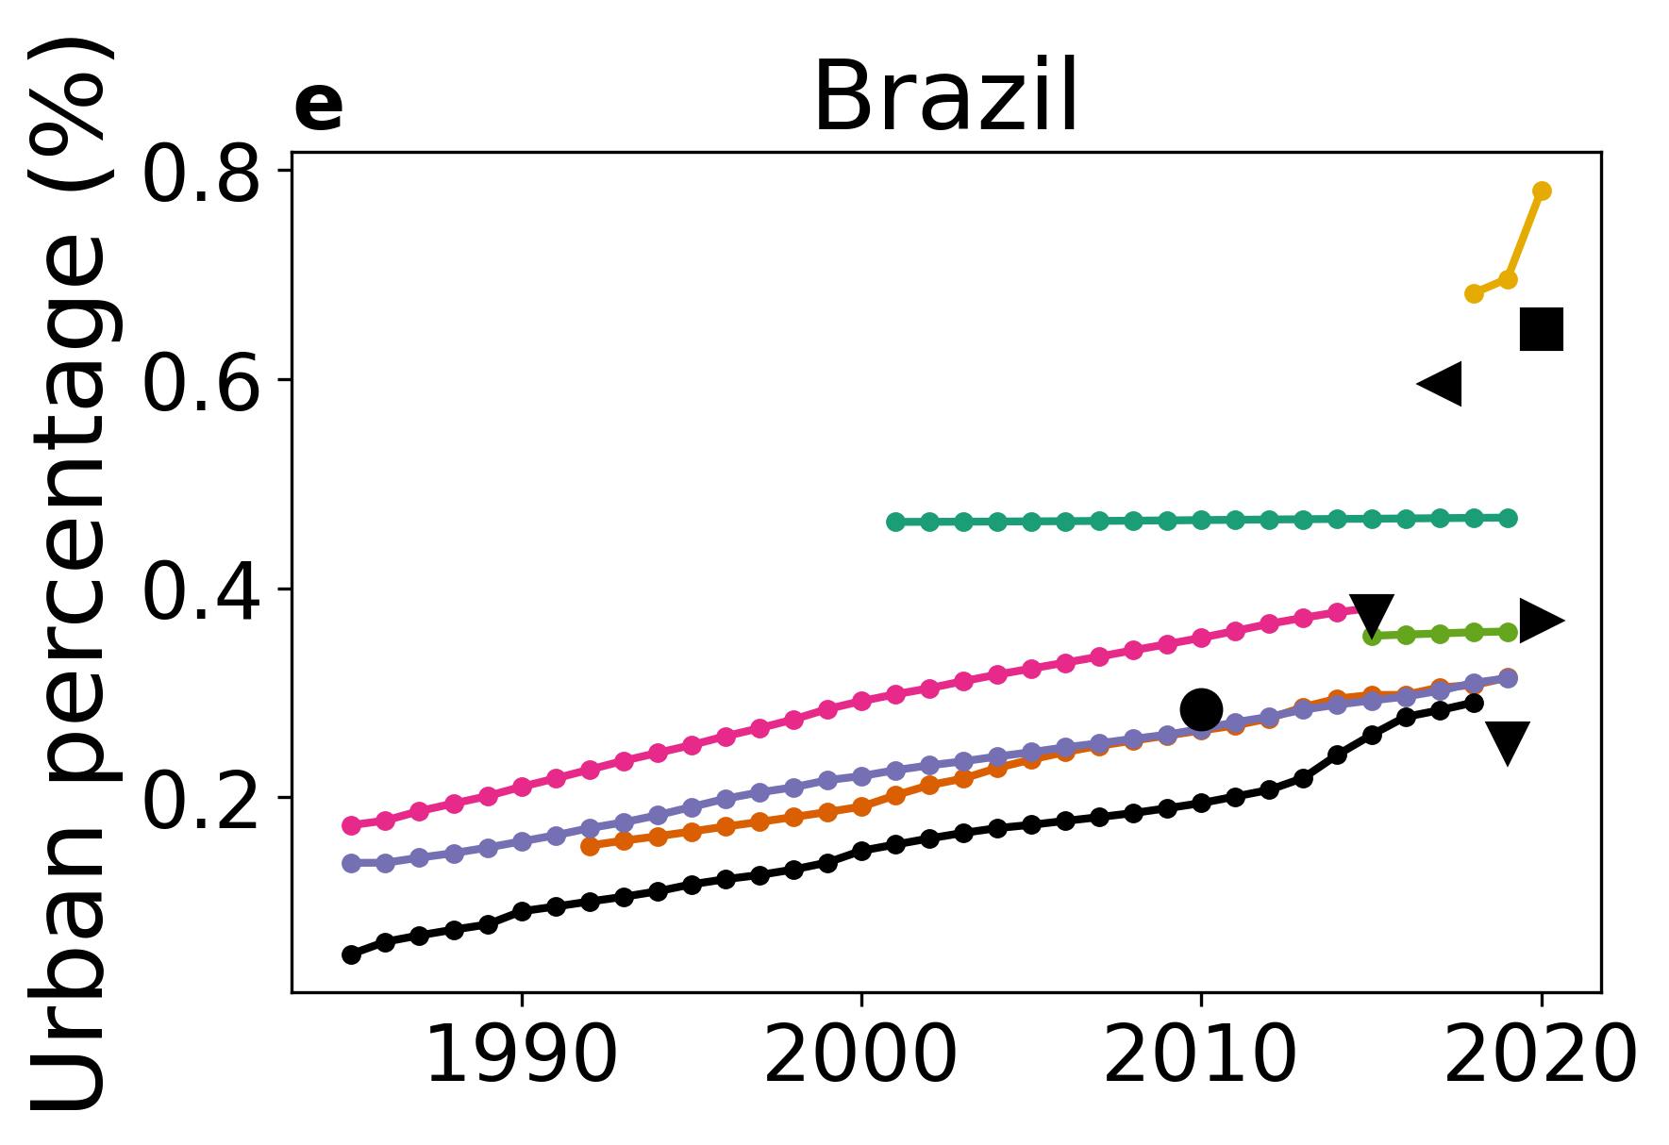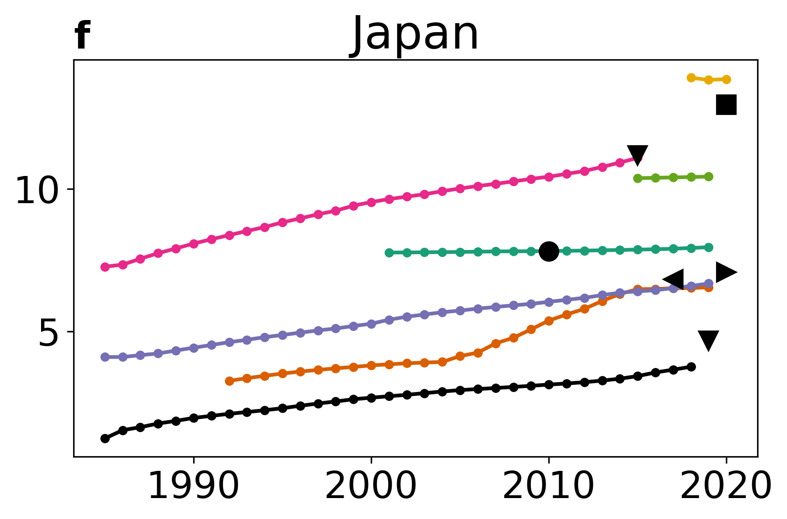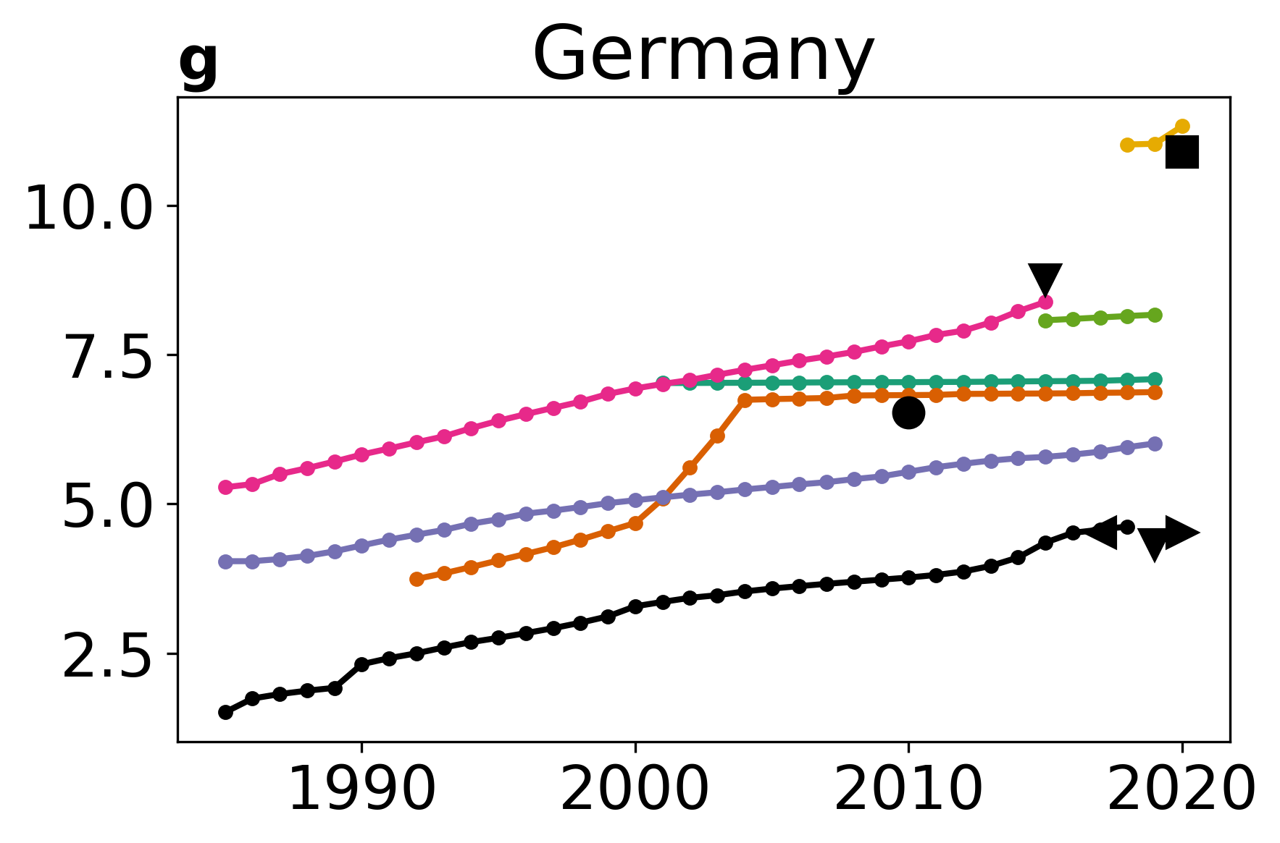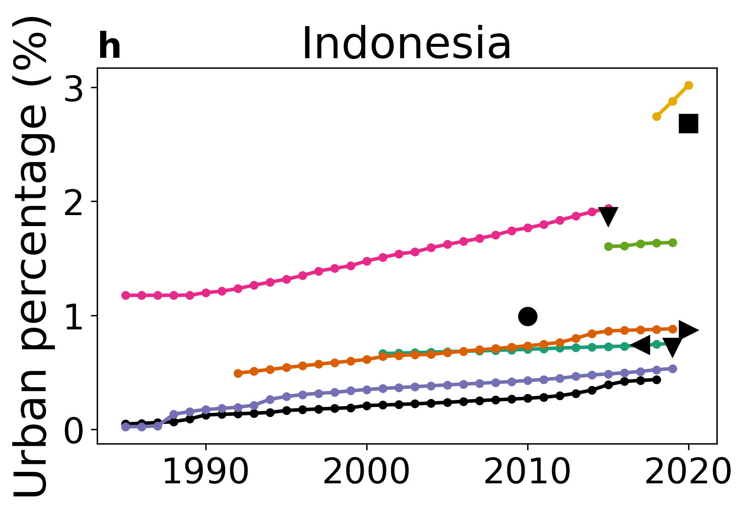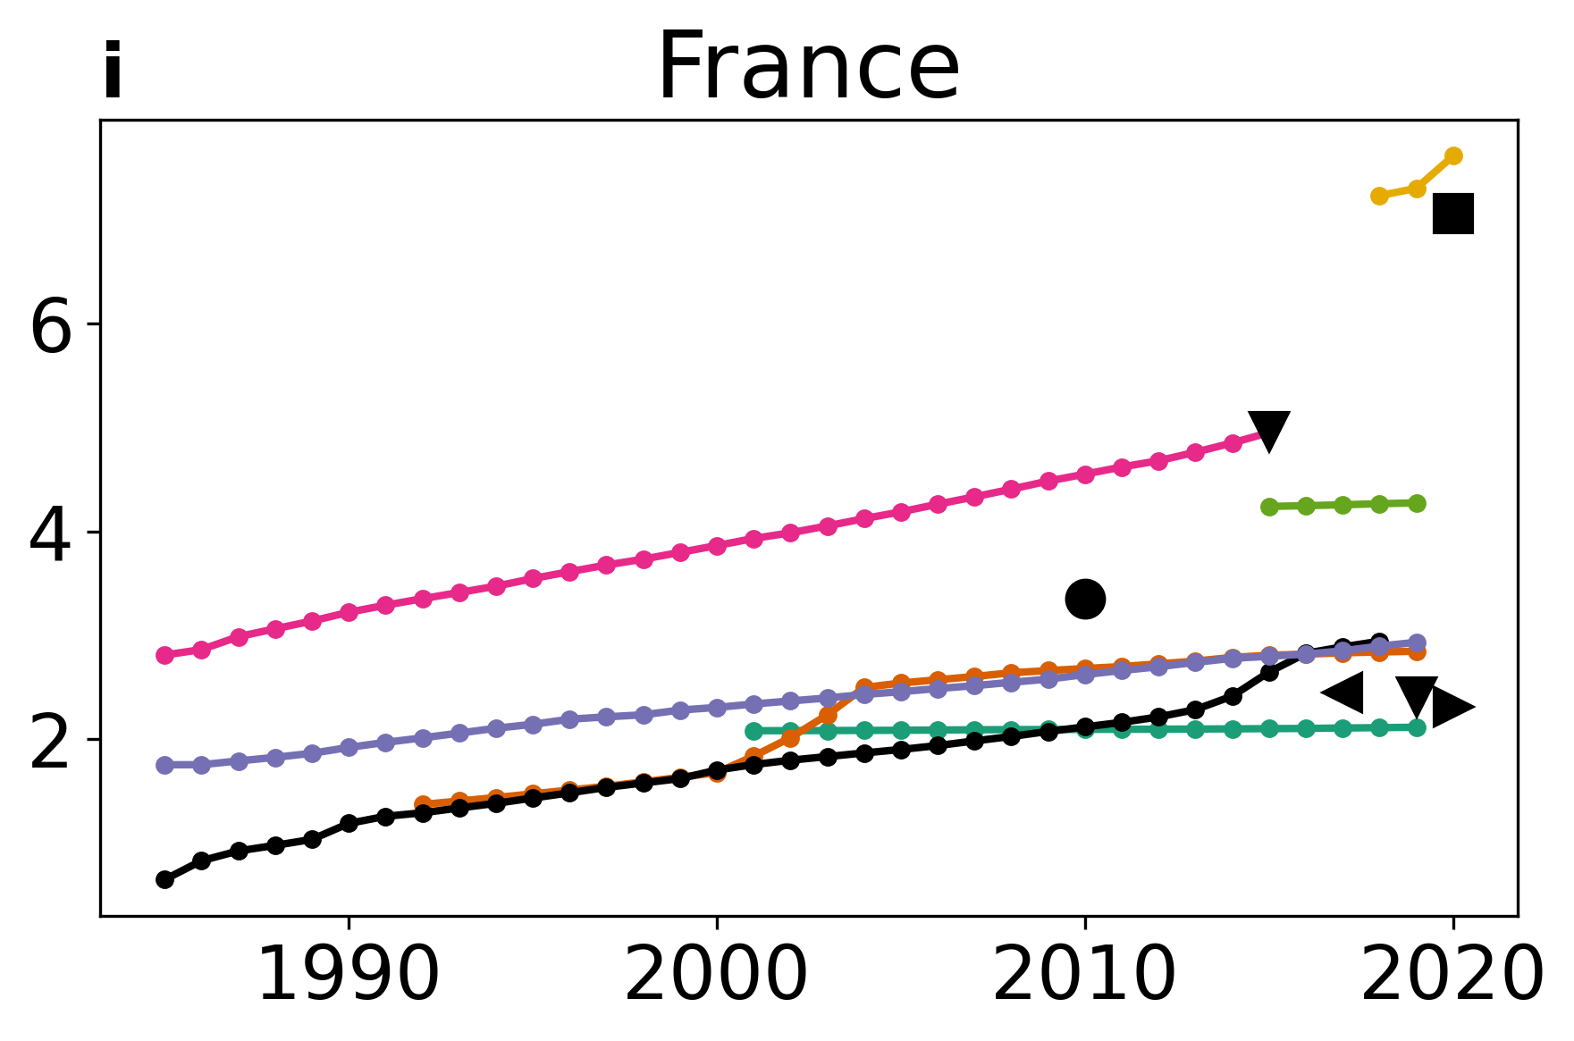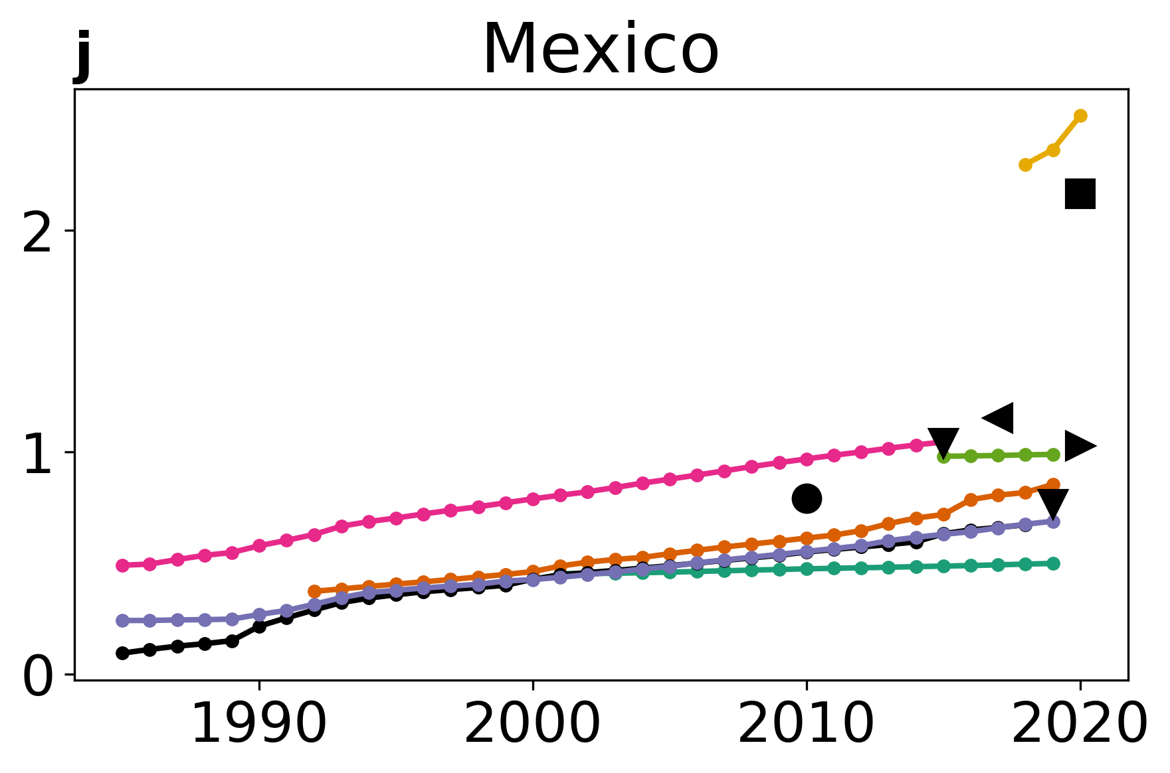
Fig. S6 | Country level urban percentage and its long-term changes across datasets | Urban percentage from 12 global data products for a China, b United States, c India, d Russia, e Brazil, f Japan, g Germany, h Indonesia, i France, and j Mexico. Long-term changes are shown for datasets that span multiple successive years.

Table S1. Summary of all urban land cover datasets considered in this study.
Dataset name | Acronym used | Spatial resolution | ‘Urban’ class name | Class definition and/or other notes | References
Moderate Resolution Imaging Spectroradiometer Land Cover Type Version 6.1 | MODIS Land Cover | 500 m | Urban and Built-up Lands | At least 30% impervious surface area including building materials, asphalt, and vehicles. | ¹
European Space Agency Climate Change Initiative Land Cover | ESA CCI Land Cover | 300 m | Urban Areas | Identified based on a combination of the Global Human Settlement Layer and the Global Urban Footprint datasets | ²
Global impervious surface area | GISA | 30 m | Impervious surface area | No predefined urban mask used | ³
Copernicus Global Land Service Dynamic Land Cover map | CGLS Land Cover | 100 m | Urban / Built up | Land covered by buildings and other man-made structures; urban class is based on World Settlement Footprint 2015 | ⁴
World Settlement Footprint 2019 | WSF 2019 | 10 m | Human settlement | Built-up areas with roads removed | ⁵
Environmental Systems Research Institute, Inc land Cover | Esri land Cover | 10 m | Built Area | Human-made structures; major road and rail networks; large homogenous impervious surfaces, including parking structures, office buildings and residential housing. | ⁶
European Space Agency WorldCover | ESA WorldCover | 10 m | Built-up | Land covered by buildings, roads and other man-made structures such as railroads. Buildings include both residential and industrial building. Urban green (parks, sport facilities) is not included in this class. Waste dump deposits and extraction sites are considered as bare. | ⁷
Dynamic World | - | 10 m | Built Area | Clusters of human-made structures or individual very large human-made structures.  Contained industrial, commercial, and private building, and the associated parking lots.  A mixture of residential buildings, streets, lawns, trees, isolated residential structures or buildings surrounded by vegetative land covers.  Major road and rail networks outside of the predominant residential areas.  Large homogeneous impervious surfaces, including parking structures, large office buildings, and residential housing developments containing clusters of cul-de-sacs. | ⁸
Global Urban Footprint | GUF | 12 m | Built-up area | Similar to WSF 2019, but developed using commercial imagery | ⁹
Global Annual Impervious Area | GAIA | 30 m | Artificial Impervious Area | Primary urban masks are first created based on Sentinel-1 Synthetic Aperture Radar data before further classification. Greater than 50% impervious area pixels are defined as urban | ¹⁰
World Settlement Evolution | WSE | 30 m | Human settlement | Cannot detect settlements that shrink over time | ⁵
World Settlement Footprint 2015 | WSF 2015 | 10 m | Human settlement | Similar to WSF 2019, but using Sentinel-1 and Landsat 8 instead of Sentinel-1 and Sentinel-2. Raw imagery not fine enough to mask out roads | ¹¹
Finer Resolution Observation and Monitoring of Global Land Cover 10m | GLC10 | 10 m | Impervious | Training data developed using 30 m Landsat data were transferred to Sentinel-2 imagery to classify them at 10 m. | ¹²

Table S2. Accuracy estimates of all land cover datasets considered for representing present-day for the world and different continents.
Region | MODIS Land Cover | ESA CCI Land Cover | GISA | CGLS Land Cover | WSF 2019 | Esri Land Cover | ESA WorldCover | Dynamic World | Sample Size
World | 80.26% | 88.19% | 99.21% | 91.59% | 99.16% | 98.89% | 81.22% | 96.36% | 2571693
Africa | 68.00% | 81.10% | 98.35% | 91.32% | 98.35% | 98.20% | 88.54% | 94.04% | 150127
Asia | 80.96% | 88.50% | 98.93% | 94.23% | 98.88% | 98.30% | 87.50% | 91.63% | 768022
Europe | 79.76% | 89.57% | 99.41% | 91.97% | 99.40% | 99.10% | 74.40% | 98.95% | 322635
North America | 82.80% | 90.43% | 99.44% | 89.08% | 99.44% | 99.38% | 72.01% | 98.92% | 847882
Oceania | 62.29% | 69.28% | 98.06% | 87.69% | 96.80% | 97.76% | 83.95% | 97.40% | 60300
Seven seas (open ocean) | 0.00% | 54.77% | 100.00% | 5.92% | 100.00% | 100.00% | 24.05% | 100.00% | 524
South America | 82.19% | 89.77% | 99.84% | 92.99% | 99.79% | 99.75% | 92.29% | 98.75% | 344117

Reference
1. Sulla-Menashe, D. & Friedl, M. A. User guide to collection 6 MODIS land cover (MCD12Q1 and MCD12C1) product. Usgs Rest. Va Usa 1, 18 (2018).
2. Bontemps, S. et al. Consistent global land cover maps for climate modelling communities: current achievements of the ESA’s land cover CCI. in Proceedings of the ESA living planet symposium, Edimburgh 9–13 (2013).
3. Huang, X. et al. 30 m global impervious surface area dynamics and urban expansion pattern observed by Landsat satellites: From 1972 to 2019. Sci. China Earth Sci. 64, 1922–1933 (2021).
4. Buchhorn, M. et al. Copernicus global land cover layers—collection 2. Remote Sens. 12, 1044 (2020).
5. Marconcini, M., Metz-Marconcini, A., Esch, T. & Gorelick, N. Understanding current trends in global urbanisation-the world settlement footprint suite. GI_Forum 9, 33–38 (2021).
6. Karra, K. et al. Global land use/land cover with Sentinel 2 and deep learning. in 2021 IEEE international geoscience and remote sensing symposium IGARSS 4704–4707 (IEEE, 2021).
7. Zanaga, D. et al. ESA WorldCover 10 m 2020 V100, Zenodo. (2021).
8. Brown, C. F. et al. Dynamic World, Near real-time global 10 m land use land cover mapping. Sci. Data 9, 251 (2022).
9. Esch, T. Breaking new ground in mapping human settlements from space – The Global Urban Footprint. ISPRS J Photogramm Remote Sens 134, 30–42 (2017).
10. Gong, P. et al. Annual maps of global artificial impervious area (GAIA) between 1985 and 2018. Remote Sens. Environ. 236, 111510 (2020).
11. Marconcini, M. et al. Outlining where humans live, the World Settlement Footprint 2015. Sci. Data 7, 242 (2020).
12. Chen, B. et al. Stable classification with limited sample: Transferring a 30-m resolution sample set collected in 2015 to mapping 10-m resolution global land cover in 2017. Sci Bull 64, 3 (2019).

