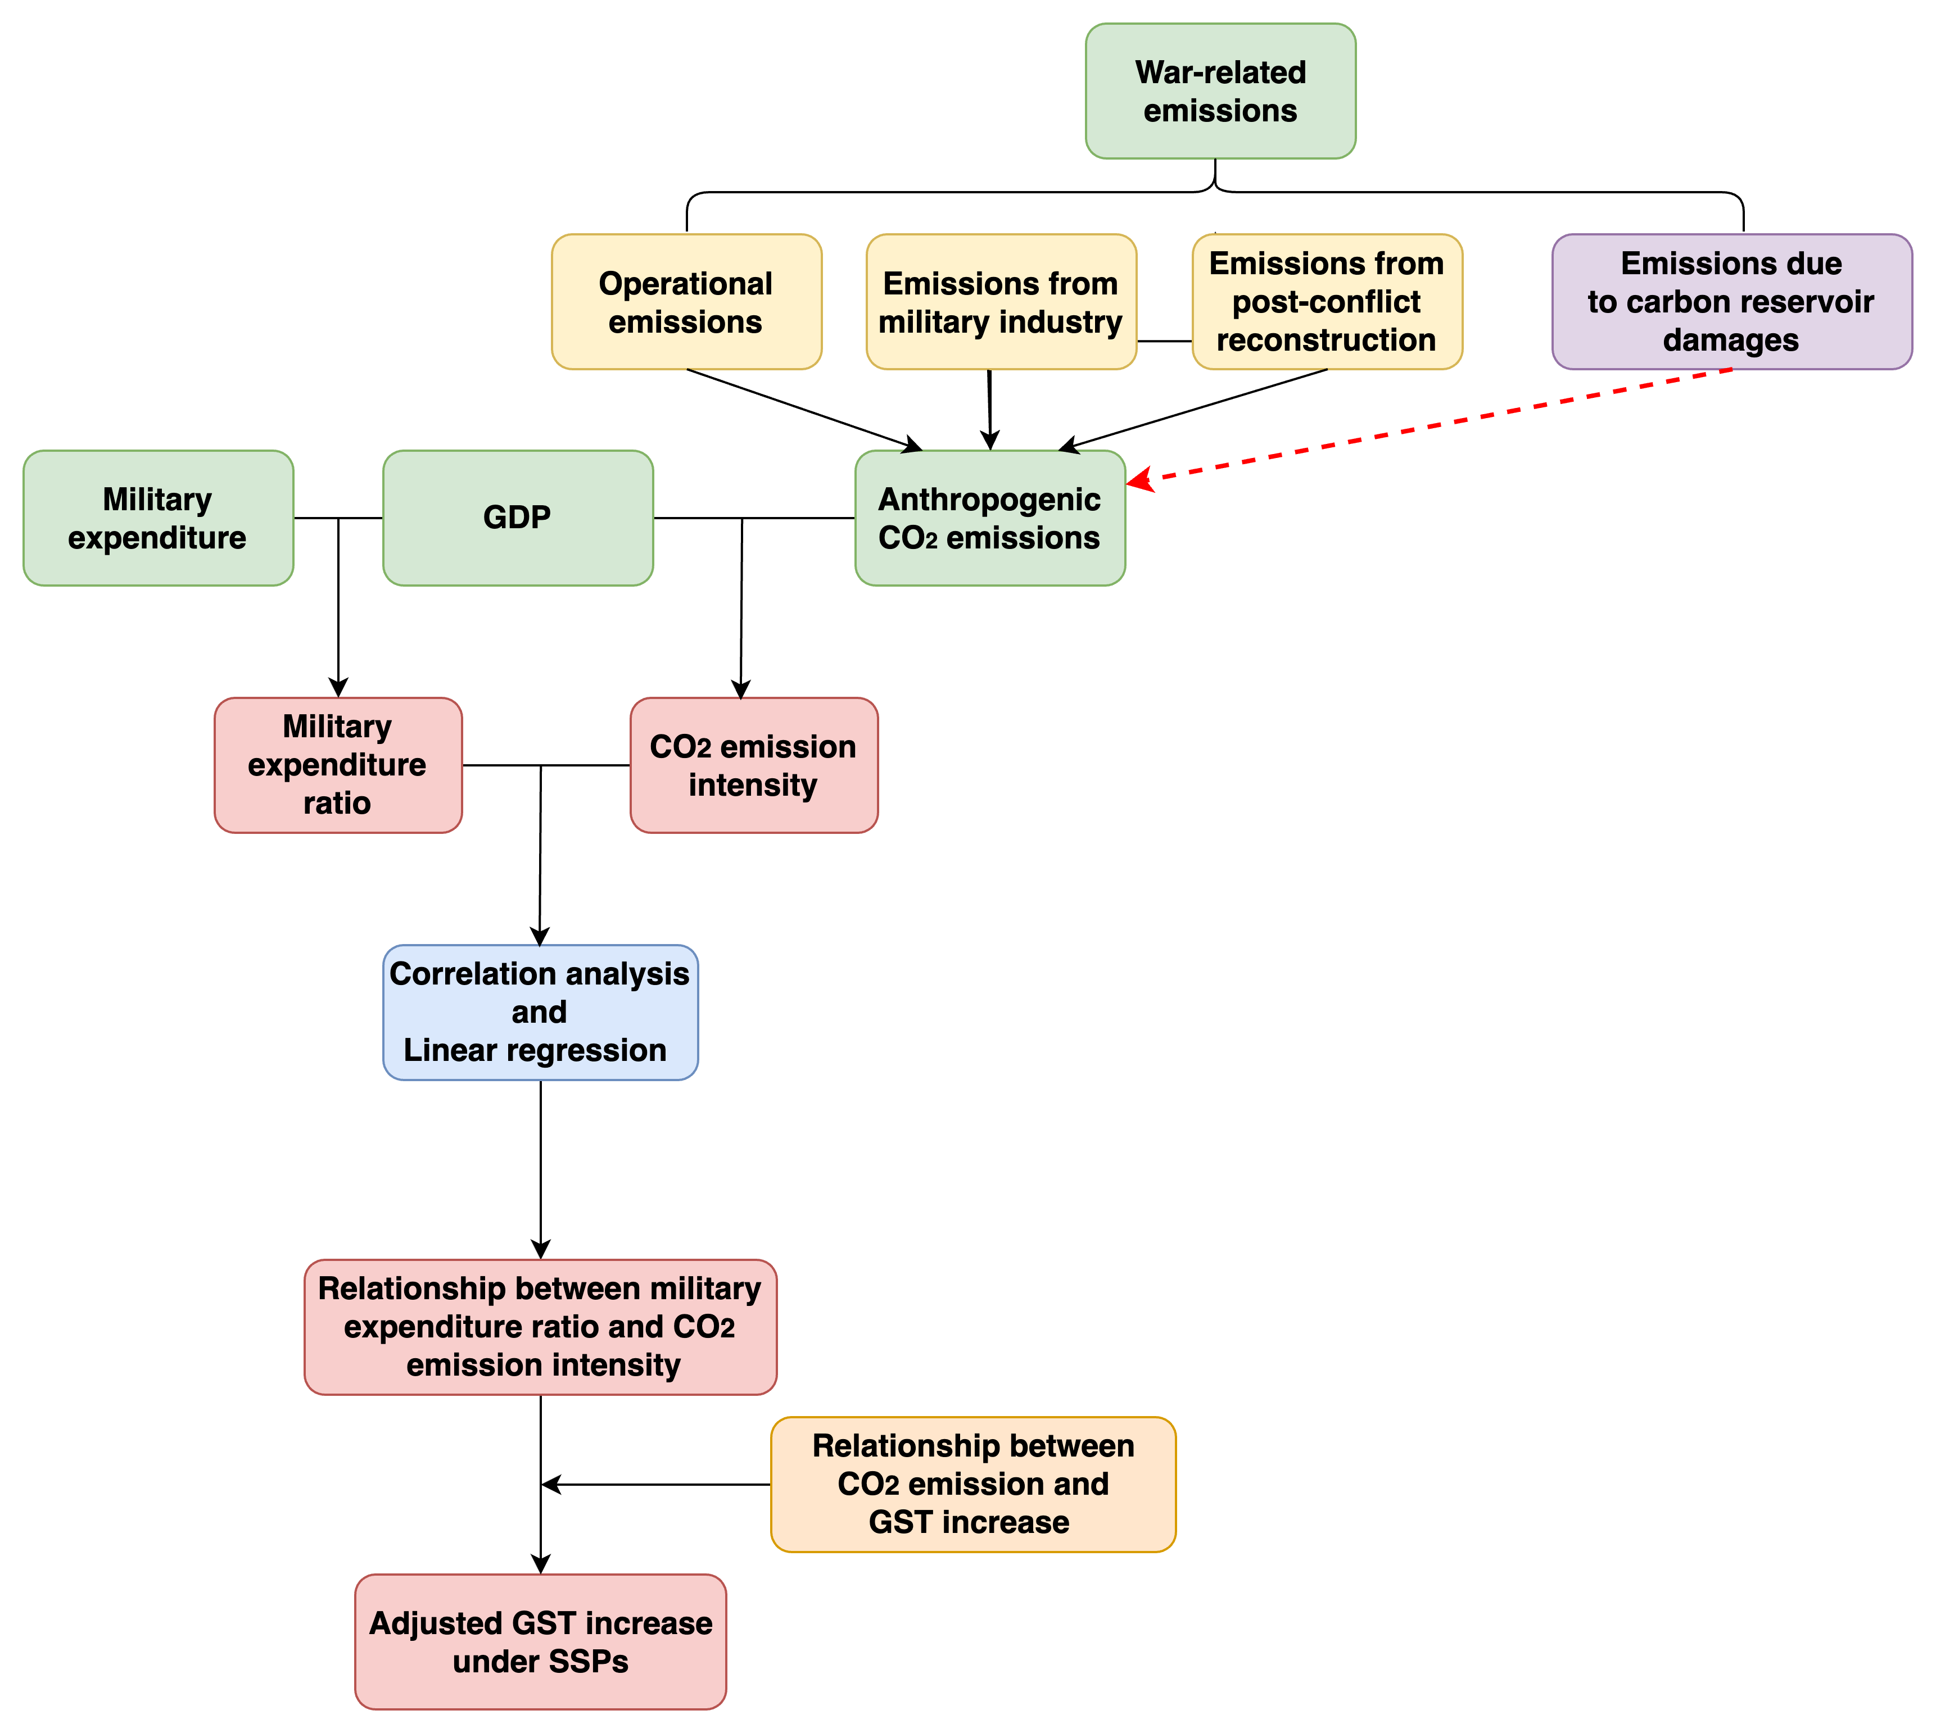
Extended Data Fig. 1. Research framework of this study.

Extended Data Table 1. Lagged Pearson’s correlation coefficient between detrended CO₂ emission intensity and global military expenditure as a percentage of GDP. “Lag” indicates the number of years lagged. Here, we consider only the possible effect of the military expenditure ratio on CO₂ emission intensity, and therefore, only the lagged correlation of CO₂ intensity with respect to the military expenditure ratio is calculated. The correlation coefficients in bold pass the Student’s t-test at 0.1 significance level (lag = 0, 1, 2) or 0.05 significance level (lag = 1). Effective degrees of freedom are used for the significance test.
Lag | 0 | 1 | 2 | 3 | 4 | 5
Correlation coefficient | 0.74 | 0.87 | 0.76 | 0.54 | 0.31 | 0.07

Extended Data Table 2. CO₂ emissions from source iv (destruction of carbon reservoirs) during different wars estimated by Michaelowa et al.^{[12]}
War or conflict | Period | CO₂ emissions (t) | Details
World War II | 1943 | 36–215 million | Entire German cities were bombed.
Vietnam War | 1961–1971 | 300 million | 0.5 million hectares of tropical forest and mangroves in southern Vietnam were destroyed.
the Gulf War | 1991 | 320 million CO₂ | Iraq set fire to 751 oil wells in Kuwait.
Nuclear  war | future | 1.8–14 million per city | /

Extended Data Table 3. Changes in GST increase (℃) relative to 1850–1900 when different global military expenditure ratio is considered in the SSP scenarios. “−x%” or “+x%” represents the global military expenditure ratio decreases or increases by x% compared with the baseline. “2050” and “2099” mean the difference in the GST increase between the baseline SSPs and the sensitivity scenarios in the year 2050 or 2099.

 | −2% |  | +5% |  | +11%
 | 2050 | 2099 | 2050 | 2099 | 2050 | 2099
SSP1-1.9 | −0.01 | −0.02 | 0.03 | 0.05 | 0.07 | 0.11
 | −2% |  | +11% |  | +23%
SSP1-2.6 | −0.01 | −0.03 | 0.06 | 0.13 | 0.13 | 0.28
SSP2-4.5 | 0.00 | 0.01 | 0.04 | 0.09 | 0.08 | 0.16
SSP3-7.0 | 0.01 | −0.01 | 0.03 | 0.05 | 0.07 | 0.1
SSP5-8.5 | 0.00 | −0.01 | 0.04 | 0.08 | 0.08 | 0.16

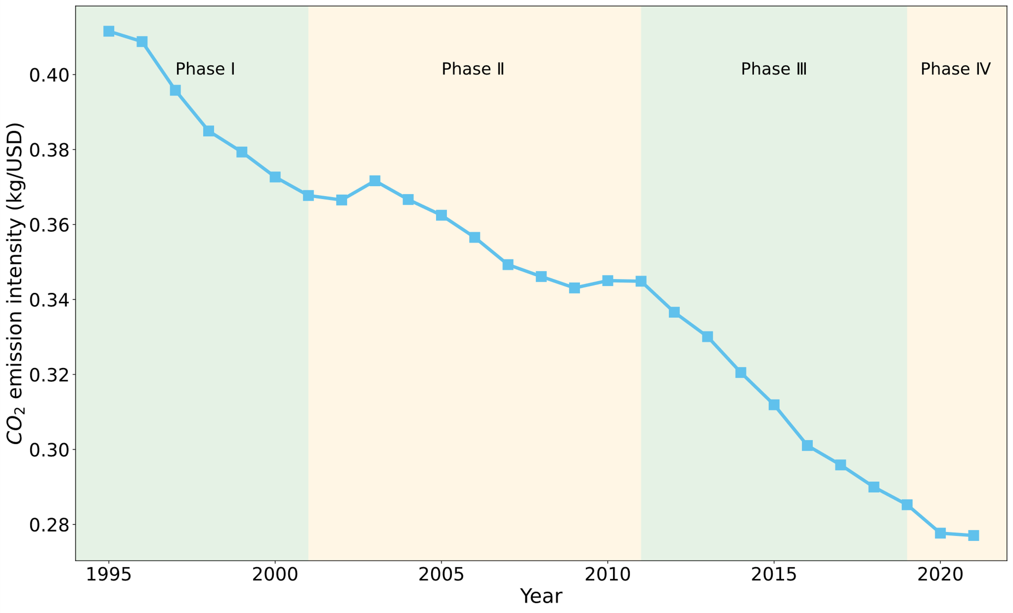
Extended Data Fig. 2. Time series of CO₂ emission intensity (kg/USD in constant 2017 of purchasing power parity; blue line) between 1990 and 2021. The entire research period is segmented into four phases, displaying a relatively peaceful phase (light-green background) and a war-ridden phase (light-orange background).

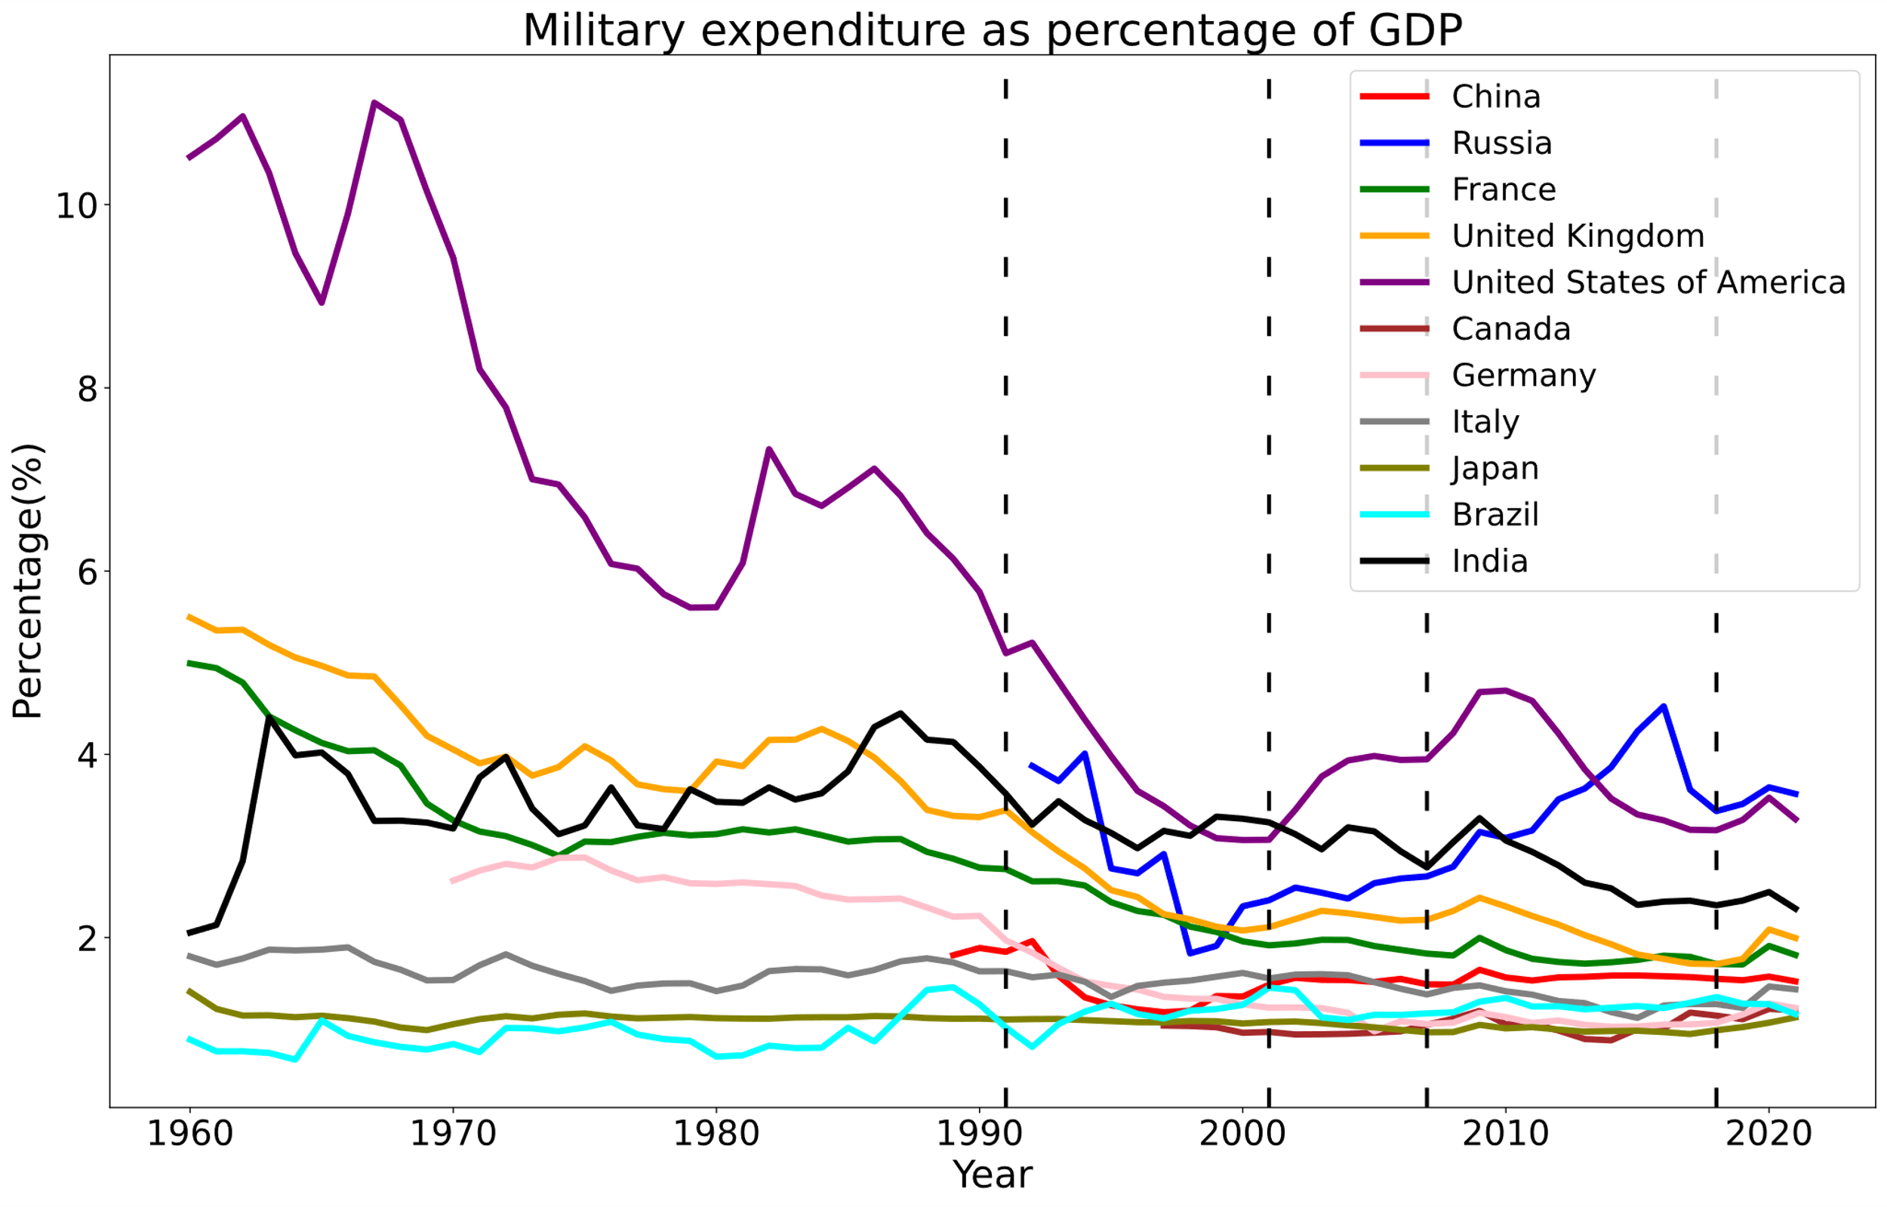
Extended Data Fig. 3. Military expenditure as a percentage of GDP for China, Russia, France, United Kingdom, United States of America, Canada, Germany, Italy, Japan, Brazil, and India between 1960 and 2021.

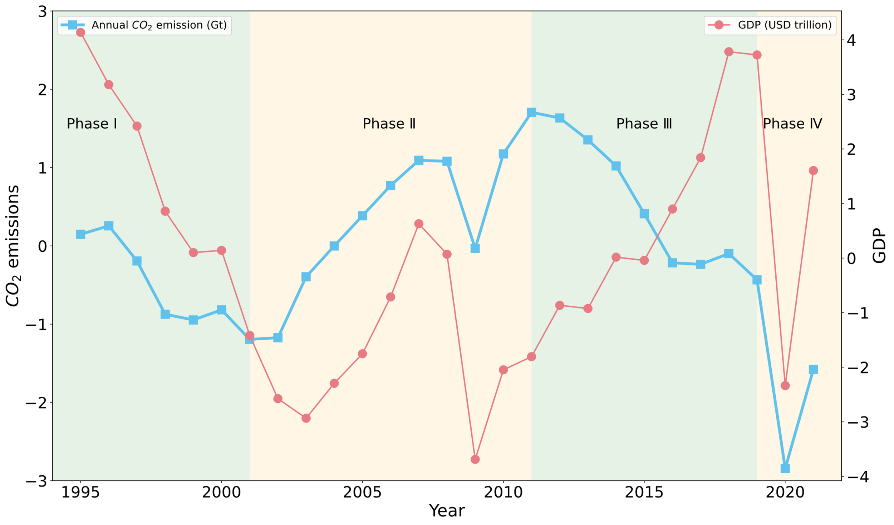
Extended Data Fig. 4.1 Detrended global annual CO₂ emissions (Gt) and detrended global GDP (US dollar trillion at constant 2017 ppp) from 1995 to 2021.

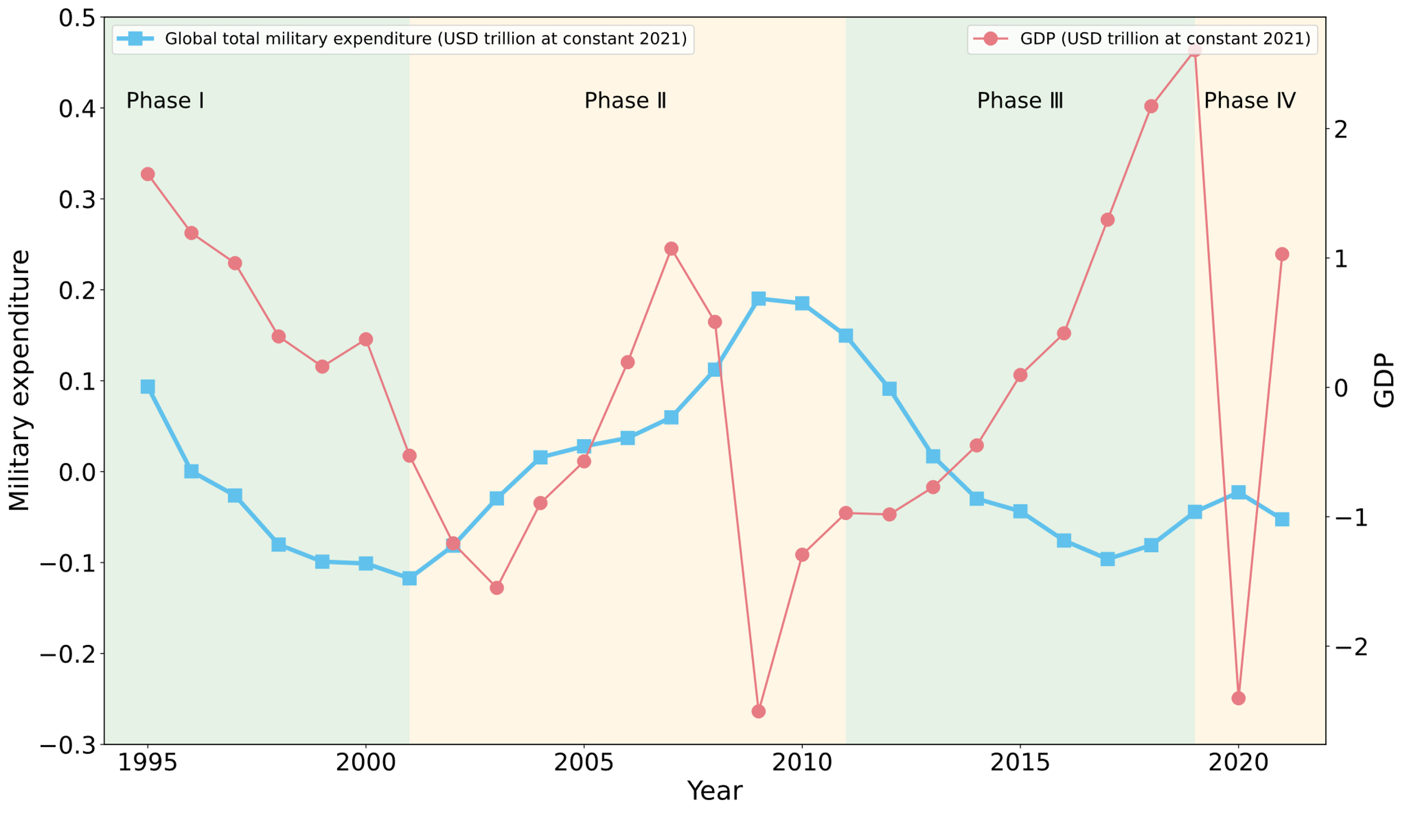
Extended Data Fig. 4.2 Detrended global military expenditure (US dollar trillion at constant 2021) and detrended global GDP (US dollar trillion at constant 2021) from 1995 to 2021.

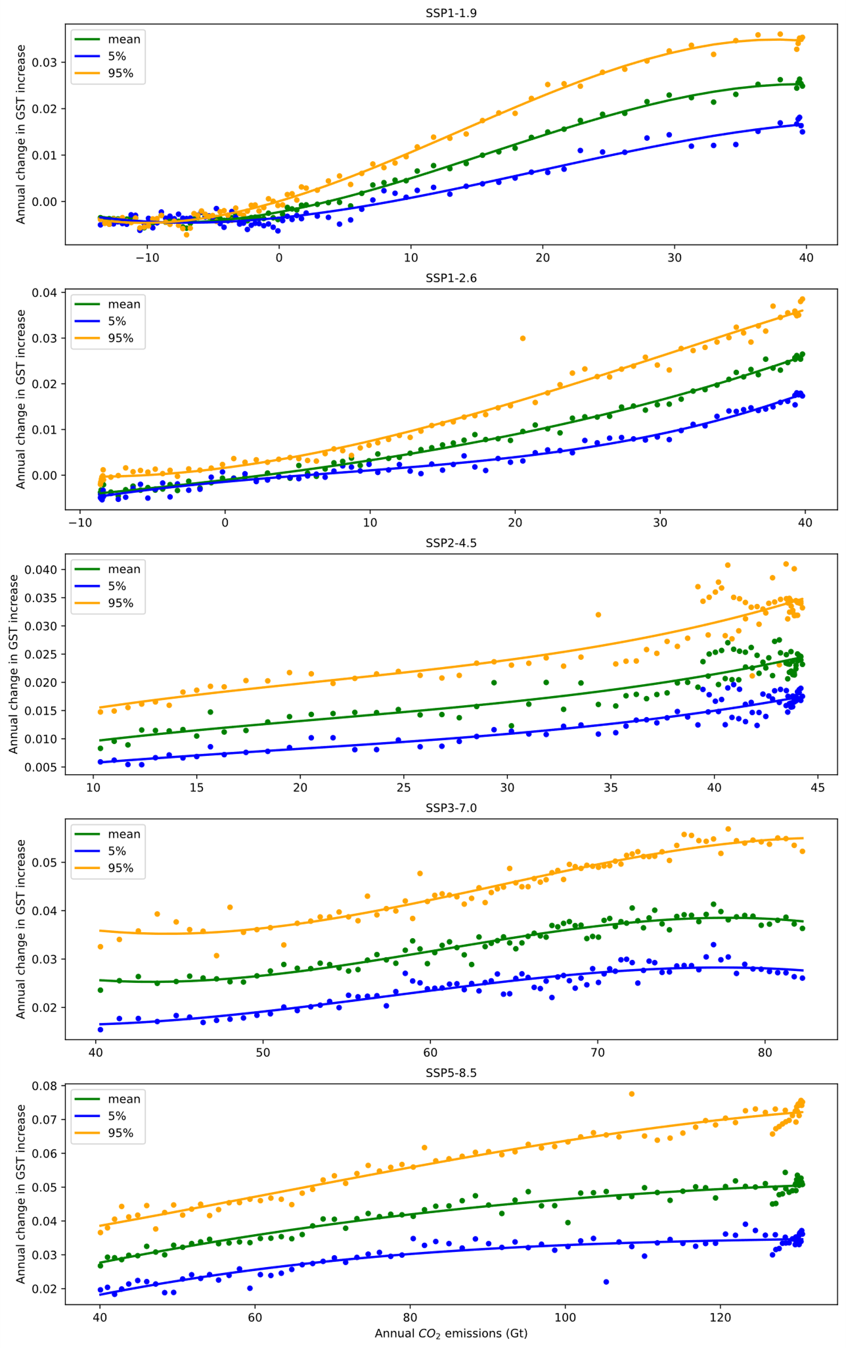
Extended Data Fig. 5. Scatter plots of annual variation in GST change relative to 1850–1900 and annual CO₂ emissions for the five SSP scenarios. Green, blue, and orange dots correspond to the mean GST variations and 5% and 95% confidence intervals of GST changes. Colored lines display the polynomial fitting of their relationship.

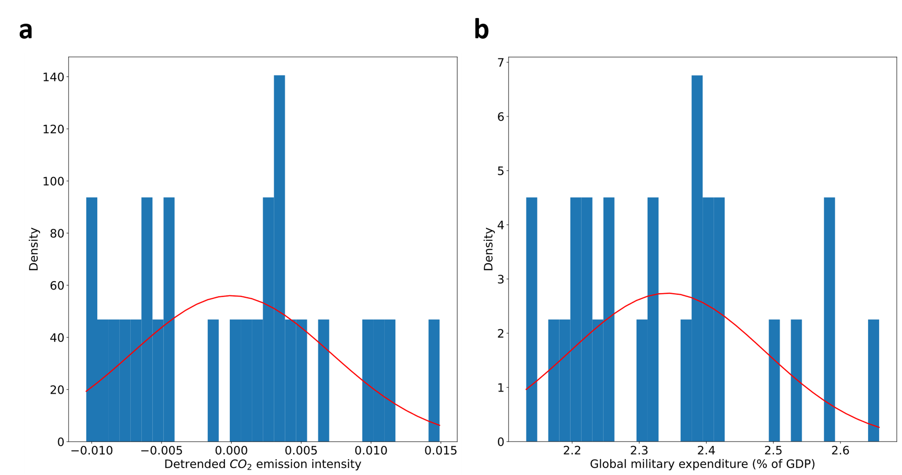
Extended Data Fig. 6. (a) Distribution of detrended CO₂ emission intensity between 1995 and 2021. (b) Distribution of weighted global military expenditure ratio between 1995 and 2021. Two distributions can be considered normal distributions (passing the 95% confidence level).

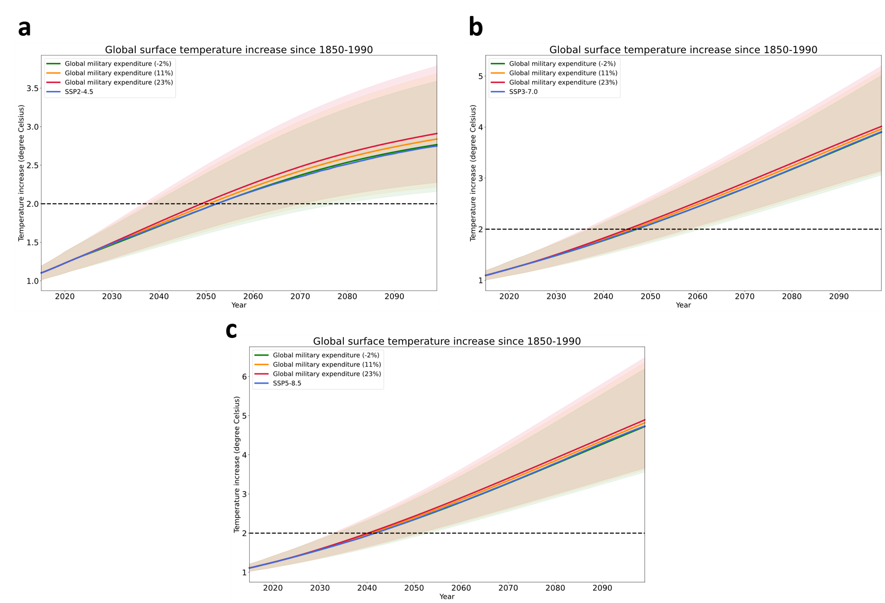
Extended Data Fig. 7. Projections of global surface temperature change relative to 1850–1900 in the SSP2-4.5, SSP3-7.0, and SSP5-8.5 baselines and the sensitivity scenarios considering alterations in global military expenditure ratio.

