Benchmarking the use of Dimensionality Reduction Techniques: A Case Study of Oesophageal Cancer Image Analysis
Shekhar Jyoti Nath 1, Satish K. Panda 2, Rajiv K. Kar 1,3

1 Jyoti and Bhupat Mehta School of Health Sciences and Technology, Indian Institute of Technology Guwahati, Assam 781039, India
2 School of Mechanical Sciences, Indian Institute of Technology Bhubaneswar, Odisha 752050, India
3 Center for Nanotechnology, Indian Institute of Technology Guwahati, Assam 781039, India

Figure Name | Figure Legend
SI-1 | Visualization of the image data in 2D scatter plots after using UMAP with different parameter combinations.
SI-2 | Comparison of different model performances in terms of accuracy and time required after using PCA with Hold-out cross validation and K-fold cross-validation
SI-3 | Comparison of different model performances in terms of accuracy and time required after using FA with Hold-out cross validation and K-fold cross-validation
SI-4 | Comparison of different model performances in terms of accuracy and time required after using LDA with Hold-out cross validation and K-fold cross-validation
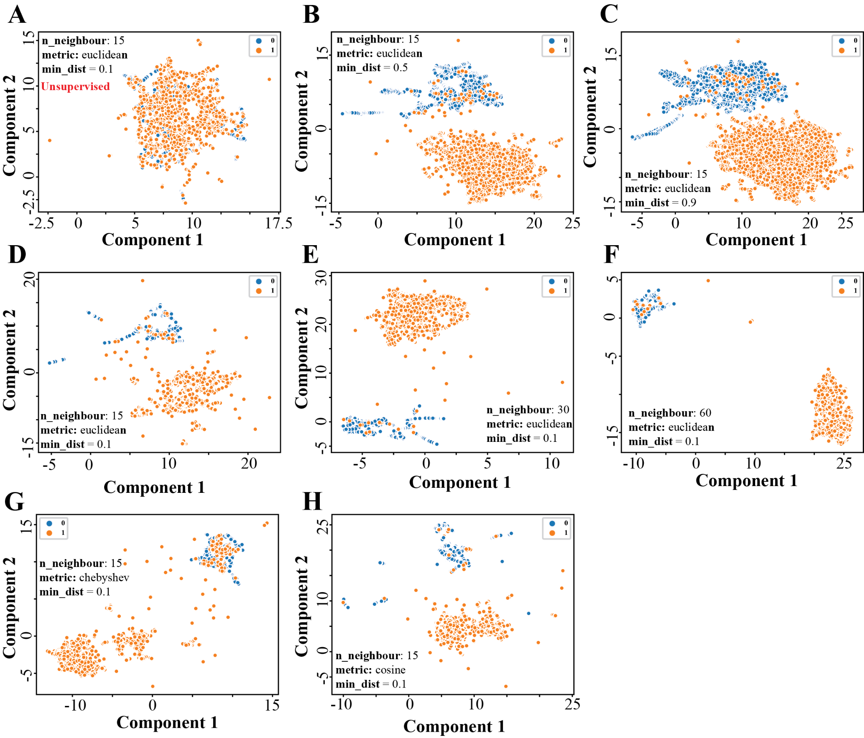
Figure SI-1: Visualization of the image data in 2D scatter plots after using UMAP with different parameter combinations

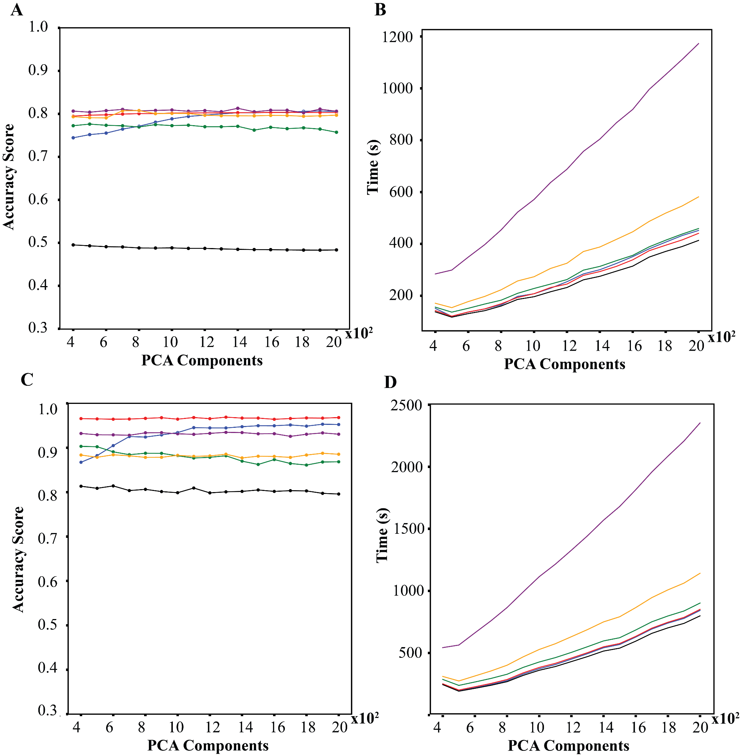

Figure SI-2: Comparison of different model performances in terms of accuracy and time required after using PCA with Hold-out cross validation and K-fold cross-validation

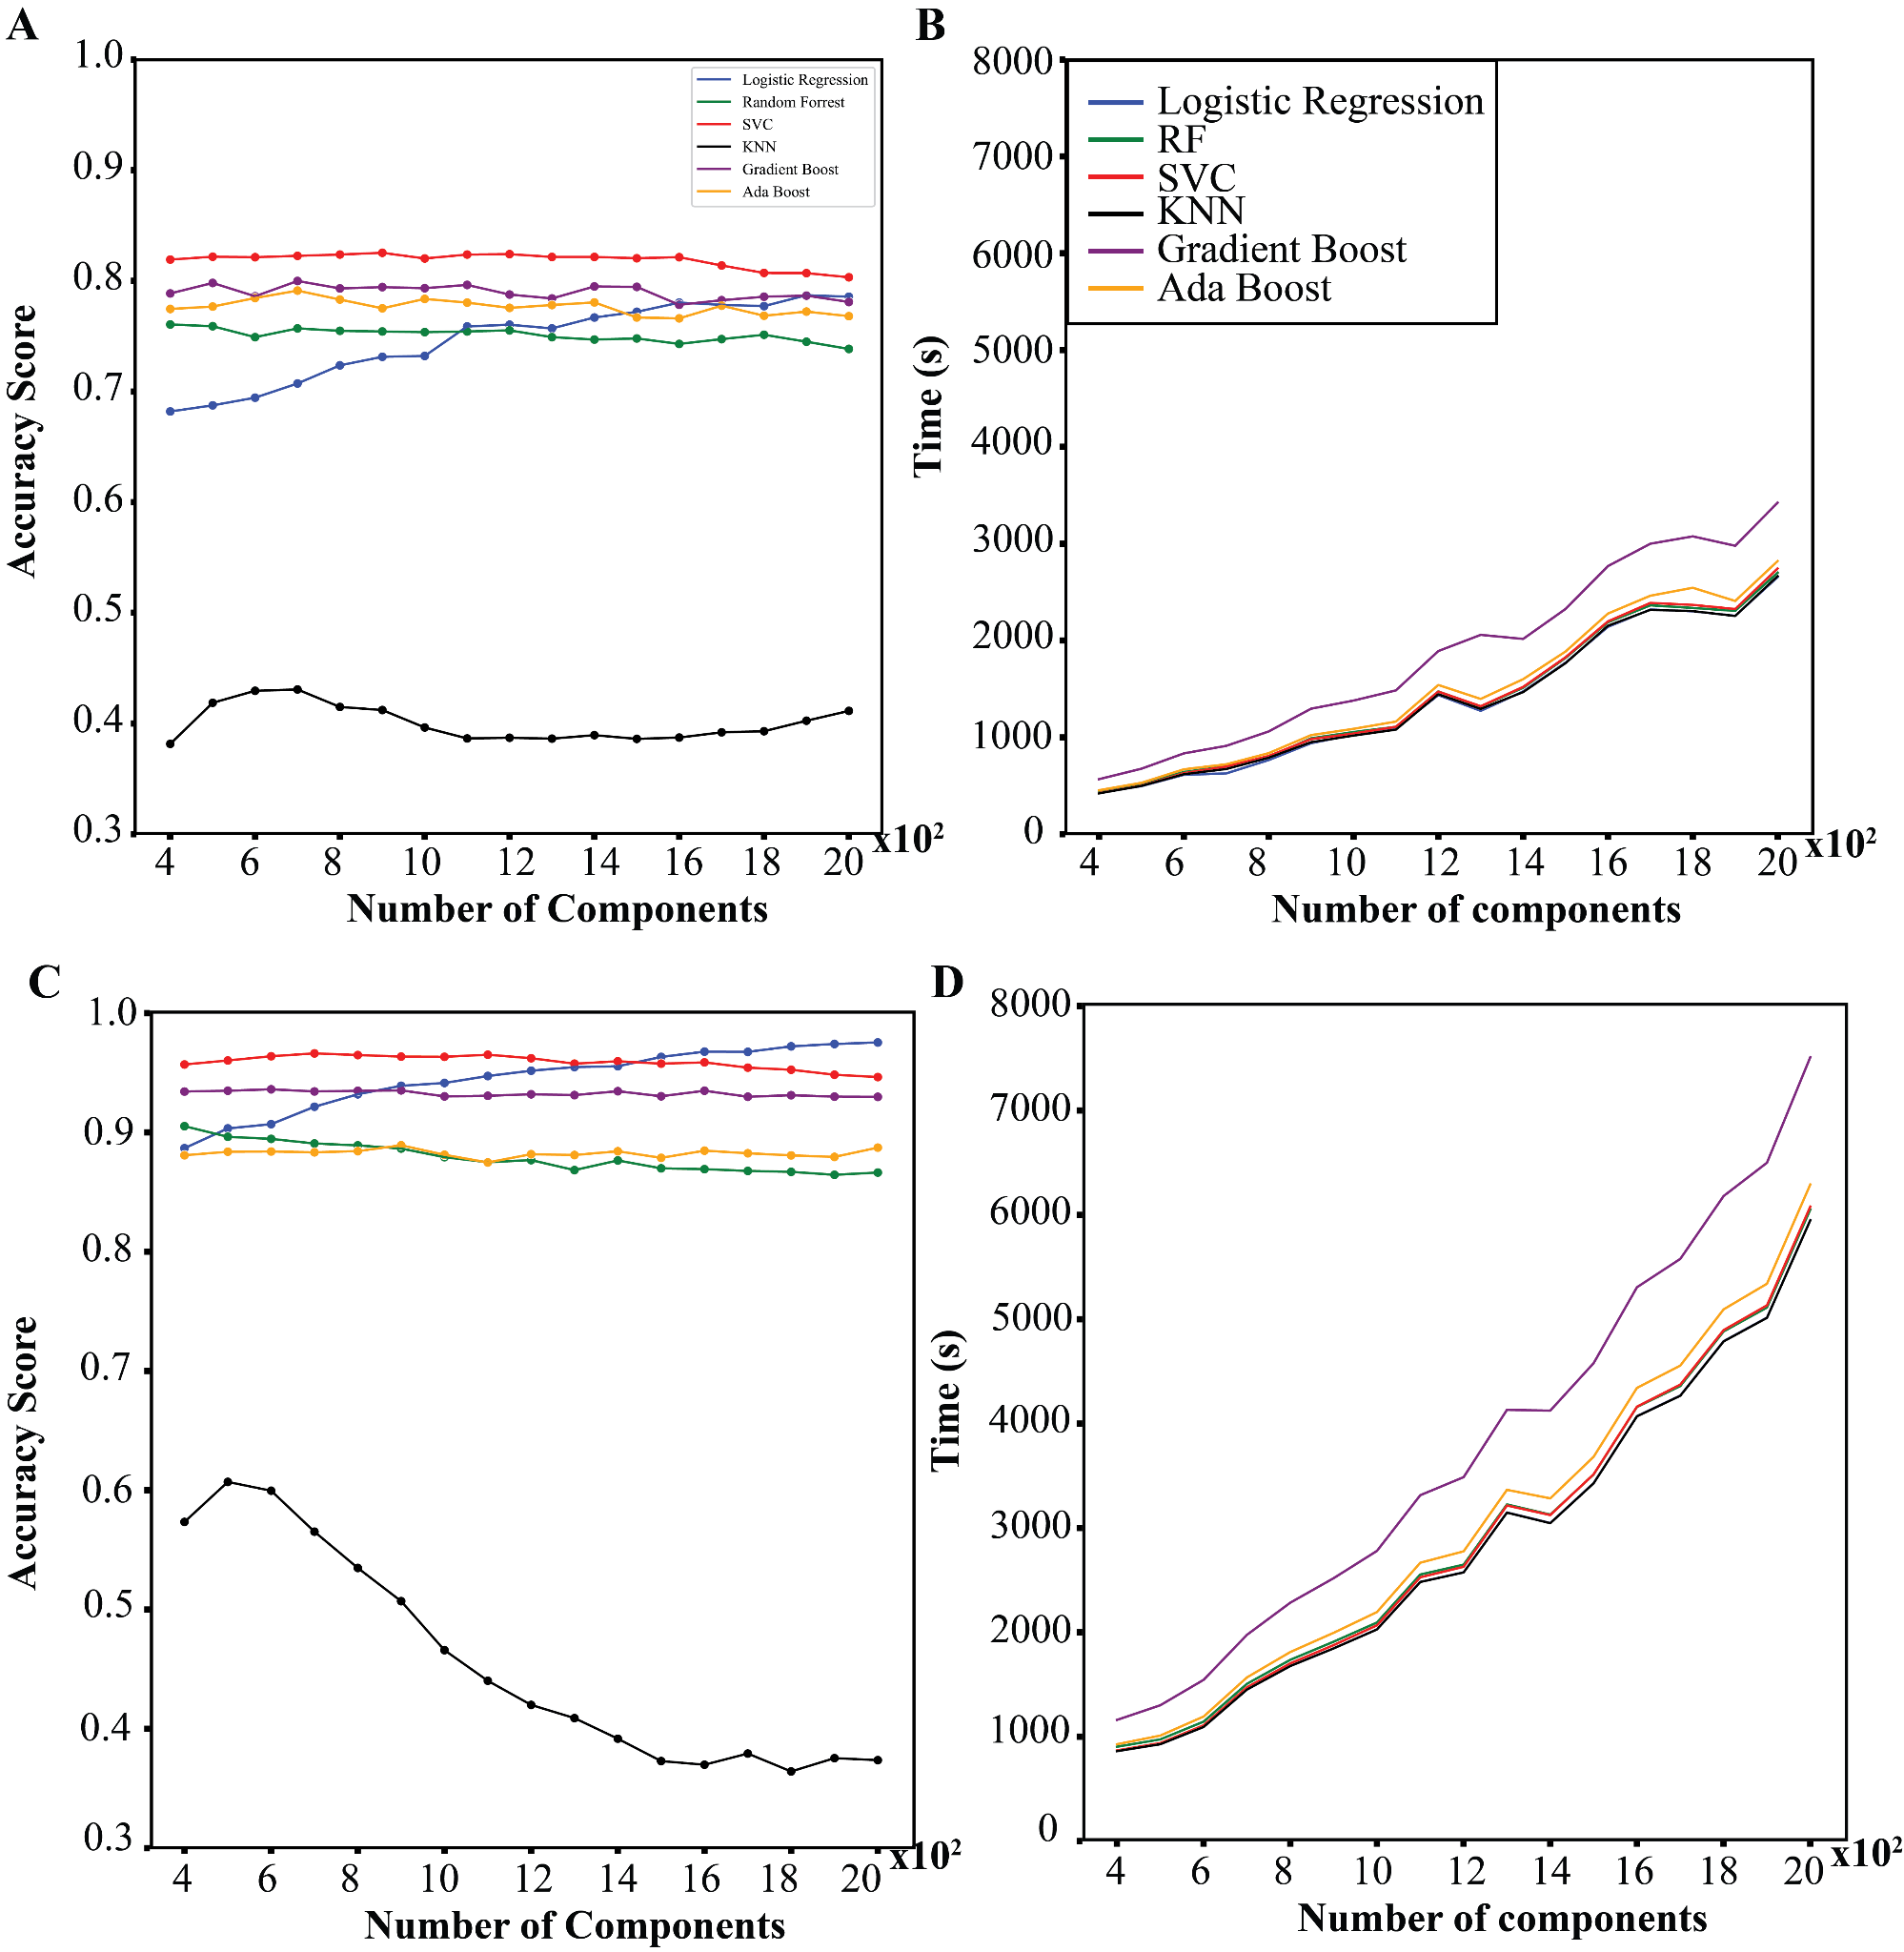

Figure SI-3 : Comparison of different model performances in terms of accuracy and time required after using FA with Hold-out cross validation and K-fold cross-validation

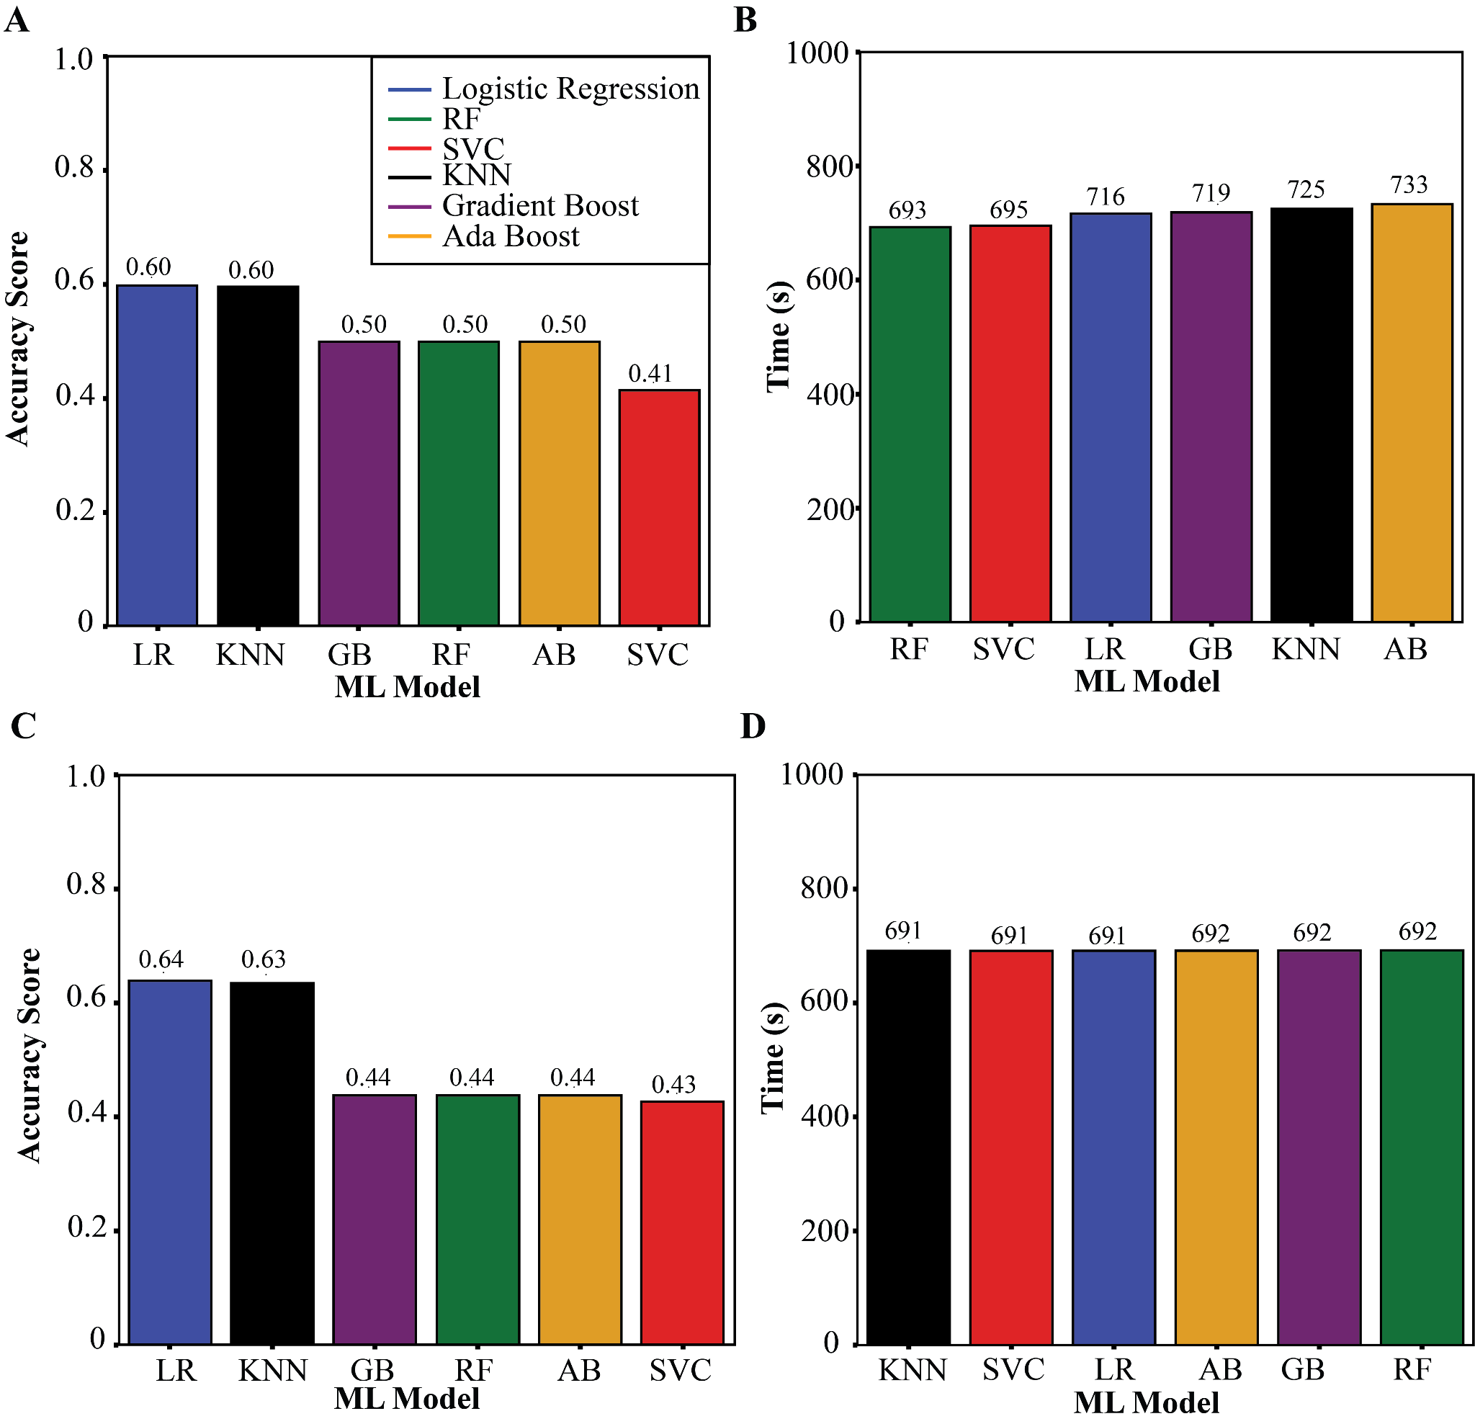

Figure SI-4 : Comparison of different model performances in terms of accuracy and time required after using LDA with Hold-out cross validation and K-fold cross-validation

