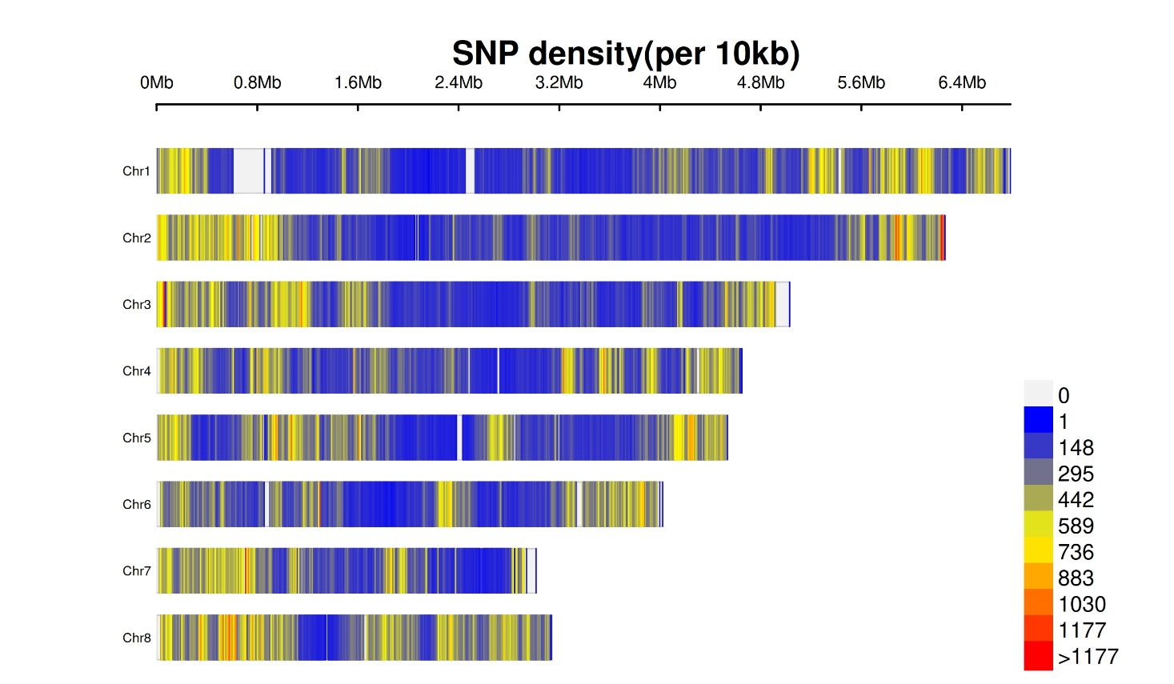
Supplementary Figure 1. Density of single nucleotide variants called using whole genome resequencing data of 346 A. flavus isolates

Supplementary Figure 2. Chromosome wise nucleotide diversity (π) based on SNVs across 346 isolates calculated using 10000bp window. Highest mean nucleotide diversity (π) was identified on chromosome 8.

Supplementary Figure 3. Chromosome wise Tajimas’s D diversity index calculated using SNVs across 346 isolates in a 10000bp window.

