Supplemental figures and tables

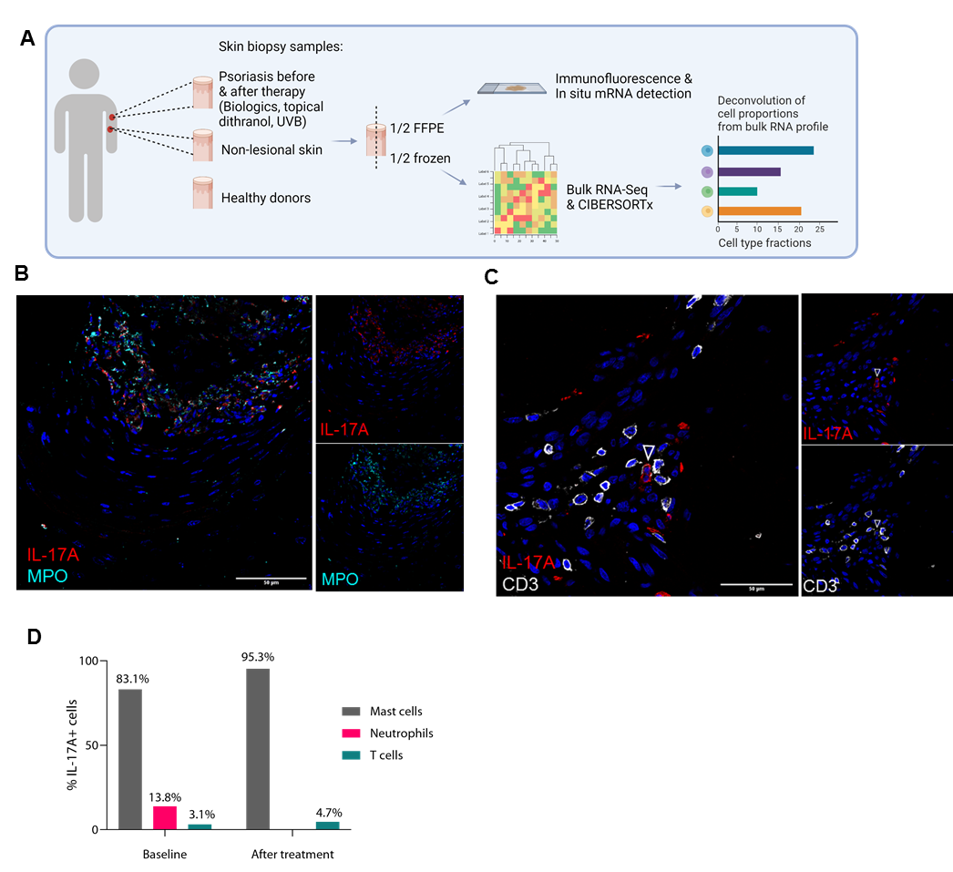

Supplemental Figure 1: Overview of biopsy sampling, sample processing, experimental set-up, and analysis (A). Skin biopsies were taken before therapy from lesional skin (n = 23) and non-lesional skin (n = 15), after topical dithranol therapy (n = 12), biologics (n = 10) and UVB (n = 2). In addition, skin biopsy samples from healthy donors (n = 11) were included. All samples were subjected to immunofluorescence staining and histological analysis. Twenty-one samples (non-lesional, n = 5; lesional before therapy, n = 8; lesional after topical dithranol, n = 8) were subjected to RNA-sequencing and subsequent CIBERSORTx analysis. Created with BioRender.com (A). In active psoriasis, mast cells, neutrophils, and T cells are positive for IL-17A. Representative images of immunofluorescence staining of IL-17A and myeloperoxidase (MPO; B) and IL-17A and CD3 (C). Nuclei are stained with DAPI and shown in blue. Scale bar = 50 µm. Percentage of IL-17+ cells before and after dithranol treatment (D).

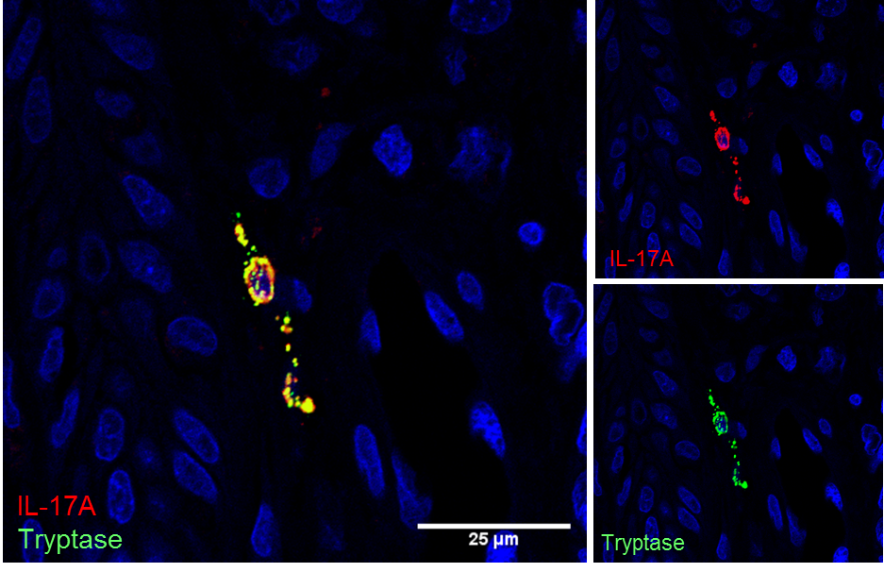
Supplemental Figure 2: Strong colocalization of tryptase and IL-17A suggests that IL-17A is localized in secretory granules of mast cells in psoriasis. Representative image of immunofluorescence staining of IL-17A and tryptase. Scale bar = 25 µm.

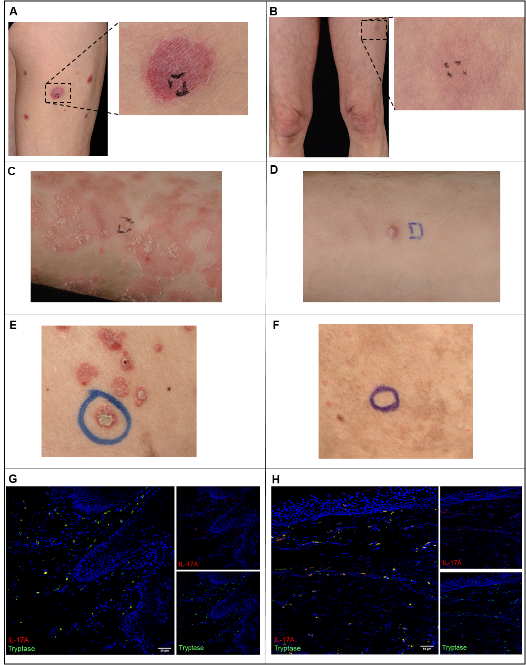

Supplemental Figure 3: Clinical images of psoriasis lesions with marked areas where biopsy samples for this study were taken before therapy (A, C, E) and after treatment with ixekizumab (B, D) and dithranol (F). Representative immunofluorescence images of IL-17A (red) and tryptase for mast cells (green) of psoriasis lesion before treatment (G) and postlesional skin after treatment (H).

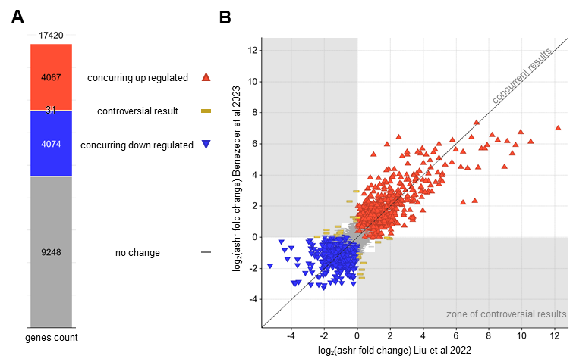

Supplemental Figure 4: Comparison of results from RNA-seq in this study to those in Liu et al. (2022) (GSE 171012), comparing week 0 to week 12 of secukinumab treatment. Bar chart showing overlapping genes. No change indicate that both comparisons are either not significant or both |LFC| < 1. Concurring downregulated indicates significant results in either comparison (BH adjusted P < 0.05, s-value < 0.005) and both LFC < 0. Concurring upregulated indicates significant results in either comparison (BH adjusted P < 0.05, s-value < 0.005) and both LFC > 0. Controversial results indicate significant results in either comparison, but that LFC show in different directions (A). Plot directly comparing all gene expression LFCs in both datasets showing strongly concurring results (B). Signs and colors as described in (A).

Table S 1: Demographics of psoriasis patients.
N.a. = not available. Local disease score was composed by rating erythema, induration, and scaling, on a scale from 0-4, resulting in a maximum score of 12. OR = ongoing remission
Patient ID | Age (in years at time of biopsy) | Sex (f, female; m, male) | PASI at baseline | Therapy | Local disease score (at baseline) | Time of biopsy after treatment start (weeks) | Local disease score (after therapy) | Weeks from treatment end until recurrence
S1_1 | 29 | F | 31.5 | Topical dithranol | 7 | 6.7 | 1 | persistent disease
S1_2 | 29 | M | 24.1 | Topical dithranol | 7 | Drop out
S1_3 | 55 | F | 12.8 | Topical dithranol | 9 | 6.7 | 2 | 5.9
S1_4 | 61 | M | 7 | Topical dithranol | 8 | 5.6 | 5 | persistent disease
S1_5 | 63 | M | 39 | Topical dithranol | 7 | Drop out
S1_6 | 41 | M | 6 | Topical dithranol | 8 | 7.0 | 2 | 17.4
S1_7 | 59 | M | 6.6 | Topical dithranol | 6 | 4.4 | 1 | 21.9
S1_8 | 33 | F | 6.6 | Topical dithranol | 4 | 4.3 | 1 | 42.6
S1_9 | 54 | M | 12.8 | Topical dithranol | 7 | 6.4 | 2 | persistent disease
S1_10 | 20 | F | 3.6 | Topical dithranol | 6 | 6.1 | 3 | 75.7
S1_11 | 52 | M | 15.7 | Topical dithranol | 6 | 4.9 | 3 | 0.3
S1_12 | 21 | M | 19.1 | Topical dithranol | 7 | 4.7 | 1 | persistent disease
S1_13 | 77 | M | 6.7 | Topical dithranol | 7 | 5.0 | 1 | 76.9
S1_14 | 27 | M | 8.2 | Topical dithranol | 6 | Drop out
S1_15 | 23 | M | 4.2 | Topical dithranol | 6 | 4.4 | 2 | 26.0
S2_1 | 63 | F | n.a. | Risankizumab | n.a. | 4.9 | 1 | OR
S2_2 | 45 | M | 2.7 | Ixekizumab | n.a. | 110.9 | 0 | OR
S2_3 | 64 | F | 15.4 | Risankizumab | 9 | 14.7 | 0 | OR
S2_4 | 25 | M | 31.3 | Ixekizumab | 7 | 13.0 | 0 | OR
S2_5 | 55 | F | 4 | Ixekizumab | 9 | 13.0 | 0 | OR
S2_6 | 77 | F | 3.6 | UVB 311nm | 9 | 10.7 | 3 | OR, after switch to risankizumab
S2_7 | 61 | M | 4.1 | UVB 311nm | 5 | 16.1 | 5 | OR, afer repeated UVB treatment
S2_8 | 31 | M | 18.3 | Ixekizumab | n.a. | 58.7 | 0 | OR
S2_9 | 50 | M | 19 | Ixekizumab | 9 | 12.0 | 0 | OR
S2_10 | 47 | M | 15.4 | Ixekizumab | 8 | 12.9 | 1 | OR
S2_11 | 85 | M | 1.5 | UVB 311nm | n.a. | 11.1 | 1 | 47.7
S2_12 | 56 | F | 7.4 | Ixekizumab | 3 | 14.0 | 0 | OR
S2_13 | 52 | M | 1.7 | Ustekinumab | n.a. | 346.9 | 0 | OR
S2_14 | 44 | M | 14.7 | UVB 311nm | 5 | Drop out
S2_15 | 45 | F | 14.6 | Tildrakizumab | n.a. | 19.1 | 0 | OR

Table S 2: Oligonucleotide sequences used in in situ mRNA detection
Reverse primer | Sequences (5´ - 3´)
RV_RORC_1 | TTGCACCCCTCACAG
RV_RORC_2 | TAGGCCGCGTTACAG
RV_RORC_3 | CTGTTTCTGCACTTCT
RV_RORC_4 | GTTGCTGCTGTTGCC
RV_RORC_5 | TGAGGCTTTCAGGAGG
RV_RORC_6 | AATATGAGGGCCCAG
RV_RORC_7 | CTCTCTCTGCCCTCA
RV_RORC_8 | CTGCCTGTGCTATAGA
RV_RORC_9 | GCCTGTGTTCCTCAAAA
RV_RORC_10 | AGTTCCCCAAGCCCA
RV_RORC_11 | CTCCCTGTAGGACTT
RV_RORC_12 | GATGTTGGAGCGCTG
RV_RORC_13 | ATCTGGTCATTCTGG
RV_RORC_14 | TTGCTCCTGCTTTGA
RV_RORC_15 | CTGATGAGCTCGCTG
RV_RORC_16 | GAAGTCAAAGATGGAG
RV_RORC_17 | CACATGCTGGCTACAC
RV_RORC_18 | GTGCTGGAAGATCTG
RV_RORC_19 | CAGGTGACTCGGTTT
RV_RORC_20 | TCTTCCAGGTCACTT
RV_IL17F_1 | GGTCTTCACTGTCAT
RV_IL17F_2 | ACTTGACCATGGCTG
RV_IL17F_3 | ATTTTCCGAGCTGCC
RV_IL17F_4 | AAGCTTCATACTACCTC
RV_IL17F_5 | TGATGATGCCAATGT
RV_IL17F_6 | GACAGTGTAATTCCAG
RV_IL17F_7 | CCTTTCCTTGAGCATT
RV_IL17F_8 | GGAATTCATGGAGATGT
RV_IL17F_9 | AGAAACAGAGCAGCC
RV_IL17F_10 | GCACCTTCTCCAACT
RV_IL17F_11 | GGCATTTCTACAGCTT
RV_IL17F_12 | GAATTGGGGGTCAGACAG
RV_IL17F_13 | GAGTCCTGTGAAGTG
RV_IL17A_1 | CTTCACTATGGCCTC
RV_IL17A_2 | CGTGGGATTGTGATT
RV_IL17A_3 | GGGATTGGTATTGGTA
RV_IL17A_4 | GGTTGTAGTAATCTGAGG
RV_IL17A_5 | GCCTCCCAGATCACA
RV_IL17A_6 | TGATGCAGCCCAAGT
RV_IL17A_7 | AGGAGTTGGGGCAGT
RV_IL17A_8 | AGTATCTTCTCCAGCC
RV_IL17A_9 | TTTGGGGAGTGTGGG
RV_IL17A_10 | GTCGGCTCTCCATAGT
RV_IL17A_11 | TCCGAAATGAGGCTG
RV_IL17A_12 | GACAAACTGCCTTAAGA
RV_IL17A_13 | GGTGCCTTGATCAGA
RV_IL17A_14 | CTTTCTGGGTTGTGT
RV_IL17A_15 | TTGGGCTGAACTTTTCT
RV_IL17A_16 | CTCTGGAATTGAATGTG
Padlock probes (plp) | Sequences (5´ - 3´)
plp_RORC_1 | /5Phos/TGGGATCCACTACGGAGAGAGTAGTACTTCCGACTTGCGTCTATTTAGTGGAGCCTACTTCTTACGGTCGATCCTGGGGACAAGTCGTC
plp_RORC_2 | /5Phos/CATGTCCAAGAAGCAAGAGAGTAGTACTTCCGACTTGCGTCTATTTAGTGGAGCCTACTTCTTACGGTCGATCCTGTCAAGTTCGGCCG
plp_RORC_3 | /5Phos/GGGGCTCCCAGACGGAGAGAGTAGTACTTCCGACTTGCGTCTATTTAGTGGAGCCTACTTCTTACGGTCGATCCCCTCACCTACACCTT
plp_RORC_4 | /5Phos/GAGCGGGGCAAGGCTAGAGAGTAGTACTTCCGACTTGCGTCTATTTAGTGGAGCCTACTTCTTACGGTCGATCCCTTGAATACAGCCCT
plp_RORC_5 | /5Phos/ATGTGGACTTCGTTTAGAGAGTAGTACTTCCGACTTGCGTCTATTTAGTGGAGCCTACTTCTTACGGTCGATCCGCTGACCCCTGACCG
plp_RORC_6 | /5Phos/CAGAGATAGAGCACCAGAGAGTAGTACTTCCGACTTGCGTCTATTTAGTGGAGCCTACTTCTTACGGTCGATCCCCTATGCCTCCCTGA
plp_RORC_7 | /5Phos/TTTATGGAGCTCTGCAGAGAGTAGTACTTCCGACTTGCGTCTATTTAGTGGAGCCTACTTCTTACGGTCGATCCAAGAGGCTCTCAGGC
plp_RORC_8 | /5Phos/CGGTGGCATGGAGCTAGAGAGTAGTACTTCCGACTTGCGTCTATTTAGTGGAGCCTACTTCTTACGGTCGATCCTTTTGAAGGCAAATA
plp_RORC_9 | /5Phos/AGCTTCGGAGCCTGTAGAGAGTAGTACTTCCGACTTGCGTCTATTTAGTGGAGCCTACTTCTTACGGTCGATCCTGCCACCCAAGGGGA
plp_RORC_10 | /5Phos/TACAAGGAGCTCTTCAGAGAGTAGTACTTCCGACTTGCGTCTATTTAGTGGAGCCTACTTCTTACGGTCGATCCGCTTTCCCTCCACTC
plp_IL17F_1 | /5Phos/CAGCGCAACATGACACAGTGAATGCGAGTCCGTCTTGCGTCTATTTAGTGGAGCCTACTTGTAGATAGCGAGCGCACAAAGTAAGCCAC
plp_IL17F_2 | /5Phos/CTTGCCTTTCTGAGTCAGTGAATGCGAGTCCGTCTTGCGTCTATTTAGTGGAGCCTACTTGTAGATAGCGAGCGCTGTCGATATTGGGG
plp_IL17F_3 | /5Phos/CCGCCTGTGCCAGGACAGTGAATGCGAGTCCGTCTTGCGTCTATTTAGTGGAGCCTACTTGTAGATAGCGAGCGAAGCCTGAGAGTTGC
plp_IL17F_4 | /5Phos/CTCCACCTCCCCCTGCAGTGAATGCGAGTCCGTCTTGCGTCTATTTAGTGGAGCCTACTTGTAGATAGCGAGCGTAACATCGAGAGCCG
plp_IL17F_5 | /5Phos/TAGGAACTTGGGCTGCAGTGAATGCGAGTCCGTCTTGCGTCTATTTAGTGGAGCCTACTTGTAGATAGCGAGCGTGTACAGGCCCAGTG
plp_IL17F_6 | /5Phos/GGAAGCACCAAGGCTCAGTGAATGCGAGTCCGTCTTGCGTCTATTTAGTGGAGCCTACTTGTAGATAGCGAGCGCCCTGGTCGTCCGGA
plp_IL17F_7 | /5Phos/CATATCCACTCAGCTCAGTGAATGCGAGTCCGTCTTGCGTCTATTTAGTGGAGCCTACTTGTAGATAGCGAGCGGTGCAGTAAGAGGTG
plp_IL17F_8 | /5Phos/CTCTGCAACAAGTCCCAGTGAATGCGAGTCCGTCTTGCGTCTATTTAGTGGAGCCTACTTGTAGATAGCGAGCGACTCCTTACCCAGTG
plp_IL17A_1 | /5Phos/ATTGGTGTCACTGCTCCTCAATGCACATGTTTGGCTCCTGCGTCTATTTAGTGGAGCCCACGACAACTTAGTACATCCTGGGAAGACCTC
plp_IL17A_2 | /5Phos/TGGTCAACCTGAACACCTCAATGCACATGTTTGGCTCCTGCGTCTATTTAGTGGAGCCCACGACAACTTAGTACATCCCCCGGACTGTGA
plp_IL17A_3 | /5Phos/GAGAGATATCCCTCTCCTCAATGCACATGTTTGGCTCCTGCGTCTATTTAGTGGAGCCCACGACAACTTAGTACACGCAATGAGGACCCT
plp_IL17A_4 | /5Phos/AGCCTCCACACTGCCCCTCAATGCACATGTTTGGCTCCTGCGTCTATTTAGTGGAGCCCACGACAACTTAGTACATGGTCCTGCGCAGGG
plp_IL17A_5 | /5Phos/TAAGAGCTCTGGGGACCTCAATGCACATGTTTGGCTCCTGCGTCTATTTAGTGGAGCCCACGACAACTTAGTACAGTCCACCATGTGGCC
plp_IL17A_6 | /5Phos/CCTTCAAAGACAGCCCCTCAATGCACATGTTTGGCTCCTGCGTCTATTTAGTGGAGCCCACGACAACTTAGTACACTCAGGAACCCTCAT
plp_IL17A_7 | /5Phos/GGGCCTGGCTTCTGTCCTCAATGCACATGTTTGGCTCCTGCGTCTATTTAGTGGAGCCCACGACAACTTAGTACACAAGCAACACTCCTA
plp_IL17A_8 | /5Phos/GAACGAACTTTAAGTCCTCAATGCACATGTTTGGCTCCTGCGTCTATTTAGTGGAGCCCACGACAACTTAGTACAGGAGCTGATGGGGCA
Detection probe | Sequences (5´ - 3´)
D_IL17A_TR | TR-CCTCAATGCACATGTTTGGCTCC
D_RORC_Cy5 | Cy5-AGAGAGTAGTACTTCCGACT
D_IL17F_Atto425 | Atto425-CAGTGAATGCGAGTCCGTCT
D-Anchor_Cy7 | CY7-UGCGUCUAUUUAGUGGAGCC
Padlock probes were 5’-phosphorylated. The detection oligos were 5´conjugated with fluorophores (Atto425, Cyanine 5 (Cy5), Cyanine 7 (Cy7), and Texas red (TR) are fluorescent labels).

Table S 3: List of antibodies
Antibody | Vendor | Identifier | Dilution
Anti-CD3  Rat, monoclonal | Abcam | Cat.No.: ab11089 | 1:200
Anti-IL-17A  Goat, polyclonal | RnD Systems | Cat.No.: BAF317 | 1:200
Anti-tryptase  Mouse, monoclonal | ThermoFisher | Cat.No.: MA5-11711 | 1:2000
Anti-tryptase  Goat, monoclonal | Santa Cruz Biotechnology | Cat.No.: sz-17039 | 1:500
Anti-CD103  Rabbit, monoclonal | Abcam | Cat.No.: ab129202 | 1:200
Anti-Myeloperoxidase (MPO)  Rabbit, polyclonal | Abcam | Cat.no.: ab45977 | 1:500
Donkey anti-rabbit IgG secondary antibody Alexa FluorTM 488 | Abcam | Cat.No.: ab150073 | 1:1000
Donkey anti-goat IgG secondary antibody Alexy FluorTM 647 | Thermofisher | Cat.No.: A32849 | 1:1000
Donkey anti-rat IgG secondary antibody Alexa FluorTM 555 | Thermofisher | Cat.No.: A48270 | 1:1000
Donkey anti-rabbit IgG secondary antibody Alexy FluorTM 555 | Thermofisher | Cat.No.: A31572 | 1:1000
Donkey anti-mouse IgG secondary Antibody Alexa FluorTM 488 | Thermofisher | Cat.No.: A21202 | 1:1000

