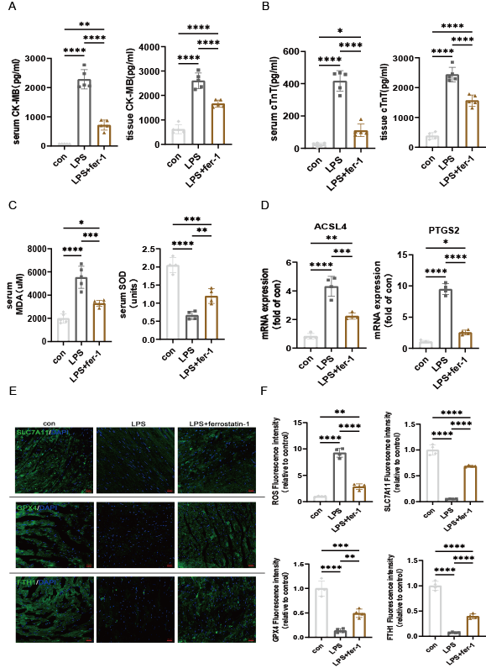
Supplementory figure 1. LPS-induced myocardial injury, oxidative stress, and lipid peroxidation can be alleviated by ferrostatin-1.
A-B The levels of CK-MB and cTnT in serum(A) and myocardial tissue(B) in mice with injection of lipopolysaccharide(LPS)(10mg/kg) with or without administration of ferrostatin-1 ( n =5 per group). C The level of malondialdehyde(MDA) and superoxide dismutase(SOD) in serum with injection of LPS(10mg/kg) with or without administration of ferrostatin-1 ( n =5 per group). D The mRNA level of PTGS2 and ACSL4 in myocardial tissue(n =4 per group). E Representative fluorescence images of SLC7A11, GPX4 and FTH1 in cardiac tissue(scale bar, 20 μM). F Quantitative fluorescence intensity of reactive oxygen species(ROS) and E in cardiac tissue (n =4 per group, scale bar, 20 μM). Error bars represent mean ± s.e.m. n numbers refer to individual mice. One-way ANOVA was used for statistical analysis in B-G. *P < 0.05; **P < 0.01; ***P < 0.001; ****P < 0.0001. Con: control. Fer-1: ferrostatin-1.
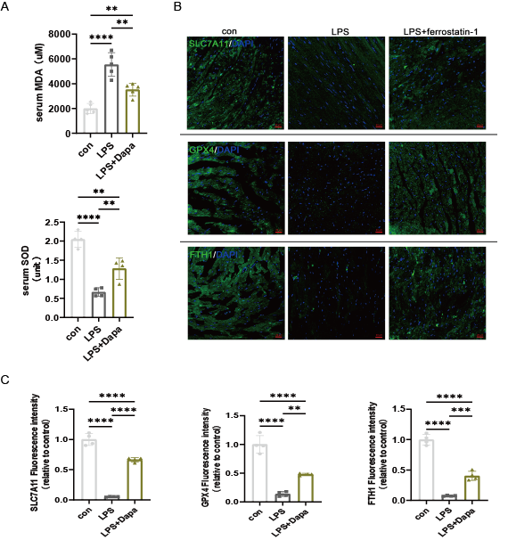
Supplementory figure 2. LPS-induced ferroptosis and oxidative stress can be inhibited by dapagliflozin.
A The levels of MDA and SOD in serum following injection of LPS (10mg/kg) with or without dapagliflozin. B Representative fluorescence images of SLC7A11, GPX4 and FTH1(scale bar, 20 μM). C Quantification of fluorescence intensity relative to the control group in B(n =4 per group). Error bars represent mean ± s.e.m. n numbers refer to individual mice. One-way ANOVA was used for statistical analysis in B-G. **P < 0.01; ***P < 0.001; ****P < 0.0001. Con: control. Dapa: dapagliflozin.

