Additional File 1
Content

1.) Meta-analytic approach 1
2.) Information-theoretic approach 2
3.) Prentice criteria and Proportion of Treatment Effect Explained (PTE) 3
4.) Technical Details about the fitting Process of the Bayesian Models 4
5.) Simulation Study 5
6.) List of R-packages 6
7.) Tables 8
8.) Figures 11
9.) References 29

Meta-analytic approach
In this paper we focused on two frameworks to validate surrogates on the individual level. An established method for that is the meta-analytic approach (MA) first described by Buyes (1). The MA provides the association measurement between surrogate endpoint (SEP) and the clinical endpoint (CEP) which ranges from 0 (when no association between SEP and CEP can be seen) to 1 (when there is a deterministic relationship between SEP and CEP). This association is determined considering the residual correlation of a joint mixed model with random effects for trial specific treatment effects with joint outcome SEP and CEP:
1)
$$S_{ij}=μ_{S}+m_{Si}+\left(α+a_{i}\right)Z_{ij}+ϵ_{Sij}$$
$$T_{ij}=μ_{T}+m_{Ti}+\left(β+b_{i}\right)Z_{ij}+ϵ_{Tij ,}$$
where
- For $i in 1,…,n_{c}$ comparisons with $j in 1,…,n_{p}$patients.
- S is the surrogate endpoint
- T is the clinical endpoint
- Z is treatment indicator
- $μ_{S}$ and $μ_{T}$ are the fixed intercepts for S and T
- $α$ and$β$are the fixed treatment effects on $Z_{ij}$ for trial i and individual j.
- $ϵ_{Sij}$ and $ϵ_{Tij}$ are correlated error terms assumed to be normally distributed with zero-mean and covariance:
2)
$$Σ=\left[\begin{matrix}σ_{SSi} & σ_{STi} \\ σ_{STi} & σ_{TTi}\end{matrix}\right]$$
- $m_{Si}$ and $m_{Ti}$ are trial-specific random effects and $a_{i}$ and $b_{i}$are the corresponding random treatment effects assumed to be normally distributed with mean zero and covariance D:
3)
$$D=\left[\begin{matrix}d_{SS} & d_{ST} & d_{Sa} & d_{Sb} \\ d_{ST} & d_{TT} & d_{Ta} & d_{Tb} \\ d_{Sa} & d_{Ta} & d_{aa} & d_{ab} \\ d_{Sb} & d_{Tb} & d_{ab} & d_{bb}\end{matrix}\right]$$
R_{ind}² can then be determined as follows:
4)
$$R_{indiv}^{2}=\frac{σ_{ST}^{2}}{σ_{SS}σ_{TT}}$$

Information-theoretic approach
Another method to validate surrogates on the individual level is the information-theoretic approach (IT), which uses the mutual information $I\left(X,Y\right)$ and the likelihood ratio test statistics to estimate the information, which is captured, if S becomes available (2). Consider the following two models:
5)
$$gT\left[E\left(T_{ij}\right)\right]=μ_{Ti}+β_{i}Z_{ij}$$
6)
$gT|S\left[E\left(T_{ij} | S_{i}j\right)\right]=γ_{0i}+γ_{1i}Z_{ij}+γ_{2i}S_{ij}$,
where $gT$and $gT|S$are function to link the expectation value to the linear predictor.

7)
$I\left(X,Y\right)=h\left(Y\right)-h\left(Y | X\right)$,
where $h$ is the Shanon entropy. In 2007, Alonso introduced a new association measurement R²_{ht}, which has similar properties as R²_{indiv} from equation 4):
8)
$R_{hindiv}^{2}=1-e^{-2I\left(ϵ_{Sij},ϵ_{Tij}\right)}$,
where $ϵS_{ij}$ and $ϵT_{ij}$ are correlated error terms of S and T. The $R_{hindiv}^{2}$ can be estimated using the likelihood reduction factor (LRF):
9)
$$\hat{R_{hindiv}^{2}}=LRF=1-\frac{1}{N}\sum_{i}{e^{-\frac{G_{i}^{2}}{n_{i}}}} =R_{Λ}^{2},$$
with
$I\left(X,Y\right)=\frac{1}{n}\sum{\left(log\left[f\left(y_{i} | xi,\hat{θ}\right)\right]-log\left[f\left(y_{i} | \hat{θ_{0}}\right)\right]\right)}=\frac{1}{n}G^{2}$,
and with
- density function $f\left(X,Y | θ\right)$
- realizations of $\left(x_{i},y_{i}\right),$ $i = 1,2,…,n$
- parameter $θ$ has form $θ=\left(θ_{0},θ_{1}\right)$
- $\hat{θ_{0}}$ = maximum likelihood estimate (under the null hypothesis of independence: $θ_{1}=0$)
- G² is log likelihood ratio test
- $\hat{θ}$ is full model likelihood estimator
- N is the number of trials
- $n_{i}$ is the number of individuals in trial i
In other words, the mutual information can be estimated performing the log likelihood ratio test between models 5) and 6). In turn the LRF can be estimated. Asymptotic confidence intervals for LRF can be estimated following the approach of Kent and Alonso (3) (4).

Prentice criteria and Proportion of Treatment Effect Explained (PTE)
Prentice criteria:
- $f\left(SEP | Z\right)≠f\left(SEP\right):{ SEP}_{j}=μ_{s}+αZ_{j}+ϵ_{Sj}$
- $f\left(CEP | Z\right)≠f\left(CEP\right):{CEP}_{j}=μ_{T}+βZ_{j}+ϵ_{Tj}$
- $f\left(CEP | SEP\right)≠f\left(CEP\right) : {CEP}_{j}=μ+γS_{j}+ϵ_{j}$
- $f\left(CEP | SEP,Z\right) = f\left(CEP | SEP\right): {CEP}_{j} =μ_{T} + β_{S} Z_{j} + γ_{Z} {SEP}_{j} +ϵ_{T}$, where
- j = 1,2,…,n subjects
- SEP: Surrogate endpoint
- CEP: Clinical endpoint
- Z: Treatment indicator
- $μ,μ_{s},μ_{T}$: Model specific intercepts
- $α:$ Treatment effect on SEP. (To fulfill the criterion, this estimate must be significant)
- $β:$ Treatment effect on CEP (To fulfill the criterion, this estimate must be significant)
- $γ:$ Effect of SEP on CEP (To fulfill the criterion, this estimate must be significant)
- $β_{S}:$ Treatment Effect when SEP is an independent variable in the model (Treatment effect captured by SEP). To fulfill the criterion, this estimate must be non-significant.
CEP was the number of relapses and SEP the number of new or newly enlarged T2 lesions. We used a negative binomial model family to fit the models of the prentice criteria (as shown in the publication of Sormani et al. (5)).
PTE:
$PTE\left(CEP,SEP,Z\right)=\frac{β-β_{S}}{β}=1-\frac{β_{S}}{β}$, where
- $β:$ Treatment effect on CEP
- $β_{S}:$ Treatment effect, when SEP is an independent variable in the model (Treatment effect captured by SEP).

Technical details about the fitting process of the Bayesian Models
The Bayesian joint models were fitted using the brms package (6). We used four Markov chains with at least 15000 (20000 for Gaussian – Poisson joint models) iterations were run per model. The number of burn-in iterations was always half of the total number of iterations. Additionally, a thinning of 10 was applied. This resulted in at least 3000 draws (15000/2 * 4 * 0.1) from the posterior distribution per parameter of each joint model. NUTS tuning parameter delta was set to 0.95 (target Metropolis acceptance rate. The closer delta to one the smaller the step sizes during the Hamiltonian Monte Carlo algorithm, which is used by STAN. To set delta closer to one can increase sampling efficiency and might decrease the number of divergent transitions, which occurs, if the NUTS sampler has difficulties to fully explore the posterior distribution (7,8).
Algorithm convergence issues are characterized by the occurrence of transition divergences and high $\hat{R}$ values. $\hat{R}$ relates the between- and within-chain estimates of the model parameters. If the Markov chains did not mix, $\hat{R}$ is higher than one (e.g., $\hat{R}$ >= 1.05). See elsewhere for details (9). If convergence issues occurred, the number of iterations were increased to 20000 (25000 for Gaussian – Poisson joint models) and delta was set to 0.99. If there were still convergence issues, we concluded, that the underlying joint model failed to describe the data properly.

Simulation study
At a first step, SEP were sampled for k time points from a multivariate normal distribution with mean zero and considering $k x k$correlation matrix $R_{S}$ with a first order auto-regressive auto-correlation with $ϕ= 0.8$:

$SEP_{ik}\sim MNV\left(μ,Σ_{S}\right)$ ,with
$$i=1,2,…,n_{p}$$
$$n_{p}=number of patients \left(100, 300 or 600\right)$$
$$μ= 0$$
$$Σ_{S}=D*R_{S}* D$$
$D=1_{k x k}*$ $ϵ$
$$ϵ= 1$$
$Σ_{S}$ was adjusted according to the methodology of Barbiero and Ferrari (10). CEP was estimated afterwards:

$CEP_{ik}\sim MNV\left(α*SEP_{ik},Σ_{S}\right)$, with
$$α= 0.1, 0.5, or 2.25$$

Starting from $CEP_{ik}$and $SEP_{ik}$, Poisson distributed $CEP_{ik}^{Poisson}$and $SEP_{ik}^{Poisson}$were generated:
$$SEP_{ik}^{Poisson} \sim Pois_{cum}^{-1}\left(p_{SEP_{i}},λ\right)$$
$CEP_{ik}^{Poisson} \sim Pois_{cum}^{-1}\left(p_{CEP_{i}},λ\right)$, with
$$p_{SEP_{i}} = P_{norm}\left(SEP_{ik},μ, ϵ\right)$$
$$p_{CEP_{i}} = P_{norm}\left(CEP_{ik},μ, ϵ\right)$$
$λ= 2$ , and where
$$Pois_{cum}^{-1} is the inverse Poisson cumulative density function$$
$$P_{norm} is the normal probability function$$

Additionally. Starting from $SEP_{ik}^{Poisson}$and $CEP_{ik}^{Poisson}$, the transformation algorithm by Huber and colleagues were applied to generate normally distributed data (11). Finally, 18 data sets with 2 or 4 measurement timepoints, 100, 300, or 600 subjects, and three different values for $α$ (0.1, 0.5, 2.25) were generated. Each data set includes correlated normally distributed, Poisson distributed, and transformed SEP and CEP. In this way, all SEP/CEP combinations can be created (Gaussian – Gaussian, Gaussian – Poisson, Poisson – Gaussian, Poisson – Poisson, Gaussian – transformed Poisson, transformed Poisson – Gaussian, and transformed Poisson - transformed Poisson)
The true LRF or $R_{Λ}^{2}$ is calculated as follows:
A $k x k$correlation matrix $R_{S}$ with a first order auto-regressive autocorrelation with $ϕ= 0.8$ and k representing the number of measurement time points were defined to calculate LRF and $R_{Λ}^{2}$:

$R_{Λ}^{2}= LRF = \left(1-Λ\right)$, where
$$Λ=\frac{\left|Σ\right|}{\left|Σ_{TT}\right|\left|Σ_{SS}\right|}$$
$Σ =$ $\left[\begin{matrix}Σ_{SS} & Σ_{ST} \\ Σ_{TS} & Σ_{TT}\end{matrix}\right]$
$$Σ_{SS}=D*R_{S}* D$$
$Σ_{ST}= Σ_{TS} =α* Σ_{S}$
$$Σ_{TT}=(α² + ϵ²)* Σ_{S}$$
$D=1_{k x k}*$ $ϵ$
$$ϵ= 1$$
$$α= 0.1, 0.5, or 2.25$$

The script to generate the simulated data can be found on GitHub (12).

List of R-packages

- sas7bdat 0.6
- tidyverse 1.3.2
- haven 2.5.1
- lubridate 1.9.2
- rlist 0.4.6.2
- MASS 7.3.58.1
- lme4 1.1.32
- pbapply 1.7.0
- parallel 4.2.2
- nlme 3.1.162
- ggcorrplot 0.1.4
- glmmTMB 1.1.6
- ordinal 2022.11.16
- foreach 1.5.2
- doParallel 1.0.17
- brms 2.18.0
- cAIC4 1.0
- mgcv 1.8.41
- boot 1.3.28
- MCMCpack 1.6.3
- Matrix 1.5.3
- mvtnorm 1.1.3
- GenOrd 1.4.0
- data.table 1.14.6
- ggh4x 0.2.5
- rstan 2.26.15
- ggarchery 0.4.2
- kableExtra 1.3.4
- grid 4.2.2
- gridExtra 2.3
- ggrepel 0.9.4
- ggpubr 0.6.0

Tables

Table S1: Model strategies
Surrogate Endpoint (SEP) | Clinical Endpoint (CEP) | Transformed Count Outcome | Model(s) Used | Distribution Family Used for Outcome(s) | Association Measurement between CEP and SEP | Association Metric
Metanalytic Approach (One Joint Model with SEP and CEP as Outcome)
Log(T2 Volume cm³) | EDSS | no | Joint Model | Gaussian/Gaussian | Correlated residuals | $$R_{Λ}^{2}$$
Log(T2 Volume cm³) | Number Relapses | no | Joint Model | Gaussian/Poisson | Corelated random effects | $$R_{Λ}^{2}$$
New/Enlarged T2 Lesions | EDSS | no | Joint Model | Poisson/Gaussian | Corelated random effects | $$R_{Λ}^{2}$$
New/Enlarged T2 Lesions | Number Relapses | no | Joint Model | Poisson/Poisson | Corelated random effects | $$R_{Λ}^{2}$$
Log(T2 Volume cm³) | Number Relapses | yes | Joint Model | Gaussian/Gaussian | Correlated residuals | $$R_{Λ}^{2}$$
New/Enlarged T2 Lesions | EDSS | yes | Joint Model | Gaussian/Gaussian | Correlated residuals | $$R_{Λ}^{2}$$
New/Enlarged T2 Lesions | Number Relapses | yes | Joint Model | Gaussian/Gaussian | Correlated residuals | $$R_{Λ}^{2}$$
Information-Theoretic Approach (Two Models with CEP as Outcome)
Log(T2 Volume cm³) | EDSS | no | GLMM Models | Gaussian, Ordinal | Information gained by SEP | LRF
Log(T2 Volume cm³) | Number Relapses | no | GLMM Models | Ordinal, Negative Binomial, Zero Inflated, Poisson | Information gained by SEP | LRF
New/Enlarged T2 Lesions | EDSS | no | GLMM Models | Gaussian, Ordinal | Information gained by SEP | LRF
New/Enlarged T2 Lesions | Number Relapses | no | GLMM Models | Ordinal, Negative Binomial, Zero Inflated, Poisson | Information gained by SEP | LRF
Log(T2 Volume cm³) | Number Relapses | yes | GLMM Models | Gaussian, Ordinal | Information gained by SEP | LRF
New/Enlarged T2 Lesions | EDSS | yes | GLMM Models | Gaussian, Ordinal | Information gained by SEP | LRF
New/Enlarged T2 Lesions | Number Relapses | yes | GLMM Models | Gaussian, Ordinal | Information gained by SEP | LRF
Abbreviations: GLMM, generalized linear mixed model; EDSS, expanded disability status scale; SEP, surrogate endpoint; CEP, clinical endpoint
The table displays the models utilized in both the meta-analytic and information-theoretic approaches for both transformed and untransformed data. It's important to note that these model strategies were applied in the analysis of both simulation and clinical trial data. For further details, please refer to the methods section.

Table S2:
Abbreviation: IQR, inter quartile range; SEP, surrogate endpoint; CEP, clinical endpoint
For each SEP/CEP combination dataset, the table either presents the median (and interquartile range) of EDSS or T2 volume change from baseline, derived from aggregated trial data, or includes the median and interquartile range of the relapse or new/newly enlarged T2 lesion rate per trial visit.
SEP [Median (IQR)] | CEP [Median (IQR)]
Log(T2 volume) change from baseline [-0.024 (-0.128; 0.059)] | EDSS change from baseline [0 (-0.5,0)]
Log(T2 volume) change from baseline [-0.031 (-0.116; 0.033)] | Relapse rate per measurement time point [0.21 (0.14,0.36)]
New or newly enlarged T2 lesions rate per measurement time point [1.45 (0.81;1.90)] | EDSS change from baseline [0 (0,0)]
New or newly enlarged T2 lesions rate per measurement time point [1.46 (0.73;2.09)] | Relapse rate per measurement time point [0.12 (0.03,0.20)]

Figures

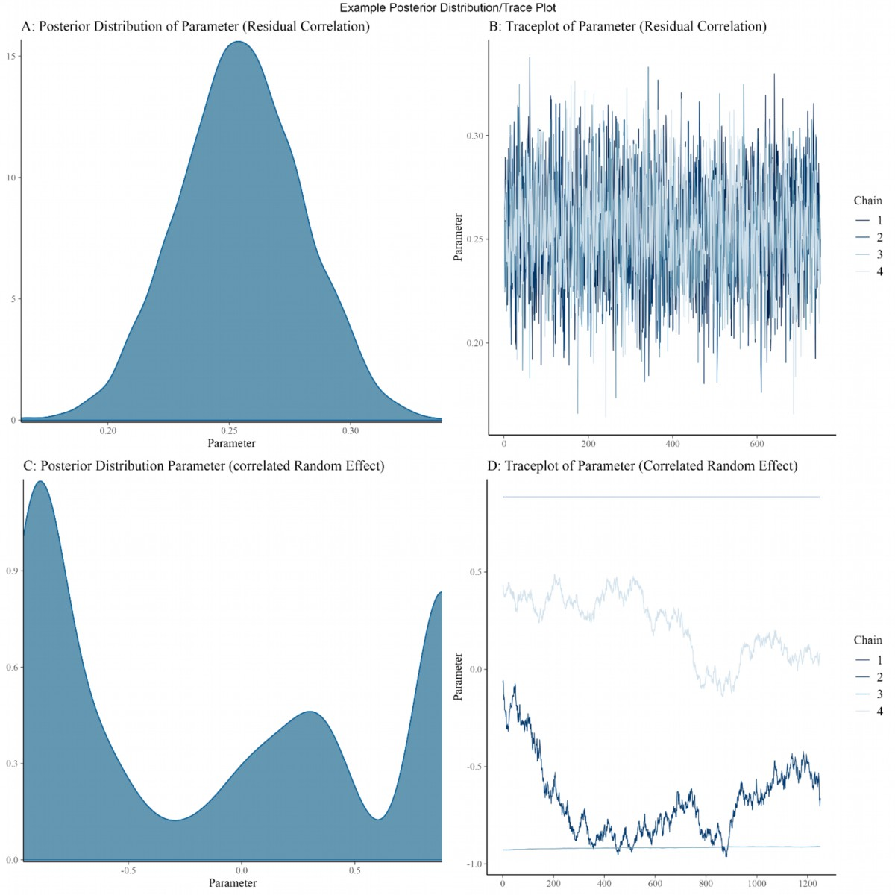
Figure S1
Representative example of the distribution of model parameter and corresponding trace plot. Panel A and B show , if the NUTS algorithm run properly. Panels C and D reveal convergence issues.
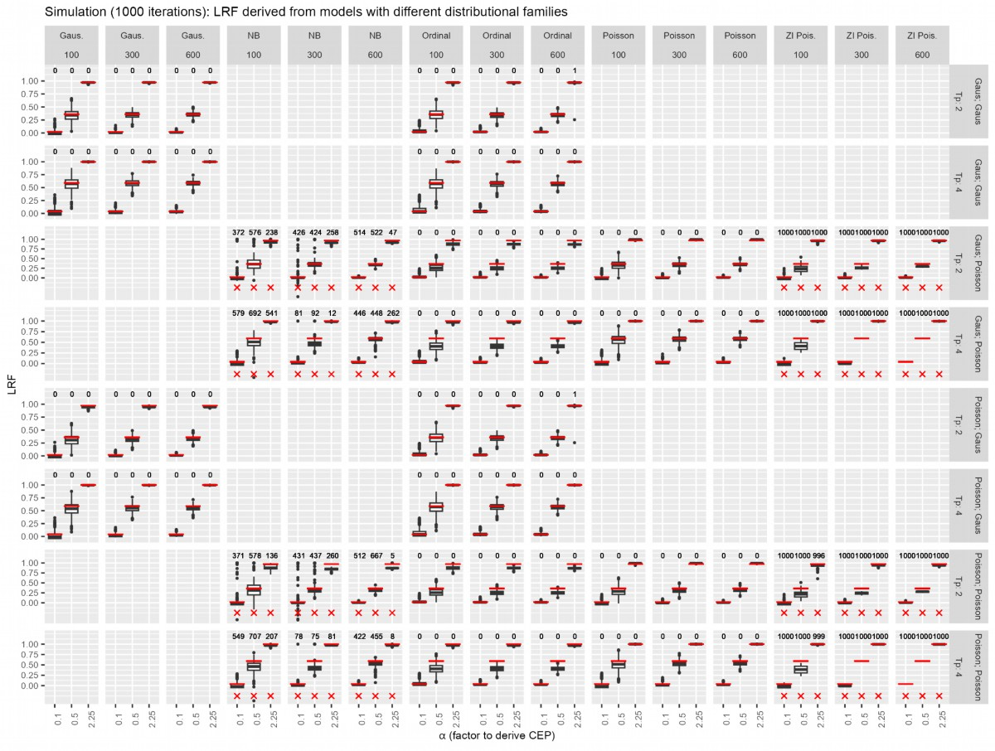
Figure S2
Abbreviations: LRF, Likelihood Reduction Factor; Gaus., Gaussian; NB negative Binomial; ZI. Poisson, Zero Inflated Poisson,
Results from the simulation study (with n = 1000 iterations) utilizing the information-theoretic approach are presented. Red horizontal lines in the figures represent the true LRF values, and the numbers at the top of the panels indicate the instances of convergence issues during the simulation study. To derive the LRF, Gaussian, Negative Binomial, Poisson, zero-inflated Poisson, and ordinal models were employed. Datasets with 100, 300, and 600 simulated subjects, each with two or four measurement time points, were generated. Four combinations of SEP – CEP were considered: 1) Gaussian – Gaussian, 2) Gaussian – Poisson, 3) Poisson – Gaussian, and 4) Poisson – Poisson.

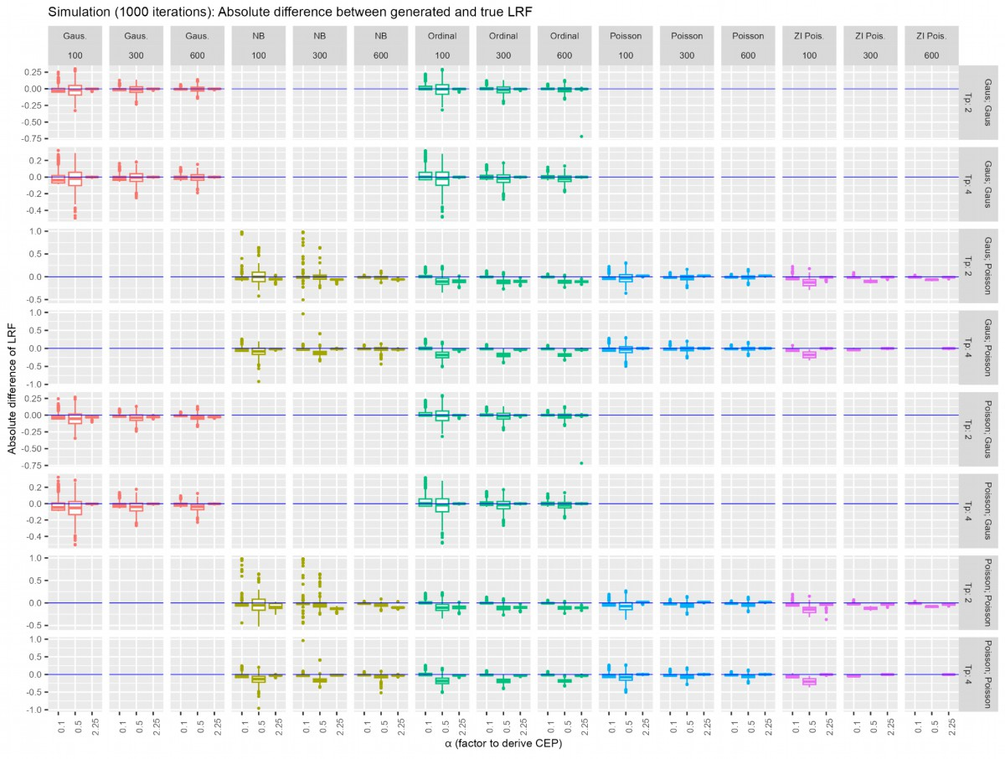
Figure S3:
Abbreviations: LRF, Likelihood Reduction Factor; Gaus., Gaussian; NB negative Binomial; ZI. Poisson, Zero Inflated Poisson,
Results from the simulation study (with n = 1000 iterations) using the information-theoretic approach are presented. The displayed information represents the absolute difference between the generated and true LRF. To derive the LRF, Gaussian, Negative Binomial, Poisson, zero-inflated Poisson, and ordinal models were employed. Simulated datasets were created with 100, 300, and 600 subjects, each having two or four measurement time points. Four SEP – CEP combinations were considered, symbolized by different colors: 1) Gaussian – Gaussian, 2) Gaussian – Poisson, 3) Poisson – Gaussian, and 4) Poisson – Poisson. Triangles symbolize the true LRF of one generated dataset.

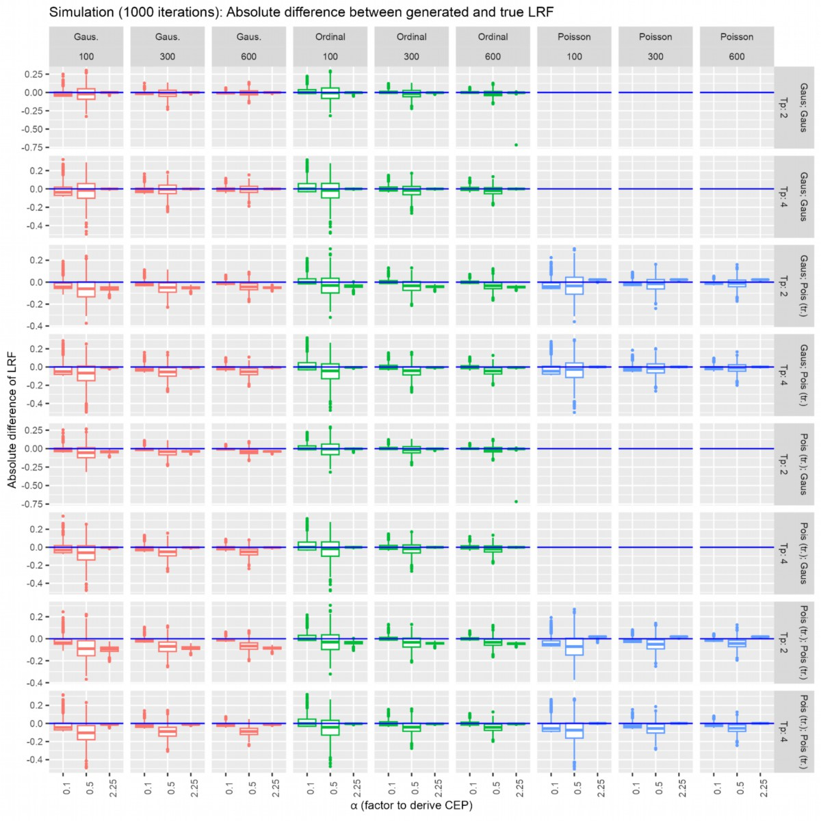
Figure S4
Abbreviations: LRF, Likelihood Reduction Factor; tr., transformed; Pois, Poisson
Results from the simulation study (with n = 1000 iterations) using the information-theoretic approach are presented. The displayed information represents the absolute difference between the generated and true LRF. To derive the LRF, Gaussian, Poisson, or ordinal models were employed. Simulated datasets were generated with 100, 300, and 600 subjects, each having two or four measurement time points. It's important to note that results from the Poisson family were analyzed in their untransformed state. Four SEP – CEP combinations were considered: 1) Gaussian – Gaussian, 2) Gaussian – (transformed) Poisson, 3) transformed Poisson – Gaussian, and 4) transformed Poisson – (transformed) Poisson.

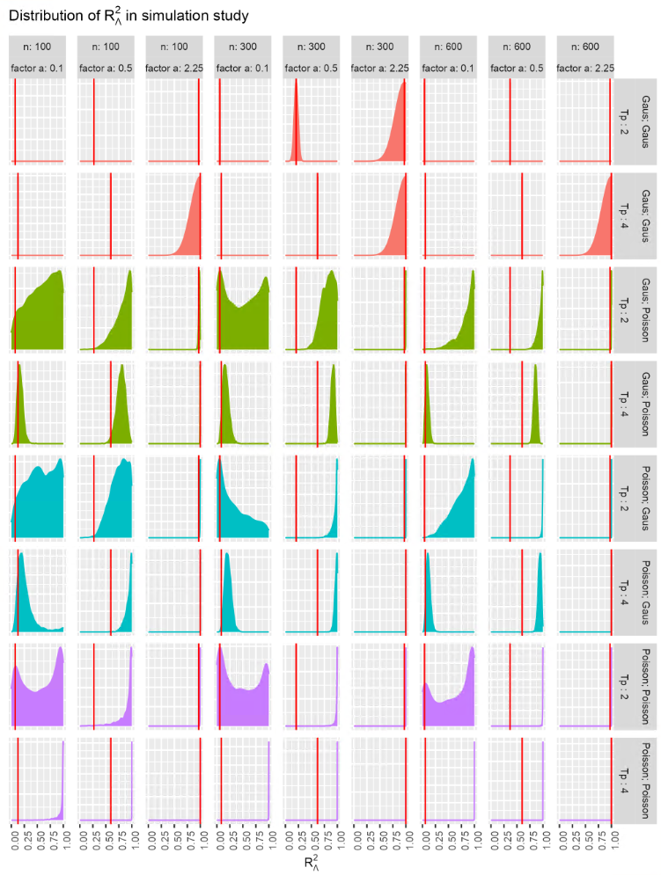

Figure S5:
Results of the simulation study using the meta – analytic approach. To derive $R_{Λ}^{2}$, longitudinal Gaussian – Gaussian, Gaussian – Poisson, Poisson – Gaussian, or Poisson - Poisson joint models were estimated using Bayesian inference. Data sets with 100, 300 and 600 simulated subjects with two or four measurement time points were generated. Four SEP – CEP combinations were considered (symbolized by different colors): 1) Gaussian – Gaussian, 2) Gaussian – Poisson, 3) Poisson – Gaussian, 4) Poisson – Poisson. Vertical red lines symbolize the true $R_{Λ}^{2}$ of one generated data set.

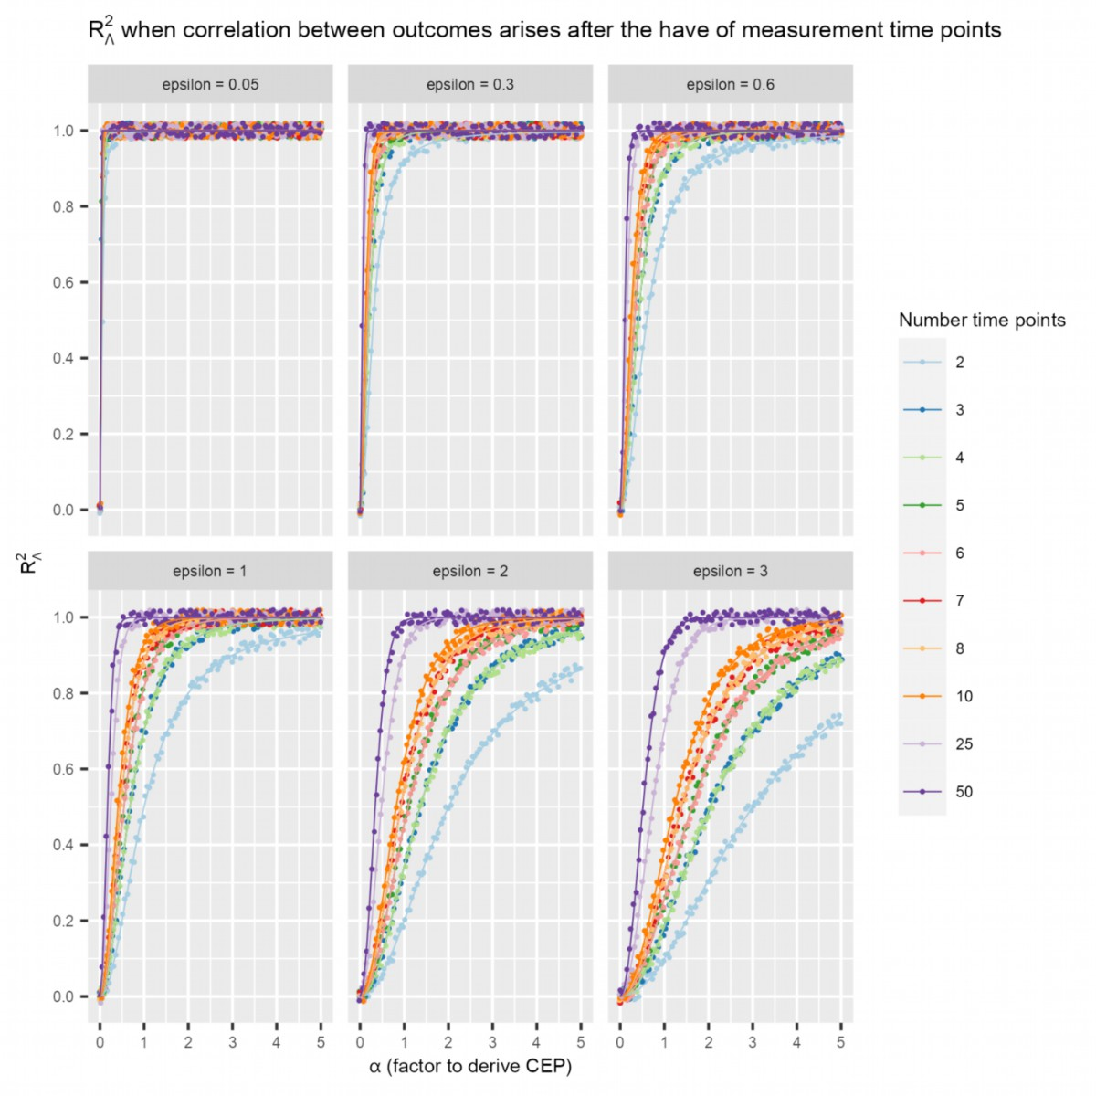
Figure S6:
Abbreviations: CEP, Clinical Endpoint.
$R_{Λ}^{2}$ is calculated in different correlation settings when the correlation between SEP and CEP emerges after half of the considered time points (correlation for uneven time points begins at the number of time points/2 - 0.5). Here, $α$ represents the factor used to derive CEP, and $ϵ$ corresponds to the error in CEP, defined as $CEP = α* SEP + ϵ$.
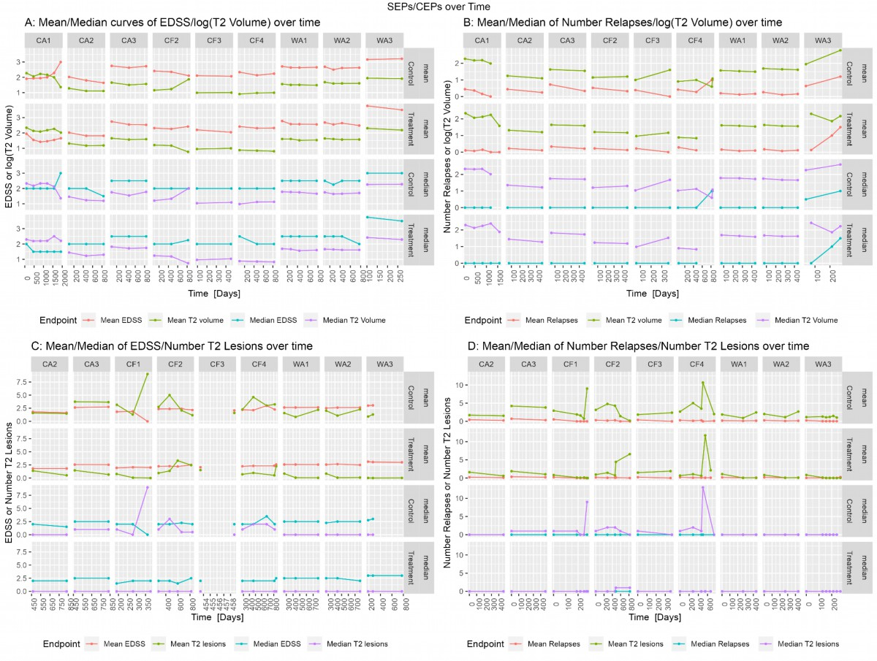
Figure S7:
Abbreviations: LRF, Likelihood Reduction Factor; EDSS, expanded disease status scale.
The figure displays the mean or median trajectories over time for EDSS and log(T2 volume) (A), the number of relapses and log(T2 volume) (B), EDSS and the number of new or newly enlarged T2 lesions (C), and the number of relapses and the number of new or newly enlarged T2 lesions (D) for each treatment and control group within the ten clinical trials included in our study.
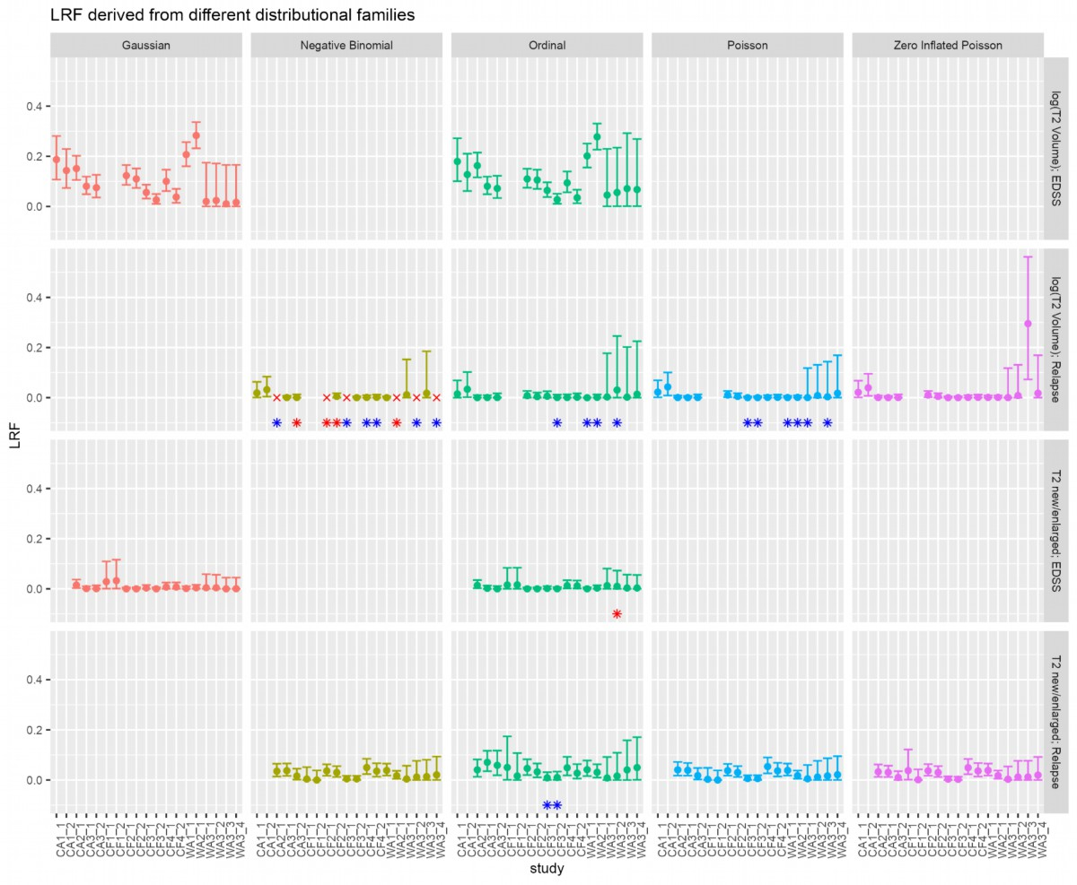
Figure S8:
Abbreviations: LRF, Likelihood Reduction Factor; EDSS, expanded disease status scale.
LRFs were computed for each trial arm combination (intervention vs. control) using the information-theoretic approach by Alonso and colleagues. To derive the LRF, Gaussian, Negative Binomial, Poisson, zero-inflated Poisson, and ordinal models were utilized. Four SEP – CEP combinations were considered: 1) T2 Volume – EDSS, 2) transformed T2 lesion count – transformed relapses, 3) T2 Volume – transformed relapses, and 4) transformed T2 lesion count – EDSS. Blue or red asterisks indicate convergence problems with one or both models from which the LRFs were derived. Notably, the content in column 3 of Figure 3 and column 4 of Figure S8, both utilizing the Poisson distribution family, is identical. Furthermore, the combination of T2V and EDSS outcomes remains consistent between Figure 3 and Figure S8.
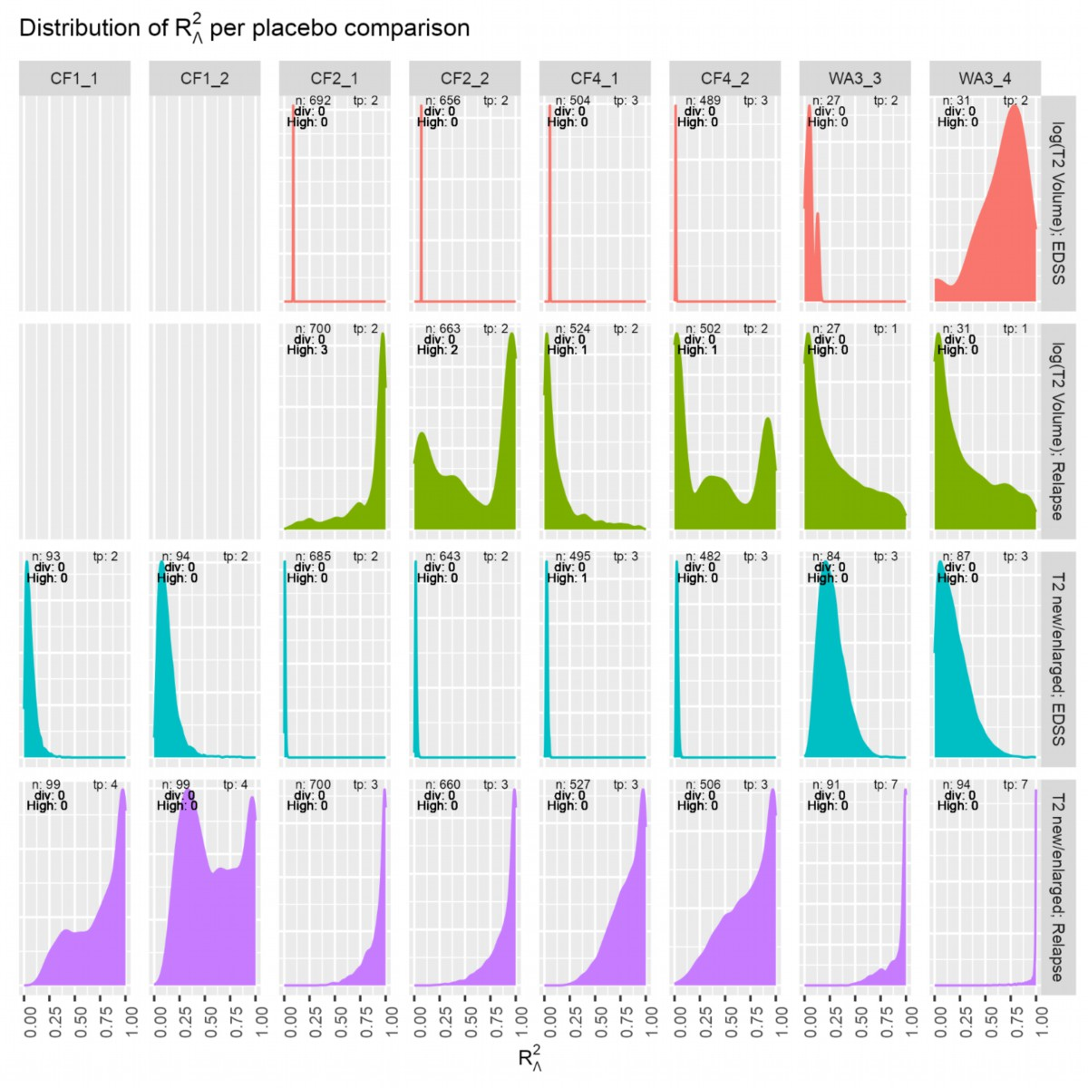

Figure S9:
Abbreviations: EDSS, expanded disease status scale; n, number of subjects; tp, number of measurement time points; High R, number of high $\hat{R}$ values; div, transition divergence after warm-up.
$R_{Λ}^{2}$ densities were derived for each trial arm combination (intervention vs. placebo control) using a Bayesian version of the meta-analytic approach. To obtain $R_{Λ}^{2}$, longitudinal Gaussian – Gaussian, Gaussian – Poisson, Poisson – Gaussian, or Poisson - Poisson joint models were fitted using Bayesian inference. Four SEP – CEP combinations were considered, symbolized by different colors: 1) T2 Volume – EDSS, 2) transformed T2 lesion count – transformed relapses, 3) T2 Volume – transformed relapses, and 4) transformed T2 lesion count – EDSS. Note, the T2V EDSS outcome combination is identical for Figure 4 and Figure S9.

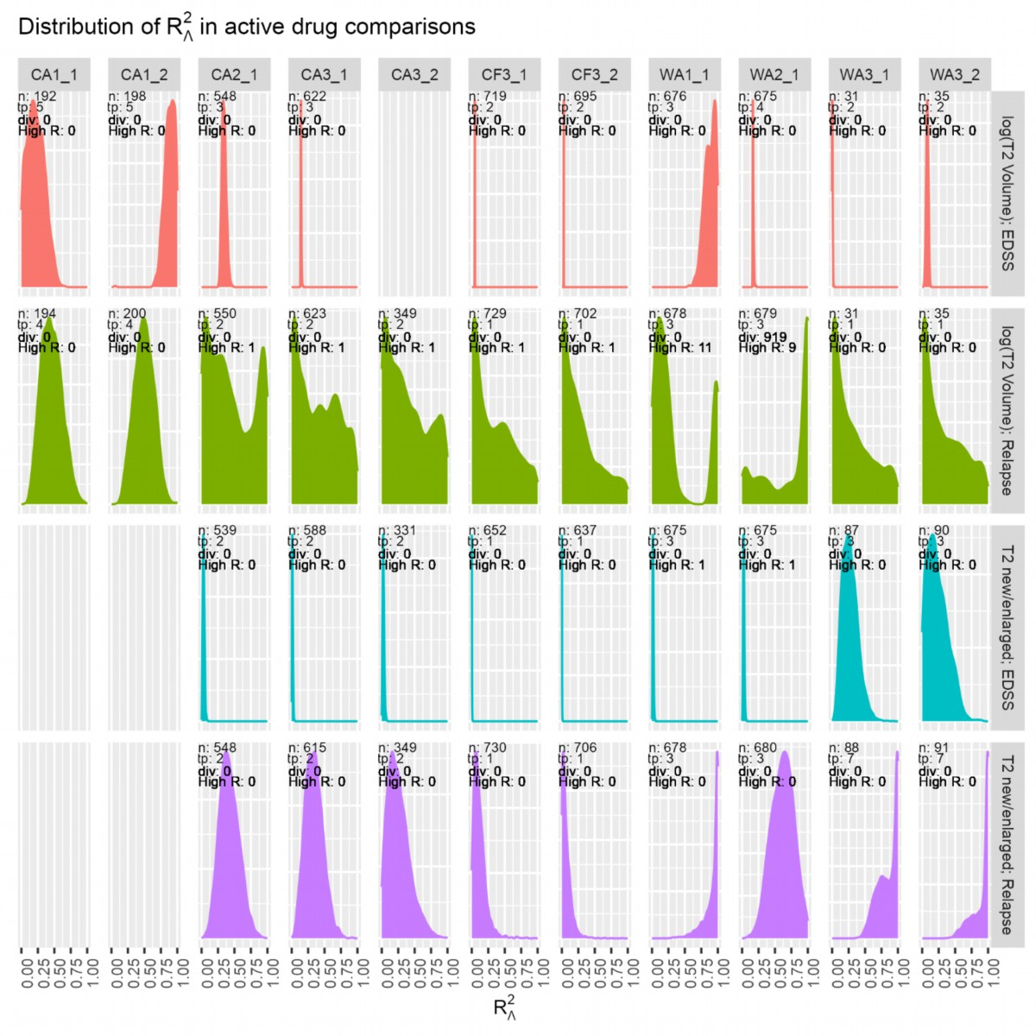
Figure S10:
Abbreviations: EDSS, expanded disease status scale; n, number of subjects; tp, number of measurement time points; High R, number of high $\hat{R}$ values; div, transition divergence after warm-up.
$R_{Λ}^{2}$ densities were derived for each trial arm combination (intervention vs. active control) using a Bayesian version of the meta-analytic approach. To obtain $R_{Λ}^{2}$, longitudinal Gaussian – Gaussian, Gaussian – Poisson, Poisson – Gaussian, or Poisson - Poisson joint models were fitted using Bayesian inference. Four SEP – CEP combinations were considered, symbolized by different colors: 1) T2 Volume – EDSS, 2) transformed T2 lesion count – transformed relapses, 3) T2 Volume – transformed relapses, and 4) transformed T2 lesion count – EDSS. Note, the T2V EDSS outcome combination is identical for Figure 5 and Figure S10.

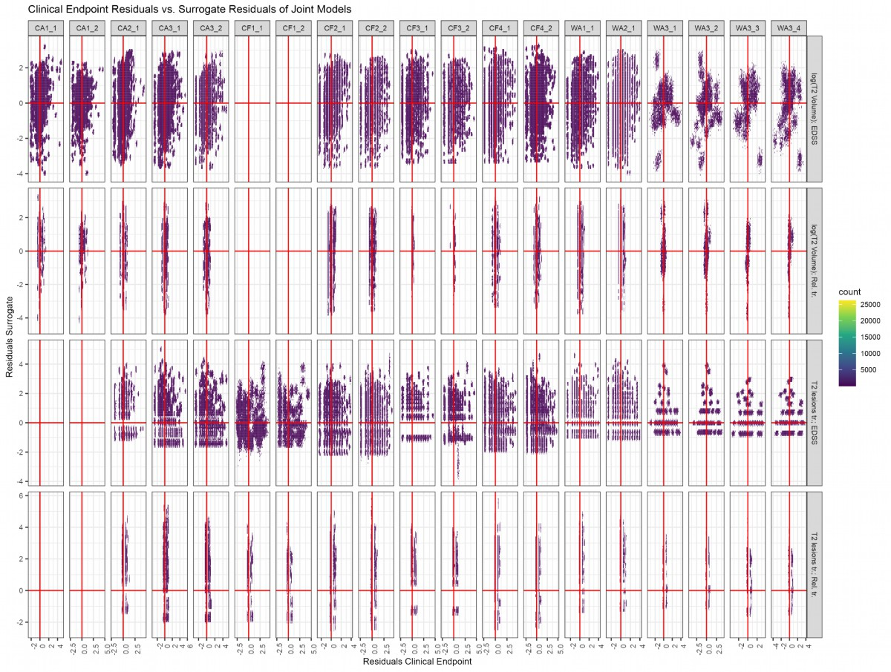
Figure S11:
Abbreviations: EDSS, expanded disease status scale; tr., transformed.
Two-dimensional histograms illustrate the residuals of the joint models in the meta-analytic approach, encompassing all treatment/comparison arm combinations and surrogate/clinical endpoint combinations. Note, count data were transformed prior to the analysis. Red lines denote the x and y axes of the cartesian system.
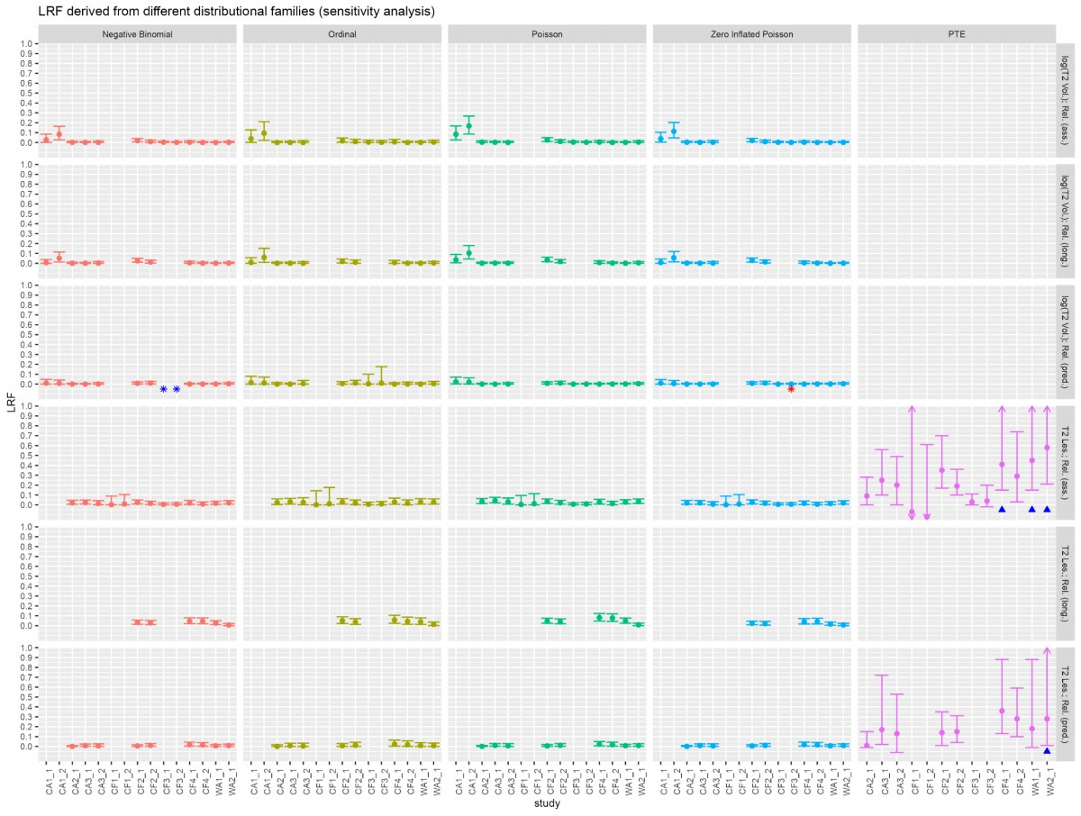
Figure S12:
Abbreviations: LRF, likelihood reduction factor; PTE, proportion explained; ass., associative; long., longitudinal; pred., predictive. T2 les., number of new/newly enlarged T2 lesions; T2 Vol. T2 volume; Rel., number of relapses.
Results of the sensitivity analyses are presented. The information-theoretic (IT) methodology is considered in columns one to four, and the proportion explained (PTE) is shown in column five. Blue or red asterisks indicate model convergence issues within the IT methodology, while blue triangles indicate the fulfillment of the Prentice’ criteria. Surrogate outcomes include new/newly enlarged lesions or log(T2 volume) change from baseline and the number of relapses as the clinical endpoint. The associative approach (rows one and four) evaluates the surrogate and clinical endpoint cross-sectionally after two years. The longitudinal approach (rows two and five) considers surrogate measurements (T2 lesion count or T2 volume change from baseline) at months six and twelve, with the number of relapses within the first year and within the second year as the clinical endpoint. The predictive approach (rows three and six) evaluates the surrogate (T2 lesion count or T2 volume change from baseline) and the number of relapses within the second year of the trial as the clinical endpoint. The IT approach was utilized to evaluate individual surrogacy. Only trials providing the necessary time structure are included.

References

1. Buyse M, Molenberghs G, Burzykowski T, Renard D, Geys H. The validation of surrogate endpoints in meta-analyses of randomized experiments. Biostatistics. 2000 Mar 1;1(1):49–67.
2. Alonso A, Molenberghs G. Surrogate marker evaluation from an information theory perspective. Biometrics. 2007;63(1):180–6.
3. Alonso A, Molenberghs G, Geys H, Buyse M, Vangeneugden T. A unifying approach for surrogate marker validation based on Prentice’s criteria. Statistics in medicine. 2006;25(2):205–21.
4. Kent JT. Information gain and a general measure of correlation. Biometrika. 1983;70(1):163–73.
5. Sormani MP, Stubinski B, Cornelisse P, Rocak S, Li D, Stefano ND. Magnetic resonance active lesions as individual-level surrogate for relapses in multiple sclerosis. Multiple Sclerosis Journal. 2011;17(5):541–9.
6. Bürkner PC. Advanced Bayesian multilevel modeling with the R package brms. arXiv preprint arXiv:170511123. 2017;
7. Carpenter B, Gelman A, Hoffman MD, Lee D, Goodrich B, Betancourt M, et al. Stan: A probabilistic programming language. Journal of statistical software. 2017;76.
8. Bürkner PC. Bayesian item response modeling in R with brms and Stan. arXiv preprint arXiv:190509501. 2019;
9. Gelman A, Rubin DB. Inference from iterative simulation using multiple sequences. Statistical science. 1992;7(4):457–72.
10. Barbiero A, Ferrari PA. Simulation of correlated Poisson variables. Applied Stochastic Models in Business and Industry. 2015;31(5):669–80.
11. Huber W, Von Heydebreck A, Sültmann H, Poustka A, Vingron M. Variance stabilization applied to microarray data calibration and to the quantification of differential expression. Bioinformatics. 2002;18(suppl_1):S96–104.
12. Buchka S. R-code for publication: Individual level surrogacy of MRI T2 lesion information for future disease severity: a methodological discussion and application to recent MS Phase II and III trials [Internet]. 2023. Available from: https://github.com/StefanBuchka/Papers

