Supporting Information

Production of rare ginsenosides by biotransformation of Panax notoginseng saponins using Aspergillus fumigatus
Lian Yang¹, Dongmei Lin¹, Feixing Li¹, Xiuming Cui¹, Dengji Lou^{2*}, Xiaoyan Yang^{1,2}*

Abstract
Panax notoginseng saponins (PNS) are the main active components of Panax notoginseng. But after oral administration, they need to be converted into rare ginsenosides by human gut microbiota and gastric juice before they can be readily absorbed into the bloodstream and exert their effects. The sources of rare ginsenosides are extremely limited in P. notoginseng and other medical plants, which hinders their application in functional foods and drugs. Therefore, the production of rare ginsenosides by the transformation of PNS using Aspergillus fumigatus was studied in this research. During 50 days at 25 ℃ and 150 rpm, A. fumigatus transformed PNS to 14 products (1-14). They were isolated by varied chromatographic methods, such as silica gel column chromatography, Rp-C₁₈ reversed phase column chromatography, semi-preparative HPLC, Sephadex LH-20 gel column chromatography, and elucidated on the basis of their NMR and MS spectroscopic data. Then, the transformed products (1-14) were isolated and identified as ginsenosides C-K, 20 (R/S)-Rg₃, Rg₅, 20 (R)-Rh₁, Rk₁, Rh₄, Rk₃, 20(S)-protopanaxatriol, 20(S)-I, 20 (R/S)-Rg₂, and notoginsenosides 20 (R/S)-R_{2,} respectively. In addition, all transformed products (1-14) were tested for their antibacterial activity. Among them, compounds 5 and 7 showed moderate antibacterial activities against Staphylococcus aureus and Candida albicans with MIC values of 6.25/25.00, and 1.25/25.00 μg/mL, respectively. This study lays the foundation for production of rare ginsenosides.
Keywords Panax notoginseng saponins, biotransformation, rare ginsenosides, Aspergillus fumigatus, antibacterial activity

Content

Figure S1. Proposed possible biosynthetic pathways of major ginsenosides Rg₁, Re, Rb₁ and notoginsenoside R₁ of PNF by A. fumigatus 3
Figure S2. HPLC analysis of transformation products of PNF by A. fumigatus 4
Table S1. The yield of some transformation products--------------------------------------5
Table S2. Antibacterial activity of compounds 1-14 (MIC, μg/mL) ---------------------5
Figure S3. ¹H-NMR and ¹³C-NMR spectrum of compound 1 6
Figure S4. ¹H-NMR and ¹³C-NMR spectrum of compound 2 7
Figure S5. ¹H-NMR and ¹³C-NMR spectrum of compound 3 8
Figure S6. ¹H-NMR and ¹³C-NMR spectrum of compound 4 9
Figure S7. ¹H-NMR and ¹³C-NMR spectrum of compound 5 10
Figure S8. ¹H-NMR and ¹³C-NMR spectrum of compound 6 11
Figure S9. ¹H-NMR and ¹³C-NMR spectrum of compound 7 12
Figure S10. ¹H-NMR and ¹³C-NMR spectrum of compound 8 13
Figure S11. ¹H-NMR and ¹³C-NMR spectrum of compound 9 14
Figure S12. ¹H-NMR and ¹³C-NMR spectrum of compound 10 15
Figure S13. ¹H-NMR and ¹³C-NMR spectrum of compound 11 16
Figure S14. ¹H-NMR and ¹³C-NMR spectrum of compound 12 17
Figure S15. ¹H-NMR and ¹³C-NMR spectrum of compound 13 18
Figure S16. ¹H-NMR and ¹³C-NMR spectrum of compound 14 19

Fig. S1 Proposed possible biosynthetic pathways of major ginsenosides Rg₁, Re, Rb₁ and notoginsenoside R₁ of PNF by A. fumigatus. The solid line represents the determined path, and the dashed line represents the speculated path.

Fig. S2 HPLC analysis of transformation products of PNF by A. fumigatus. a, Rare ginsenosides mixed; b, Sample of PNS after transformation; c: PNS. 1-5, R₁, Rg₁, Re, Rb₁, Rd. 6, 20 (S)-I; 7+8, 20 (S)-R₂+20 (S)-Rg₂; 9, 20 (R)-Rg₂+20 (R)-R₂; 10, 20 (R)-Rh₁; 11, Rk₃; 12, Rh₄; 13, 20 (R)-Rg₃; 14, 20 (S)-Rg₃; 15, 20 (S)-Protopanaxatriol; 16, Rk₁; 17, Rg₅; 18, CK.

Table S1 The yield of some transformation products
Substrates | transformation rate  (%) | Products | Productivity (%)
R₁  Rg₁  Re  Rb₁ | 32.52  19.35  24.74  100 | 20(S)-Rg₃  Rk₁  Rg₅  Rk₃  Rh₄  CK  20(R)-Rg₃  20(S)-I | 17.90  3.25  6.30  3.61  6.42  0.19  22.29  5.60

Table S2 Antibacterial activity of compounds 1-14 (MIC, μg/mL)
Compounds | Bacterial pathogens
Compounds | Staphylococcus aureus | Candida albicans
1 | >100 | >100
2 | >100 | >100
3 | >100 | >100
4 | >100 | >100
5 | 6.25 | 1.25
6 | >100 | >100
7 | 1.25 | 25
8 | >100 | >100
9 | >100 | >100
10 | 25 | 25
11 | 50 | 50
12 | >100 | >100
13 | >100 | >100
14 | >100 | >100
ciprofloxacin | 1.56 | 0.78

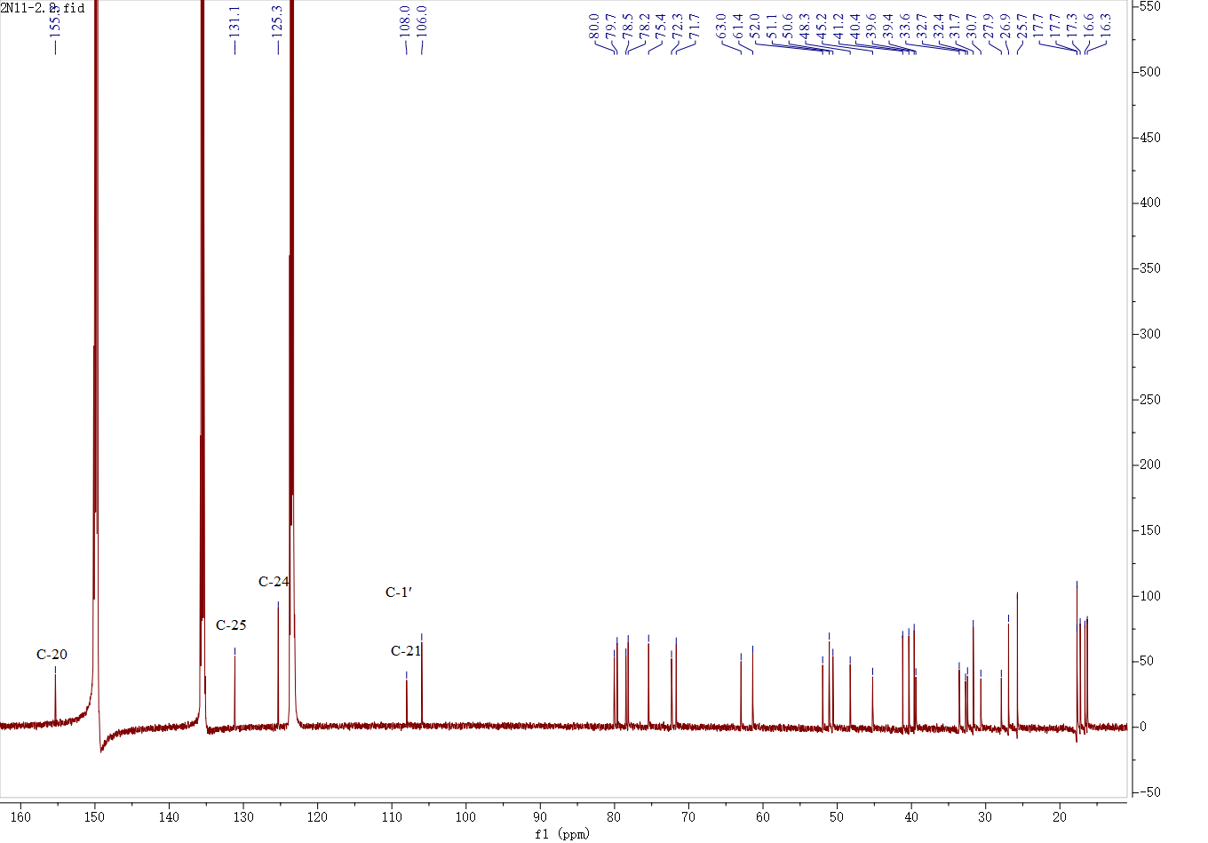
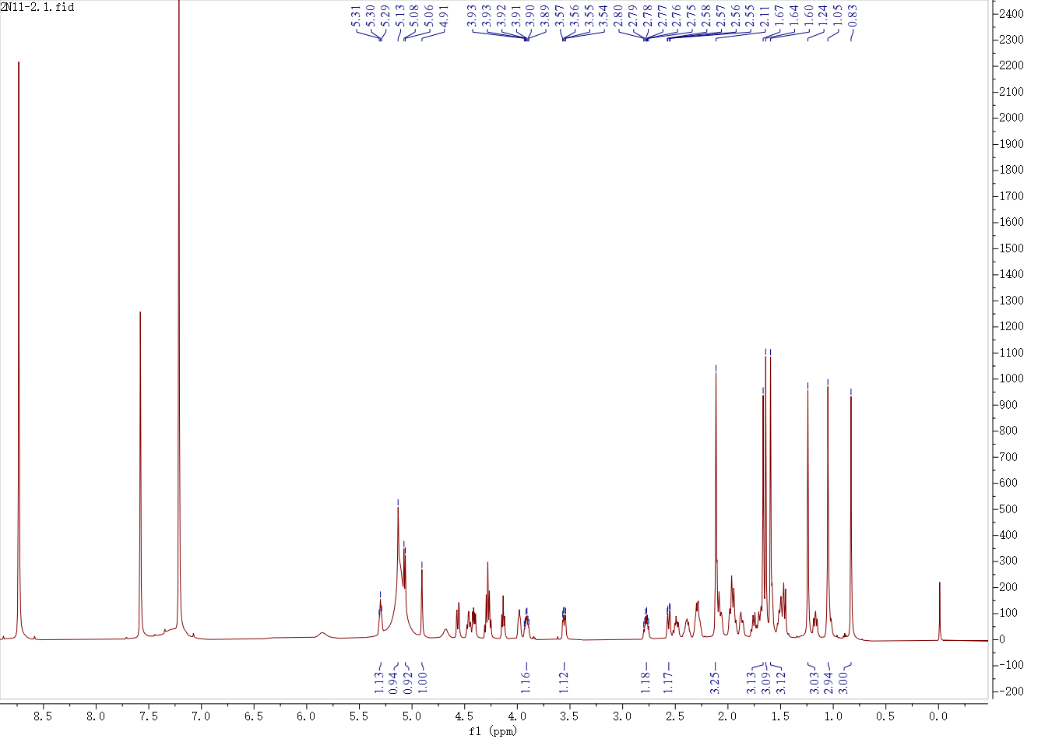

Fig. S3 ¹H-NMR and ¹³C-NMR spectrum compound 1

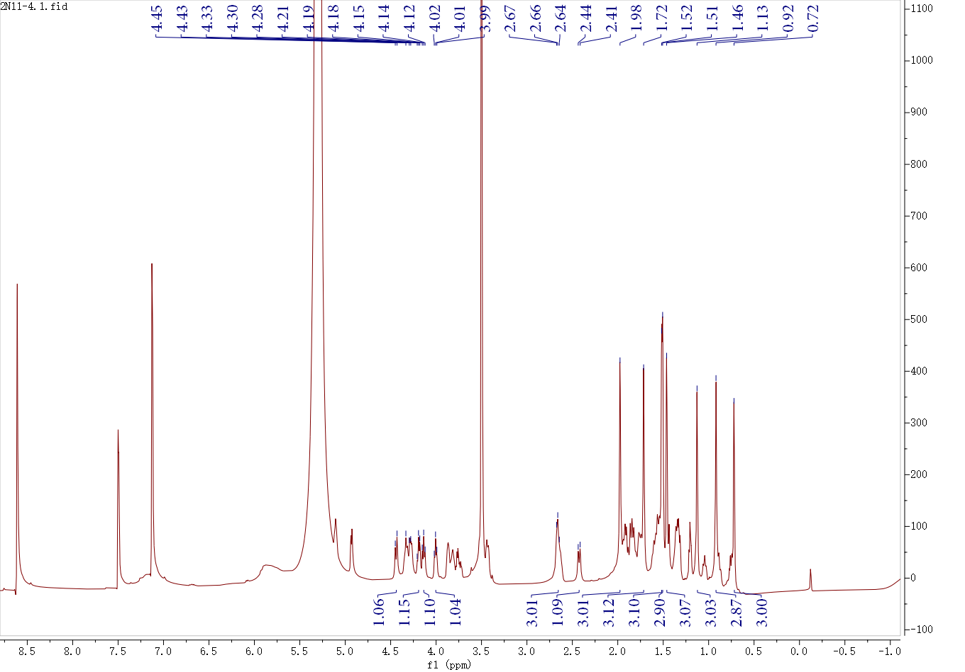
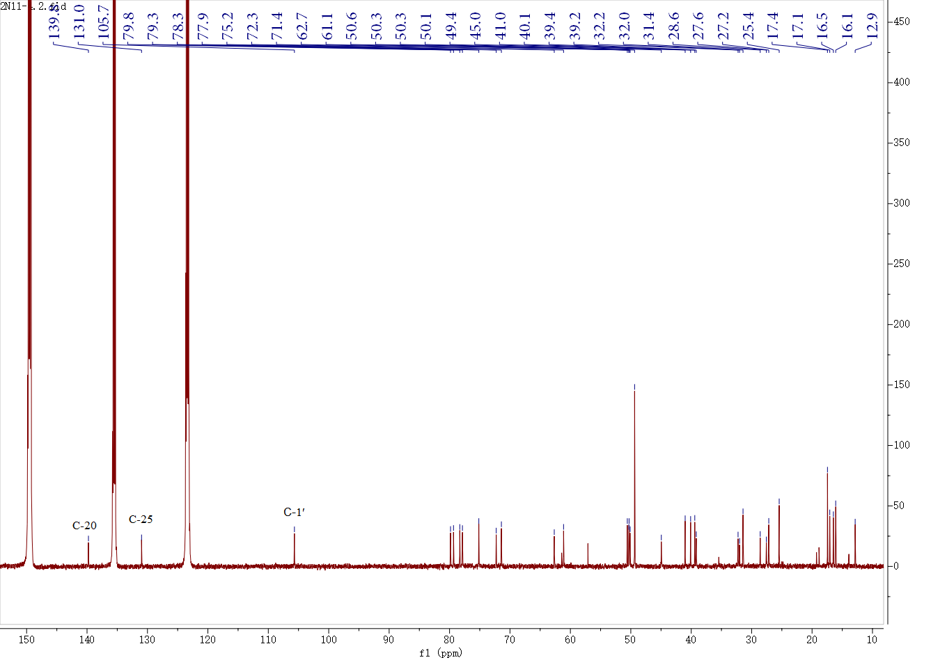
Fig. S4 ¹H-NMR and ¹³C-NMR spectrum compound 2

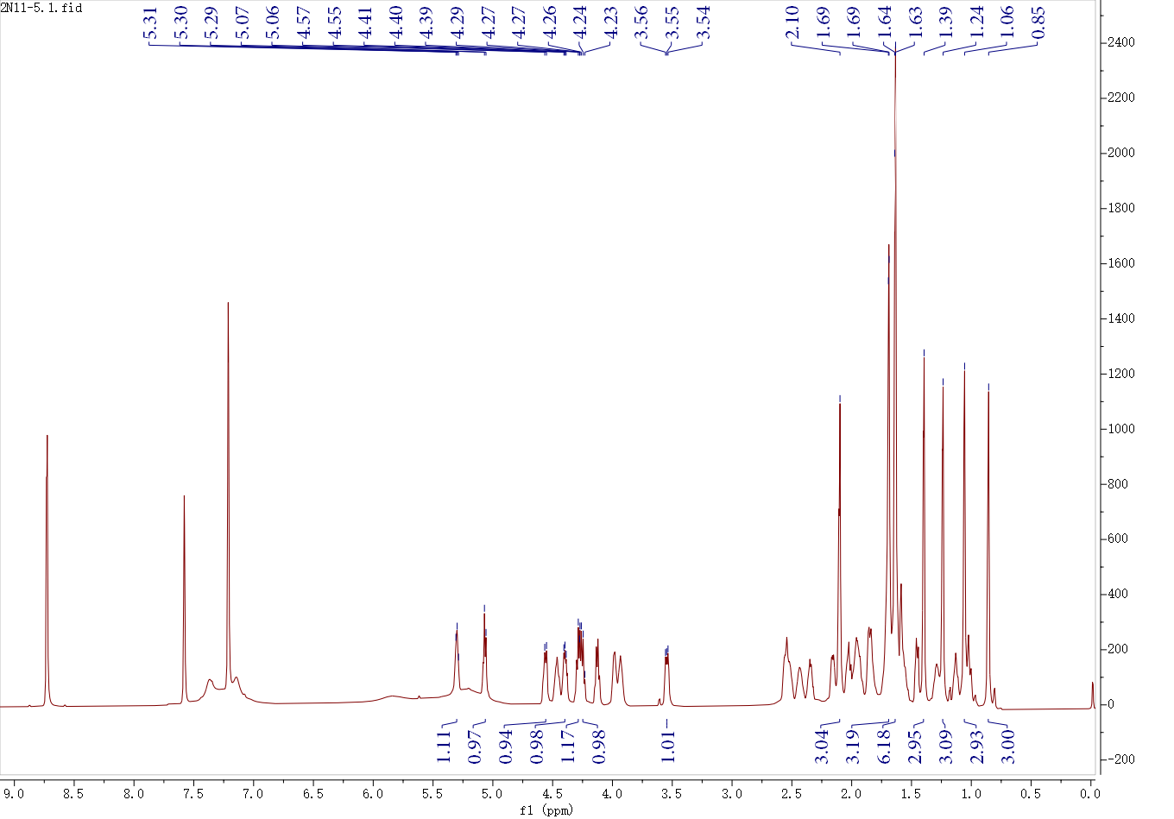

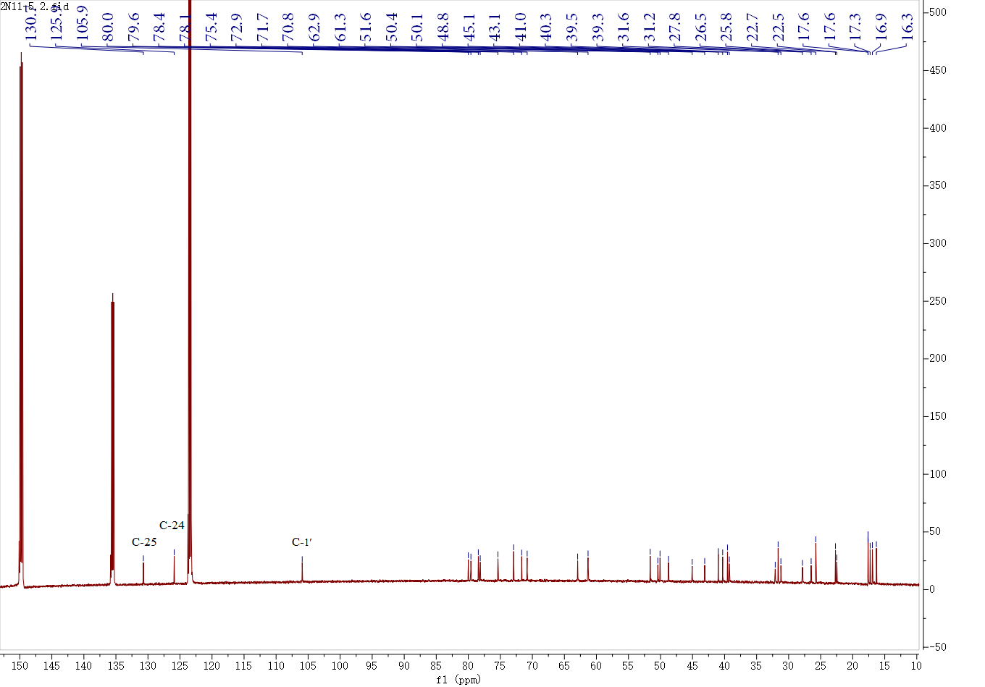
Fig. S5 ¹H-NMR and ¹³C-NMR spectrum compound 3

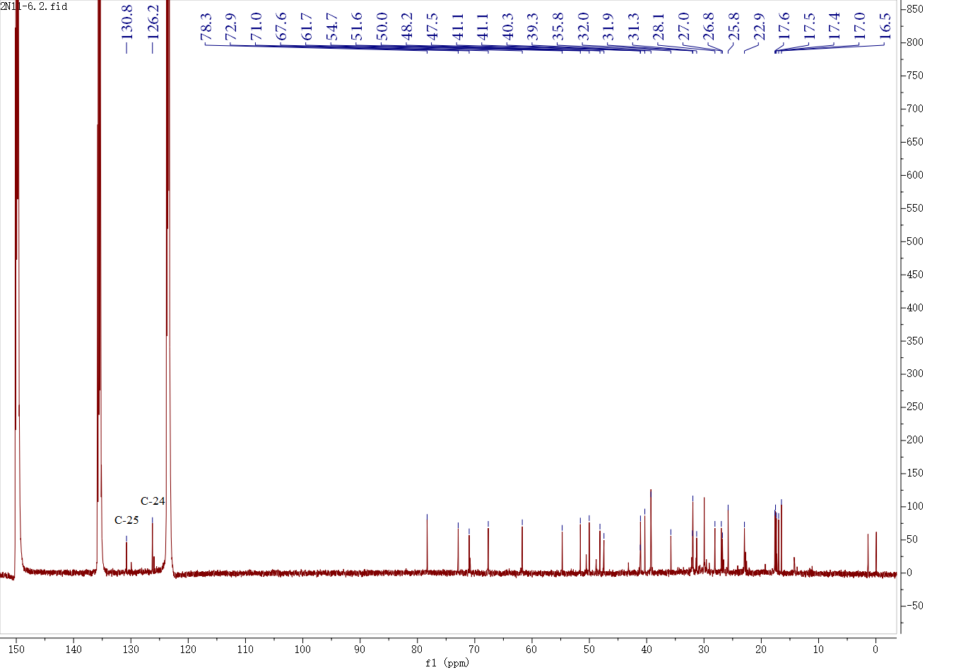
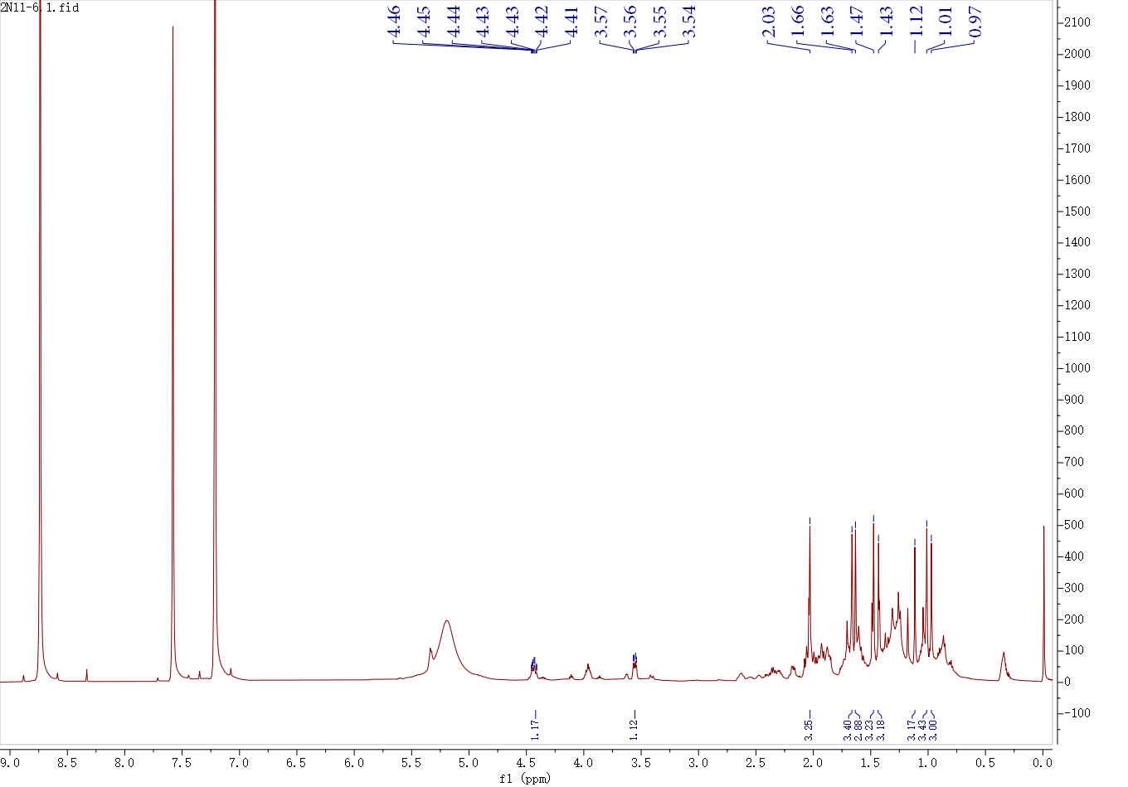
Fig. S6 ¹H-NMR and ¹³C-NMR spectrum compound 4

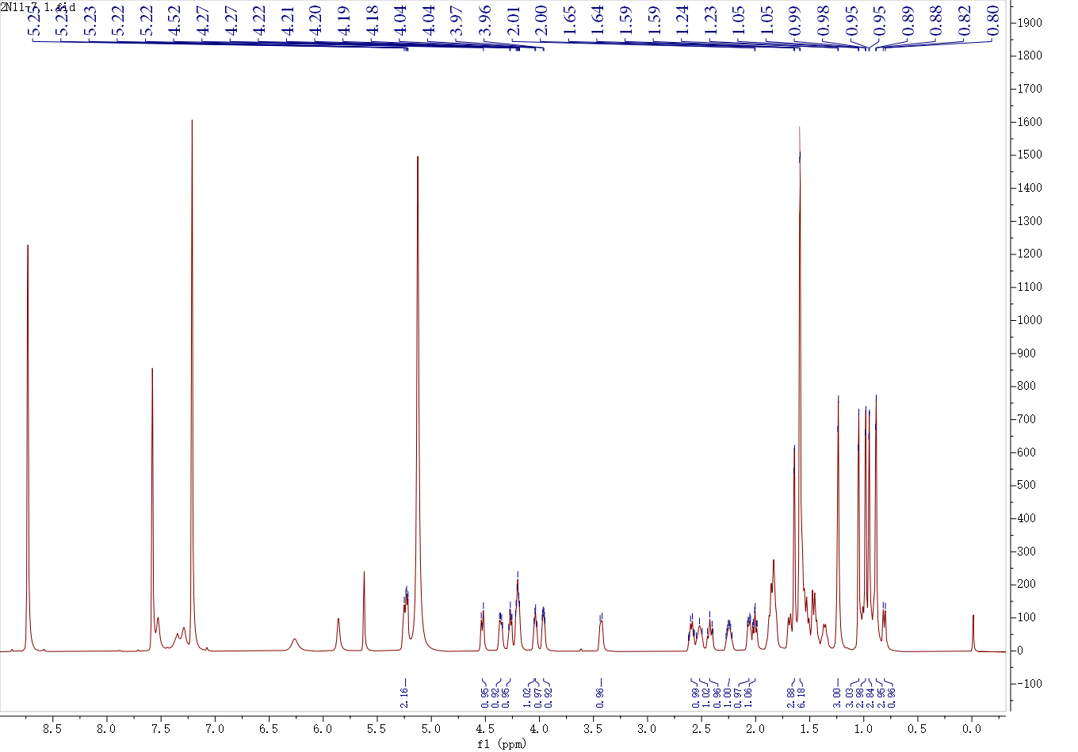
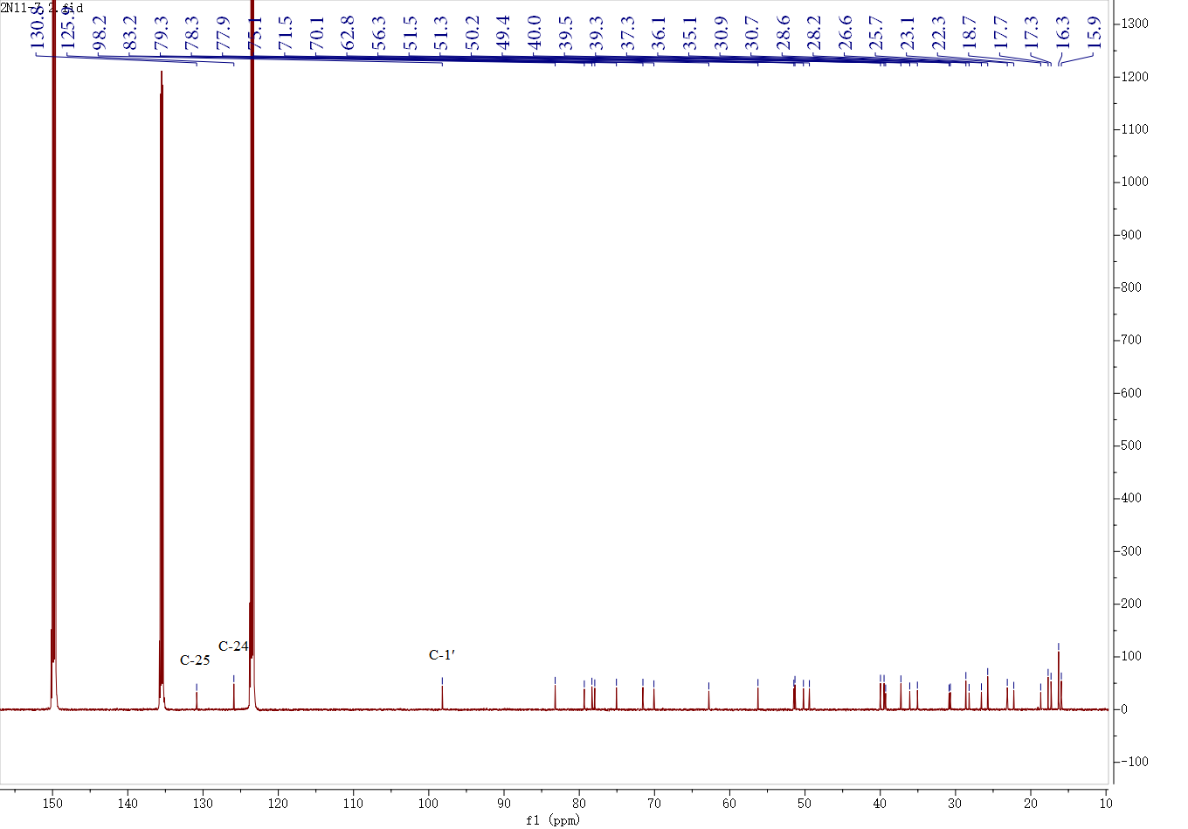

Fig. S7 ¹H-NMR and ¹³C-NMR spectrum compound 5

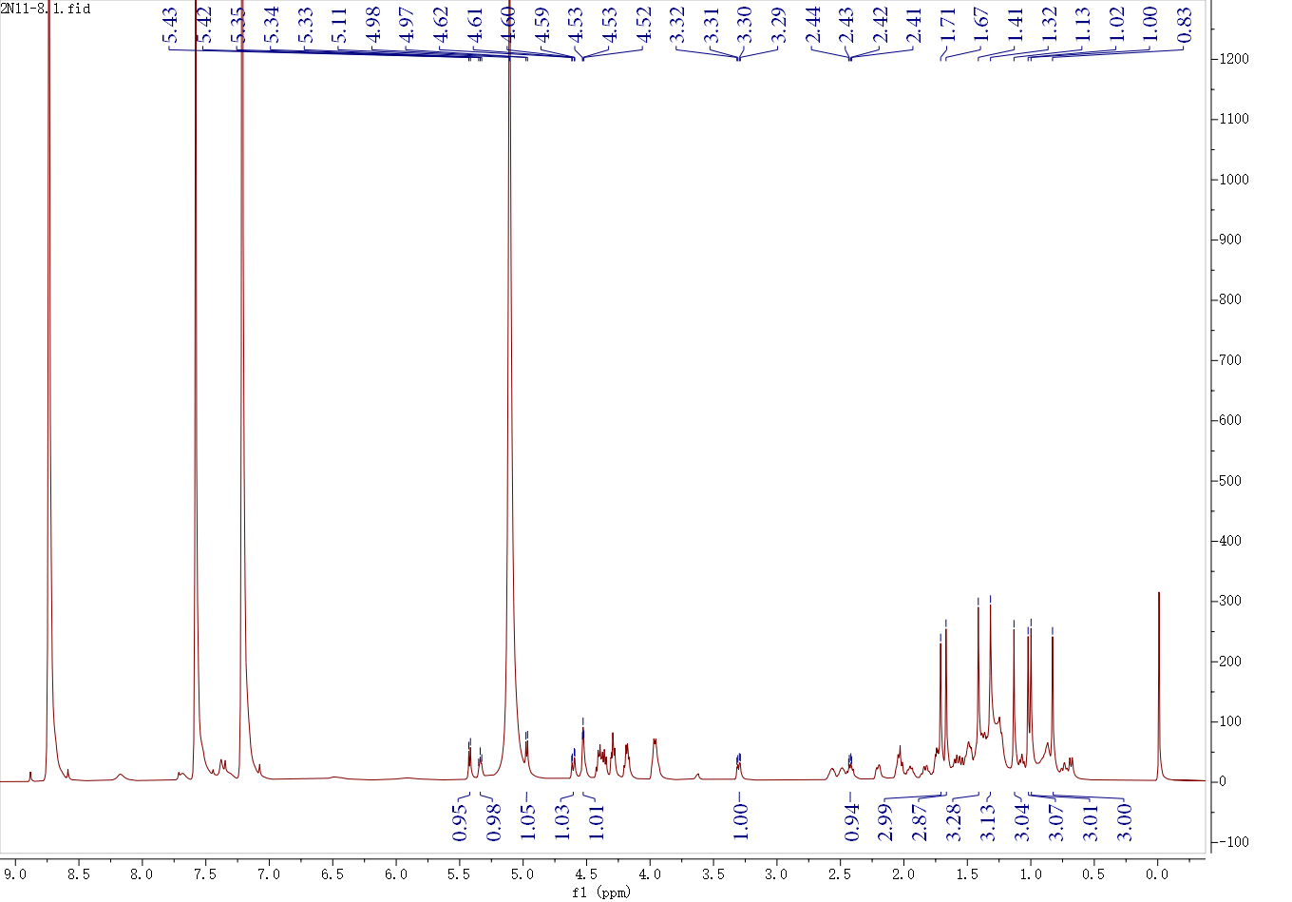
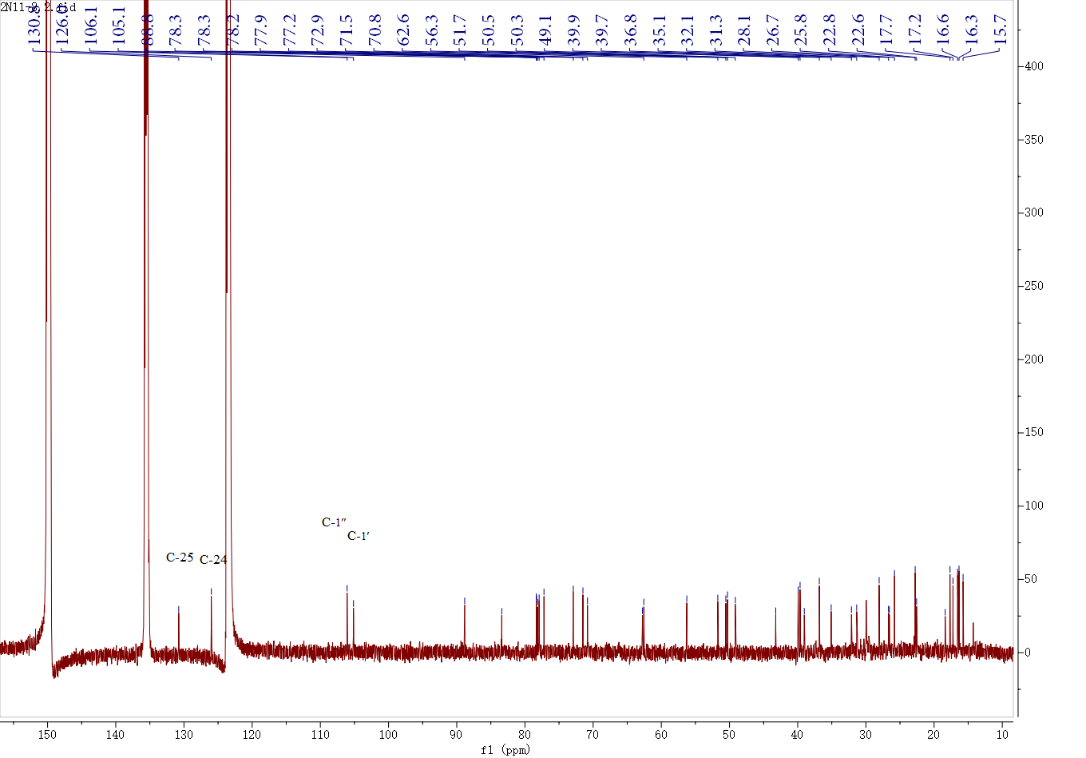

Fig. S8 ¹H-NMR and ¹³C-NMR spectrum compound 6

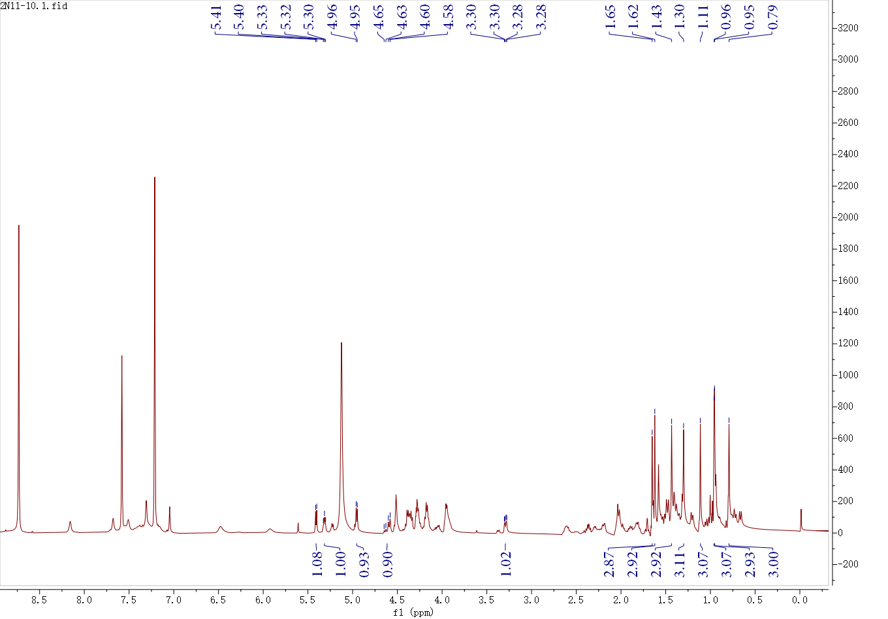
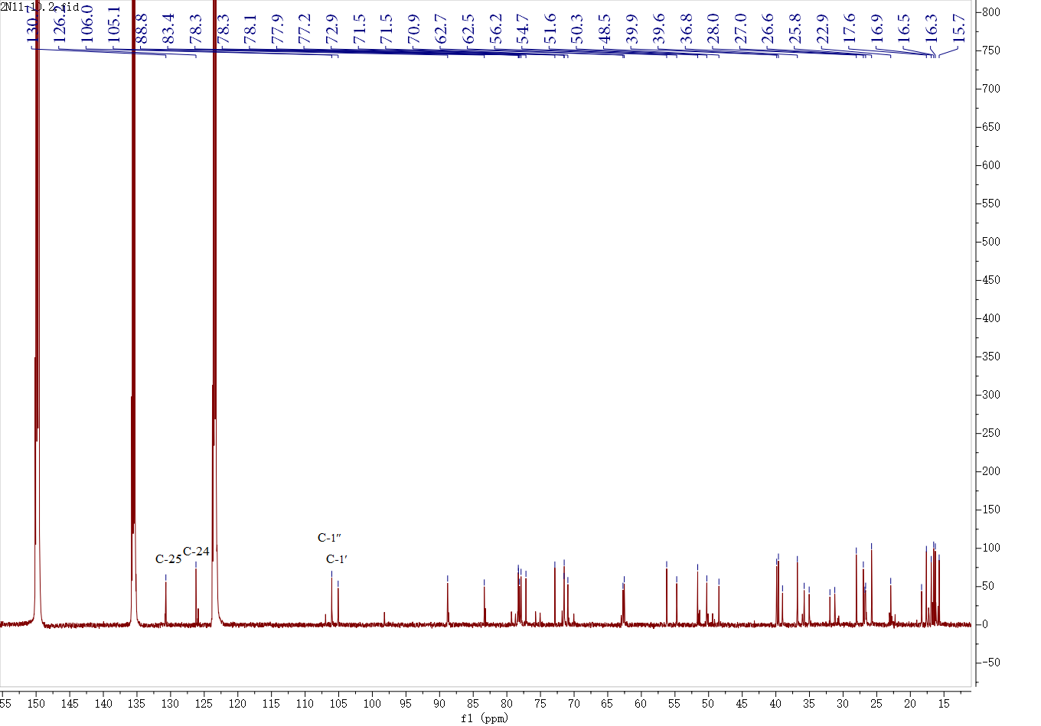

Fig. S9 ¹H-NMR and ¹³C-NMR spectrum compound 7

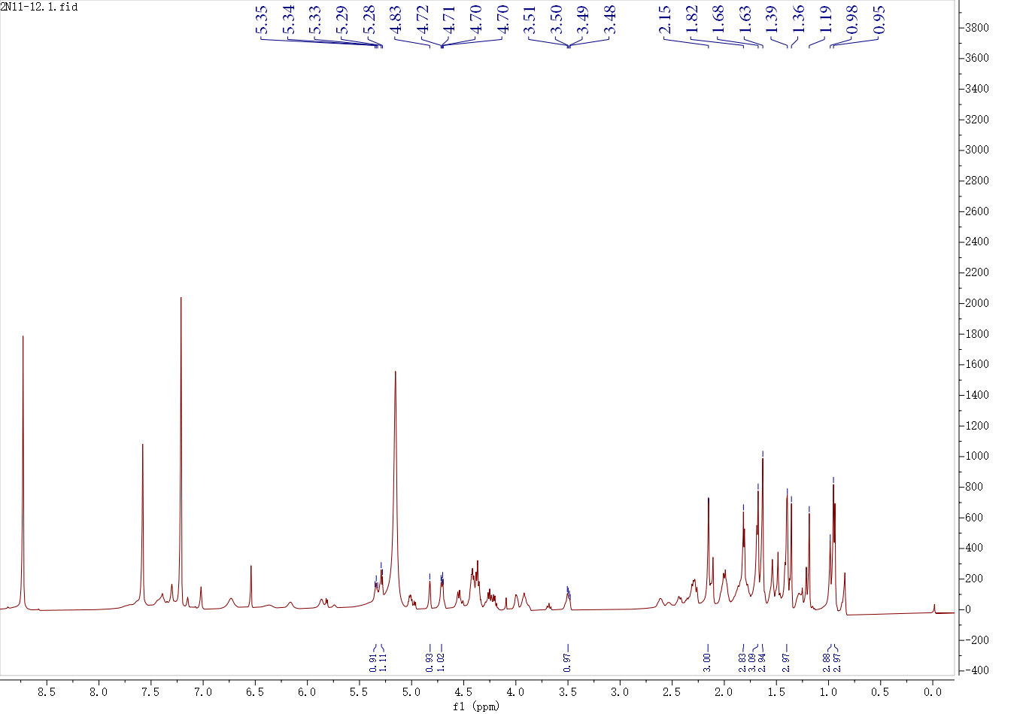
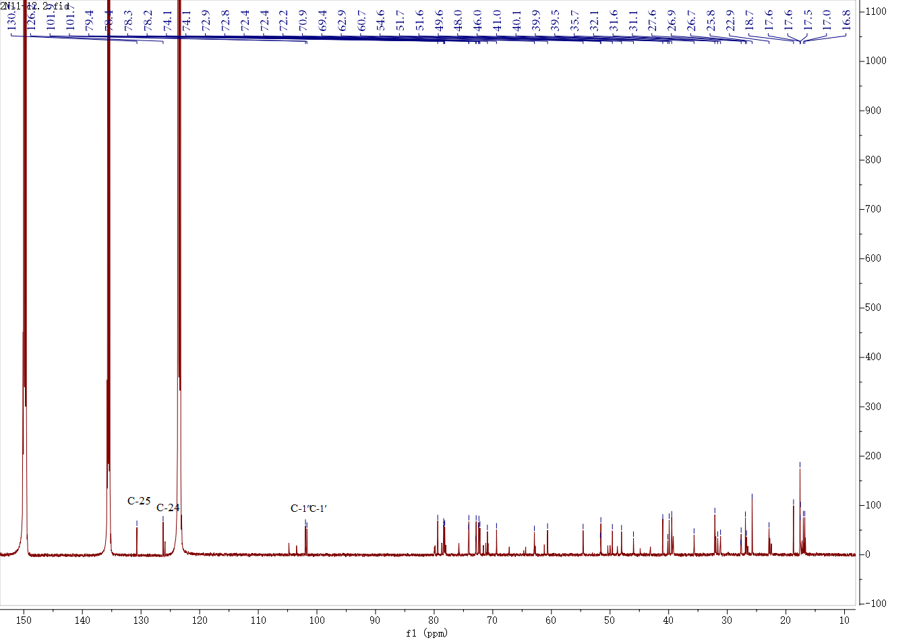

Fig. S10 ¹H-NMR and ¹³C-NMR spectrum compound 8

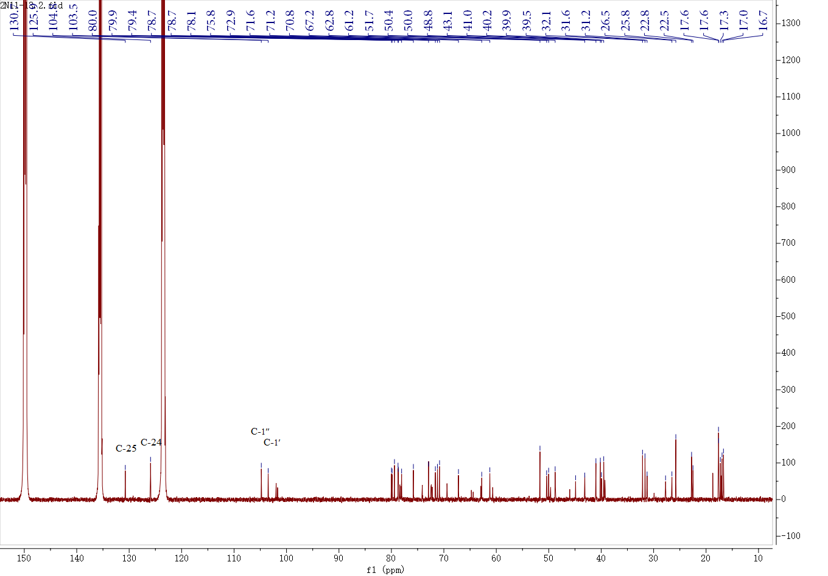
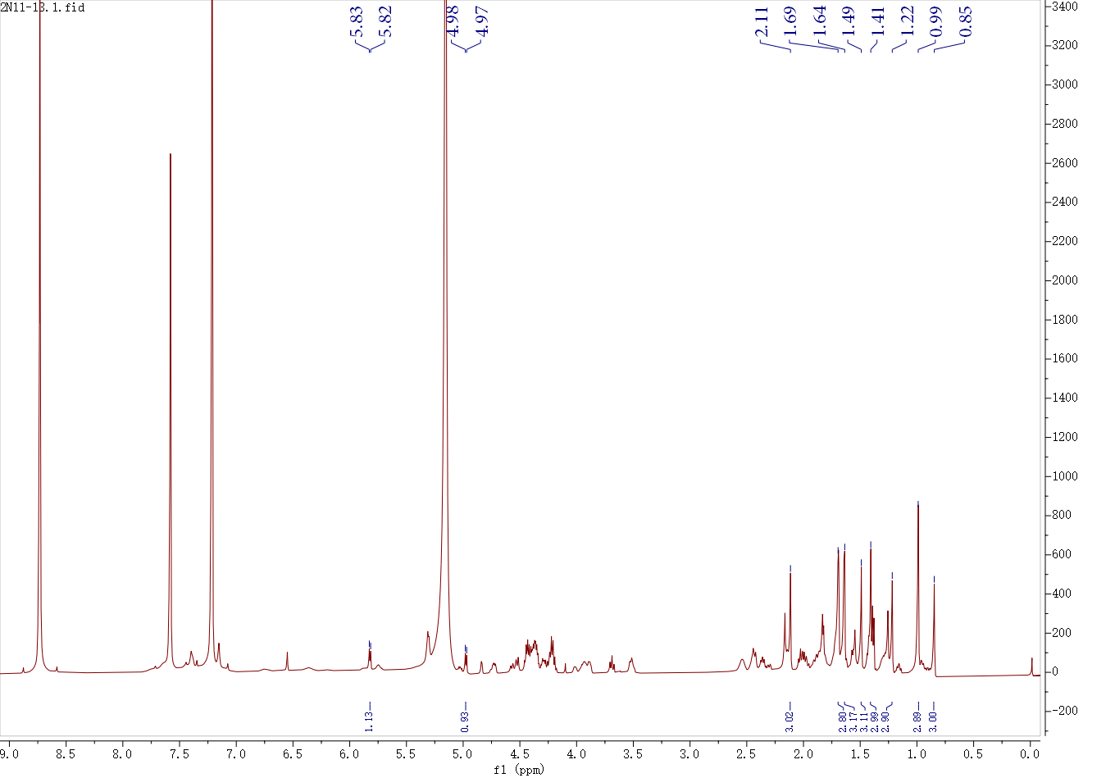
Fig. S11 ¹H-NMR and ¹³C-NMR spectrum compound 9

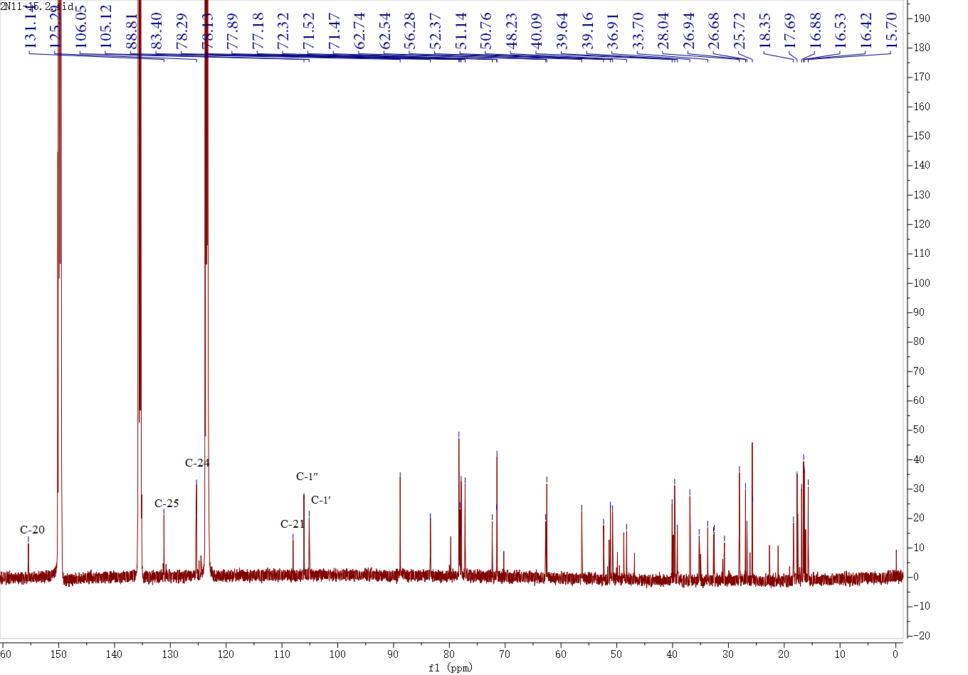
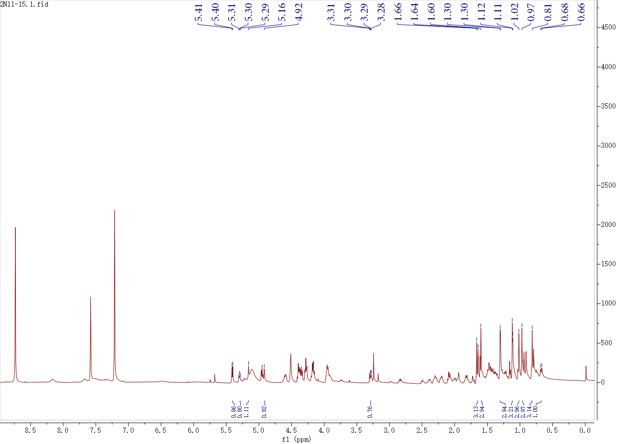
Fig. S12 ¹H-NMR and ¹³C-NMR spectrum compound 10

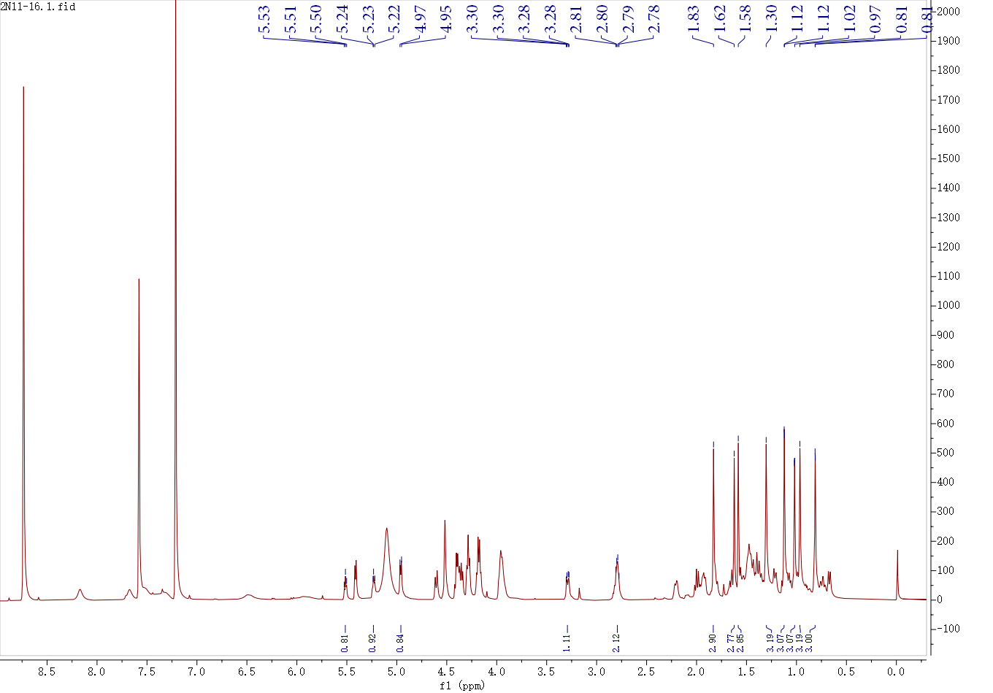
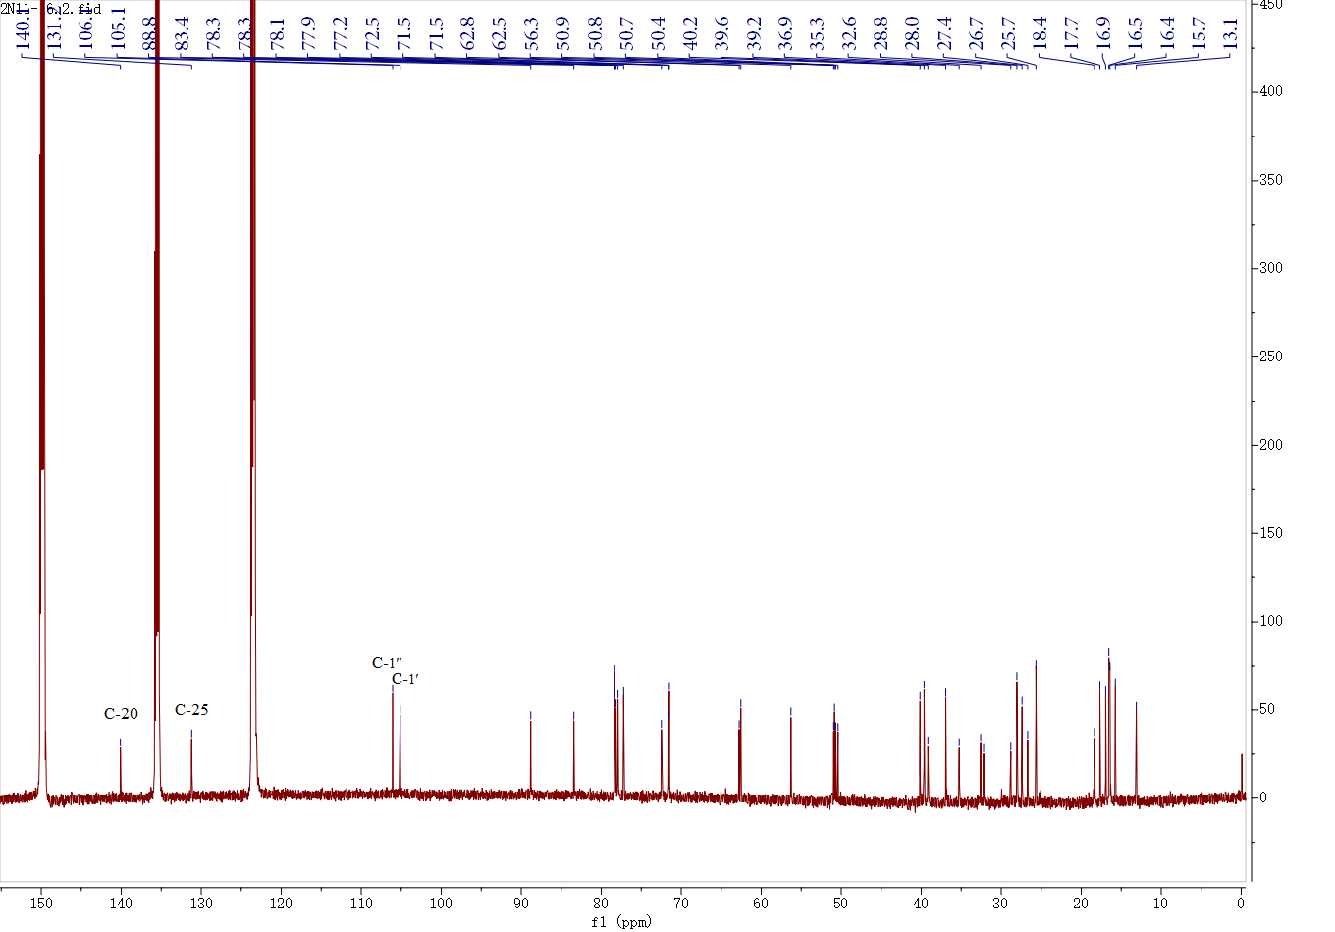

Fig. S13 ¹H-NMR and ¹³C-NMR spectrum compound 11

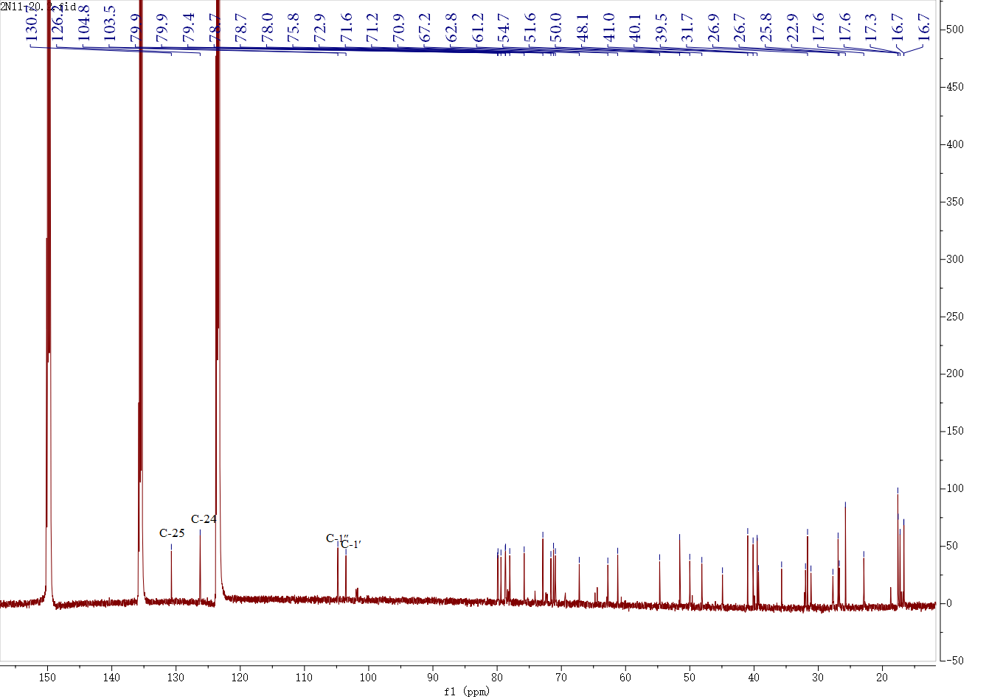
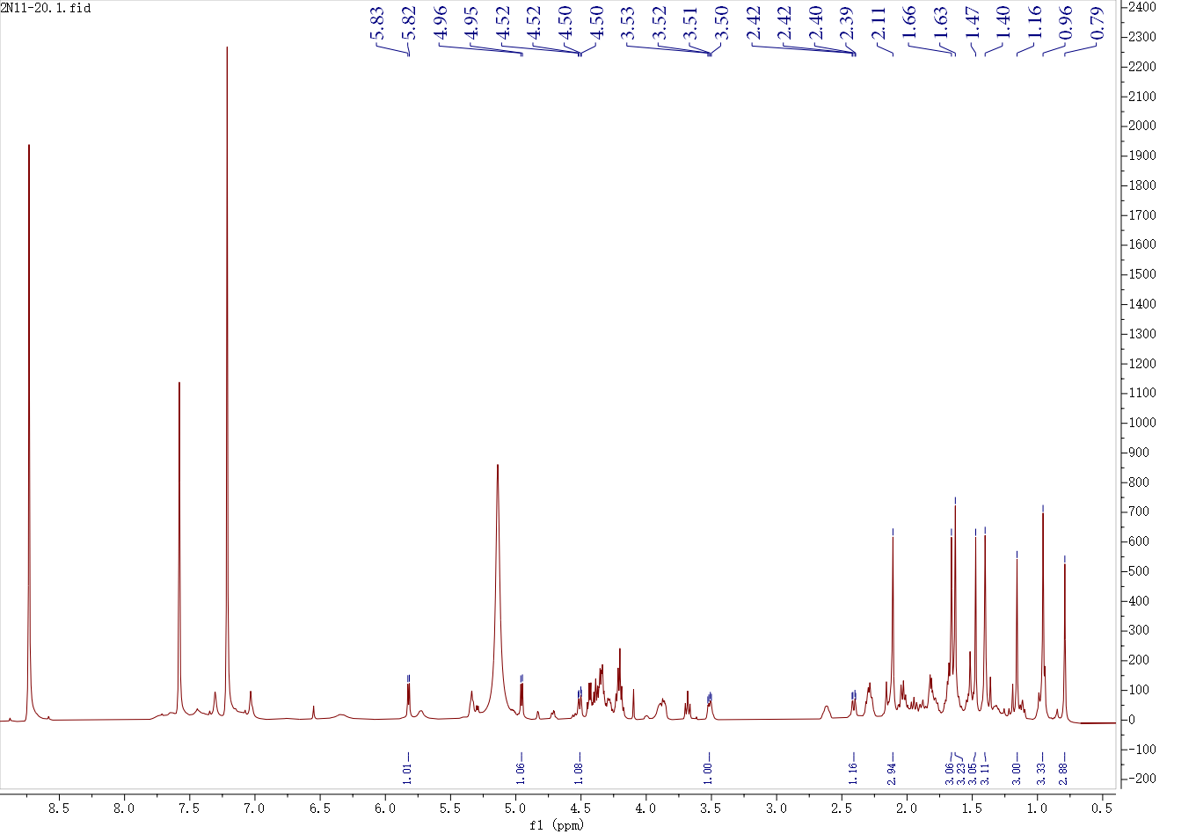
Fig. S14 ¹H-NMR and ¹³C-NMR spectrum compound 12

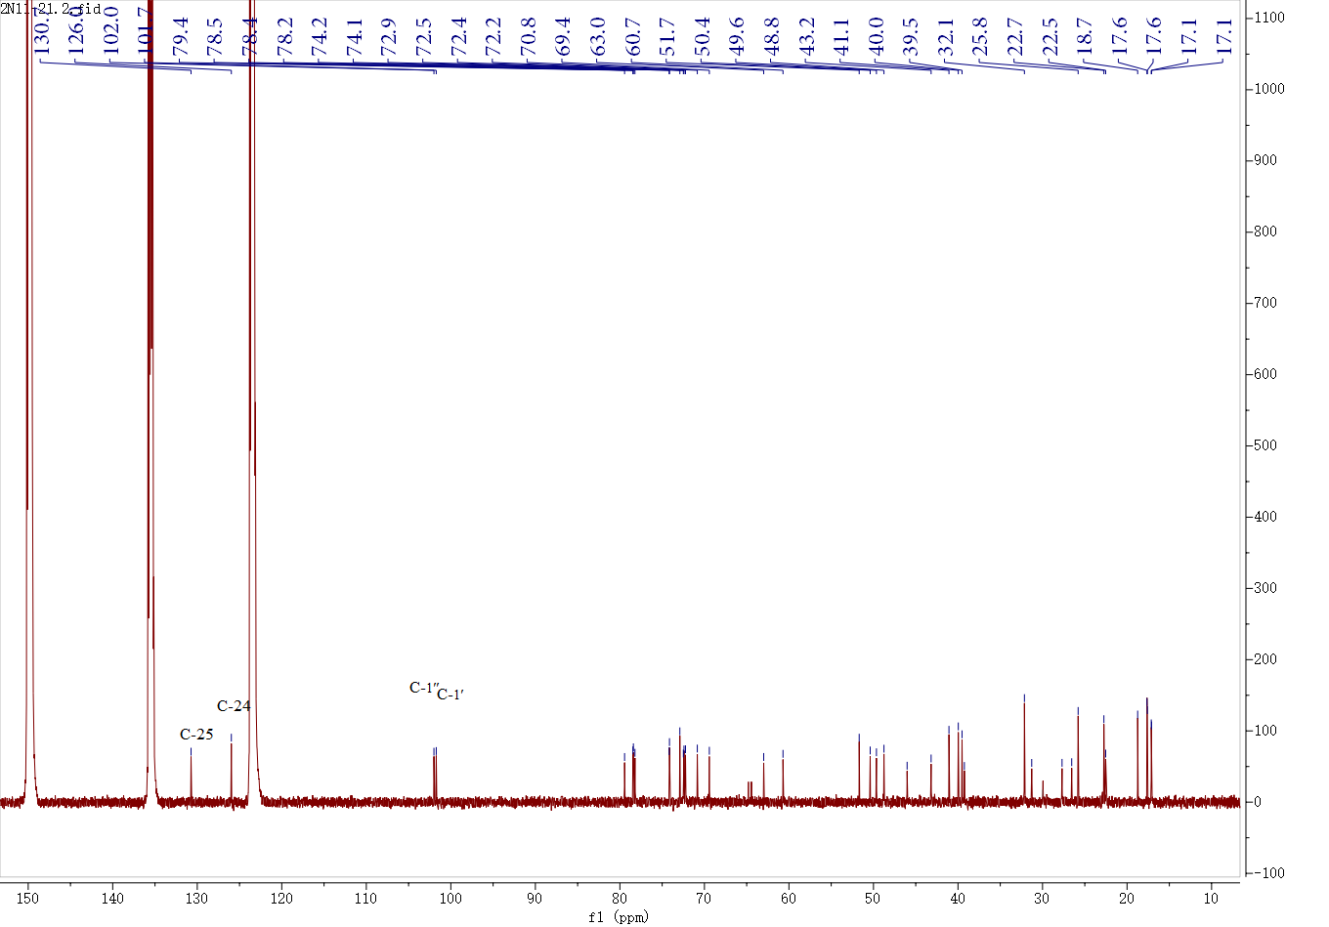
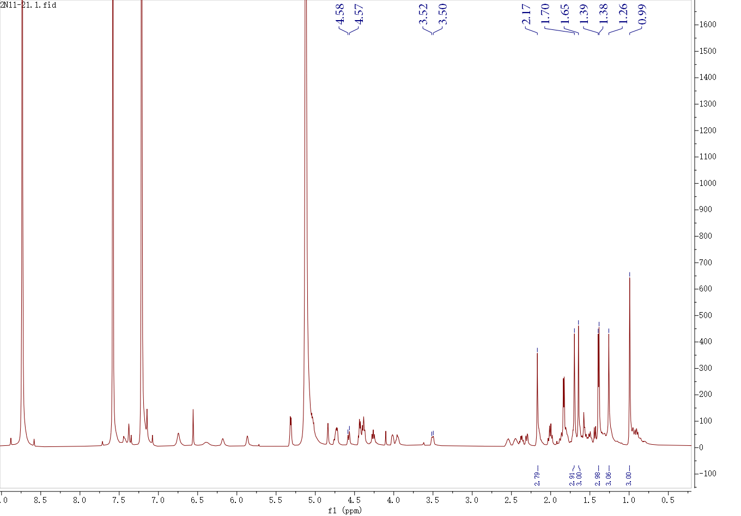
Fig. S15 ¹H-NMR and ¹³C-NMR spectrum compound 13

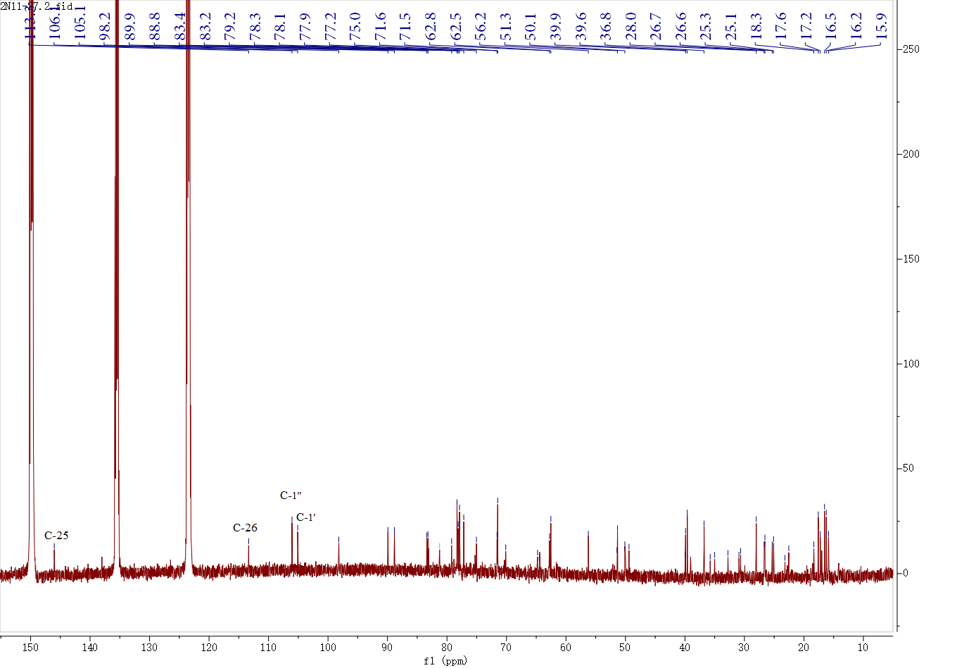
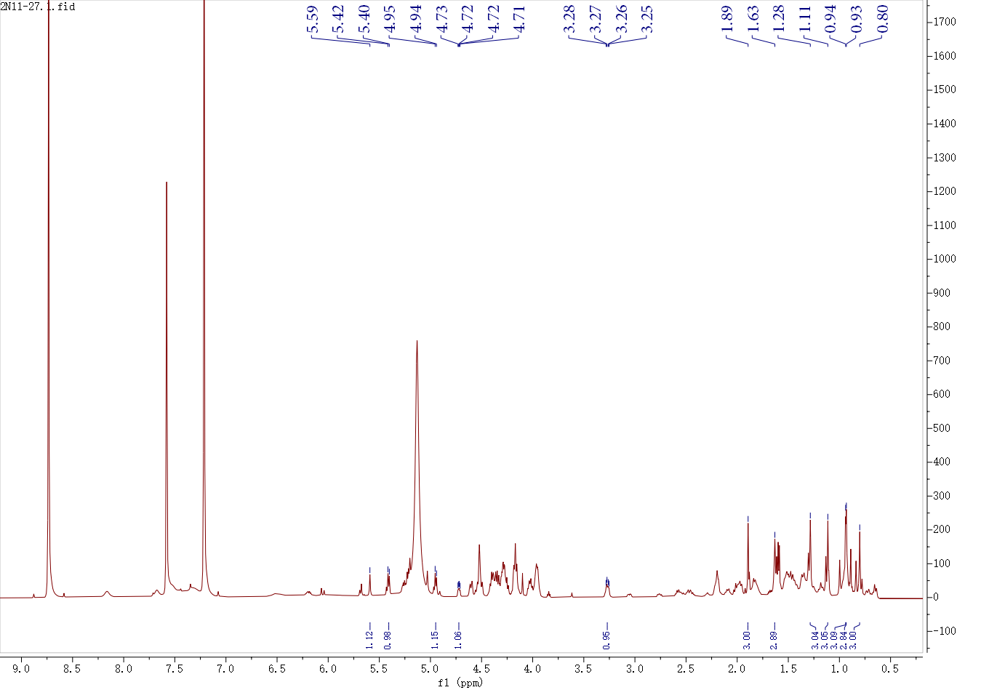
Fig. S16 ¹H-NMR and ¹³C-NMR spectrum compound 14

*Correspondence: Xiao-Yang Yang yangxiaoyan9999@163.com Deng-Ji Lou loudengji@yxnu.edu.cn Full list of author information is available at the end of the article

