Table 1: Plackett-Burman experimental design for evaluating the influence of various independent variables on the production of lignin peroxidase
 | Factor 1 | Factor 2 | Factor 3 | Factor 4 | Factor 5 | Factor 6 | Factor 7 | Factor 8 | Response
Run | A: Glucose (%) | B: Meat extract (%) | C: Seed age (h) | D: Inoculum size (%) | E:  Substrate conc. (%) | F:  pH | G:  Production time (h) | H:  Temp  (ºC) | R1 (U/ml)
1 | 0.1 | 0.5 | 24 | 2 | 0.005 | 8 | 24 | 35 | 2.99 ±0.42
2 | 0.1 | 0.5 | 4 | 2 | 0 | 6 | 24 | 25 | 2.34±0.76
3 | 0.1 | 1.5 | 24 | 6 | 0 | 6 | 24 | 35 | 1.95±0.54
4 | 1 | 0.5 | 24 | 6 | 0 | 8 | 72 | 35 | 18.07±0.78
5 | 0.1 | 1.5 | 24 | 2 | 0.005 | 8 | 72 | 25 | 8.19±0.72
6 | 1 | 1.5 | 4 | 6 | 0.005 | 8 | 24 | 25 | 0.15±0.44
7 | 1 | 0.5 | 24 | 6 | 0.005 | 6 | 24 | 25 | 3.51±0.39
8 | 0.1 | 1.5 | 4 | 6 | 0.005 | 6 | 72 | 35 | 1.81±0.24
9 | 0.1 | 0.5 | 4 | 6 | 0 | 8 | 72 | 25 | 15.23±0.28
10 | 1 | 1.5 | 4 | 2 | 0 | 8 | 24 | 35 | 5.85±0.84
11 | 1 | 1.5 | 24 | 2 | 0 | 6 | 72 | 25 | 5.72±0.88
12 | 1 | 0.5 | 4 | 2 | 0.005 | 6 | 72 | 35 | 0.47±0.21

Table 2: Experimental data obtained for positive response variables obtained from Plackett-Burman in CCD
Run | A: pH | B:Seed age (h) | C: Inoculum size (%) | D: Production Time (h) | Response (U/ml)
1 | 6.5 | 2 | 2 | 24 | 2.4±1.02
2 | 6.5 | 12 | 6 | 72 | 35.87±0.82
3 | 8.5 | 12 | 2 | 24 | 23.73±0.68
4 | 8.5 | 2 | 2 | 72 | 21.48±0.70
5 | 8.5 | 12 | 6 | 24 | 16.03±0.74
6 | 6.5 | 12 | 2 | 72 | 20.78±0.62
7 | 6.5 | 12 | 2 | 24 | 21.96±0.37
8 | 7.5 | 7 | 4 | 48 | 54.87± 0.58
9 | 7.5 | 7 | 4 | 96 | 35.98±0.29
10 | 6.5 | 12 | 6 | 24 | 29.32±0.55
11 | 8.5 | 12 | 2 | 72 | 29.45±0.34
12 | 8.5 | 2 | 2 | 24 | 16.9±0.22
13 | 7.5 | -3 | 4 | 48 | 0.07±0.76
14 | 7.5 | 7 | 8 | 48 | 32.48±0.52
15 | 6.5 | 2 | 2 | 72 | 34.57±0.67
16 | 7.5 | 7 | 4 | 48 | 53.92±0.54
17 | 6.5 | 2 | 6 | 24 | 29.5±0.77
18 | 7.5 | 7 | 4 | 48 | 30.23±0.73
19 | 7.5 | 17 | 4 | 48 | 32.82±0.48
20 | 8.5 | 12 | 6 | 72 | 29.32±0.64
21 | 7.5 | 7 | 4 | 48 | 54.83±0.66
22 | 8.5 | 2 | 6 | 24 | 33.33±0.34
23 | 5.5 | 7 | 4 | 48 | 5.47±0.49
24 | 9.5 | 7 | 4 | 48 | 53.72±0.76
25 | 7.5 | 7 | 4 | 0 | 0.79±0.82
26 | 7.5 | 7 | 0 | 48 | 0.03±0.27
27 | 6.5 | 2 | 6 | 72 | 26.9±0.75
28 | 8.5 | 2 | 6 | 72 | 33.83±0.41
29 | 7.5 | 7 | 4 | 48 | 54.52±0.43
30 | 7.5 | 7 | 4 | 48 | 54.32±0.22

Table 3: Model analysis using ANOVA test.
Source | Sum of Squares | df | Mean Square | F-value | p-value
Model | 5874.30 | 14 | 419.59 | 2.60 | 0.0384 | Significant
A-pH | 410.61 | 1 | 410.61 | 2.54 | 0.1316
B-Seed age | 222.35 | 1 | 222.35 | 1.38 | 0.2588
C-Inoculum size | 679.79 | 1 | 679.79 | 4.21 | 0.0580
D-Production Time | 691.33 | 1 | 691.33 | 4.28 | 0.0562
AB | 29.08 | 1 | 29.08 | 0.1801 | 0.6773
AC | 27.38 | 1 | 27.38 | 0.1696 | 0.6863
AD | 7.36 | 1 | 7.36 | 0.0456 | 0.8338
BC | 70.52 | 1 | 70.52 | 0.4368 | 0.5187
BD | 6.59 | 1 | 6.59 | 0.0408 | 0.8426
CD | 34.66 | 1 | 34.66 | 0.2147 | 0.6497
A² | 521.08 | 1 | 521.08 | 3.23 | 0.0926
B² | 1603.57 | 1 | 1603.57 | 9.93 | 0.0066
C² | 1623.56 | 1 | 1623.56 | 10.06 | 0.0063
D² | 1391.90 | 1 | 1391.90 | 8.62 | 0.0102
Residual | 2421.38 | 15 | 161.43
Lack of Fit | 1930.23 | 10 | 193.02 | 1.97 | 0.2361 | non-significant
Pure Error | 491.15 | 5 | 98.23
Cor Total | 8295.68 | 29
Table 4: Model summary statistics.
Std. Dev. | 12.71 | R² | 0.7081
Mean | 28.99 | Adjusted R² | 0.4357
C.V. % | 43.83 | Predicted R² | 0.4255
 |  | Adeq Precision | 5.8146

Table 5: Relative seed germination (%) of selected plant with LiP treated and untreated dyes
Name of plants | Seed germination (%)
Name of plants | Congo red |  | Crystal violet |  | Coomassie brilliant blue |  | Malachite Green
Name of plants | LiP treated | Untreated | LiP treated | Untreated | LiP treated | Untreated | LiP treated | Untreated
Vigna radiate (green gram) | 90.00±2.70 | 36.33± 0.82 | 83.00±2.02 | 36.66±1.98 | 80.0±0.94 | 53.33±1.06 | 93.29±0.75 | 70.00±0.66
Cicer arietinum (Chickpea) | 60.00±0.70 | 33.32±0.37 | 50.00±0.08 | 26.62±0.98 | 53.45±0.78 | 23.37±1.42 | 73.38±0.65 | 33.43±0.82
Phaseolus vulgaris (kidney beans) | 13.34±0.68 | - | 16.67±0.88 | 6.67±076 | 13.28±0.13 | 8.67±0.04 | 20.00±0.79 | 10.00±0.02

Table 6: Relative root germination (%) of selected plant with LiP treated and untreated dyes
Name of plants | Root germination (%)
Name of plants | Congo red |  | Crystal violet |  | Coomassie brilliant blue |  | Malachite Green
Name of plants | LiP treated | Untreated | LiP treated | Untreated | LiP treated | Untreated | LiP treated | Untreated
Vigna radiate (green gram) | 85.70±.92 | 56.11± 0.88 | 80.01±1.12 | 33.23±0.74 | 73.76±1.09 | 49.63±1.62 | 82.66±0.75 | 57.67±1.04
Cicer arietinum (Chickpea) | 36.66±0.94 | 19.4±0.18 | 73.34±1.28 | 16.67±0.54 | 41.10±1.32 | 26.10±0.59 | 49.97±1.74 | 12.61±0.89
Phaseolus vulgaris (kidney beans) | 25.23±0.66 | 3.37±0.86 | 31.76±0.24 | 4.00±0.67 | 36.5±0.38 | 7.00±0.82 | 40.00±0.54 | 3.33±0.50

Table 7: Germination index of selected seeds with LiP treated and untreated dyes
Name of plants | Germination index (%)
Name of plants | Congo red |  | Crystal violet |  | Coomassie brilliant blue |  | Malachite Green
Name of plants | LiP treated | Untreated | LiP treated | Untreated | LiP treated | Untreated | LiP treated | Untreated
Vigna radiate (green gram) | 77.13±1.2 | 20.38± 0.48 | 66.40±0.34 | 12.07±1.34 | 59.01±0.49 | 26.46±2.46 | 77.14±1.75 | 40.36±0.66
Cicer arietinum (Chickpea) | 22.00±1.42 | 6.46±.98 | 36.65±0.28 | 4.43±0.33 | 21.96±1.21 | 6.08±0.44 | 36.64±0.74 | 4.21±0.99
Phaseolus vulgaris (kidney beans) | 3.36±0.28 | 0.03±0.021 | 5.29±1.80 | 0.26±0.08 | 4.85±1.33 | 0.60±0.06 | 8.00±0.66 | 1.26±0.02

Table 8: Microbial toxicity studies of pure and LiP treated dyes against selected bacterial isolates
Dyes Used |  | Zone of inhibition (mm)
 |  | Escherichia coli | Bacillus sp. | Pseudomonas sp. | Lactobacillus sp.
Congo Red | LiP treated | 06 ±0.59 | - | - | -
Congo Red | Untreated | 12 ±0.75 | 02 ±0.36 | 4±0.1 | 04 ±0.25
Crystal violet | LiP treated | - | - | 03 ±0.07 | -
Crystal violet | Untreated | 14 ±0.78 | 11 ±0.54 | 13 ±1.78 | 10 ±1.2
Commasie brilliant blue | LiP treated | 04 ±0.07 | 10 ±0.95 | 06 ±0.53 | -
Commasie brilliant blue | Untreated | 10 ±.80 | 15 ±0.81 | 10 ±0.72 | -
Malachite Green | LiP treated | 02 ±0.02 | - | - | 02 ±0.01
Malachite Green | Untreated | 10 ±0.65 | 14 ±0.90 | - 0.50 | 08 ±0.98
- No measurable zone of inhibition observed

Fig. 1. Pareto chart showing cumulative effect of different growth factors on the production of lignin peroxidase. Orange bars indicates the variables positively regulate LiP production, while the blue bars highlighting the variables with either negligible or negative impact on LiP production.

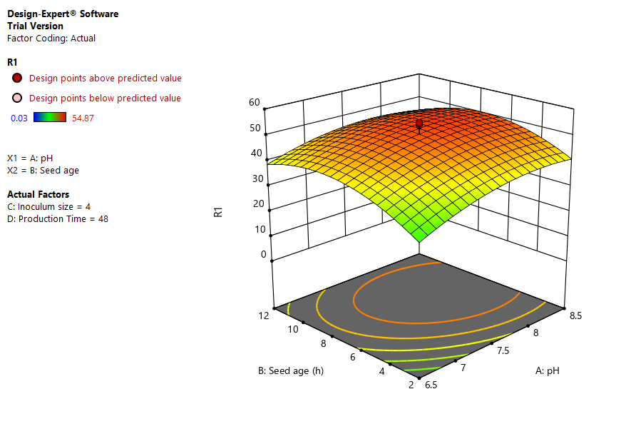  A | 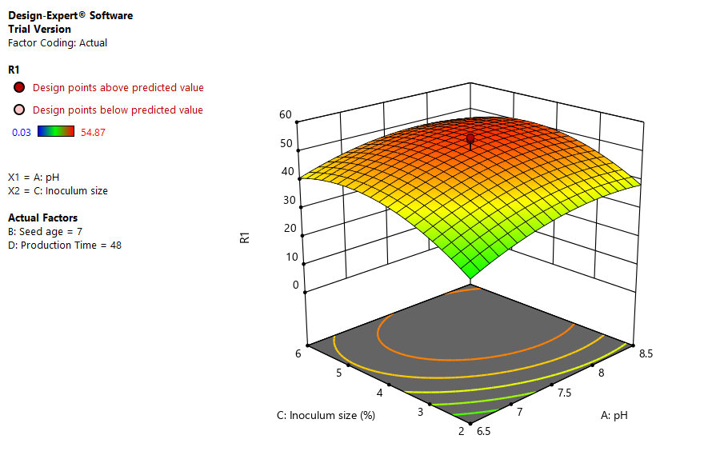  B
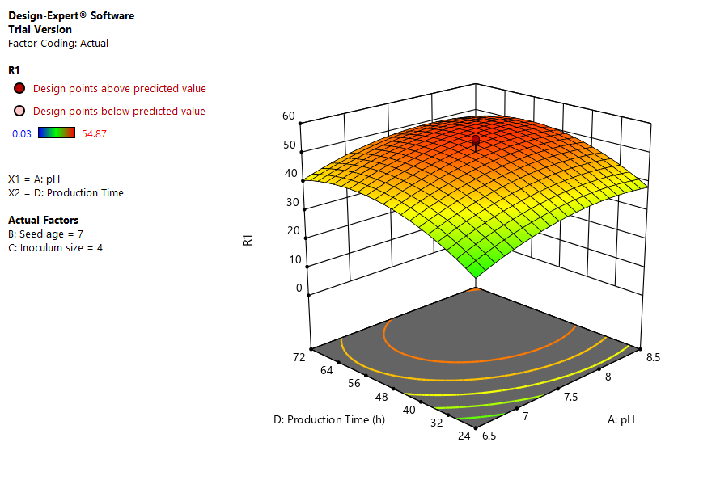  C D | 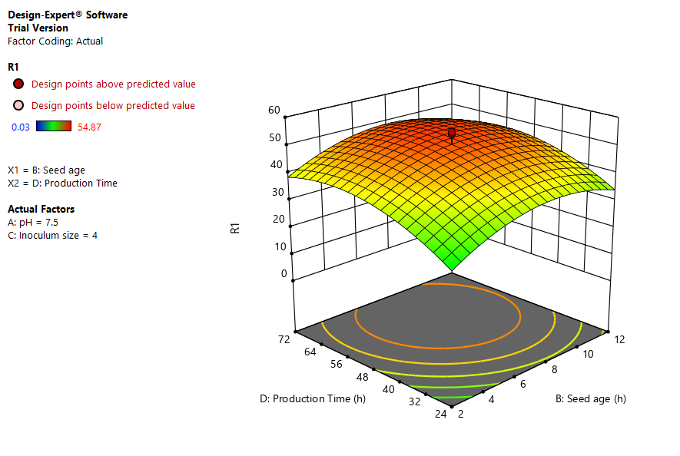
E F | 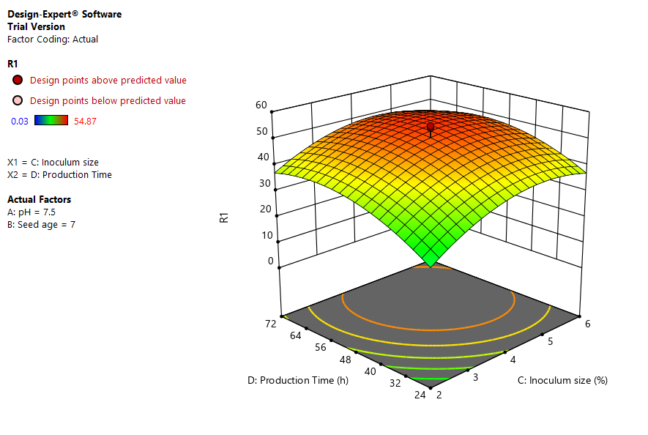
Fig. 2. Three dimensional graphs of CCD model showing interaction among different positive growth variables: A) Seed age (h) and pH, B) Inoculum age (%) and pH, C) Production time (h) and pH, D) Inoculum size (%) and seed age (h), E) Production time and seed age, F) Production time (h) and Inoculum size (%)

Fig. 3: Microbial toxicity effect of LiP treated and Untreated dyes against: (A.) Bacillus (B.) E.coli (C.) Pseudomonas.

