Extended Data Figures

Extended Data Fig. 1: An on-chip angiogenesis assay system using ECs and pericytes and a hydrostatic pressure loading system
a, Microfluidic device mounted on a 35 mm glass bottom dish (left panel). Top view of the area surrounded by a red square (right panel). The device contains five flow channels (1-5) with 700 µm in width, each partitioned by microposts (100 µm window). b, Schematic illustration of the on-chip angiogenesis assay, in which ECs (HUVECs) were administered via channel 4 with or without pre-administration of pericytes (hPlPCs). Sprouting angiogenesis was induced in fibrin-collagen gel (channel 3) by coculturing human lung fibroblasts (hLFs) in channel 1. A representative DIC image of angiogenic branches 3 days after starting cultivation (right panel). Scale bars, 50 µm. c, Representative confocal z-projection images of angiogenic branches visualized by whole-mount immunostaining of CD31 (ECs), VE-cadherin (ECs) and DAPI (Nuclei). Scale bars, 50 µm. d, e, Structural evaluation. A representative confocal z-projection (left panel of c) or 3D image (left panel of e) and its orthogonal views (right panels) showing vascular lumen structures in the angiogenic branches composed of ECs with (e) or without (d) adjacent pericytes detected by PDGFRβ. Angiogenic branches have lumen structures (asterisks) regardless of whether or not pericytes are present. Scale bars, 50 µm for d and 100 µm for e. f, Schematic representation of how to load additional intraluminal pressure (60 Pa) onto on-chip angiogenic branches by producing hydrostatic pressure differences among culture media for the vessel distensibility. The height of the water surface in a syringe barrel, which had been filled with culture media and connected to channel 4 of the device through a pressure resistant connection tube, was adjusted.

Extended Data Fig. 2: Diameter size correlation between lumen and branch in murine retinal angiogenic branches.
A dot graph showing relationship between lumen diameter and branch diameter sizes in P4 murine retinal branches. To induce retinal angiogenic branches without pericytes, mice were treated with anti-PDGFRβ antibodies (APB5) on P1. The data were obtained from portions around the tip (Distal) and more proximal sites (Prox) in murine retinal angiogenic branches with (Cont) and without (APB5) pericyte coverage (Cont-Distal, n=9, Cont-Prox, n=9 from 1 retina; APB5-Distal, n=9, APB5-Prox, n=9 from 1 retina). There was a clear positive relationship between lumen diameter and branch diameter sizes.

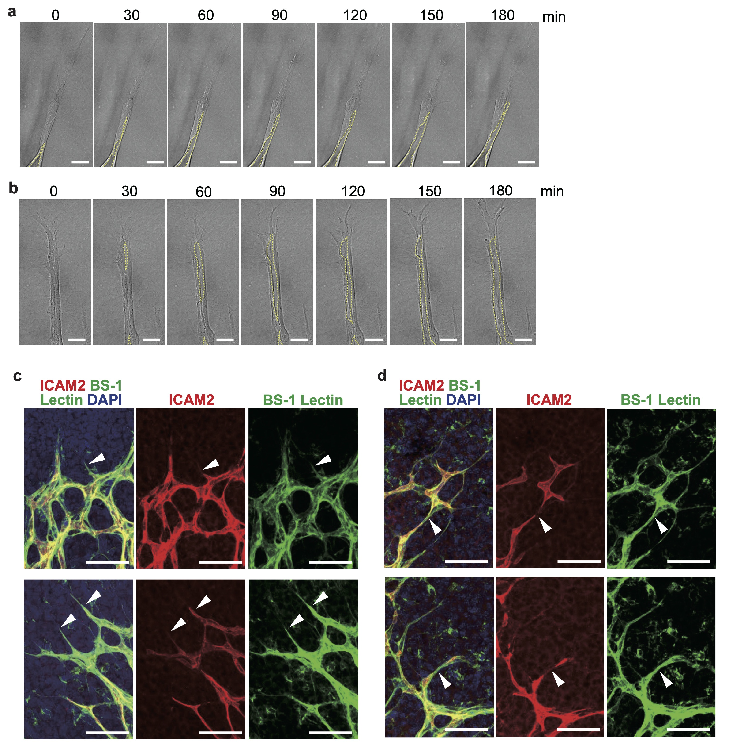

Extended Data Fig. 3: Two patterns of de novo lumen formation in angiogenesis
a, b, Representative time-lapse DIC images showing two different patterns of de novo vascular lumen development around the tip of elongating branches in an on-chip angiogenesis assay: ‘Proximal-to-Distal’ extension of pre-existing proximal lumen toward the tip of the vessel (a, See also Supplementary Video 2) and ‘Distal-to-Proximal’ fusion of large vacuole-like structures initially established in the distal portion of the vessel and secondarily connected to the pre-existing proximal lumen (b, See also Supplementary Video 3). Yellow lines indicate lumen structures. Scale bars, 25 µm. c, d, Representative confocal z-projection images of the leading fronts of developing murine retinal vasculature on P3, showing vascular lumen structure, detected by ICAM2, in BS-1 Lectin-positive EC branches. Angiogenic branches at the tip showed a tapered lumen structure toward the distal tip (white arrowheads), possibly corresponding to “Proximal-to-Distal” extension (c). Less frequently, some angiogenic branches at the tip displayed discontinuous structures (white arrowheads) of vascular lumens from the proximal side toward the distal side, possibly suggesting the ‘Distal-to-Proximal’ fusion pattern of lumen formation seen in the on-chip angiogenesis assay (d). Scale bars, 50 µm.

Extended Data Fig. 4: Quantification of relationships in dynamics between EC movement and vascular lumen expansion in on-chip angiogenesis
a, b, Single EC shape analysis in angiogenic branches using a mosaic method to determine analyzed vascular lumen area on day 4 after starting cultivation. A representative confocal z-projection image of UEA-1 positive EC branches including a small population of genetically GFP-labeled HUVECs (GFP-HUVECs) (left panel of a). A schematic illustration of a representative cell morphology of GFP-HUVEC moving toward the tip of an angiogenic branch (right panel of a). Box plots of length from the center of the nucleus to the front (205-58 µm) or the rear (166-27 µm) of the GFP-HUVEC (n=40 from 5 branches) (b). Scale bar, 25 µm. Data are expressed as means ± SD. c, Kymographs of EC movement (red) and lumen area (proximal area in brue) in elongating branches (upper panel). Serial DIC images of angiogenic branches with trajectory (red line) of the center of the EC nucleus at timepoints indicated in numbers on the kymograph (orange dotted line) (lower panel). Tip EC movement decelerated (white arrows from iv to v) when the lumen was developed via ‘Distal-to-Proximal’ extension (yellow arrowheads) (See also Supplementary Video 5). Scale bars, 25 µm.

Extended Data Fig. 5: Tip EC movement patterns in elongating branches cocultured with and without pericytes, demonstrated by on-chip angiogenesis
Kymographs of individual tip EC movements in elongating angiogenic branches in the absence (a, from 3 devices) or the presence (b, from 3 devices) of pericytes, which correspond to the data in Fig. 3a. A “move forward and stop” pattern of tip EC movement was frequently seen in elongating angiogenic branches without pericyte coculture (a) but rarely in those with pericyte coculture (b).

Extended Data Fig. 6: Setting of area analyzed for quantification of Col-IV or laminin deposition on VBM in murine retinal angiogenic branches
a, Representative confocal z-projection images of leading front of murine retinal angiogenic branches on P4, visualized by whole-mount staining with BS1-lectin (ECs), ICAM2 (vascular lumen) and DAPI (Nuclei). Scale bars, 25 μm. b, Distances from the distal tip of the lumen to the proximal ends of the nuclei of the tip ECs on confocal z-projection images were measured in murine retinal angiogenic branches with (APB) and without (CTL) anti-PDGFRβ antibody treatment (control (CTL), n=28 from 2 retinas; APB5, n=19 from 2 retinas). Data are expressed as means ± SD. c, Schematic representation of VBM area analyzed for quantification of Col-IV or laminin deposition. Based on the analyzed data shown in b, the perivascular area was set within 31 μm distal from the proximal ends of the nuclei of the tip ECs.

Extended Data Fig. 7: Laminin deposition on VBM around the tip at the site of de novo vascular lumen formation in on-chip angiogenesis and in murine retinal angiogenesis
a, Representative confocal z-projection images (z-projection) and confocal x-y slice images at specific z-positions (slice) of on-chip angiogenic branches with and without pericyte coculture, visualized by whole-mount immunostaining for UEA-1 lectin (ECs), laminin and DAPI (nuclei). Scale bars, 50 µm. b, Quantitative analysis of laminin deposition on VBM, evaluated by the following parameters: ‘Coverage rate’ (left panel, pericyte (-), n=10 from 2 devices; pericyte (+), n=10 from 2 devices) and ‘Fluorescence intensity per volume’ (right panel, pericyte (-), n=9 from 2 devices; pericyte (+), n=10 from 2 devices). Data are expressed as means ± SD. Mann-Whitney U test. c, Representative confocal z-projection images of murine retinal angiogenic branches on P4, visualized by whole-mount immunostaining for CD31 (ECs), laminin and DAPI (nuclei), with and without anti-PDGFRβ neutralizing antibody (APB5) treatment that induces removal of pericyte coverage. Scale bars, 20 µm. d, Quantitative analysis of laminin deposition on VBM in the perivascular area around the site of de novo lumen formation (control (CTL), n=25 from 2 retinas; APB5, n=22 from 2 retinas). Data are expressed as means ± SD. Mann-Whitney U test.

Extended Data Fig. 8: Expressions of col4a1 and col4a2 genes in ECs and pericytes and their knock-down using siRNAs
a, Quantitative PCR data for gene expressions of col4a1 and col4a2 in cultured HUVECs and hPlPC (pericytes). Data are expressed as means of ΔΔCT values (n=3 for each group). b, Quantitative PCR data for gene expressions of col4a1 and col4a2 in HUVECs treated with Col4 si (siRNAs for both col4a1 and co4a2 genes) or control (CTL) si for 2 days. Data are expressed as the means of the relative values of ΔΔCT to one in CTL si (n=2 for each group).

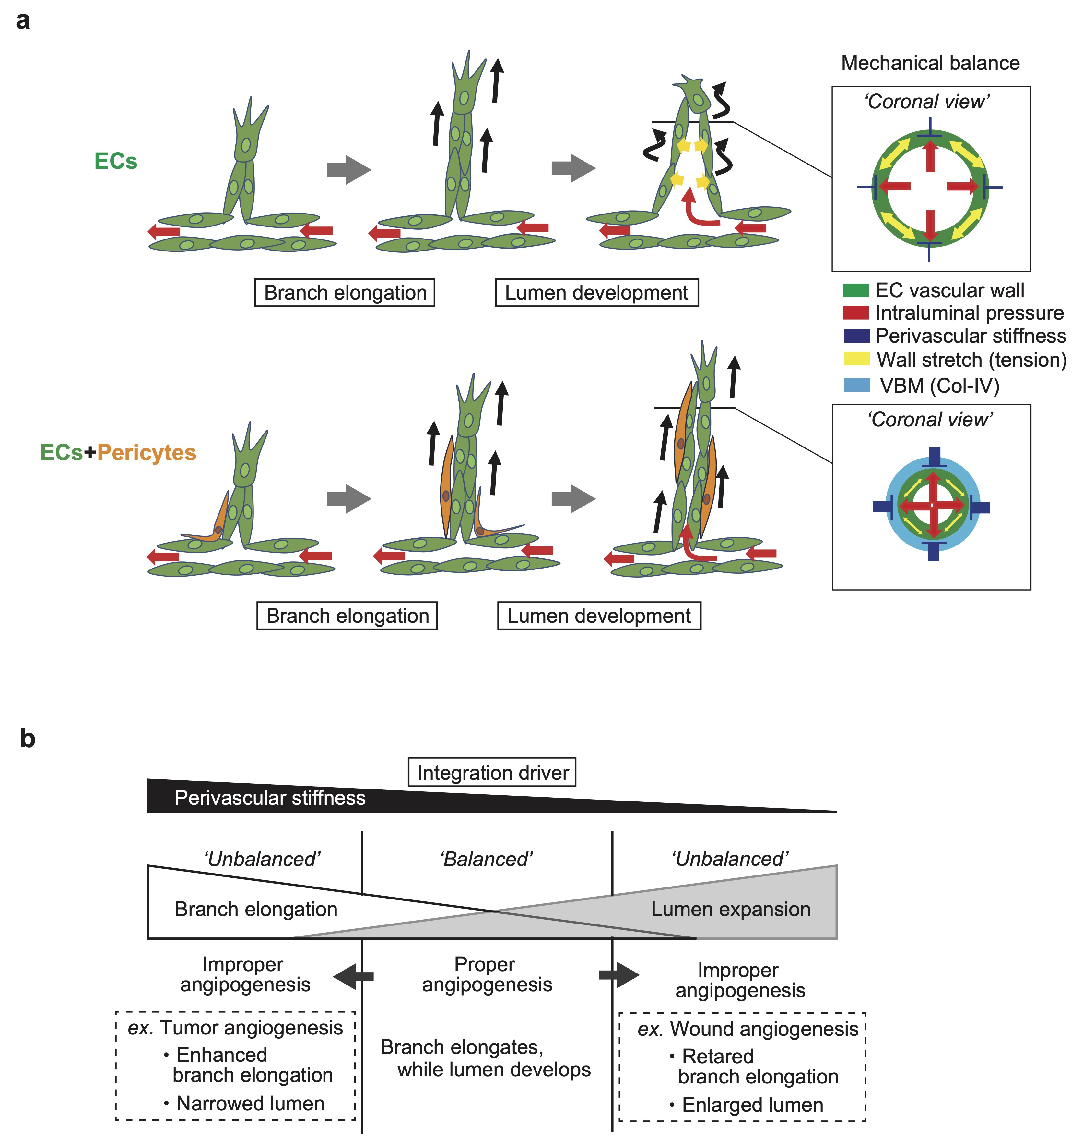

Extended Data Fig. 9: Schematic representations of proposed models of a mechanism integrating branch elongation and lumen expansion in angiogenic morphogenesis and the involvement of their breakdown in improper angiogenesis
a, A biomechanical control model of angiogenic morphogenesis. Upper panel, forward directional movement (black arrows) of ECs, including tip ECs, drive efficient branch elongation. Immediately after the vascular lumen emerges in the elongating branch, blood flows into the lumen, driven by cardiac pumping pressure (blood flow, red arrows), which increases intraluminal pressure followed by circumferential expansion of lumen and branch. The expansion of the lumen and the branch slows forward movement of ECs (winding black arrows). Lower panel, in physiological angiogenesis during the developmental stage, perivascular pericytes adjacent to ECs forming the branch counter-regulate the blood flow-induced inhibition of EC forward movement and branch elongation. Excessive circumferential expansion of the lumen and branch is biomechanically prevented by pericyte-dependent stiffening of the perivascular environment due to enhanced deposition of Col-IV on VBM. In this model, the physical property of the perivascular environment serves as the main driver integrating branch elongation and lumen development by controlling the mechanical balance among factors governing perivascular stiffness, intraluminal pressure and vascular wall stretch (tension). b, A mechanistic model centrally explains proper and improper angiogenesis in different types of situations. In physical situations like the developmental stage, angiogenesis proceeds properly, with branch elongation, while the vascular lumen develops concurrently, under an appropriate mechanical balance among factors governing perivascular stiffness, intraluminal pressure and vascular wall (stretch) tension (‘Balanced’). However, in certain pathological situations, this mechanical balance can be distorted (‘Unbalanced’): for instance, in wound angiogenesis, ectopically increased intraluminal pressure can result in an unbalanced mechanical state, which hinders branch elongation and enlarges both the lumen and the branch. In contrast, in tumor angiogenesis, the perivascular tumor micro-environment is stiffened and perivascular interstitial pressure is elevated, which can induce an unbalanced mechanical state, resulting in enhanced branch elongation with a narrow lumen and thin branch.

Supplemental Tables

Supplementary Table 1. Primer sequences for qPCR.

qPCR
Col4a1 | CCAGGGGTCGGAGAGAAAG | GGTCCTGTGCCTATAACAATTCC
Col4a2 | TTATGCACTGCCTAAAGAGGAGC | CCCTTAACTCCGTAGAAACCAAG
GAPDH | GTCTCCTCTGACTTCAACAGCG | ACCACCCTGTTGCTGTAGCCAA

Supplemental Video Legends

Supplementary Video 1
Long-term DIC time-lapse imaging of on-chip angiogenesis composed of ECs. Elapsed time (min: sec) is shown in the upper left corner. See also Fig. 1a, b.

Supplementary Video 2
DIC time-lapse imaging of the leading front of on-chip angiogenesis composed of ECs. Elapsed time (min: sec) is shown in the upper left corner. See also Extended Data Fig. 3a.

Supplementary Video 3
DIC time-lapse imaging of the leading front of on-chip angiogenesis composed of ECs. Elapsed time (min: sec) is shown in the upper left corner. See also Extended Data Fig. 3b.

Supplementary Video 4
DIC time-lapse imaging of the leading front of on-chip angiogenesis composed of ECs. Elapsed time (min: sec) is shown in the upper left corner. See also Fig. 2c.

Supplementary Video 5
DIC time-lapse imaging of the leading front of on-chip angiogenesis composed of ECs. Elapsed time (min: sec) is shown in the upper left corner. See also Extended Data Fig. 4c.

Supplementary Video 6
DIC time-lapse imaging of the leading front of on-chip angiogenesis composed of ECs. Elapsed time (min: sec) is shown in the upper left corner. See also Fig. 2d.

Supplementary Video 7
DIC time-lapse imaging of the leading front of on-chip angiogenesis composed of ECs. Elapsed time (min: sec) is shown in the upper left corner. See also Fig. 3c.

