S Figure 1 Partial scattered nodules on CT scan of patient
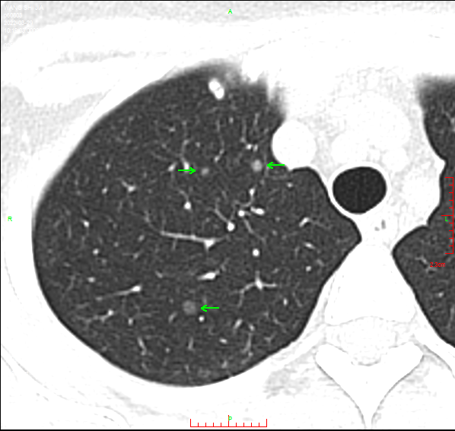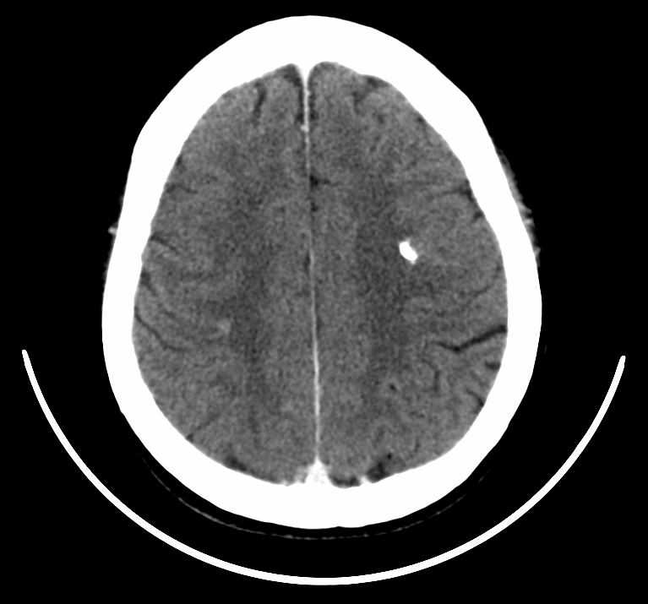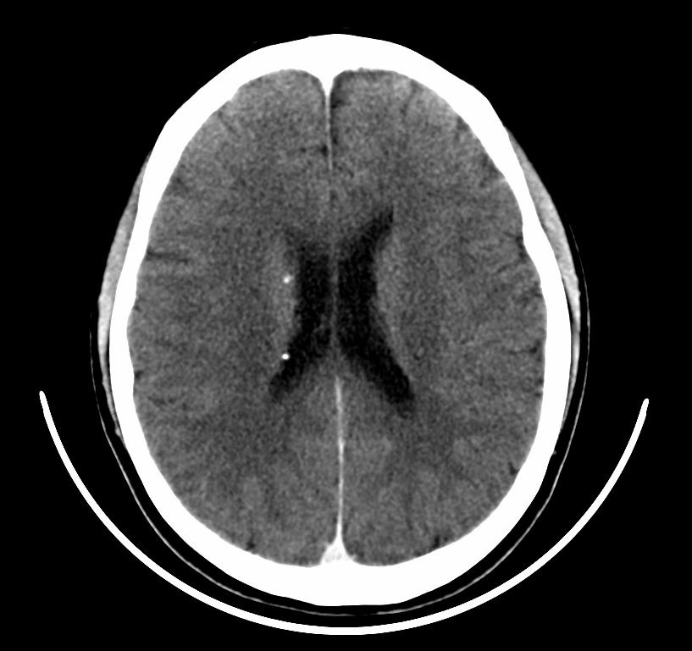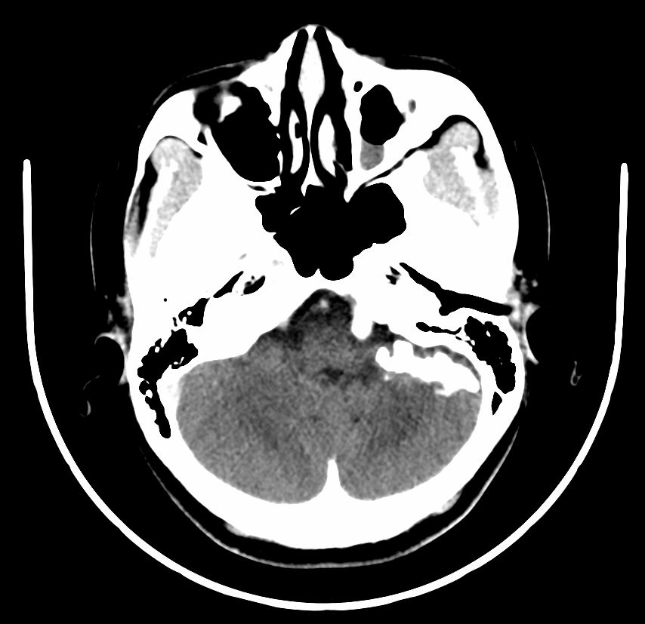
→

→
→

→

→

A
B
C
D
Note: (A) Lung scattered nodules, (B) High-density mass in the left cerebellar hemisphere, (C) High-density nodules in the left frontal lobe, (D) High-density nodules subependymal in the ventricle

S Figure 2 Hypointensity T1 signals were scattered throughout the brain including the bilateral frontotemporal occipital lobes, lateral ventricles, and left cerebellar hemisphere. And the bilateral frontotemporal occipital lobes, and lateral ventricles showed hyperintensity T2 signals while the left cerebellar hemisphere showed the hypointensity T2 signal.
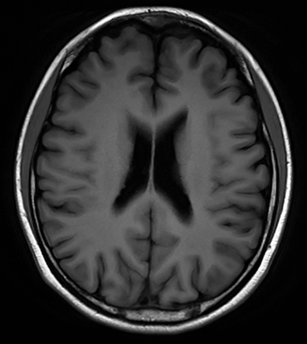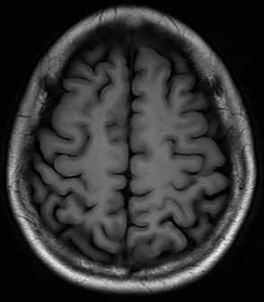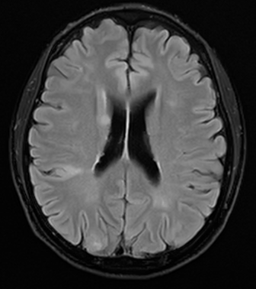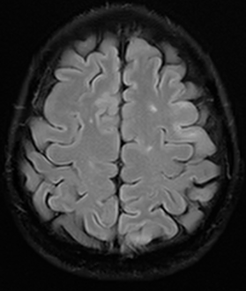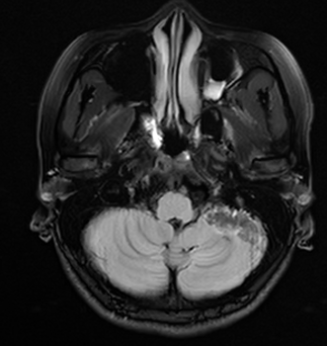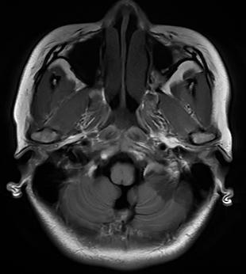

S Figure 3 abnormal signals were also found on the skeleton by Subsequent Positron Emission Tomography Computed Tomography
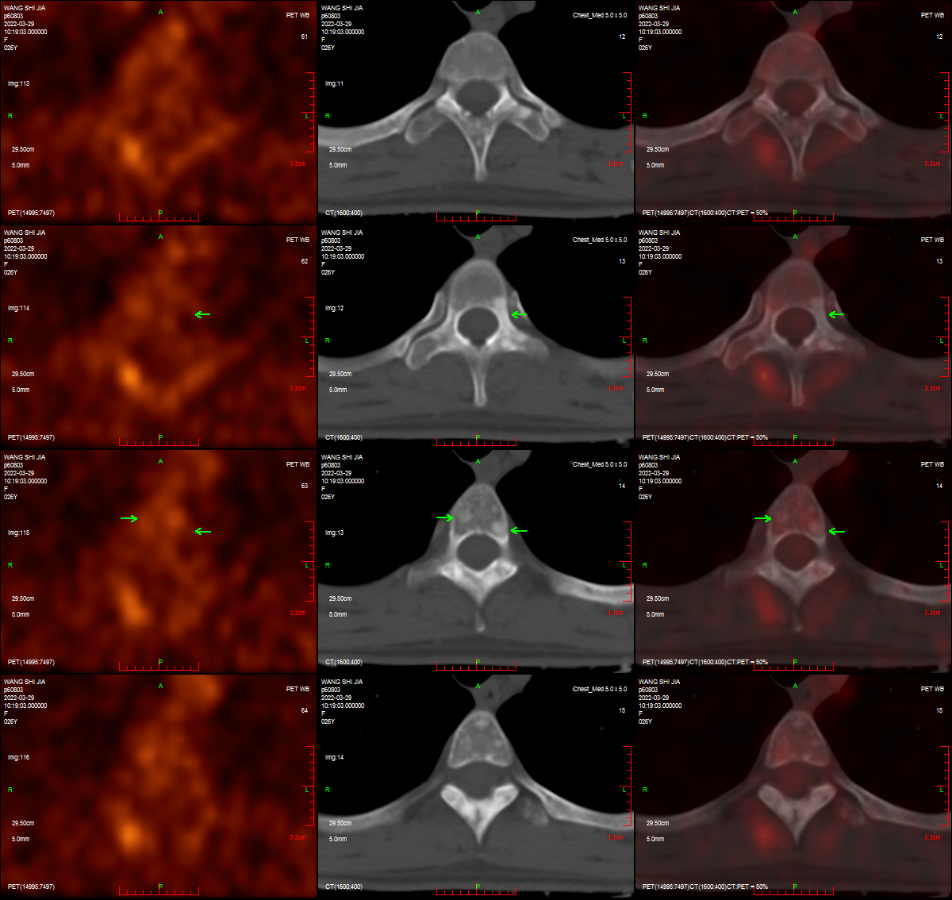

S Figure 4 The left side shows the EEG before antiepileptic treatment, and the right side shows the EEG after antiepileptic treatment
