Supplementary File 1: Full images of the blots
Raw blots for Figure 8:
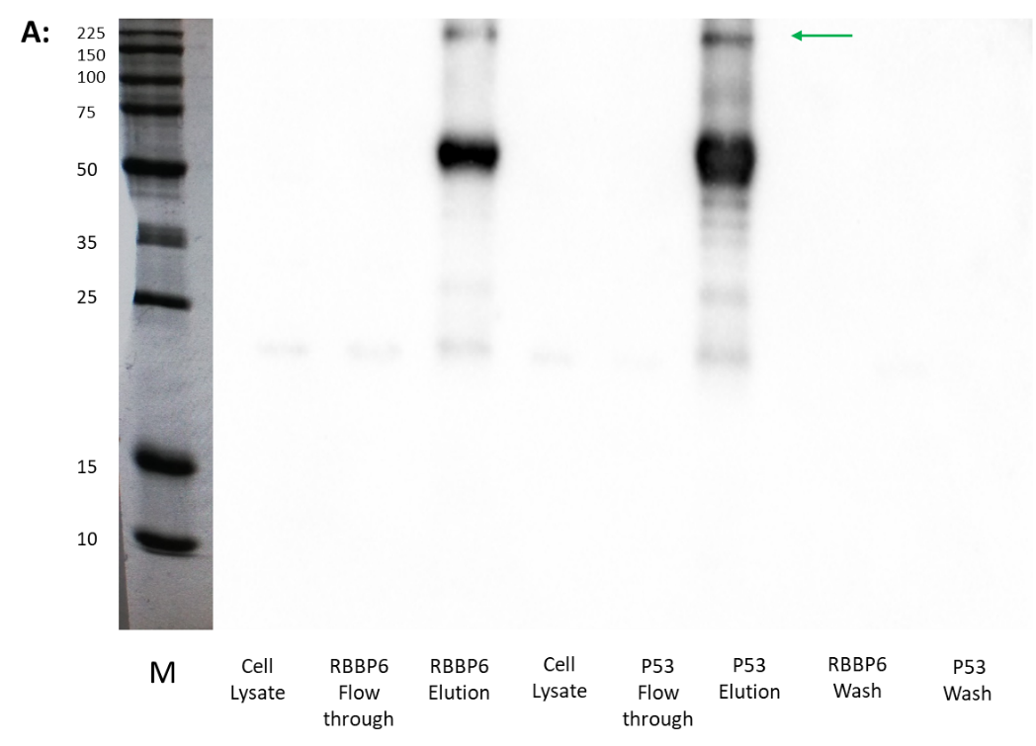

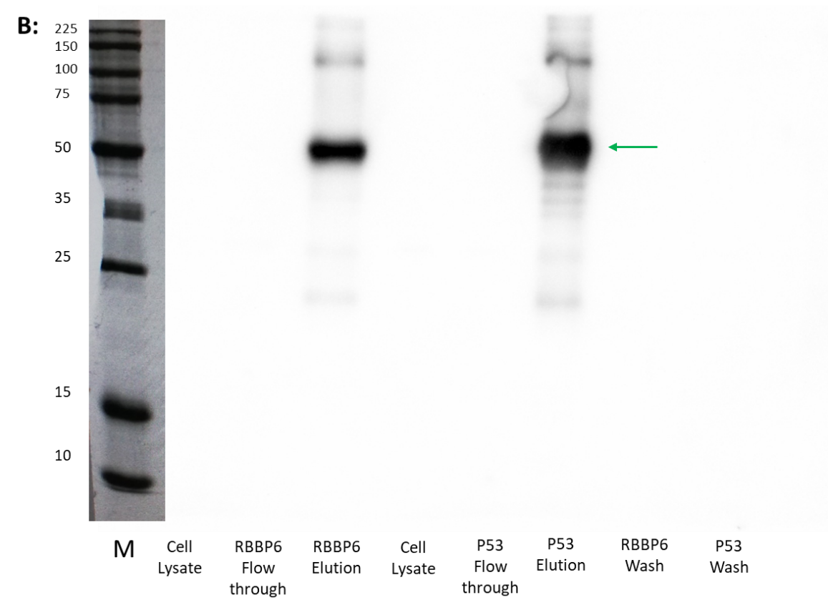
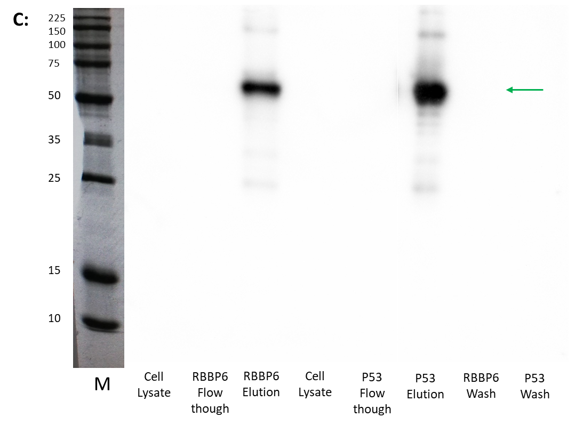
Western blot analysis of samples collected during Co-IP assays using HEK293 T cells. Cell lysate is the lysed HEK293 T cells used in the experiment. Flow-through is the proteins that did not bind the antibody-Protein A agarose beads. Elution is the immuno-complexes isolated during the assay eluted off the beads. (A) Western blot detecting RBBP6, band at 200 kDa indicated with green arrow is RBBP6 present in both elution steps. Protein bands at 50 kDa and 25 kDa are the antibody's heavy and light chains, as the same antibody species (rabbit) was used in Co-IP assay and Western blot. (B) Western blot detecting p53, showing p53 present in both elution steps (shown with green arrow). (C) Western blot detecting MDM2, showing the presence of MDM2 in both elution steps (green arrow). Both p53 and MDM2 antibodies used for Western blot were raised in mice, resulting in some similar background bands seen in both blots. Cell lysate samples are dilute compared to elution steps, which is potentially why proteins are not seen in lysate samples. The molecular mass marker (marked as “M”) (Merck chemicals, 69079) has sizes in kDa, marked on the blot.

Raw blots for Figure 9:
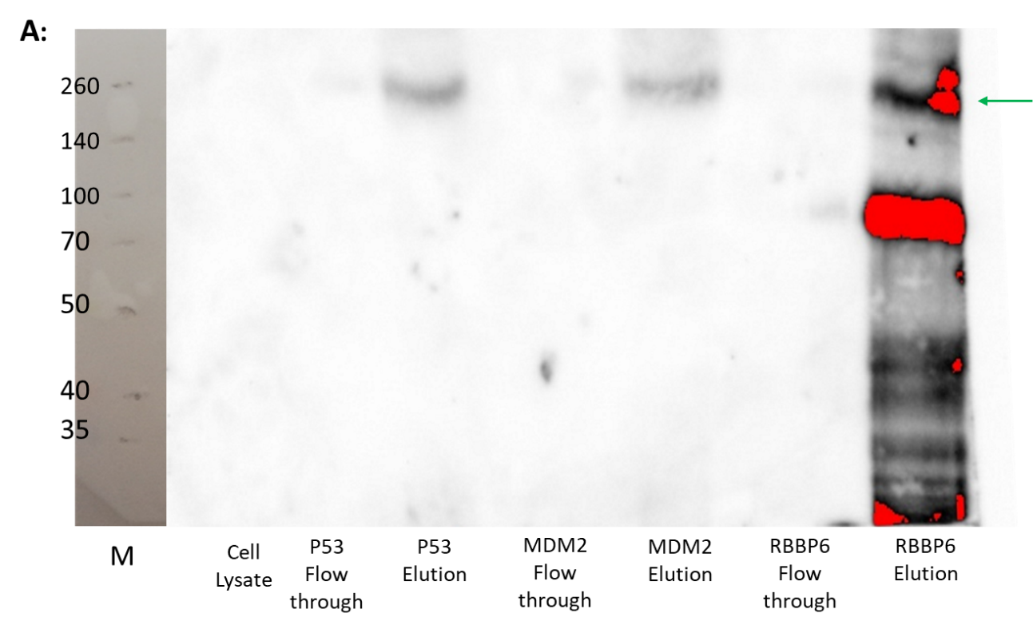
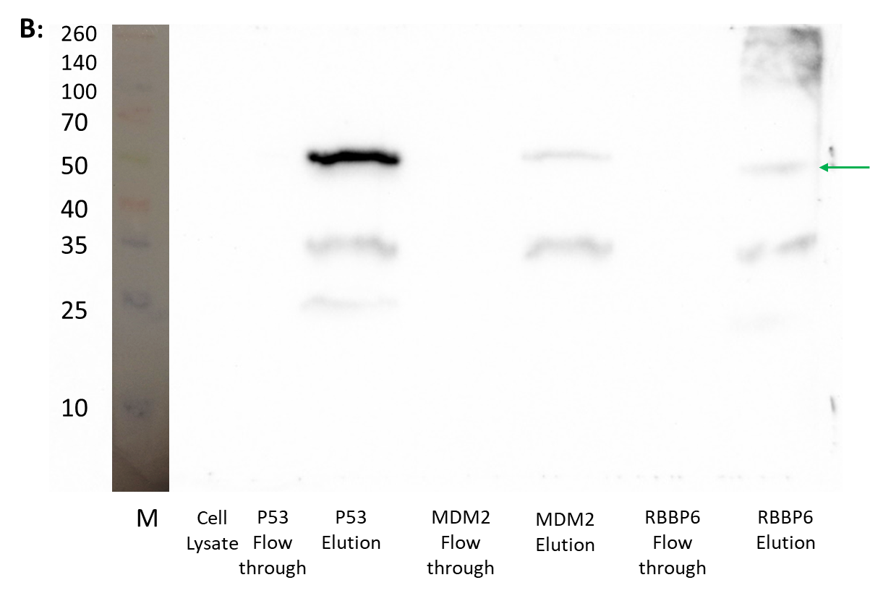

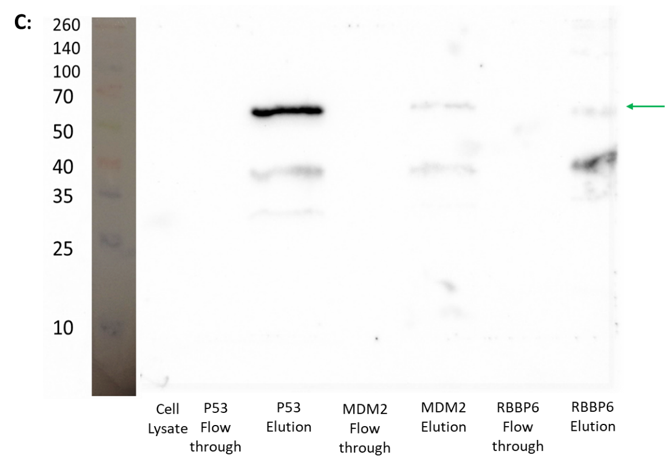
Western blot analysis of samples collected during Co-IP assays using MCF7 cells. Cell lysate is the lysed MCF7 cells used in the experiment. The molecular weight markers (Thermo Scientific, 26634) were used to stain the membrane and then sized to blot images, with molecular weights in kDa indicated. Flow-through is the proteins that did not bind the antibody-Protein A agarose beads. Elution is the immuno-complexes isolated during the assay eluted off the beads. (A) Western blot detecting RBBP6, band at 200 kDa indicated with green arrow is RBBP6 present in all three elution steps. Protein bands at 50 kDa and 25 kDa are the antibody's heavy and light chains, as the same species were used for antibodies used in Co-IP assay and Western blot. (B) Western blot detecting p53, showing p53 present in all three elution steps (shown with green arrow). (C) Western blot detecting MDM2, showing the presence of MDM2 in all three elution steps (green arrow). Both p53 and MDM2 antibodies used for Western blot were raised in mice, resulting in some similar background bands seen in both blots. Cell lysate samples dilute compared to elution steps, which is potentially why proteins are not seen in lysate samples.

