Additional file 1

Rational engineering a xylanase hyper-producing system in Trichoderma reesei for efficient biomass degradation

Su Yan, Yan Xu, Xiao-Wei Yu*
Key Laboratory of Industrial Biotechnology, Ministry of Education, School of Biotechnology, Jiangnan University, Wuxi 214122, P.R. China
* Corresponding author
E-mail addresses: yuxw@jiangnan.edu.cn (X.W. Yu)

Table S1 Strains used in this study
Strains | Genotype | Source
TOP10 | Escherichia coli used for Cloning | Stored in lab
AGL1 | Agrobacterium tumefaciens AGL1 typically used for ATMT | Stored in lab
Rut-C30 | Trichoderma reesei CICC 13052 | See in paper
Δura3 | ura3⁻ | Stored in lab
C30/xyn2 | ura3⁺ hyg⁺ Pcbh1-xyn2-Tcbh1 | This study
C30/xyn2Δcbh1 | ura3⁺ hyg⁺ Δcbh1::Pcbh1-xyn2-Tcbh1 | This study
C30/pdcxyn2 | ura3⁺ hyg⁺ Ppdc-xyn2-Tcbh1 | This study
OExyr1 | ura3⁺ Pgpd-xyr1 | This study
OExyr1Δace1 | ura3⁺ Δace1::Pgpd-xyr1 | This study
OExyr1/xyn2 | ura3⁺ hyg⁺ Pgpd-xyr1; Pcbh1-xyn2-Tcbh1 | This study
OExyr1Δace1/xyn2 | ura3⁺ hyg⁺ Δace1::Pgpd-xyr1; Pcbh1-xyn2-Tcbh1 | This study
OExyr1/xyn2Δcbh1 | ura3⁺ hyg⁺ Pgpd-xyr1; Δcbh1::Pcbh1-xyn2-Tcbh1 | This study
OExyr1Δace1/xyn2Δcbh1 | ura3⁺ hyg⁺ Δace1::Pgpd-xyr1; Δcbh1::Pcbh1-xyn2-Tcbh1 | This study

Table S2 Primers used for recombinant plasmid construction
Primers | Sequence (5’-3’) | Target
Pcbh1 F | tcggtacccatgaaaggctatgagaaattctggagacg (KpnⅠ) | cbh1 promoter
Pcbh1 R | aaggagaccatgatgcgcagtccgcggtt | cbh1 promoter
Xyn2 F | gactgcgcatcatggtctccttcacctccctcc | xyn2 coding sequences
Xyn2 R | agctgagctcttagctgacggtgatggaagc | xyn2 coding sequences
Tcbh1 F | agctaagagctcagctccgtggcgaaag | cbh1 terminator (right arm)
Tcbh1 R | aatacgtaaactcgtgctctctcgcg (SnaBⅠ) | cbh1 terminator (right arm)
Ppdc F | aattggtaccaggacttccagggctacttggc (KpnⅠ) | pdc promoter
Ppdc R | gggaggtgaaggagaccatgattgtgctgtagctgcgctg | pdc promoter
Cbh1L F | taattcgggggaattcgcgtacatccatcatcacgcacgac | cbh1 left arm
Cbh1L R | aaatccagatcgagctctacgaacaaacaagcgacccaattgg | cbh1 left arm
Poly F | cgtagagctcgatctggattttagtactggattttggttttag | Backbone of pCAMBIA1301G
Lb R | acgcgaattcccccgaattaattcggcgttaattcagt | Backbone of pCAMBIA1301G
Xyr1 F | cgcttgagcagacatcaccatgttgtccaatcctctccgtcg | xyr1 coding sequences
Xyr1 R | tccggtcggcatctactttagagggccagaccggttcc | xyr1 coding sequences
Ura3 F | taacggtgagactagcggccg | ura3 complementary cassette
Ura3 R | gtttccaggtgctcctgggcc | ura3 complementary cassette
Ace1L F | attcgggggaattcgcgtgcttgcactgctgatttccgac | ace1 left arm
Ace1L R | atgaagctccatattctccgcaagcccgagatagacgaaggc | ace1 left arm
Ace1R F | cccaggagcacctggaaacagatgctgcaaacgcttatccac | ace1 right arm
Ace1R R | ggattcaatcttaatacgtacctgcacagaggtacgcagcaaagag | ace1 right arm
* Sequence with underline means restriction sites, and the reverse complementary sequences were shown in bold font. F means forward primer and R means reverse primer.

Table S3 Primers used for RT-qPCR
Primer | Forward (5’-3’) | Reverse (5’-3’)
xyr1 | taccaagtgcgatggcttac | ctctctcggacatattcgca
xyn1 | ggttggacgactggatct | ggttgtcctccatgatgtag
xyn2 | cgagtactacatcgtcgagaa | cgtgcggtaaatgtcgtag
xyn3 | gtacaagggcaagattcgt | aaggcaatcgagacaaact
xyn4 | gggtggcgagagatactt | tgcccactcagtctgtatg
bxl1 | acatcaagcctggtcactc | cagactcgtcggtgttca
axe1 | tcttcgataatgccctctgc | ttatagggcaggccatgaatg
abf1 | atggagttttcgtgtctcca | tctcggcgttgccatagt
sar1 | tggatcgtcaactggttctacga | tgtgtagcaacgtggtcttt

Table S4 Saccharification of alkali pretreated corn stover
 |  | FPase activity (U/mL) | Xylanase activity (U/mL) | pNPXase activity (U/mL) | Volume of load (μL) | Total FPU (mU)
Rut-C30 |  | 4.79±0.28 | 674.18±58.55 | 2.65±0.12 | 41.7 | 199.74
OExyr1 |  | 7.18±0.14 | 1095.72±25.37 | 7.82±1.01 | 27.8 | 199.60
C30/xyn2 |  | 4.18±0.09 | 2163.84±120.21 | 3.22±0.41 | 47.8 | 199.80
OExyr1/xyn2 |  | 6.37±0.08 | 2969.76±359.11 | 3.23±0.28 | 31.4 | 200.02
Rut-C30+ OExyr1/xyn2Δcbh1 9:1 | Rut-C30 | 4.79±0.28 | 674.18±58.55 | 2.65±0.12 | 37.5 | 179.63 | 199.64
Rut-C30+ OExyr1/xyn2Δcbh1 9:1 | OExyr1/xyn2Δcbh1 | 1.64±0.03 | 4531.92±7.81 | 8.64±0.31 | 12.2 | 20.01 | 199.64
Rut-C30+ OExyr1/xyn2Δcbh1 8:2 | Rut-C30 | 4.79±0.28 | 674.18±58.55 | 2.65±0.12 | 33.4 | 159.99 | 200.01
Rut-C30+ OExyr1/xyn2Δcbh1 8:2 | OExyr1/xyn2Δcbh1 | 1.64±0.03 | 4531.92±7.81 | 8.64±0.31 | 24.4 | 40.02 | 200.01
Rut-C30+ cOExyr1/xyn2Δcbh1 7:3 | Rut-C30 | 4.79±0.28 | 674.18±58.55 | 2.65±0.12 | 29.2 | 139.87 | 199.73
Rut-C30+ cOExyr1/xyn2Δcbh1 7:3 | OExyr1/xyn2Δcbh1 | 1.64±0.03 | 4531.92±7.81 | 8.64±0.31 | 36.5 | 59.86 | 199.73
Rut-C30+ OExyr1/xyn2Δcbh1 6:4 | Rut-C30 | 4.79±0.28 | 674.18±58.55 | 2.65±0.12 | 25.0 | 119.75 | 199.78
Rut-C30+ OExyr1/xyn2Δcbh1 6:4 | OExyr1/xyn2Δcbh1 | 1.64±0.03 | 4531.92±7.81 | 8.64±0.31 | 48.8 | 80.03 | 199.78

Figure S1
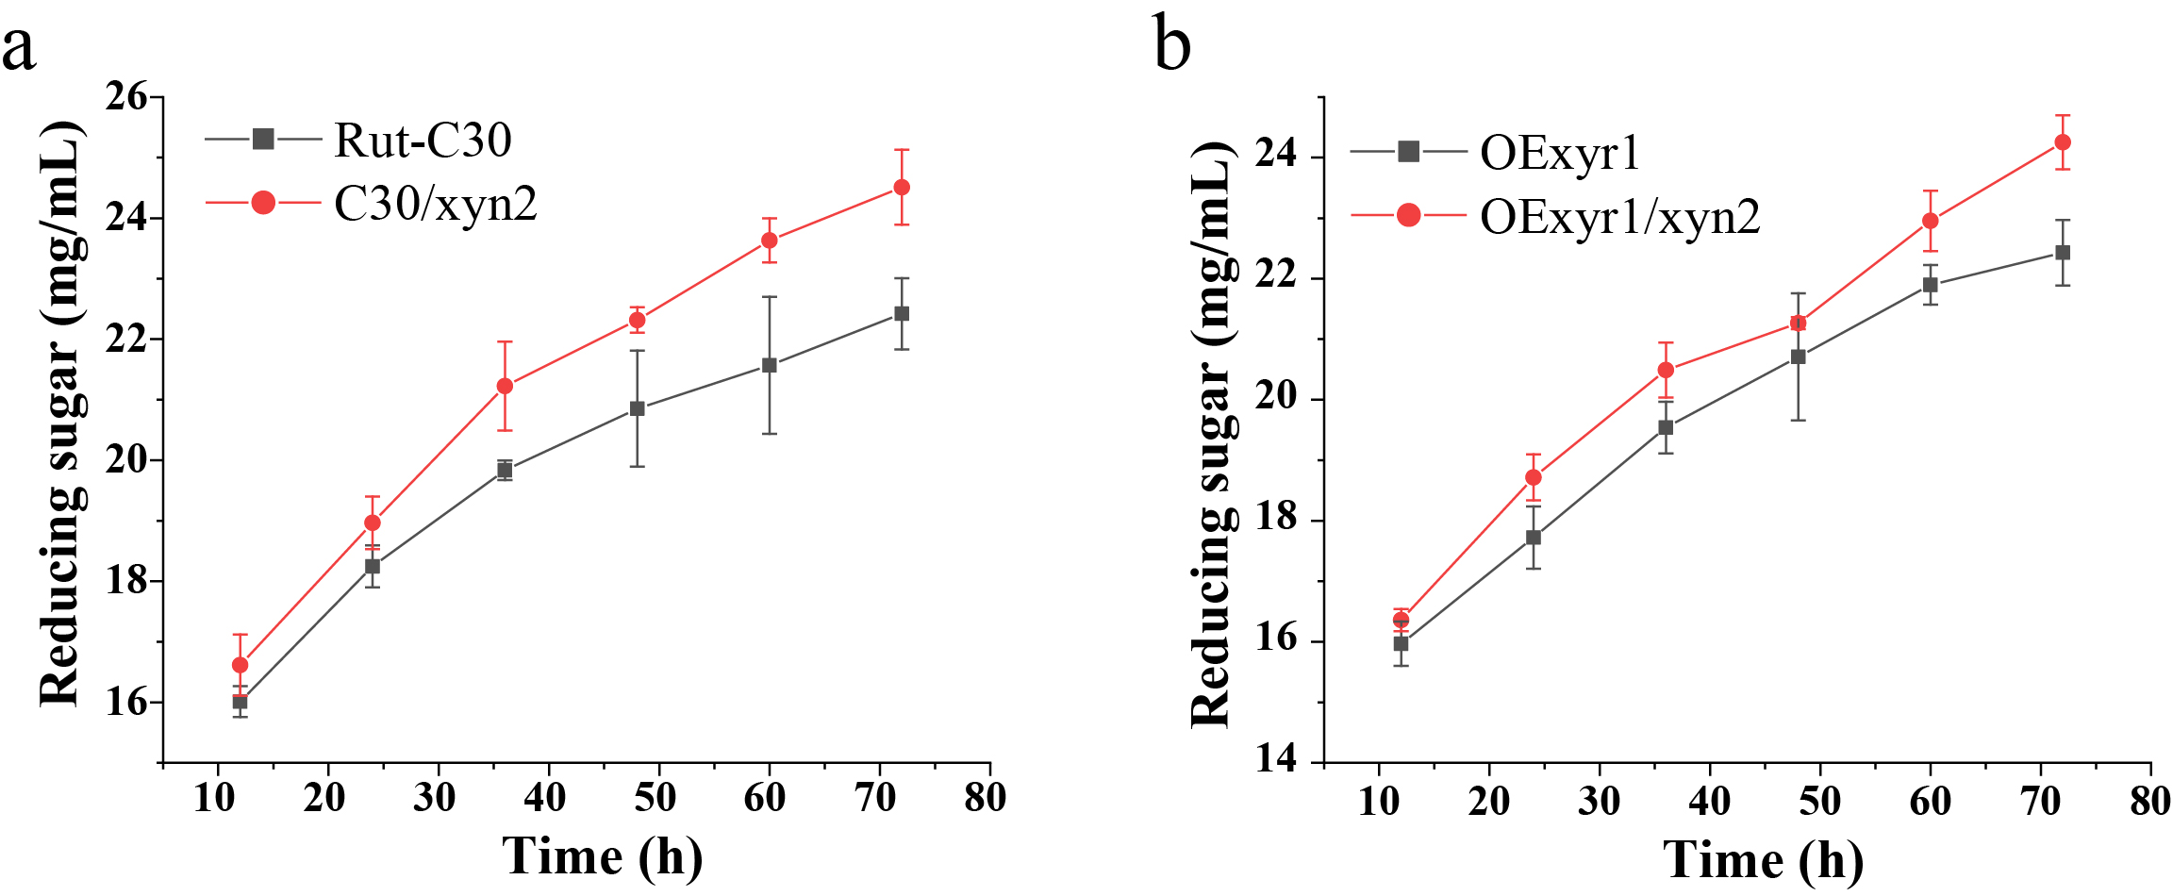
Figure S1 Saccharification of alkali pretreated corn stover (APCS) with enzymes produced by the recombinant strains. a, saccharification of APCS with enzymes produced by Rut-C30 and C30/xyn2. b, saccharification of APCS with enzymes produced by OExyr1 and OExyr1/xyn2. Equal FPU was loaded for each sample, all the experiments were performed with three individual biological repetitions.

