Fig. S1 The figure shows the PTE content of cultivars from various compost amendments (n=3) of both the soils along with Dunnett test (mg/100g)

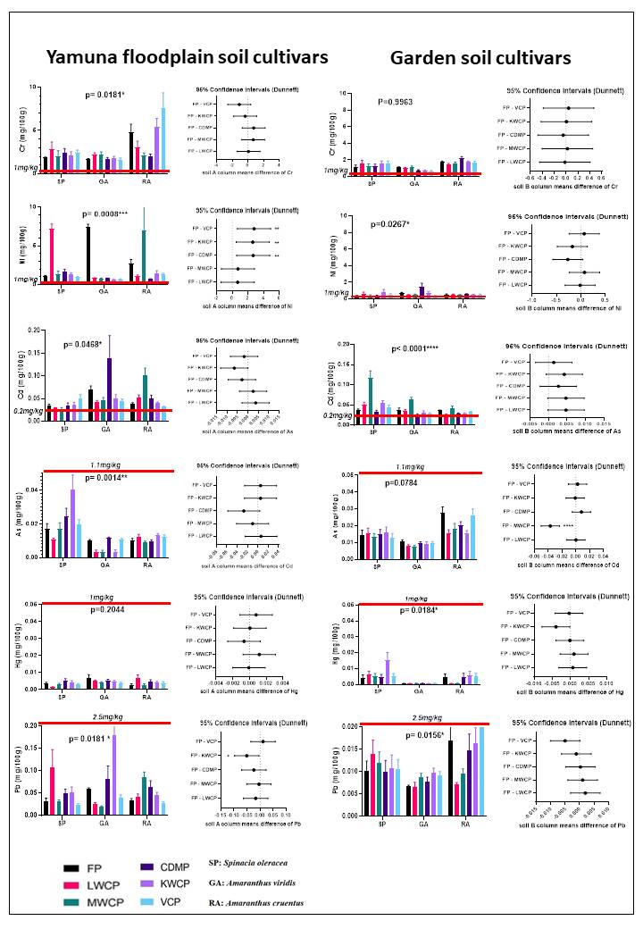 FP, fertilizer amended cultivars; LWCP, leaf waste compost amended cultivars; MWCP, municipal waste compost amended cultivars; CDMP, cow dung manure amended cultivars; KWCP, kitchen waste compost amended cultivars; VCP, vermicompost amended cultivars. The red line is the indicator for permissible limits given by Food Safety and Standards (Contaminants, Toxins and Residues) Regulation, Govt. of India, 2011.
*=p<0.05, **=p<0.01, ***=p<0.001and ****=p<0.0001
Fig. S2 The figure shows the antioxidants content of cultivars from various compost amendments (n=3) of both the soils along with Dunnett test (mg/100g)
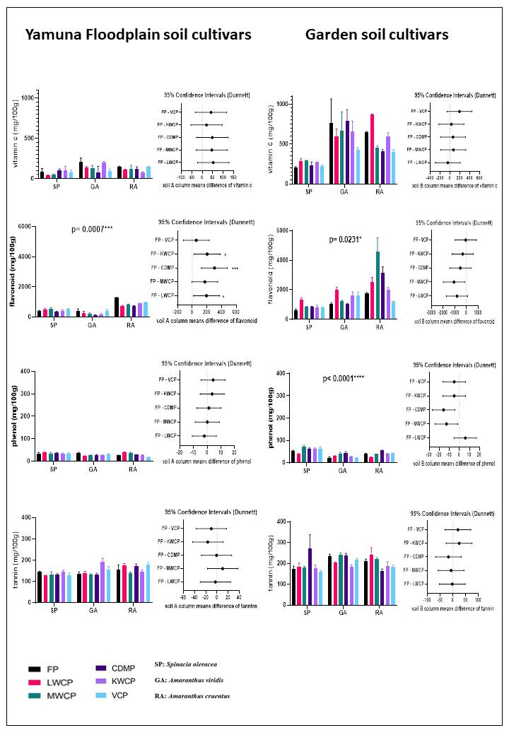
FP, fertilizer amended cultivars; LWCP, leaf waste compost amended cultivars; MWCP, municipal waste compost amended cultivars; CDMP, cow dung manure amended cultivars; KWCP, kitchen waste compost amended cultivars; VCP, vermicompost amended cultivars
*=p<0.05, **=p<0.01, ***=p<0.001and ****=p<0.0001
Fig. S3 The figure shows the antinutrients content of cultivars from various compost amendments (n=3) of both the soils along with Dunnett test (mg/100g)
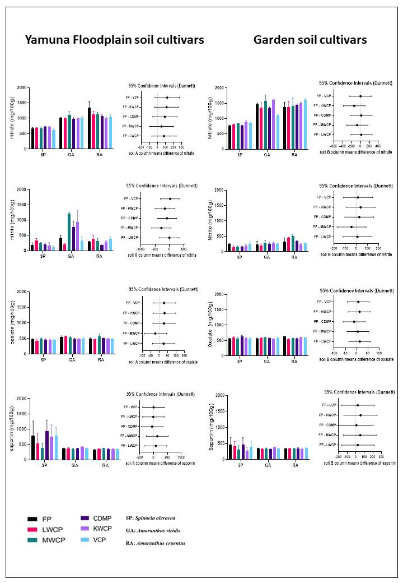
FP, fertilizer amended cultivars; LWCP, leaf waste compost amended cultivars; MWCP, municipal waste compost amended cultivars; CDMP, cow dung manure amended cultivars; KWCP, kitchen waste compost amended cultivars; VCP, vermicompost amended cultivars

