Computational and Synthetic Approach with Biological Evaluation of Substituted Thiazole Derivatives as Small Molecule L858R/T790M/C797S Triple Mutant EGFR Inhibitors Targeting Resistance in Non-Small Cell Lung Cancer (NSCLC)
Sonali S. Shinde¹, Aniket P. Sarkate^{1*}, Sanket S. Rathod², Jaydeo T. Kilbile³, Somdatta Y. Chaudhari⁴, Shailee V. Tiwari⁵, Rajesh Yadala⁶, Smita C. Pawar⁶, Shashikant V. Bhandari⁷
¹Department of Chemical Technology, Dr. Babasaheb Ambedkar Marathwada University, Chhatrapati Sambhajinagar, 431 004 (MS), India.
²Department of Pharmaceutical Chemistry, Bharati Vidyapeeth College of Pharmacy, Kolhapur, 416 013 (MS), India.
³Department of Chemistry, SBAS, MGM University, Chhatrapati Sambhajinagar -431003, (MS), India.
⁴Department of Pharmaceutical Chemistry, PES's Modern College of Pharmacy, Yamunanagar, Nigdi, Pune, 411 044 (MS), India.
⁵Department of Pharmaceutical Chemistry, Shri Ramkrishna Paramhans College of Pharmacy, Hasnapur, Parbhani-431401, Maharashtra, India.
⁶Department of Genetics and Biotechnology Osmania University, Hyderabad-500007, Telangana, India
⁷Department of Pharmaceutical Chemistry, AISSMS College of Pharmacy, Near RTO, Kennedy Road, Pune-411001, Maharashtra, India
*Corresponding author
Dr. Aniket P. Sarkate
E-mail: apssonali21@gmail.com

Email ID of all authors:
Sonali Shinde shindesonali5645@gmail.com
Aniket Sarkate apssonali21@gmail.com
Sanket Rathod ssrathod7588@gmail.com
Jaydeo T. Kilbile kilbilej@gmail.com
Somdatta Chaudhari somuchaudhari@gmail.com
Shailee V. Tiwari shailee2010@gmail.com
Rajesh Yadala rajeshyadala14@gmail.com
Smita C. Pawar Smita.prof@gmail.com
Shashikant V. Bhandari sh
- ashikantbhandari2011@gmail.com

Compound 4a (¹H NMR, DMSO-d₆, 500 MHz)
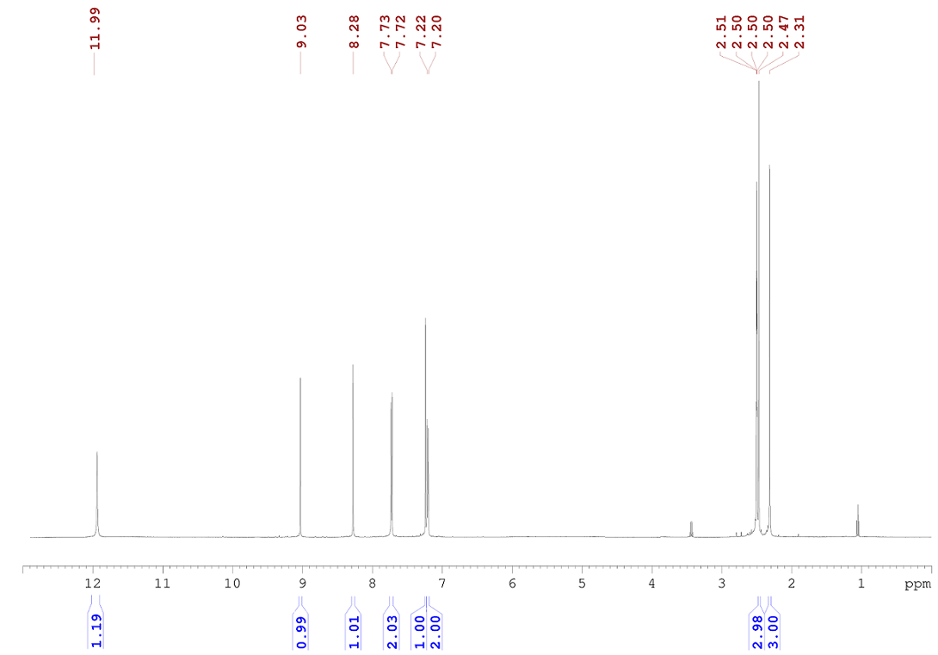
Compound 4a (¹³C NMR, DMSO-d₆, 125 MHz)
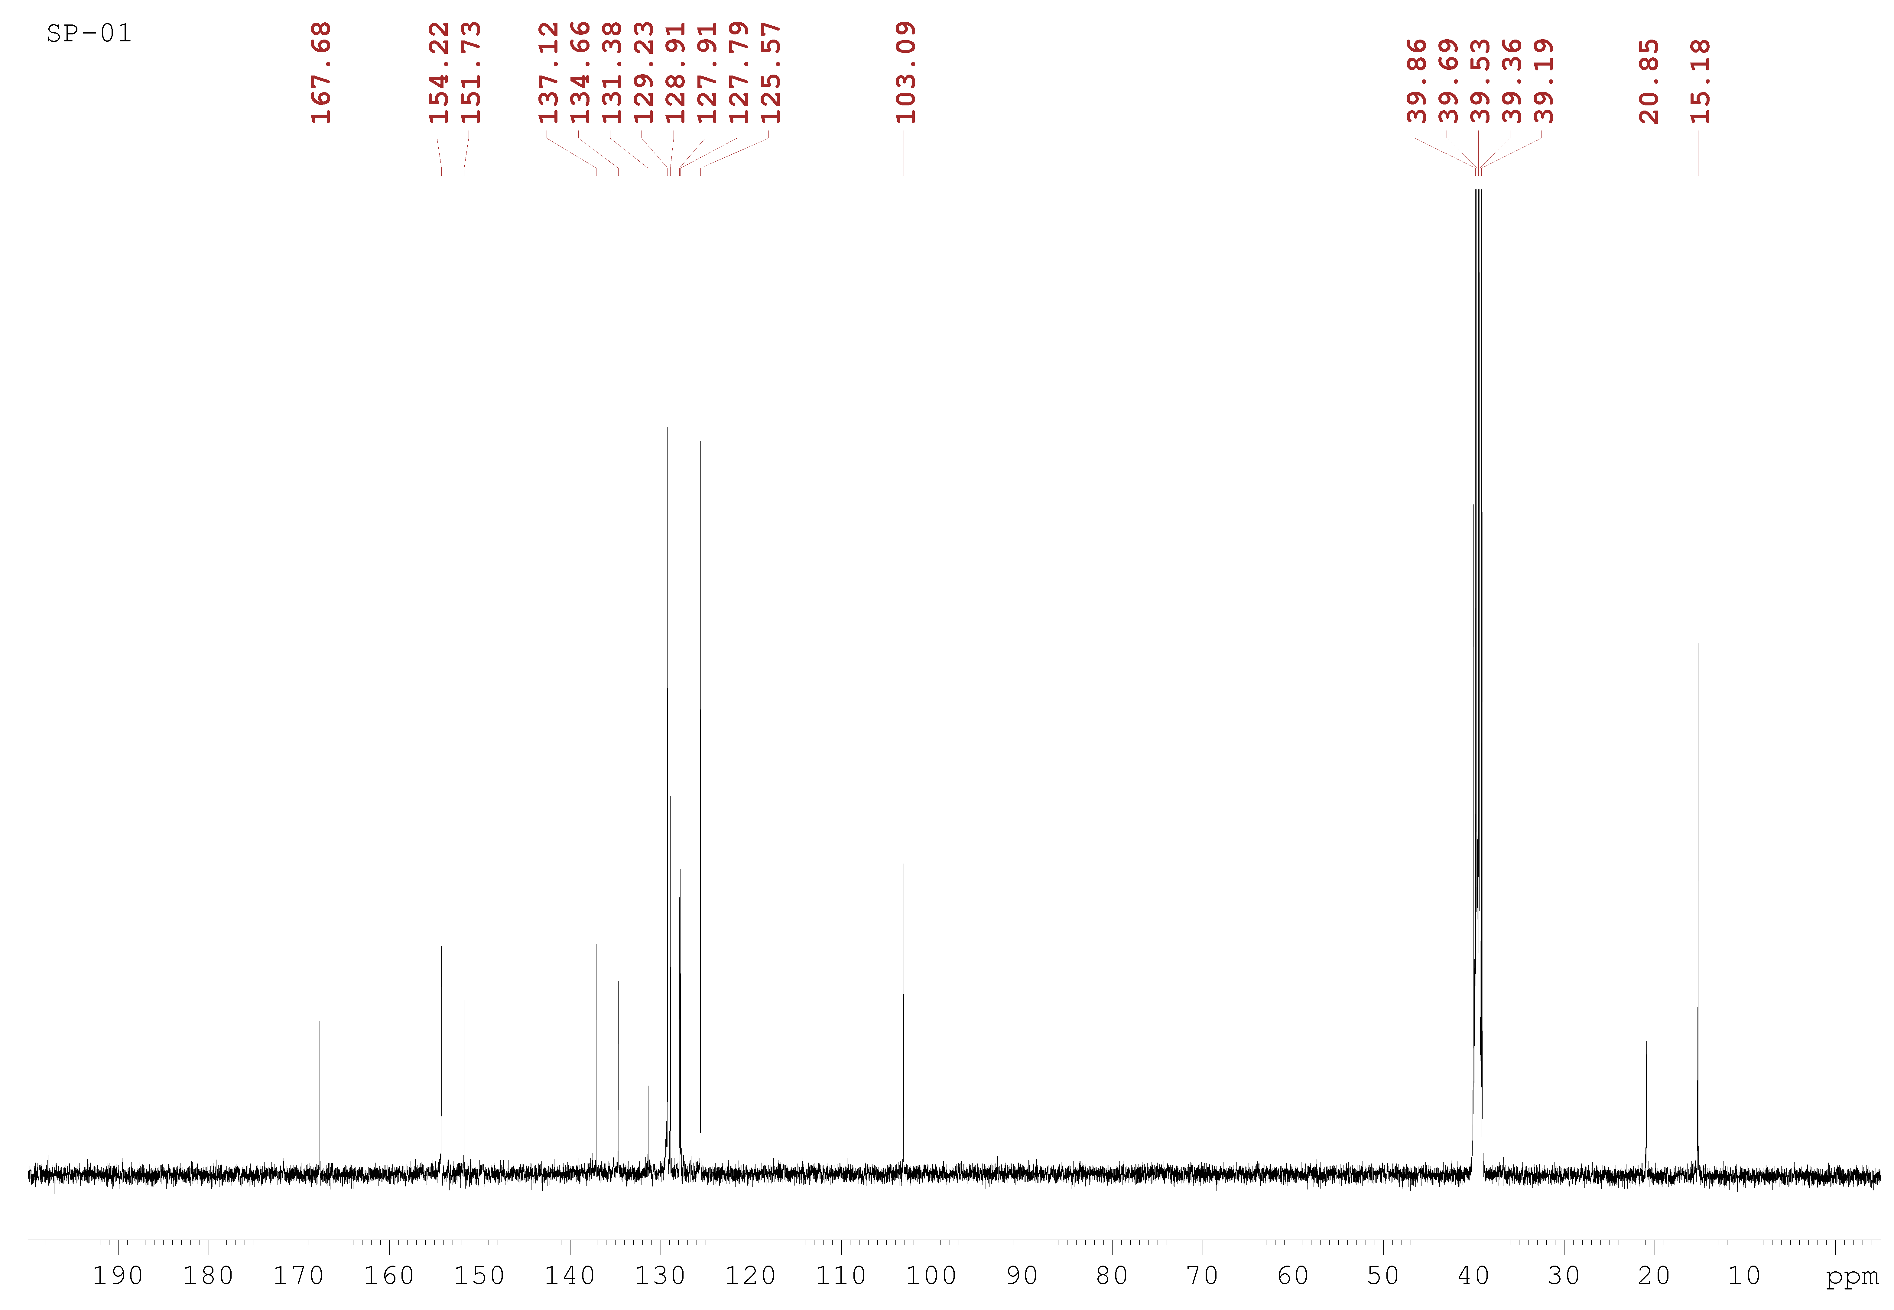
Compound 4a (IR)

Compound 4a Compound 4a (HRMS)
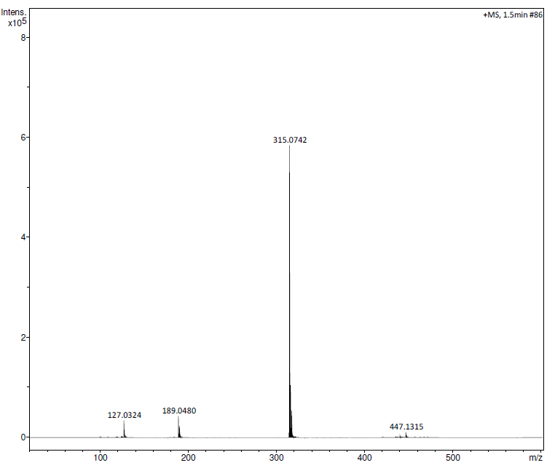

Compound 4b (¹H NMR, DMSO-d₆, 500 MHz)

Compound 4b (¹³C NMR, DMSO-d₆, 125 MHz)
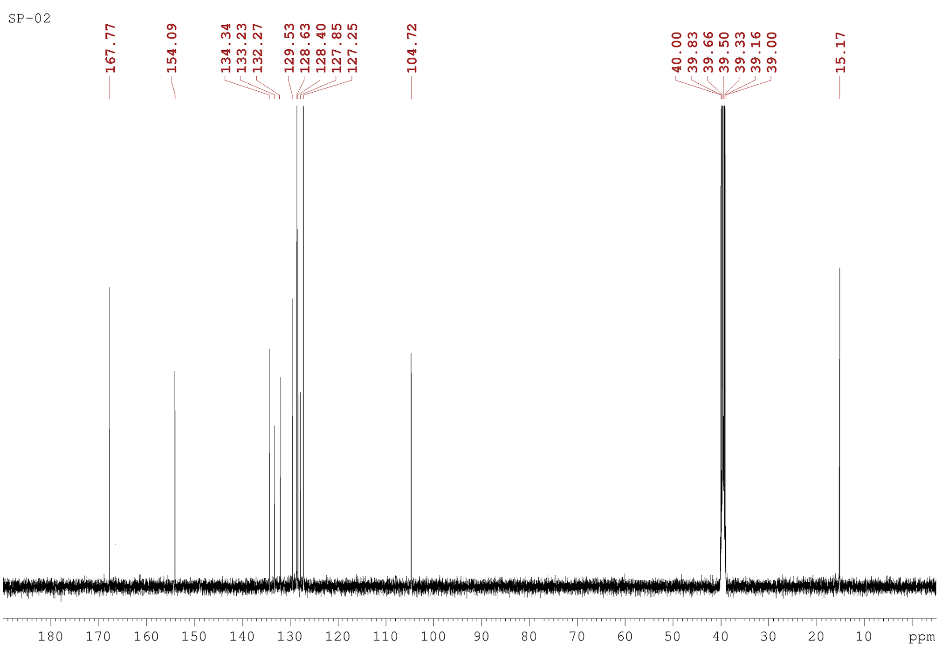

Compound 4b (IR)

Compound 4b (HRMS)
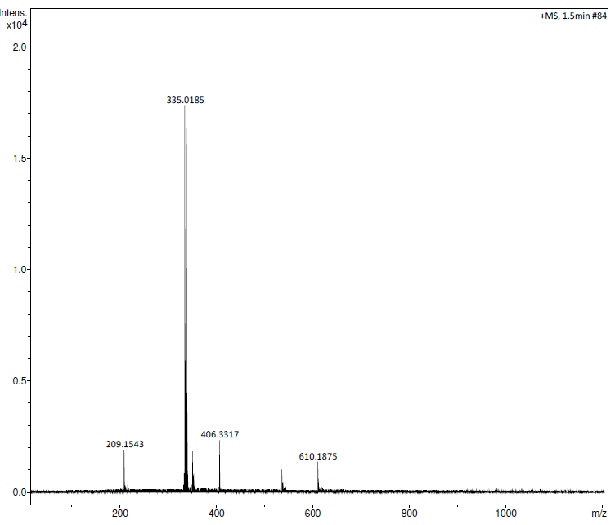

Compound 4c (¹H NMR, DMSO-d₆, 500 MHz)

Compound 4c (¹³C NMR, DMSO-d₆, 125 MHz)
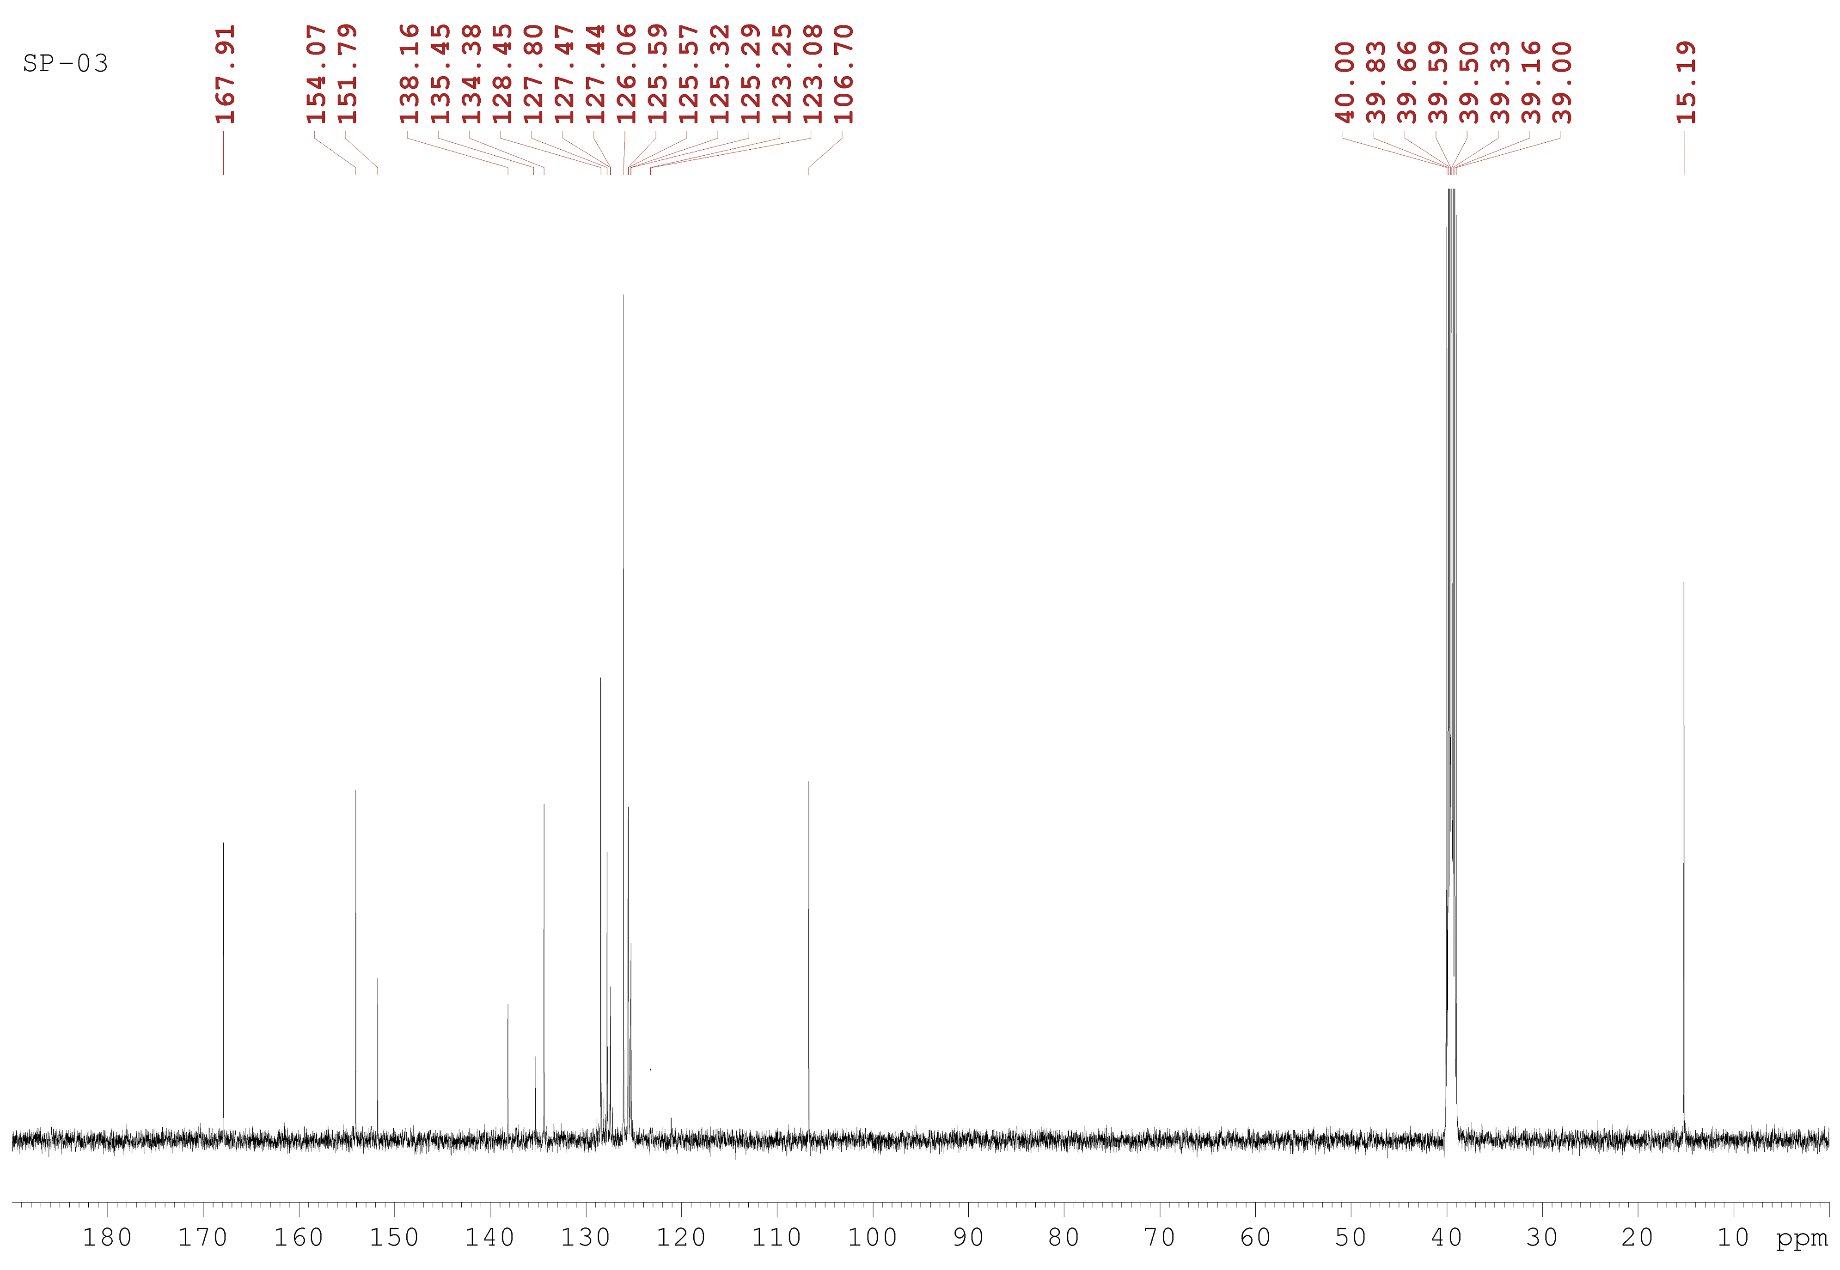

Compound 4c (IR)

Compound 4c (HRMS)
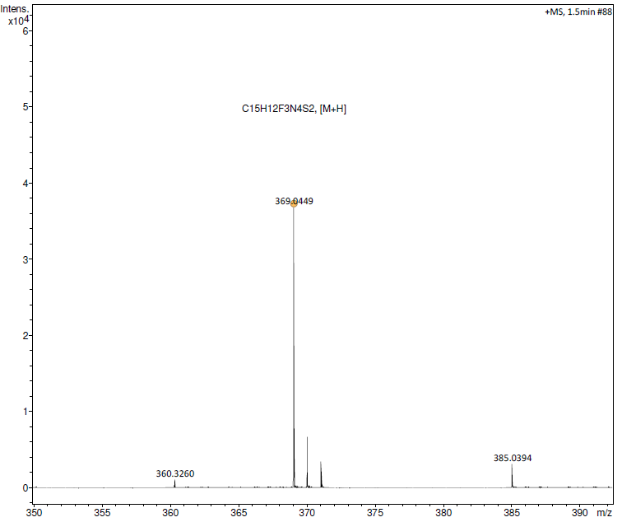

Compound 4d (¹H NMR, DMSO-d₆, 500 MHz)

Compound 4d (¹³C NMR, DMSO-d₆, 125 MHz)
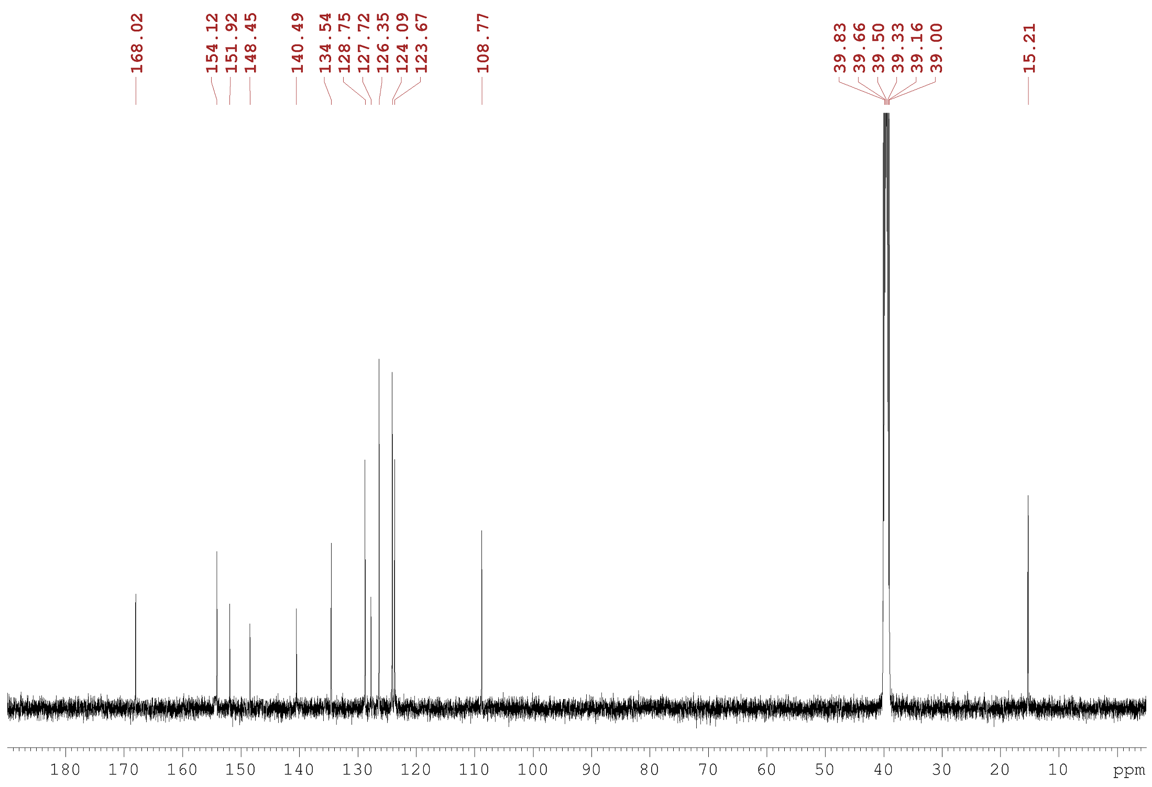

Compound 4d (IR)

Compound 4d (HRMS)
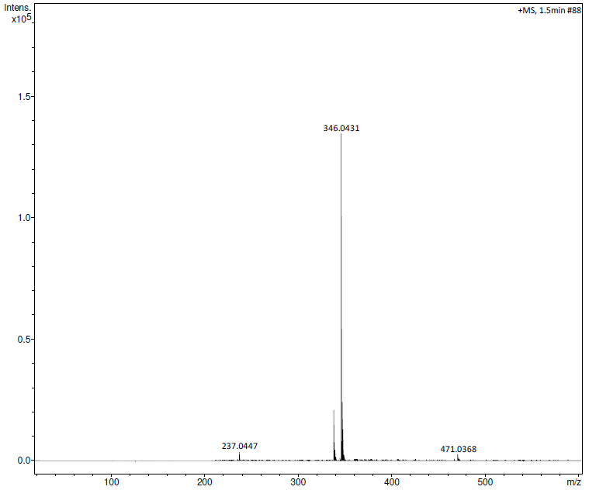
Compound 4e (¹H NMR, DMSO-d₆, 500 MHz)

Compound 4e (¹³C NMR, DMSO-d₆, 125 MHz)
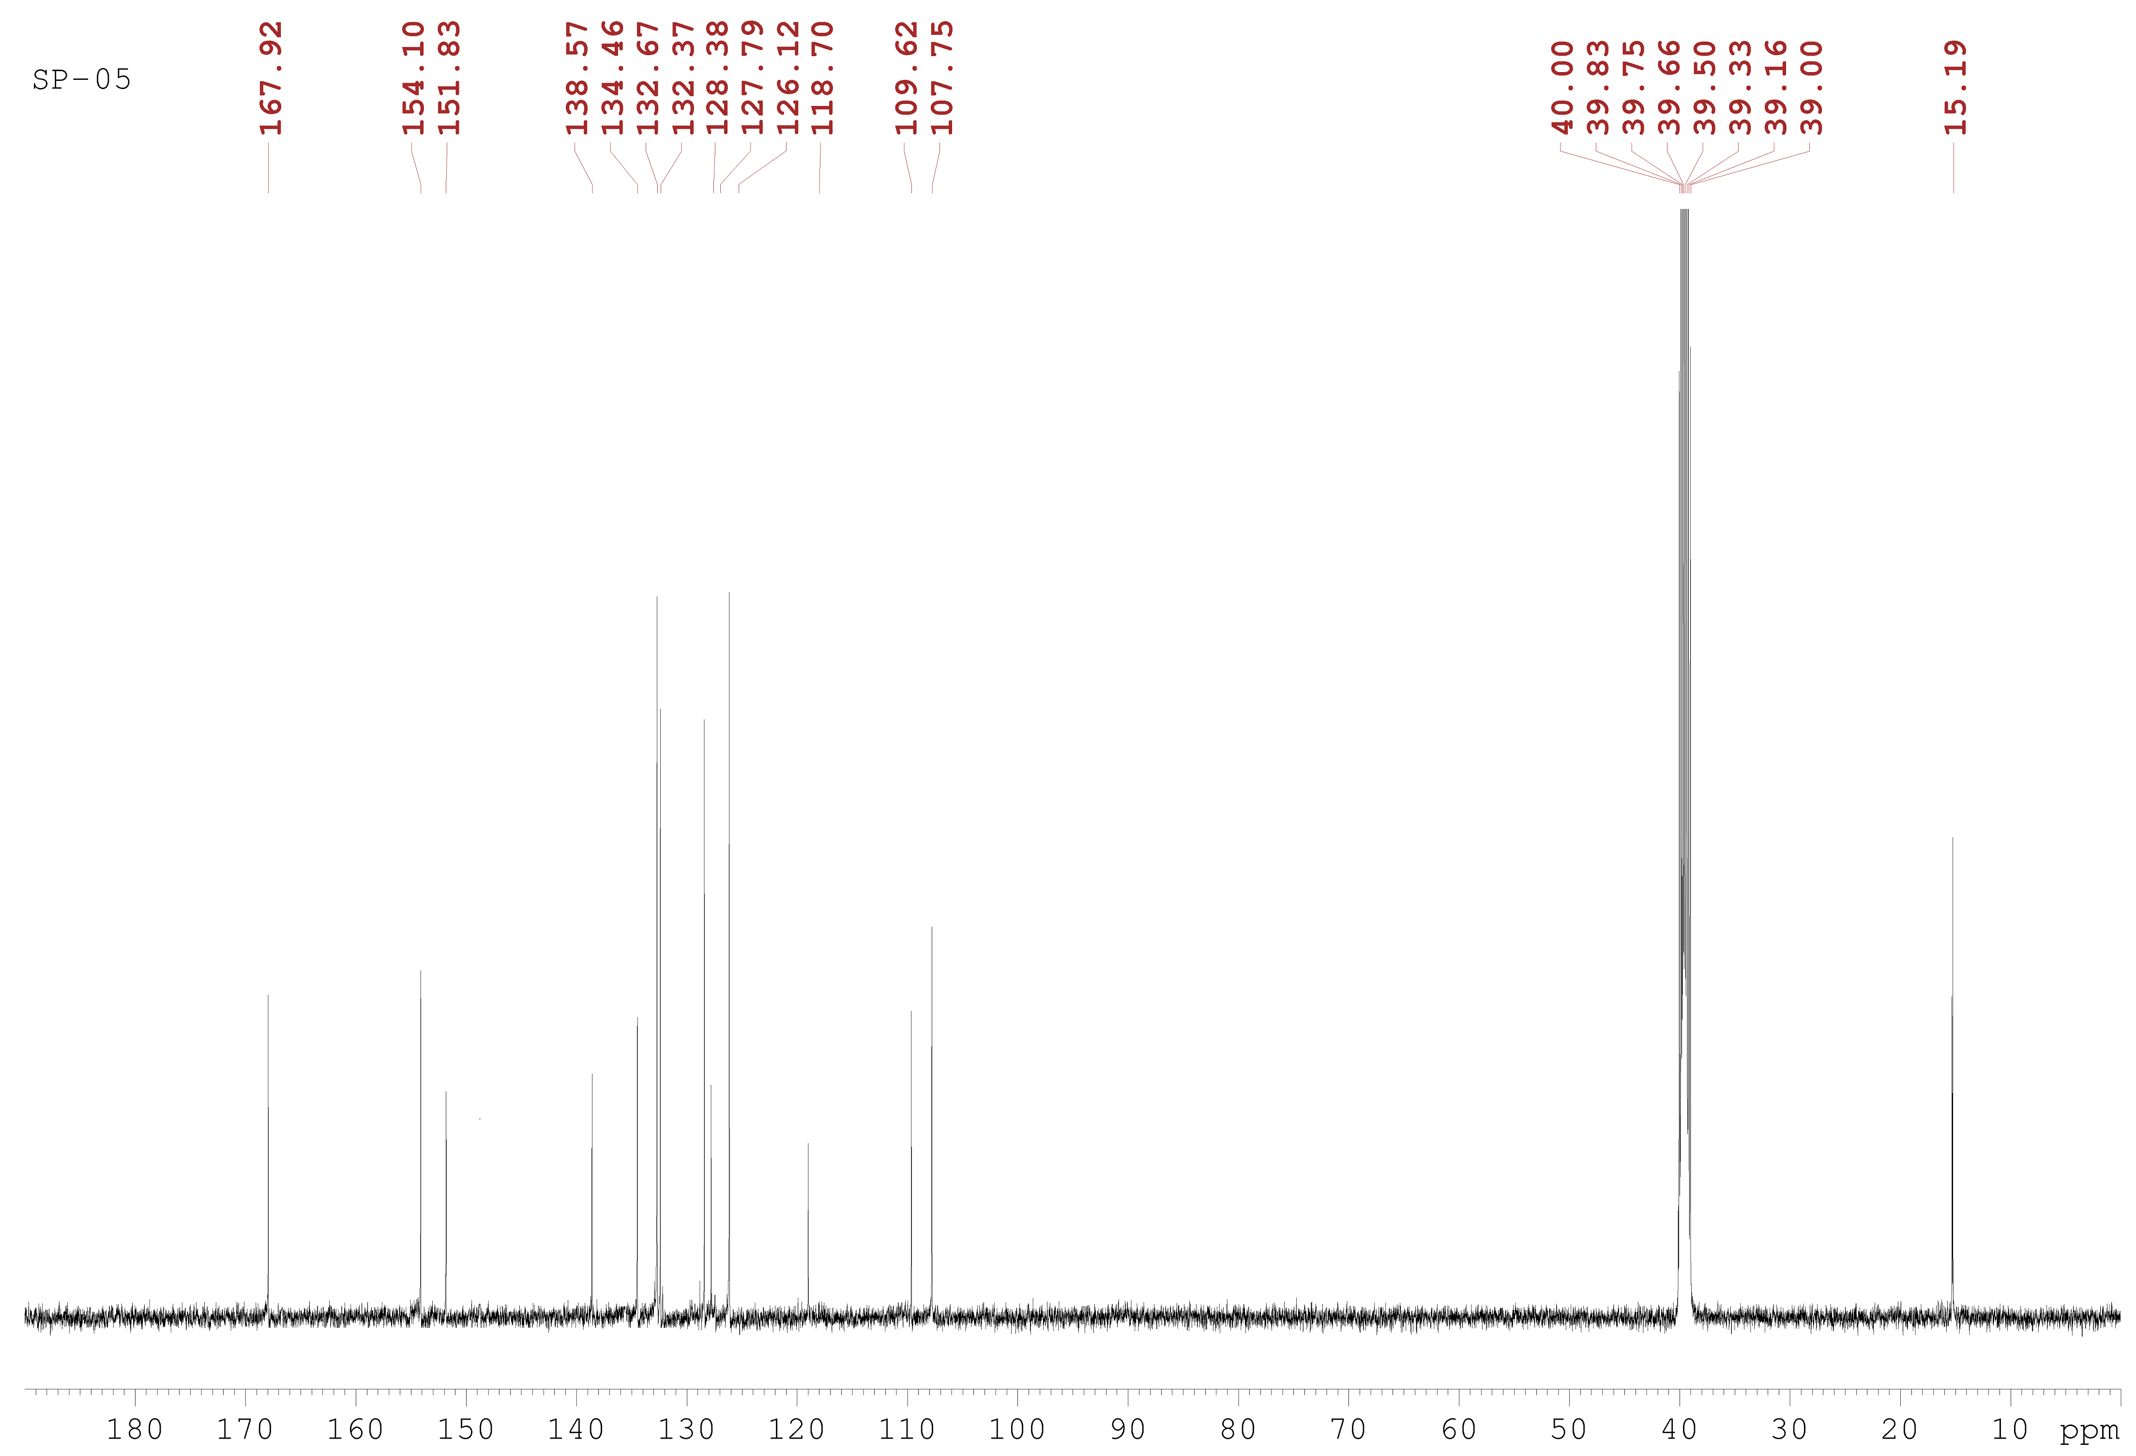

Compound 4e (IR)

Compound 4e (HRMS)
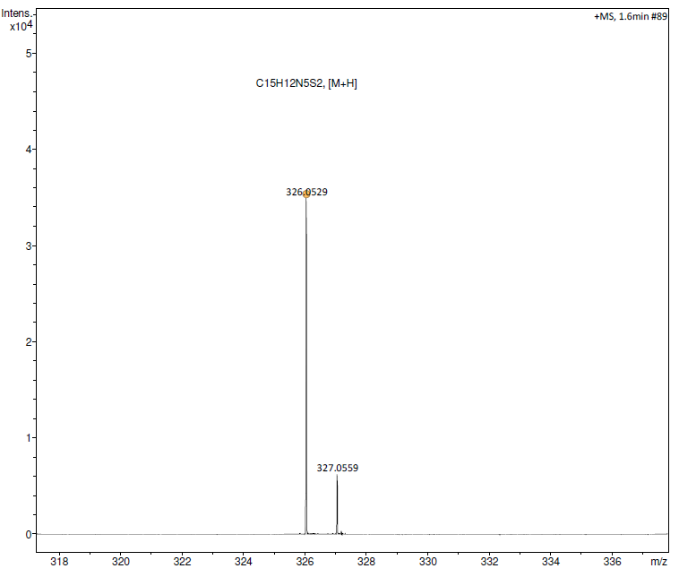
Compound 4f (¹H NMR, DMSO-d₆, 500 MHz)

Compound 4f (¹³C NMR, DMSO-d₆, 125 MHz)
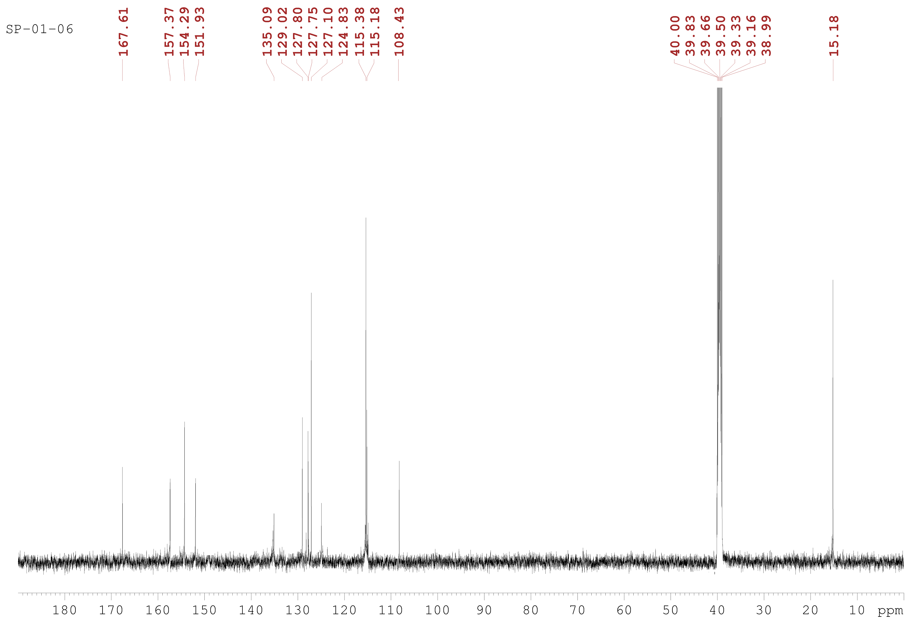

Compound 4f (IR)

Compound 4f (HRMS)
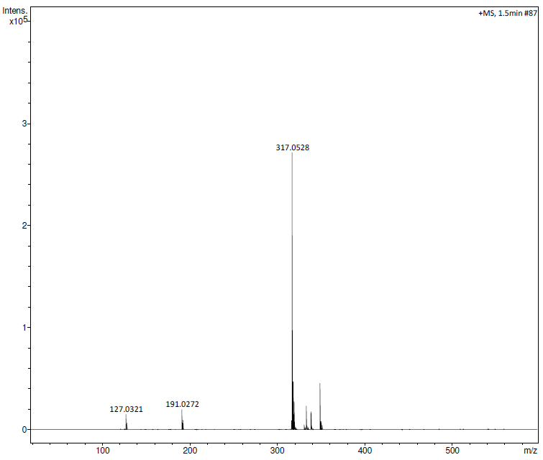
Compound 4g (¹H NMR, DMSO-d₆, 500 MHz)

Compound 4g (¹³C NMR, DMSO-d₆, 125 MHz)
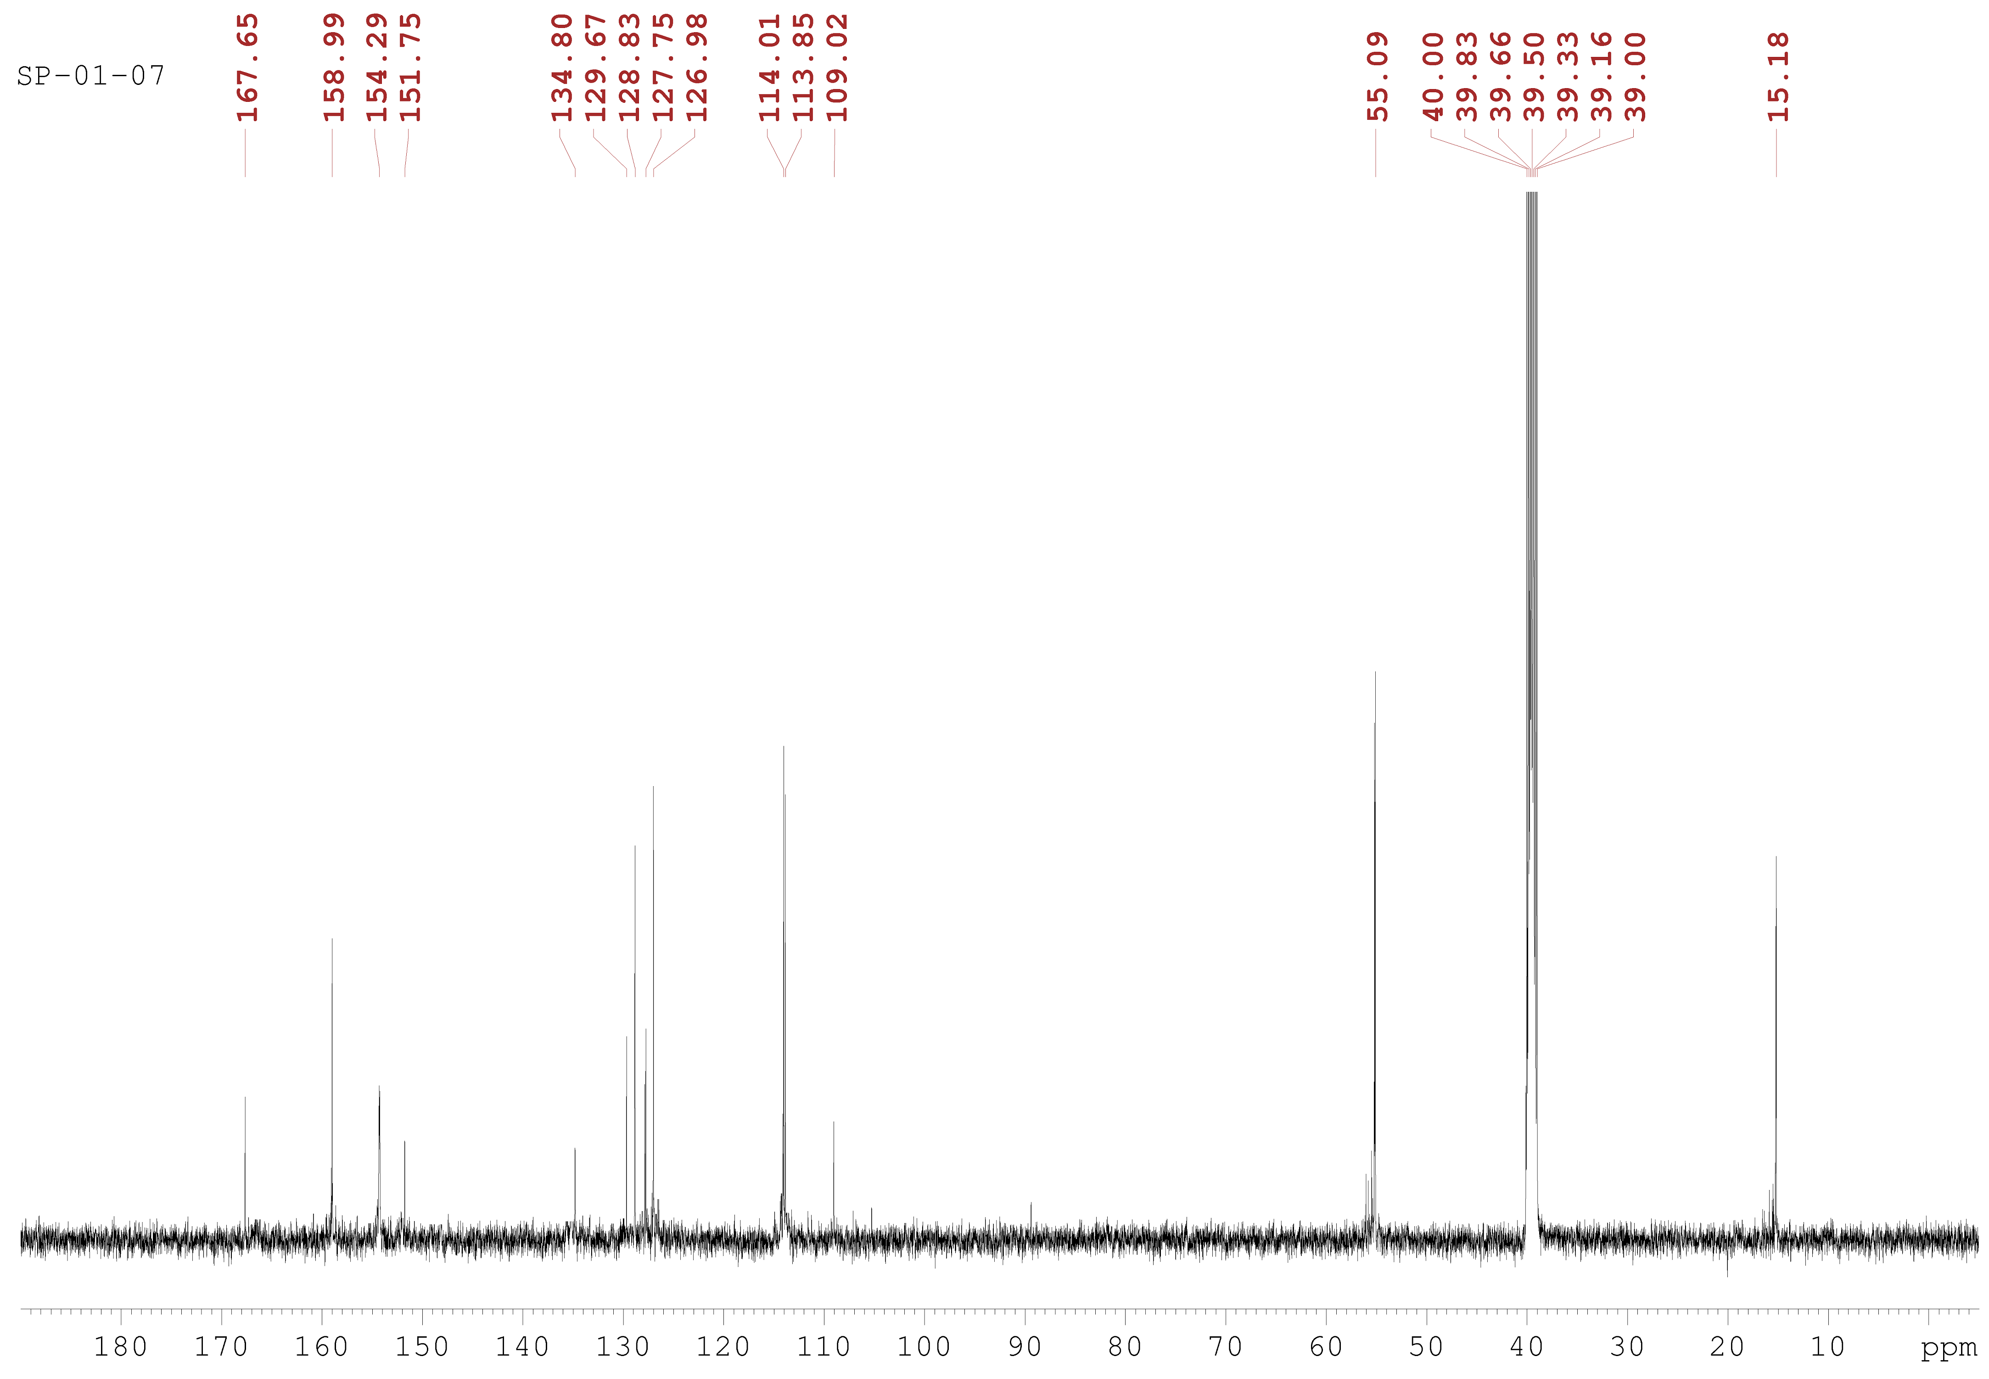

Compound 4g (IR)

Compound 4g (HRMS)
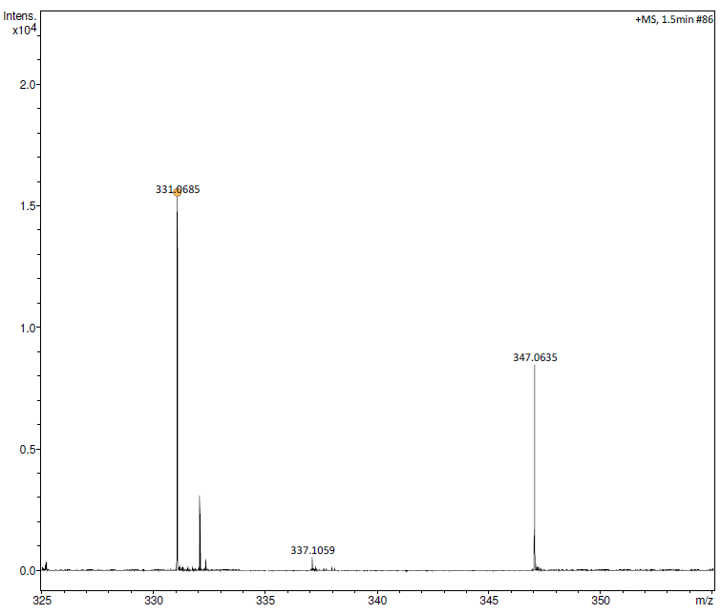
Compound 4h (¹H NMR, DMSO-d₆, 500 MHz)

Compound 4h (¹³C NMR, DMSO-d₆, 125 MHz)
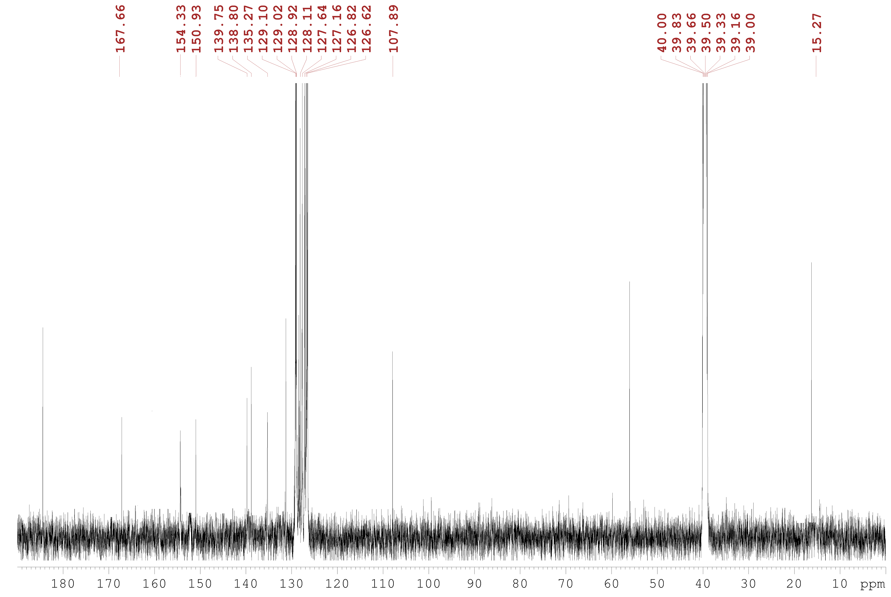

Compound 4h (IR)

Compound 4h (HRMS)
