Supplementary material
Cholelithiasis and cholecystectomy increase the risk of gastroesophageal reflux disease and barrett's esophagus: evidence from meta-analysis and mendelian randomization analysis

Supplementary Table1. MOOSE Checklist for Meta-analyses of Observational Studies
Item No | Recommendation | Reported  on Page  No
Reporting of background should include
1 | Problem definition | Background paragraph 2
2 | Hypothesis statement | Background paragraph 2
3 | Description of study outcome(s) | Result paragraph 2 and 3
4 | Type of exposure or intervention used | Methods paragraph 1
5 | Type of study designs used | Methods paragraph 1
6 | Study population | Methods paragraph 2
Reporting of search strategy should include
7 | Qualifications of searchers (eg,librarians and investigators) | Methods paragraph 3
8 | Search strategy, including time period included in the synthesis and key words | Supplement
9 | Effort to include all available studies, including contact with authors | Supplement
10 | Databases and registries searched | NA
11 | Search software used,name and version, including special features used (eg,explosion) | NA
12 | Use of hand searching (eg,reference lists of obtained articles) | Methods paragraph 3
13 | List of citations located and those excluded, including justification | Methods paragraph 3
14 | Method of addressing articles published in languages other than English | NA
15 | Method of handling abstracts and unpublished studies | Supplement
16 | Description of any contact with authors | Supplement
Reporting of methods should include
17 | Description of relevance or appropriateness of studies assembled for assessing the hypothesis to be tested | Methods paragraph 3
18 | Rationale for the selection and coding of data (eg,sound clinical principles or  convenience) | NA
19 | Documentation of how data were classified and coded (eg,multiple raters,blinding anonterrater reliability) | NA
20 | Assessment of confounding (eg,comparability of cases and controls in studies where appropriate) | Methods paragraph 3
21 | Assessment of study quality, including blinding of quality assessors, stratification or regression on possible predictors of study results | Methods paragraph 3
22 | Assessment of heterogeneity | Supplement
23 | Description of statistical methods (eg,complete description of fixed or random effects models, justification of whether the chosen models account for predictors of study results,dose-response models,or cumulative meta-analysis)in sufficient detail to be replicated | Methods paragraph 4
24 | Provision of appropriate tables and graphics | Supplement
Reporting of results should include
25 | Graphic summarizing individual study estimates and overall estimate | Figure4

Supplementary Table1. (Continued)
26 | Table giving descriptive information for each study included | Table1
27 | Results of sensitivity testing (eg,subgroup analysis) | Result paragraph 2 and 3
28 | ndication of statistical uncertainty of findings | NA

Supplementary Table2. Search Strategy for the Meta-analysis
Database | Search strategies | Results
PubMed | ((("Cholelithiasis"[Mesh]) OR (Cholelithiasis) OR ("Cholelithiases"[MeSH Terms]) OR ("Cholelithiases") OR ("Gallstone Disease"[MeSH Terms]) OR ("Gallstone Disease") OR ("Gallstone Diseases"[MeSH Terms]) OR ("Gallstone Diseases") OR ("Cholecystectomy"[Mesh]) OR (Cholecystectomy) OR (Cholecystectomies[MeSH Terms]) OR (Cholecystectomies)) AND (("Barrett Esophagus"[Mesh]) OR ("Barrett Esophagus") OR ("Barrett Metaplasia" or "Barrett Metaplasias" or "Metaplasia, Barrett" or "Metaplasias, Barrett" or "Barrett's Syndrome" or "Barretts Syndrome" or "Barrett Syndrome" or "Barrett's Esophagus" or "Barretts Esophagus" or "Esophagus, Barrett's" or "Esophagus, Barrett" or "Barrett Epithelium" or "Epithelium, Barrett") OR ("Esophageal Diseases"[Mesh]) OR ("Esophageal Diseases") OR ("Disease, Esophageal"[MeSH Terms]) OR ("Disease, Esophageal") OR ("Diseases, Esophageal"[MeSH Terms]) OR ("Diseases, Esophageal") OR ("Esophageal Disease"[MeSH Terms]) OR ("Esophageal Disease") OR (esophageal or esophagus) OR ("Gastroesophageal Reflux"[Mesh]) OR ("Gastroesophageal Reflux") OR ("Gastric Acid Reflux" or "Acid Reflux, Gastric" or "Reflux, Gastric Acid" or "Gastric Acid Reflux Disease" or "Gastro-Esophageal Reflux Disease" or "Gastro Esophageal Reflux Disease" or "Gastro-Esophageal Reflux Diseases" or "Reflux Disease, Gastro-Esophageal" or "Gastro-oesophageal Reflux" or "Gastro oesophageal Reflux" or "Reflux, Gastro-oesophageal" or "Gastroesophageal Reflux Disease" or "GERD" or "Reflux, Gastroesophageal" or "Esophageal Reflux" or "Gastro-Esophageal Reflux" or "Gastro Esophageal Reflux" or "Reflux, Gastro-Esophagea") OR ("Esophageal Neoplasms"[Mesh]) OR ("Esophageal Neoplasms") OR ("Esophageal Neoplasm" or "Neoplasm, Esophageal" or "Esophagus Neoplasm" or "Esophagus Neoplasms" or "Neoplasm, Esophagus" or "Neoplasms, Esophagus" or "Neoplasms, Esophageal" or "Cancer of Esophagus" or "Cancer of the Esophagus" or "Esophagus Cancer" or "Cancer, Esophagus" or "Cancers, Esophagus" or "Esophagus Cancers" or "Esophageal Cancer" or "Cancer, Esophageal" or "Cancers, Esophageal" or "Esophageal Cancers") OR ("esophageal adenocarcinoma"))) | 898 records
Embase | 'cholecystectomies') AND ('barrett esophagus'/exp OR 'barrett esophagus' OR 'barrett metaplasia'/exp OR 'barrett metaplasia' OR 'barrett metaplasias' OR 'metaplasia, barrett' OR 'metaplasias, barrett' OR 'barretts syndrome' OR 'barrett syndrome'/exp OR 'barrett syndrome' OR 'barretts esophagus'/exp OR 'barretts esophagus' OR 'esophagus, barretts' OR 'esophagus, barrett'OR 'barrett epithelium' OR 'epithelium, barrett' OR 'esophageal diseases'/exp OR 'esophageal diseases' OR 'disease, esophageal' OR 'diseases, esophageal' OR 'esophageal disease'/exp OR 'esophageal disease' OR 'esophageal' OR 'esophagus'/exp OR 'esophagus' OR 'gastroesophageal reflux'/exp OR 'gastroesophageal reflux' OR 'gastric acid reflux' OR 'acid reflux, gastric' OR | 1604 records

Supplementary Table2. (Continued)
Database | Search strategies | Results
Embase  Web of Science | 'reflux, gastric acid' OR 'gastric acid reflux disease' OR 'gastro-esophageal reflux disease' OR 'gastro esophageal reflux disease' OR 'gastro-esophageal reflux diseases' OR 'reflux disease, gastro-esophageal' OR 'gastro-oesophageal reflux'/exp OR 'gastro-oesophageal reflux' OR 'gastro oesophageal reflux'/exp OR 'gastro oesophageal reflux' OR 'reflux, gastro-oesophageal' OR 'gastroesophageal reflux disease'/exp OR 'gastroesophageal reflux disease' OR 'gerd' OR 'reflux, gastroesophageal'/exp OR 'reflux, gastroesophageal' OR 'esophageal reflux'/exp OR 'esophageal reflux' OR 'gastro-esophageal reflux'/exp OR 'gastro-esophageal reflux' OR 'gastro esophageal reflux'/exp OR 'gastro esophageal reflux' OR 'reflux, gastro-esophagea' OR 'esophageal neoplasms'/exp OR 'esophageal neoplasms' OR 'esophageal neoplasm' OR 'neoplasm, esophageal' OR 'esophagus neoplasm'/exp OR 'esophagus neoplasm' OR 'esophagus neoplasms'/exp OR 'esophagus neoplasms' OR 'neoplasm, esophagus' OR 'neoplasms, esophagus' OR 'neoplasms, esophageal' OR 'cancer of esophagus' OR 'cancer of the esophagus'/exp OR 'cancer of the esophagus' OR 'esophagus cancer'/exp OR 'esophagus cancer' OR 'cancer, esophagus'/exp OR 'cancer, esophagus' OR 'cancers, esophagus' OR 'esophagus cancers' OR 'esophageal cancer'/exp OR 'esophageal cancer' OR 'cancer, esophageal' OR 'cancers, esophageal' OR 'esophageal cancers' OR 'esophageal adenocarcinoma'/exp)  TS=(“Cholelithiasis” OR "Cholelithiases" OR "Gallstone Disease" OR "Gallstone Diseases" OR “Cholecystectomy” OR “Cholecystectomies”) AND TS= ("Barrett Esophagus" OR "Barrett Metaplasia" OR "Barrett Metaplasias" OR "Metaplasia, Barrett" OR "Metaplasias, Barrett" OR "Barrett's Syndrome" OR "Barretts Syndrome" OR "Barrett Syndrome" OR "Barrett's Esophagus" OR "Barretts Esophagus" OR "Esophagus, Barrett's" OR "Esophagus, Barrett" OR "Barrett Epithelium" OR "Epithelium, Barrett" OR "Esophageal Diseases" OR "Disease, Esophageal" OR "Diseases, Esophageal" OR "Esophageal Disease" OR “esophageal” OR “esophagus” OR "Gastroesophageal Reflux" OR "Gastric Acid Reflux" OR "Acid Reflux, Gastric" OR "Reflux, Gastric Acid" OR "Gastric Acid Reflux Disease" OR "Gastro-Esophageal Reflux Disease" OR "Gastro Esophageal Reflux Disease" OR "Gastro-Esophageal Reflux Diseases" OR "Reflux Disease, Gastro-Esophageal" OR "Gastro-oesophageal Reflux" OR "Gastrooesophageal Reflux" OR "Reflux, Gastro-oesophageal" OR "Gastroesophageal Reflux Disease" OR "GERD" OR "Reflux,Gastroesophageal" OR "Esophageal Reflux" OR "Gastro-Esophageal Reflux" OR "Gastro Esophageal Reflux" OR "Reflux, Gastro-Esophagea" OR "Esophageal Neoplasms" OR "Esophageal Neoplasm" OR "Neoplasm, Esophageal" OR "Esophagus Neoplasm" OR "Esophagus Neoplasms" OR"Esophagus Cancer" OR "Cancer, Esophagus" OR "Cancers, Esophagus" OR "Esophagus Cancers" OR "Esophageal Cancer" OR "Cancer, Esophageal" OR "Cancers, Esophageal" OR "Esophageal Cancers" OR "esophageal adenocarcinoma") | 1604 records  869 records
Supplementary Table3. Results of univariate Mendelian randomization analysis
Exposure | Outcome | Methods | OR | P | Q-statistics | Ph | Egger  intercept | P intercept
Cholelithiasis | GERD | Inverse variance weighted | 1.06(1.02-1.10) | 0.0006 | 124.552 | 1.30×10⁻¹⁰
Cholelithiasis | GERD | MR Egger | 1.06(0.97-1.16) | 0.19 | 124.491 | 7.32×10⁻¹¹ | .0005 | .891
Cholelithiasis | GERD | Weighted median | 1.05(1.02-1.09) | 0.001
Cholelithiasis | BE | Inverse variance weighted | 1.21(1.11-1.32) | 6.39×10⁻⁶ | 63.43 | .01
Cholelithiasis | BE | MR Egger | 1.24(1.01-1.51) | 0.039 | 63．331 | .008 | -.002 | .806
Cholelithiasis | BE | Weighted median | 1.20(1.08-1.33) | 0.0003
Cholelithiasis | EAC | Inverse variance weighted | 0.99(0.99-1.00) | 0.76 | 59.78 | .484
Cholelithiasis | EAC | MR Egger | 1.00(0.99-1.00) | 0.34 | 58.106 | .508 | -4.13×10⁻⁵ | .2
Cholelithiasis | EAC | Weighted median | 1.00(0.99-1.00) | 0.79
Cholecy-stectomy | GERD | Inverse variance weighted | 1.04(1.02-1.06) | 5.79×10⁻⁶ | 47.156 | .006
Cholecy-stectomy | GERD | MR Egger | 1.04(1.00-1.07) | 0.02 | 44.628 | .009 | .003 | .245
Cholecy-stectomy | GERD | Weighted median | 1.04(1.02-1.06) | 8.74×10⁻⁵
Cholecy-stectomy | BE | Inverse variance weighted | 1.13(1.06-1.19) | 2.08×10⁻⁵ | 38.553 | .053
Cholecy-stectomy | BE | MR Egger | 1.09(0.99-1.19) | 0.07 | 36.881 | .059 | .008 | .297
Cholecy-stectomy | BE | Weighted median | 1.08(1.01-1.15) | 0.01
Cholecy-stectomy | EAC | Inverse variance weighted | 0.99(0.99-1.00) | 0.66 | 35.211 | .553
Cholecy-stectomy | EAC | MR Egger | 1.00(0.99-1.00) | 0.33 | 34.984 | .517 | -1.76×10⁻⁵ | .636
Cholecy-stectomy | EAC | Weighted median | 0.99(0.99-1.00) | 0.86
GERD, gastroesophageal reflux disease; BE, Barrett's esophagus; EAC, esophageal adenocarcinoma.

Supplementary Table4. Results of multivariable Mendelian randomization analysis adjusting BMI, smoking, and alcohol assumption
Exposure | Outcome | OR | P
Cholelithiasis | GERD | 1.05(1.01-1.1) | 0.028
 | BE | 1.18(1.07-1.31) | 0.0017
 | EAC | 1.00(0.99-1.00) | 0.67
Cholecystectomy | GERD | 1.07(1.02-1.12) | 0.0021
 | BE | 1.18(1.05-1.33) | 0.0045
 | EAC | 0.99(0.99-1.00) | 0.7
BMI, body mass index; GERD, gastroesophageal reflux disease; BE, Barrett's esophagus; EAC, esophageal adenocarcinoma.

Supplementary Figure 1 Risk of bias assessment tool for included studies for the Meta-analysis.
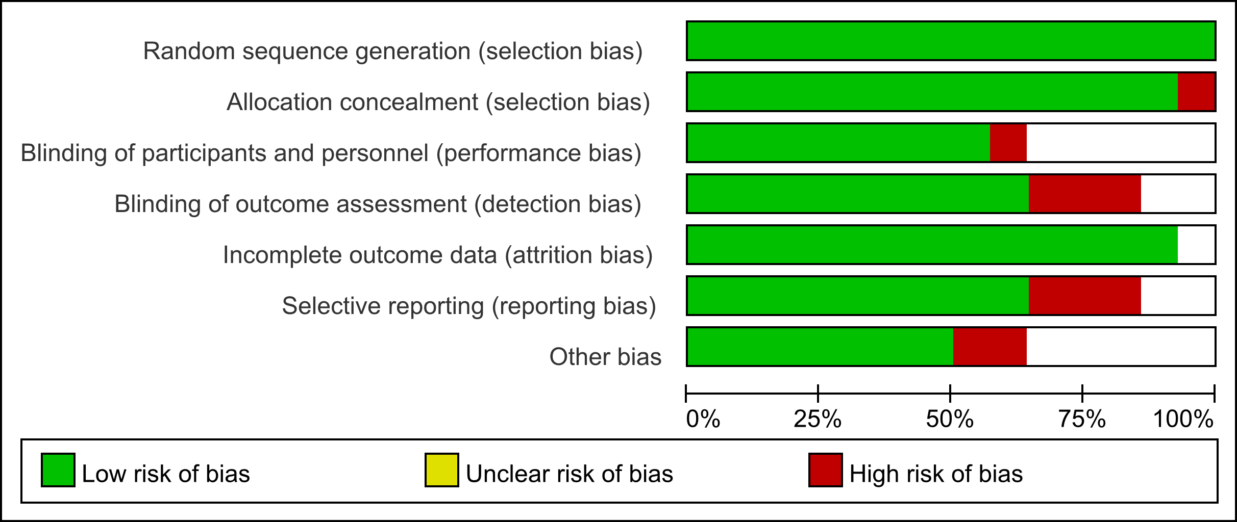

Supplementary Figure 2 Summary of risk of bias in included studies for the Meta-analysis.
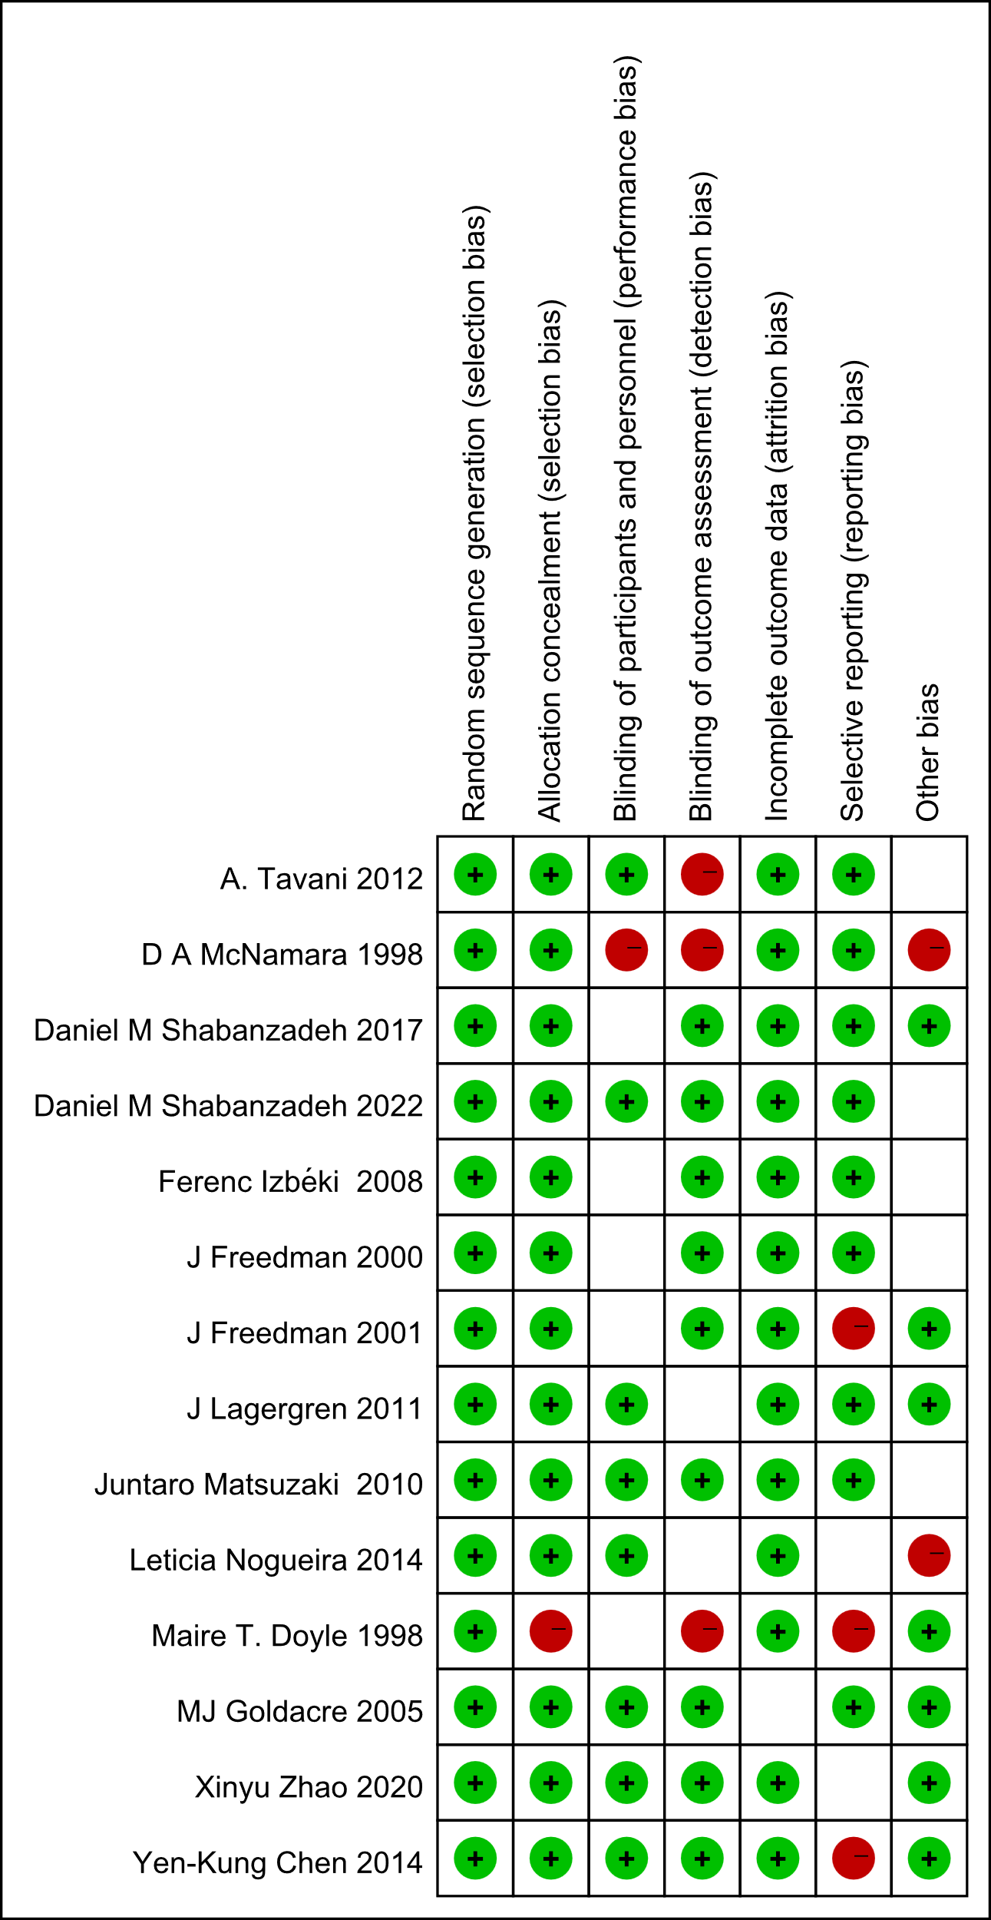

Supplementary Figure 3 Forest plot between cholelithiasis and GERD (A), BE (D), and EAC (G). Leave-one-out analysis between GERD (B), BE (E), and EAC (H). Scatter plot between GERD (C), BE (F), EAC (I).
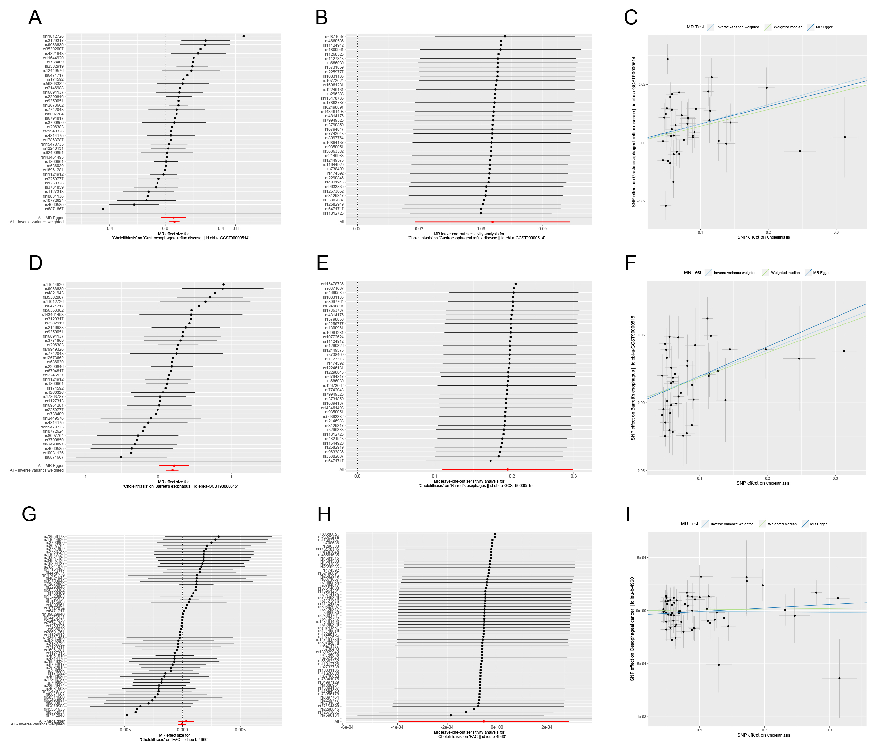
GERD, gastroesophageal reflux disease; BE, Barrett's esophagus; EAC, esophageal adenocarcinoma.

Supplementary Figure 4 Forest plot between cholecystectomy and GERD (A), BE (D), and EAC (G). Leave-one-out analysis between GERD (B), BE (E), and EAC (H). Scatter plot between GERD (C), BE (F), EAC (I).
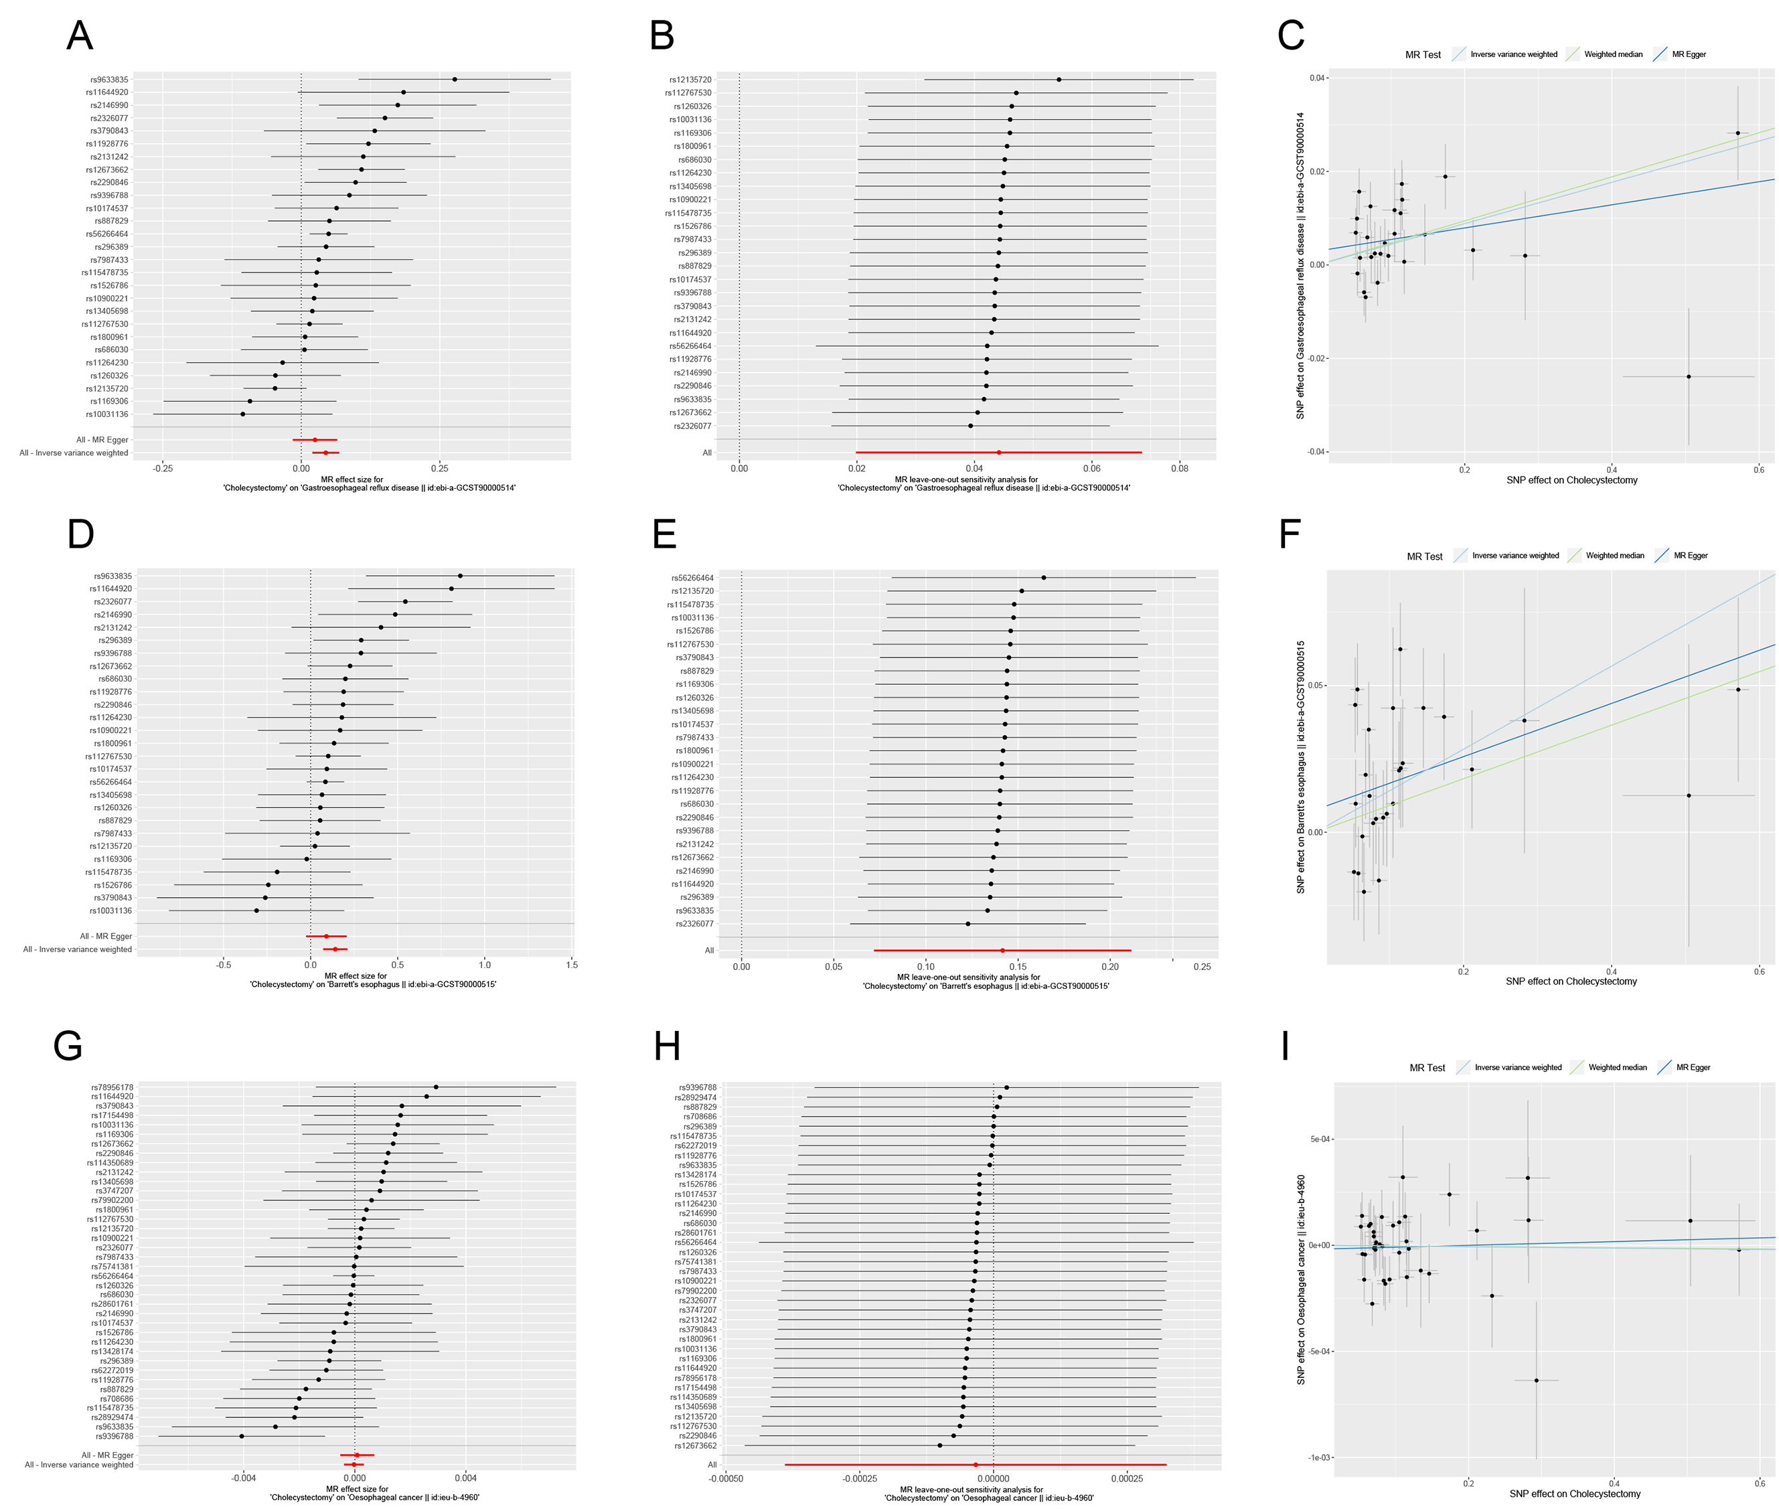
GERD, gastroesophageal reflux disease; BE, Barrett's esophagus; EAC, esophageal adenocarcinoma.

