Table 1: Magnification of outer surface of sample (a) POPU, (b) FPOPU-2 phr, (c) FPOPU-4 phr, and (d) FPOPU-8 phr
(b)
(a)
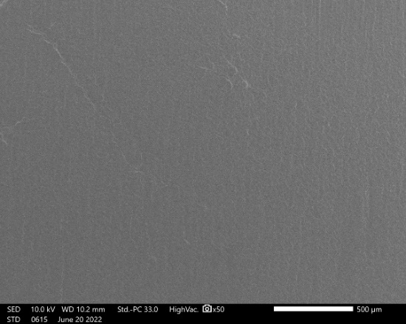 | 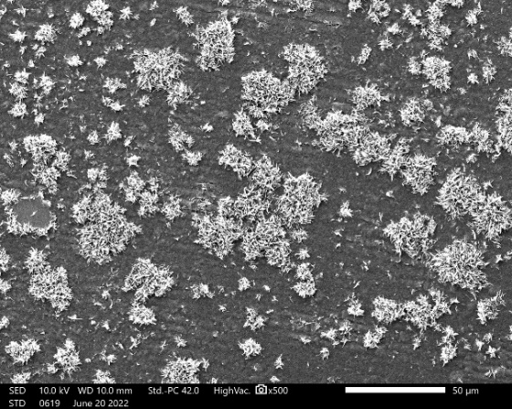
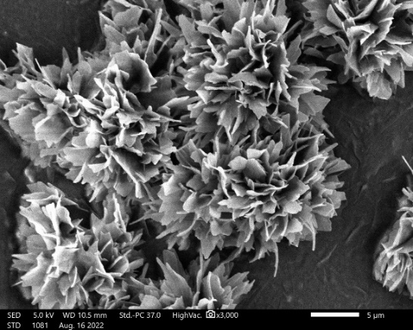  (c) | 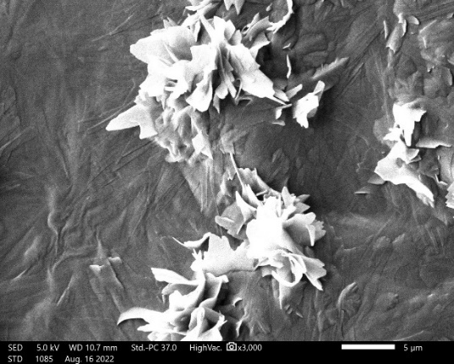  (d)

Table 2: Area under the graph of the amorphous peaks at 2θ = 20° for FPOPU and POPU
Formulation | Area under the Graph for the Curves at 2θ = 20° | Crystallinity Index
POPU | 13316.587 | 64.157
FPOPU-2 phr | 6335.352 | 50.316
FPOPU-4 phr | 5565.107 | 45.656
FPOPU-6 phr | 3188.653 | 48.137
FPOPU-8 phr | 3214.173 | 43.247
FPOPU-10 phr | 2523.709 | 42.217
FPOPU-12 phr | 1165.109 | 37.535

Table 3: Gel content of FPOPU
Formulation | G_{c} (%)
POPU | 83.495 ± 0.482
FPOPU-2 phr | 82.679 ± 0.402
FPOPU-4 phr | 82.469 ± 0.261
FPOPU-6 phr | 82.095 ± 0.146
FPOPU-8 phr | 80.601 ± 0.431
FPOPU-10 phr | 79.710 ± 1.101
FPOPU-12 phr | 79.045 ± 0.838

Table 4: Pencil Hardness grade for POPU and FPOPU (glass)
Formulation | Result | Index
POPU | 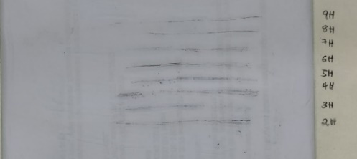 | 2H
FPOPU-2 phr | 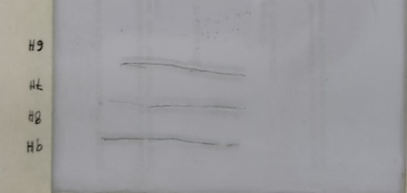 | 6H
FPOPU-4 phr | 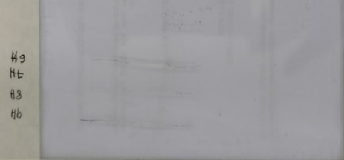 | 6H
FPOPU-6 phr | 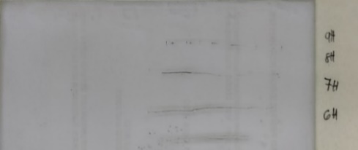 | 6H
FPOPU-8 phr | 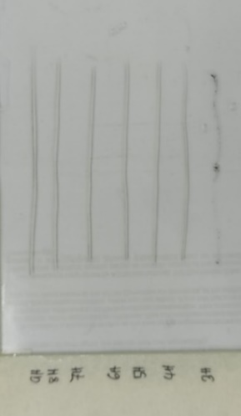 | 3H
FPOPU-10 phr | 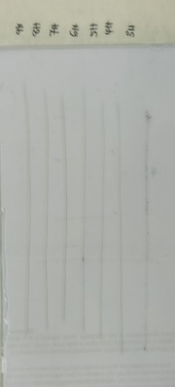 | 3H
FPOPU-12 phr | 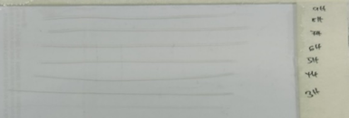 | 3H

Table 5: Pencil Hardness grade for POPU and FPOPU (wood )
Formulation | Result | Index
POPU | 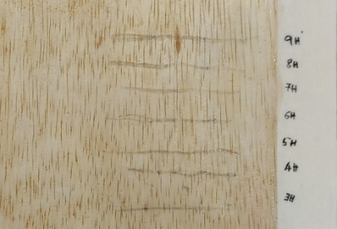 | 3H
FPOPU-2 phr | 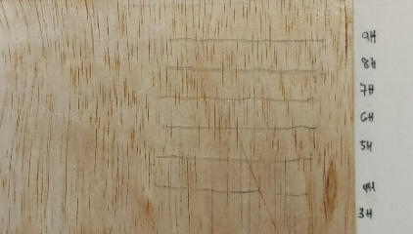 | 3H
FPOPU-4 phr | 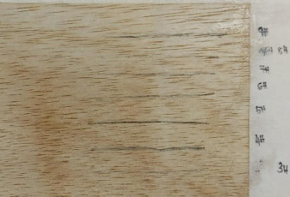 | 3H
FPOPU-6 phr | 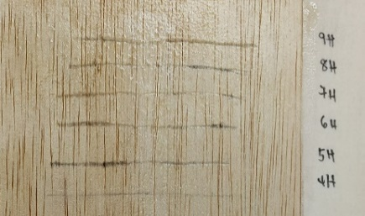 | 4H
FPOPU-8 phr | 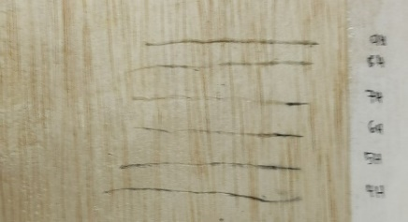 | 4H
FPOPU-10 phr | 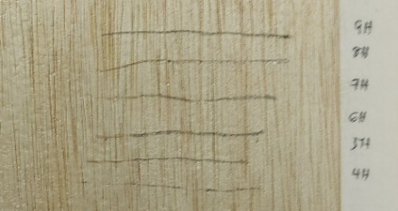 | 4H
FPOPU-12 phr | 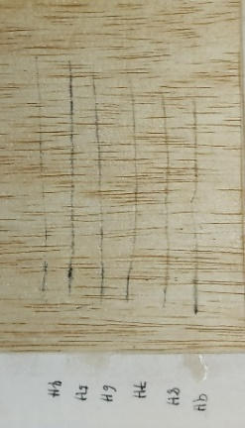 | 4H

Table 6: Pencil Hardness grade for POPU and FPOPU (steel )
Formulation | Result | Index
POPU | 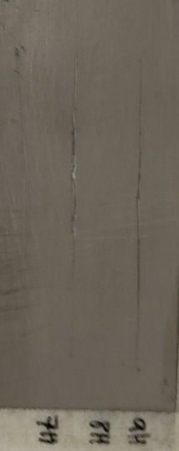 | H
FPOPU-2 phr | 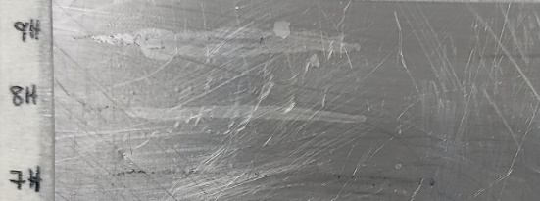 | 7H
FPOPU-4 phr | 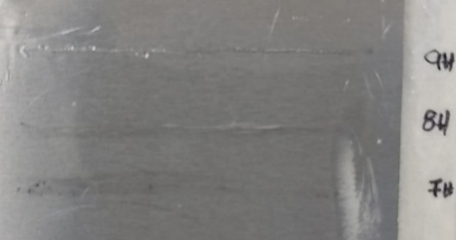 | 7H
FPOPU-6 phr |  | 8H
FPOPU-8 phr | 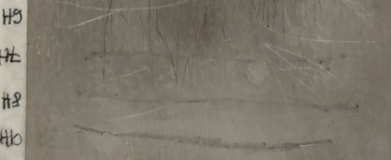 | 6H
FPOPU-10 phr | 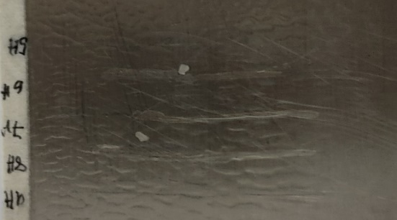 | 5H
FPOPU-12 phr | 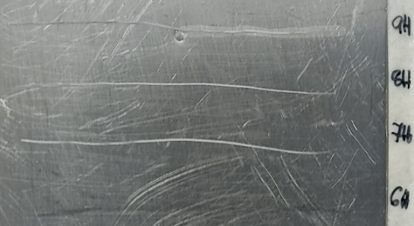 | 6H

Table 7: Glass surface before and after adhesion test with grade
Formulation | Before | After | Class
POPU | 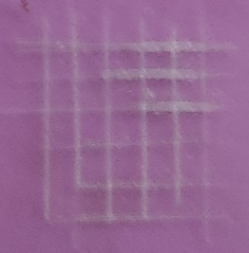 | 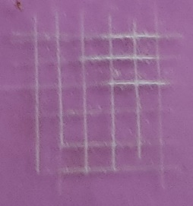 | 4B
FPOPU-2 phr | 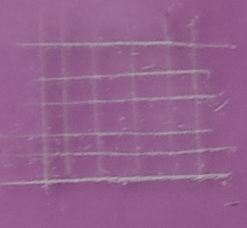 | 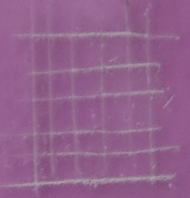 | 4B
FPOPU-4 phr | 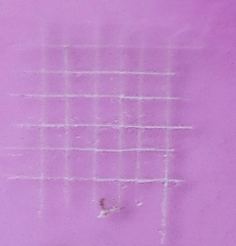 | 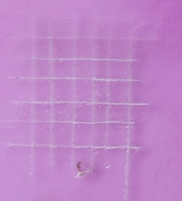 | 4B
FPOPU-6 phr | 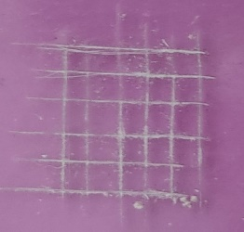 | 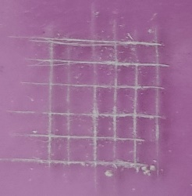 | 3B
FPOPU-8 phr | 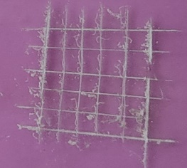 | 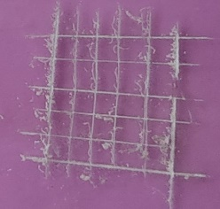 | 3B
FPOPU-10 phr | 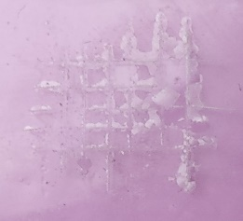 | 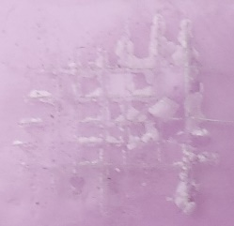 | 2B
FPOPU-12 phr | 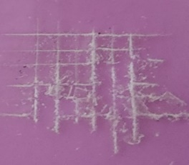 | 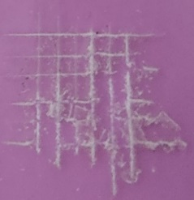 | 2B

Table 8: Wood surface before and after adhesion test with grade
Formulation | Before | After | Class
POPU | 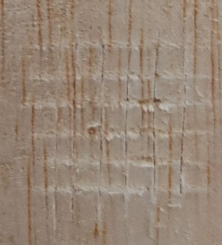 | 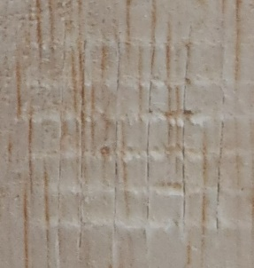 | 3B
FPOPU-2 phr | 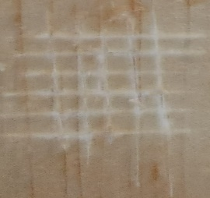 | 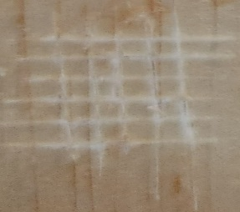 | 3B
FPOPU-4 phr | 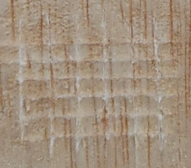 | 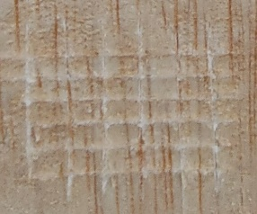 | 3B
FPOPU-6 phr | 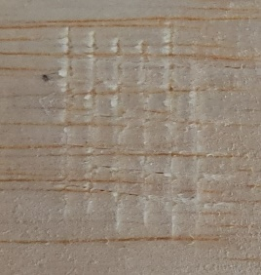 | 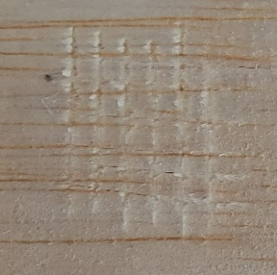 | 3B
FPOPU-8 phr | 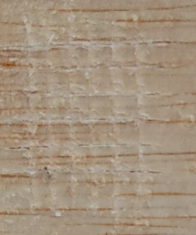 | 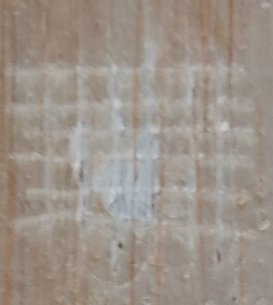 | 2B
FPOPU-10 phr | 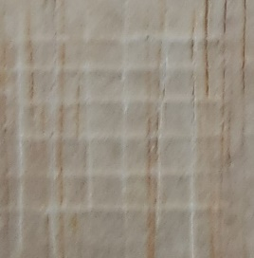 | 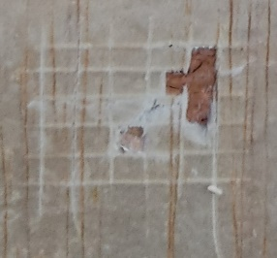 | 2B
FPOPU-12 phr | 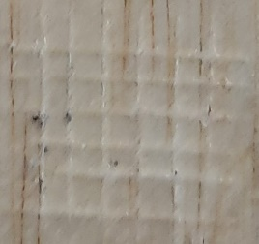 | 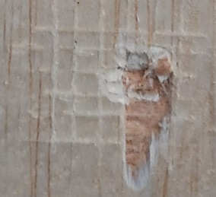 | 2B

Table 9: Steel surface before and after adhesion test with grade
Formulation | Before | After | Class
POPU | 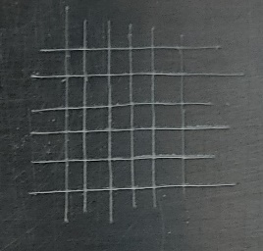 | 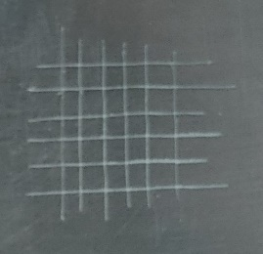 | 5B
FPOPU-2 phr | 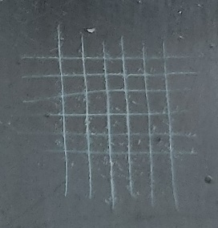 | 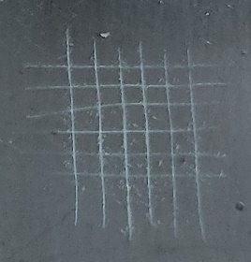 | 5B
FPOPU-4 phr | 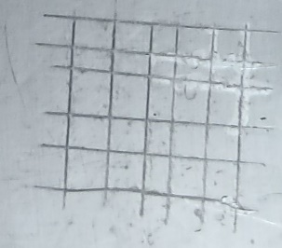 | 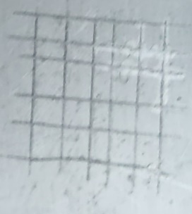 | 4B
FPOPU-6 phr | 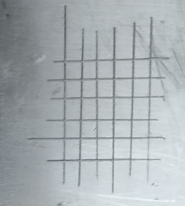 | 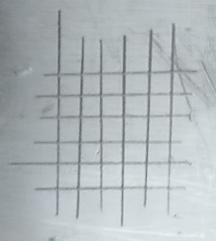 | 5B
FPOPU-8 phr |  | 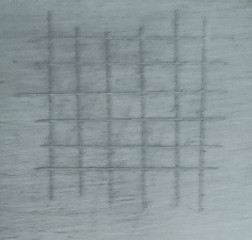 | 5B
FPOPU-10 phr | 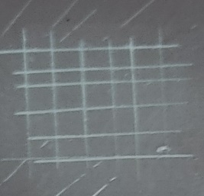 | 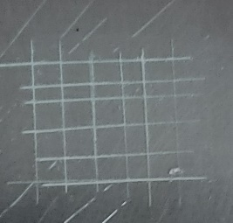 | 5B
FPOPU-12 phr | 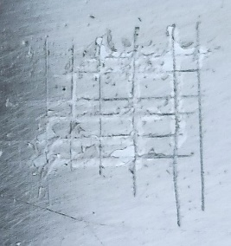 | 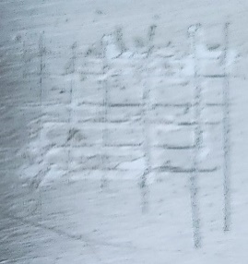 | 3B

Formulation | T_{5%} / ℃ | T_{10%} / ℃ | T_{50%} / ℃ | Residual Weight at 700 ℃ (%)
POPU | 162.717 | 207.475 | 415.296 | 6.245
FPOPU-2 phr | 177.961 | 231.610 | 417.349 | 11.725
FPOPU-4 phr | 178.326 | 232.553 | 418.209 | 15.332
FPOPU-6 phr | 161.225 | 200.815 | 409.278 | 9.493
FPOPU-8 phr | 150.576 | 226.255 | 414.066 | 7.736
FPOPU-10 phr | 148.943 | 249.145 | 415.520 | 6.583
FPOPU-12 phr | 132.793 | 213.361 | 414.133 | 6.064
Table 10: Thermal Data for FPOPU
Table 10: Thermal data for POPU and FPOPU

Sample | Glass Transition Temperature (T_{g1}) | Glass Transition Temperature (T_{g2}) | Melting Point (T_{m}) | Melting Point Area
POPU | 128.8 | 221.1 | 310.2 | 107.556
FPOPU-2 phr | 129.6 | 227.1 | 309.3 | 121.693
FPOPU-4 phr | 125.2 | 208.6 | 311.5 | 167.528
FPOPU-6 phr | 122.4 | 202.2 | 310.5 | 99.888
FPOPU-8 phr | 121.5 | 205.3 | 308.2 | 102.737
FPOPU-10 phr | 120.3 | 190.8 | 309.4 | 98.562
FPOPU-12 phr | 122.4 | 189.8 | 314.7 | 64.768
Table 11: Thermal Data for FPOPU

