SUPPLEMENTAL MATERIALS FOR:

A randomized proof-of-mechanism trial of TNF antagonism for motivational anhedonia and related corticostriatal circuitry in depressed patients with high inflammation

Michael T. Treadway,*^{1,2,3} Sarah M. Etuk¹, Jessica A. Cooper², Shabnam Hossein¹, Emma Hahn¹, Samantha A. Betters¹, Shiyin Liu¹, Amanda R. Arulpragasam¹, Brittany A. M. DeVries¹, Nadia Irfan¹, Makiah R. Nuutinen¹, Evanthia C. Wommack¹, Bobbi J. Woolwine², Mandakh Bekhbat², Philip A. Kragel^{1,2}, Jennifer C. Felger^{2,3}, Ebrahim Haroon^{2,3}, and Andrew H. Miller^{2,3}

¹Department of Psychology, Emory University, Atlanta, GA 30322
²Department of Psychiatry and Behavioral Sciences
³The Winship Cancer Institute, Emory University School of Medicine, Atlanta, GA 30322

SUPPLEMENTAL METHODS

Eligibility Criteria: Inclusion criteria were a primary diagnosis of major depression (MD) or Bipolar, depressed type (as determined by Structured Clinical Interview (SCID) for DSM-5 and CRP > 3mg/L. Of note, both depressive diagnoses have exhibited responses in anhedonic symptoms following infliximab treatment¹. Additionally, participants were required to be off antidepressant medications for at least 4 weeks (8 weeks for fluoxetine) prior to the baseline visit. Exclusion criteria were any autoimmune disorder (as confirmed by medical history, physical exam and laboratory testing); a history of tuberculosis (as confirmed by medical history, chest X-ray, and skin or blood testing) or at high risk of tuberculosis exposure; hepatitis B, hepatitis C, or human immunodeficiency virus infection (as confirmed by medical history and laboratory testing); a history of fungal infection; a history of recurrent or viral bacterial infections; a history of cancer (any type); unstable cardiovascular, endocrinologic, hematologic, hepatic, renal, or neurologic diseases (as confirmed by medical history, physical examination and laboratory testing); a history of a non-mood-related psychotic disorder, active psychotic symptoms, substance abuse/dependence within 6 months of study entry (as confirmed by SCID); a score of ≥ 3 on the Columbia Suicide Severity Rating Scale (C-SSR); a current eating disorder; a history of a cognitive disorder or a score ≤ 28 on the Mini-Mental State Exam; pregnancy or lactation; not effectively and appropriately using medically accepted means of contraception for those who could become pregnant; known allergy to murine products or other biologic therapies; chronic use of non-steroidal anti-inflammatory agents (with the exception of 81mg of aspirin), medications that contain glucocorticoids or statins; and a diagnosis of co-morbid obsessive compulsive disorder (as confirmed by SCID).

Recruitment: Participants were recruited in response to community advertisements or were referred from Emory’s Behavioral Immunology Program. Urine-drug screens were used to ensure that all participants were free from common drugs of abuse. No subjects were removed from antidepressant treatment for the purposes of this study. All patients were medically stable, as determined by reported medical history, physical exam, and laboratory testing. Additionally, all patients were monitored for significant worsening symptoms and suicidal risk over the course of their participation in the study. As an additional precaution, all participants were re-contacted 30 days after completion of the study to assess for any adverse events or worsening symptoms. Subject gender was determined by self-report.

Adverse Events: Of the 42 participants randomized, a total of 34 (81%) experienced at least 1 adverse event. Of the adverse events reported, 33% occurred prior to receiving drug infusion (infliximab or placebo), and 67% occurred following infusion. All reported AEs were mild to moderate and were similar across study phases and treatment groups. There were no serious adverse events associated with either the placebo or infliximab groups. AEs were similar to our previously published results in patients treated with infliximab and placebo. A full listing of all AEs is available on clinicaltrials.gov (NCT03006393).

Reasons for Early Termination: Of the 42 participants randomized, one withdrew due to a move out of state prior to study termination, one withdrew due to poor venous access during the infusion, one withdrew due to change in work demands that restricted their availability, and one withdrew due to an adverse event (unintended pregnancy).

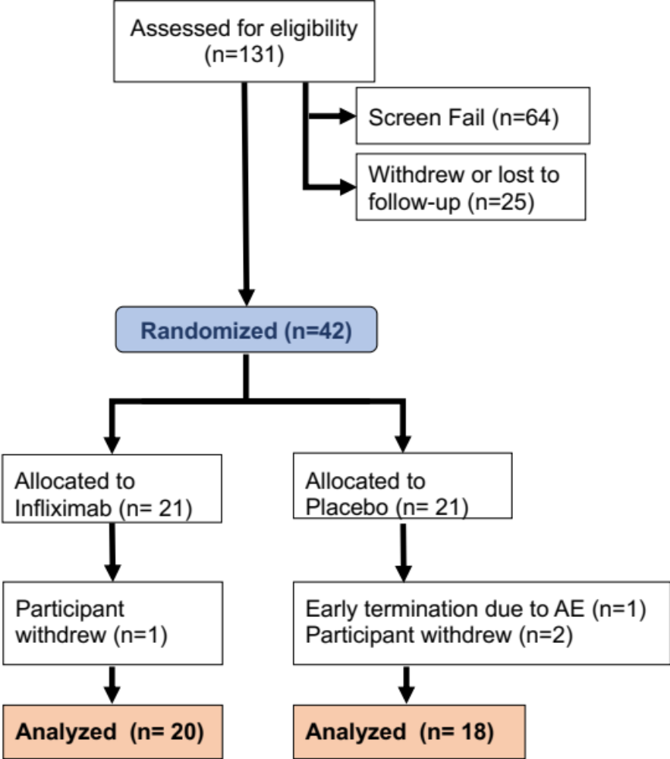

Figure S1. Consort Diagram. This shows the flow chart for screening, enrollment and analysis of the patients included in the current study. Abbreviations: AE – adverse event.

Pre-registration: Hypotheses, key dependent variables, and primary methods were posted previously on the website of the Open Science Foundation (OSF) and may be found here: https://osf.io/r6m49/.

The current paper focuses on a subset of these data. Specifically, given the focus of the current paper on effects of infliximab on motivational circuitry, we used the secondary behavioral endpoint from the EBDM task due to its temporal proximity to task-based neuroimaging. Baseline cross-sectional associations between symptom, inflammatory and neuroimaging measures will be reported elsewhere. Supplemental Table 1 summarizes the primary, secondary and exploratory analyses included in the current manuscript, and the rationale for any deviations from our pre-registered plan.

Supplemental Table 1: Pre-registered and exploratory analyses included in the current manuscript.
Analysis | Primary,  Secondary or  Exploratory | Pre-registered variables | Deviations from  pre-registration
Effects of infliximab vs. placebo on inflammatory cytokines | Primary – Infliximab Effects Hypothesis 1 | - TNF (baseline only)  - sTNFR2 (pre-post)  - IL-1beta  - IL-6  - hsCRP | Based on our prior work, MCP1/CCL2 was also evaluated^{2, 3}.  To reduce the number of comparisons, a MANOVA was used as opposed to serial ANOVAs.
Effects of infliximab vs. placebo on self-report measures of motivational anhedonia | Primary – Infliximab Effects Hypothesis 2 | - IDS-SR Anhedonia subscale  - MAP-SR subscale  - MDFI RM subscale  - MFDI RA subscale | N/A
Effects of infliximab vs. placebo on EBDM behavior | Secondary- Hypothesis 3 | - Proportion of effortful options  - k-discounting parameter | Current paper emphasizes the secondary behavioral outcome effort-based choice task collected at 14 days (pre-registered as a secondary outcome measure) rather than the EEfRT collected at day 7 to maximize sample size and examine associations with neuroimaging data.
Effects of infliximab on EBDM fMRI activity | Primary – Hypothesis 2 | - Proportion of effortful options  - k-discounting parameter | N/A
Effects of infliximab on EBDM fMRI activity | Primary –  Hypothesis 2 | - Activity in dmPFC, striatum, insula, midbrain and vmPFC during contrasts related to subjective value, effort and reward | All pre-registered contrasts and ROIs were tested for effects of infliximab. Additionally included the subjective value of the chosen option (SVC) as a whole-brain analysis.
Association between change in fMRI activity and change in task behavior | Secondary – Hypothesis 3 | - Proportion of effortful options  - k-discounting parameter | N/A
Association between changes in sTNFR2 and change in fMRI activity | Exploratory | N/A | Because change in sTNFR2 was found to correlate with change in effort discounting and effort choices, we examined its association with neuroimaging data.
sTNFR2 and brain-based mediation analyses | Exploratory | N/A | Because change in sTNFR2 was found to correlate with change in effort discounting and neuroimaging data, we tested for a mediation effect with drug condition
Multivariate classification of drug condition in using striatal brain areas | Exploratory | N/A | N/A
Effects of infliximab of fMRI beta-series correlation | Exploratory | N/A | N/A
Effects of infliximab on monetary reward signature | Exploratory | N/A | N/A

EBDM Supplemental Task Description. The participant’s maximum effort was measured prior to the scan. A rapid event-related design with an exponential jitter between trials drawn from a Poisson distribution was used to optimize HRF estimation. An MRI-compatible button-box was used to record task responses. To prevent motion artifacts, participants made their choices in the scanner and then completed their button presses outside of the scanner. For example, once participants were outside of the scanner, they were presented with the effortful choices that they made in the scanner (ex. $2.40 for 80% effort) and given the option to either make their effortful button presses or change their option. At the baseline fMRI scan, the participant’s chose to complete the accepted effort on 91% $±$ 12% of trials. At the endpoint fMRI scan, the participant’s chose to complete the accepted effort on 96% $±$ 7% of trials. Trials on which participants did not respond quickly enough (“timed out”) were excluded from behavioral analysis. Excluding participants with a high percentage (>20%) of timed-out trials at either timepoint (n=2) did not alter the primary effects of infliximab (see Supplemental Materials).
The primary behavioral variables for the task include the percentage of accepted effortful offers at each level of effort, and a model-derived estimate of effort-discounting (‘k’ discounting parameter). A full description of the model-fitting procedure, including comparison across models and parameter recovery analyses, is provided below. Additionally, for imaging analysis we also examined the predicted subjective value, an expected subjective value prediction error, and an estimate of choice difficulty, consistent with our prior work using this paradigm⁴.

EBDM Task Modeling: Four valuation models and one fixed probability model were fit using maximum likelihood estimation. Parameters from the best-fitting model were then used to generate trial-wise subjective values for use as parametric modulators in neuroimaging analysis and log transformed to examine the effect of infliximab on effort discounting.

Each valuation model assumes that the subjective value of an objective reward is decreased according to the amount of effort required to obtain the reward. The subjective values (SVs) for each trial are estimated using the amount of effort required (E; 0.2, 0.5, 0.8, 1) and the amount of reward offered (R; $1-$5.75). The four valuation models each utilize a different discounting function (Equations 1-4).

The linear discounting model assumes that rewards are discounted at the same rate per each additional unit of effort (Equation 1). In this model, the slope or rate of discounting is represented by free parameter k.

$SV=R-kE$ Eq. 1

Hyperbolic discounting functions have been used widely in modeling choice behavior in both temporal discounting^{5, 6} and in effort discounting tasks^{7, 8}. Under the hyperbolic discounting function (Equation 2), the largest change in valuation per unit change in effort occurs at the lowest effort levels.

$SV= \frac{R}{(1+kE)}$ Eq.2

The quadratic or parabolic discounting (Equation 3) follows a concave shape where the relative devaluation of rewards increases at higher levels of effort. Quadratic models of effort discounting have been used in recent work to model behavior in effort-based decision-making tasks^{9, 10}.

$SV=R-kE^{2}$ Eq. 3

The final valuation model that we fit, the flexible power model, uses a two-parameter power function to estimate subjective values for each option on each trial (Equation 4). This is the most flexible of the discounting models that we fit to our data and has been found to provide a good fit in this task⁴ and other effort discounting tasks¹¹. In this model, free parameter p dictates the curvature of the discounting function. Depending on the value of p, the discounting curve of the two-parameter power function can be linear (p=1), concave (p>1), convex (p<1), or flat (p=0).

$SV=R-kE^{p}$ Eq. 4

Each of the subjective value models utilized the Softmax function (Equation 5) to transform subjective values into probabilities of selecting each option.

$P_{t}(a)= \frac{e^{β∙{SV}_{a}}}{\sum_{i=1}^{2}{e^{{β∙SV}_{i}}}}$ Eq. 5
The final model that we fit is a fixed probability model that assumes that participants make choices without systematically integrating information about available rewards and effort costs. The model includes a single free parameter that represents a fixed probability of declining the effortful option. While this model does not include valuation and is the simplest model that we compared, this model can provide a good fit for participants who respond with a strong preference for either option. The fixed probability model provides a baseline to which other more complex models can be compared¹².

All models were fit in MATLAB using the optimization function fmincon for maximum likelihood estimation and compared using Bayesian Information Criterion¹³ (BIC). BIC incorporates goodness of fit (likelihood, L_{i}) and model complexity (number of free parameters; V_{i}), and the number of observations (i.e., number of trials, m_{i}; Equation 6), penalizing models with additional flexibility to select the most parsimonious model.

${BIC}_{i}= -2ln\left(L_{i}\right)+V_{i}ln⁡(m_{i})$ Eq. 6

BIC values for each model were calculated individually for each participant and compared to identify the best-fitting model for each participant. BIC values were additionally summed across participants within each group to compare model fit at the group level. For all groups, the models with the lowest BIC (i.e. best fit) were the flexible power model and the quadratic discounting model. However, the quadratic model was the best fitting model for the greatest proportion of participants in each group (see Supplementary Table 2) and was used for subsequent analyses.

SUPPLEMENTAL RESULTS

Simulation-based Model Validation for EBDM task
To verify that the quadratic model can generate the patterns of behavior that we observed in this study and capture the differences in behavior that we observed in response to treatment with infliximab, we simulated 50 surrogate datasets using each of the best-fitting parameters of study participants obtained at baseline and at the day 14 session. On each trial, we utilized the actual trial-wise reward and effort presented to participants, along with the best-fitting parameters, to calculate the subjective value of each option using Equation 3. The subjective values of the effort and no effort option were then transformed into probabilities of selecting each option using the Softmax equation (Equation 5) and the participants’ best-fitting inverse temperature parameter. The probabilities from the Softmax equation were used to probabilistically assign a choice on each trial (effort or no effort). To account for variation in responses due to probabilistically assigning these choices, multiple (50) sets of surrogate data were generated using each real participant’s parameter values. The behavior from the surrogate data was then analyzed to calculate the proportion of high effort choices at each effort level and compared to the actual behavior observed in the task (i.e., the data used to obtain the parameter estimates). The quadratic model was fit to the surrogate data to examine the association between the recovered and generative parameters.

The proportion of hard effort choices in the real and simulated data (averaged within each set of generating parameters) were strongly correlated both at baseline r(36) = .925, p<.001 and at the day 14 visit, r(36) = .934, p<.001. The best-fitting parameters obtained by fitting the quadratic model to the simulated data were also strongly correlated with generative parameters and both baseline and 14 days, r(36) = .935, p < .001, r(36) = .998, p<.001 for k (effort discounting), and t (inverse temperature), r(36) = .955, p<.001 (baseline), r(36)= .948, p<.001 (14-day).

We additionally verified that behavioral effects associated with treatment with infliximab were reflected in the surrogate data, namely that data simulated from the best-fitting parameters of the participants treated with infliximab showed increased selections of the high-effort option at the 80% and 100% effort level at the day 14 visit, relative to surrogate data generated using the parameters of the participants who received the placebo treatment. Consistent with the actual data, high-effort selections in simulated data from the “infliximab group” was higher than the “placebo group” at 80% effort, t(36) = 2.017, p =.051 (Figure S2) and at 100% effort, t(36) = 2.026, p =.050 (Figure S2).

Model-based estimates of choice difficulty
Choice difficulty for each trial was estimated using the quadratic model (Equation 3) and each participant’s best-fitting parameters. For this analysis, the difficulty of a choice was defined by the difference in value between the no effort and effortful options, where a trial with options that are close in value is considered a more difficult choice, and a trial with options that are further apart in value is considered an easier choice. We first calculated the unsigned difference in subjective value (SVdiff) between the effort and no effort option (Equation 7)

SV_{diff} = |SV_{effort} - SV_{no effort}| Eq 7

The difference in subjective value (SVdiff) for each trial (t) was then normalized for each subject to range from 0 to 1. As higher values would indicate easier choices (i.e., greatest difference between options), all values were subtracted from 1 so that higher values reflected increased difficulty. The trial-wise measures of choice difficulty were then used as a parametric modulator in neuroimaging analysis presented in the main text.

$Difficulty\left(t\right)=1- \frac{{SV}_{diff}\left(t\right)-min⁡({SV}_{diff})}{\max\left({SV}_{diff}\right)- min⁡({SV}_{diff})}$ Eq 8

Supplementary Table 2: Model fit and mean best-fitting parameters.
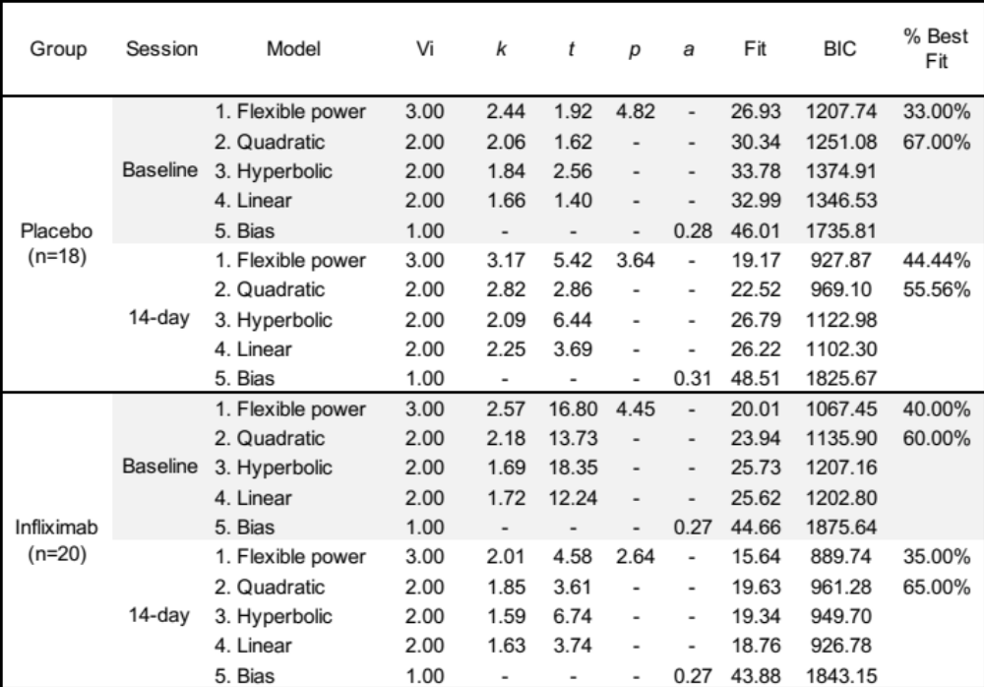
Note: Fit for each model is reported as negative log likelihood. Vi: the number of parameters in each model. BIC: Bayesian Information Criterion, summed over participants in each group. k: effort discounting parameter. t: inverse temperature parameter. p: exponent in flexible power model. a: parameter representing bias for no effort option. % best fit: the percentage of participants best fit (lowest BIC) when comparing the fit of the flexible power model and quadratic model.

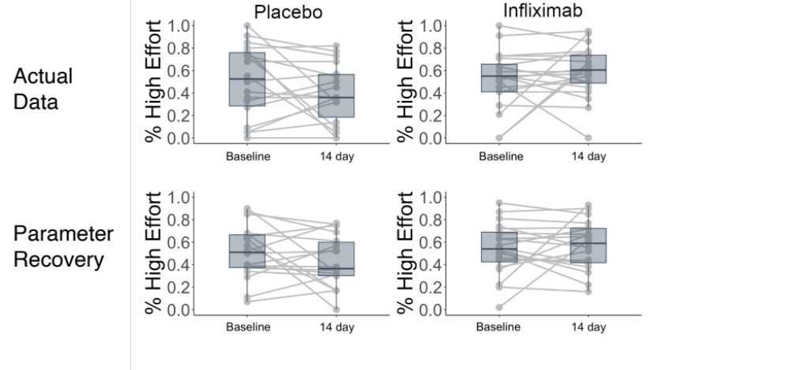
Figure S2: High effort selections at the 80% and 100% effort levels for real data (top) and data simulated using the quadratic discounting model (bottom).

Max Press Rate
Prior to each administration of the EBDM task, participants were instructed to perform a button press at the maximum speed possible for 20 seconds. This was performed three times, and the average of these three trials was used as the estimate of the participant’s max press rate for that scanning session. This estimate of maximum presses was then used as the basis for determining the number of presses required for the 20%, 50%, 80%, and 100% effort conditions during the EBDM task, and participants were required to practice each of these effort levels before entering the scanner. Due to loss of data, max press data were unavailable for three participants for the day 14 session.
To determine whether drug condition affected the max press rate, we examined an ANCOVA predicting the max press rate at 14 days with drug condition, baseline press rate, sex and age entered as covariates. We found no evidence that infliximab had a significant impact on max press rate (F_{(4,35)}=.34, p =.557, η² = .012). Moreover, there were no associations between change in max press and other behavioral, immunologic, or neuroimaging variables (all p’s >0.15, Pearson correlations). When evaluating the influence of including change in max press rate as a covariate, we found that the association between Δ100%Effort and change in the reward signature dropped to trend-level (p=0.087), though this change may have been partly influenced by the lack of max press data for three participants. Additional sensitivity analyses with max press rate are described below (“Sensitivity Analyses”).

Effects of Infliximab on Circulating Inflammatory Markers.
As anticipated, a single dose of infliximab was associated with a significant group (placebo vs. infliximab) by time (baseline vs. 14 days) interaction (F(1,34) = 5.751, p= 0.022, η_{p}² = .145) such that patients receiving infliximab exhibited a significant reduction in CRP (t₍₁₉₎ = 3.169, p=.010, d=.71) while those receiving placebo did not (t₍₁₇₎ = 0.631, p=.268, d=.15). We note that for two participants, inflammatory markers were unable to be collected at two weeks, and markers from blood samples collected at one-week post-infusion samples were used in their place. To test for effects of infliximab on other inflammatory markers, we used a multivariate analysis of variance (MANOVA). We examined the effects of infliximab relative to placebo on 7 inflammatory markers: interleukin 1beta (IL1-beta), interleukin-1 receptor antagonist (IL1-beta ra), interleukin-6 (IL-6), interleukin-6 soluble receptor (IL-6sr), and soluble tumor necrosis factor receptor 2 (sTNFR2), Monocyte Chemoattractant Protein 1 (MCP1, also known as CCL2) and CRP. We note that we did not include TNF-alpha because the antagonistic effects of infliximab can result in an increase in unbound TNF-alpha that does not accurately reflect TNF-alpha signaling. The model included baseline measurements for each of the six inflammatory markers, along with drug condition, sex and age. Dependent variables included each of the six inflammatory markers at end-point. The overall effect of drug condition was large (η² = .586, p < 0.001). Results for effects of drug condition on individual cytokines provided in Table 3 below and shown in Figure S3.

Supplementary Table 3: Results from MANOVA analysis of effects of infliximab on inflammatory markers.
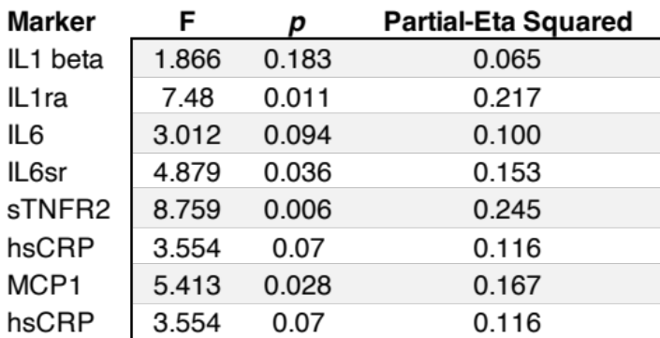
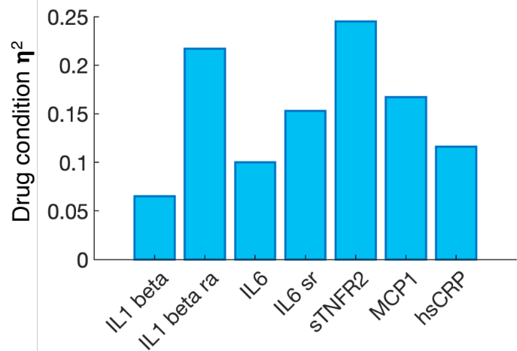

Figure S3: Results from MANOVA analysis of effects of infliximab on inflammatory cytokines and their receptors/receptor antagonist. Partial-eta squared of group (drug condition) by time (baseline or 14day) interaction on inflammatory markers.
Change in Pre-registered self-report measures for motivational anhedonia.
As described in the main results section, there was no significant group × time interaction for any of the four symptom measures of motivational anhedonia. This was largely driven by nominal improvement across measures for both groups. In addition to the reported results for the IDS-SR anhedonia subscale and the MDFI Reduced Motivation subscale (see main text and Figure 2E-F), we present the results for the pre-registered MDFI Reduced Activity Subscale and MAP-SR motivation and effort to engage in activities subscale below. Neither group showed significant improvement on neither the MDFI reduced activity scale or the MAP-SR effort, though both groups showed nominal improvement.
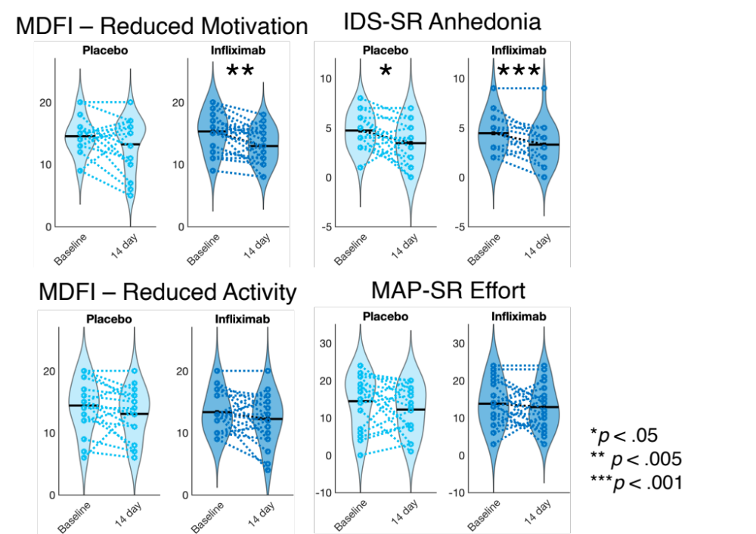
Figure S4: Violin plots depicting change in additional pre-registered self-report measures for motivational anhedonia. All measures are scored such that lower scores are associations with lower levels of motivational anhedonia.
Abbreviations: MDFI – multidimensional fatigue inventory; MAP-SR – Motivation and Pleasure Scale self-report.

Neuroimaging Results for Pre-Registered Analyses
A full list of pre-registered regions of interest for each contrast is provided in Supplementary Table 4. There were no significant main effects of drug condition in our pre-defined a priori regions of interest. Whole-brain analysis did reveal a significant effect of drug condition in supplemental motor area, such that individuals receiving placebo exhibited greater activity following a shift in choice as compared to those receiving infliximab (contrast 7) as well as decreased activity in primary visual cortex during trials where choosing between the effortful and non-effortful options was more difficult (contrast 6) (See Supplementary Table 5). All coordinates are in MNI space.

Supplementary Table 4: Pre-registered Regions of Interest for each contrast. Note that contrast 4, SV_{chosen} did not have a pre-registered ROI.

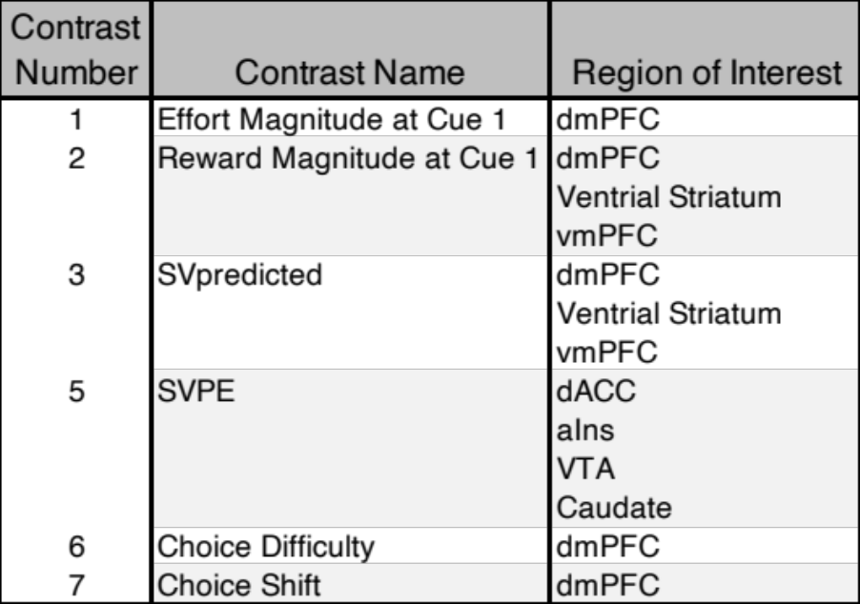

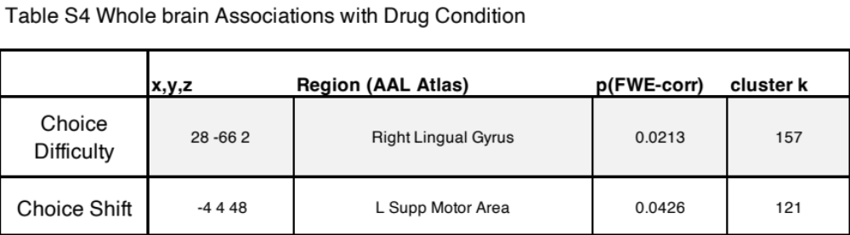
Supplementary Table 5: Whole-brain associations with Choice Difficulty (contrast 6) and Choice Shift (contrast 7).

Whole-brain Neuroimaging Results for Associations with ΔsTNFR2, Δk, Δ100% Effort Choices
Whole-brain analyses examining the associations between ΔsTNFR2, Δk, and Δ100% Effort Choices and ΔSV_{chosen} activity (contrast 4) revealed activity in a variety of brain areas associated with motor processing and cognitive control. While the main text focused on interpreting results associations with dmPFC, the full list of areas identified in these analyses is provided in Supplementary Table 6. All coordinates are in MNI space.

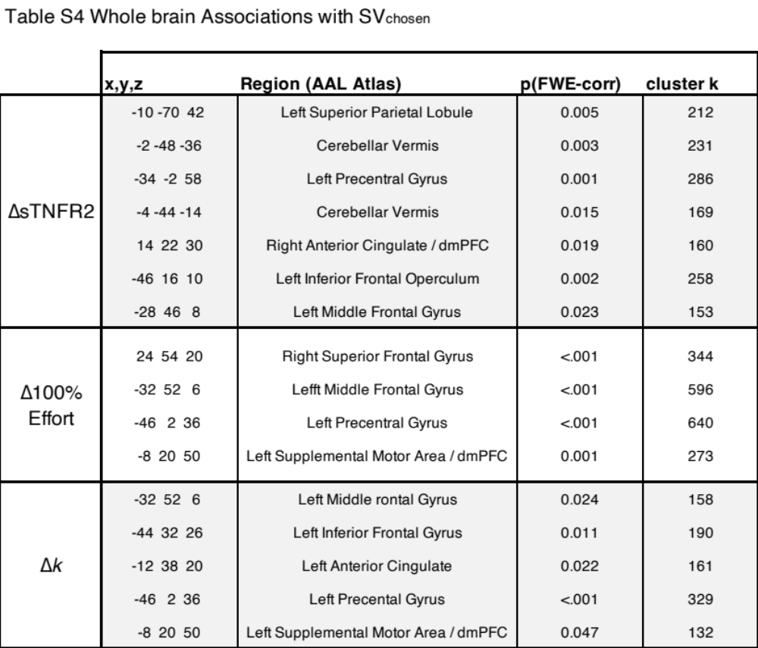
Supplementary Table 6: Whole-brain associations with SV_{chosen} (contrast 4)

Validation of Reward Signature for EBDM task
Given that the reward signature developed by Speer and colleagues¹⁴ was trained to discriminate between wins and losses during the monetary incentive delay task¹⁵, we sought to confirm that it would be sensitive to high and low value trials during the staggered EBDM task. Therefore, we combined two previously published datasets collected using this task^{4, 16}. This resulted in a dataset obtained from 47 healthy control participants (n=29 female (61%), mean age = 21.4 +/- 3.26 years). To assess the sensitivity of the reward signature, we generated single-trial models from these 47 datasets, and divided trials based on the median split of the model-derived subjective value estimates for each trial. Subjective value estimates relied on previously published methods for these samples, but were highly similar model-fitting approaches described above. For each subject, we then calculated a mean image for Cue 2 activity during low and high SV trials, and estimated the cosine similarity between these images and the reward signature for each subject. As expected, these data revealed a strong significant difference between conditions (Cohen’s D = 1.05, t₄₆ = -5.024, p=8e-6). Notably, the low SV trials had a negative cosine similarity, indicating they appeared to be more “loss like”. High SV trials were much closer to zero, which is consistent with the notion that these trials were not necessarily monetary wins, but attractive cost/benefit exchanges that included monetary wins. Moreover, the high SV trials had a higher cosine similarity than the low SV trials for 35 participants (75%) of the sample. As a control analysis, we also evaluated the sensitivity of the Picture-Induced Negative Emotion Signature (PINES), which was trained to classify the level of negative emotional response to visual stimuli. As expected, this signature showed little sensitivity to high vs low SV trials (p = .702), and we observed a significant signature X condition interaction (F_{(1,46)} =16.4, p<.001) (Figure 5A). Taken together, these data support the hypothesis that this reward signature was sensitive to high and low value trials during this task.

Sensitivity Analyses: Effects of Performance Metrics and Imaging Data Quality on Reported Results.
All results reported in this manuscript include all participants for which data was available. To evaluate the robustness of our results to potential data quality issues, we conducted a number of sensitivity analyses in which we examined the impact of potential covariates or re-ran analyses in the absence of participants with potentially poorer data quality. For EBDM task behavior, this included examining the impact of individuals who timed out on >20% of trials during either the baseline or 14day EBDM scan (n=2) the impact of a low max press at 14 days relative to baseline (n=1), and the impact of the number of post-scan switches at either the baseline or day 14. For analyses involving sTNFR2, this involved including a dummy-coded covariate for participants whose blood was only available at 7-days instead of 14-days (n=2), and for imaging analyses, this included a covariate for subjects with motion >3mm (n=5). All analyses presented in the main text were re-run with these variables included as covariates or participant exclusions, as appropriate. When accounting for these factors, the mediation effect of ΔsTNFR2 on drug condition and the Δk parameter (Figure 2D bottom) dropped from 95% CI to 90% CI, the mediation effect of ΔsTNFR2 on Δk parameter and dmPFC SVC beta weights dropped from 95% to 90% and the association between Δ100% and the Reward Signature lost significance (p=0.11). All originally reported results retained significance following the sensitivity analyses.

SUPPLEMENTAL REFERENCES

1. Raison CL, Rutherford RE, Woolwine BJ, Shuo C, Schettler P, Drake DF et al. A Randomized Controlled Trial of the Tumor Necrosis Factor Antagonist Infliximab for Treatment-Resistant DepressionThe Role of Baseline Inflammatory BiomarkersInfliximab for Treatment-Resistant Depression. JAMA Psychiatry 2013; 70(1): 31-41.

2. Goldsmith DR, Haroon E, Woolwine BJ, Jung MY, Wommack EC, Harvey PD et al. Inflammatory markers are associated with decreased psychomotor speed in patients with major depressive disorder. Brain, behavior, and immunity 2016; 56: 281-288.

3. Goldsmith DR, Massa N, Pearce BD, Wommack EC, Alrohaibani A, Goel N et al. Inflammatory markers are associated with psychomotor slowing in patients with schizophrenia compared to healthy controls. npj Schizophrenia 2020; 6(1): 8.

4. Arulpragasam AR, Cooper JA, Nuutinen MR, Treadway MT. Corticoinsular circuits encode subjective value expectation and violation for effortful goal-directed behavior. Proc Natl Acad Sci 2018: 201800444.

5. Frederick S, Loewenstein G, O’Donoghue T. Time discounting and time preference: a critical review. Journal of Economic Literature 2002; 40: 351-401.

6. Green L, Fry AF, Myerson J. Discounting of delayed rewards: a life span comparison. Psychological Science 1994; 5(1): 33-36.

7. Prevost C, Pessiglione M, Metereau E, Clery-Melin ML, Dreher JC. Separate valuation subsystems for delay and effort decision costs. J Neurosci 2010; 30(42): 14080-14090.

8. Sugiwaka H, Okouchi H. Reformative self-control and discounting of reward value by delay or effort. Japanese Psychological Research 2004; 46: 1-9.

9. Chong TT, Apps M, Giehl K, Sillence A, Grima LL, Husain M. Neurocomputational mechanisms underlying subjective valuation of effort costs. PLoS Biol 2017; 15(2): e1002598.

10. Hartmann MN, Hager OM, Tobler PN, Kaiser S. Parabolic discounting of monetary rewards by physical effort. Behav Processes 2013; 100: 192-196.

11. Klein-Flugge MC, Kennerley SW, Saraiva AC, Penny WD, Bestmann S. Behavioral modeling of human choices reveals dissociable effects of physical effort and temporal delay on reward devaluation. PLoS Comput Biol 2015; 11(3): e1004116.

12. Gureckis TM, Love BC. Short-term gains, long-term pains: how cues about state aid learning in dynamic environments. Cognition 2009; 113(3): 293-313.

13. Schwarz G. Estimating the dimension of a model. The annals of statistics 1978; 6(2): 461-464.

14. Speer SP, Keysers C, Barrios JC, Teurlings CJ, Smidts A, Boksem MA et al. A multivariate brain signature for reward. Neuroimage 2023; 271: 119990.

15. Knutson B, Fong GW, Adams CM, Varner JL, Hommer D. Dissociation of reward anticipation and outcome with event-related fMRI. Neuroreport 2001; 12(17): 3683-3687.

16. Suzuki S, Lawlor VM, Cooper JA, Arulpragasam AR, Treadway MT. Distinct regions of the striatum underlying effort, movement initiation and effort discounting. Nature Human Behaviour 2021; 5(3): 378-388.

