Supporting Information for Andrade et al.

CONTENTS

- Supplementary Figure S1…...………………………………………………... 2
- Supplementary Figure S2.……..……………………………………………... 3
- Supplementary Table S1.…..………………………………………………..…4
- Supplementary Table S2……..………………………………………………...5
- Supplementary Table S3..……………………………………………………...6
- Additional references associated with Supplementary Information …….....7

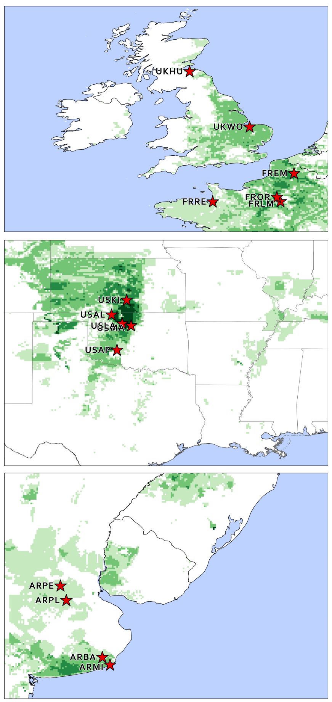
Supplementary Figure 1 Locations of trial sites and climate zones in United Kingdom and France (top), United States (middle), and Argentina (bottom panel). The stars represent the trial sites used in this study. The green color represents wheat crop area distribution (IFPRI, 2019). Trials are indicated with a single code (refer to Supplementary Table 2 for full site names).

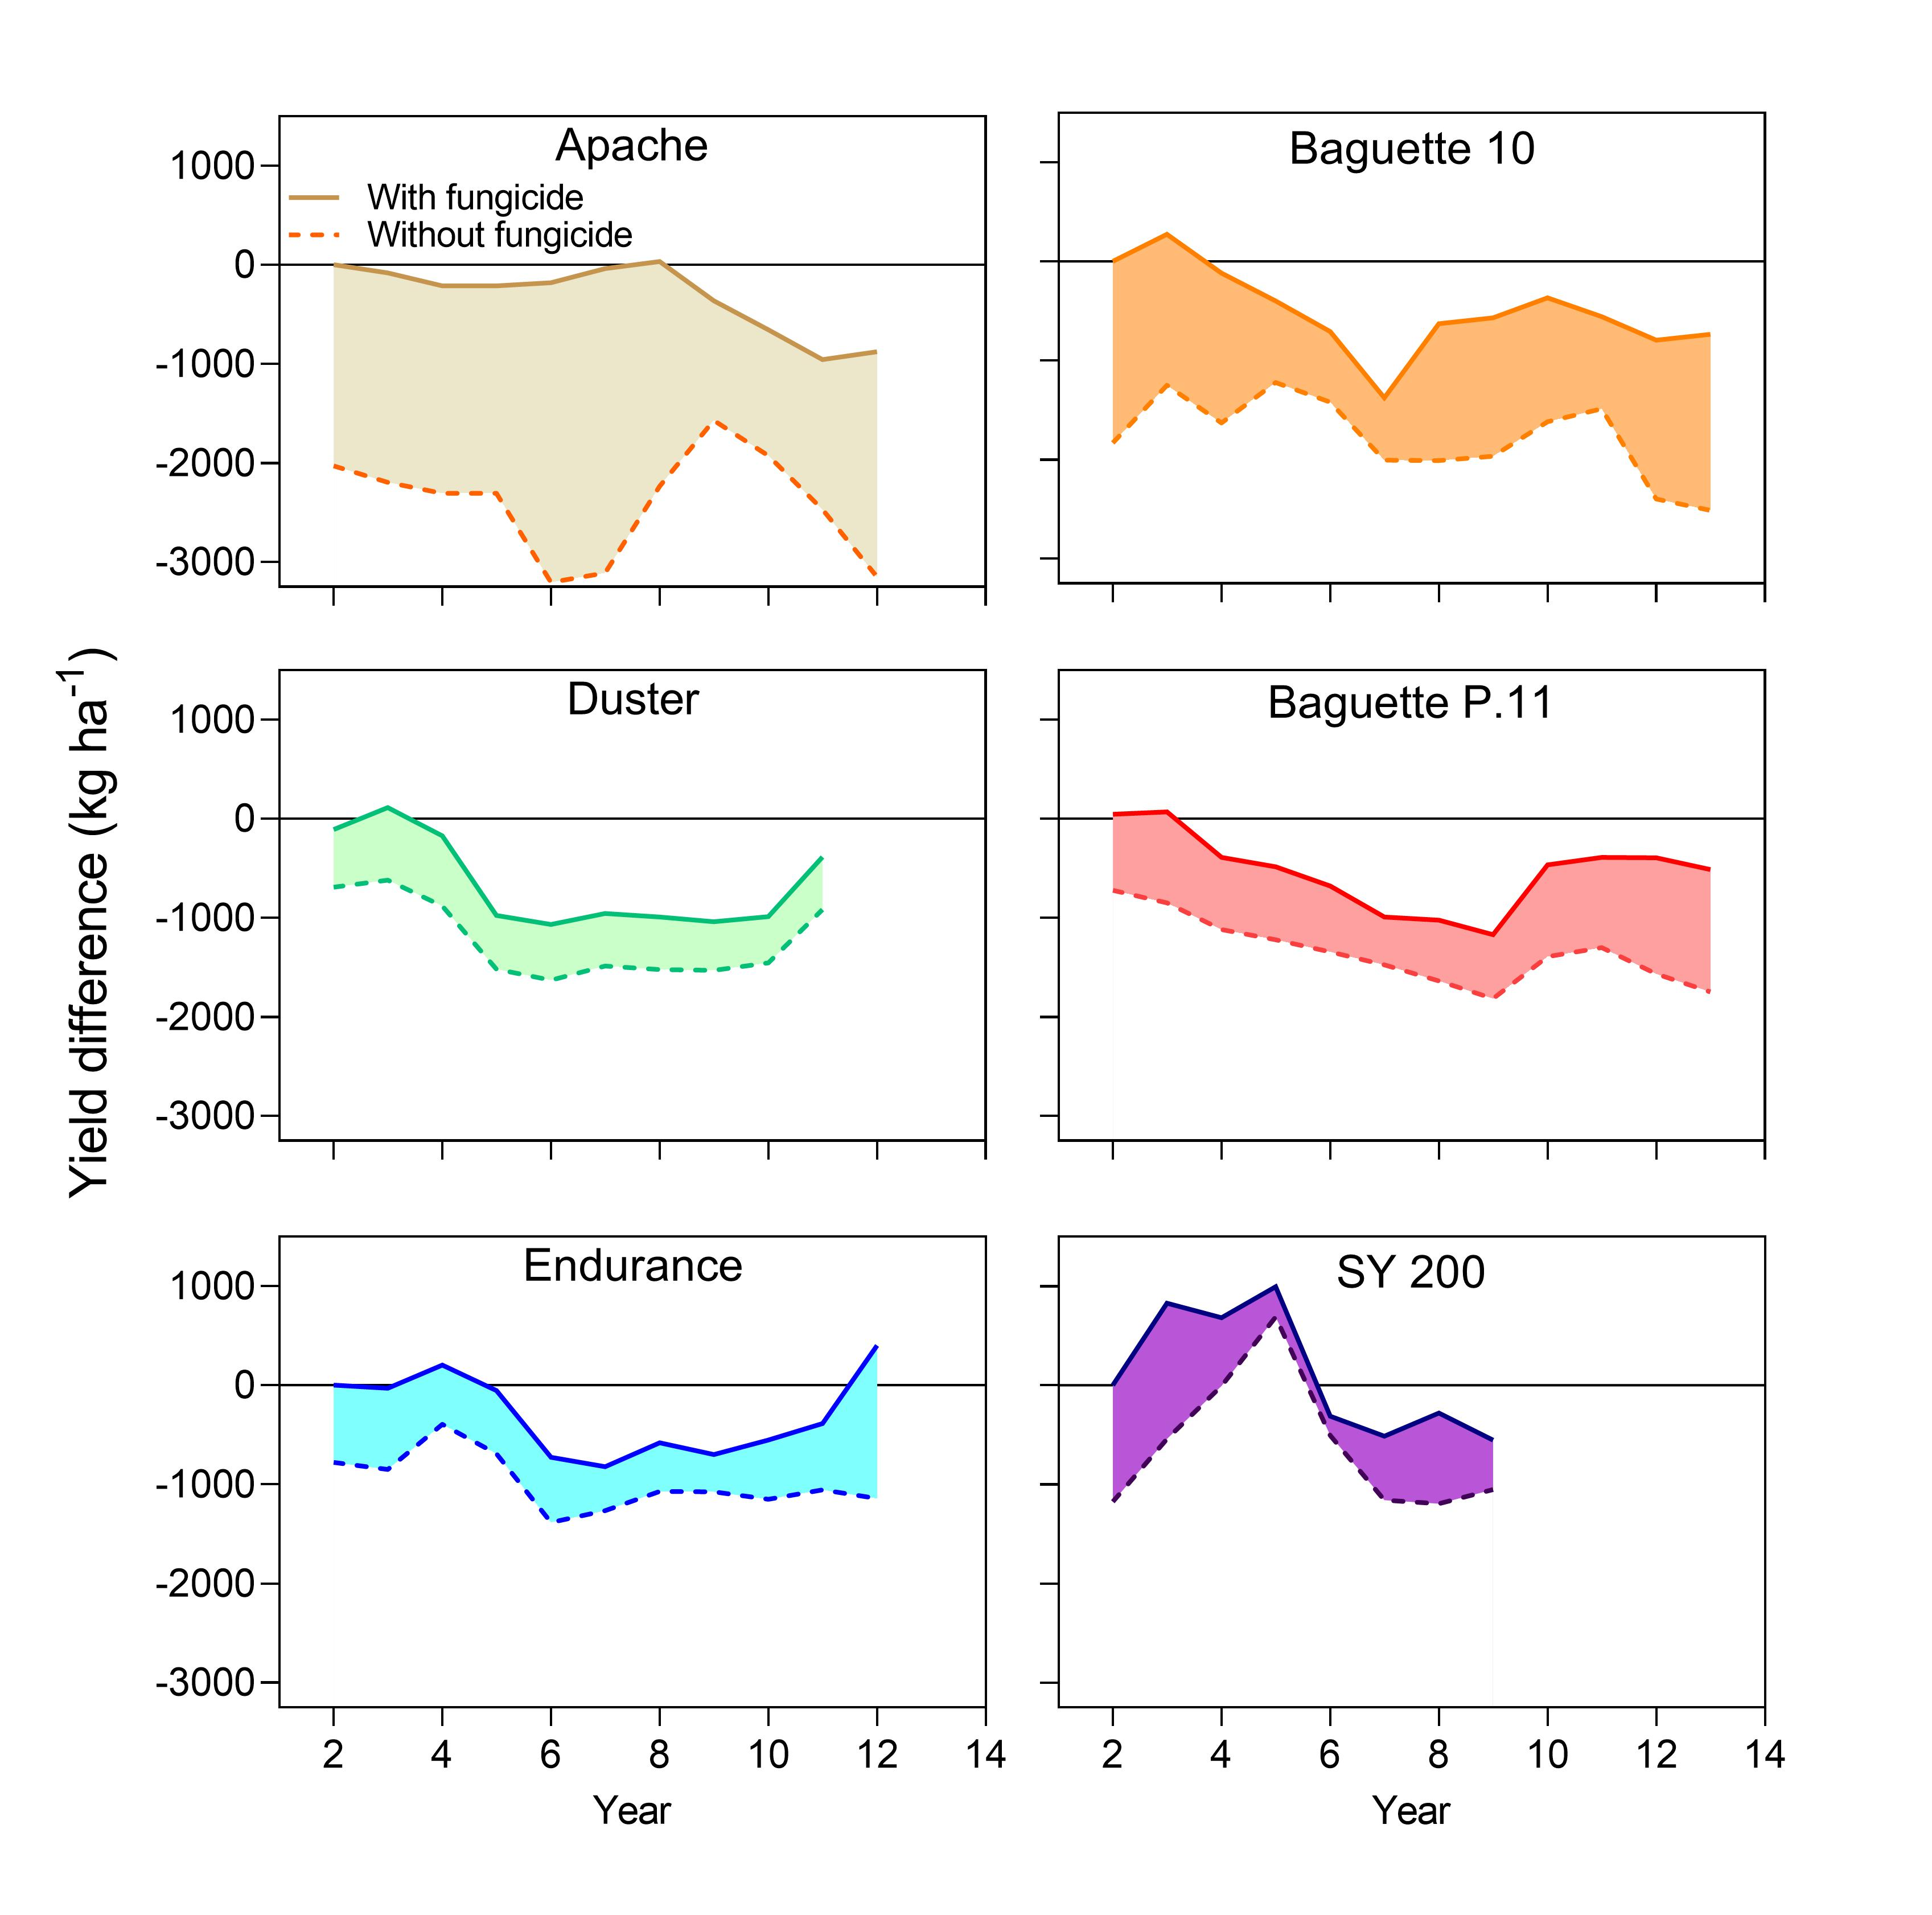
Supplementary Figure S2. Yield trends for check cultivars with and without fungicide. Trends in yield for individual check cultivars (a) and for the top yielding entries (b) treated or not with in-season foliar fungicide (solid and dashed lines, respectively). The average yield difference is shown in each case. In all cases, year one represents the time when a given check cultivar was released and included in the trial. Yields are expressed relative to the average yield with fungicide during the first three years of the time-period and 3-year moving averages are shown to smooth the inter-annual yield variation. Trials were conducted in Argentina (Baguette 10, Baguett P.11, and SY 200), Western Europe (Apache), and United States (Duster and Endurance). Weather influence was previously deducted from Baguette P.11, Baguette 10, Cordiale, SY 200.
Supplementary Table S1. Overview of data sources and number of cultivars evaluated in Argentina, France, United Kingdom, and United States.
Country | Average no. of cultivars tested per year | Data source
Argentina | 25 | INASE (https://www.argentina.gob.ar/inase/red-variedades-de-trigo); Chacra Experimental Miramar (https://www.chacramiramar.com.ar/)
France | 37 | INRA-URGI (https://urgi.versailles.inra.fr/ephesis/ephesis/viewer.do#dataResults/trialSetIds=8)
United Kingdom | 41 | AHDB (https://ahdb.org.uk/rl)
United States | 23 | DPSS of OSU (http://wheat.okstate.edu/variety-testing/grain-yield)

Supplementary Table S2. Overview of 33 site x check cultivar x fungicide treatment combinations in Argentina, France, United Kingdom, and United States.
No. | Country | Location | Check cultivar | Fungicide | Timespan | Reference
1 | Argentina | Balcarce | Baguette P.11 | Y | 2005-2018 | ARBA
2 |  | Balcarce | Baguette P.11 | N | 2005-2018 | ARBA
3 |  | Pla | Baguette P.11 | Y | 2005-2017 | ARPL
4 |  | Pla | Baguette P.11 | N | 2005-2017 | ARPL
5 |  | Pergamino | Baguette P.11 | Y | 2005-2018 | ARPE
6 |  | Pergamino | Baguette P.11 | N | 2005-2018 | ARPE
7 |  | Miramar | Baguette P.11 | Y | 2005-2017 | ARMI
8 |  | Miramar | Baguette P.11 | N | 2005-2017 | ARMI
9 |  | Miramar | Baguette 10 | Y | 2002-2016 | ARMI
10 |  | Miramar | Baguette 10 | N | 2002-2016 | ARMI
11 |  | Miramar | SY 200 | Y | 2012-2021 | ARMI
12 |  | Miramar | SY 200 | N | 2012-2021 | ARMI
13 | France | Estrees-Mons | Apache | Y | 2002-2014 | FREM
14 |  | Estrees-Mons | Apache | N | 2002-2014 | FREM
15 |  | Le Moulon | Apache | Y | 2002-2014 | FRLM
16 |  | Le Moulon | Apache | N | 2002-2014 | FRLM
17 |  | Orgeval | Apache | Y | 2002-2014 | FROR
18 |  | Orgeval | Apache | N | 2002-2014 | FROR
19 |  | Rennes | Apache | Y | 2002-2014 | FRRE
20 |  | Rennes | Apache | N | 2002-2014 | FRRE
21 | United Kingdom | Humbie | Claire | Y | 2004-2016 | UKHU
22 |  | Humbie | Cordiale | Y | 2004-2017 | UKHU
23 |  | Wolferton | Cordiale | Y | 2004-2017 | UKWO
24 | United States | OK-Apache | Duster | Y | 2006-2018 | USAP
25 |  | OK-Apache | Duster | N | 2006-2018 | USAP
26 |  | OK-Lahoma | Duster | Y | 2006-2018 | USLA
27 |  | OK-Lahoma | Duster | N | 2006-2018 | USLA
28 |  | OK-Lahoma | Endurance | Y | 2005-2017 | USLA
29 |  | OK-Lahoma | Duster | N | 2006-2017 | USLA
30 |  | OK-Apache | Endurance | Y | 2005-2017 | USAP
31 |  | OK-Alva | Endurance | N | 2005-2016 | USAL
32 |  | OK-Kingfisher | Endurance | N | 2005-2017 | USKI
33 |  | OK-Marshall | Endurance | N | 2005-2017 | USMA
Fungicide: no fungicide was applied (N); fungicide was applied (Y).

Supplementary Table S3. Slope of yield trend of check cultivars (kg ha⁻¹ y⁻¹). Regression lines were adjusted to the 3-year moving averages in Figure 2. Statistical significance is indicated as p-value of the slope. Weather influence based on 3-yr moving average of simulated yields was previously deducted from Baguette P.11 (-23 kg ha⁻¹ y⁻¹), Baguette 10 (-57 kg ha⁻¹ y⁻¹), Cordiale (100 kg ha⁻¹ y⁻¹), SY 200 (59 kg ha⁻¹ y⁻¹).

Check cultivar | Slope of yield of check cultivars  (kg ha⁻¹ y⁻¹) | Slope  Std error | p-value
Apache | -60 | 10 | <0.001
Baguette 10 | -75 | 15 | <0.001
Baguette P.11 | -72 | 14 | <0.001
Claire | 14 | 25 | 0.575
Cordiale | -190 | 27 | <0.001
Duster | -106 | 17 | <0.001
Endurance | -44 | 18 | 0.038
SY 200 | -16 | 45 | 0.725
Average | -68 | 11 | <0.001

Additional references associated with Supplementary Information

- International Food Policy Research Institute, 2019, "Global Spatially-Disaggregated Crop Production Statistics Data for 2010 Version 2.0", https://doi.org/10.7910/DVN/PRFF8V, Harvard Dataverse, V4

