Supplementary materials

The role of long-term trends and internal variability in altering fire weather conditions in the western United States

Jiale Lou ^{1 *}, Youngji Joh ¹ , Thomas L. Delworth ²
¹Atmospheric and Oceanic Sciences Program, Princeton University, Princeton, NJ, USA.
² Geophysical Fluid Dynamics Laboratory, NOAA, Princeton, NJ, USA.

* Corresponding author: Jiale Lou (jiale.lou@noaa.gov)

Supplementary Table 1: Seasonal lead-lag correlations between the first VPD mode and the Atlantic Multidecadal Variability (AMV) and the Pacific Decadal Oscillation (PDO). The negative lags here indicate the AMV and PDO lead the target VPD conditions.
AMV | -0month | -3months | -6months | -9months | -12months
DJF | 0.28 | 0.33* | 0.40* | 0.36* | 0.22
MAM | 0.17 | 0.44* | 0.39* | 0.39* | 0.34*
JJA | 0.31* | 0.28 | 0.35* | 0.32* | 0.33*
SON | 0.35* | 0.36* | 0.33* | 0.33* | 0.30*
PDO | -0month | -3months | -6months | -9months | -12months
DJF | -0.30* | -0.37* | -0.25 | -0.32* | -0.23
MAM | -0.39* | -0.31* | -0.32* | -0.30* | -0.30*
JJA | -0.35* | -0.32* | -0.33* | -0.32* | -0.32*
SON | -0.33* | -0.26 | -0.30* | -0.32* | -0.28
*Statistically significant correlation coefficients at the 95% confidence level, accounting for effective degrees of freedom following Davis

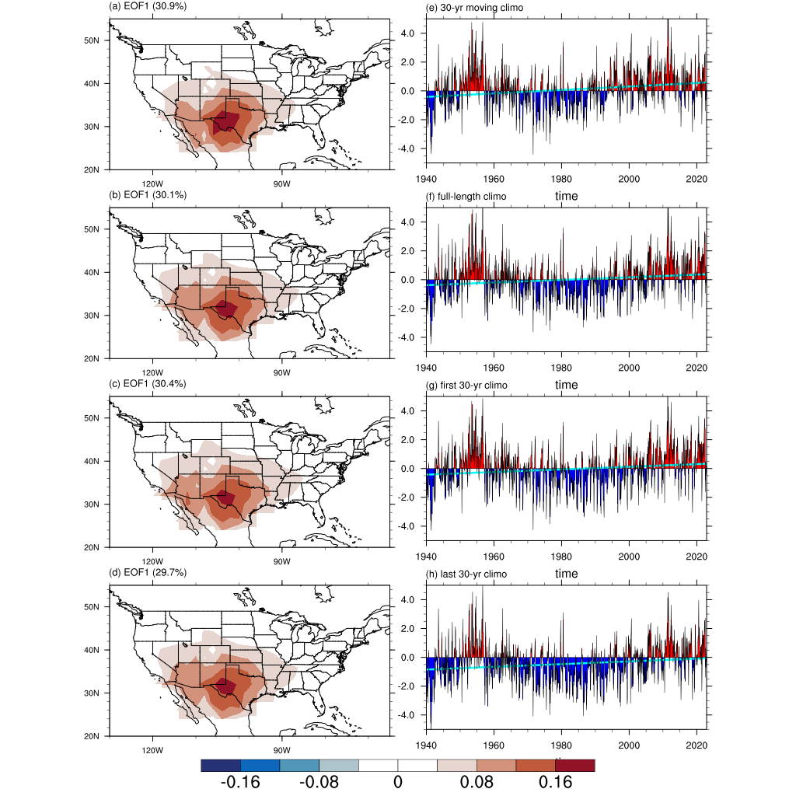
Supplementary Figure 1: Spatiotemporal features of the first vapor pressure deficit (VPD) mode. The first EOF mode of the monthly VPD anomalies defined by removing (a and e) an evolving 30-year, (b and f) the full-length, (c and g) the first 30-year, and (d and h) the last 30-year climatology. The first EOF mode explains 30.9%, 30.1%, 30.4%, and 29.7% of the corresponding variance, respectively. The cyan line indicates the linear trend with slopes of 0.12, 0.09, 0.09, and 0.09 per decade, respectively, which are all statistically significant at the 95% confidence level.

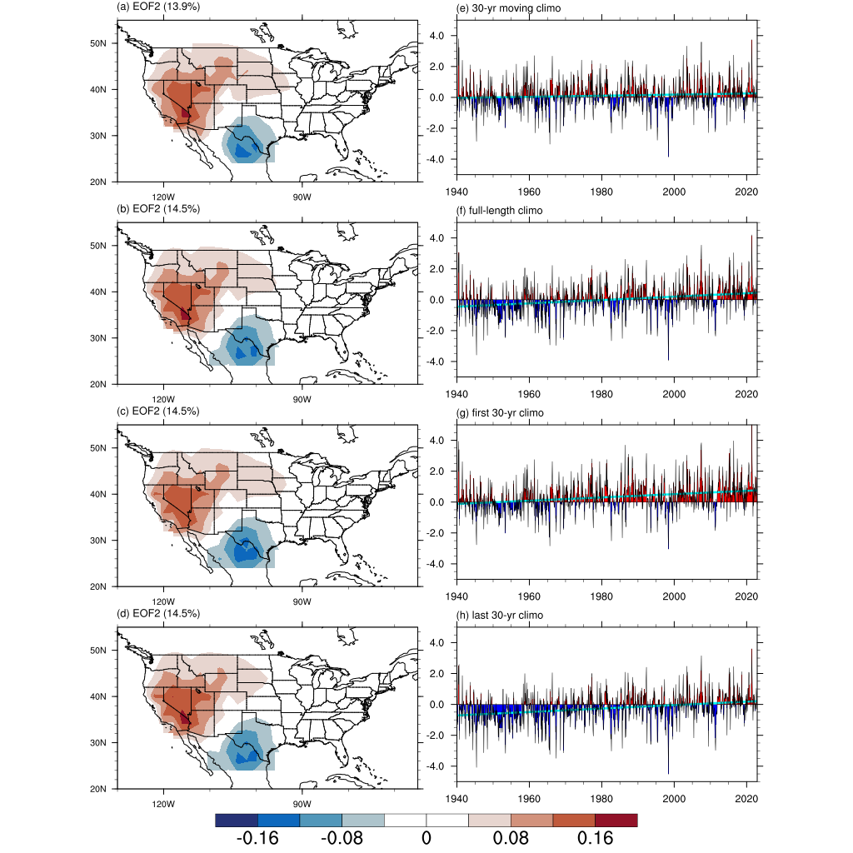
Supplementary Figure 2: Spatiotemporal features of the second vapor pressure deficit (VPD) mode. The second EOF mode of the monthly VPD anomalies defined by removing (a and e) an evolving 30-year, (b and f) the full-length, (c and g) the first 30-year, and (d and h) the last 30-year climatology. The second EOF mode explains 13.9%, 14.5%, 14.5%, and 14.5% of the corresponding variance, respectively. The cyan line indicates the linear trend with slopes of 0.04, 0.11, 0.11, and 0.11 per decade, respectively, which are statistically significant at 95% confidence level, except the one derived from the evolving climatology.

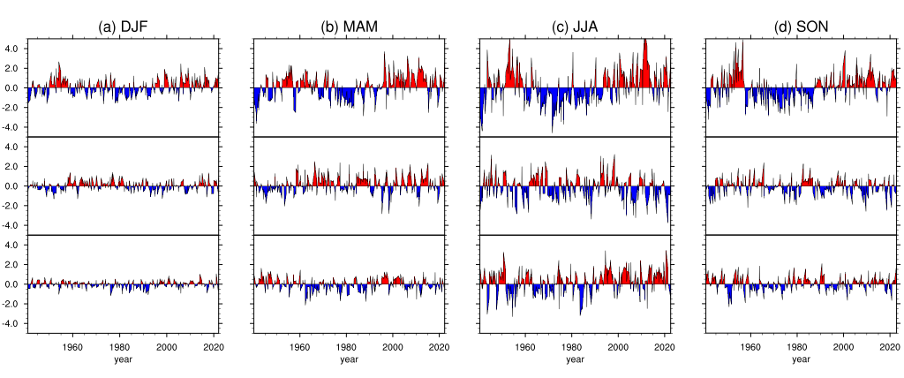
Supplementary Figure 3: Seasonal PC time series of the leading three VPD modes. The leading three PC time series of the seasonal VPD anomalies for (a) DJF, (b) MAM, (c) JJA, and (d) SON. The linear trends are removed before applying EOF analysis. The PC time series are computed by projecting the EOF patterns onto the seasonal VPD anomalies. The units of the PC time series are kPa.

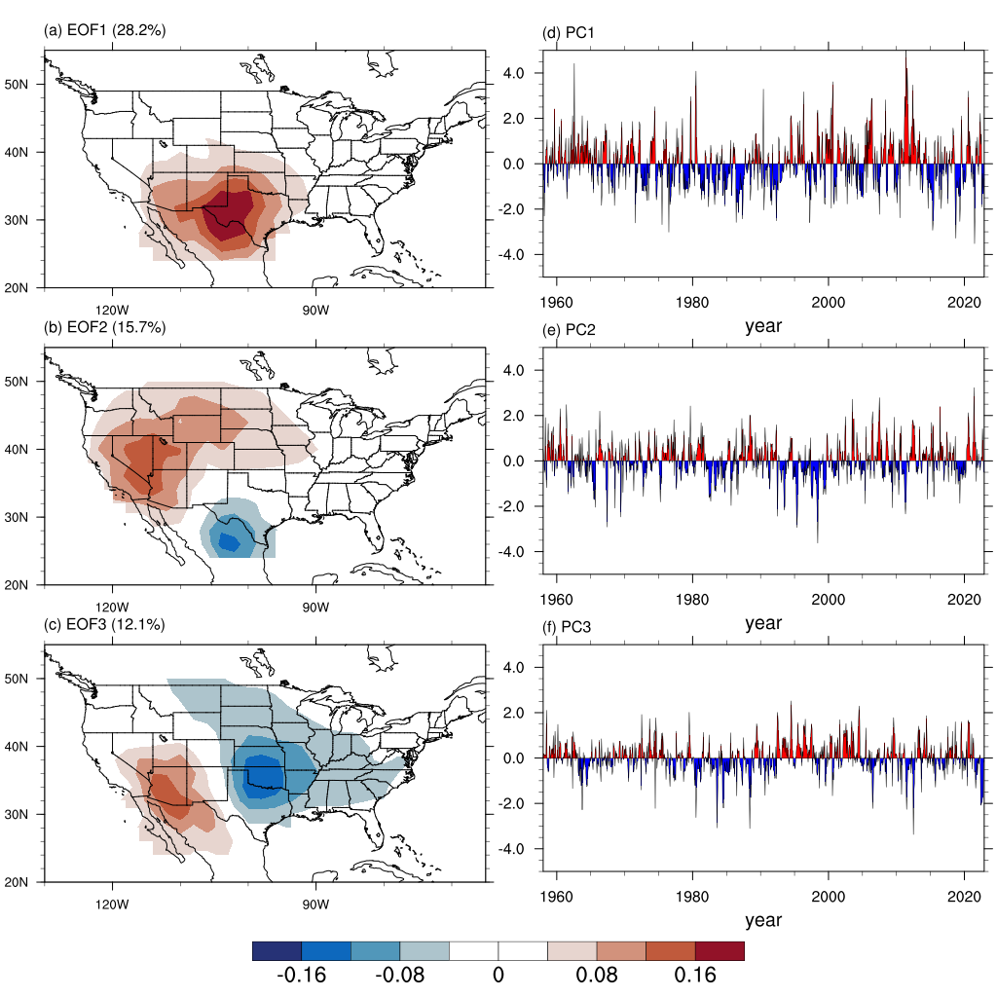
Supplementary Figure 4: Spatiotemporal features of the monthly vapor pressure deficit (VPD) anomalies. (a-c) The spatial patterns of the leading three EOF modes of the monthly detrended VPD anomalies and (d-f) the corresponding PC time series. The leading three EOF modes explain 28.2%, 15.7%, and 12.1% of the total variance, respectively. The reanalysis data were taken from JRA55 for the period of 1958-2022.

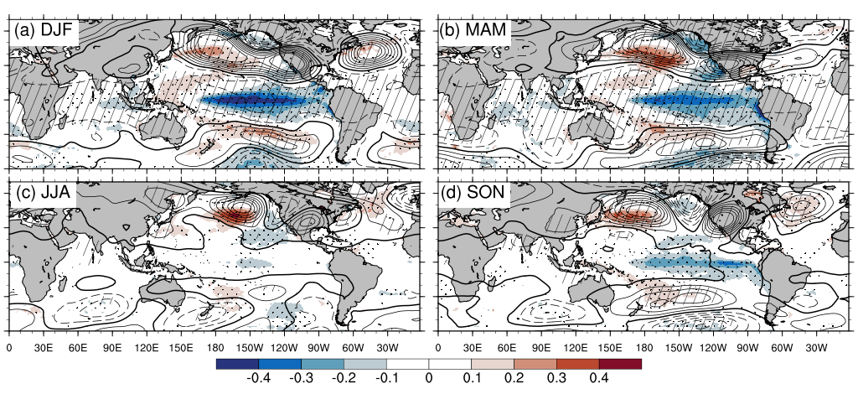
Supplementary Figure 5: Regression maps. Linear regression of seasonal SST (shaded) and 500hPa geopotential height (Z500; contour) anomalies onto the leading seasonal VPD PC time series for (a) DJF, (b) MAM, (c) JJA, and (d) SON, respectively. The contours range from -12.0 to 12.0 with intervals of 2.0 (units: m kPa⁻¹). The zero contour is thickened in the plot. Stippled and hatched areas show that the regression coefficients are significant at 95% confidence level (p<0.05) for the SST and Z500 anomalies, respectively.

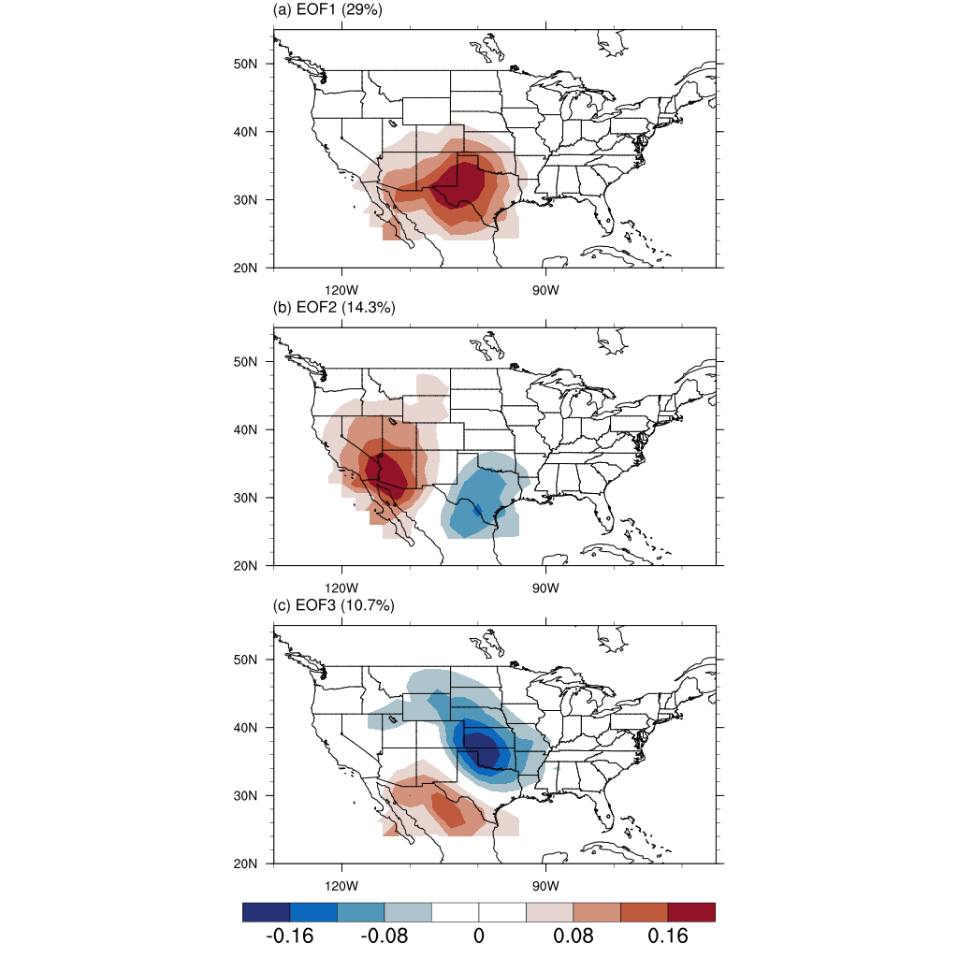
Supplementary Figure 6: The first three EOF patterns of the monthly VPD based on the SPEAR-LE. The first three EOF modes explain 29%, 14.3%, and 10.7% of the total variance, respectively.
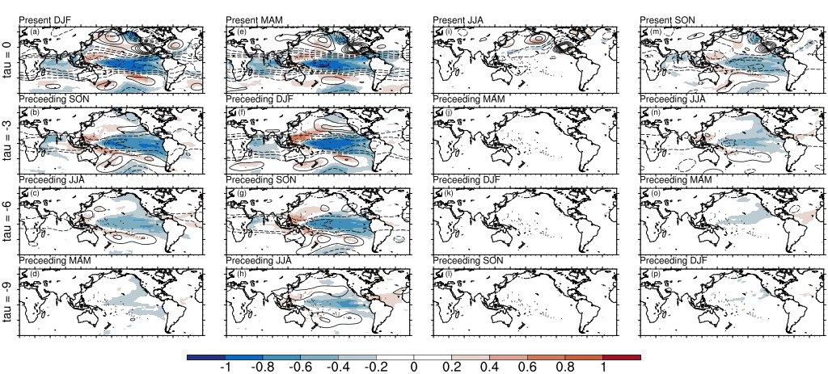
Supplementary Figure 7: Same as shown in Fig. 8, but for 80 model-analogs.

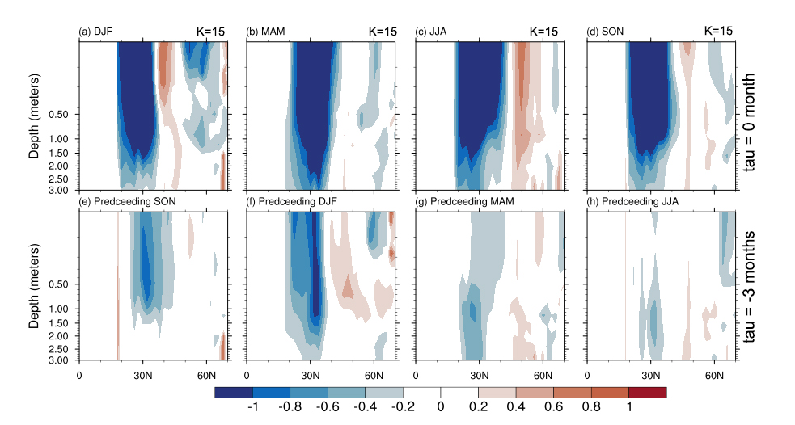
Supplementary Figure 8: Backward signal-to-noise ratio (SNR) maps of the cross-sections (0-70ºN,120-100ºW) of soil moisture at depths down to 3 meters. The target state is pre-specified as the positive phase of the leading VPD mode. The time lag interval is -3 months ranging from 0-month lag to -3-month time lag. 15 model-analogs are used. The ensemble means of the selected 15 model-analogs represent the desired signal, and the standard deviation of them denotes the ensemble spread (i.e., noise). SNR is then the fraction between signal and noise. The analogous states are taken from SPEAR-LE.

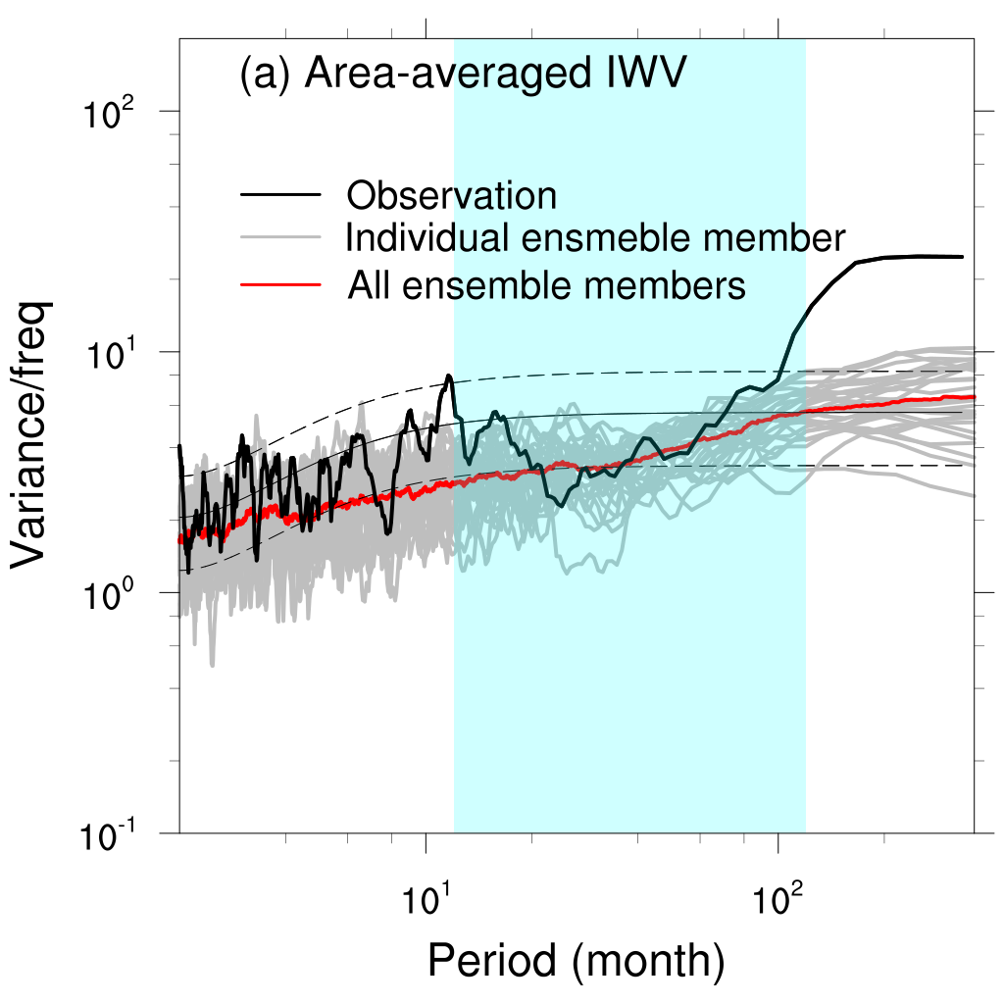
Supplementary Figure 9: Spectrum analysis of the total column-integrated water vapor (IWV, units: kg m⁻²) in the southwest US. Thick black curve represents the observations, thick red curve represents all 30 SPEAR-LE ensemble members. Grey curves indicate individual SPEAR-LE ensemble members. Thin solid curves show the red noise, and upper and lower dashed curves indicate confidence intervals from 5% to 95%. The cyan shading indicates the period from 1 year to 10 years for reference. The x and y axes are on a log-log scale. The bandwidth for all the spectra is confined to 0.03.

