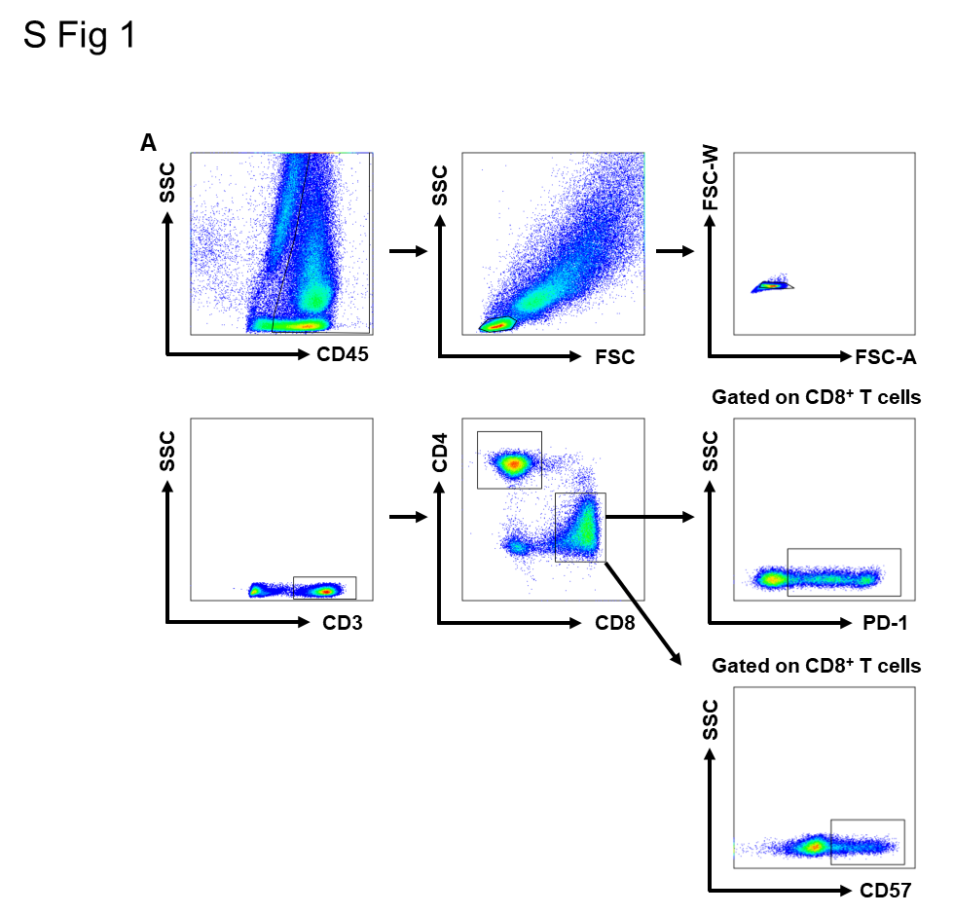

Supplementary Figure 1. Representative plots from all presented populations.

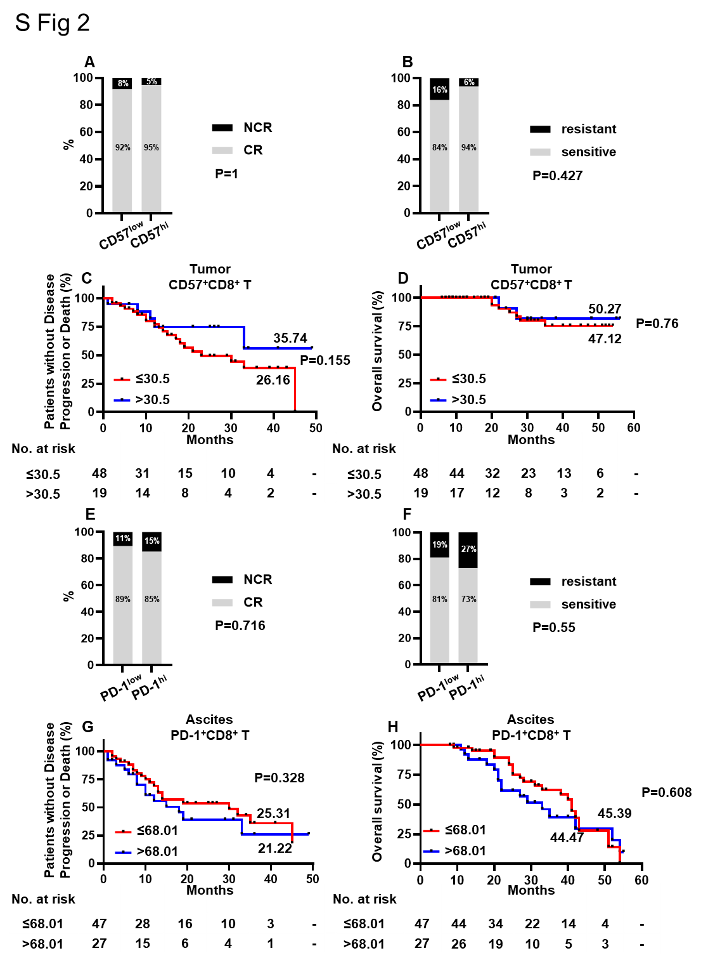
Supplementary Figure 2. Prognostic relevance of advanced HGSOC patients with different level of CD57⁺CD8⁺ TILs (n=67) and PD-1⁺CD8⁺ TALs (n=74). (A) CR rate and (B) chemosensitivity according to CD57⁺CD8⁺ TILs status. (C) PFI and (D) OS was grouped according to the proportion of CD57⁺CD8⁺ TILs. (E) CR rate and (F) chemosensitivity according to PD-1⁺CD8⁺ TALs status. (G) PFI and (H) OS was grouped according to the proportion of PD-1⁺CD8⁺ TALs. The optimal cut-off for survival risk was calculated using the log-rank maximization method. Chi square (x2) test was used to compare differences between groups. Kaplan-Meier method was used to estimate PFI and OS, and plot survival curves. Log-rank test was used to compare survival differences among groups.

Supplementary Table 1 Reagent used in this research
Reagent | Com | Catalog | Clone
FITC anti-human CD3 | Biolegend | 300306 | HIT3a
APC-Cy7 anti-human CD3 | Biolegend | 300426 | A161A1
APC-Cy7 anti-human CD4 | Biolegend | 300426 | UCHT1
PE anti-human CD4 | Biolegend | 300508 | RPA-T4
PerCP-cy5.5 anti-human CD8 | Biolegend | 344710 | SK1
PE-Cy7 anti-human CD28 | Biolegend | 302926 | CD28.2
BV605 anti-human CD28 | Biolegend | 302968 | CD28.2
Brilliant Violet 605™ anti-human CD45 | Biolegend | 304041 | HI30
FITC anti-human CD57 | Biolegend | 359604 | HNK-1
Pacific Blue anti-human CD57 | Biolegend | 359607 | HNK-1
PE anti-human PD-1 | Biolegend | 329906 | EH12.2H7
PE-CF594 anti-human CCR7 | Biolegend | 353236 | G043H7
BV510 anti-human CD45RA | Biolegend | 304141 | HI100
BV421 anti-human Tim-3 | Biolegend | 345007 | F38-2E2
BV650 anti-human Lag-3 | Biolegend | 369315 | 11C3C65
APC anti-human Ki67 | Biolegend | 350514 | Ki-67
FITC anti-human IFN-γ | Biolegend | 502506 | 4S.B3
PE-CF594 anti-human TNF-α | Biolegend | 502946 | MAb11
APC anti-human Granzyme B | Biolegend | 372204 | QA16A02
BV605 anti-human IL-2 | Biolegend | 500331 | MQ1-17H12
Ultra-LEAF™ Purified anti-human CD3 | Biolegend | 300331 | HIT3a
Ultra-LEAF™ Purified anti-human CD28 | Biolegend | 302934 | CD28.2
Cell Activation Cocktail (without Brefeldin A) | Biolegend | 423302 | -
Brefeldin A Solution (1,000X) | Biolegend | 420601 | -
Fixation Buffer | Biolegend | 420801 | -
Intracellular Staining Perm Wash Buffer (10X) | Biolegend | 421002 | -
True NuclearTM 4X Fix Concentrate | Biolegend | 73158 | -
True NuclearTM Fix Diluent | Biolegend | 73160 | -
True NuclearTM 10X Perm | Biolegend | 73162

Supplementary Table 2. Clinical characteristics difference of patients with high/low levels of PD-1⁺CD8⁺ TILs and CD57⁺CD8⁺ TILs.
Characteristics | PD-1^{low}(<87.8%, n=36) | PD-1^{hi}(>87.8%, n=31) | Sig. | CD57^{low}(<30.5%, n=48) | CD57^{hi}(>30.5%, n=19) | Sig.
Age (years) |  |  | 1 |  |  | 0.36
<65 | 27 | 24 |  | 38 | 13
>65 | 9 | 7 |  | 10 | 6
FIGO stage |  |  | 0.802 |  |  | 0.58
Ⅲ | 23 | 18 |  | 28 | 13
Ⅳ | 13 | 13 |  | 20 | 6
Ascites |  |  | 1 |  |  | 1
Without | 7 | 7 |  | 10 | 4
<1000 ml | 11 | 9 |  | 14 | 6
>1000 ml | 17 | 15 |  | 23 | 9
Lymph node metastasis |  |  | 0.577 |  |  | 0.029
Without | 9 | 12 |  | 19 | 2
With | 17 | 15 |  | 20 | 12
HRD score |  |  | 0.051 |  |  | 0.137
<50 (-) | 8 | 0 |  | 4 | 4
>50 (+) | 8 | 6 |  | 12 | 2
Tumorous PD-L1(% tumorous cells), n (%) |  |  | 1 |  |  | 0.669
<1 | 4 | 1 |  | 3 | 2
1-5 | 5 | 2 |  | 6 | 1
>5 | 5 | 1 |  | 4 | 2
Surgical satisfaction |  |  | 0.214 |  |  | 0.284
R0 | 18 | 21 |  | 30 | 9
NR0 | 18 | 10 |  | 18 | 10
FIGO stage, International Federation of Gynecology and Obstetrics stage; HRD, homologous recombination deficiency; NR0, not reach R0; R0, no macroscopically visible residual tumor. Chi square (x2) test was used to compare differences between groups. Statistical significant differences are highlighted in bold font.

Supplementary Table 3. Clinical characteristics difference of patients with high/low levels of PD-1⁺CD8⁺ TALs and CD57⁺CD8⁺ TALs.
Characteristics | PD-1^{low}(<68.01%, n=47) | PD-1^{hi}(>68.01%, n=27) | Sig. | CD57^{low}(<32.66%, n=55) | CD57^{hi}(>32.66%, n=19) | Sig.
Age (years) |  |  | 1 |  |  | 0.364
<65 | 35 | 20 |  | 39 | 16
>65 | 12 | 7 |  | 16 | 3
FIGO stage |  |  | 0.635 |  |  | 0.599
Ⅲ | 23 | 15 |  | 27 | 11
Ⅳ | 24 | 12 |  | 28 | 8
Ascites |  |  | 0.574 |  |  | 1
<1000 ml | 10 | 8 |  | 14 | 4
>1000 ml | 37 | 19 |  | 41 | 15
Lymph node metastasis |  |  | 0.403 |  |  | 0.529
Without | 14 | 7 |  | 17 | 4
With | 18 | 16 |  | 24 | 10
HRD score |  |  | 1 |  |  | 0.343
<50 (-) | 6 | 2 |  | 4 | 4
>50 (+) | 10 | 4 |  | 11 | 3
Tumorous PD-L1 (% tumorous cells), n (%) |  |  | 0.058 |  |  | 0.093
<1 | 8 | 0 |  | 5 | 3
1-5 | 3 | 3 |  | 6 | 0
>5 | 3 | 2 |  | 2 | 3
Surgical satisfaction |  |  | 0.333 |  |  | 0.792
R0 | 23 | 17 |  | 29 | 11
NR0 | 24 | 10 |  | 26 | 8
FIGO stage, International Federation of Gynecology and Obstetrics stage; HRD, homologous recombination deficiency; NR0, not reach R0; R0, no macroscopically visible residual tumor. Chi square (x2) test was used to compare differences between groups.

Supplementary Table 4. Clinical characteristics difference of patients in different group.
Characteristics | Good (n=16) | Median (n=23) | Poor (n=6) | Sig.
Age (years) |  |  |  | 0.121
<65 | 14 | 15 | 6
>65 | 2 | 8 | 0
FIGO stage |  |  |  | 1
Ⅲ | 9 | 13 | 4
Ⅳ | 7 | 10 | 2
Ascites |  |  |  | 0.212
<1000 ml | 5 | 6 | 4
>1000 ml | 11 | 17 | 2
Lymph node metastasis |  |  |  | 0.372
Without | 6 | 6 | 0
With | 8 | 11 | 4
HRD score |  |  |  | 0.315
<50 (-) | 0 | 2 | 3
>50 (+) | 2 | 5 | 1
Tumorous PD-L1 (% tumorous cells), n (%) |  |  |  | 0.303
<1 | 0 | 1 | 2
1-5 | 2 | 3 | 0
>5 | 0 | 1 | 2
Surgical satisfaction |  |  |  | 0.106
R0 | 11 | 8 | 3
NR0 | 5 | 15 | 3
FIGO stage, International Federation of Gynecology and Obstetrics stage; HRD, homologous recombination deficiency; NR0, not reach R0; R0, no macroscopically visible residual tumor. Chi square (x2) test was used to compare differences between groups.

Supplementary Table 5. Univariate analysis explored the effect of clinical characteristics on PFI and OS in patients with advanced HGSOC (Kaplan-Meier method and Log-rank test).
Characteristics | No. of Patients | Mean PFI（month） | Sig. | Mean OS（month） | Sig.
Age (years) |  |  | 0.693 |  | 0.173
<65 | 71 | 26.02 |  | 45.5
>65 | 25 | 26.46 |  | 51.98
FIGO stage |  |  | 0.882 |  | 0.629
Ⅲ | 53 | 25.29 |  | 46.85
Ⅳ | 43 | 26.50 |  | 46.59
Ascites |  |  | 0.491 |  | 0.416
Without | 14 | 29.89 |  | 53.38
<1000 ml | 23 | 21.10 |  | 42.69
>1000 ml | 28 | 24.87 |  | 46.3
Lymph node metastasis |  |  | 0.087 |  | 0.122
Without | 30 | 30.17 |  | 49.87
With | 43 | 23.19 |  | 45.33
HRD score |  |  | 0.564 |  | 0.512
<50 (-) | 12 | 13.81 |  | 33.49
>50 (+) | 20 | 23.52 |  | 41.59
Tumorous PD-L1 (% tumorous cells), n (%) |  |  | 0.543 |  | 0.721
<1 | 11 | 19.6 |  | 38
1-5 | 8 | 20.42 |  | 35
>5 | 8 | 17.63 |  | 33.33
Surgical procedure |  |  | 0.075 |  | 0.375
PDS | 58 | 29.09 |  | 49.03
NACT+IDS | 38 | 21.19 |  | 44.31
Surgical satisfaction |  |  | 0.033 |  | 0.013
R0 | 57 | 29.32 |  | 50.61
NR0 | 39 | 21.30 |  | 42.77
Chemotherapy schedule |  |  | 0.129 |  | 0.147
TC | 66 | 27.63 |  | 49.07
TC+VEGFi | 30 | 20.74 |  | 40.08
Maintenance treatment |  |  | 0.007 |  | 0.307
None | 27 | 18.24 |  | 44.85
PARPi | 47 | 32.59 |  | 48.36
FIGO stage, International Federation of Gynecology and Obstetrics stage; HRD, homologous recombination deficiency; IDS, interval debulking surgery; NACT, neoadjuvant chemotherapy; NR0, not reach R0; OS, overall survival; PARPi, Poly ADP-ribose Polymerase inhibitors; PDS, primary debulking surgery; PFI, platinum free interval; R0, no macroscopically visible residual tumor; TC, paclitaxel+platinum; VEGFi, vascular endothelial growth factor inhibitors. P<0.05 is considered significant. Kaplan-Meier method was used to estimate PFI and OS, and plot survival curves. Log-rank test was used to compare survival differences among groups. Statistical significant differences are highlighted in bold font.

Supplementary Table 6. Association of the composite score with plantinum free interval in advanced HGSOC patients
Variables | No. of Patients | Hazard Ratio (95% CI) | Sig.
Surgical satisfaction |  |  | 0.917
R0 | 19 | 1
NR0 | 16 | 1.064 (0.329~3.446)
Maintenance regimen |  |  | 0.166
None | 15 | 1
PARPi | 20 | 0.429 (0.13~1.421)
Combined scoring |  |  | 0.032
Good | 14 | 1
Median | 16 | 3.566 (0.831~15.294)
Poor | 5 | 13.655 (1.938~96.321)
Multivariate analysis using Cox roportional hazards regression. PARPi, Poly ADP-ribose Polymerase inhibitors, R0, no macroscopically visible residual tumor; NR0, not reach R0. P<0.05 is considered significant. Statistical significant differences are highlighted in bold font.

Supplementary Table 7. Association of the composite score with overall survival in advanced HGSOC patients
Variables | No. of Patients | Hazard Ratio (95% CI) | Sig.
Surgical satisfaction |  |  | 0.608
R0 | 22 | 1
NR0 | 23 | 1.565 (0.282~8.671)
Combined scoring |  |  | 0.034
Good | 16 | 1
Median | 23 | 3.012 (0.303~29.941)
Poor | 6 | 17.628 (1.457~213.226)
Multivariate analysis using Cox roportional hazards regression. R0, no macroscopically visible residual tumor; NR0, not reach R0. P<0.05 is considered significant. Statistical significant differences are highlighted in bold font.

