Liquid metal interface mechanochemistry disentangles energy density and biaxial-stretchability tradeoff in composite capacitor film

Zilong Xie¹, Jianan Zhu¹, Zhengli Dou¹, Yongzheng Zhang¹, Ke Wang¹, Kai Wu^{1 ,2}*, Qiang Fu^{1,}*

¹College of Polymer Science and Engineering, State Key Laboratory of Polymer Materials Engineering, Sichuan University, Chengdu, 610065, China
²Materials Science and Engineering Program and Walker Department of Mechanical Engineering, The University of Texas at Austin, Austin, TX 78712, USA

*Corresponding author.
E-mail: (K. Wu) kaiwu@scu.edu.cn; (Q. Fu) qiangfu@scu.edu.cn

Methods
Materials. Hexangonal boron nitride powder (BN, <1 μm, 98.0%) was purchased from Sigma-Aldrich. Galinstan alloy liquid metal (LM, 62.5 wt% gallium, 21.5 wt% indium, 16 wt% tin) was provided by Hunan Santech Materials, China. Polypropylene granules (PP, HC311BF) which have a wide molecular weight distribution and low ash residuals were offered by Borealis, Austria. Polydimethylsiloxane (PDMS, SYLGARD184) was purchased from Dow Corning Silicone Co., Ltd. The water used in this experiment was deionized water. The rest materials, if not mentioned specifically, were supplied by Aladdin, China.

Synthesis of LM-BN: The LM BN heterstructure(LM-BN) can be prepared by a facile one-step processing. BN powder was placed together with centain amounts of LM inside a mortar and grinded using an agate mortar with a speed of 30 rpm at room temperature for 2 h. BN and LM with volume ratios of 96:4, 85:15, and 70:30 respectively were chosen to prepare 4-LM-BN, 15-LM-BN and 30-LM-BN respectively. Finally, the as-prepared material was sealed to prevent excessive oxidation.

Synthesis of BOPP/LM-BN film: The synthetic process of biaxially-oritentated polypropylene/ liquid metal boron nitride heterstructure composites film(BOPP/LM-BN) was divided into two steps. Firstly, certain amounts of PP pellets and LM-BN powder were added into the high speed pulverizer at 10000 rpm for 10 s for the good pre-mixing. The pre-mixed PP/LM-BN composite powders were further mixed by Haake Minilab micro-compounder at melt condition, with screw speed of 130 rpm, mixing time of 8 min, and temperature of 195 ℃. Then, the melting-mixed product were cut into small pellets. The product pellets were hot pressed to fabricate PP/LM-BN composites sheets (thickness 200±100 μm) by putting them in between two Kapton films, with temperature around 200 ℃ and pressure around 10 MPa, followed by a step of cold pressing at room temperature and 10 Mpa to cooling the sample sheets. Secondly, the PP/LM-BN sheets were put in the biaxial extensometer (Bruckner Karo IV) and fixed by a series of clamps on four sides of sheets. The sheets were stretched according to the following programs: (1) preheating at 157 ℃ for 60 s; (2) stretching synchronously at a stretching temperature of 157 ℃ and stretching speed of 10% /s; (3) cooling at room temperatures. The thickness and the lateral size of composites films can be tuned by the thickness and size of raw sheets and the stretching ratios. For the most characterizations, the thicknesses of BOPP composites films, except for the ultra-thin demo,were all kept around 10 μm to prevent performance interference from sample thiknesses.
As a demo, the kilogram-weighted PP/LM-BN pellets and the meter-sized BOPP/LM-BN film were also fabricated by the aforementioned steps, where the Haake Minilab micro-compounder was replaced by the continsous two-screw high-speed extruder (Leistritz ZSE18 MAXX, Germany) to examine the scalibility, with a screw speed of 500 rpm, extrusion temperature of 195 ℃, water cooling treatment and a maximun extrusion speed of 40 kg/h.

Device fabrication of multilayer film capacitors: As shown in Supplementary Figure 22 , Al foil with around 6 μm was used as a substrate and electrode layer on the plate. Put an as-prepared capacitor film as a energy storage layer on the top of Al foil. Then the Al foil layer and capacitor film layer were alternatively constructed layer by layer and finally it ends with the electrode foil layer on the top. When stacking, the position of the capacitor film was always in the middle position, while the position of each electrode foil layer was in the alternating order of the left and right position to creat a 5 mm margin between the foil edge and capacitor film edge to distinguish the anode and cathode. Then, the stacked multilayer sheet was pressed at a relatively low temperature of 100 ℃ with pressure around 10 Mpa for 5 min to remove the interspace in layers via the thermocompressor, followed by cooling it to room temperature and obtain the dense multilayer sheets. Cu wires were leaded as outer terminal electrodes to the left side and right side of the multilayer sheets with the help of silver paste to construct the final inner core of capacitor. The inner core was rolled up or directly used to fabricate the rolling packaged capacitors or stacking packaged capacitors after sealing them in moulds that filled with PDMS at 80 ℃ for 1 h.

Characterization of LM-BN and BOPP/LM-BN. Changes in element valence states on the surface of BN and LM-BN were obtained using X-ray photoelectron spectroscopy (K-Alpha, Thermo Scientific, USA). The crystal structures of BN, LM, and LM-BN were obtained by X-ray diffraction (Ultima IV, Rigaku, Japan) with Cu Kα radiation (wavelength λ=1.5418Å). Scanning electron microscopy (SEM) images were obtained by Nova NanoSEM450 (Thermo Fisher Scientific, FEI, USA). Transmission Electron Microscope (TEM) (F200S, Talos, USA) equipped with an energy dispersive spectrometer (EDS) was used to characterize the elemental distribution and morphologies. The size distribution of BN was calculated by Nanomeasure software. The band gap of BOPP, BN, LM, and LM-BN was determined by the wave lengthen-dependant absorption changes from 200 to 700 nm in UV-Vis diffuse reflection spectroscopy (Shimadzu UV-3600i Plus, Japan). The highest occupied molecular orbital (HOMO) position of BOPP, BN, LM, and LM-BN was analysized by the ionization potential data in ultraviolet photoelectron spectra (UPS) (ThermoFisher Nexsa, USA). The height distribution images, modulus distribution images, and polarization distribution images of LM-BN and BN were respectively dected by the contact mode, peakforce quantitative nanomechanical mapping mode, and piezo force modes of atomic force microscope (AFM) (Bruker Dimension ICON, USA). The in-situ surface potential distribution images of BOPP/LM-BN and BOPP/BN film was detected by the kelvin probe force mode of AFM, where the bottom of the sample film was fixed by the conductive tape on the metal pan substrate. Time-dependent stretching stresses of BOPP/LM-BN and BOPP/BN film during biaxial-stretching were real-time recorded by the force sensors of biaxial extensometer (Bruckner Karo IV) .

Electric performances and capacitive storage performance measurement. Before the tests of electric performances and capacitive performance of film samples, they were sputtered by Au electrode using the sputter coater (Quorum Technologies Q300TD, UK) with sputtering time of 300 s on two sides. Frequency-dependent dielectric properties (dielectric permittivity and dielectric dissipation factor) were acquired from 10² Hz to 10⁶ Hz at room temperature by broadband dielectric impedance spectrometer (Novocontrol Technologies Concept 50, Germany). Dielectric breakdown strength was measured via the electrostatic pull-down method under a DC voltage ramp of 250 V/s using the voltage withstanding tester (CJ2678, China) in insulated silicone oil. The breakdown strength is ccaulated with a two-parameter Weibull statistic described as $P\left(E\right)=1-exp(-{(E/E_{b})}^{β})$ , in which P(E) is the cumulative probability of electric failure, E is the measured breakdown field, the scale parameter E_{b} is defined as the Weibull breakdown strength corresponding to 63.2% probability of breakdown and the shape parameter β indicates the scattering of experimental data. Unipolar electrical displacement–electric field hysteresis loops (D-E loops) (at 100 Hz) and leakage currents (with measuring time of 10000 ms) was obtained by the ferroelectric precision materials analyzer (Radiant Technology Premier II, USA), where the samples were immersed by the insulated silicone oil to prevent the intetrferences from air and moisture. The cyclic charge–discharge tests were also performed using the Radiant Technology Premier II by a built-in program to repeat the charge-discharge cycles of D-E loops. The fast capacitive discharge performances was measured by the discharge test system (Tongguo technology CFD-003, China), where the dielectric films were charged to a given field E (at 200 MV/m) and through a high-voltage MOSFET switch, the stored energy is discharged to a resistor R_{L} with 100 Ω. Characterizaiton of the capacitance of multilayer film capacitors device was done on the platform of a home-built system for film capacitor with Novocontrol Concept 50 unit and a bending control unit.

Finite Element Analysis Methods. The dynamic stretching process of BOPP/BN and BOPP/LM-BN film was studied by the finite element analysis (FEA). The stretching failure was studied by observing the stress distribution evaluations at the cross-section of the films during stretching. The films were described as three phase composites (PP, LM, and BN). The lateral size and thickness of BN was set as 250 nm and 15 nm, and the shape of LM was simplified as mountain-like morphology to cover the BN. Liner elastic material model was used to calculate the relationship among the stress, the strain and material parameters (modulus, poisson's ratio, and density) of each phase¹. The films were biaxially stretched along the horizontal direction to 300% times of the original size of the sample with stretching speed of 10%/s at two sides (left and right) of the film. When specifically studying the effect of LM content in LM-BN (4-LM-BN, 15-LM-BN, and 30-LM-BN), the continuous stretching setting was simplified as a constant stretching force of 2 N at two side of film without continuous strains (according to Figure 3b) to reduced the integration calculation. The calculating unit size was set as normal.

Density Functional Theory Calculations Methods. The electrostatic potential for BN and LM-BN was studied by density functional theory (DFT), where the structures was firstly optimized via DMol3 package². The model of BN was composed of five six-membered B/N rings constructed by the periodic structure. The model of LM-BN composed of the BN model and the free Ga atoms, In atoms, and Sn atoms above the BN ring to simulate the amorphous structure of liquid metal, and an additional O atom was introduced around the metal atoms owing to the oxidation nature of LM. The generalized gradient approximation (GGA) in the Perdew–Burke–Ernzerhof form and semicore pseudopotential method (DSPP) with the double numerical basis sets plus the polarization functional (DNP) were adopted^{3, 4}. A DFT-D correction with Grimme scheme was used to account for the dispersion interaction⁵. The SCF convergence for each electronic energy was set as 10^{–5} Ha, and the geometry optimization convergence criteria were set up as follows: 10^{–5} Ha for energy, 0.004 Ha Å^{–1} for force, and 0.01 Å for displacement, respectively. The Brillouin zone integration is performed using 3*3*1 Monkhorst-Pack k-point sampling for a primitive cell. The electrostatic potential was also calculated by DMol3 package.

Calculation of the Weibull breakdown strength. Dielectric breakdown behaviour is analysed with a two-parameter Weibull statistic described as $P(E)=1-e^{-{(\frac{E}{Eb})}^{β}}$, in which P(E) is the cumulative probability of electric failure, E is the measured breakdown electric field strengthen, Eb is defined as the Weibull breakdown strength corresponding to 63.2% probability of electric breakdown and the shape parameter β indicates the scattering of experimental data⁶.

Statistical Analysis. All data were expressed in this manuscript as mean ± S.D. All the results have been performed at least three times by independent experiments. The statistical analysis was performed by using Origin 2023 (OriginLab, USA).

Supplementary Figures
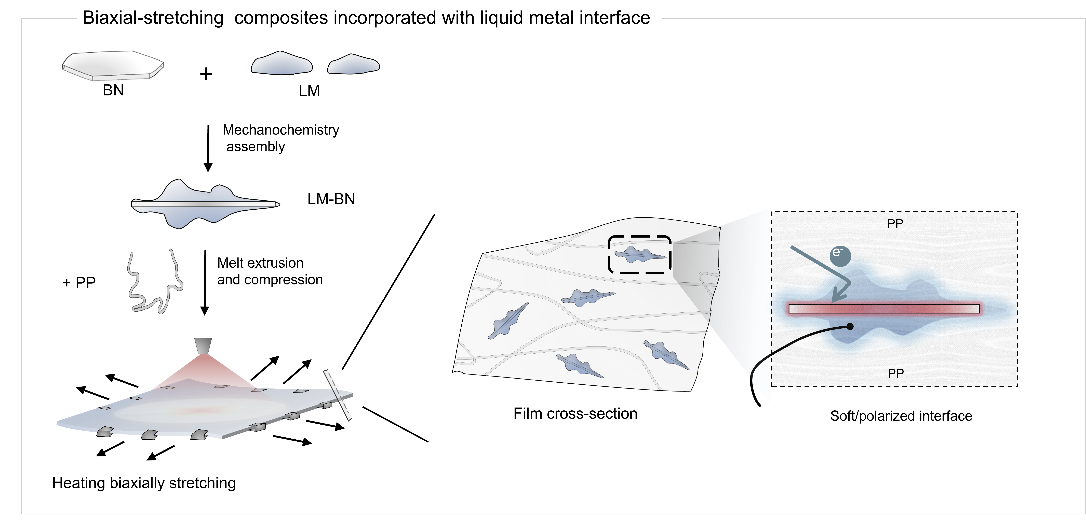
Supplementary Figure 1. Schemiatic illustration for the preparation of BOPP/LM-BN composites, involving mechanochemical assembly, melt extrusion, hot pressing, and biaxial stretching.

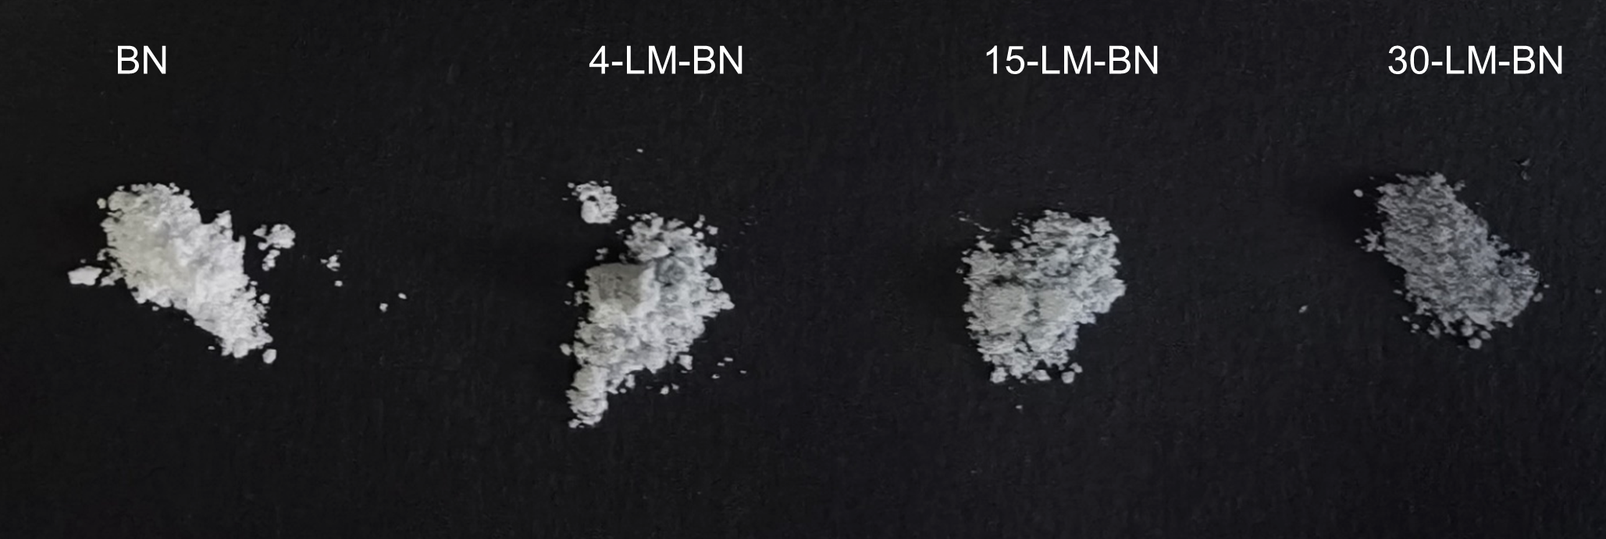
Supplementary Figure 2. Optical photographs of the pure BN powder and LM-BN powder (4-LM-BN, 15-LM-BN and 30-LM-BN respectively denote the LM and BN volume ratioes of 4:96, 15:85, and 30:70 respectively).

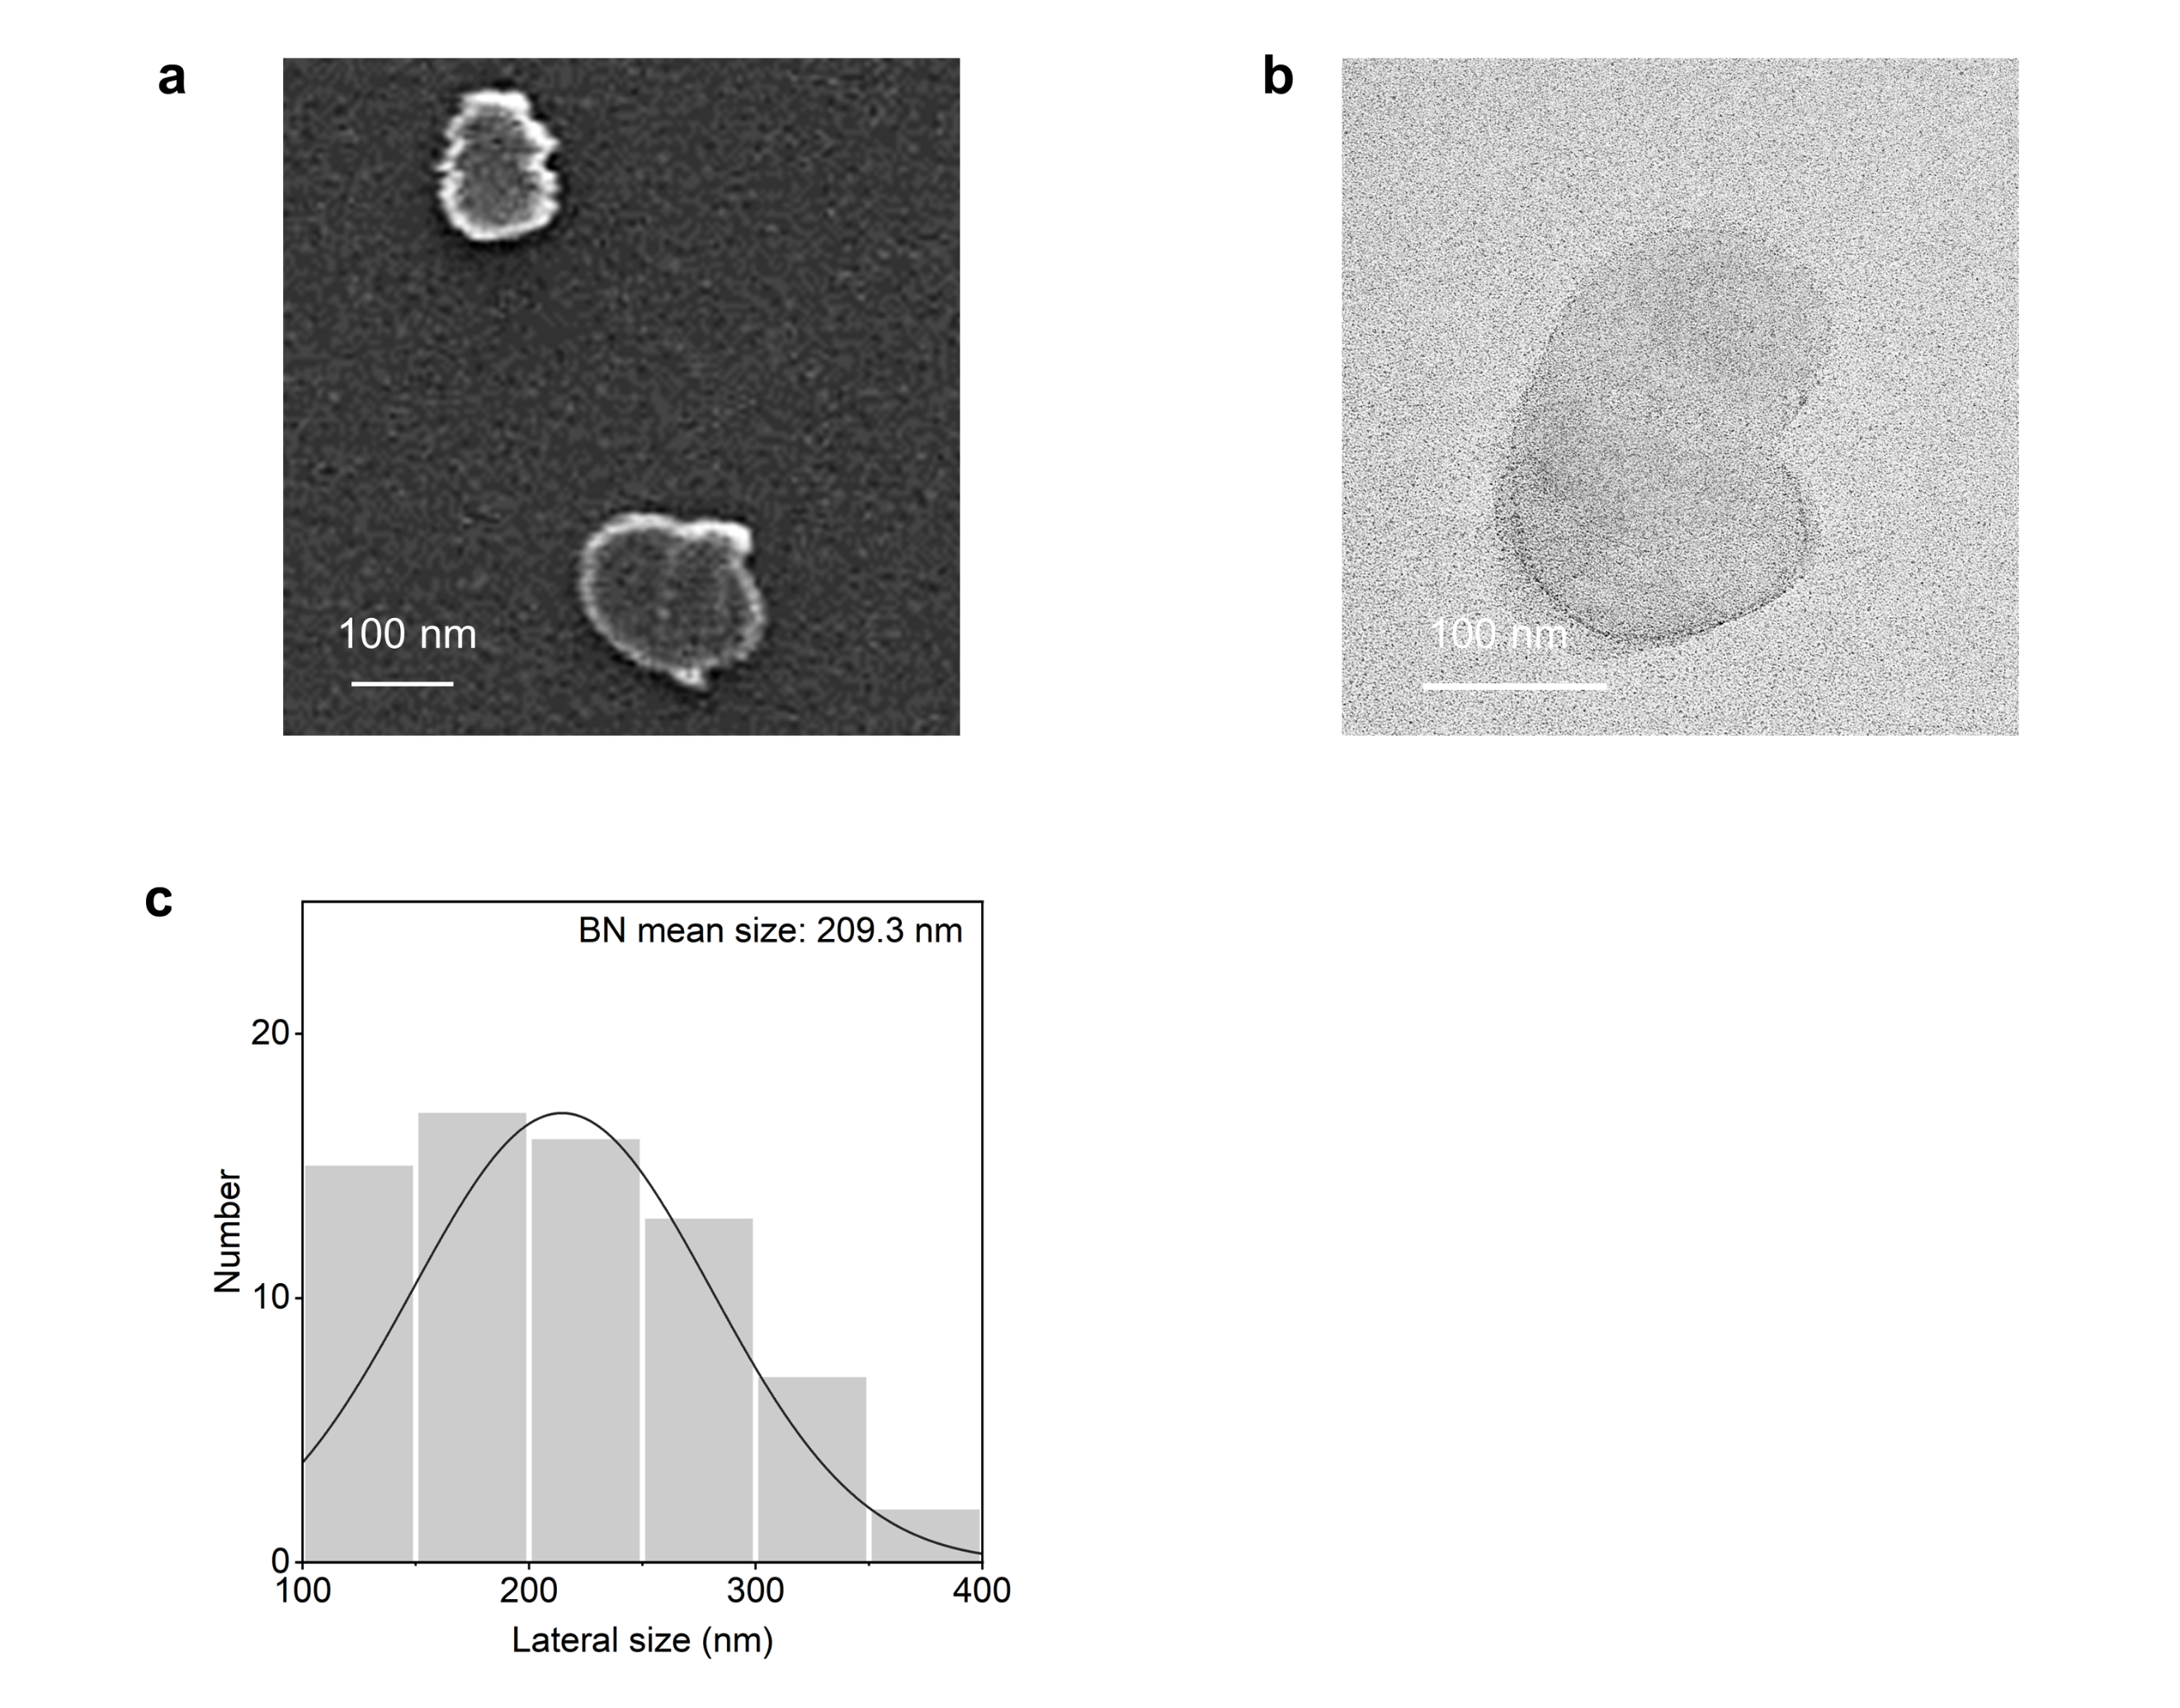
Supplementary Figure 3. (a) The SEM image and (b) TEM image and (c) corresponding lateral sizes statistics of BN.

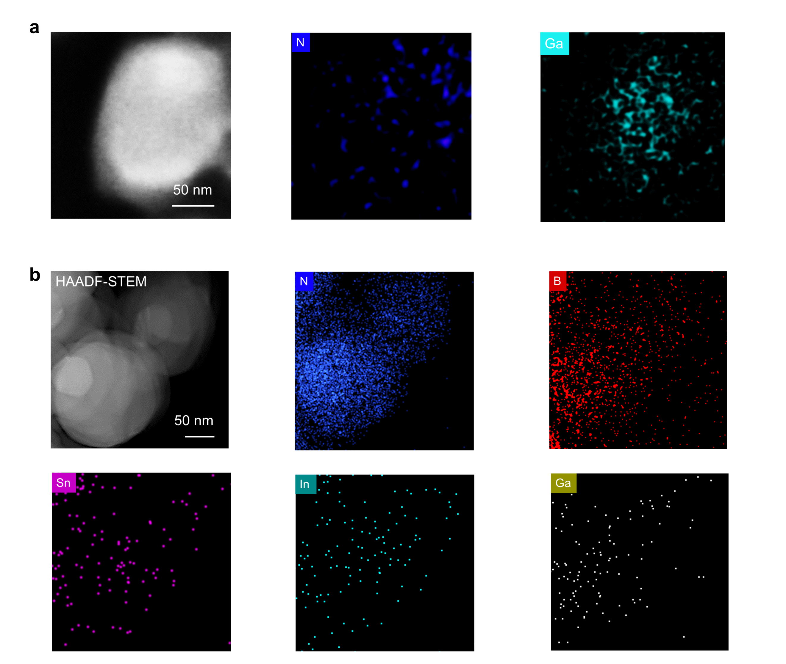
Supplementary Figure 4. (a) SEM images and corresponding energy dispersive spectroscopy elementary images of the LM-BN (b) HAADF-STEM images and corresponding energy dispersive spectroscopy elementary images of the LM-BN.

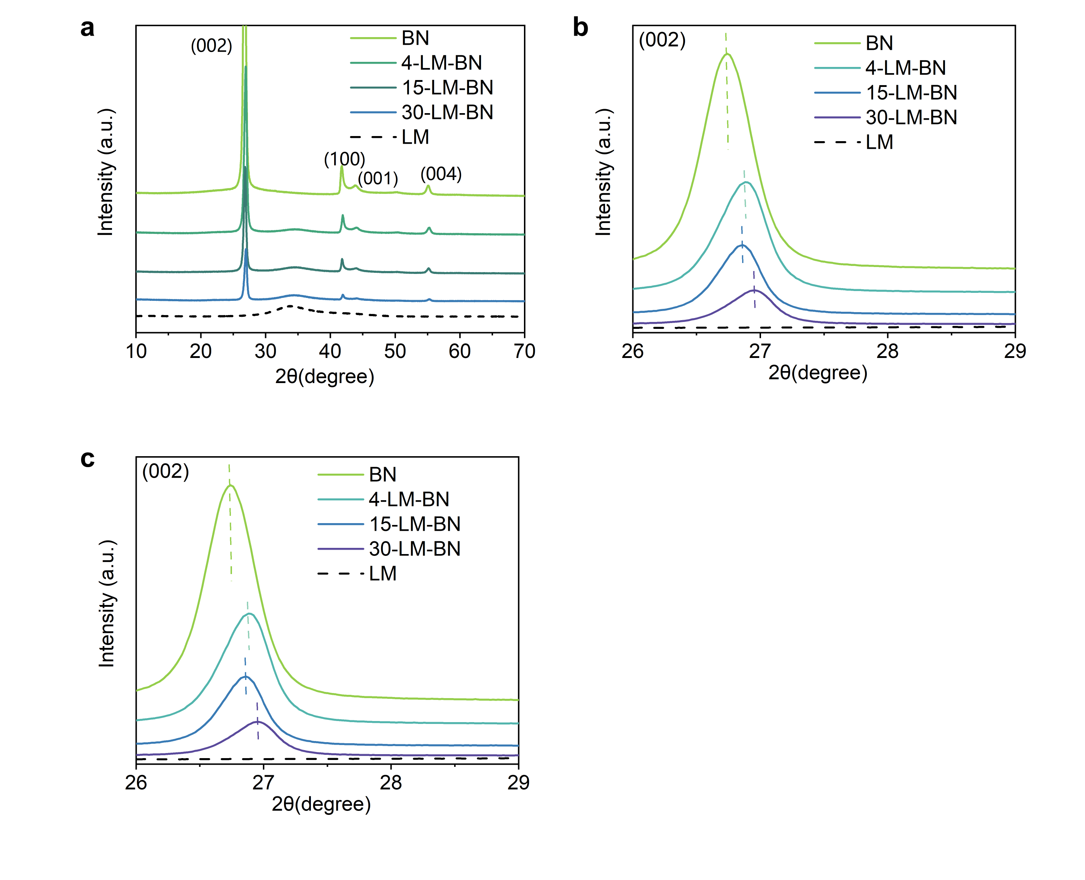
Supplementary Figure 5. (a) XRD result of the BN, LM-BN (with different LM and BN ratio) and LM, (b) the large version of (002) crystal region, and (c) the large version of (004) crystal region.

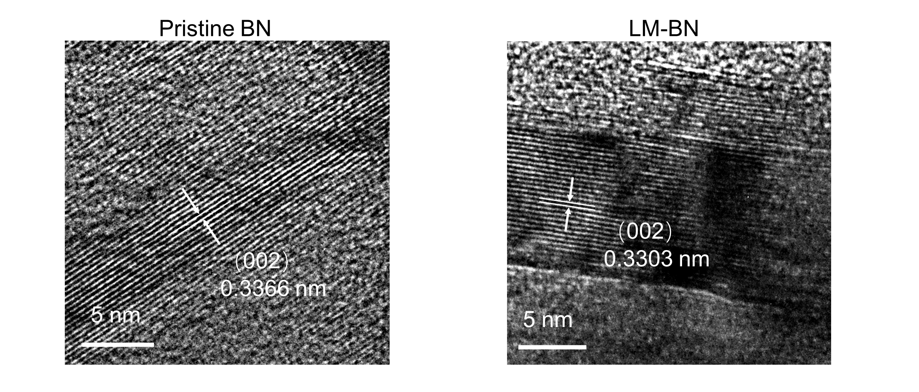
Supplementary Figure 6. High resolution TEM images of BN and LM-BN.

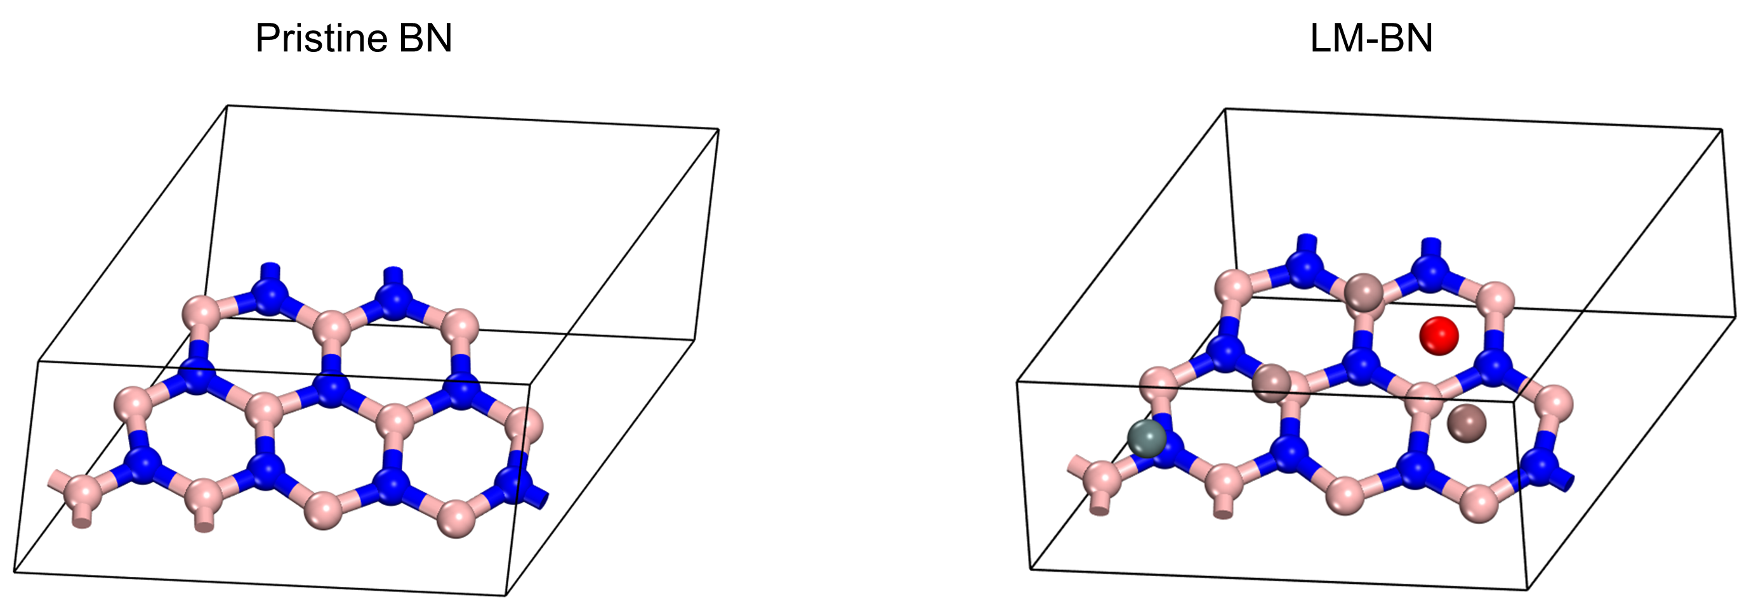
Supplementary Figure 7. The optimized structure models of BN and LM-BN for DFT calculation, where the pink, blue, red, gray, light brown, and brown balls denote B, N, O, Sn, Ga, and In atoms, respectively.

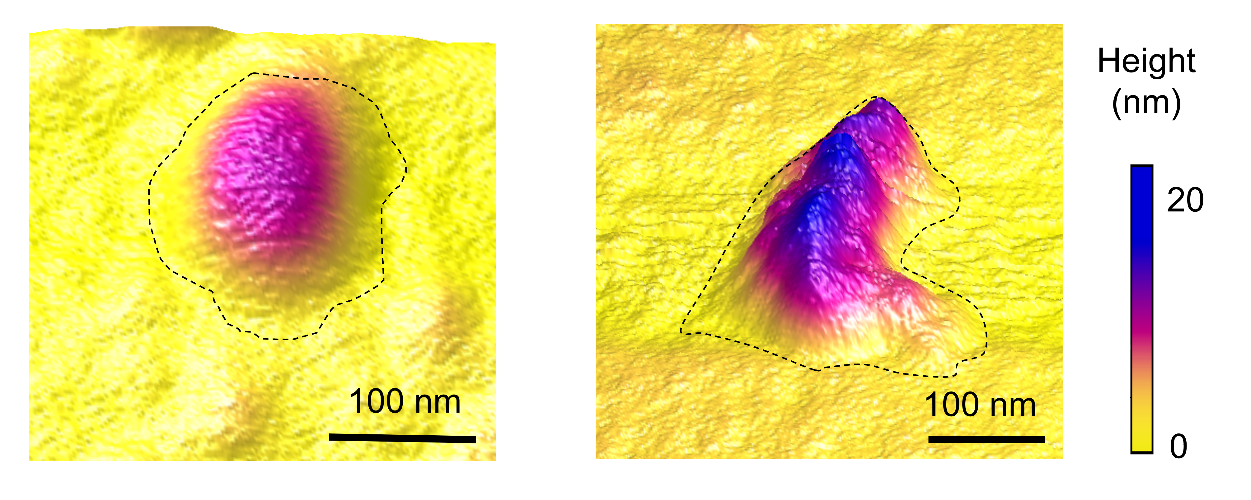
Supplementary Figure 8. In-situ topological morphology of BN and LM-BN as detected by probe force microscopy. This figure presents height distribution images comparing BN (left) and LM-BN (right). The images reveal that LM-BN exhibits distinctive mountain-range-like morphologies, in contrast to the smoother surface of BN.

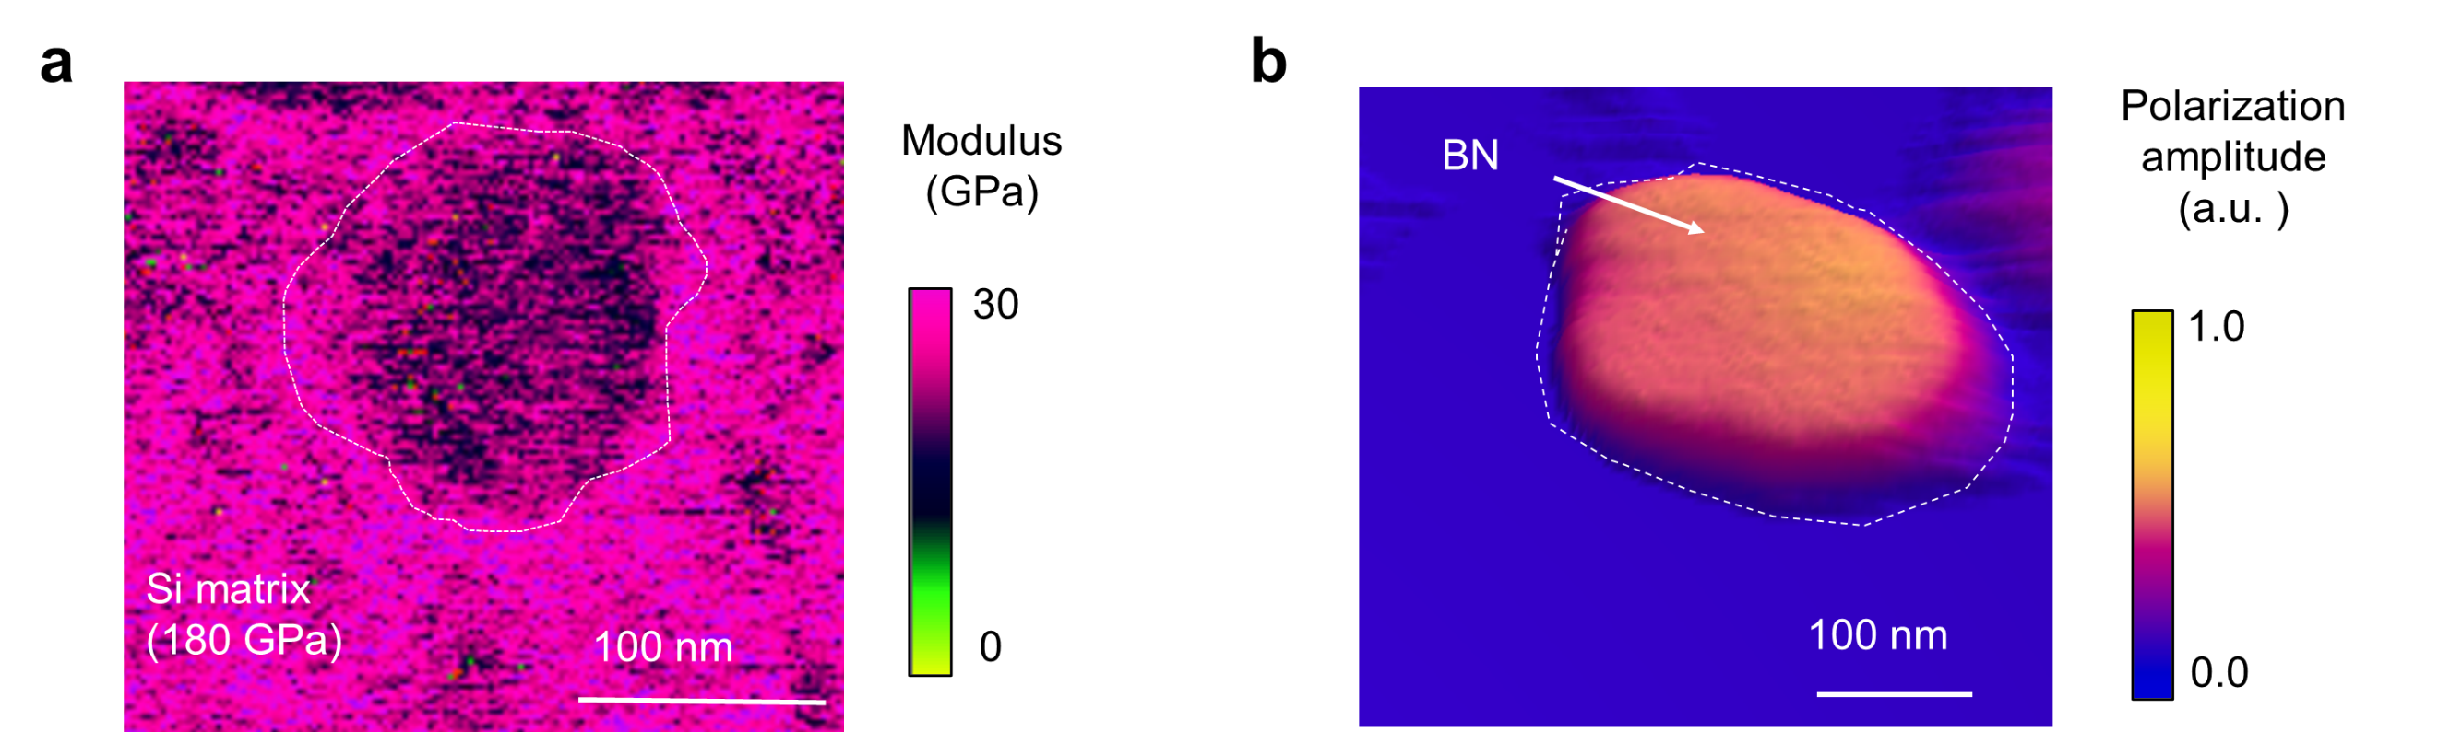
Supplementary Figure 9. (a) PFM modulus distribution images (b) and polarization amplitude distribution image of BN, suggesting the relatively hard mechanical properties and weak polarization properties of BN.

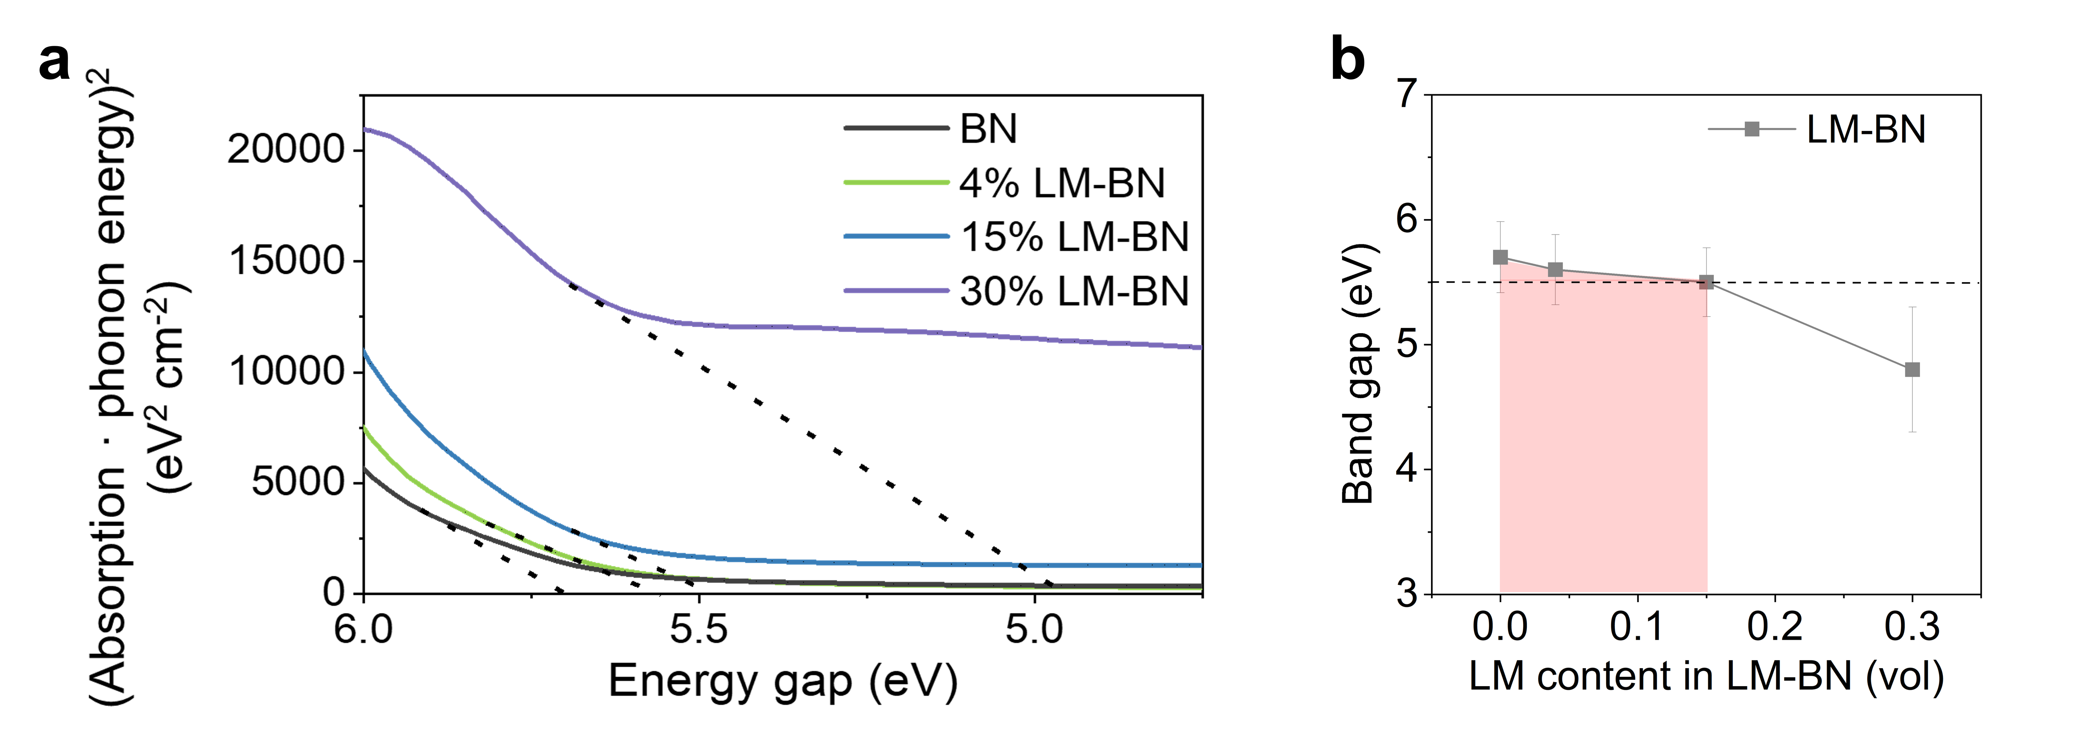
Supplementary Figure 10. (a) Depicts a plot of (absorption phonon energy)² against the energy gap for both BN and LM-BN, derived from UV-vis spectra. (b) Bandgap values of LM-BN filler with different LM contents, suggesting good insulation can be maintained at suitable LM content.

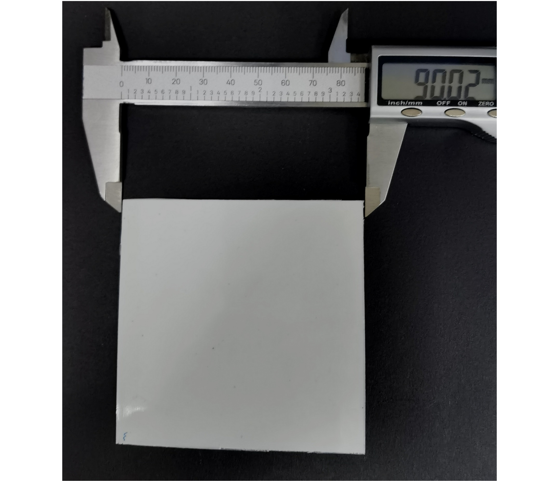
Supplementary Figure 11. Optical photographs of the PP composite material sheet sample for biaxial-stretching (the size of BOPP film can be modulated by changing the size and the stretching ratios of the sheet).

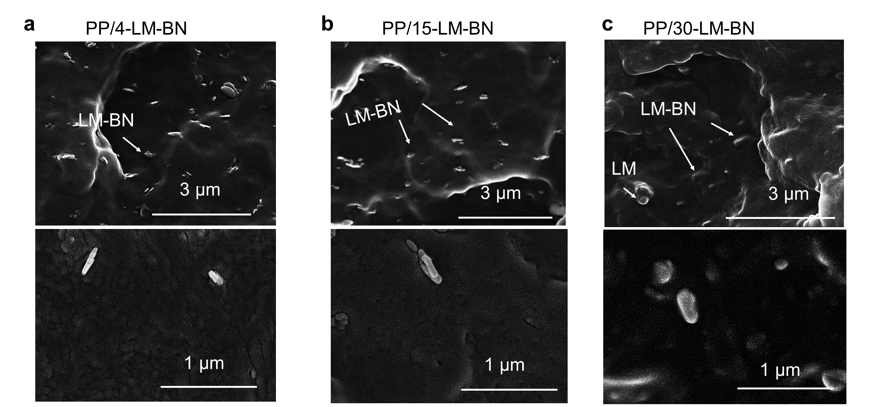
Supplementary Figure 12. SEM images of the cross-section of (a) PP/4-LM-BN, (b) PP/15-LM-BN, and (c) PP/30-LM-BN at the filler content of 4 vol%, indicating that the LM layer in LM-BN was getting thicker with the increase of LM content.

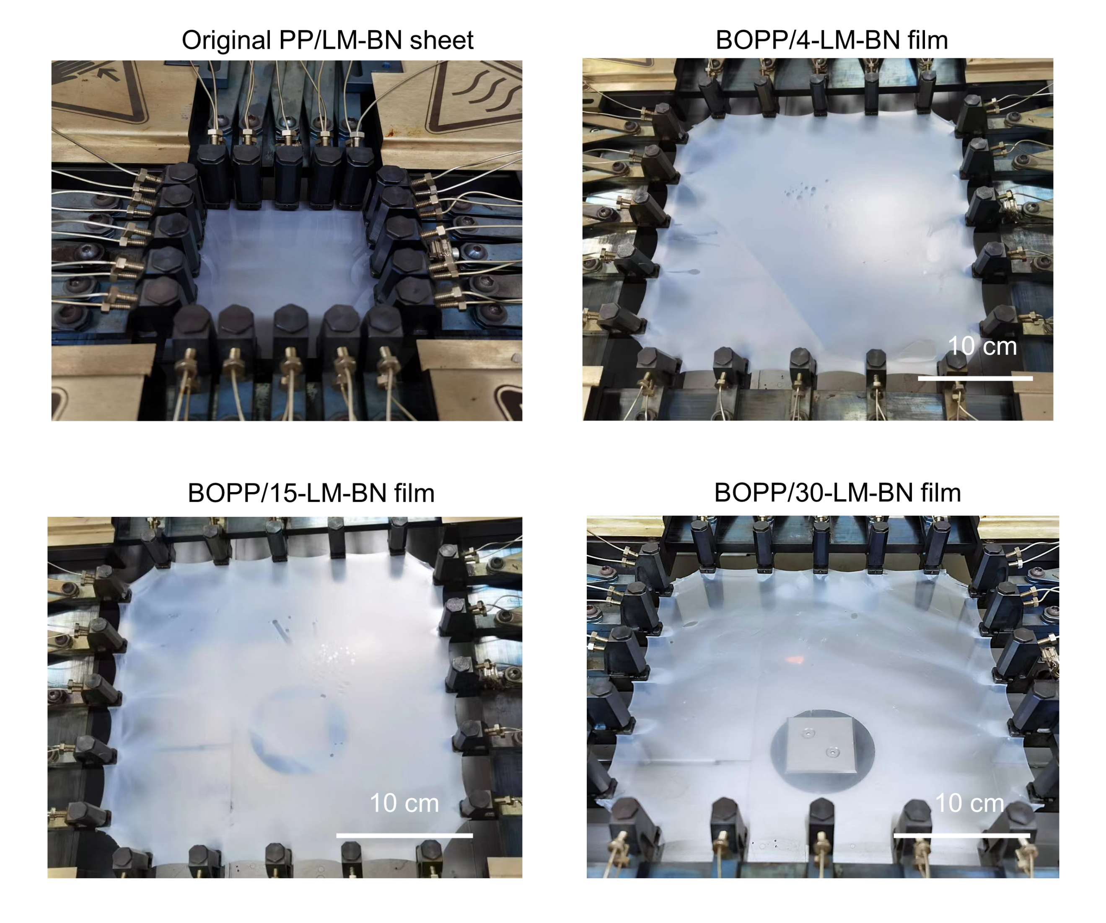
Supplementary Figure 13. Optical photographs of the PP/LM-BN composite sheet before stretching, and the BOPP/4-LM-BN film, BOPP/15-LM-BN film, and BOPP/30-LM-BN film after stretching.

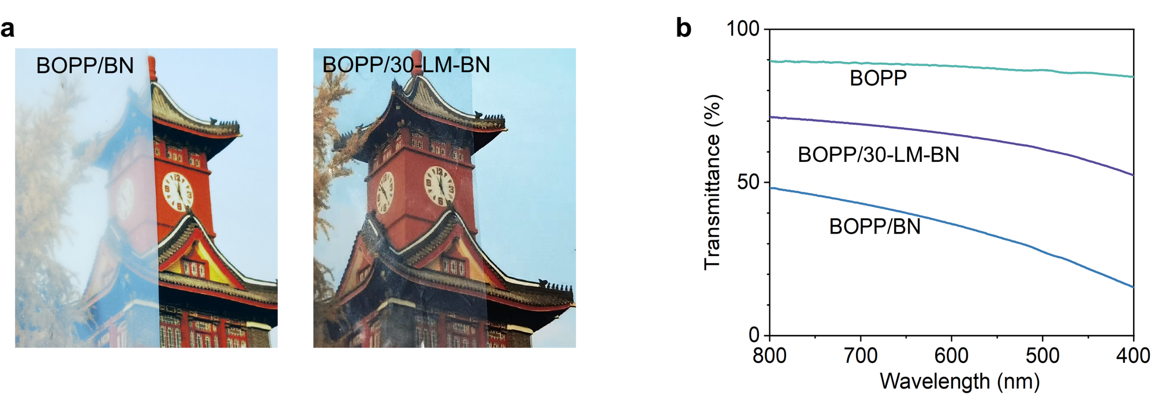
Supplementary Figure 14. (a) Optical photographs and (b) the corresponding visible light transmittance curves of BOPP/BN film and BOPP/30-LM-BN film (at filler content of 1 vol%), showing that the trasnpancy of BOPP/LM-BN film is enhanced.

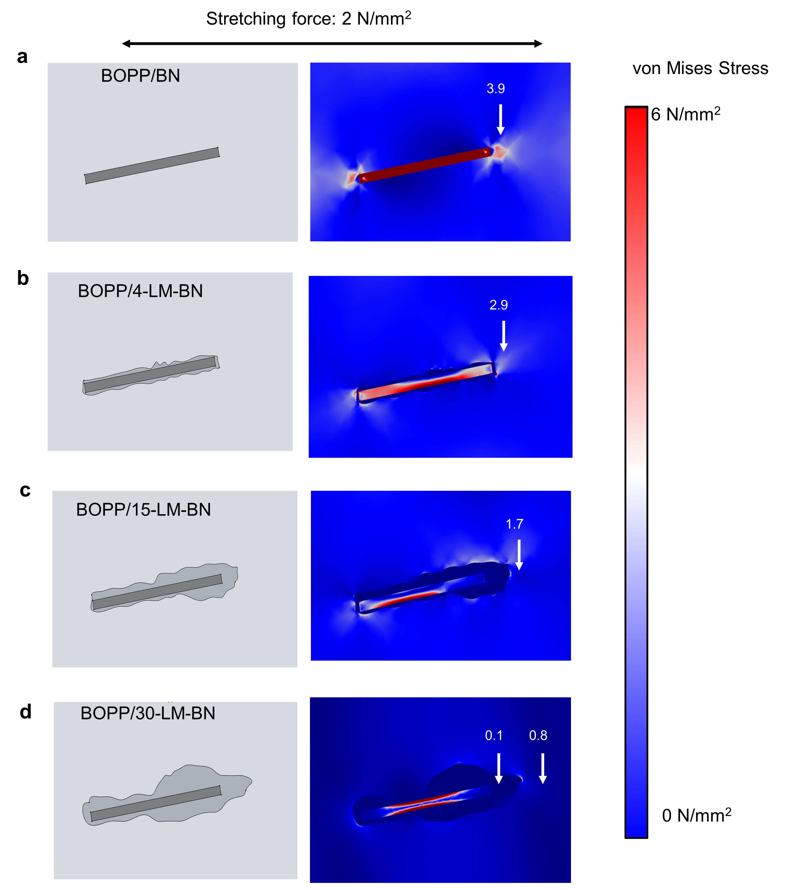
Supplementary Figure 15. The model and the von mises stress distribution image of (a) BOPP/BN, (b) BOPP/4-LM-BN, (c) BOPP/15-LM-BN, and (d) BOPP/30-LM-BN composites film under external biaxial force of 2 N/mm² (from left diection and right direction) calculated by finite element analysis, suggesting that the interface stress weakenes with the increase of LM content in LM-BN.
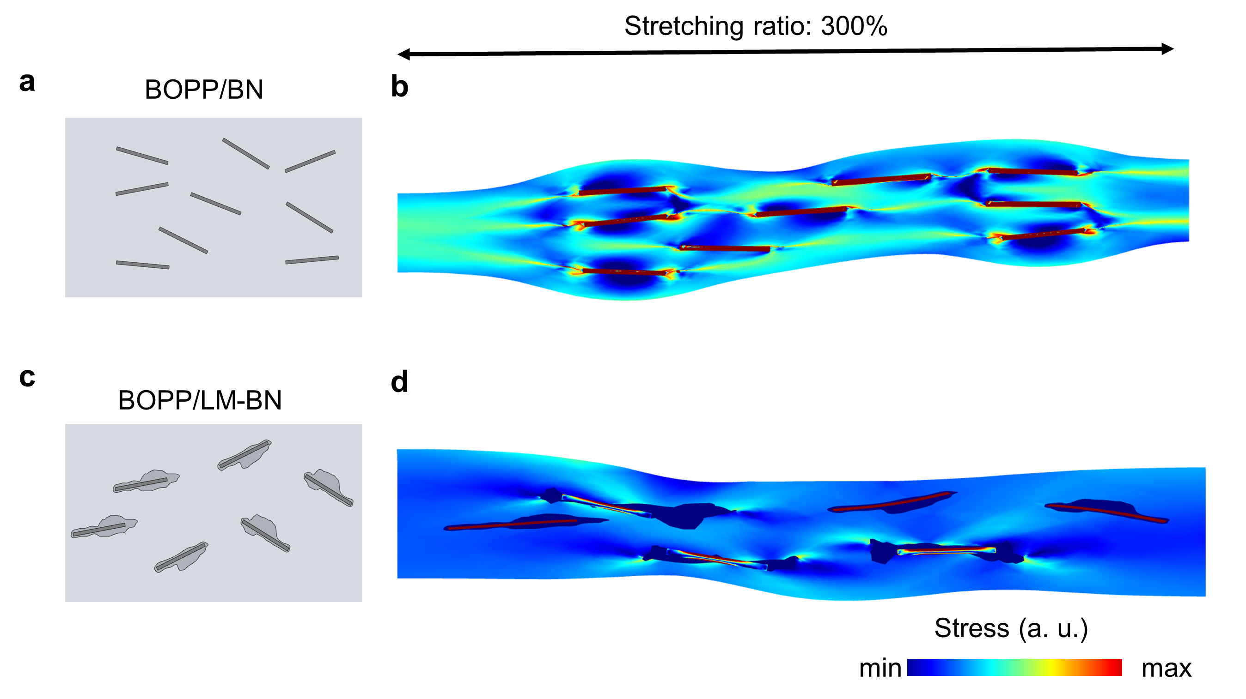
Supplementary Figure 16. The models of the cross-section of (a) BOPP/BN and (c) BOPP/LM-BN film at the filler content about 4 vol% and (b, d) the corresponding von mises stress distribution images of them after 300%*300% stretching at a stretching rate of 10%/s and temperature of 157 ℃ by finite element analysis, which suggests that the area of stress concentration region (gree and red region) in interfaces is greatly reduced in BOPP/LM-BN films.

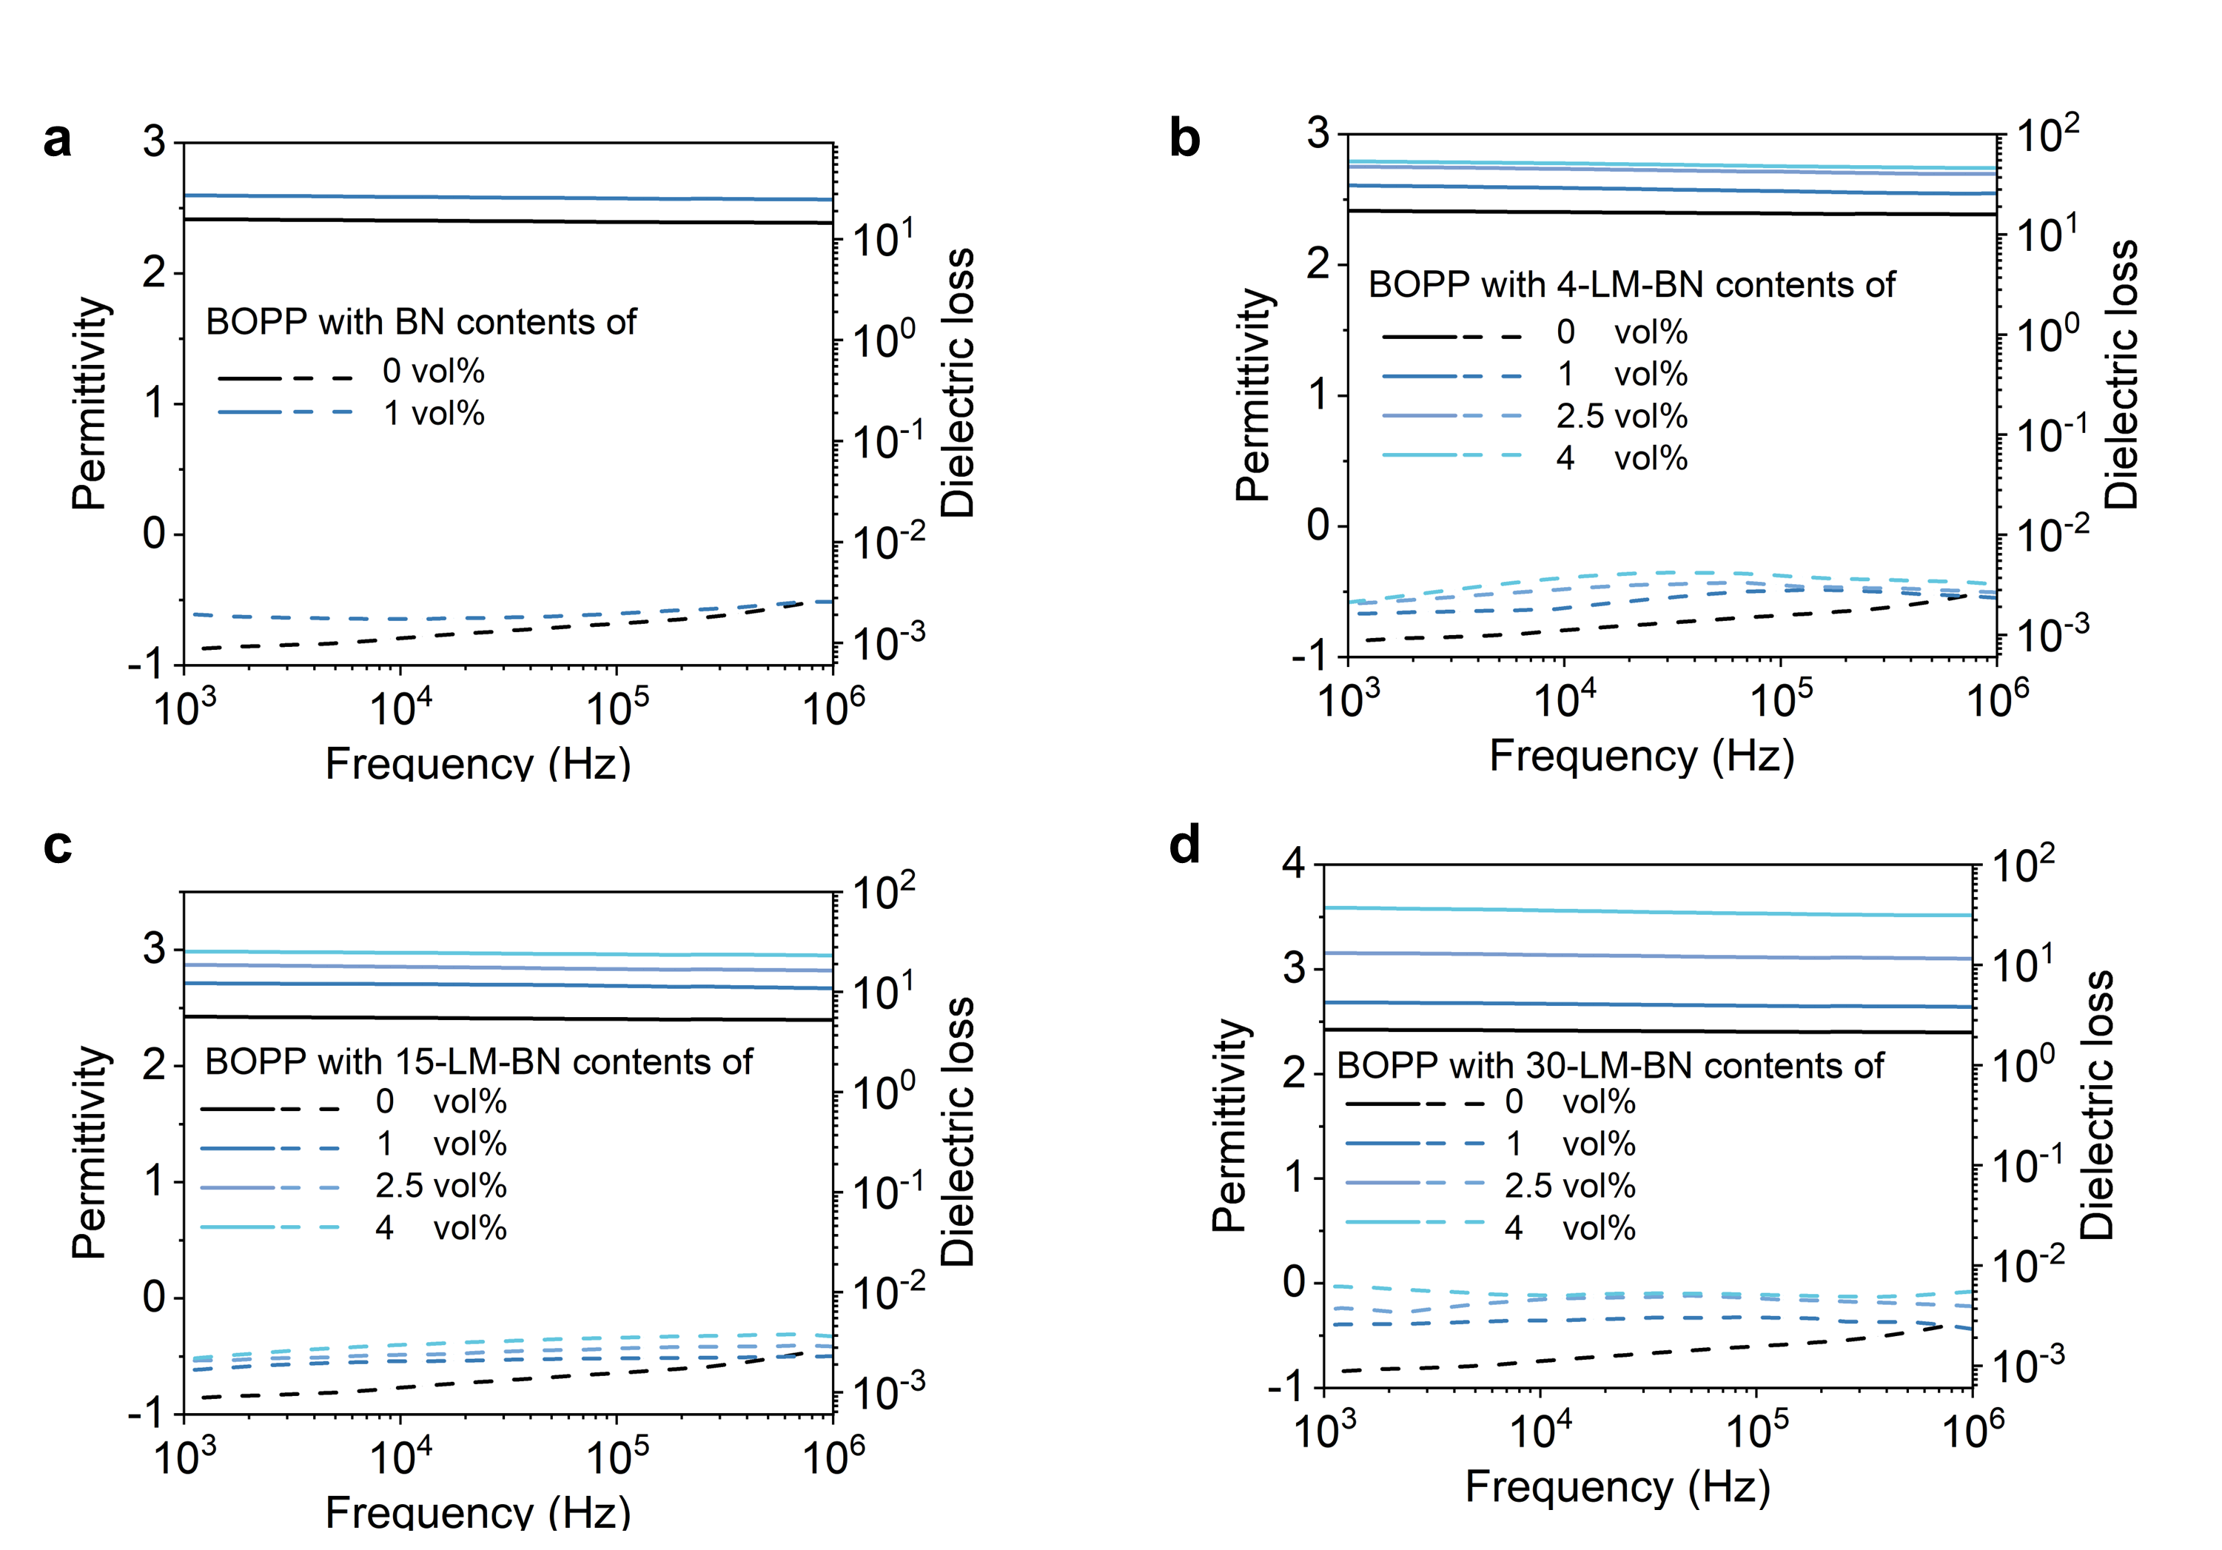
Supplementary Figure 17. Frequency-dependant dielectric properties (dielectric permittivity and dielectric loss) of (a) BOPP/BN film, (b) BOPP/4-LM-BN film, (c) BOPP/15-LM-BN film, and (d) BOPP/30-LM-BN films with different filler contents at the stretching ratio of 300%*300%.

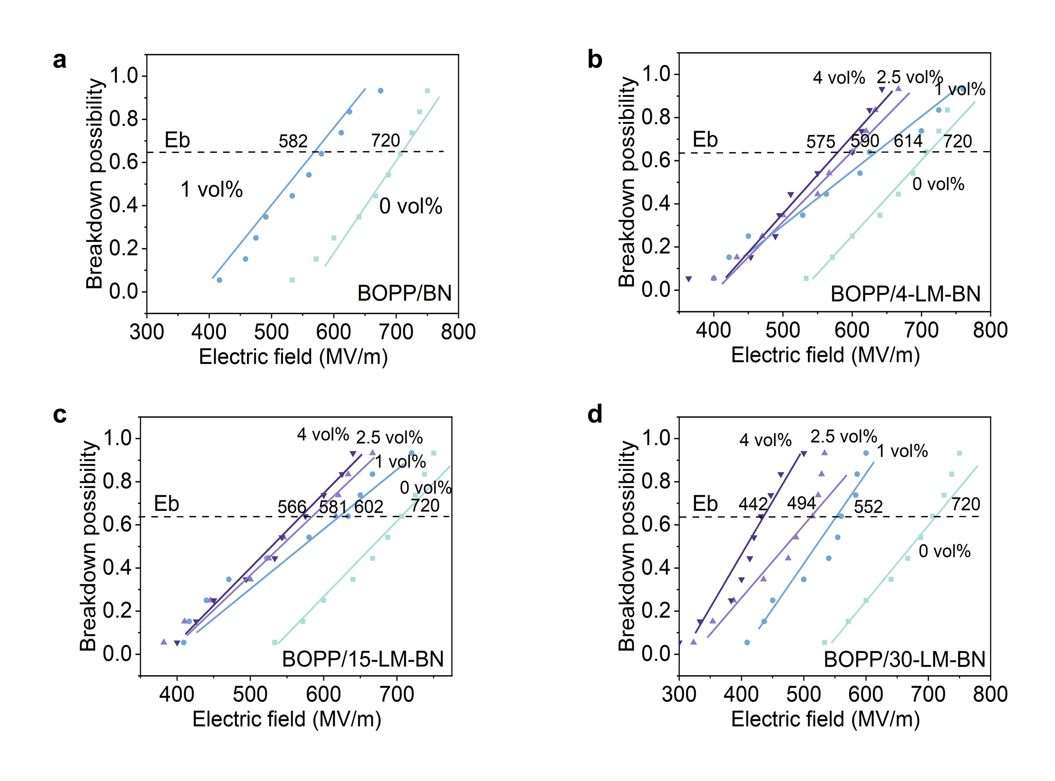
Supplementary Figure 18. Electrical breakdown strengthen distribution of (a) BOPP/BN films, (b) BOPP/4-LM-BN films, (c) BOPP/15-LM-BN films, and (d) BOPP/30-LM-BN films with different filler contents at the stretching ratio of 300%*300%.

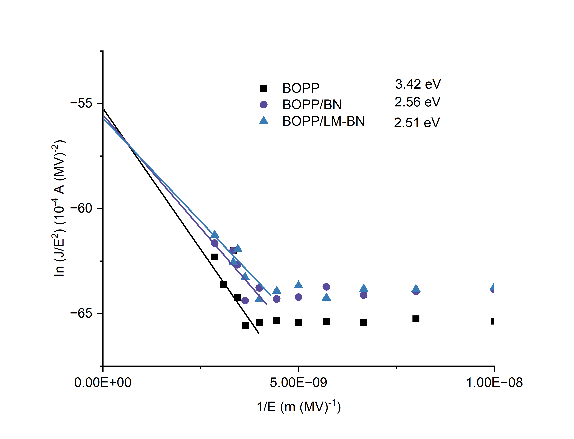
Supplementary Figure 19. Electrical fields dependant current densities of (a) BOPP, (b) BOPP/BN and (c) BOPP/LM-BN films for calculating the Fowler-Nordheim model energy barrier.
Space charge plays an important role in breakdown strengthenes and dielectric losses of the materials, since the movement of space charges influence the elelctrical tree propagation to produce the electrical breakdown, and induce the space charge polarization to increase the dielectric loss. Space charges can be injected from the electrode and trapped by the charge traps at the filler/polymer interfaces. The space charge injection can be described by a series of models, for example, the Richardson-Schottky model for high temperature environment and the Fowler-Nordheim model for the high electric field environment⁷. For PP capacitor films, as the working temperatures (< 85 ℃) of PP capacitor was not so high, Fowler-Nordheim model was more proper. According to the model, the current density (J) is related to the applied electrical fields (E) as:
$J=\frac{e^{3}E^{2}}{16π^{2}ħφ}exp⁡(-\frac{4\sqrt{2m}φ^{3/2}}{3eħE})$
where e is the element charge, ħ is the reduced Planck constant, φ is the energy barrier relevant to the space charge movement, and m is the effective mass of the carrier in the materials^{7, 8}. Supplementary Figure 15 shows a plot of ln(J/E²) versus 1/E of BOPP, BOPP/BN and BOPP/LM-BN film for fitting the Fowler-Nordheim model. The φ can be obtained by the intercept of the curves.

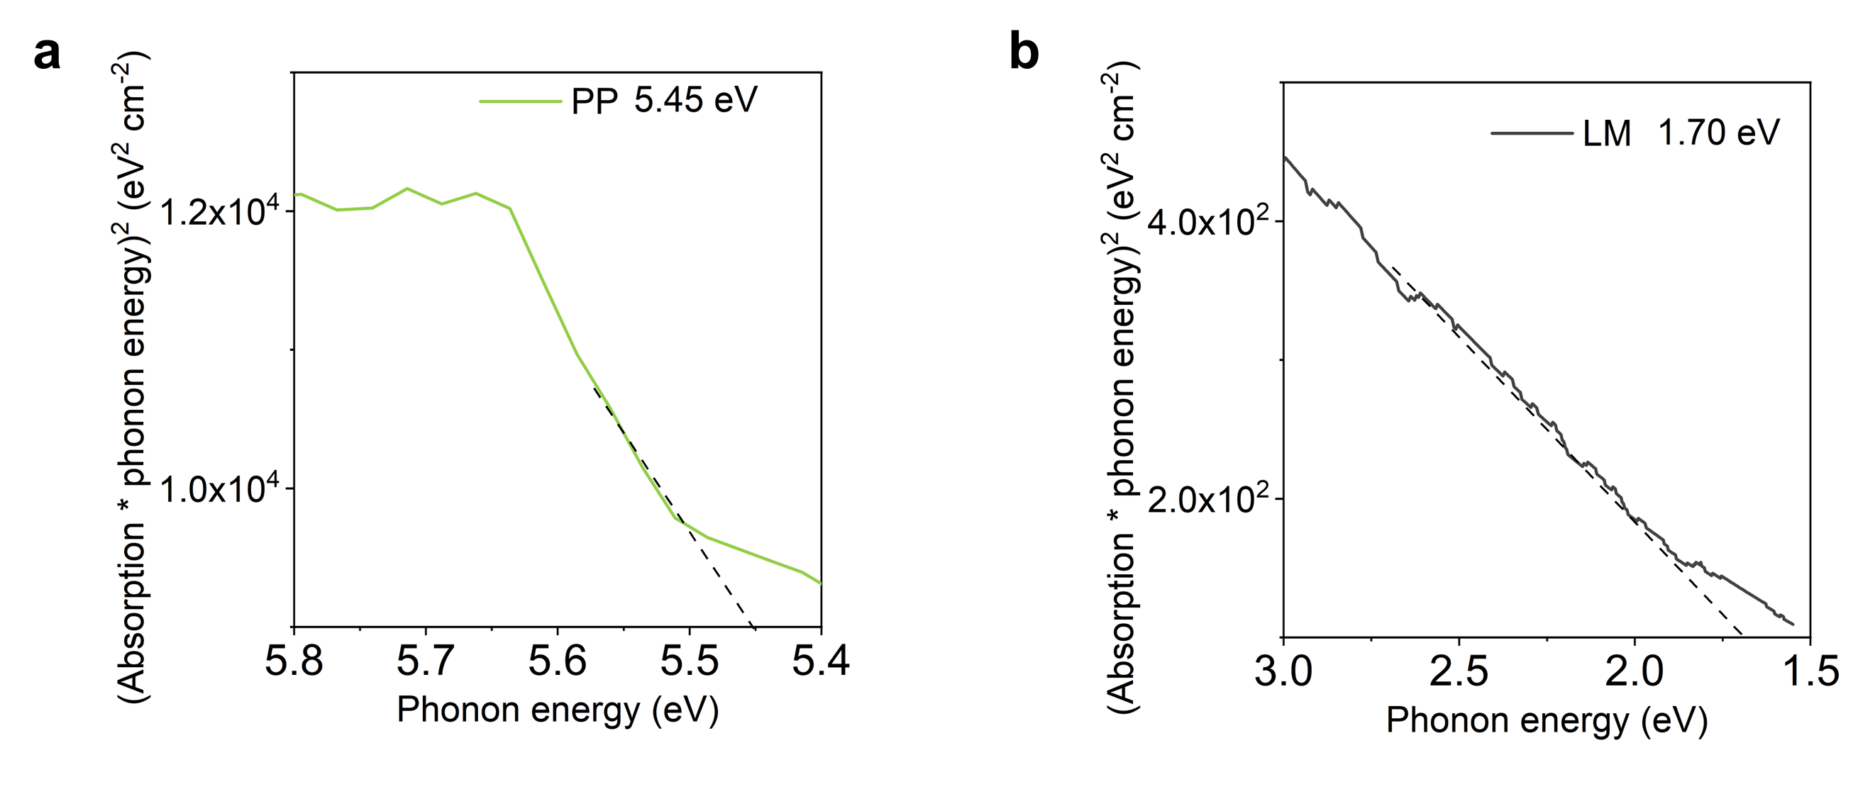
Supplementary Figure 20. UV-vis absorption spectra converted by the Tauc plot of (a) PP and (b) LM. The band gaps (Eg) are determined from the absorption onset of the linear region, are 5.45 eV and 1.70 eV for PP and LM, respectively.
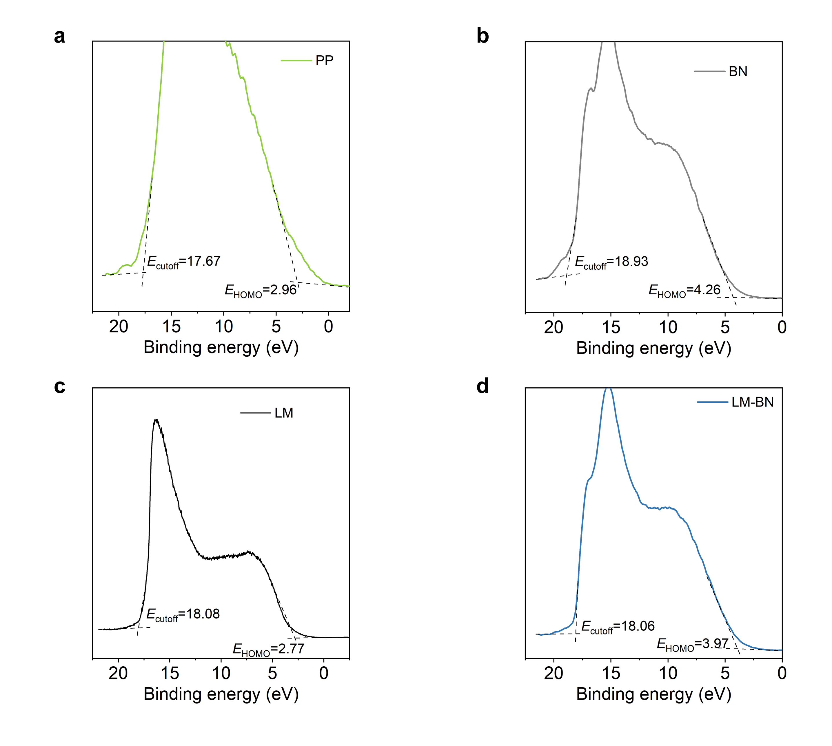
Supplementary Figure 21. UPS measurement of the secondary electron cutoff region and HOMO region of the (a) PP, (b) BN, (c) LM, and (d) LM-BN. The E_{cutoff} values of PP, BN, LM and LM-BN are 17.67 eV, 18.93 eV, 18.08 eV and 18.06 eV, respectively. The work function (𝜙_{d}), calculated by the difference between the incident photoelectron energy (21.2 eV) and E_{cutoff}, are 3.53 eV, 2.27 eV, 3.12 eV and 3.14 eV for PP, BN, LM and LM-BN, respectively. The highest occupied molecular orbital (E_{HOMO}) values of PP, BN,LM and LM-BN are 2.96 eV, 4.26 eV, 2.77 eV and 3.97 eV, respectively. The IP values ( 𝜙_{IP} ), calculated by the summation of 𝜙_{d} and E_{HOMO}, are 6.49 eV, 6.53 eV, 5.89 eV and 7.11 eV for PP, BN, LM and LM-BN, respectively.
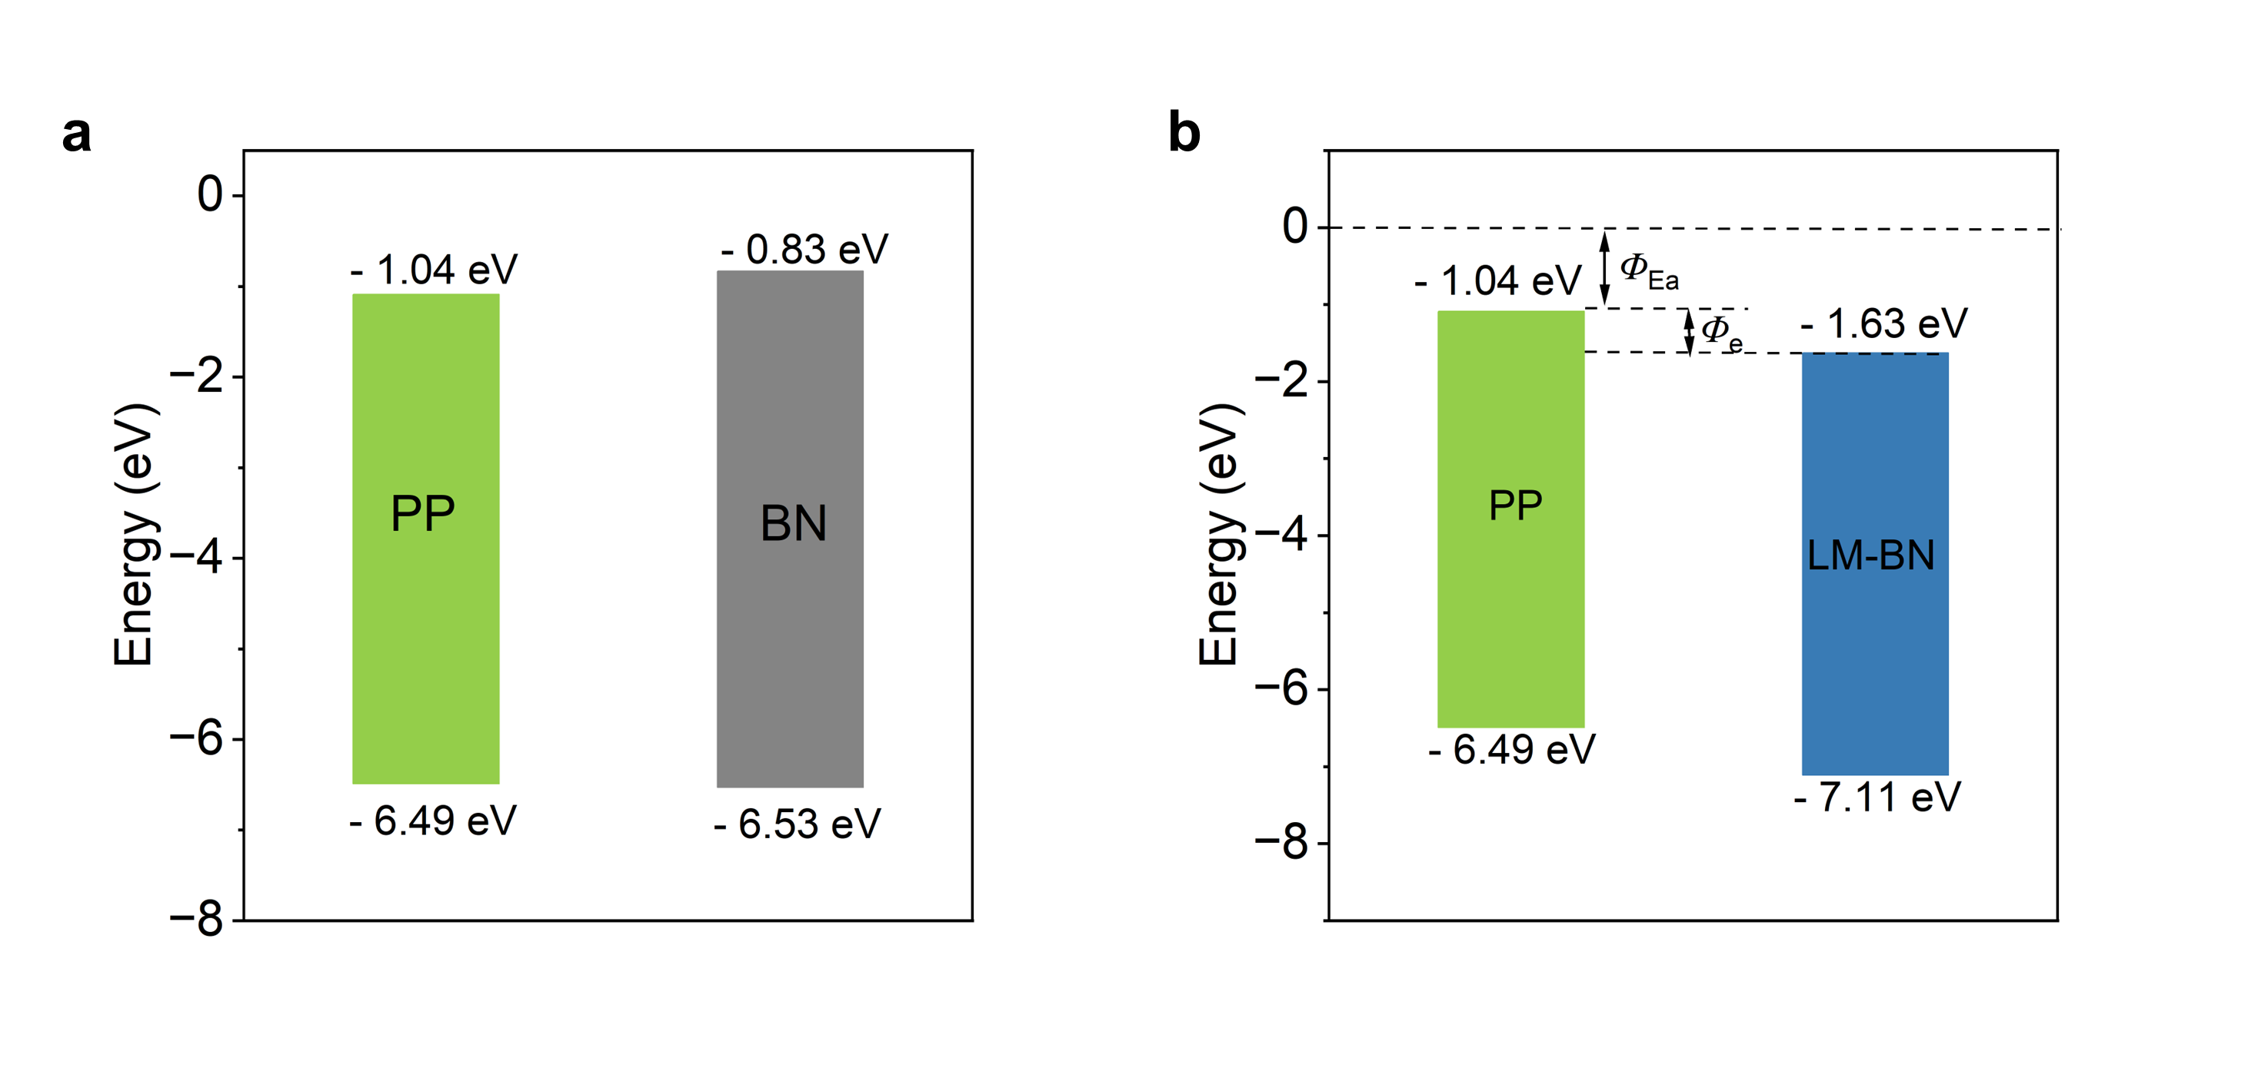
Supplementary Figure 22. Energy band diagram for PP/BN composites and PP/LM-BN composites. 𝜙 _{EA}, electron affinity; E_{vac}, vacuum level. The ionization potential (𝜙_{IP}) is obtained by the UPS measurement in Supplementary Figure 17. With the obtained 𝜙_{IP} , the position of the HOMO level can be determined. The band gaps (E_{g}) are obtained by the UV-vis measurement in Supplementary Figure 16 and Figure 2c. Thus, the position of LUMO (lowest unoccupied molecular orbital) levels, calculated by the difference between the HOMO level and the band gap, are 1.04 eV, 0.83 eV and 1.63 eV for PP, BN, and LM-BN, respectively, which are also their respective electron affinity (𝜙_{EA}). Energy values are reported as absolute values relative to a vacuum.

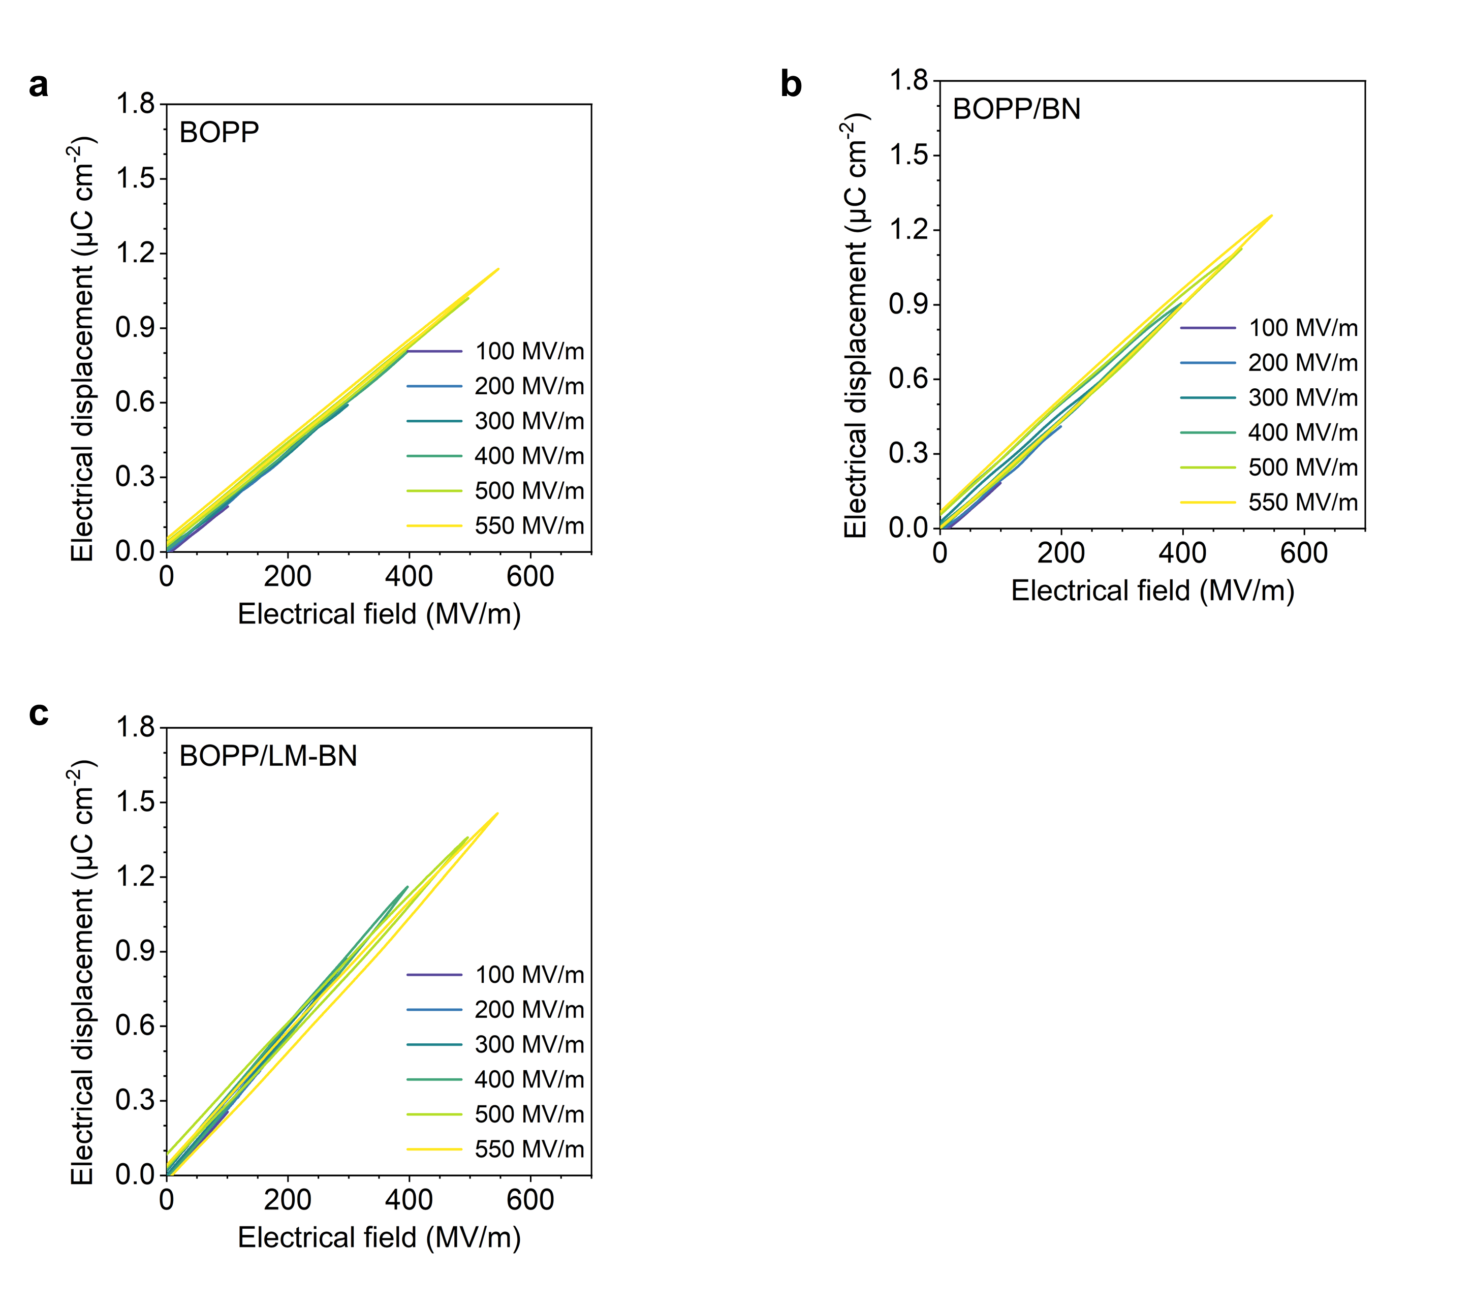
Supplementary Figure 23. Electrical field dependant electrical displacement cureves of (a) BOPP, (b) BOPP/BN, and (c) BOPP/LM-BN films at various electrical fields.

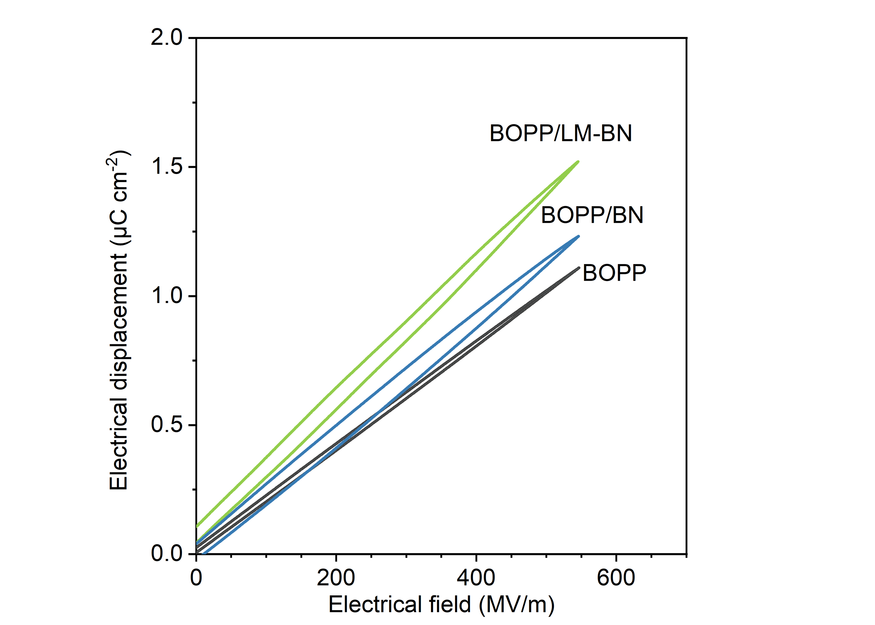
Supplementary Figure 24. The comparison of the electrical displacements among BOPP, BOPP/BN and BOPP/LM-BN at electrical field of 550 MV/m.

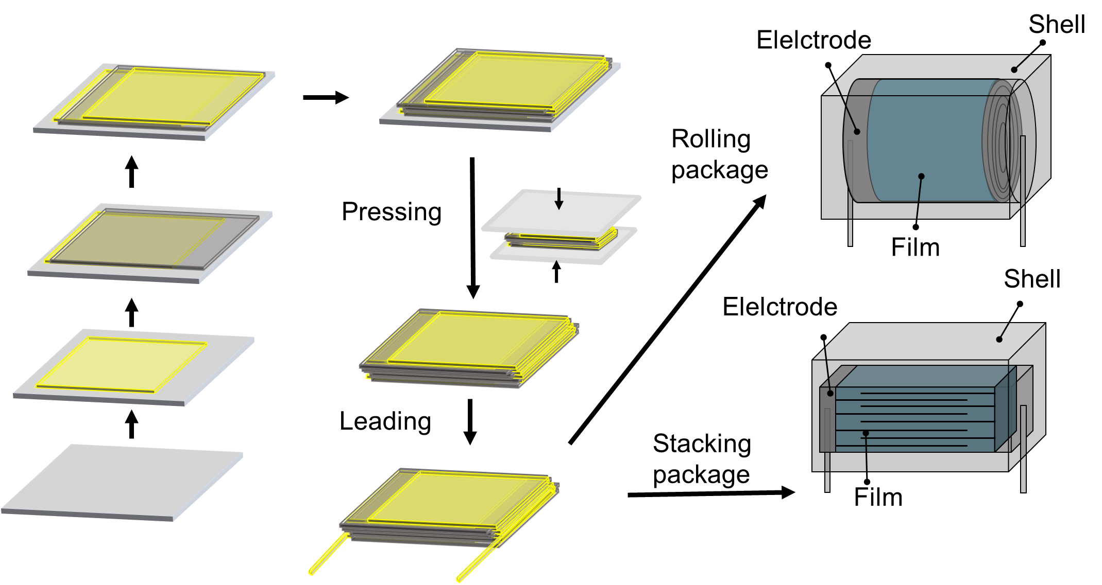
Supplementary Figure 25. Schematic manufacturing process of the prototype of multilayer polymer foil film capacitor device: firstly, layered dielectric layer and electrode foil was stacked for multilayer devices. Secondly, hot pressing the multilayer block and leading the anode and cathode. Thirdly, the multilayer polymer film capacitor core was rolled or directedly used, followed by a sealing process to obtain the final capacitor devices with rolling structure or stacking structure.

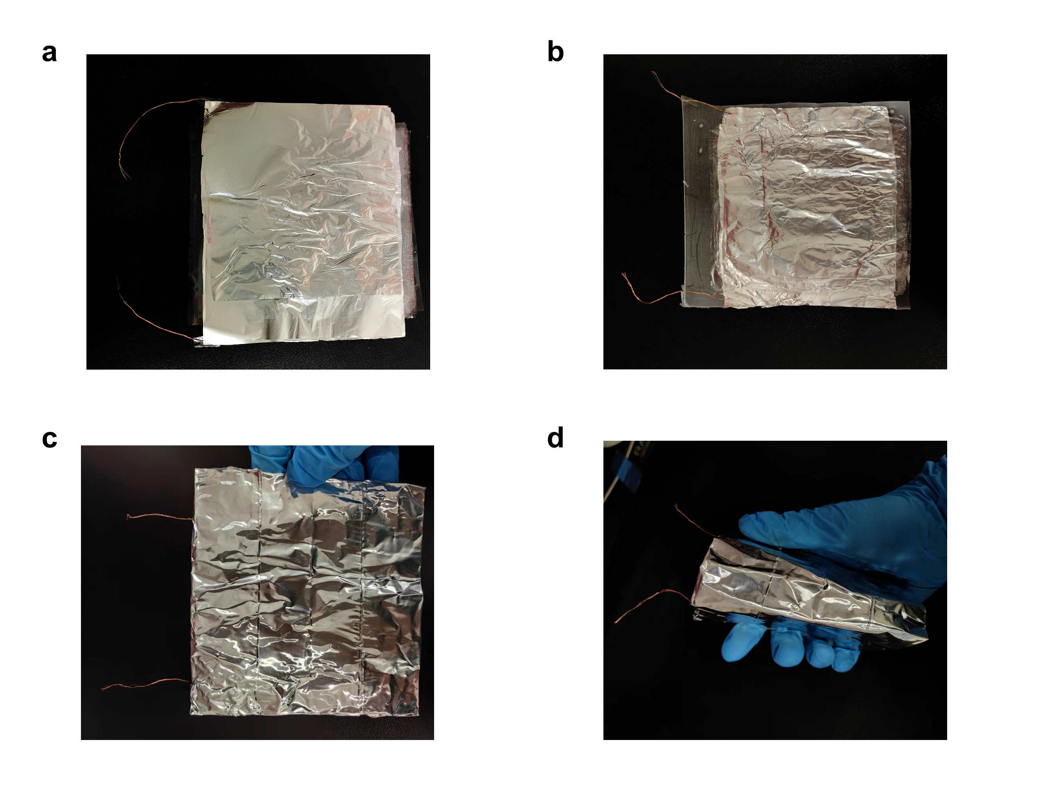
Supplementary Figure 26 The fabrication of film capacitor: (a) repeatedly stacked capacitor films with Al foil electrodes and Cu leads (b) the packed capacitor after encapsulating polydimethylsiloxane (PDMS). (c) the capacitor sealed by the metal adhesive tape. (d) the bending picture of a sealed capacitor.

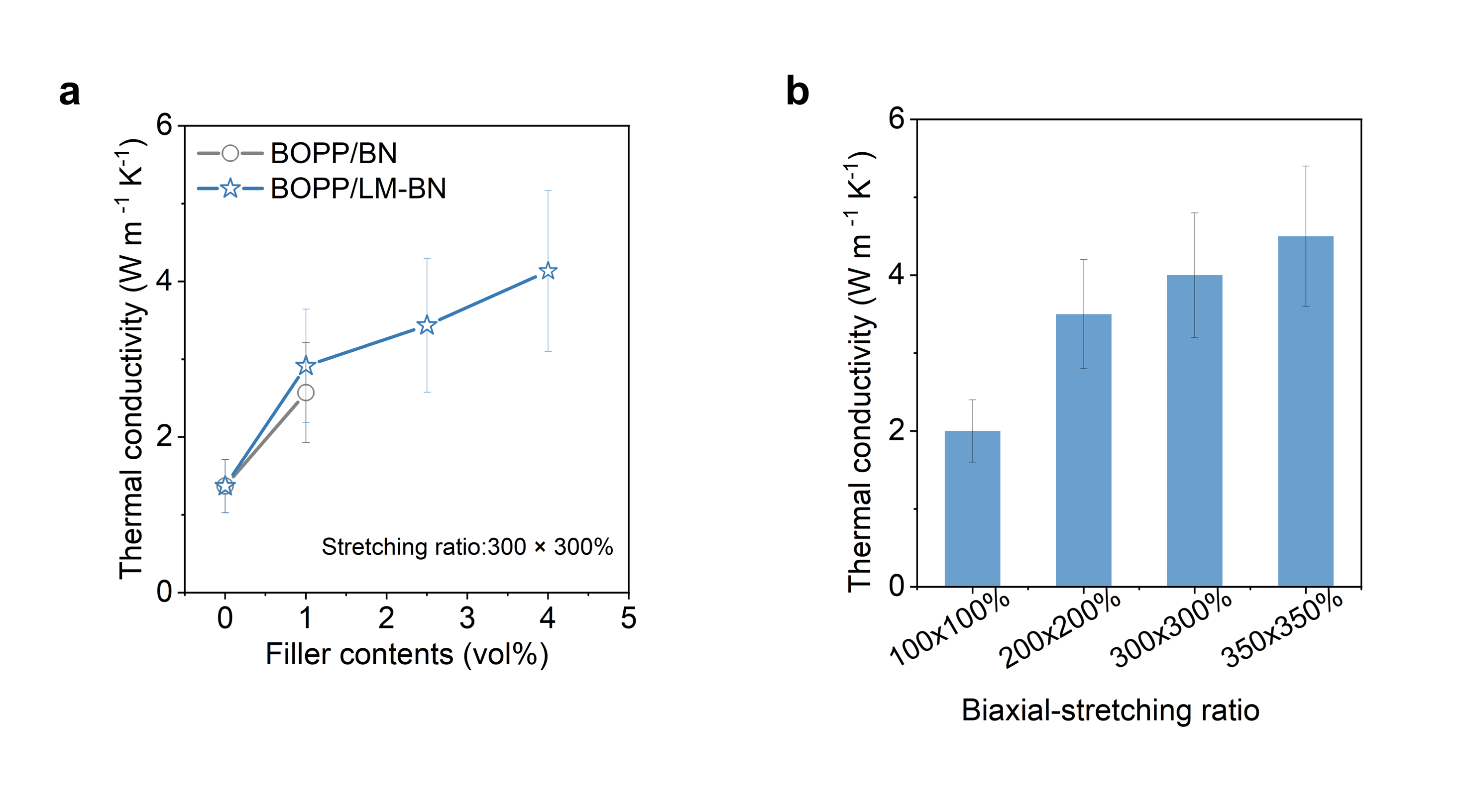
Supplementary Figure 27. The comparison of the in-plane thermal conductivity: (a) BOPP/BN and BOPP/LM-BN with different filler content at the stretching ratio of 300 × 300 %；(b) BOPP/LM-BN with different biaxial-stretching ratios, which shows that more thermo-conductive BN filler can be incorporated in BOPP/LM-BN to enhance the thermal conductivity; the high stretching ratio promotes the orientation effect both in chain level and filler level to further enhance the thermal conductivity.

Table S1. Comparison of the discharge energy density and the biaxial-stretching ratio for the BOPP/LM-BN composite film with the representative polymer capacitor films in previous literatures at the electrical filed of 550 MV/m.
Materials | Discharge energy density  at above 90% efficiency  (J cm⁻³) | Biaxial-stretching ratio  (%) | Ref
Novel polymer (Solution casting)
PP-OH | 4.1 | 100×100% | ⁹
PSBNP-PTNI | 4.9 | 100×100% | ¹⁰
XL-VK | 4.7 | 100×100% | ¹¹
PI-oxo-iso | 4.6 | 100×100% | ¹²
F-PI/PCBM | 4.0 | 100×100% | ¹³
Biaxial stretching composites
BOPP/CaCO₃* | 3.0 | 560×560% | ¹⁴
BOPP/BN/MT | 3.4 | 350×350% | ¹⁵
BOPP/BN | 3.0 | 300×300% | ^{This work}
BOPP/BN | 3.1 | 150×150% | ^{This work}
Surface coating
SiO₂ coatd BOPP | 3.0 | 600×600% | ¹⁶
Al₂O₃ coated BOPP | 3.1 | 600×600% | ¹⁷
PVA/MT coated BOPP* | 3.2 | 600×600% | ¹⁸
Commercial product
BOPP | 2.8 | 600×600% | ^{This work}
^{This work}
BOPP/4-LM-BN | 4.2 | 400×400% | /
BOPP/30-LM-BN | 4.3 | 450×450% | /
BOPP/15-LM-BN | 4.5 | 350×350% | /
Note:
PP-OH: Polypropylene with modified hydroxyl; PSBNP-PTNI: ladderphane derived copolymers; XL-VK: Crosslinked fluoropolymers; PI-oxo-iso: Polyimide modified with cyclohexane and isopropyl; F-PI/PCBM: fluorinated polyimide incorporated with phenyl C61 butyric acid methyl ester; MMT: montmorillonite; BN: boron nitride; PVA:polyvinvl alcohol; LM: liquid metal.
*The discharge energy density (U_{e}) of BOPP/CaCO₃ composites and PVA/MT coated BOPP film was obtained by the formula ($U_{e}=\frac{1}{2}ε_{r}ε_{0}{E_{b}}^{2}$ ,wherein ε_{r}, ε₀ , and E_{b}, respectively correspond to the dielectric constant of the materials, vacuum permittivity, and the breakdown strength of the materials) for linear dielectrics, owing to the lack of discharge data in literatures and the reported linear low loss charastiscs.

Table S2. Comparison of raw mateirals cost analysis of this work with other alternative commercial capacitor film polymer dielectric materials.
Materials | Mateirals cost (dollar/kg)
This work
PP/LM-BN | ~6.0
Commercial product
PP | ~2.0
PEI | ~11.0
PEN | ~90.0
PI | ~100.0
PVDF | ~16.0
P(VDF-TRFE-CFE) | ~350.0
Pioneered synthesized polymers in literatures
Ladderphane derivatives | Without commericilization
Polyimide derivatives | Without commericilization
Note:
PP: polypropylene; PEI: polyetherimide; PEN: polyethylene naphthalate; PI: polyimide; PVDF: Polyvinylidene fluoride ; P(VDF-TRFE-CFE):Vinylidene fluoride-trifluoroethylene-chlorofluoroethylene terpolymer.
The price data was obtained from the median prices from global factory purchasing website by Alibaba Group Holding Ltd.: https://re.1688.com/；All the materials chosen were low-ash grade for insulative capacitor use.

Author contributions
Z. Xie, K. Wu and Q. Fu conceived the idea. Z. Xie and J. Zhu fabricated the materials and measured the material performance. Z. Xie, K. Wu and Q. Fu analyzed the data. K. Wu and Z. Xie organized the experimental data and wrote the manuscript. K. Wu and Q. Fu supervised the overall conception. All authors contributed to the discussion on the results and improved the manuscript.

Reference
1. Choi DK, et al. Highly efficient, heat dissipating, stretchable organic light-emitting diodes based on a MoO₃/Au/MoO₃ electrode with encapsulation. Nat. Commun. 12, 2864 (2021).
2. Delley B. From molecules to solids with the DMol 3 approach. J. Chem. Phys. 113, 7756-7764 (2000).
3. Delley B. Hardness conserving semilocal pseudopotentials. Phys. Rev. B 66, 155125 (2002).
4. Perdew JP, Burke K, Ernzerhof M. Generalized gradient approximation made simple. Phys. Rev. Lett. 77, 3865 (1996).
5. Grimme S. Semiempirical GGA‐type density functional constructed with a long‐range dispersion correction. J. Comput. Chem. 27, 1787-1799 (2006).
6. Li Q, et al. Flexible high-temperature dielectric materials from polymer nanocomposites. Nature 523, 576-579 (2015).
7. Zhu Y, et al. High energy density polymer dielectrics interlayered by assembled boron nitride nanosheets. Adv. Energy Mater. 9, 1901826 (2019).
8. Chua C, Ang YS, Ang LK. Tunneling injection to trap-limited space-charge conduction for metal-insulator junction. Appl. Phys. Lett. 121, (2022).
9. Yuan X, Matsuyama Y, Chung TM. Synthesis of functionalized isotactic polypropylene dielectrics for electric energy storage applications. Macromolecules 43, 4011 (2010).
10. Chen J, et al. Ladderphane copolymers for high-temperature capacitive energy storage. Nature 615, 62-66 (2023).
11. Li H, et al. Crosslinked fluoropolymers exhibiting superior high-temperature energy density and charge–discharge efficiency. Energy Environ. Sci. 13, 1279-1286 (2020).
12. Wang R, et al. Designing tailored combinations of structural units in polymer dielectrics for high-temperature capacitive energy storage. Nat. Commun. 14, 2406 (2023).
13. Ren W, et al. Scalable Ultrathin All‐Organic Polymer Dielectric Films for High‐Temperature Capacitive Energy Storage. Adv. Mater. 34, 2207421 (2022).
14. Virtanen S, et al. Structure and dielectric breakdown strength of nano calcium carbonate/polypropylene composites. J. Appl. Polym. Sci. 131, 39504 (2013).
15. Liu D, et al. Largely enhanced energy density of polypropylene based nanocomposites via synergistic hybrid fillers and high shear extrusion assisted dispersion. Composites, Part A 119, 134-144 (2019).
16. Zhou Y, et al. A Scalable, High-Throughput, and Environmentally Benign Approach to Polymer Dielectrics Exhibiting Significantly Improved Capacitive Performance at High Temperatures. Adv. Mater. 30, e1805672 (2018).
17. Bao Z, et al. Improved Working Temperature and Capacitive Energy Density of Biaxially Oriented Polypropylene Films with Alumina Coating Layers. ACS Appl. Energy Mater. 5, 3119-3128 (2022).
18. Ren M, Liu J, Sun L, Cao Y. Enhancing dielectric property of polymer films with nanoclay coatings. In: 2016 IEEE Conference on Electrical Insulation and Dielectric Phenomena (CEIDP)). IEEE (2016).

