Supporting Information for

Metformin hydrolase is a recently evolved, nickel-dependent, heteromeric ureohydrolase
M. Sinn^{1*}, L. Riede¹, J. R. Fleming², D. Funck¹, H. Lutz², A. Bachmann², O. Mayans^{2,3} and J. S. Hartig^{1,3*}
¹ Department of Chemistry, University of Konstanz, Germany
² Department of Biology, University of Konstanz, Germany
³ Konstanz Research School Chemical Biology (KoRS-CB), University of Konstanz, Germany

Content:
- Supplementary Fig. 1: Schematic representation of the expression constructs for MefH and DmgH
- Supplementary Fig. 2: Denaturing polyacrylamide gel with purified PmMefH
- Supplementary Fig. 3: Calibration of guanylurea quantification by LC-MS
- Supplementary Fig. 4: Sequence Alignment of MefH and DmgH
- Supplementary Fig. 5: 6x His-PmMefH purified after expression in the presence of different metal ions
- Supplementary Fig. 6: Metal dependency of DmgH activity
- Supplementary Fig. 7: ICP-OES analysis of the DmgH metal content
- Supplementary Fig. 8: Urea bound in the MefHα active site
- Supplementary Fig. 9: Biuret binding site of MefHα.
- Supplementary Fig. 10: Phylogenetic tree of MefH and related sequences
- Supplementary Fig. 11: Expression of MefH/DmgH mixed heteromers and DmgH variants
- Supplementary Fig. 12: Enzymatic activity of DgmH variant T₂₈₉S.
- Supplementary Fig. 13: Linearity of guanylurea and urea production over time
- Extended Data Table 1: Peptide mass fingerprint analysis of purified PmMefH
- Extended Data Table 2: Compounds of the substrate screen
- Extended Data Table 3: X-ray diffraction data collection and refinement statistics
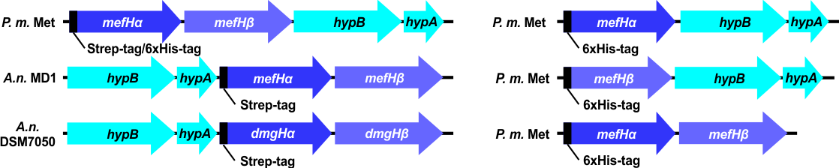
Supplementary Fig. 1: Schematic representation of the expression constructs for MefH and DmgH. In each case, only one ureohydrolase family protein was 6x His- or Strep-tagged for purification. Note that the operon was shuffled for P. mendocina (P.m.) MET, whereas the constructs with genes from Aminobacter niigataensis (A.n.) strains DSM7050 and MD1 are in the native order.

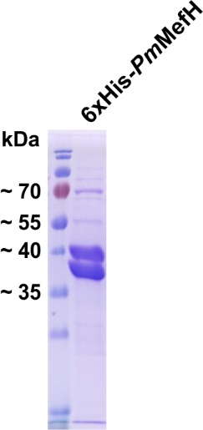

Supplementary Fig. 2: Denaturing polyacrylamide gel with purified PmMefH. 6x His-PmMefH was purified by nickel affinity chromatography. Two bands were observed at the expected sizes of 6xHis-MefHα (42 kDa) and MefHβ (37 kDa).

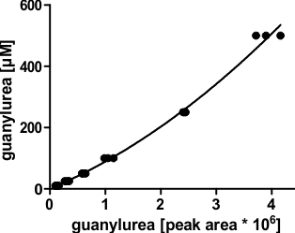
Supplementary Fig. 3: Calibration of guanylurea quantification by LC-MS. Standards in reaction buffer containing guanylurea and metformin a combined concentration of 2 mM were measured in technical triplicates. Data were fitted with a polynomic regression (solid line, R²= 0.9931). The resulting equation was used to calculate guanylurea concentrations of the enzyme assay samples.
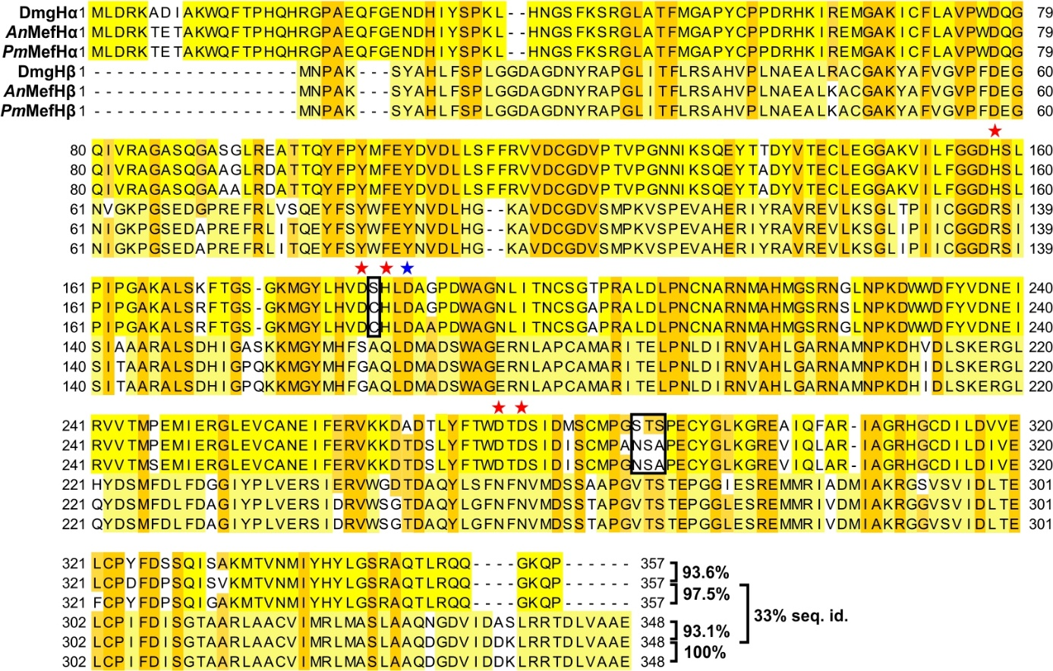
Supplementary Fig. 4: Sequence Alignment of MefH and DmgH subunits. Clustal omega was used to generate a multiple sequence alignment of all six subunits of AnMefH, PmMefH and DmgH. Residues conserved in all proteins are highlighted in dark orange, over 50% conservation is highlighted in light orange. Residues that are completely conserved in the corresponding subunits are highlighted in yellow. Residues participating in metal binding (as inferred from the crystal structure and alignment with GdmH, not shown for reasons of clarity) are marked with asterisks (red: mutated in β-subunits, blue: conserved throughout all proteins). Residues changed in the mutational studies are marked with a black box.
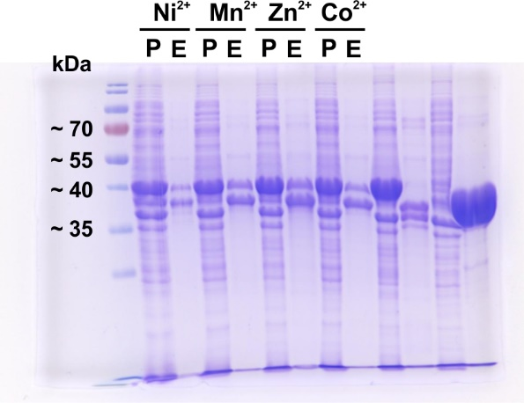
Supplementary Fig. 5: 6xHis-PmMefH purified after expression in the presence of different metal ions. 6xHis-PmMefH was expressed in the presence of 50 µM Ni²⁺, Mn²⁺, Zn²⁺ or Co²⁺and purified by nickel affinity chromatography. Unsoluble fractions after lysis (P) and purified enzymes (E) were analyzed by denaturing polyacrylamide gel electrophoresis.

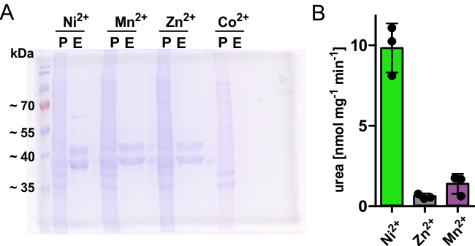
Supplementary Fig. 6: Metal dependency of DmgH activity. A Denaturing polyacrylamide gel of purified Strep-DmgH after expression in the presence of different metals. Strep-DmgH was expressed in the presence of 100 µM Ni²⁺, Mn²⁺, Zn²⁺ or Co²⁺ and purified by nickel affinity chromatography. Unsoluble fraction after lysis (P) and purified enzyme (E) were loaded. Please note that expression in the presence of Co²⁺ failed. Repetition of expression resulted in poor yields of enzyme. In light of the results with PmMefH, that was expressed but inactive in the presence of Co²⁺, we decided to stop the experiments. B Urea production rates were determined for purified DmgH expressed with the annotated metals. Columns represent the average of technical triplicates and consistent results were obtained with independent preparations (error bars, s.d.).
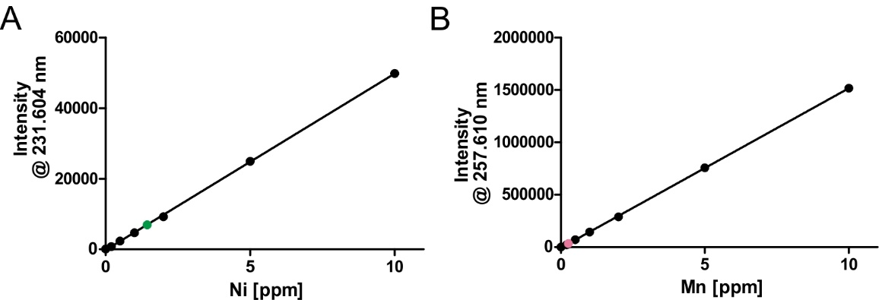
Supplementary Fig. 7: ICP-OES analysis of the DmgH metal content. DmgH was expressed in medium containing 0.5 mM Ni²⁺. The cells were lysed in virtually Ni²⁺-free buffer and DmgH was purified by Strep-Tactin affinity chromatography followed by a buffer exchange into enzyme buffer on a PD-Midi desalting column. Metal standards containing nickel (Ni) and manganese (Mn) (Agilent) were measured in enzyme buffer (black dots). Data were fitted with a linear regression (solid line, R² = 0.9998 and 0.9999, respectively) and were used to calculate the nickel (green dot) and manganese (magenta dot) content of the protein samples. Data points represent the average of technical triplicates and consistent results were obtained with independent preparations. (error bars, s.d.). Please note that error bars were too small to be visualized on the scale of the graph.
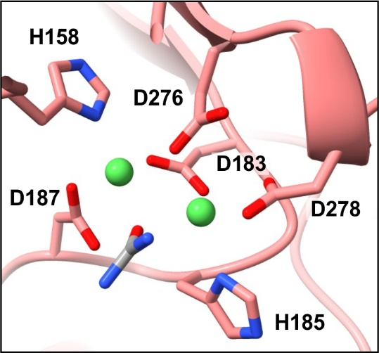
Supplementary Fig. 8: Urea bound in the MefHα active site. Close-up of the MefHα active site with the amino acids coordinating the Ni²⁺ ions (green spheres) and the bound urea (grey).
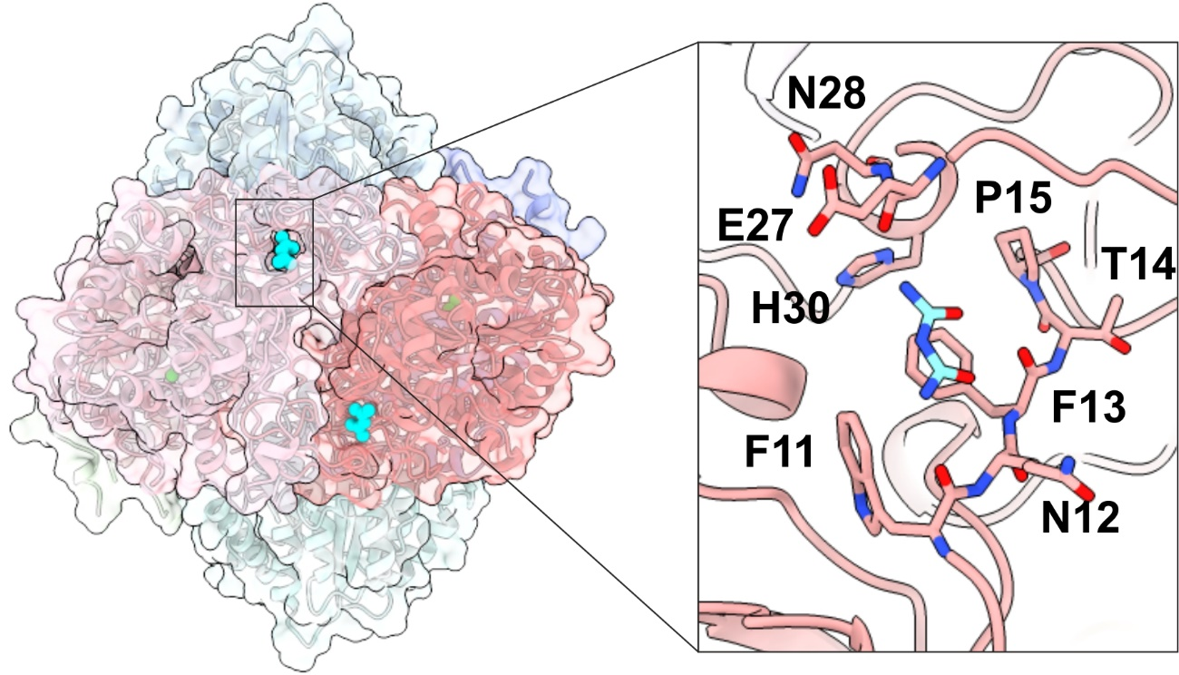 Supplementary Fig. 9: Biuret binding site of MefHα. Global view of the biuret binding site at the N-terminus of MefHα and a close-up with the residues participating in the biuret binding. Biuret is an impurity (≤ 0.1%) of the urea that was used for soaking.
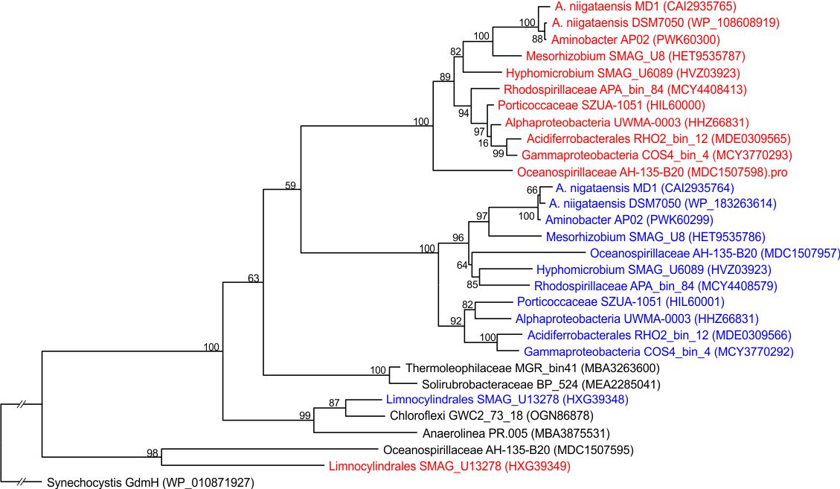
Supplementary Fig. 10: Phylogenetic tree of MefH and related sequences. From BLAST searches with MefHα and MefHβ, Genbank hits representing full-length ureohydrolase sequences were selected. We checked in each case if they were from individual genes or from genes arranged in tandem. Red and blue letters indicate first and second sequences, respectively, in tandem-arranged genes. Bootstrap values are given next to each node and NCBI protein accession numbers are in brackets behind the organism identifiers. The branch length for GdmH was shortened for a better graphical representation of the other nodes.

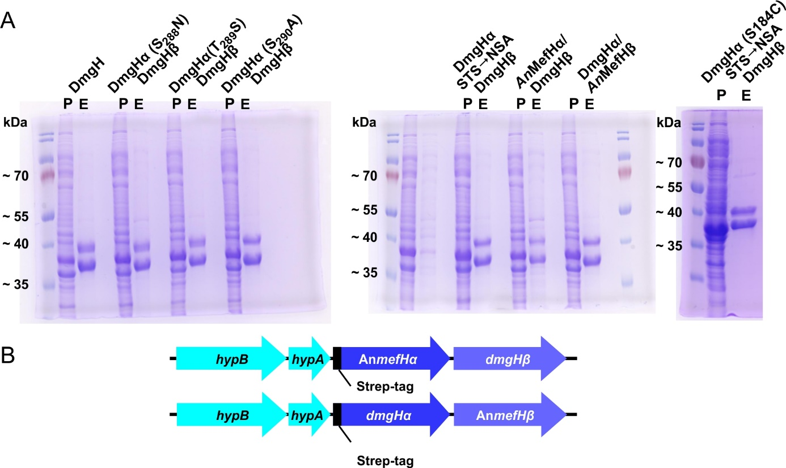
Supplementary Fig. 11: Expression of MefH/DmgH mixed heteromers and DmgH variants. A Denaturing polyacrylamide gels with purified DmgH variants and mixed heteromers. B Schematic representation of the expression constructs for the mixed heteromers.

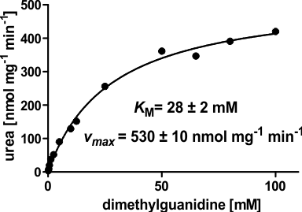
Supplementary Fig. 12: Enzymatic activity of DgmH variant T₂₈₉S. Urea production at substrate concentrations from 0.16-100 mM was measured to determine Michaelis constant K_{M} and maximal reaction rate (v_{max}) for the mutated DmgH. Data points represent the average of technical triplicates and consistent results were obtained with independent preparations (error bars, s.d.).

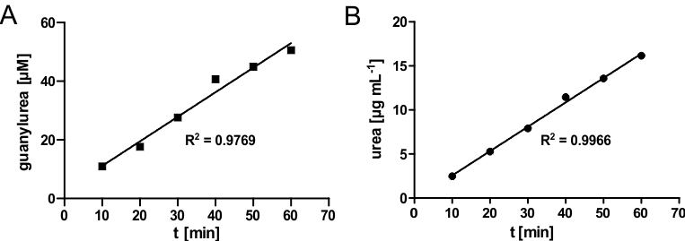
Supplementary Fig. 13: Linearity of guanylurea and urea production over time. Concentrations of guanylurea (A) and urea (B) were plotted against the reaction time of the enzyme assays with MefH and DmgH, respectively. Data were analyzed by linear regression and the calculated R² values confirmed that the reaction was bona fide linear within the 1 h used in end-point determinations of enzyme activity. Data points represent the average of technical triplicates and consistent results were obtained with independent preparations (error bars, s.d.).

Extended Data Table 1: Peptide mass fingerprint analysis of purified PmMefH. 6xHis-PmMefH was purified by nickel affinity chromatography. Protein bands at ~37 kDa and ~42 kDa were excised from a denaturing polyacrylamide gel and subjected to peptide mass fingerprint analysis.
Band | Description | Score | Coverage | # Proteins | # Unique Peptides | # Peptides | # PSMs
42 kDa | MefHα | 11598.23 | 75.20 | 1 | 23 | 23 | 428
42 kDa | MefHβ | 7412.98 | 88.22 | 1 | 27 | 27 | 376
42 kDa | HypB | 2392.28 | 68.73 | 1 | 19 | 19 | 73
37 kDa | MefHα | 2026.02 | 53.07 | 1 | 16 | 16 | 84
37 kDa | MefHβ | 32200.81 | 96.26 | 1 | 35 | 35 | 1220
37 kDa | HypB | 5702.26 | 68.73 | 1 | 21 | 21 | 167

Extended Data Table 2: Compounds of the substrate screen.
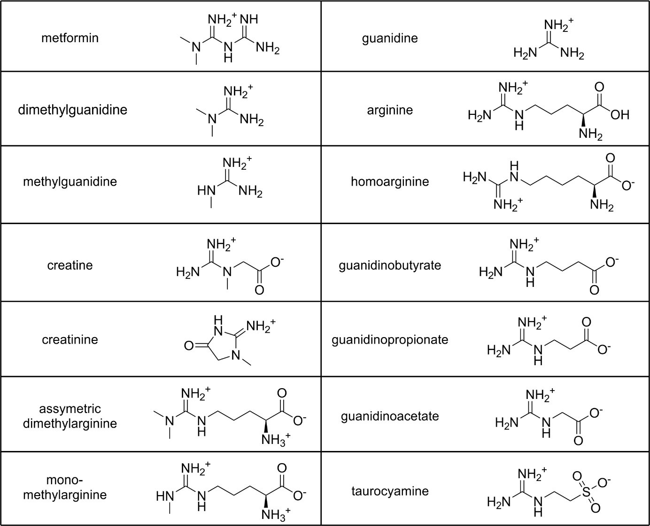
Extended Data Table 3: X-ray diffraction data collection and refinement statistics
 | Metformin hydrolase
PDB code | 8RYI
Space group | C2
Cell dimensions:
a, b, c (Å)  α, β, γ (º) | 163.99, 86.52, 168.41  90, 113.99, 90
Subunit copies in ASU | 2α, 4β
Data Processing
Beamline | P13 (MX1), PETRA III
Detector | Dectris EIGER1 Si 16M
Wavelength (Å) | 0.97626
Resolution (Å) | 29.97 – 2.06 (2.08-2.06)ª
No. unique reflections | 130397 (3627) ª
R_{sym}(I) (%) | 11.9 (215.0) ª
<I/σ(I)> | 10.31 (0.92) ª
CC_{1/2} (%) | 99.8 (35.7) ª
Completeness (%) | 97.9 (97.8) ª
Multiplicity | 7.18 (7.47) ª
Model Refinement
No. working/free reflections | 130397 / 6573
R_{work}/Rf_{ree} (%) | 16.17/19.53
No. Atoms Protein | 15885
No. Atoms Solvent | 929 x H₂O; 4 x Ni²⁺; 2 x URE ^{b}; 2 x C5J ^{c}
R.m.s.d. bond length (Å) | 0.007
R.m.s.d. angles (°) | 0.88
Ramachandran plot
Favoured/disallowed (%) | 96.86/0

ª values in parentheses correspond to the highest resolution shell; ^{b} URE, Urea; ^{c} C5J, Biuret

