SUPPLEMENTAL INFORMATION

Dynamics of cardiomyocyte gene expression and reversibility of catecholamine-induced heart injury

Running title: Catecholamine-induced heart injury

Christine Bode¹, Sebastian Preissl¹, Lutz Hein^{1,2}, Achim Lother^{1,3}

¹ Institute of Experimental and Clinical Pharmacology and Toxicology, Faculty of Medicine, University of Freiburg, Germany
² BIOSS Centre for Biological Signaling Studies, University of Freiburg, Germany
³ Interdisciplinary Medical Intensive Care, Faculty of Medicine, University of Freiburg, Germany

Suppl. Table S1: qRT-PCR primer sequences
Gene symbol | Forward Primer | Reverse Primer
Bgn | CAACCTAGTCCACCAACTAAGCA | CAGGGGACACATGGTCAAT
Ctgf | TGACCCCTGCGACCCACA | TACACCGACCCACCGAAGACACAG
Lyz2 | GAATGGAATGGCTGGCTACT | CGTGCTGAGCTAAACACACC
Myh7 | ACTGTCAACACTAAGAGGGTCA | TTGGATGATTTGATCTTCCAGGG
Rps29 | ATGGGTCACCAGCAGCTCTA | AGCCTATGTCCTTCGCGTACT

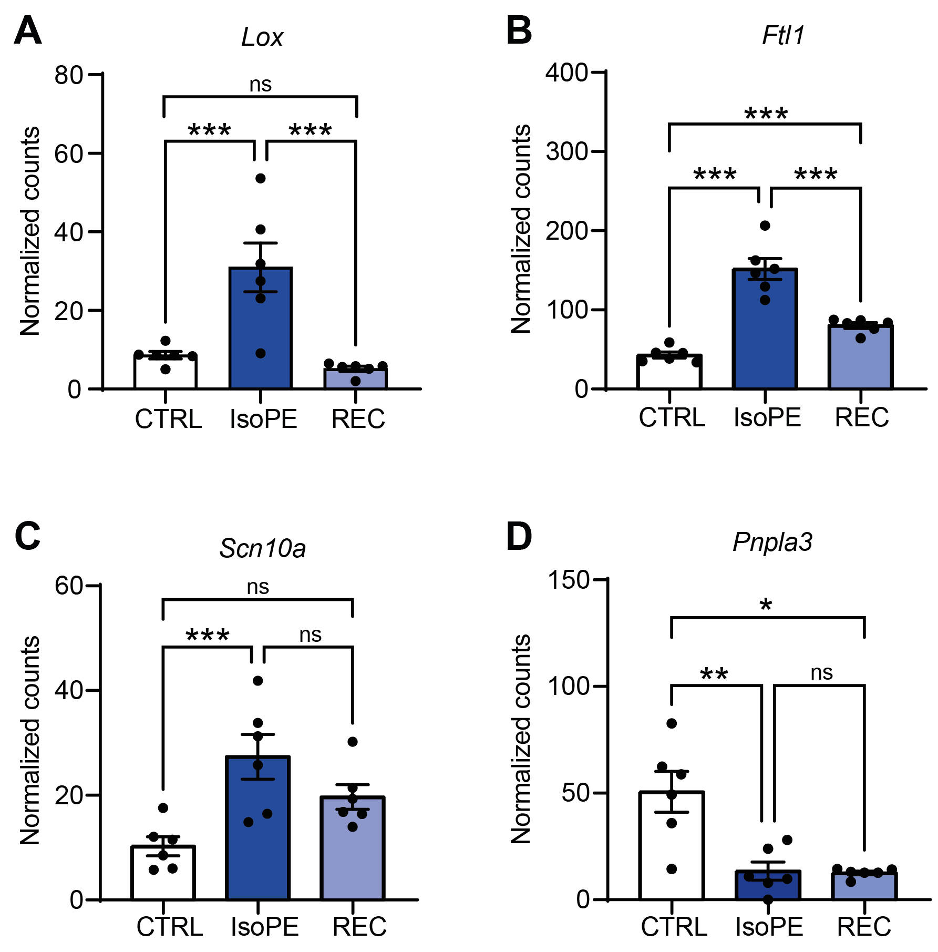
Suppl. Figure S1. Examples of differentially expressed genes. Examples of genes that were differentially expressed after IsoPE and classified as recovered (A), partially recovered (B, C), or persistently regulated (D) after recovery. Lox, lysyl oxidase; Ftl1, ferritin light polypeptide 1; Scn10a, sodium voltage-gated channel alpha subunit 10; Pnpla3, patatin like phospholipase domain containing 3. n = 6 per group. *q < 0.05, **q < 0.01, ***q < 0.001.

