Supplementary Material

Supplementary Table 1. Comparison Eastern versus Western Germany by Vaccination Status and Volunteer Characteristics
 | Western Germany |  | Eastern Germany |  | p value
 | n | % | n | % | p value
Birth Year | 1974 (1963-1986) [1932-2003] |  | 1978 (1966-1987) [1941-2003] |  | 0.022
Sex |  |  |  |  | 0.751
Female | 2798 | 58.8% | 325 | 58.0% | 0.751
Male | 1952 | 41.0% | 233 | 41.6% | 0.751
Non-binary | 10 | 0.2% | 2 | 0.4% | 0.751
Underlying Conditions
High Blood Pressure | 700 | 14.7% | 88 | 15.7% | 0.525
Coronary Heart Disease/History of Heart Attack | 86 | 1.8% | 11 | 2.0% | 0.792
Heart Failure | 47 | 1.0% | 7 | 1.3% | 0.558
Asthma/COPD/Chronic Bronchitis or Emphysema | 390 | 8.2% | 53 | 9.5% | 0.303
Chronic Hepatitis B or C | 8 | 0.2% | 0 | 0.0% | 0.332
Chronic Non-Infectious Liver Disease | 25 | 0.5% | 3 | 0.5% | 0.974
Chronic Kidney Disease | 24 | 0.5% | 10 | 1.8% | <0.001
>20 kg Overweight | 497 | 10.4% | 63 | 11.3% | 0.555
Diabetes Mellitus | 143 | 3.0% | 22 | 3.9% | 0.233
HIV | 49 | 1.0% | 3 | 0.5% | 0.261
Active Cancer <2 Years | 67 | 1.4% | 5 | 0.9% | 0.319
Epilepsy | 31 | 0.7% | 2 | 0.4% | 0.402
Chronic Illness of Stomach/Intestine | 45 | 0.9% | 4 | 0.7% | 0.588
Musculoskeletal System Disease | 58 | 1.2% | 4 | 0.7% | 0.293
Mental Illness | 255 | 5.4% | 44 | 7.9% | 0.015
History of Stroke | 30 | 0.6% | 2 | 0.4% | 0.429
Primary Series (Basic Immunization) |  |  |  |  | 0.286
No Primary Series | 711 | 14.9% | 73 | 13.0% | 0.286
Unknown whether Primary Series | 1706 | 35.8% | 217 | 38.8% | 0.286
Complete Primary Series | 2343 | 49.2% | 270 | 48.2% | 0.286
Vaccination Schedule Completeness |  |  |  |  | 0.397
Incomplete Vaccination | 1129 | 23.7% | 119 | 21.3% | 0.397
Uncertain Vaccination | 1900 | 39.9% | 235 | 42.0% | 0.397
Complete Vaccination | 1731 | 36.4% | 206 | 36.8% | 0.397
Maintenance of First Vaccination Certificate | 2770 | 58.2% | 360 | 64.3% | 0.006
Supplementary Table 2. Completeness of Vaccination Records by Age Range and Gender
 | Correspondence year of birth and year of oldest available vaccination card
 | no |  | yes
Age range | n | % | n | %
18-29 | 109 | 15.8 | 582 | 84,2
30-39 | 229 | 20.1 | 911 | 79,9
40-49 | 316 | 28.4 | 797 | 71,6
50-59 | 647 | 49.8 | 653 | 50,2
60-69 | 677 | 75.9 | 215 | 24,1
70+ | 265 | 85.5 | 45 | 14,5
Sex
Female | 1155 | 37.0 | 1968 | 63,0
Male | 1031 | 47.2 | 1154 | 52,8
Non-binary | 4 | 33.3 | 8 | 66,7

Supplementary Table 3. Vaccination Status by Age Range and Gender
 |  | Incomplete vaccination status  n=1,276 | Uncertain vaccination status  n=2,192 | Complete vaccination status  n=1,981
Female | 18-29 | 88 | 120 | 196
Female | 30-39 | 106 | 363 | 221
Female | 40-49 | 103 | 267 | 288
Female | 50-59 | 168 | 267 | 365
Female | 60-69 | 145 | 193 | 157
Female | 70+ | 59 | 59 | 28
Female | Not reported | 0 | 0 | 0
Male | 18-29 | 50 | 98 | 135
Male | 30-39 | 78 | 236 | 131
Male | 40-49 | 93 | 212 | 146
Male | 50-59 | 152 | 167 | 175
Male | 60-69 | 153 | 140 | 101
Male | 70+ | 77 | 56 | 31
Male | Not reported | 0 | 0 | 0
Non-binary | 18-29 | 2 | 1 | 1
Non-binary | 30-39 | 0 | 2 | 0
Non-binary | 40-49 | 2 | 1 | 0
Non-binary | 50-59 | 0 | 0 | 1
Non-binary | 60-69 | 0 | 2 | 0
Non-binary | 70+ | 0 | 0 | 0
Non-binary | Not reported | 0 | 0 | 0
Not reported | 18-29 | 0 | 2 | 0
Not reported | 30-39 | 0 | 2 | 1
Not reported | 40-49 | 0 | 1 | 0
Not reported | 50-59 | 0 | 1 | 4
Not reported | 60-69 | 0 | 1 | 0
Not reported | 70+ | 0 | 0 | 0
Not reported | Not reported | 0 | 1 | 0

Supplementary Figure 1. Vaccination Status Classification in the VACCELERATE Volunteer Registry
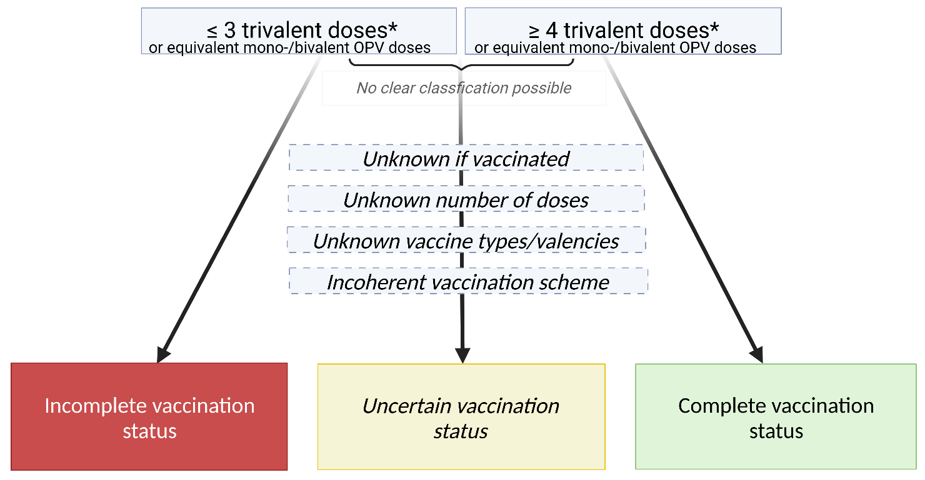
*IPV (inactivated poliovirus vaccine given by injection)/trivalent OPV (oral poliovirus vaccine)
Supplementary Figure 2. Sub Analysis Uncertain Vaccination Status – Probability for Completeness

